EXPERIMENT NUMBER: 5
AIM
To create SQL views for department salary summary and employee hierarchy, test the updatability of views, and implement a recursive CTE to display employee reporting chains.

SOURCE CODE
USE CompanyDB;

ALTER TABLE Employee
ADD manager_id INT NULL;

UPDATE Employee
SET manager_id = CASE
WHEN emp_id IN (2,3,4,5,6) THEN 1
WHEN emp_id IN (9,10,11,12) THEN 8
WHEN emp_id IN (14,15,16,17,18) THEN 13
WHEN emp_id IN (20,21,22,23,24) THEN 19
WHEN emp_id IN (26,27,28,29,30) THEN 25
ELSE NULL
END;

-- 1. Department Salary Summary View
CREATE VIEW Department_Salary_Summary AS
SELECT
dept_id,
COUNT(*) AS employee_count,
SUM(salary) AS total_salary,
AVG(salary) AS average_salary,
MAX(salary) AS maximum_salary,
MIN(salary) AS minimum_salary
FROM Employee
GROUP BY dept_id;

SELECT *
FROM Department_Salary_Summary;

-- 2. Employee Hierarchy View
CREATE VIEW Employee_Hierarchy AS
SELECT
e.emp_id,
e.emp_name AS employee_name,
e.job_title, e.manager_id,
m.emp_name AS manager_name
FROM Employee e
LEFT JOIN Employee m
ON e.manager_id = m.emp_id;
SELECT * FROM Employee_Hierarchy;
-- 3. Test Updatability of Department Salary Summary View
UPDATE Department_Salary_Summary
SET average_salary = 70000
WHERE dept_id = 1;

-- 4. Test Updatability of Employee Hierarchy View
UPDATE Employee_Hierarchy
SET job_title = 'Senior Software Engineer'
WHERE emp_id = 1;

-- 5. Recursive CTE for Reporting Chains
WITH RECURSIVE ReportingChain AS
(
SELECT
emp_id,
emp_name,
manager_id,
0 AS level,
CAST(emp_name AS CHAR(500)) AS reporting_chain
FROM Employee
WHERE manager_id IS NULL

UNION ALL

SELECT
e.emp_id,
e.emp_name,
e.manager_id,
rc.level + 1,
CONCAT(rc.reporting_chain, ' -> ', e.emp_name)
FROM Employee e
JOIN ReportingChain rc
ON e.manager_id = rc.emp_id
)
SELECT
emp_id,
emp_name,
level,
reporting_chain
FROM ReportingChain
ORDER BY reporting_chain;

OUTPUT
1. Department Salary Summary
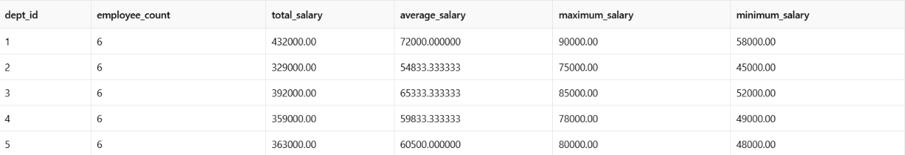

2. Employee Hierarchy View
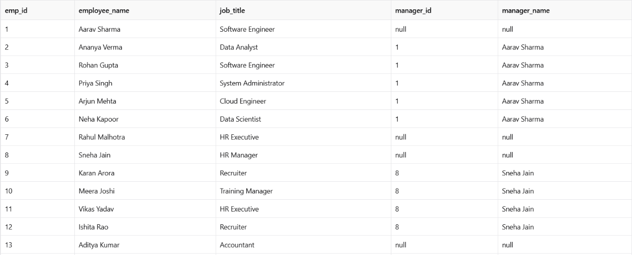
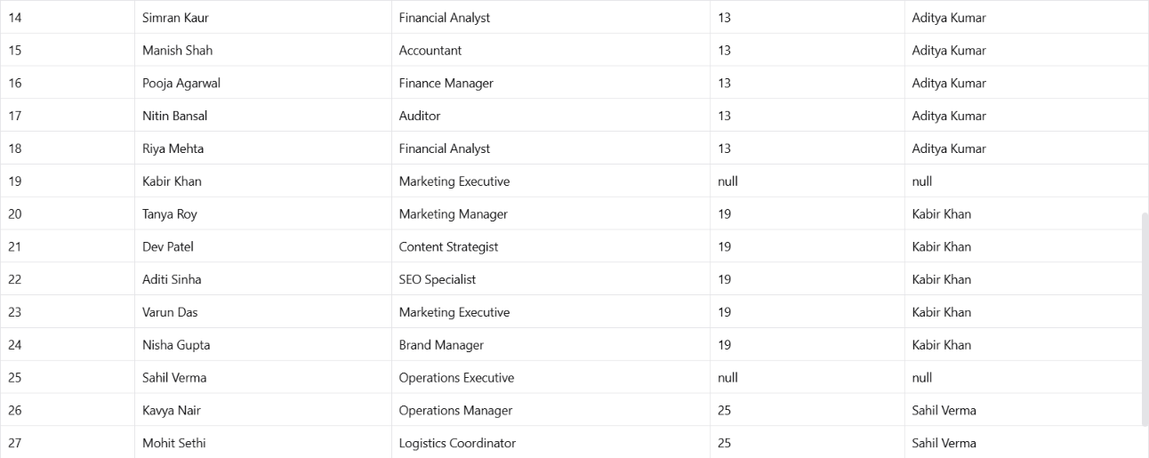

3-4. Updatability Test
The Department_Salary_Summary view cannot be updated because it contains aggregate functions such as COUNT(), SUM(), and AVG() along with GROUP BY.

The Employee_Hierarchy view is based on a self-join, so it is also not reliably updatable as a whole. Therefore, the update should be tested only to demonstrate the restriction.
5. Recursive CTE Output
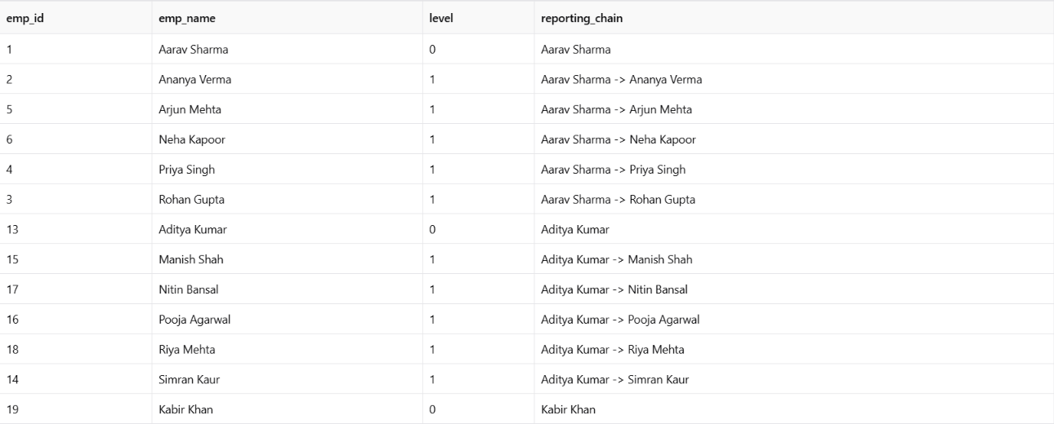
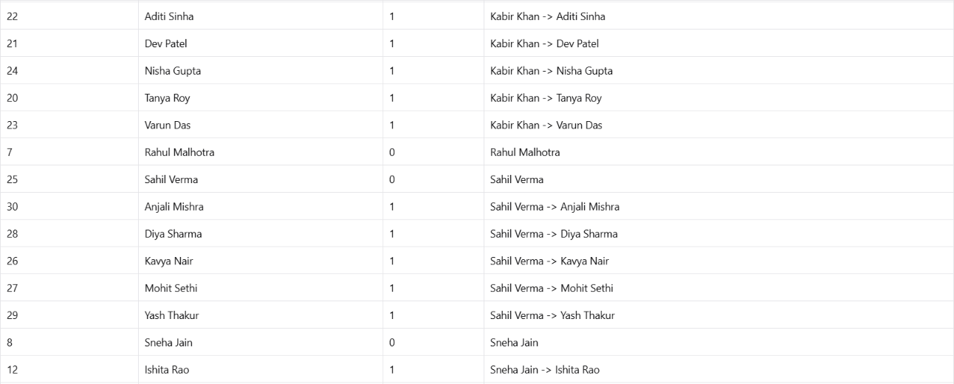

RESULT
The Department Salary Summary and Employee Hierarchy views were successfully created. Their updatability was tested, and the aggregate view was found to be non-updatable. A recursive CTE was successfully implemented to display employee reporting chains from managers to their subordinates.

