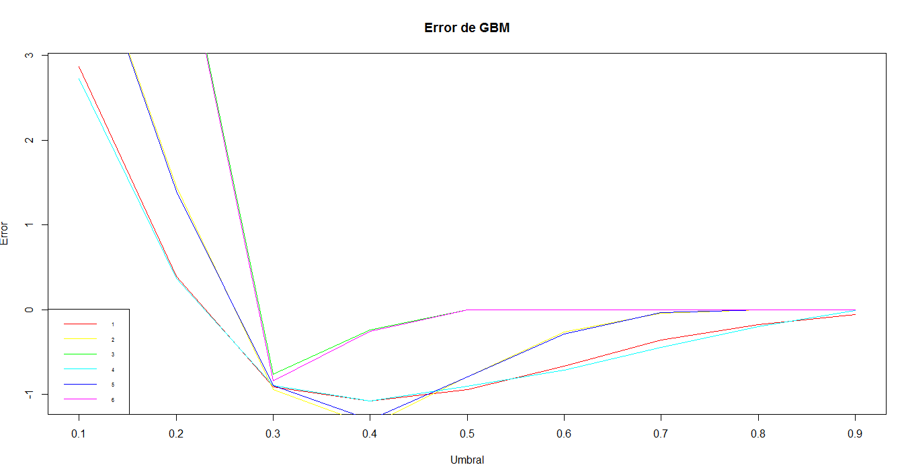

|  |  |  |
| --- | --- | --- |
| ntree | depth | shrinkage |
| 600 | 25 | 0,1 |
| 600 | 25 | 0,01 |
| 600 | 25 | 0,001 |
| 600 | 30 | 0,1 |
| 600 | 30 | 0,01 |
| 600 | 30 | 0,001 |

2.86781977;0.39664745;-0.91394405;-1.07569934;-0.94117019;-0.66623959;-0.36034593;-0.17563528;-0.05979073

4.70798633;1.45099295;-0.94650865;-1.36077301;-0.79756566;-0.26318599;-0.04377536;0.00000000;0.00000000

4.7554986;4.7554986;-0.7617980;-0.2396968;0.0000000;0.0000000;0.0000000;0.0000000;0.0000000

2.7236814;0.3662182;-0.8984625;-1.0815716;-0.9011318;-0.7185565;-0.4457613;-0.2007260;-0.0128123

4.69624173;1.39814222;-0.89899637;-1.29671151;-0.79222720;-0.28881059;-0.03469998;0.00000000;0.00000000

4.7554986;4.7554986;-0.8440102;-0.2567798;0.0000000;0.0000000;0.0000000;0.0000000;0.0000000

Detalle del fit

[[1]]

gbm(formula = as.formula(formula), distribution = "bernoulli",

data = train, n.trees = ctrl[[i]]$ntree, interaction.depth = ctrl[[i]]$depth,

shrinkage = ctrl[[i]]$shrinkage)

A gradient boosted model with bernoulli loss function.

600 iterations were performed.

There were 55 predictors of which 55 had non-zero influence.

[[2]]

gbm(formula = as.formula(formula), distribution = "bernoulli",

data = train, n.trees = ctrl[[i]]$ntree, interaction.depth = ctrl[[i]]$depth,

shrinkage = ctrl[[i]]$shrinkage)

A gradient boosted model with bernoulli loss function.

600 iterations were performed.

There were 55 predictors of which 55 had non-zero influence.

[[3]]

gbm(formula = as.formula(formula), distribution = "bernoulli",

data = train, n.trees = ctrl[[i]]$ntree, interaction.depth = ctrl[[i]]$depth,

shrinkage = ctrl[[i]]$shrinkage)

A gradient boosted model with bernoulli loss function.

600 iterations were performed.

There were 55 predictors of which 52 had non-zero influence.

[[4]]

gbm(formula = as.formula(formula), distribution = "bernoulli",

data = train, n.trees = ctrl[[i]]$ntree, interaction.depth = ctrl[[i]]$depth,

shrinkage = ctrl[[i]]$shrinkage)

A gradient boosted model with bernoulli loss function.

600 iterations were performed.

There were 55 predictors of which 55 had non-zero influence.

[[5]]

gbm(formula = as.formula(formula), distribution = "bernoulli",

data = train, n.trees = ctrl[[i]]$ntree, interaction.depth = ctrl[[i]]$depth,

shrinkage = ctrl[[i]]$shrinkage)

A gradient boosted model with bernoulli loss function.

600 iterations were performed.

There were 55 predictors of which 55 had non-zero influence.

[[6]]

gbm(formula = as.formula(formula), distribution = "bernoulli",

data = train, n.trees = ctrl[[i]]$ntree, interaction.depth = ctrl[[i]]$depth,

shrinkage = ctrl[[i]]$shrinkage)

A gradient boosted model with bernoulli loss function.

600 iterations were performed.

There were 55 predictors of which 53 had non-zero influence.