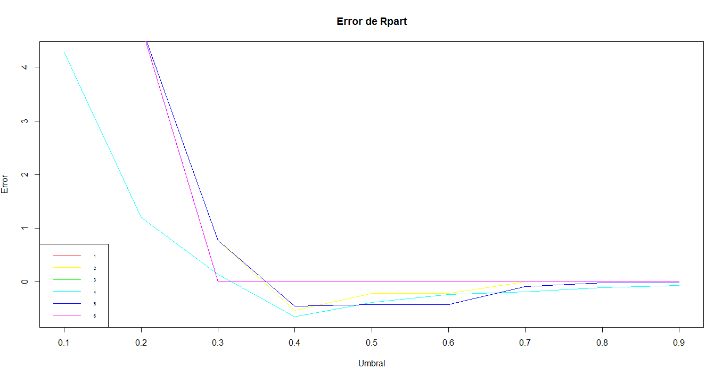

|  |  |  |
| --- | --- | --- |
| minsplit | maxdepth | cp |
| 1 | 5 | 0,0001 |
| 1 | 5 | 0,001 |
| 1 | 5 | 0,01 |
| 1 | 10 | 0,0001 |
| 1 | 10 | 0,001 |
| 1 | 10 | 0,01 |

**Detalle del error:**

4.75710015;2.89237668;0.76553491;-0.32457826;-0.24450139;-0.21513987;-0.02722614;-0.02722614;-0.02188768

4.7554986;4.7549648;0.7756780;-0.5295751;-0.2124706;-0.2124706;0.0000000;0.0000000;0.0000000

4.755499;4.755499;0.000000;0.000000;0.000000;0.000000;0.000000;0.000000;0.000000

4.27877429;1.19474696;0.13986761;-0.64808883;-0.38703822;-0.23329063;-0.18257527;-0.10730301;-0.06726457

4.75549861;4.75496477;0.77567798;-0.45643818;-0.42494128;-0.42494128;-0.09182148;-0.02188768;-0.02188768

4.755499;4.755499;0.000000;0.000000;0.000000;0.000000;0.000000;0.000000;0.000000

Segunda corrida

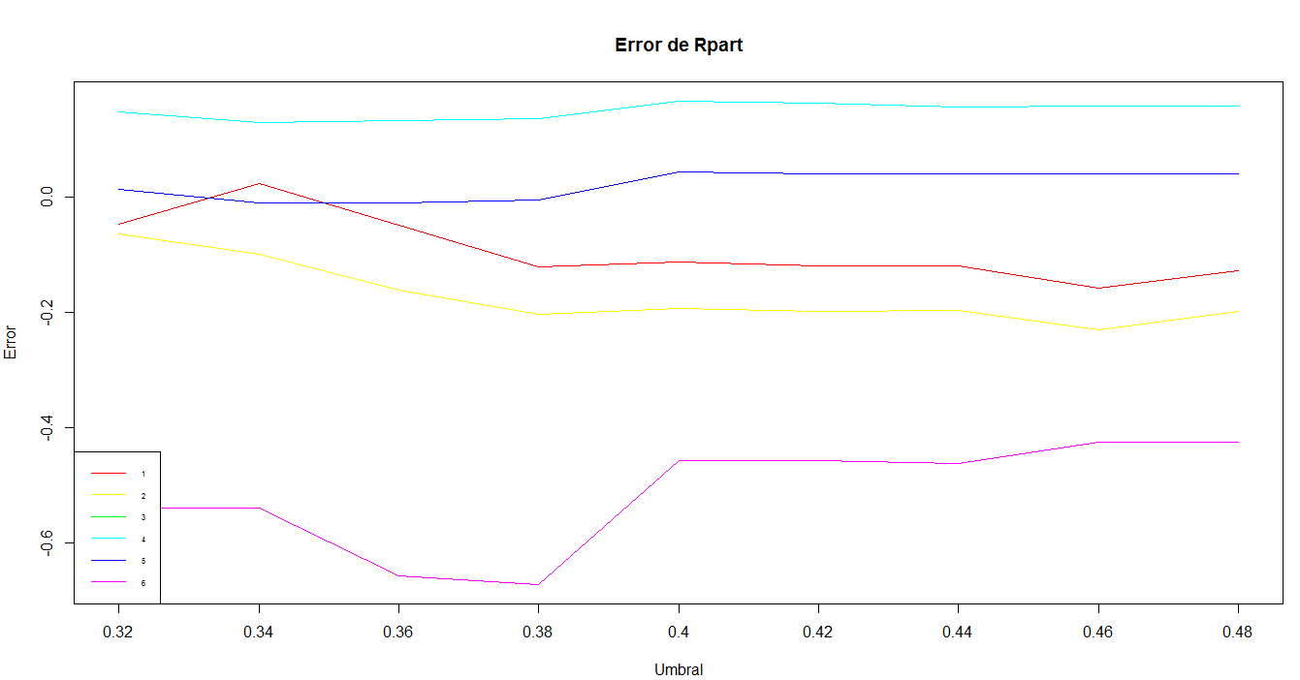

Controles

|  |  |  |
| --- | --- | --- |
| minsplit | maxdepth | cp |
| 1 | 15 | 0,00001 |
| 1 | 15 | 0,0001 |
| 1 | 15 | 0,001 |
| 1 | 20 | 0,00001 |
| 1 | 20 | 0,0001 |
| 1 | 20 | 0,001 |

**Detalle del error**

-0.04697843;0.02295537;-0.04857997;-0.12171685;-0.11317531;-0.11904762;-0.12011531;-0.15801836;-0.12705531

-0.06352765;-0.09929532;-0.16175529;-0.20339526;-0.19271834;-0.19859065;-0.19645526;-0.22955370;-0.19859065

-0.5386504;-0.5386504;-0.6566304;-0.6715780;-0.4564382;-0.4564382;-0.4628443;-0.4249413;-0.4249413

0.1473414;0.1286568;0.1318599;0.1355968;0.1660261;0.1628230;0.1564168;0.1574845;0.1574845

;0.013879991;-0.009609225;-0.009609225;-0.005872304;0.043241512;0.040038437;0.040038437;0.040038437;0.040038437

-0.5386504;-0.5386504;-0.6566304;-0.6715780;-0.4564382;-0.4564382;-0.4628443;-0.4249413;-0.4249413