AZURE-TIO-SQLDB-v1.2

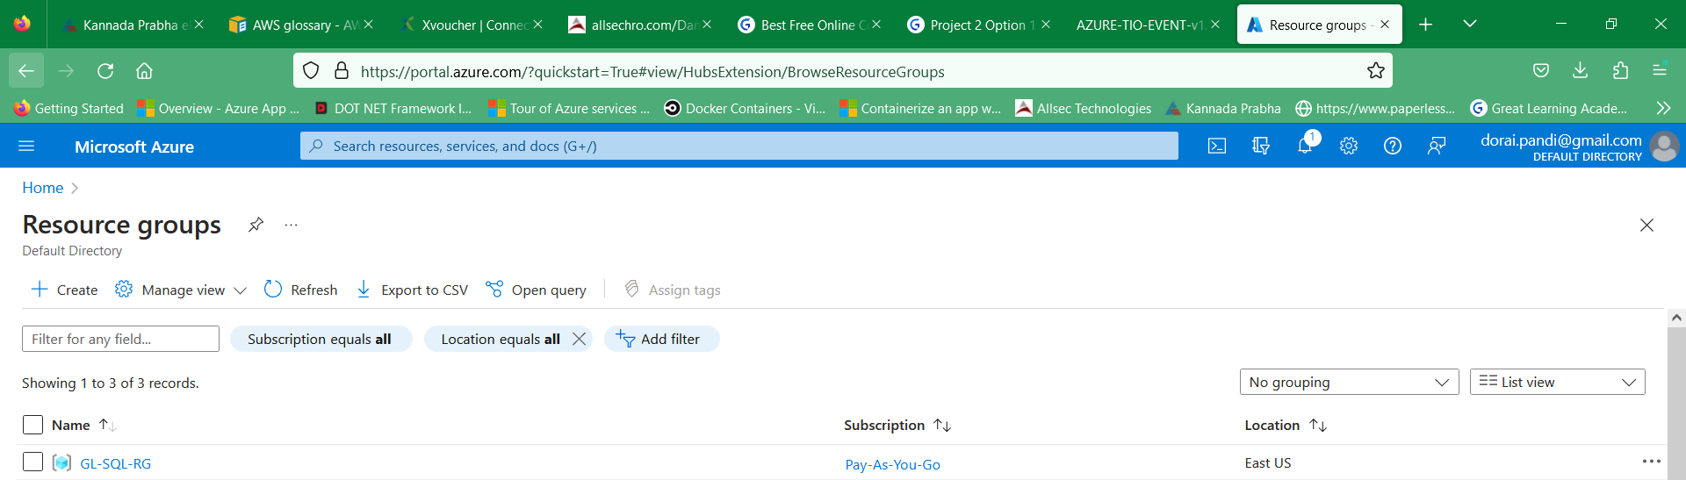

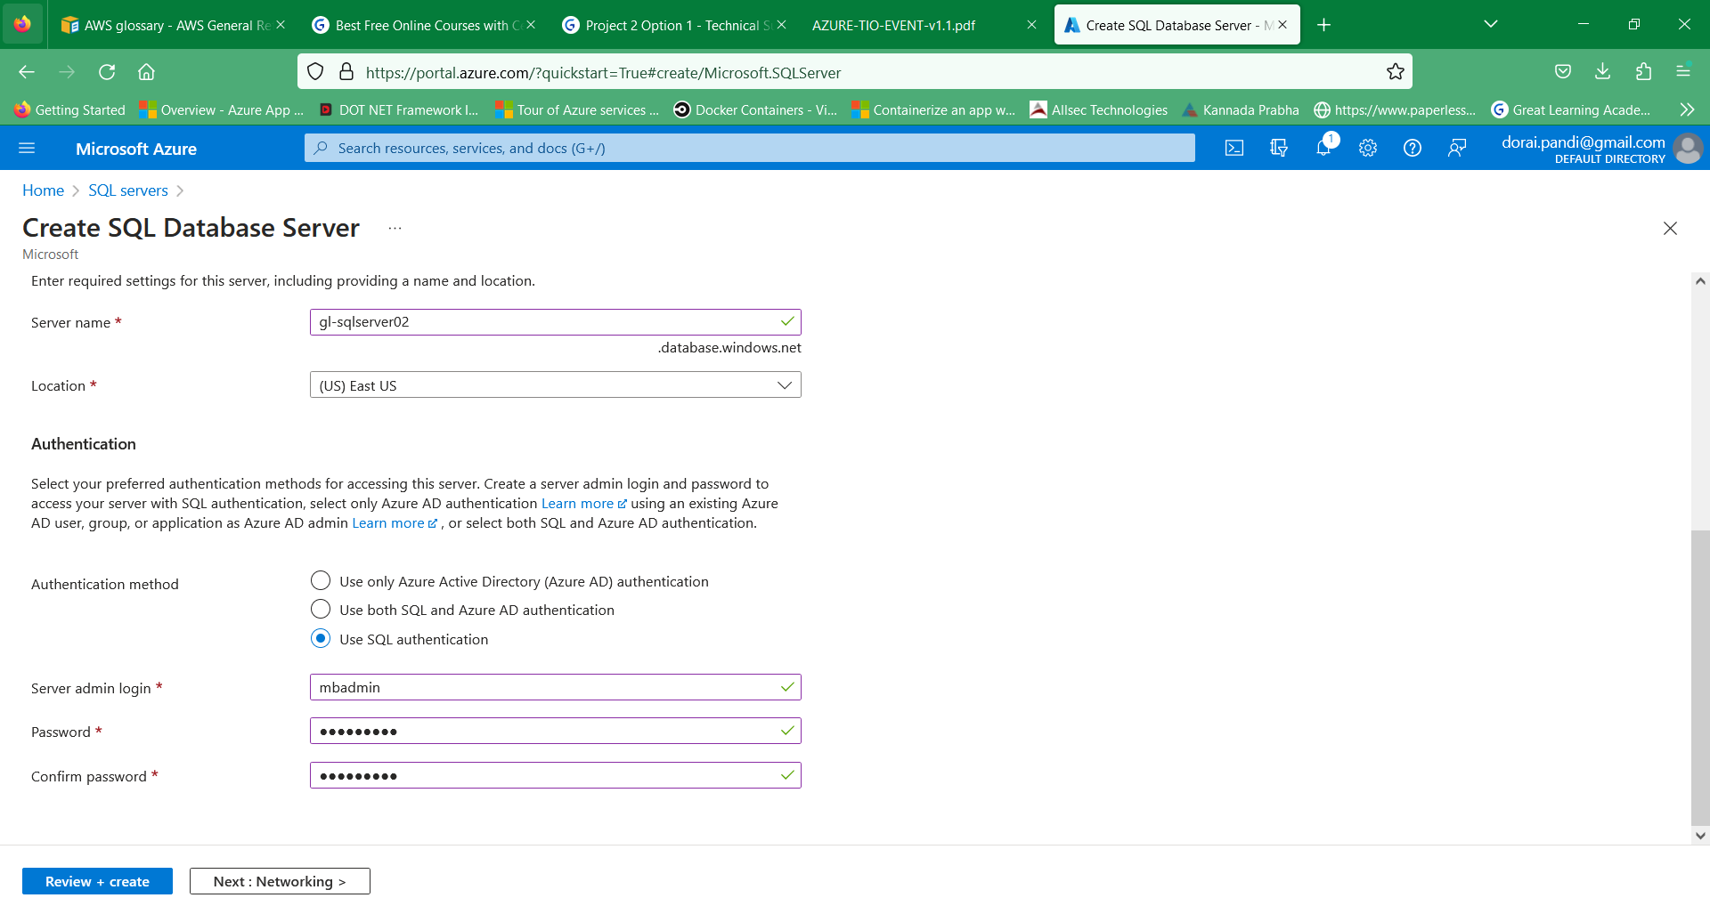

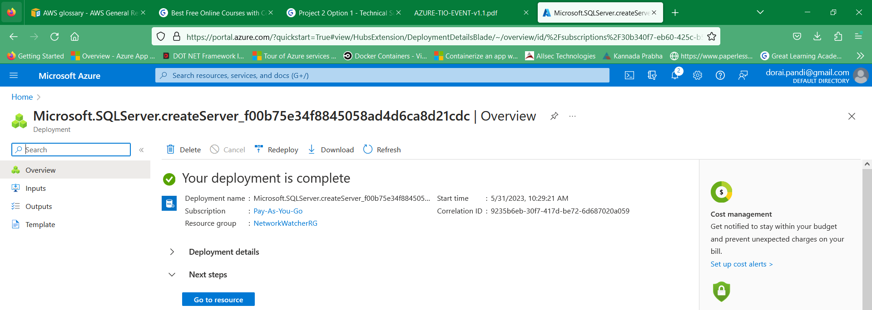

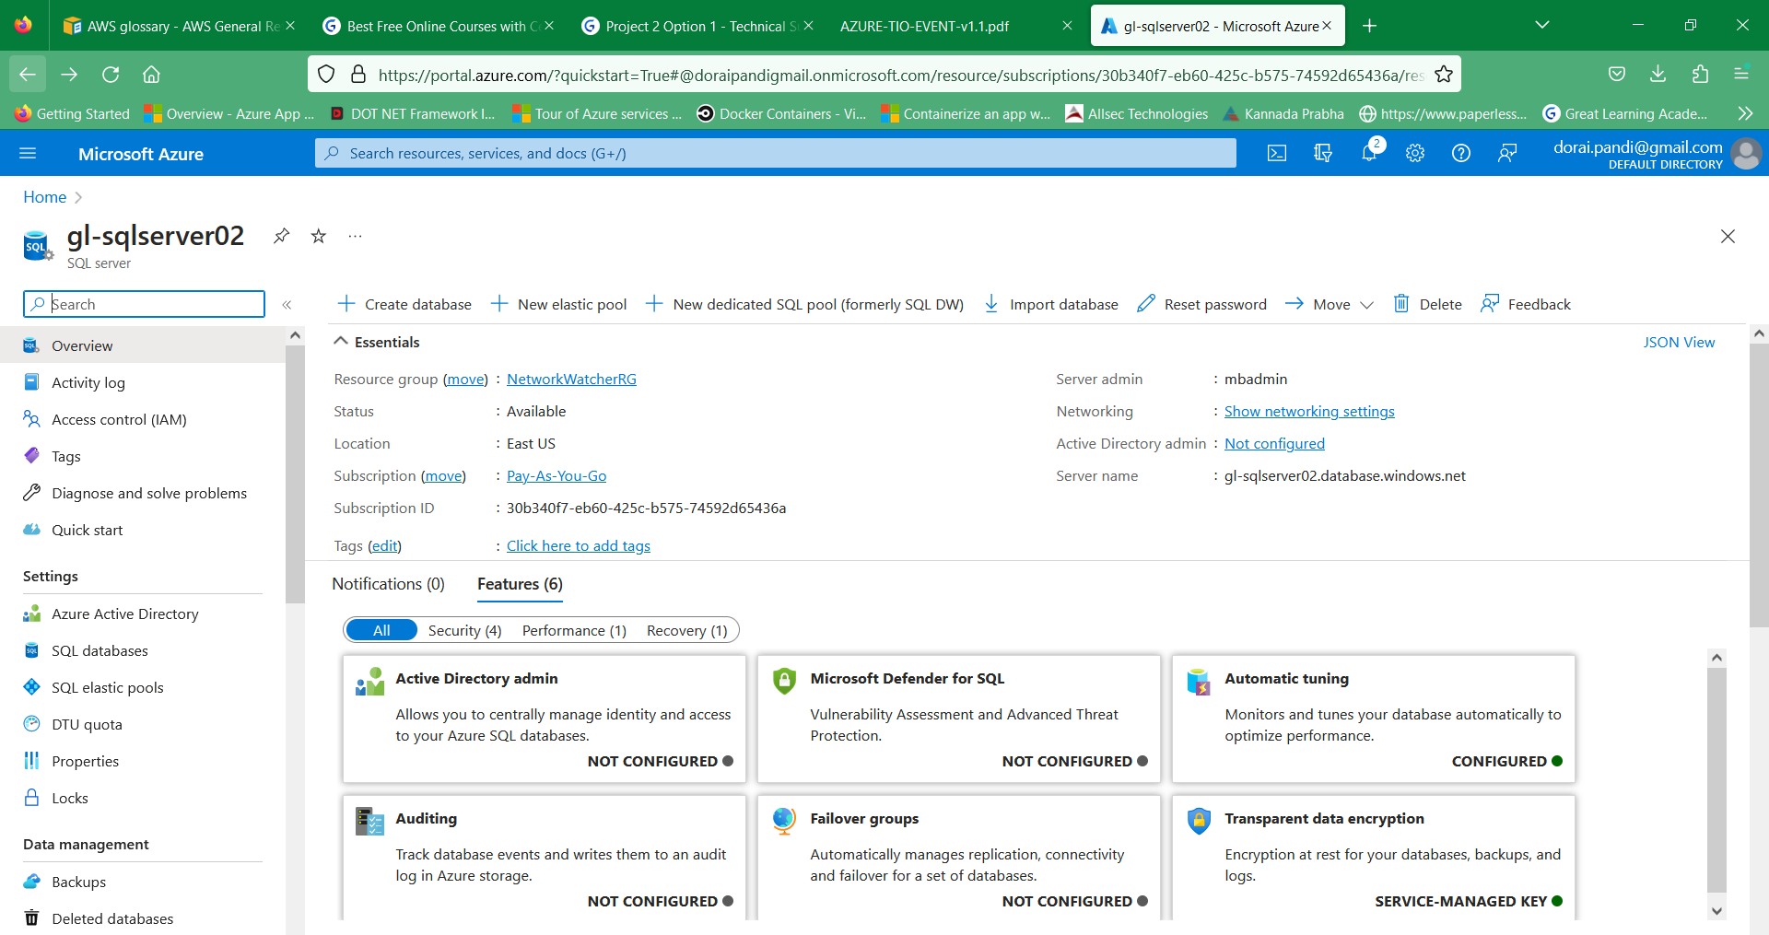

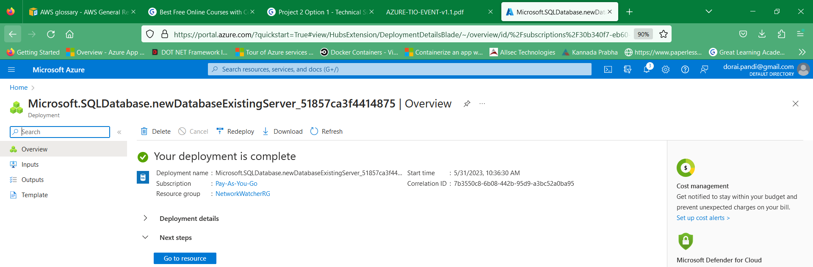

Connect to database via query editor!

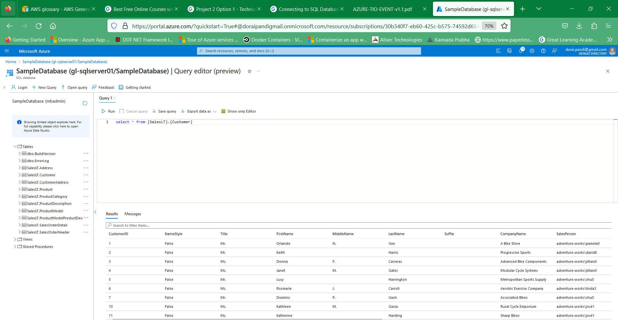

Connect to database via client tool!

VM created.

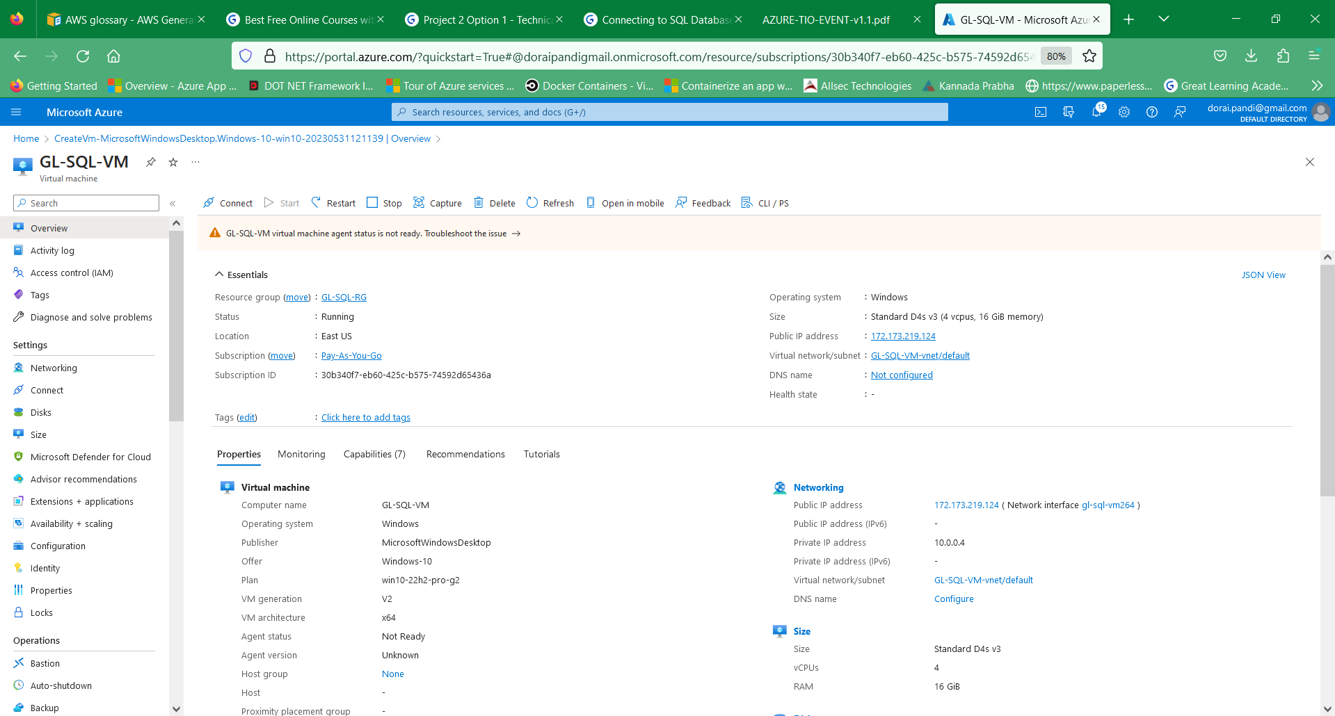

Connecting to VM, installing the Azure data studio and querying the Customer table.

