Lab 9 - W205 Section 3 Spring 2017

Sanjay Dorairaj

# What is the shortest path between DR. STRANGE and DR. DOOM?

**Query**

MATCH p=(peter:Hero {name: 'DR. STRANGE/STEPHEN'})-[:APPEARED*0..2]-(logan:Hero {name: 'DR. DOOM/VICTOR VON'}) RETURN p, length(p) ORDER BY length(p) LIMIT 1

The shortest path is 1

╒══════════════════════════════╤═══════════╕

│"p" │"length(p)"│

╞══════════════════════════════╪═══════════╡

│[{"name":"DR. STRANGE/STEPHEN"│"1" │

│,"degree":"777"},{"w":"8"},{"n│ │

│ame":"DR. DOOM/VICTOR VON","de│ │

│gree":"441"}] │ │

└──────────────────────────────┴───────────┘

# List the 5 shortest paths between DR. STRANGE and DR. DOOM

**Query**

**$**MATCH p=(peter:Hero {name: 'DR. STRANGE/STEPHEN'})-[:APPEARED*0..2]-(logan:Hero {name: 'DR. DOOM/VICTOR VON'}) RETURN p, length(p) ORDER BY length(p) LIMIT 5

The five shortest paths are

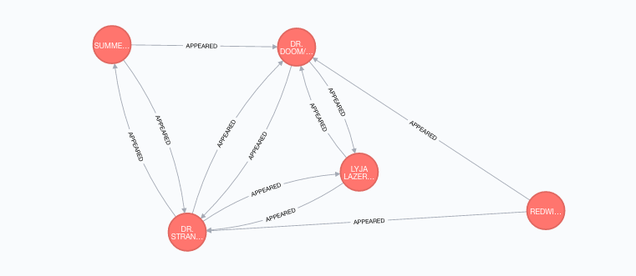

╒══════════════════════════════╤═══════════╕

│"p" │"length(p)"│

╞══════════════════════════════╪═══════════╡

│[{"name":"DR. STRANGE/STEPHEN"│"1" │

│,"degree":"777"},{"w":"8"},{"n│ │

│ame":"DR. DOOM/VICTOR VON","de│ │

│gree":"441"}] │ │

├──────────────────────────────┼───────────┤

│[{"name":"DR. STRANGE/STEPHEN"│"1" │

│,"degree":"777"},{"w":"12"},{"│ │

│name":"DR. DOOM/VICTOR VON","d│ │

│egree":"441"}] │ │

├──────────────────────────────┼───────────┤

│[{"name":"DR. STRANGE/STEPHEN"│"2" │

│,"degree":"777"},{"w":"1"},{"n│ │

│ame":"REDWING","degree":"175"}│ │

│,{"name":"REDWING","degree":"1│ │

│75"},{"w":"1"},{"name":"DR. DO│ │

│OM/VICTOR VON","degree":"441"}│ │

│] │ │

├──────────────────────────────┼───────────┤

│[{"name":"DR. STRANGE/STEPHEN"│"2" │

│,"degree":"777"},{"w":"1"},{"n│ │

│ame":"SUMMERS, NATHAN CHRI","d│ │

│egree":"422"},{"name":"SUMMERS│ │

│, NATHAN CHRI","degree":"422"}│ │

│,{"w":"1"},{"name":"DR. DOOM/V│ │

│ICTOR VON","degree":"441"}] │ │

├──────────────────────────────┼───────────┤

│[{"name":"DR. STRANGE/STEPHEN"│"2" │

│,"degree":"777"},{"w":"3"},{"d│ │

│egree":"197","name":"LYJA LAZE│ │

│RFIST [SKRU"},{"degree":"197",│

# List 5 Friends of Friends with the most connections and COLOSSUS II.

Query

MATCH (collosos:Hero { name: 'COLOSSUS II/PETER RA' })-[:APPEARED*2..2]-(friend_of_friend) WHERE NOT (collosos)-[:APPEARED]-(friend_of_friend) AND friend_of_friend.name <> 'COLOSSUS II/PETER RA' RETURN friend_of_friend.name, COUNT(*) ORDER BY COUNT(*) DESC , friend_of_friend.name LIMIT 5

╒═══════════════════════╤══════════╕

│"friend_of_friend.name"│"COUNT(*)"│

╞═══════════════════════╪══════════╡

│"WONG" │"453" │

├───────────────────────┼──────────┤

│"MOONSTONE II/KARLA S" │"370" │

├───────────────────────┼──────────┤

│"CARTER, PEGGY" │"367" │

├───────────────────────┼──────────┤

│"POWER MAN/ERIK JOSTE" │"350" │

├───────────────────────┼──────────┤

│"KINGPIN/WILSON FISK" │"342" │

# Visualize 10 Friends of friends for IRON MAN

**Query**

MATCH (ironman:Hero { name: 'IRON MAN/TONY STARK' })-[:APPEARED*2..2]-(friend_of_friend) WHERE NOT (ironman)-[:APPEARED]-(friend_of_friend) AND friend_of_friend.name <> 'IRON MAN/TONY STARK' RETURN friend_of_friend LIMIT 10

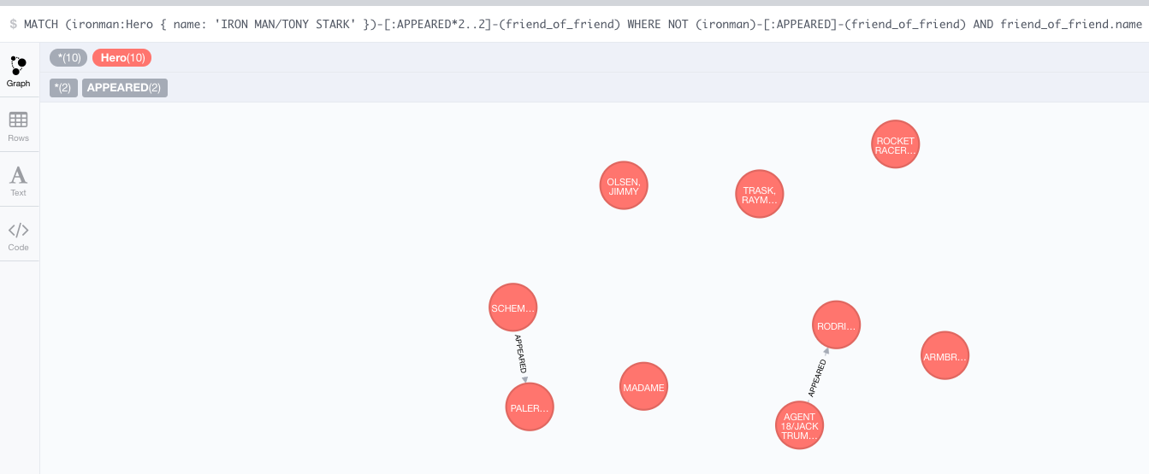

# Discover how the Avengers grew over time from 5 to 10. Find team members starting with 5 and incrementing to 10. Who was added to the team? Is the resulting graph ever not fully connected?

**Original 5**

**MATCH (wasp:Hero { name: 'WASP/JANET VAN DYNE' }),(hulk:Hero { name: 'HULK/DR. ROBERT BRUC' }),(ironman:Hero { name: 'IRON MAN/TONY STARK' }),(thor:Hero { name: 'THOR/DR. DONALD BLAK' }),(beast:Hero { name: 'BEAST/HENRY &HANK& P' })**

**return wasp,hulk,ironman,thor,beast**

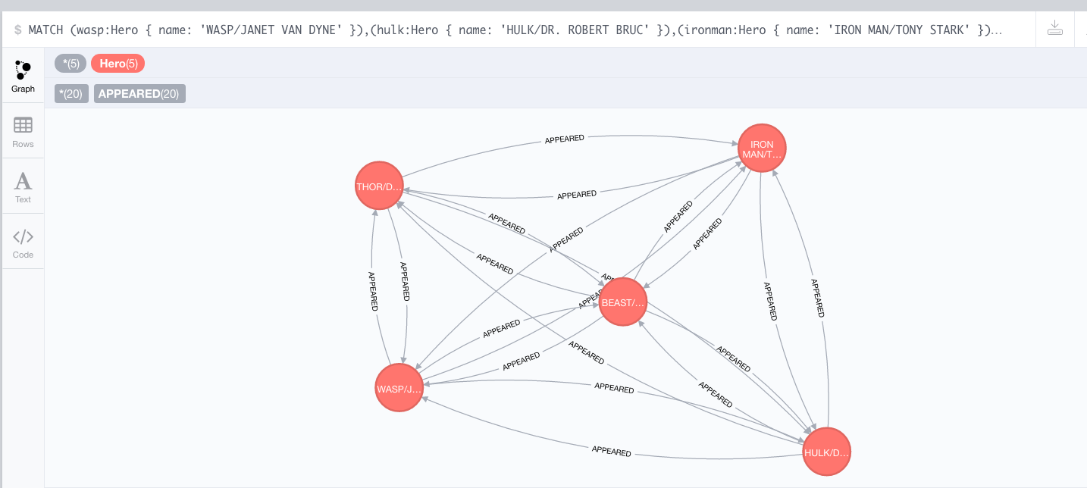

**Plus 1 – Bale, Embers**

**MATCH (wasp:Hero { name: 'WASP/JANET VAN DYNE' }),(hulk:Hero { name: 'HULK/DR. ROBERT BRUC' }),(ironman:Hero { name: 'IRON MAN/TONY STARK' }),(thor:Hero { name: 'THOR/DR. DONALD BLAK' }),(beast:Hero { name: 'BEAST/HENRY &HANK& P' })-[:APPEARED*1..1]-(friend)**

**return wasp,hulk,ironman,thor,beast,friend**

**limit 1**

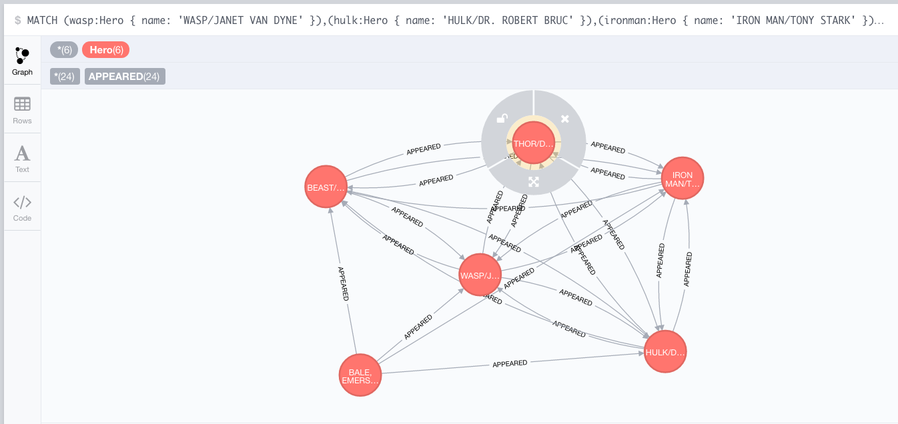

**Plus 2 – Rampa**

**MATCH (wasp:Hero { name: 'WASP/JANET VAN DYNE' }),(hulk:Hero { name: 'HULK/DR. ROBERT BRUC' }),(ironman:Hero { name: 'IRON MAN/TONY STARK' }),(thor:Hero { name: 'THOR/DR. DONALD BLAK' }),(beast:Hero { name: 'BEAST/HENRY &HANK& P' })-[:APPEARED*1..1]-(friend)**

**return wasp,hulk,ironman,thor,beast,friend**

**limit 2**

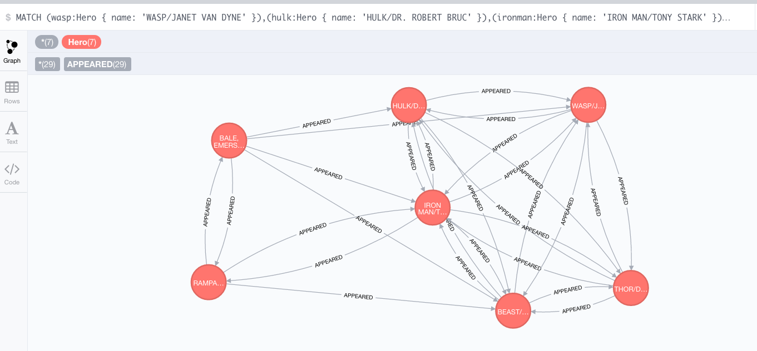

**Plus 3 – EggHead**

**MATCH (wasp:Hero { name: 'WASP/JANET VAN DYNE' }),(hulk:Hero { name: 'HULK/DR. ROBERT BRUC' }),(ironman:Hero { name: 'IRON MAN/TONY STARK' }),(thor:Hero { name: 'THOR/DR. DONALD BLAK' }),(beast:Hero { name: 'BEAST/HENRY &HANK& P' })-[:APPEARED*1..1]-(friend)**

**return wasp,hulk,ironman,thor,beast,friend**

**limit 3**

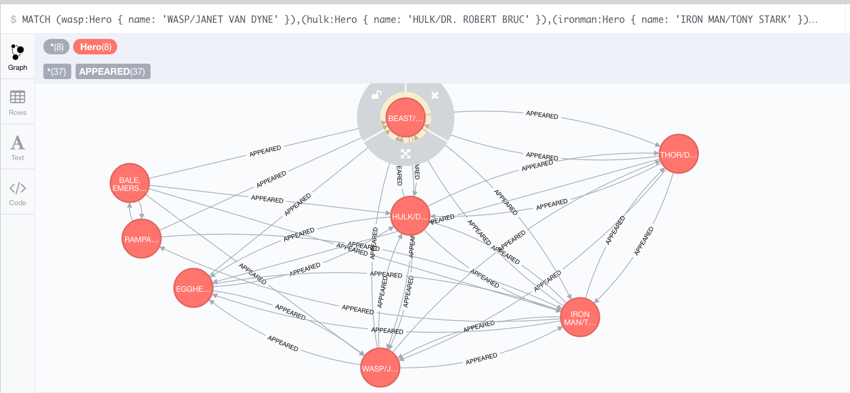

**Plus 4 – Hogar**

**MATCH (wasp:Hero { name: 'WASP/JANET VAN DYNE' }),(hulk:Hero { name: 'HULK/DR. ROBERT BRUC' }),(ironman:Hero { name: 'IRON MAN/TONY STARK' }),(thor:Hero { name: 'THOR/DR. DONALD BLAK' }),(beast:Hero { name: 'BEAST/HENRY &HANK& P' })-[:APPEARED*1..1]-(friend)**

**return wasp,hulk,ironman,thor,beast,friend**

**limit 4**

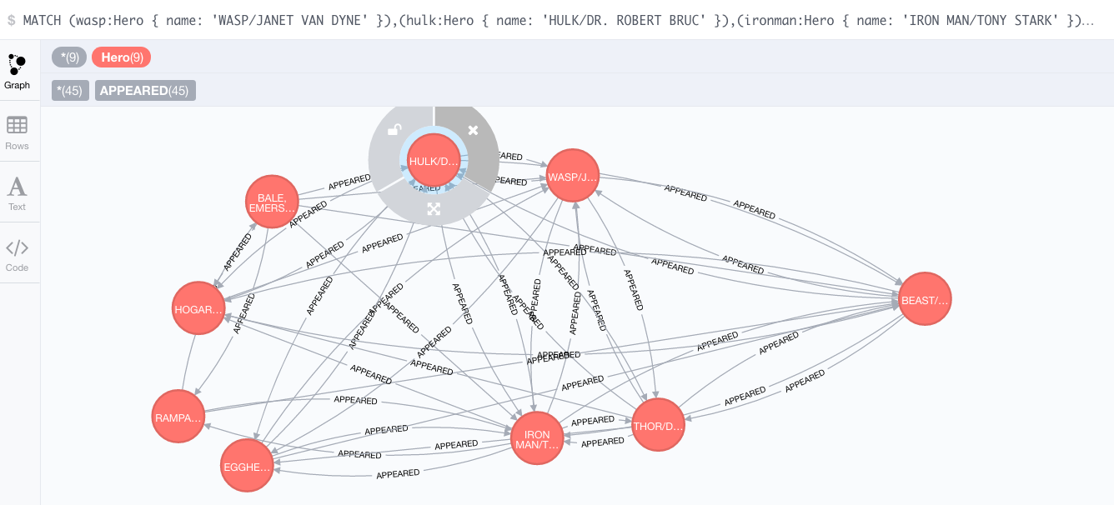

**Plus 5 – Power**

**MATCH (wasp:Hero { name: 'WASP/JANET VAN DYNE' }),(hulk:Hero { name: 'HULK/DR. ROBERT BRUC' }),(ironman:Hero { name: 'IRON MAN/TONY STARK' }),(thor:Hero { name: 'THOR/DR. DONALD BLAK' }),(beast:Hero { name: 'BEAST/HENRY &HANK& P' })-[:APPEARED*1..1]-(friend)**

**return wasp,hulk,ironman,thor,beast,friend**

**limit 5**

