Xiaowen Jiang

April 26, 2021

COEN 317: Distributed Systems Project Assignment 1

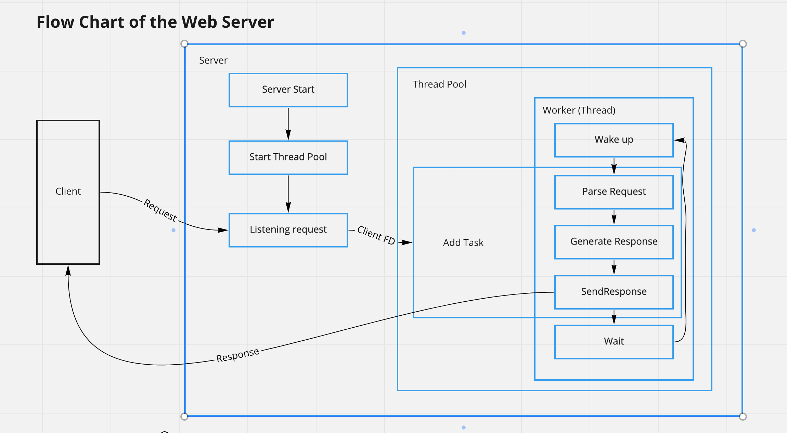
For this assignment, I use C++ to build a functional web server. In this script file, I will walk through all the user case/scenario, to demonstrate the implementation of this web server.

- Flow Chart:
On above figure. It is the follow chart of the web server, and we will explain step by step to explain what happened after server starts.
a. After Server start, the first step will be create a thread pool. For this assignment, we are using a hard coded number - 30 as the thread number in the pool. All these threads will be in waiting status and we will initial an empty queue as a task list here. Then we use the API functions provided by socket.h to create server socket(reusable), bind it to the provided port. And start to listening on the clients’ request.
b. When the server received a request from a client, we will get a client socket file descriptor(we will call it descriptor after). With this descriptor, a ConnectionTask object will be created, This ConnectionTask implemented a virtual function declared by its parent class which takes the responsibility to parsing the request, generating the response and send the response back to client.
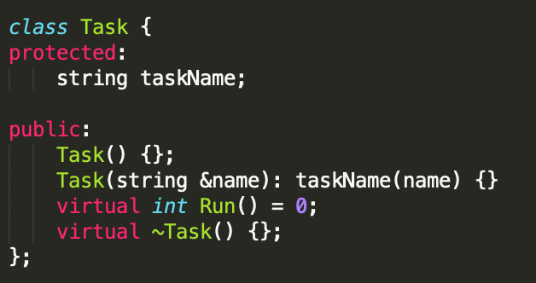
Here is the screenshot of Task class’ definition:
c. Once the the task is created, we will call the AddTask method defined in ThreadPool to add this ConnectionTask into the task list, and AddTask method also send out a signal to awake all the waiting thread. These thread will picking the tasks in the task list and back to wait status until the task list is empty.

- Scenario:
In this section, we will go through all the scenario to check how the call the server from the client. To demonstrate the workflow, we are download the most of the web content from https://www.scu.edu/ including the markup file, css files, js files, fonts etc. and store them in `./web` directory .
Use command ./server -document_root "./web" -port 8000 to start the server.
- 200 OK:
Here we are using Chrome to call our server, type localhost:8000 in location bar, the webpage will displayed:

And from network panel we can see that an `HTTP/1.1 200 OK` response is sent from server, also include the `Content-Type: text/html`, `Content-Length: 46642`, `Date: Mon, 26 Apr 2021 18:32:43 GMT` in the headers. (screenshot in next page.)

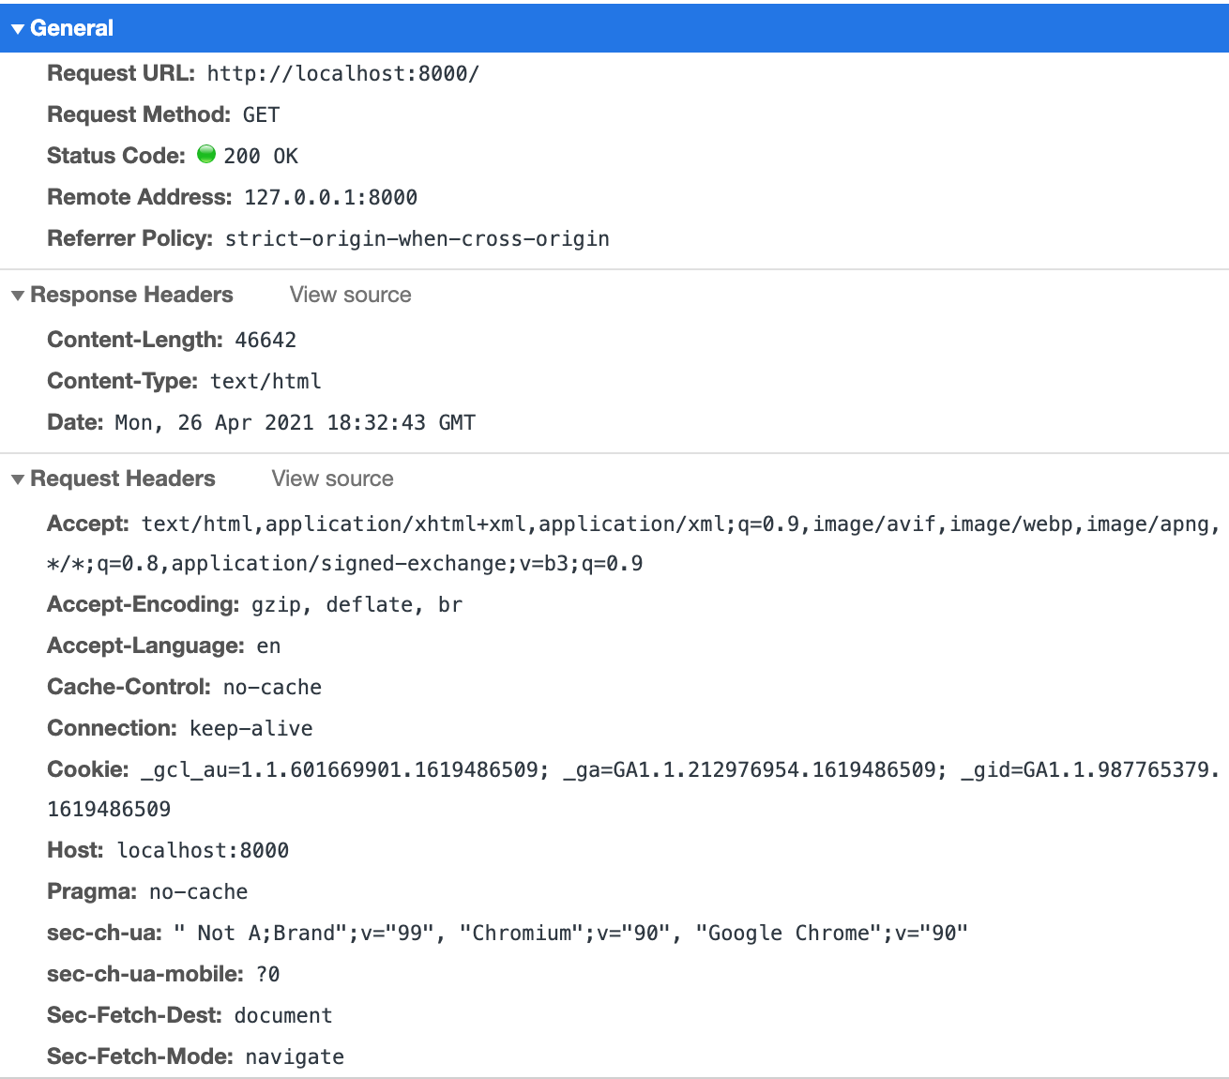

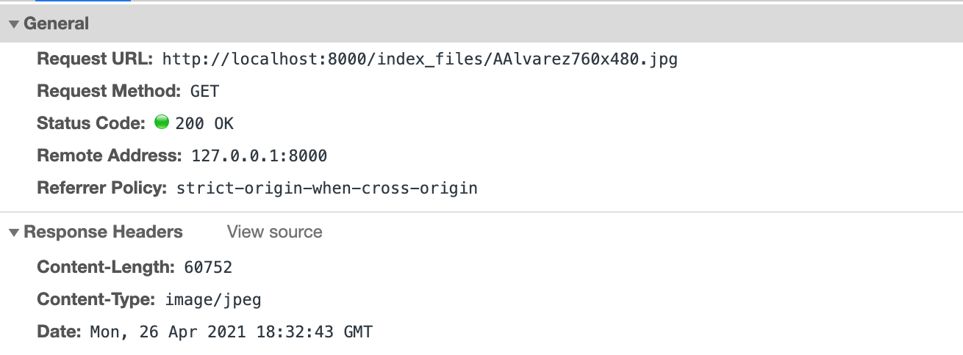
Use request filter, we can easily find a jpeg request and check the `Content-Tpye` header:

User request filter, find a png request and check the `Content-Type` header:

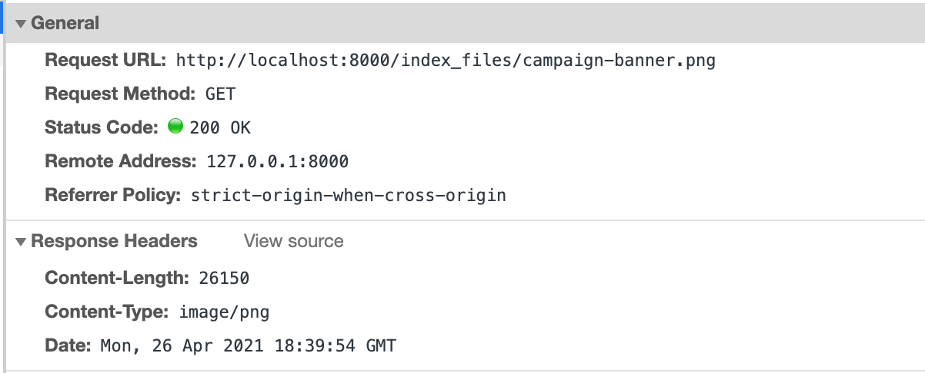
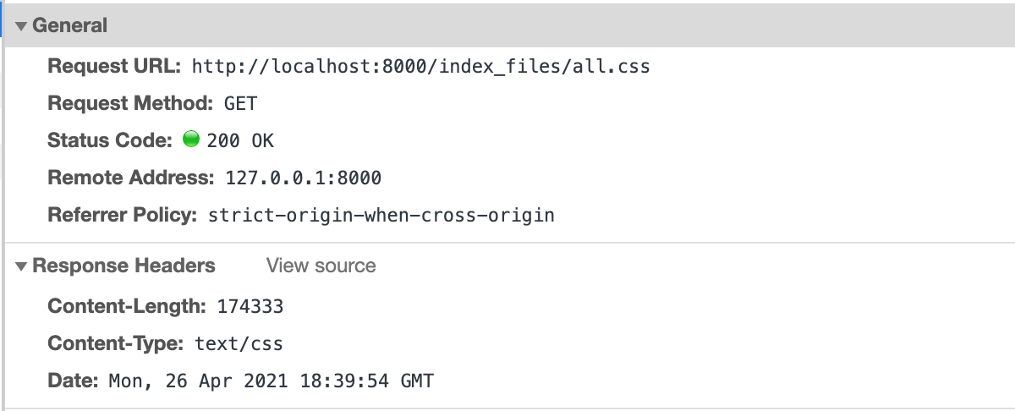
User request filter, find a css request and check the `Content-Type` header:
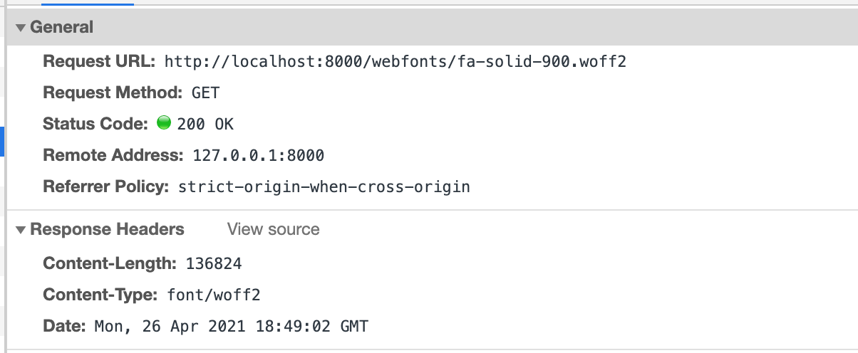
User request filter, find a font request and check the `Content-Type` header:

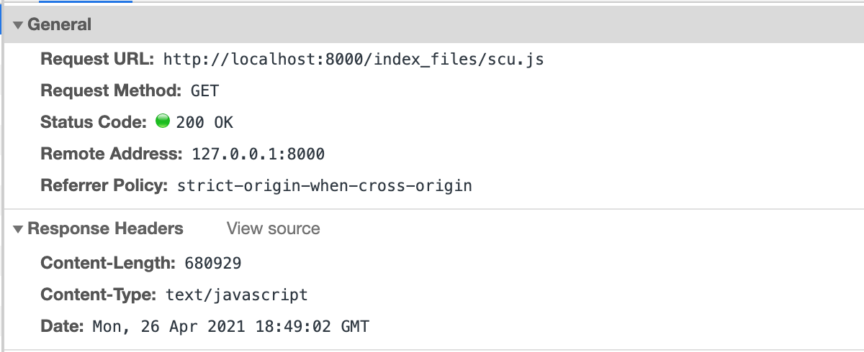
User request filter, find a js request and check the `Content-Type` header:
- Other status code:
  - 403 Forbidden
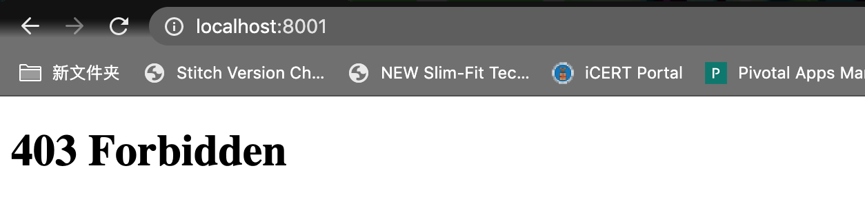
To mock this status, we need to use chmod to remove the read access to index.html. Then we can see it from the browser:

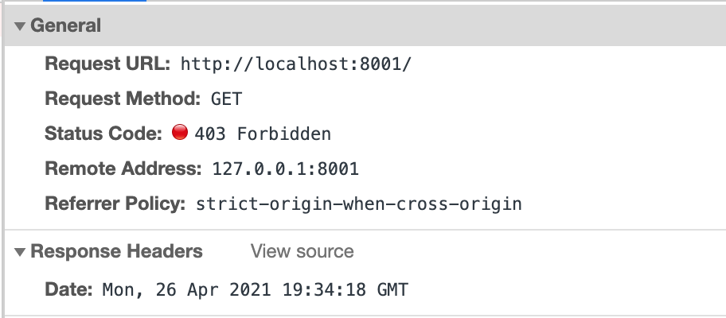
In network panel:

  - 404 Not Found
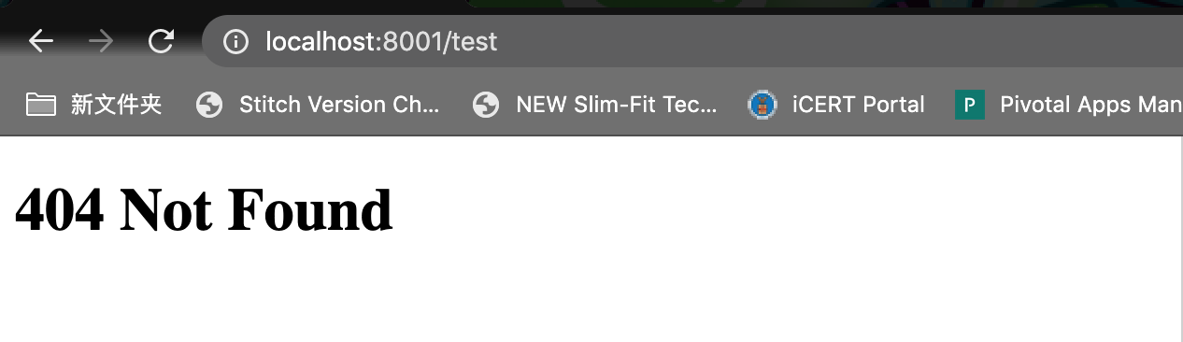
To mock this status, we need to call some url which is not existed in server root document:

And from In network panel:

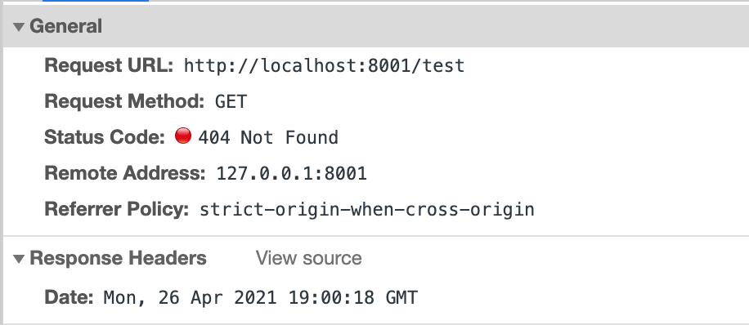

  - 501 Not Implemented
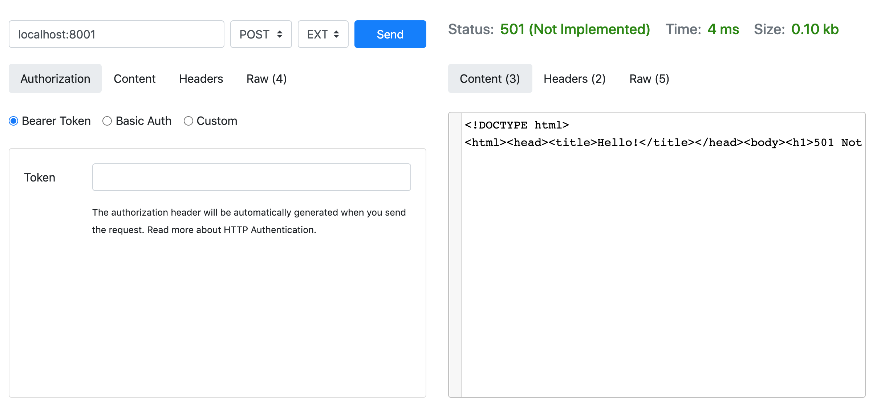
To mock this status code it is hard to directly reproduce from browser, we will use some tools to mock up a POST call and get the result:

  - 400 Bad Request
Unfortunately, I didn’t find out the way to reproduce this status code, but I have implemented the code and tried best to catch all the cases that when request is broken:
    - I had a try-catch block wrapped on the parseRequest function, if any unexpected error happened, we consider it as a bad request.
    - When parse the first line of the message if http version is not start with ‘HTTP/’ or there is no method/uri found, we will consider it as a bad request.
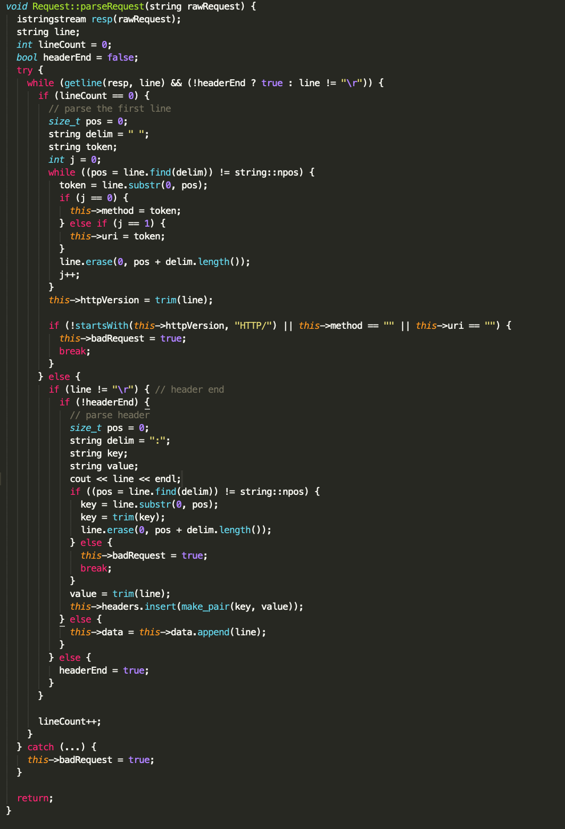
    - In each line of headers, if we are not able to see a `:` splitter, then we will consider it as a bad request.
Here is the screenshot of the parseRequest function:

