QA Report – Exercise 1 – Technical Challenge Qubika

Name: Doralys Contreras
Date: 07/23/2025
Project: Qubika Sports Club Management System
Website URL: https://club-administration.qa.qubika.com/#/auth/login
Swagger URL: https://api.club-administration.qa.qubika.com/swagger-ui/index.html#/
1. Test Objective
Perform exploratory testing on the website and its corresponding API documented in Swagger to detect functional errors, inconsistencies between frontend and backend, validation issues, or incomplete flows.
2. Tools Used
- Browser: [Chrome]
- Swagger UI
- Device: Mac15,5 Apple M3 Pro
3. Issues Found
Issue Title | Description | Steps to Reproduce | Expected Result | Actual Result | Evidence
Missing “username” field in UI  SCENARIO: LOGIN. | The Swagger login API expects a "username" field, but the frontend form only asks for email and password. | 1. Go to Swagger and inspect POST /login  2. Go to login UI form and compare inputs | The frontend should match the backend required fields. | Field "username" is not present in the UI. | 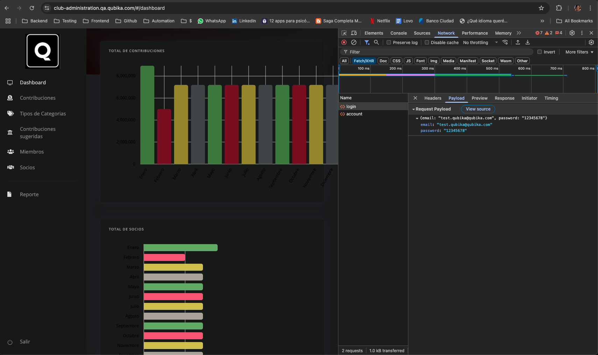  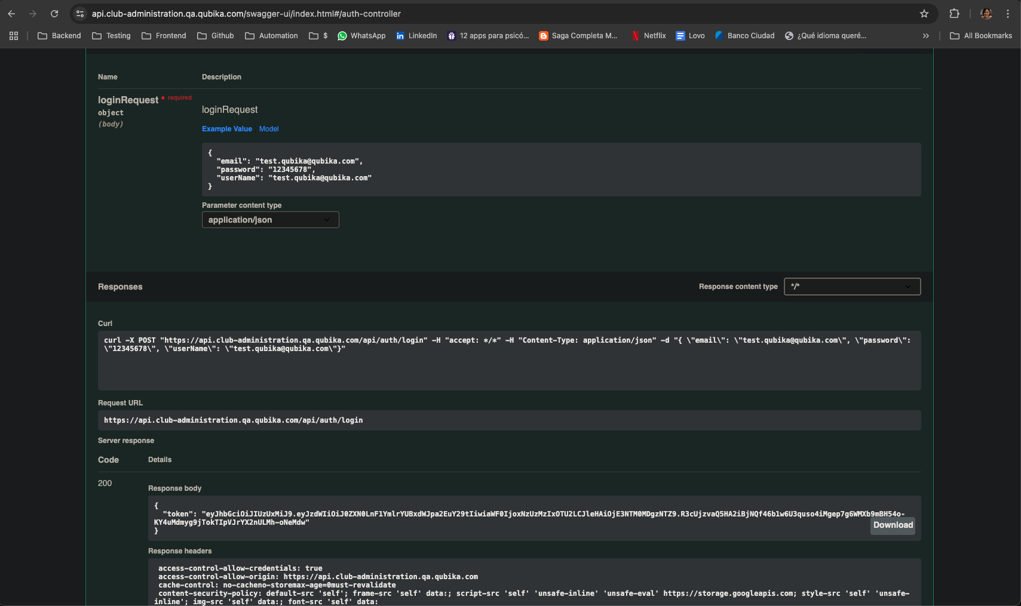
“Recordarme” checkbox has no visible check and doesn’t work  SCENARIO: LOGIN. | In addition to the missing check icon when selecting the “Recordarme” checkbox, this feature also does not retain the user credentials between sessions. Negative login scenarios were also tested (invalid email and password), and the system responded with the appropriate error messages. | 1. Go to the login page  2. Enter valid credentials and select the “Recordarme” checkbox  3. Log in  4. Refresh the page or open a new session | The “Recordarme” checkbox should retain user credentials and display a visible check mark | The checkbox shows only a minor color change and does not save login credentials between sessions. | https://www.loom.com/share/d564b16747a8488e9781e77ca0c9d7ed?sid=059e43ef-b4a5-4460-81ca-1a974b1a1f52
User avatar not visible until screen layout changes  SCENARIO: DASHBOARD. | The user avatar and its dropdown are not visible on standard screen size. They only appear when opening the developer tools (which changes the layout). | 1. Go to the dashboard after login  2. Look at the top-right corner (no avatar shown)  3. Open DevTools (inspect) and see how the avatar appears | The avatar icon should always be visible in the top-right corner after login | The avatar is not visible on normal screen layout, only becomes visible after resizing or inspecting | https://www.loom.com/share/ed9343f657dd40a18b7924fcece7b4d7?sid=ea895db7-a7e9-4569-9aae-bcc89066c138
500 error on updating partner (intermittent)  SCENARIO: UPDATE - SOCIOS. | When editing a partner and clicking 'Aceptar', a 500 error is sometimes triggered. The issue could not be consistently reproduced, but occurred multiple times previously. On Swagger is getting the correct result. | 1. Go to 'Socios'  2. Edit any partner  3. Click 'Aceptar' | Partner should be updated successfully. | An error message appears and the response returns 500 Internal Server Error. | 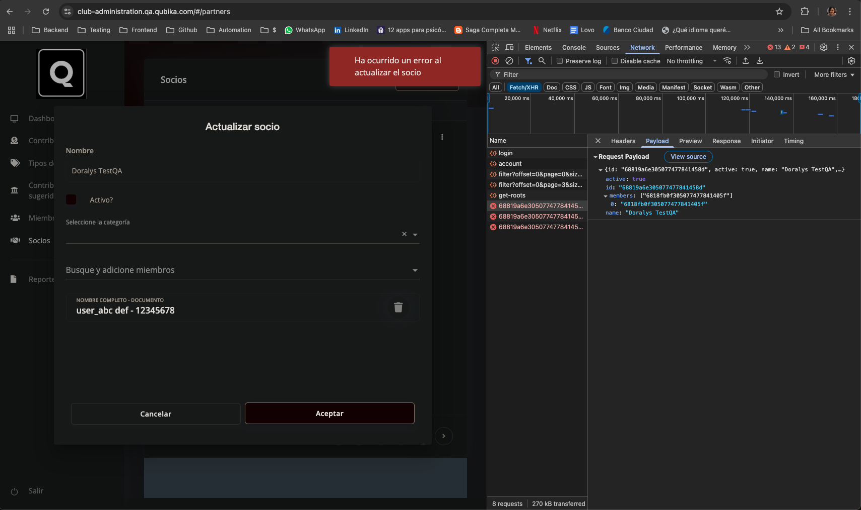  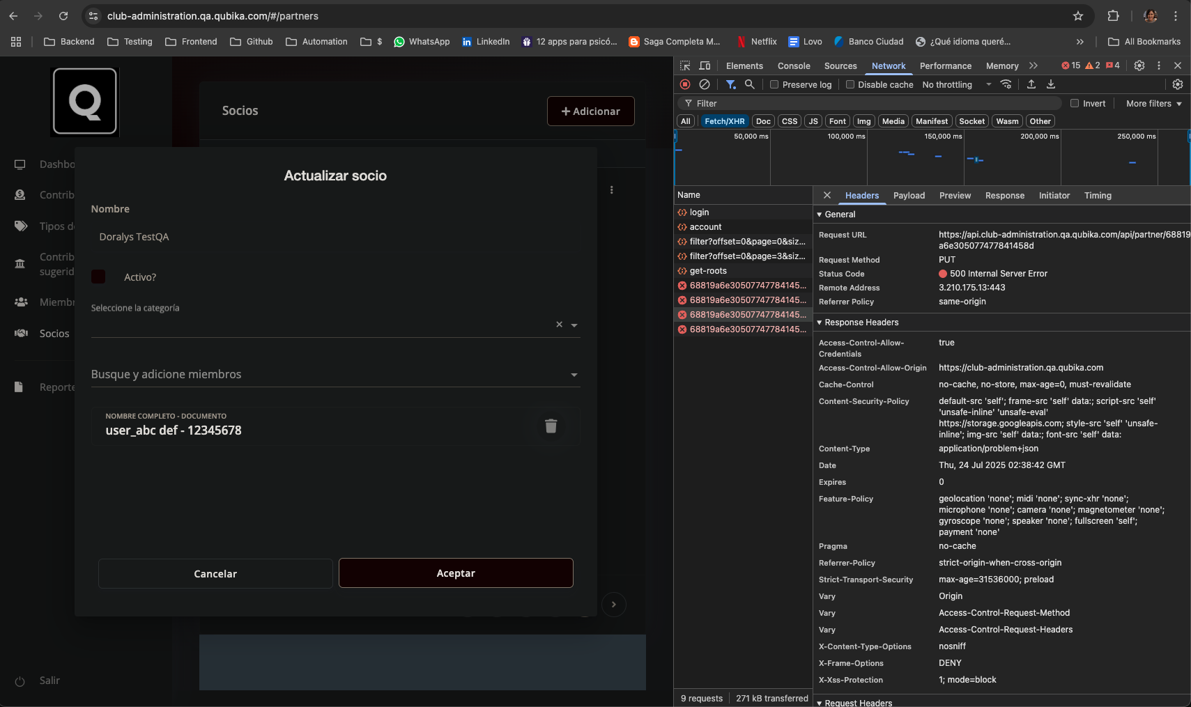  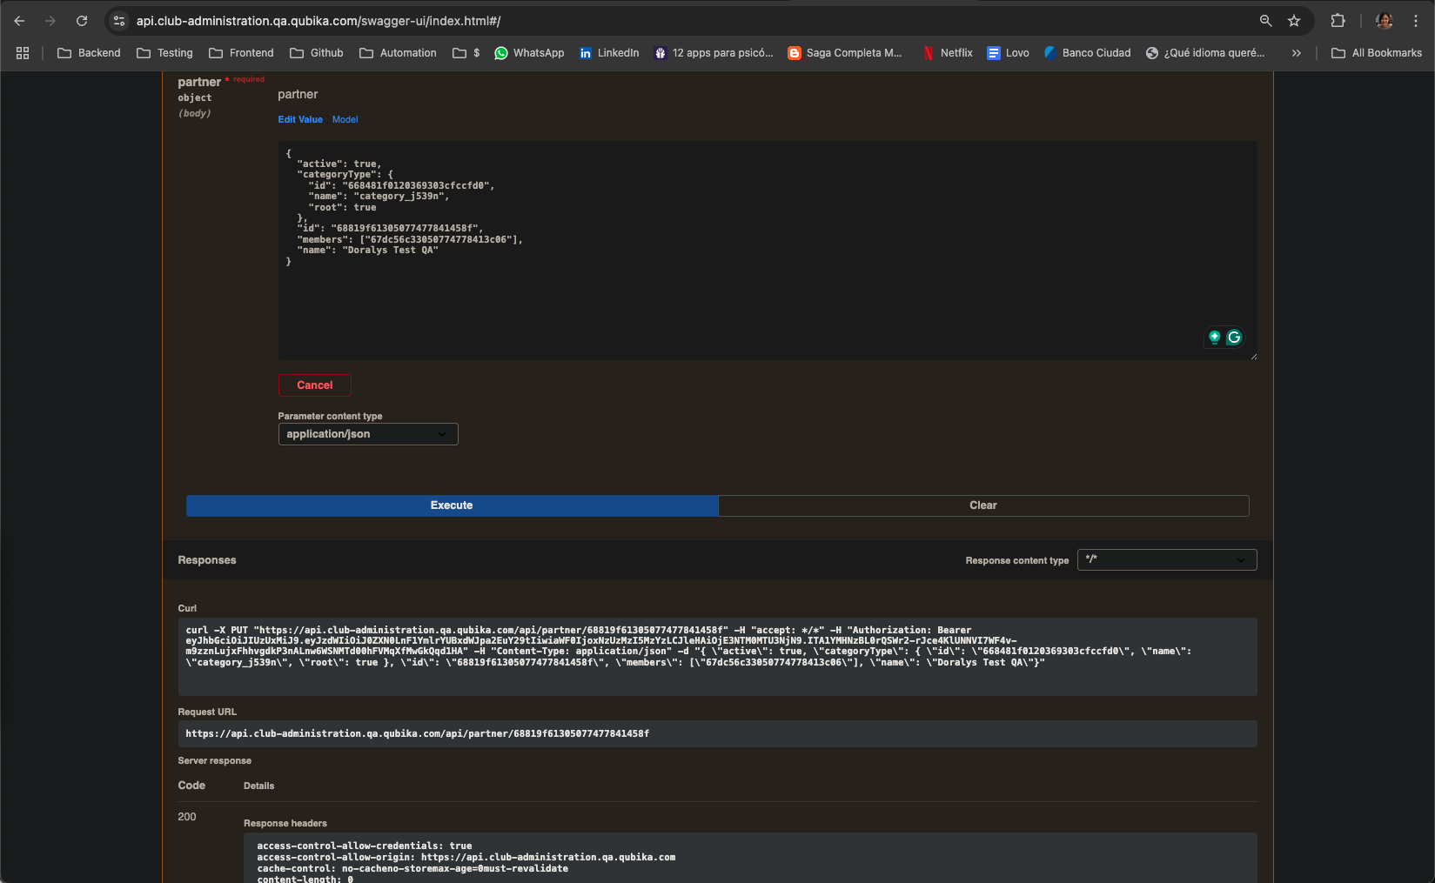
Mismatch between frontend and API category  SCENARIO: READ - SOCIOS. | When retrieving a specific partner via the API, the category returned does not match the one shown in the frontend. | 1. Go to the partner list in the frontend and confirm the assigned category.  2. Go to Swagger and execute GET /api/partner/{id} for the same partner. | The category shown in the frontend should match the category returned by the API. | The frontend shows category_j539n, but the API returns Test 1 with a different categoryType.id. | 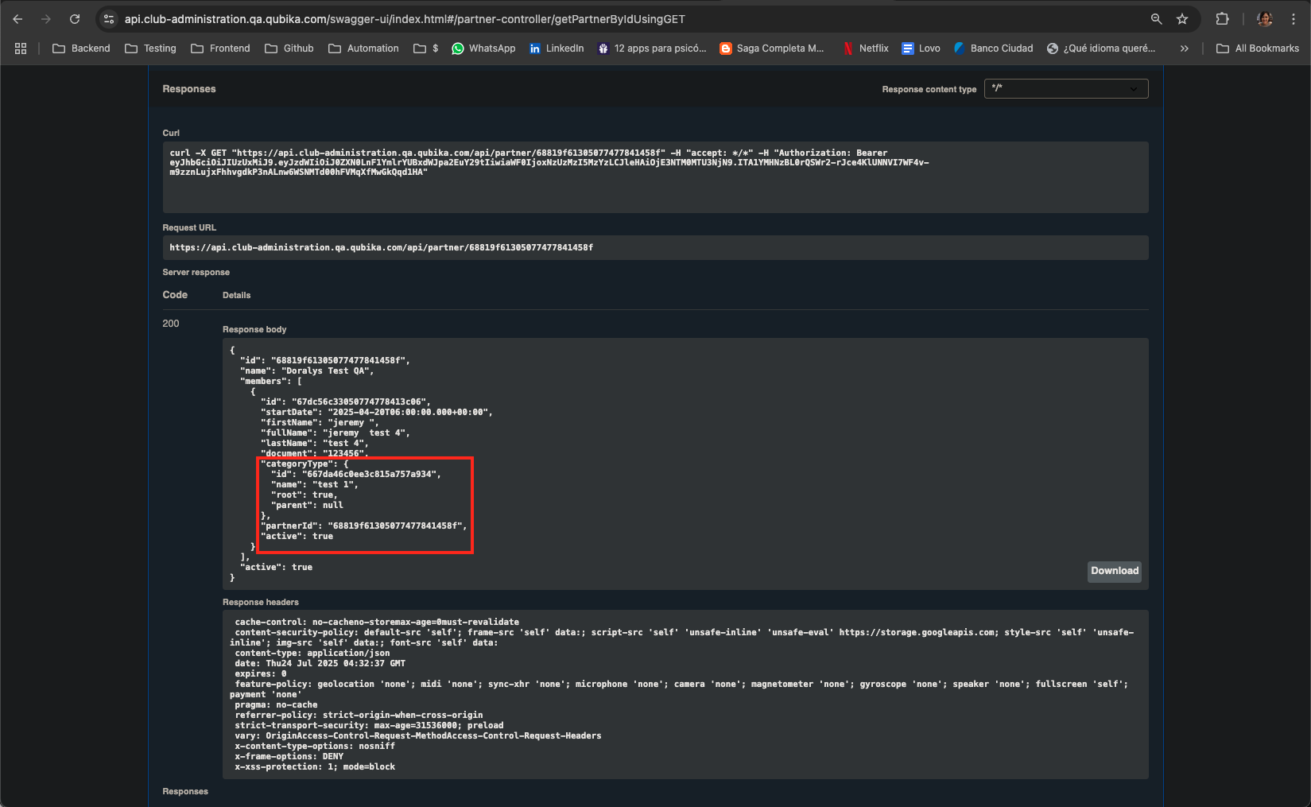  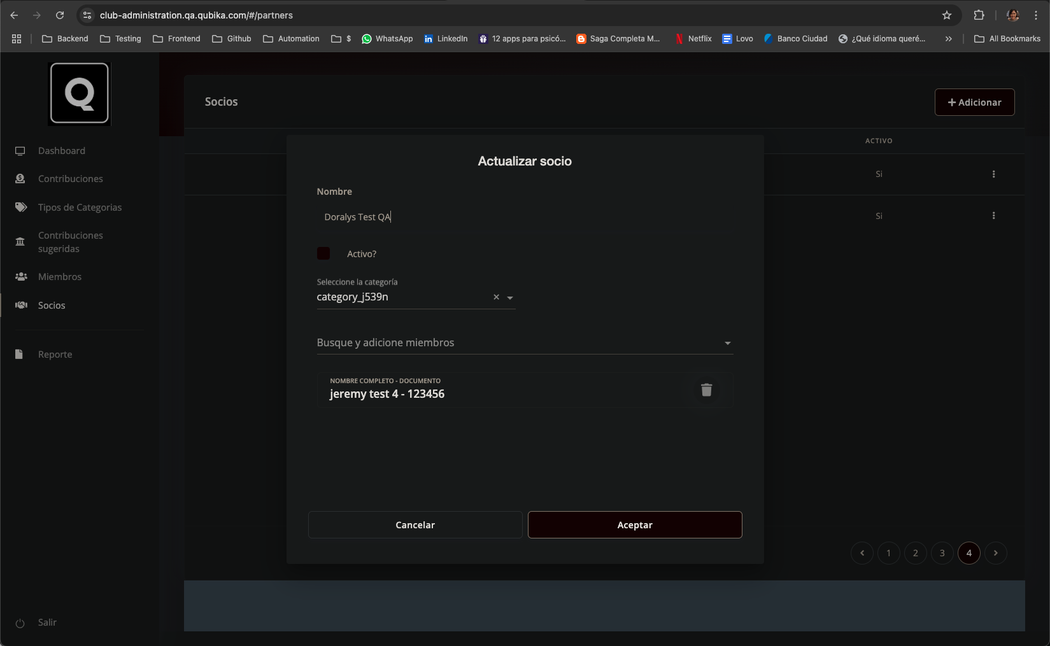  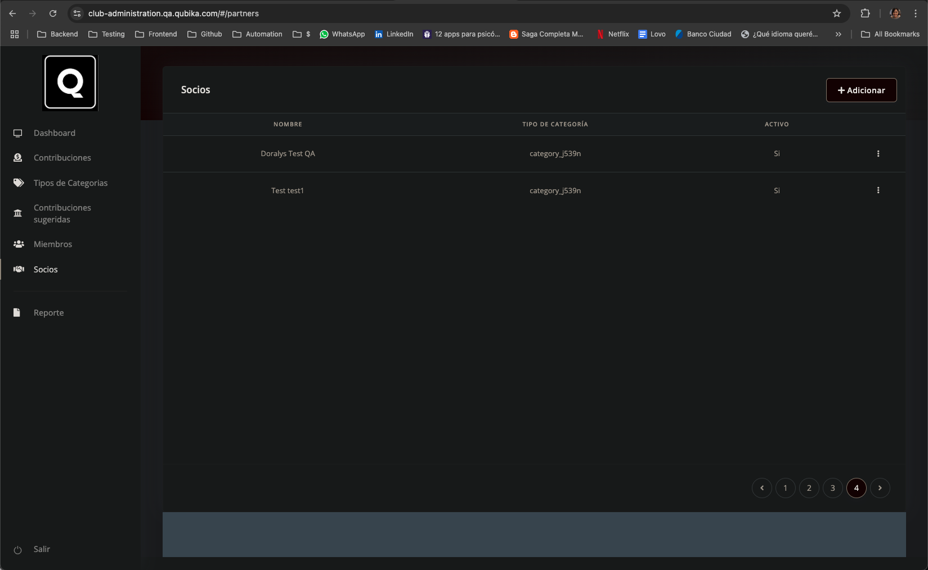
Update not reflected in frontend after API returns 200 OK  SCENARIO: UPDATE - Contribuciones sugeridas. | Even though the update request using Swagger with correct JWT token returns 200 OK and payment method is set to 'CREDIT_CARD', the frontend still displays the previous value ('Efectivo'). | 1. Go to 'Contribuciones sugeridas'  2. Edit contribution with amount -2561  3. Change payment method to 'CREDIT_CARD'  4. Submit the change via Swagger | Payment method should be updated to 'CREDIT_CARD' in frontend | Frontend still shows previous payment method.  Backend returns 200 OK.  Inconsistency between frontend and backend data | 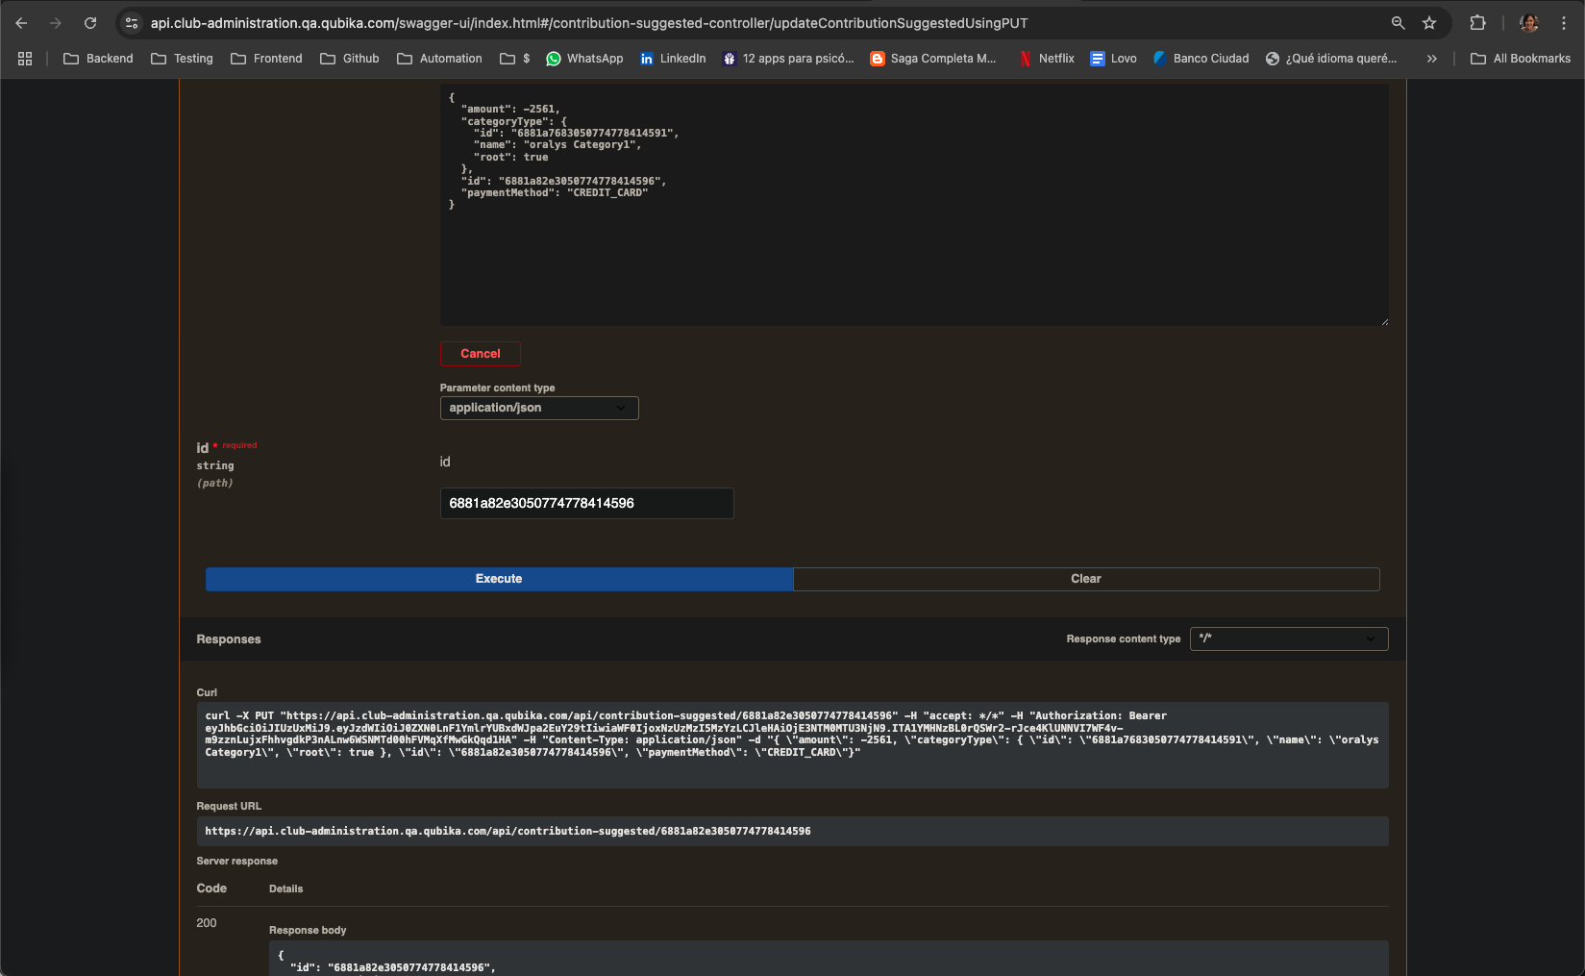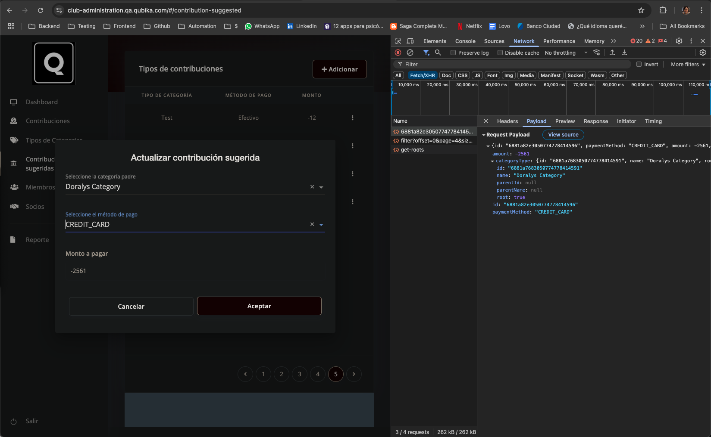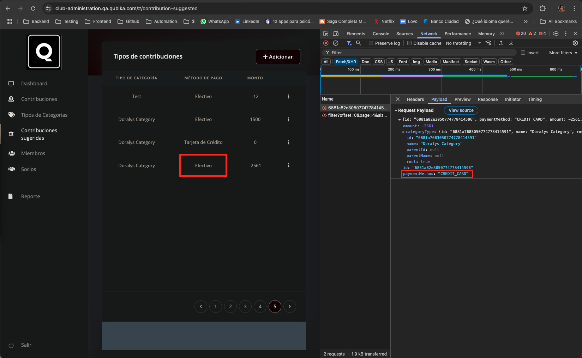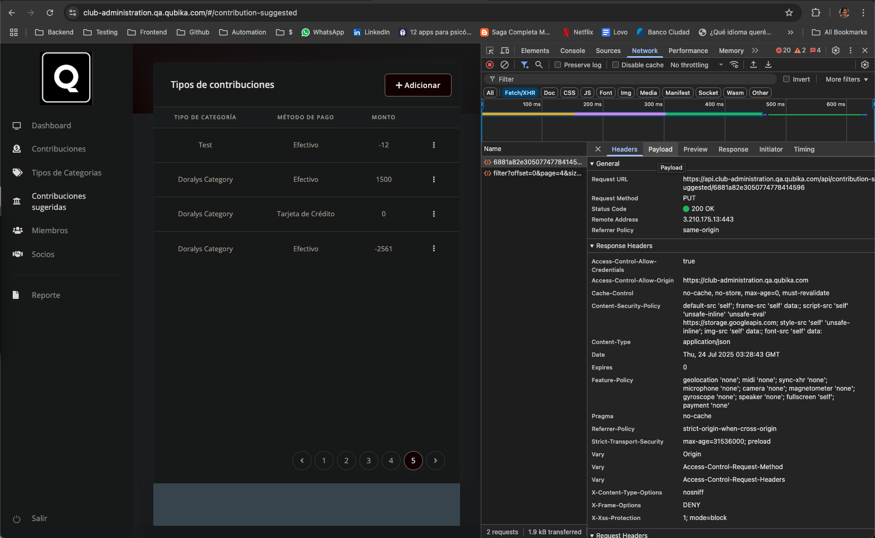

4. Conclusion
The CRUD flow of the "Socios" section (partner management) was tested both via frontend and API.
The main issues found were:
• The “Remember me” checkbox does not save login credentials for future sessions and lacks visual feedback.
• A mismatch between the category selected in the frontend and the category returned by the API when retrieving a partner by ID.
• Some update operations failed intermittently with 500 errors from the frontend.
• A 401 error appeared when using valid JSON in Swagger for updating partners, despite working in the frontend.
• The payment method value does not update visually in the frontend even when the API response is 200 OK.
Negative test cases were also performed in both login and partner flows, with proper handling of invalid inputs.
Partial testing was also conducted on the "Suggested Contributions" section, with one API issue identified and reported.

