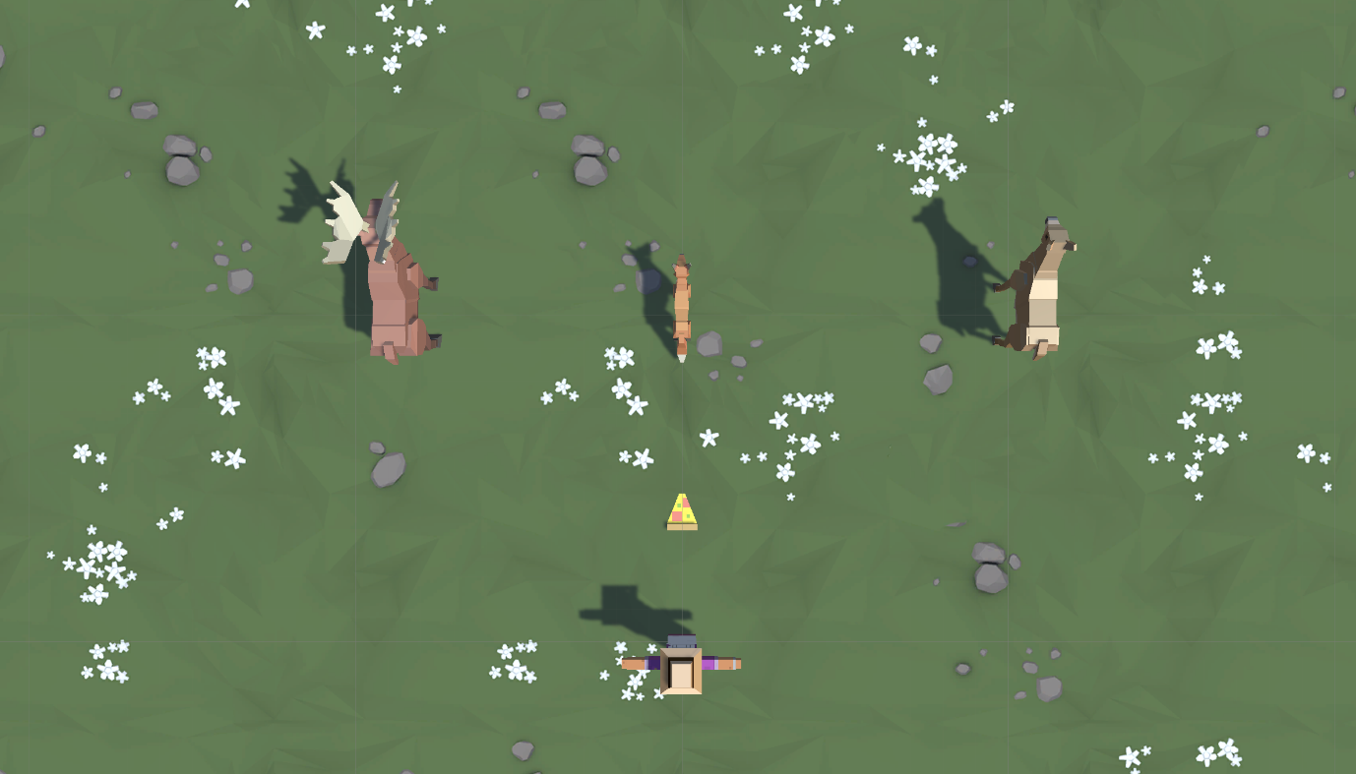

**Lesson 2.1 - Player Positioning**

**Overview:**

You will begin this unit by creating a new project for your second Prototype and getting basic player movement working. You will first choose which character you would like, which types of animals you would like to interact with, and which food you would like to feed those animals. You will give the player basic side-to-side movement just like you did in Prototype 1, but then you will use if-then statements to keep the Player in bounds.

**Project Outcome:**

The player will be able to move left and right on the screen based on the user’s left and right key presses, but will not be able to leave the play area on either side.

Materials

[Prototype 2 - Starter Files.zip](https://connect-prd-cdn.unity.com/20210507/bfd26de3-a68a-4a16-8cf6-8eacf2bb7f75/Prototype%202%20-%20Starter%20Files.zip" \t "_blank)

Remaining Time -1:35

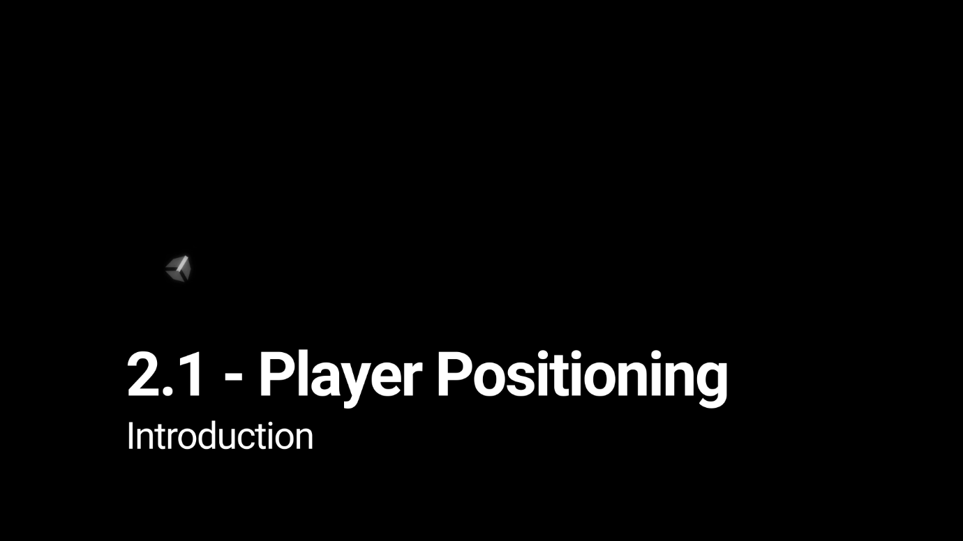

Overview

Lesson 2.1 - Player Positioning

1 Min35 Secs

**1.Create a new Project for Prototype 2**

34

*The first thing we need to do is create a new project and import the Prototype 2 starter files.*

Remaining Time -1:43

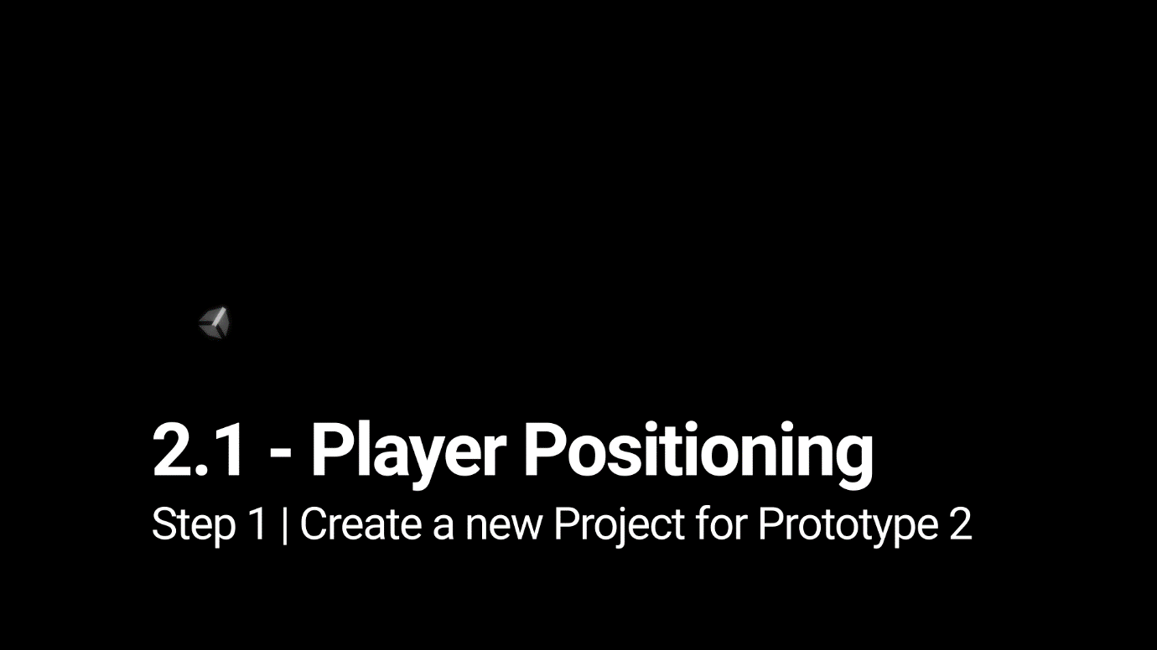

1. Open **Unity Hub** and create an empty “Prototype 2” project in your course directory on the correct Unity version. If you forget how to do this, refer to the instructions in [Lesson 1.1 - Step 1](https://learn.unity.com/tutorial/set-up-your-first-project-in-unity?uv=2018.4&courseId=5cf96c41edbc2a2ca6e8810f&projectId=5caccdfbedbc2a3cef0efe63#5cb7a1acedbc2a10b7261d15)
2. Click to download the [Prototype 2 Starter Files](https://connect-prd-cdn.unity.com/20210507/bfd26de3-a68a-4a16-8cf6-8eacf2bb7f75/Prototype%202%20-%20Starter%20Files.zip?_ga=2.29238268.1186801097.1620052249-59568313.1601905412), **extract** the compressed folder, and then **import** the .unitypackage into your project. If you forget how to do this, refer to the instructions in [Lesson 1.1 - Step 2](https://learn.unity.com/tutorial/set-up-your-first-project-in-unity?uv=2018.4&courseId=5cf96c41edbc2a2ca6e8810f&projectId=5caccdfbedbc2a3cef0efe63#5cca0230edbc2a635ca5d6d2)
3. From the Project window, open the **Prototype 2** scene and **delete** the SampleScene
4. In the top-right of the Unity Editor, change your **Layout** from Default to your custom layout

**2.Add the Player, Animals, and Food**

28

*Let’s get all of our objects positioned in the scene, including the player, animals, and food.*

Remaining Time -6:04

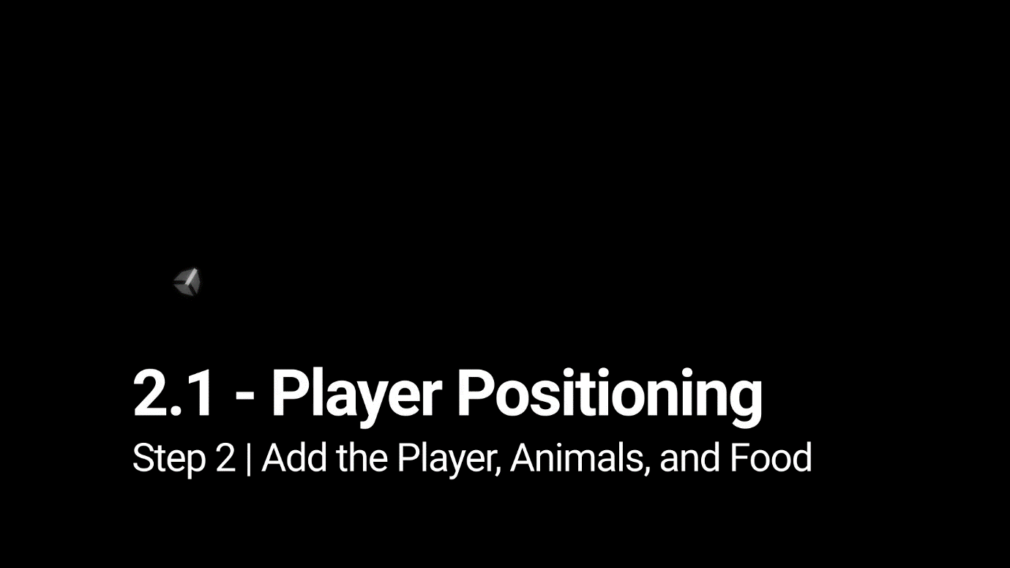

1. If you want, drag a different **material** from *Course Library > Materials* onto the Ground object
2. Drag 1 **Human**, 3 **Animals**, and 1 **Food** object into the Hierarchy
3. Rename the character “Player”, then **reposition** the animals and food so you can see them
4. Adjust the XYZ **scale** of the food so you can easily see it from above

**3.Get the user’s horizontal input**

33

*If we want to move the Player left-to-right, we need a variable tracking the user’s input.*

Remaining Time -2:59

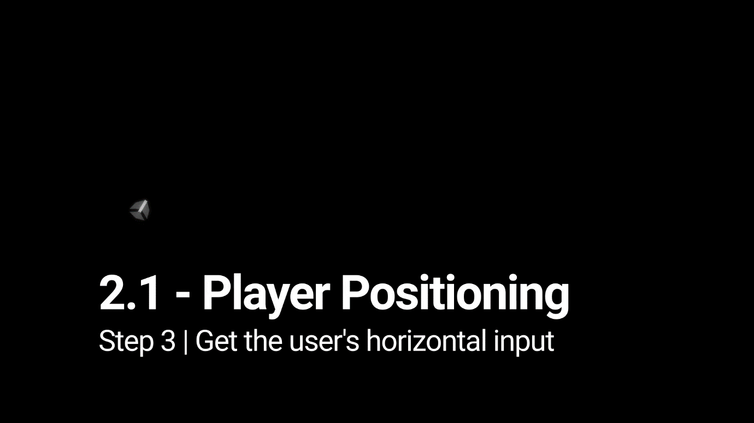

1. In your **Assets** folder, create a “Scripts” folder, and a “PlayerController” script inside
2. **Attach** the script to the Player and open it
3. At the top of PlayerController.cs, declare a new ***public float horizontalInput***
4. In ***Update()***, set ***horizontalInput = Input.GetAxis(“Horizontal”)***, then test to make sure it works in the inspector

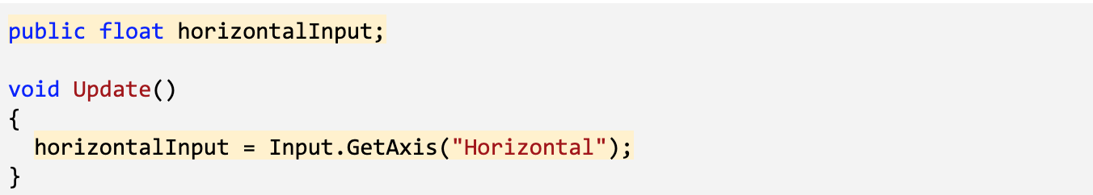

Select image to expand

**4.Move the player left-to-right**

*We have to actually use the horizontal input to translate the Player left and right.*

Remaining Time -2:35

1x

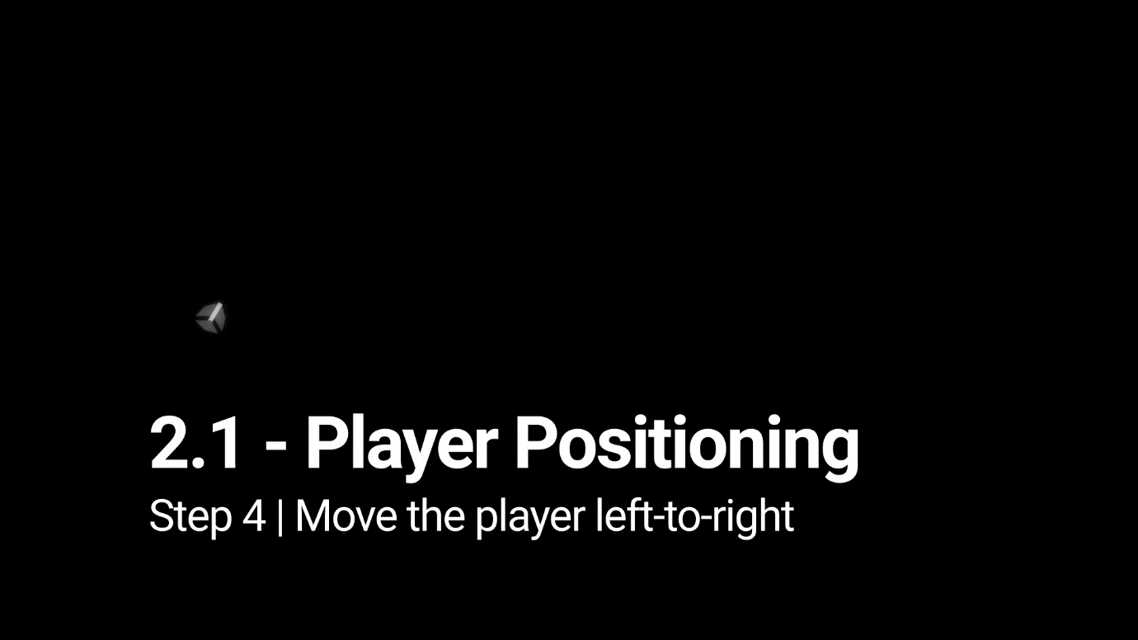

1. Declare a new ***public float speed = 10.0f;***
2. In ***Update()***, Translate the player side-to-side based on ***horizontalInput*** and ***speed***

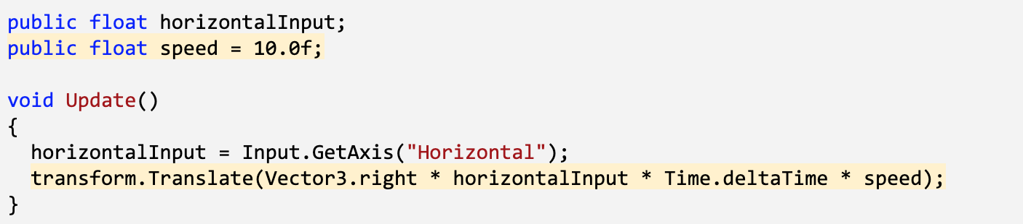

Select image to expand

**5.Keep the player inbounds**

106

*We have to prevent the player from going off the side of the screen with an if-then statement.*

Remaining Time -4:43

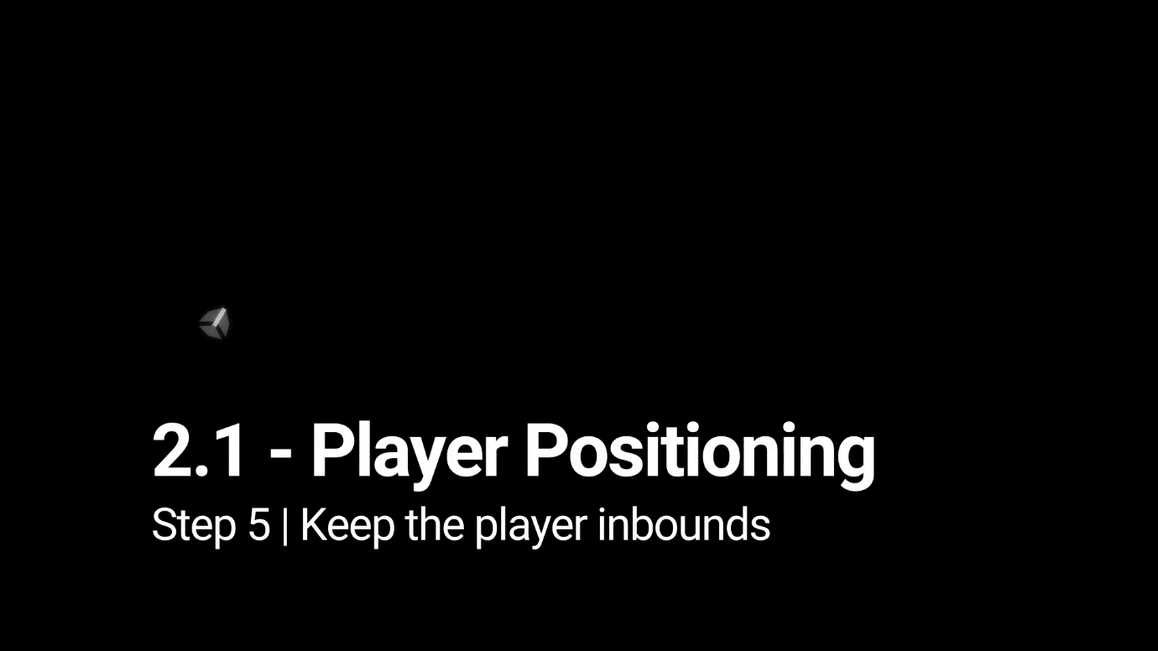

1. In ***Update()***, write an **if-statement** checking if the player’s left X position is **less than** a certain value
2. In the if-statement, set the player’s position to its current position, but with a **fixed X location**

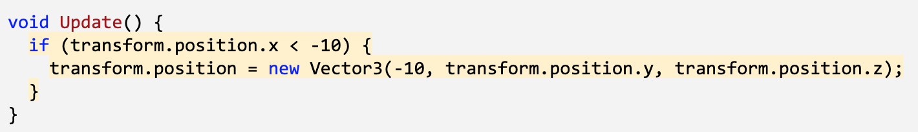

Select image to expand

**6.Clean up your code and variables**

86

*We need to make this work on the right side, too, then clean up our code.*

Remaining Time -5:36

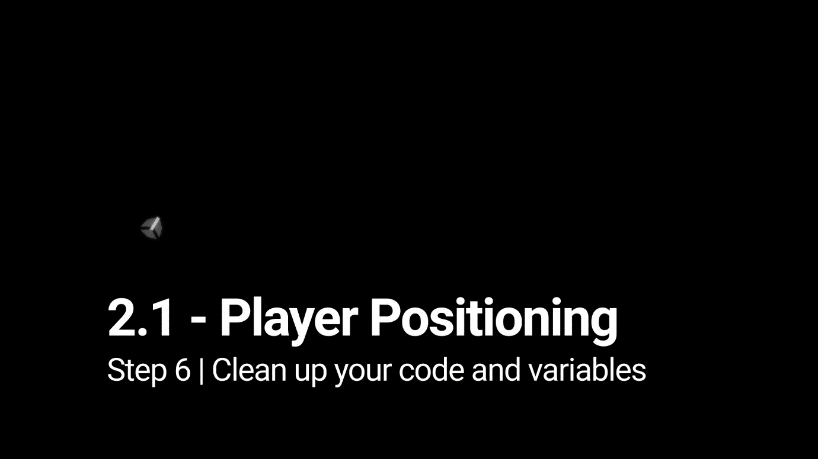

1. Repeat this process for the **right side** of the screen
2. Declare new ***xRange*** variable, then replace the hardcoded values with them
3. Add **comments** to your code

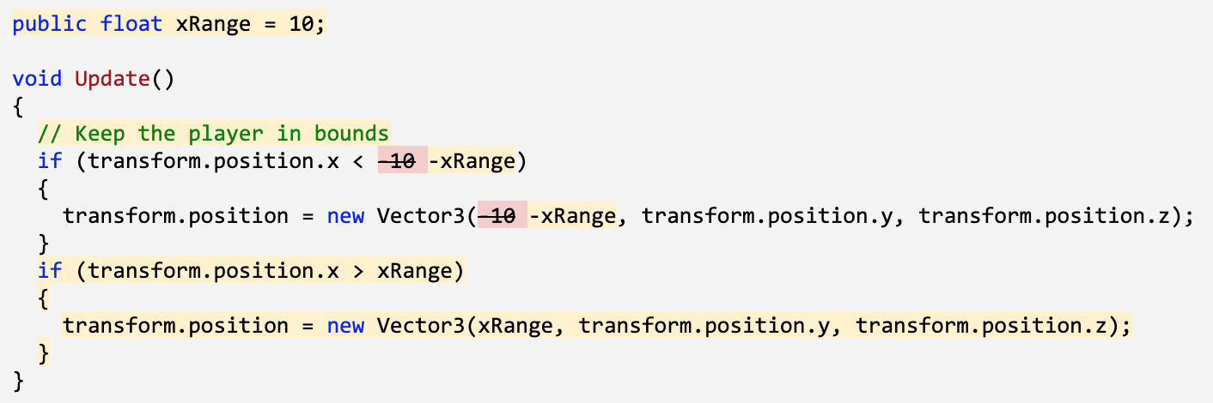

**7.Lesson Recap**

5

Remaining Time -1:13

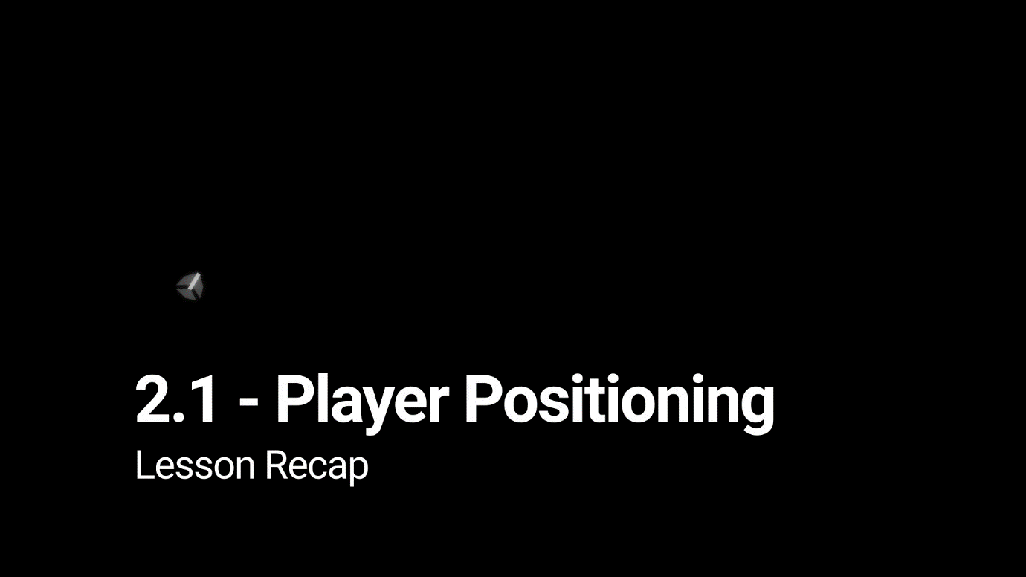

New Functionality

* The player can move left and right based on the user’s left and right key presses
* The player will not be able to leave the play area on either side

New Concepts & Skills

* Adjust object scale
* If-statements
* Greater/Less than operators

Next Lesson

* We’ll learn how to create and throw endless amounts of food to feed our animals!

Project:

Unit 2 - Basic Gameplay

Lesson 2.1 - Player Positioning