Document Title

A plain paragraph having some **bold** and some *italic.*

# Heading, level 1

Intense quote

* first item in unordered list

1. first item in ordered list

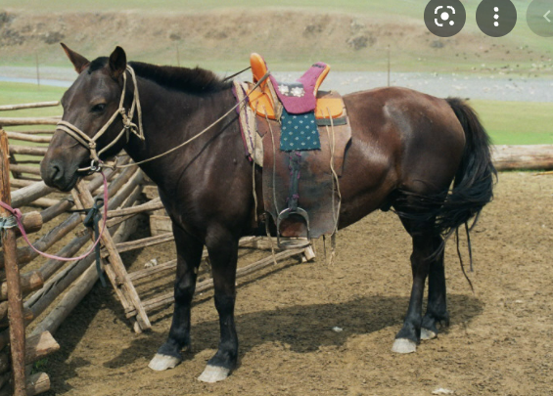

|  |  |  |
| --- | --- | --- |
| Qty | Id | Desc |
| 3 | 101 | Spam |
| 7 | 422 | Eggs |
| 4 | 631 | Spam, spam, eggs, and spam |

Happy families are all alike; every unhappy family is unhappy in its own way. Everything was in confusion in the Oblonskys’ house. The wife had discovered that the husband was carrying on an intrigue with a French girl, who had been a governess in their family, and she had announced to her husband that she could not go on living in the same house with him. This position of affairs had now lasted three days, and not only the husband and wife themselves, but all the members of their family and household, were painfully conscious of it.