***DORAN-ABVM***

**EMERGENCY VENTILATOR PROPOSAL**

**JOHN DORAN 20APR2020**

Contents

**1.** **PROJECT OVERVIEW** 3

1.1. Automated Bag Valve Mask 3

1.2. Problem Definition 3

1.3. Design Requirements 3

1.4. Development Process Overview 4

1.5. Design by Best Idea (our Philosophy). 4

1.6. Open Source. 4

**2.** **THEORY OF OPERATION** 4

2.1. Covers. 4

2.2. Tidal Volume and Force Adjustment Levers. 5

2.2.1. Force Adjustment. 6

2.2.2. Tidal Volume Adjustment. 7

2.3. Clamping Arms. 8

2.4. Motor Assembly. 8

2.5. Bearing Assembly. 9

2.6. Limit Switch Operation. 10

**3.** **!WARNING!** 11

3.1. Lung Injury. 11

3.2. Mechanical Dangers. 11

## **PROJECT OVERVIEW**

## Automated Bag Valve Mask

In response to the *Covid-19* pandemic, our aim is to develop a low-cost machine to automate a *BVM* (*Bag Valve Mask*).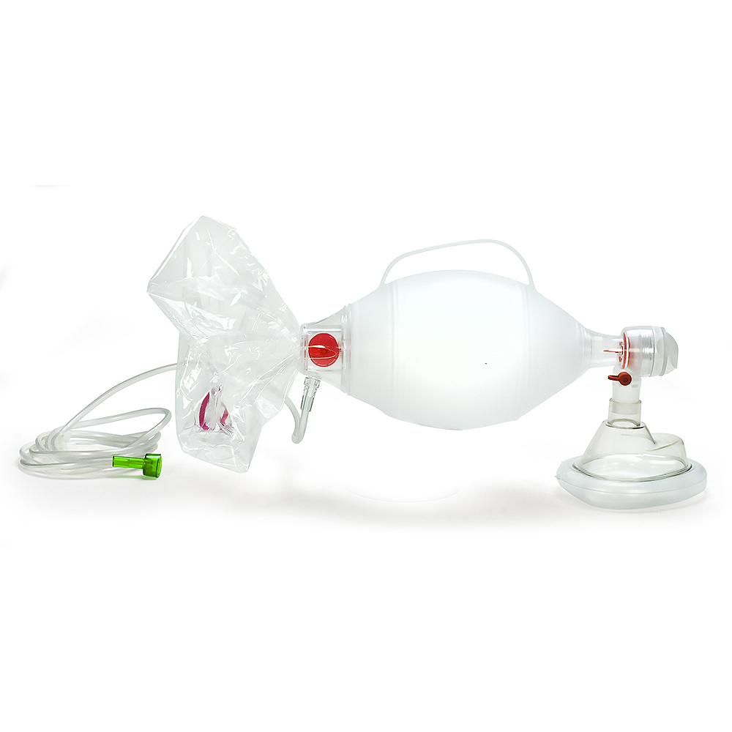

Figure 1: An AMBU branded BVM (Bag Valve Mask).

*BVM*s are low-cost single patient use mechanical ventilators, available in different sizes and are certified for medical use. A supplemental hose (not shown) allows operation at a distance from the patient.

## Problem Definition

The *COVID-19* illness, caused by a virus, *SARS-CoV-2*, can cause a respiratory infection. Patients can get critically sick and a portion of them need a ventilator to help them breathe. As the infection continues to spread around the globe the need for ventilators is increasing and the requirement for a low-cost solution has become more urgent.

Our chosen solution is to use a manual *BVM* and to develop an automated method of squeezing the bag.

## Design Requirements

Requirements:

* Very low-cost.
* Low-tech with inherent safety features (hard stops, fixed power delivery).
* Capable of manufacture with a range of readily available materials.
* Open source with rapid development and a path to medical and CE (*Conformité Européenne*) certification.
* Adjustable *Tidal Volume* (size of breath) and Adjustable *BPM* (Breaths Per Minute).
* Easy loading of *BVM*s and customisable for different models and sizes.
* Simple electrical wiring for a 12v DC system to allow use of a car battery or AC power source.

## Development Process Overview

Our design is available in 3 types. The starting point is to develop plans for a basic design configuration (named *Garage*) which can be made with hand tools using locally available materials and a few common electrical components.

Building and testing of *Garage* is open sourced via a website (<http://doran.design>). The website will provide detailed plans for the latest design and will request participants’ help to solve specific problems and to feedback observations via the site.

Using this method, we can rapidly improve the design, uncover new issues and get feedback from interested parties. This work will inform a second configuration (named *Precision*) that will form the basis for a design that can be made in high-volume. *Precision* will be more expensive to make and will require machine tools and more purchased components such as roller bearings or additional control and safety systems.

The longer-term objective is a design for high volume (named *Production*), a lower cost version of *Precision,* but with the same or improved functionality. *Production* will have safety and other certifications.

## Design by Best Idea (our Philosophy).

The origin of the word Innovation means to reuse or renew. Everyone has good ideas, but they don´t belong to anyone; some or all of the idea comes from others. Designs on the other hand, are ideas that have been translated into concrete descriptions, plans or devices.

For this reason, our design is based on the best idea at a given time. This is not a call for competing designs from which we choose the best one, rather a consensus on the nature of the problem and an agreement on the best solution. If we encounter a better idea that can improve our design were happy to adopt it, even if that means throwing out our current design (we have done this several times already).

## Open Source.

A solution is a combination of an idea and a design that requires a clearly defined problem. For this reason, we plan to list our existing set of problems for which we hope someone out there has the solution.

Our designs will be Open Source, freely available, but not for profit. Success will depend on a community of users to help build and test prototypes, and feedback design improvements. The plans will be stored on Github (@DoranITC.)

## **THEORY OF OPERATION**

## Covers.

The first released design, *Garage,* has a metal cover, but in an emergency, it could be used without covers by wrapping it in a plastic bag to maintain hygiene and avoid cross contamination by taping at the clamping arms and levers (see warning section). The covers for *Garage* can be made from different materials and thicknesses without modifying the basic mechanisim.

There is a loading door to easily replace the *BVM*. The covers are pop riveted and have a flat-topped surface to improve space utilization. A base plate and standoff feet can be added if desired.

Figure 2: Screenshot of the DORAN-ABVM (Garage) showing the Pressure Adjustment Lever (blue).

## Tidal Volume and Force Adjustment Levers.

To reduce complexity and cost, mechanical levers are used to adjust air delivery. The *Tidal Volume Lever* determines how much the bag is squeezed, limited by a hard stop attached the lever. The *Force Adjustment* *Lever* determines the bag compression force.

Both Levers employ an indent pin with a fixed number of positions. The positions can be adjusted by drilling holes with different spacings. To operate the lever it is dis-engaged from its location hole by pulling it down (in the case of the *Force Adjustment* *Lever* shown in Figure 2), or, pulling it up (in the case of the *Tidal Volume Lever* shown in Figure 3) and moving to a new indent position.

The levers can be operated while the machine is in motion (*adjustment on the fly*). Both Levers are identical to reduce the overall number of parts. Lever positions can be indicated on the cover. As a general rule, setting the levers closer to the bag yields the highest *Force* and largest *Tidal Volume*. . A picture containing white, sitting, box, table

Figure 3: Screenshot of the DORAN-ABVM (Garage) showing the three Tidal Volume Adjustment Lever positions.

## Force Adjustment.

The *Force Adjustment Lever*varies the spring force which adjusts the available bag squeezing pressure. A spring was chosen for simplicity and reliability. The maximum force at any setting is at the start of the compression cycle. This is to overcome system inertia. Then the spring force reduces over the rest of the cycle.

The design allows for different sizes and strength of extension springs, which can be matched with various materials, hole spacing and type or model of BVM. The lever should have some slight flexibility; enough to allow lifting so that the pin locates in the adjustment holes. This lever is below the clamping arms to resist the pull of the spring and keep it engaged in the adjustment holes.

Choice of the most appropriate spring pressure is one of the main unknowns that we need to learn from the early prototypes.

The main spring variables to consider are:

* Outside diameter.
* Wire diameter.
* Free length.
* Maximum extension.
* Spring rate (N/mm – increase in newtons of force per mm of extension. See figure 4).

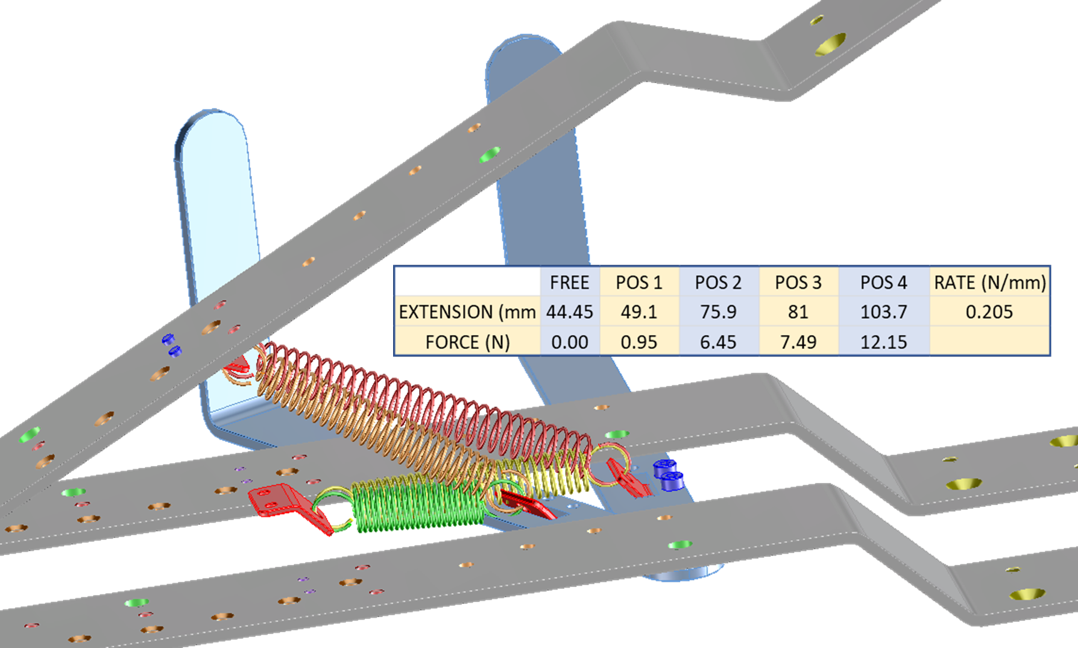

Figure 4: Screenshot showing different spring positions and the spring force v distance starting point calculations.

## Tidal Volume Adjustment.

The *Tidal Volume Lever*adjusts the amount of squeezing and thus, the volume of air delivered. This lever is located above the clamping arms to resist movement and is identical to the *Force Adjustment Lever*(for high volume manufacturing). It incorporates a hard stop (screw and nut) to limit the volume of air that can be delivered. A picture containing sign, clock, man

Figure 5: Screenshot showing multiple lever positions.

## Clamping Arms.

Not all the holes in the three identical *Clamping Arms* (*see Figure 5*) are needed for prototypes but are there to help layout for the high-volume manufacturing version. The four holes in the lower arms allow attachment to a table or base plate. Holes in the upper arm allow for customised attachments (not shown here) to improve bag emptying, and to allow compensation for different sizes or models of BVM.

The arms are made from 3mmx40mm flat stock material with four bends and drilled or tapped holes. The arms are raised using motor power, but the compression is controlled by an extension spring. The centre arm is raised 6mm to allow room for the sensors and adjustment levers.

Figure 6: Three identical Clamping arms (unfolded version in red)

## Motor Assembly.

The Motor Assembly raises the centre arm but is not involved in forced air delivery (for safety). This arrangement allows for a range of motors and motor speeds - it needs a minimum speed to allow the arm to stay ahead of the bag opening.

The motor runs on 12v DC and requires a low enough RPM (Revs Per Minute) so the arm rises at manageable speed. No complicated motor control or narrow motor selection is required since the motor does not apply pressure to the bag (that is the job of the spring). The motor merely raises the clamping arm allowing the bag to inflate spontaneously. A close up of a device

Figure 7: Screenshot of the motor and sensor assemblies.

## Bearing Assembly.

The Bearing Assemblyallows space for different configurations: drilled blocks, solid or roller bearings. The blocks also form part of the base and all three are identical (to improve cost at high volume production). The middle bearing block is rotated 180 degrees generating 6mm clearance on the centre arm. Threaded holes in the blocks facilitate arm attachment and are used to lock the bearing shaft with longer screws. The bearing shaft is 10mm diameter and is identical to the shaft used for the door hinge. An M4 tapped hole in one end of the bearing block allows cover attachment.A picture containing different, various, group, remote

Figure 8: Screenshot of the bearing assembly.

## Limit Switch Operation.

Three trip switches (Lower, Middle and Upper) control the operation and timing of the ABVM (See Figure 4). Since it´s assumed the patient will exhale spontaneously, so mechanical assistance is only required on inhalation.

The middle trip switch stops the motor when the clamping arm is fully open (held by the cam plate).

A signal (caused either by the patient starting inhalation or after a set timer delay) starts the motor briefly until it stops again at the Upper Limit Switch. There is now a clear path for the arm to pass by the cam plate. The spring pulls the arm down thus starting the compression cycle.

At the end of the compression cycle the lower switch is tripped and restarts the motor causing the arm to open stopping again at the Middle Limit Switch when the arm is fully open.

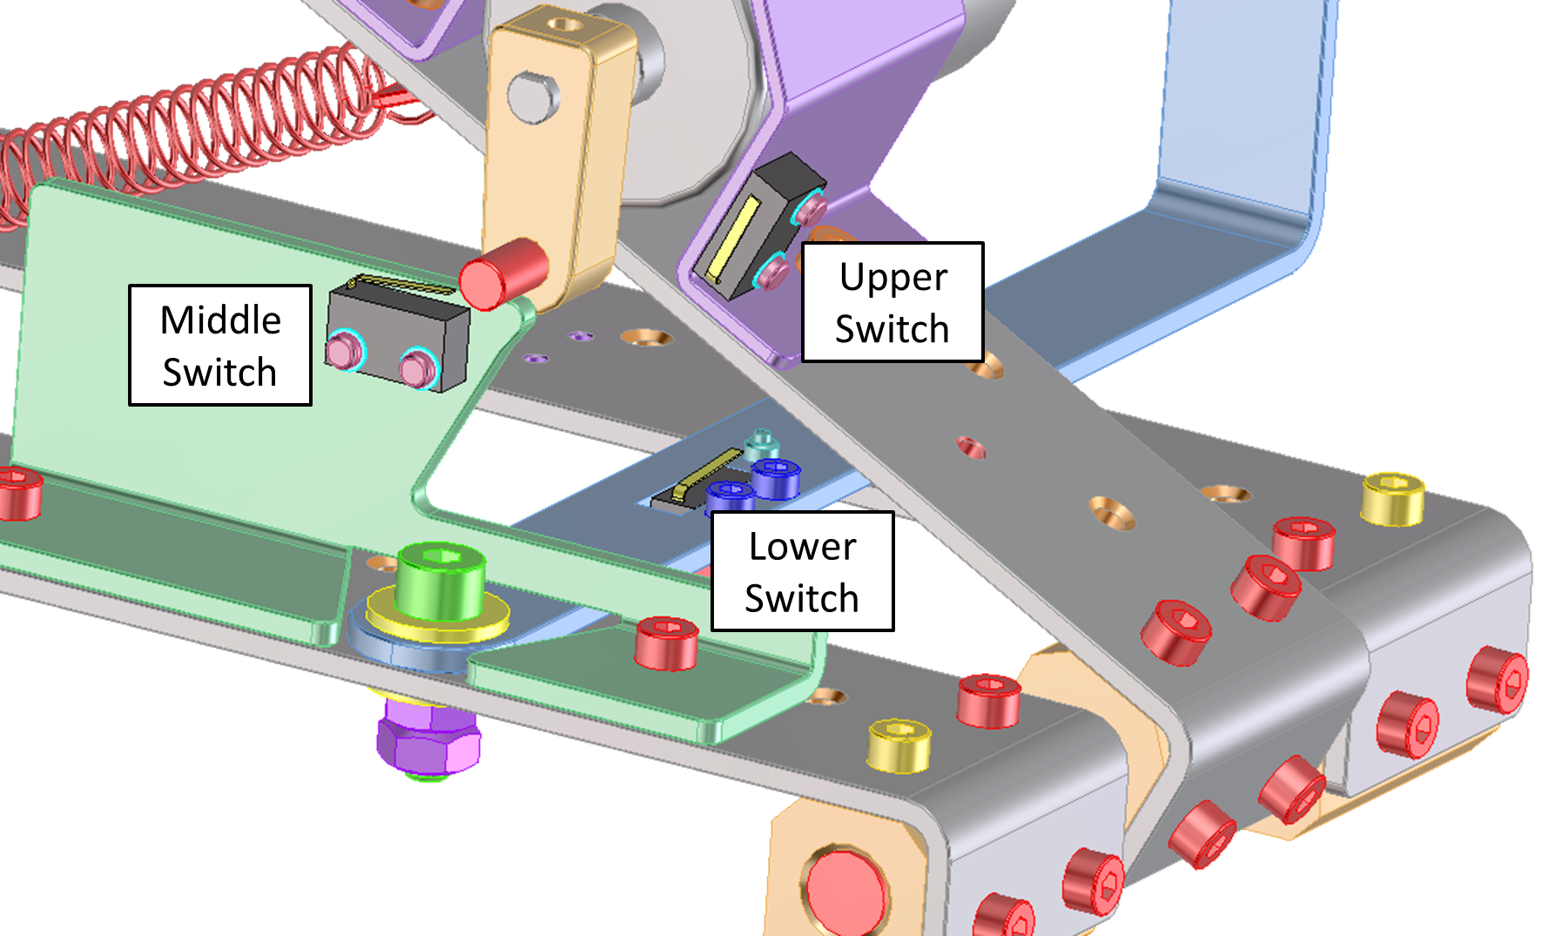

Figure 9: Screenshot of the three limit switches.

## **!WARNING!**

## Lung Injury.

* Mechanical Ventilation can cause **serious lung injury**.
* Too much pressure applied to the lungs can stretch and damage them.
* The diaphragm (breathing muscle) can rapidly deteriorate (atrophy) when not used.
* Reduced mucus mobility can lead to harmful build up in the lungs.

## Mechanical Dangers.

* Batteries can electrically shock or cause explosions.
* Springs can store energy that can lead to dangerous projectiles or other impacts.
* Levers can multiply force leading to pinch points capable of causing serious injury.
* Sharp edges can cut or stab people or cause damage to other objects.
* Compressed air or gasses can be dangerously explosive.