PRACTICUM / ON THE JOB TRAINING
AT INNOV8IT



A Narrative Report
Presented to the College Department
Quezonian Educational College Inc.
Atimonan, Quezon

In Partial Fulfillment of the Requirements for Practicum/ On the
Job Training

HITA, ISABEL MARYNIZA A.
February 7, 2026

Innov8IT Company
Innov8IT is an IT services and digital solutions company founded in August 2025, designed to help businesses grow with ease and efficiency. We focus on creating smart, scalable, and user-friendly platforms that empower our clients to succeed in the digital space
Mission
At Innov8IT, our mission is to empower clients through forward-thinking digital solutions, seamless user experiences, and adaptive strategies. We aim to embed innovation into every layer of what we do, so our partners don’t just keep up with change, they lead it.
Vision
To be a driving force of progress where innovation is not a choice but the standard. We envision a world where individuals and businesses thrive by embracing continuous creativity, smart technology, and transformative solutions.
Innov8IT Company Philosophy
At Innov8IT, we believe that technology is most powerful when it serves people with purpose. Our philosophy is rooted in integrity, doing what is right, even when no one is watching. We value innovation not as a trend, but as a mindset of continuous improvement and curiosity. Through teamwork, we recognize that the best solutions are built collaboratively, where every voice matters and shared success outweighs individual wins. We practice accountability by taking ownership of our work, our commitments, and our impact. We believe growth comes from responsibility paired with learning. Above all, we remain customer-focused, designing solutions that are not only smart and scalable, but meaningful and empowering to those who use them. We strive to create technology that simplifies complexity, sparks progress, and enables businesses and individuals to lead change, never just follow it

Daily Workplace Prayer
Lord, We thank You for the opportunity to work, create, and serve through Innov8IT.
Guide our thoughts, words, and actions today. Grant us wisdom in our decisions, creativity in our solutions, and patience in our challenges.
May integrity guide our work, teamwork strengthen our relationships, and accountability shapes our excellence.
Help us serve our clients with sincerity and purpose, and let everything we do bring value, growth, and positive impact. Amen.

ORGANIZATIONAL STRUCTURE
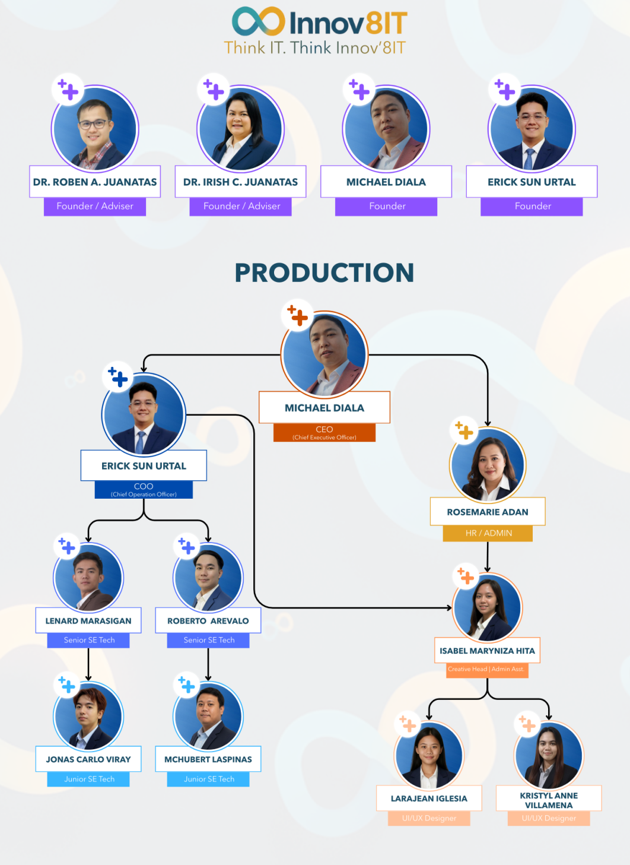

January 19, 2026
January 20, 2025 marked the first day of my On-the-Job Training (OJT) Phase. The day began with a company-wide meeting led by the CEO and COO, where they discussed the organization’s plans and goals for the current month and the succeeding months. The presentation also introduced the newly formed departments and clarified the roles and responsibilities of each team lead, giving everyone a clear understanding of the company’s direction and structure.
Before this day, I had been serving as the Creative Head and Administrative Assistant. During the meeting, I was formally appointed as the Lead of the Lead Generation Department. This new responsibility involves overseeing client acquisition efforts, searching for potential clients, and assessing the services that the company can offer to meet their needs.
Following the management’s presentation, I was given the opportunity to present my proposed plans and strategies for the newly established department. I shared my ideas on how we could effectively identify prospects, generate leads, and streamline our approach to client engagement. To conclude the day, we were tasked with cleaning and organizing the workplace. Since it was our first day back in the office after the Christmas party, we ensured that the environment was neat and ready for regular operations the following day.

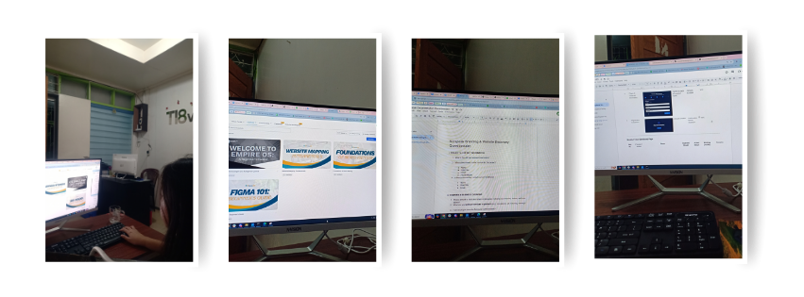

January 20, 2026
On this day of my On-the-Job Training, I focused on both documentation and lead generation tasks that support the company’s operations and client acquisition efforts. I prepared the Netspeak End-of-Shift Report to summarize the team’s daily accomplishments and progress. In addition, I created the Netspeak User Acceptance Documentation for both teachers and administrators to ensure that the system’s features, requirements, and usability standards are clearly defined and aligned with the needs of its intended users. I also collaborated with Ma’am Lara in developing the Netspeak Documentation Questionnaire to gather essential information for system evaluation and improvement.
Alongside these documentation tasks, I worked closely with the team to strengthen our lead generation process. I gathered prospect customers and inquiries using Google Sheets to maintain an organized database of potential clients. We also created structured Lead Generation Plans through Google Docs, outlining strategies and action steps to effectively reach and engage target customers. Furthermore, I worked with Ma’am Marie to define the lead criteria and qualifications to help identify high-quality prospects and improve the efficiency of our outreach efforts.

January 21, 2026
On this day of my On-the-Job Training, I continued working on strengthening the company’s lead generation initiatives. I gathered prospect customers and inquiries and organized their details using Google Sheets to maintain an updated and systematic database. This helped ensure that all potential clients are properly tracked and monitored for follow-up and future engagement.
I also collaborated with the team in creating Lead Generation Plans through Google Docs, where we outlined strategies and approaches for identifying, reaching, and converting prospects into clients. Together with Ma’am Marie, I defined the lead criteria and qualifications to determine which prospects best match the company’s target market and services. Establishing these standards allows the team to focus on high-quality leads and improve the efficiency of our outreach efforts.
Additionally, I initiated communication with a prospect lead through Innov8IT’s Instagram account, applying professional messaging techniques to build rapport and introduce the company’s services

January 22, 2026
This day, I focused primarily on improving and updating the documentation for the Netspeak system. I modified and refined the Netspeak User Acceptance Documentation as well as the Netspeak Documentation Questionnaire to ensure that all information is accurate, organized, and aligned with the current system requirements. I also inserted a detailed checklist for the Custom ESL Portal Management to guide future updates and track system enhancements effectively.
In addition, I assisted in implementing a page lock feature to enhance system control and security, ensuring that certain sections are protected from unauthorized edits or access. I also created the Contract and Non-Disclosure Agreement (NDA) for Netspeak, which are essential documents for establishing clear terms, responsibilities, and confidentiality between the company and its stakeholders. These tasks strengthened my understanding of both technical documentation and administrative processes.
Alongside my documentation responsibilities, I continued my lead generation efforts by sourcing five prospect leads from LinkedIn and updating their information in our Google Sheets tracker.

Janauary 23, 2026
The first week of my ojt lasted, during this day my tasks centered on improving both our lead generation workflow and Netspeak system documentation. I developed a centralized Innov8IT Lead Generation Sheet for the Socials CRM to organize and monitor all prospects efficiently. I also gathered nine prospect leads from Instagram, Facebook, and LinkedIn, engaged with some of their posts to build initial connections, and compiled message template sheets to standardize and streamline our outreach process.
At the same time, I continued refining the Netspeak documents by applying necessary modifications to the User Acceptance Documentation and Documentation Questionnaire. I added a checklist for Custom ESL Portal Management to guide updates and ensure all system improvements are properly tracked. These revisions helped enhance the clarity and organization of our documentation.
Additionally, I supported system and administrative tasks by implementing the page lock feature for added security and preparing the Contract and Non-Disclosure Agreement (NDA) for Netspeak.

January 26, 2026
It’s first day for our second week as an OJT Trainee, this tasks focused on organizing lead generation workflows and finalizing key system documentation for Netspeak. I created and organized dedicated sheets for hiring and comment tracking to streamline monitoring and improve the overall management of lead generation activities. I also generated fifteen new leads from Facebook, Instagram, and LinkedIn, expanding our prospect database and supporting the team’s client acquisition efforts.
In addition, I completed the finalization of Netspeak’s branding to ensure consistency in the system’s identity and presentation. I also compiled a list of implemented features within the Netspeak system to document completed updates and provide a clear reference for both the team and stakeholders.
Overall, the day was productive, as I was able to contribute to both marketing operations and system development while improving organization, documentation, and lead sourcing processes.

January 27, 2026
I created a Prospect Message Sheet in both Tagalog and English to support the company’s client outreach efforts. This sheet aims to make it each with communication with potential clients and ensure clear in messaging. I also generated 10 leads from LinkedIn and Facebook, identifying potential clients who could benefit from the company’s services and contributing to business development.
In addition, I revised and finalized the Netspeak Branding Kit, reviewing all design materials and making necessary adjustments to align with the company’s branding standards. This task helped ensure that the company’s visual identity remains consistent and professional across all platforms.
Lastly, I tested and updated implemented features in the Netspeak system, checking for errors and applying necessary updates to improve system functionality. Completing these tasks allowed me to enhance my practical skills in marketing, branding, client engagement, and system testing, further supporting my on-the-job training objectives.

January 28, 2025
On this day, I successfully generated 18 local leads from Facebook, identifying potential clients for the company’s products and services. This activity contributed to expanding the company’s customer base and provided valuable opportunities for business growth.
I also added prospect messages on lead generation for hiring, including messages tailored for both product/service inquiries in comment sections and for job-related posts. This task ensured that communication with potential leads and applicants was clear, consistent, and professional.
Additionally, I finished designing the Netspeak Home Page, completing all layout and visual elements according to the company’s branding guidelines. These tasks enhanced my skills in lead generation, client engagement, and web design, further supporting my OJT learning objectives.

January 29, 2026
January was almost done, but during this day, I assisted Ma’am Marie with administrative tasks, including preparing client rosters, certificates, and task deployment. This allowed me to support the smooth operation of daily office functions and gain practical experience in office administration.
I also created a revised plan for lead generation to improve the efficiency of reaching potential clients. I also implement the improvements I have failed to for the last week. In addition, I compiled all implemented features in the Netspeak system, ensuring proper documentation and easy reference for the team.
Lastly, I created an invoice for the purchase of a system, helping to manage financial and procurement records. These activities enhanced my skills in administration, planning, documentation, and basic finance, contributing to my overall learning goals during my OJT Journey.

January 30, 3036
For the last week of January, I generated 5 new leads from Facebook and reached out to 8 leads through comments, supporting client engagement and business development. I also assisted in creating social media posts and reels for Mam Lara and Mam Kristyl, contributing to the company’s online marketing efforts.
Additionally, I worked on the User Acceptance Documentation (UAD) for Netspeak to ensure system features were properly recorded. I also attended a meeting led by the CEO and COO discussing departmental achievements, improvements, and preparations for the weekly KPI and progress report presentation.
These activities enhanced my skills in lead generation, social media management, and system documentation while providing insights into organizational planning, departmental coordination, and performance tracking.

February 2, 2026
On February 2, 2026, I generated 10 new leads from Facebook and reached out to 8 new leads together with Mam Kristyl and Sir Tito, supporting the company’s client engagement and business development efforts.
I also assisted with administrative tasks and task deployment, while monitoring the designers’ tasks as a creative head to ensure projects were on track and aligned with company standards. I also help ma’am on QA Testing on Netspeak System and coordinate with Sir for the Actual Process.
Additionally, I took notes for the ongoing KPI and weekly progress reports of the management team, helping to track performance and maintain accurate records. These activities enhanced my skills in lead generation, administration, team coordination, and performance tracking.

February 3, 2026
For this day of the month, I surpassed the previous number of gathered as I generated 14 new leads from Facebook in Jaas with Mam Kristyl and messaged 15 newly generated leads, successfully receiving 2 replies. I also took charge of lead generation, coordinating outreach activities to ensure effective engagement with potential clients.
Additionally, I finalized the handouts for the User Acceptance Documentation (UAD) of Netspeak, ensuring all implemented features were properly documented and ready for review. I also provided insights and feedback on my co-workers’ weekly presentations, contributing to the improvement of team reports and performance tracking.
Through these tasks, I enhanced my skills in lead generation, client communication, system documentation, and team collaboration, while actively participating in improving the company’s processes and supporting my OJT objectives.

February 4, 2026
This is the second time I almost follow the daily quota for Lead Generation as I generated a total of 31 new leads from Facebook and LinkedIn, including gathering 20 leads for Jaas and messaging 11 new cold leads from Facebook. These activities contributed to expanding the company’s potential client base and improving outreach efficiency while improving our capacity to search and join more group and connections across lead platforms
I also updated the Netspeak User Documentation for the new Version 1, covering Admin, Branch Admin, and User roles from starting to the registration phase up to settings of the system. Additionally, I participated in QA testing, coordinating with Sir to identify bugs and provide feedback to improve system functionality.
Furthermore, I joined the Upskill English Training, participating in English speaking practice through Maya AI to enhance my communication skills. These tasks strengthened my skills in lead generation, system documentation, quality assurance, and professional development, supporting my overall skills.

February 5, 2026
First Week of the February feels like a great improvement for my department, Lead Generation as I gathered a total of 37 new leads from Facebook, including gathering 23 leads for Jaas and messaging 14 cold leads to engage potential clients. This is the highest and widest reach of our daily quota which makes me proud and happy. These activities contributed to the company’s business development and expanded the pool of prospective client while maintaining status of our tasks is onset
I also compiled all Innov8IT information to meet OJT requirements, ensuring that all documentation and data were complete and organized for review. Additionally, I provided insights and feedback on Mam Kristyl and Mam Lara’s KPI reports, helping improve the clarity and effectiveness of their presentations. In addition, I have started doing the Innov8IT Funnel Design with Ma’am Kristyl
Overall, the following tasks given to me allowed me to enhance my skills in lead generation, improve my ability to connect and engage with more people, client communication, user documentation and testing, also performance evaluation, while actively supporting team reporting and organizational objectives.

January 6, 2026
For the last day of this week, I generated a total of 9 new leads from Facebook, including gathering 2 leads for Jaas and messaging 7 cold leads, supporting the company’s ongoing client acquisition efforts. It’s a slow phase for Lead Generation to accumulate new leads due to continuation of important task but this department slows down a bit but still striving to gather more prospect clients next week.
Then, I also conducted Netspeak speed testing and data processing, while coordinating wit the developer, continued working on Innov8IT funnels, highlighting websites process and application form and created a sample visual data workflow to improve the team’s understanding of data processes. Additionally, I started designing an Innov8IT pricing banner to contribute to marketing and promotional materials specifically significant to the potential clients asking for pricing packages
I believe through the first week of February, the activities improve my capabilities and patience in lead generation, system testing, data workflow visualization, and creative design, while allowing me to actively take part to both operational and marketing initiatives during my OJT.

Challenges
Leading the lead generation function is a new responsibility for me, which requires time to learn, adapt, and build effective processes. Lead gathering, especially sourcing leads from social media comments, is time-consuming due to country restrictions and the need to ensure that leads are relevant and date-specific. At the same time, managing multiple responsibilities such as lead generation, documentation, and design tasks presents challenges in balancing priorities. Maintaining consistent outreach messaging across different platforms while adapting to their unique requirements has also been difficult. Additionally, selecting an appropriate accent color for the branding kit of a proposed website required careful consideration to ensure visual harmony and alignment with the overall brand identity.
Coping Strategies for the Challenges
To address these challenges, I focused on gradually developing structured workflows and documenting processes to improve efficiency and consistency. I implemented a more systematic approach to filtering and validating leads to ensure accuracy and relevance despite the time-intensive nature of the task. Prioritizing responsibilities through task planning and time management techniques helped me handle multiple roles more effectively. To maintain consistent outreach messaging, I created standardized templates that can be adjusted per platform while preserving the brand’s core message. For branding decisions, I relied on design principles, visual references, and feedback to guide the selection of appropriate accent colors.
Expectations from Work
Moving forward, I expect continued growth and improvement in lead generation as processes become more refined. Clear priorities, realistic timelines, and consistent communication will help in managing multiple responsibilities more efficiently. I also expect constructive feedback and collaboration to strengthen outreach strategies and branding efforts. With proper alignment and support, I aim to enhance productivity, maintain quality standards, and contribute more effectively to both strategic and creative aspects of the role.

