Intelligence Engine
Role-by-Role Operations Guide
Six human seats, their activities, and the evidence that each one works.
Every screenshot is from the live deployment; every diagram is rendered
from the same source the repository publishes.

Orientation
The Intelligence Engine is a pre-engagement intelligence substrate for management consultants. Synthetic workforce data flows through a governed medallion data plane; an episodic LLM pipeline turns it into client briefings; a hosted console puts a human checkpoint in front of anything that ships. It runs on a single AWS account, deployed entirely from CloudFormation templates in a public repository.
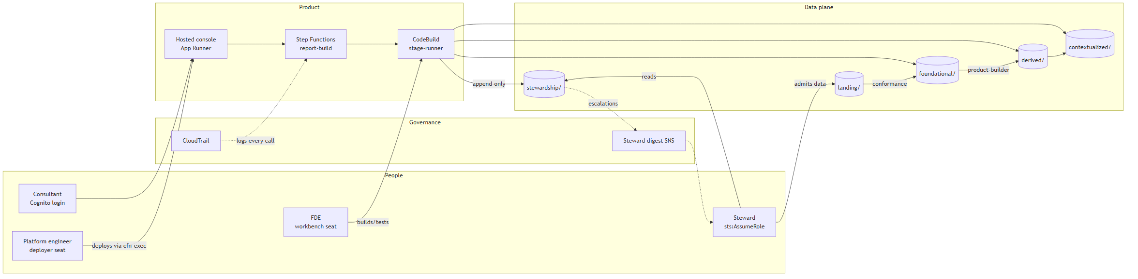
Figure 1. The whole system: people, product, governed data plane, and the governance surfaces that watch all of it.
Two properties are worth stating before anything else, because every chapter below depends on them.
- Everything that exists is in a template. Fifteen stacks own every bucket, role, state machine and trail in the account; a drift detector (scripts/iac_coverage.py) fails if anything exists outside them.
- Read and write are never the same grant. Each medallion tier has separate read and write policies held by different roles, so no identity can rewrite the tier it consumes.
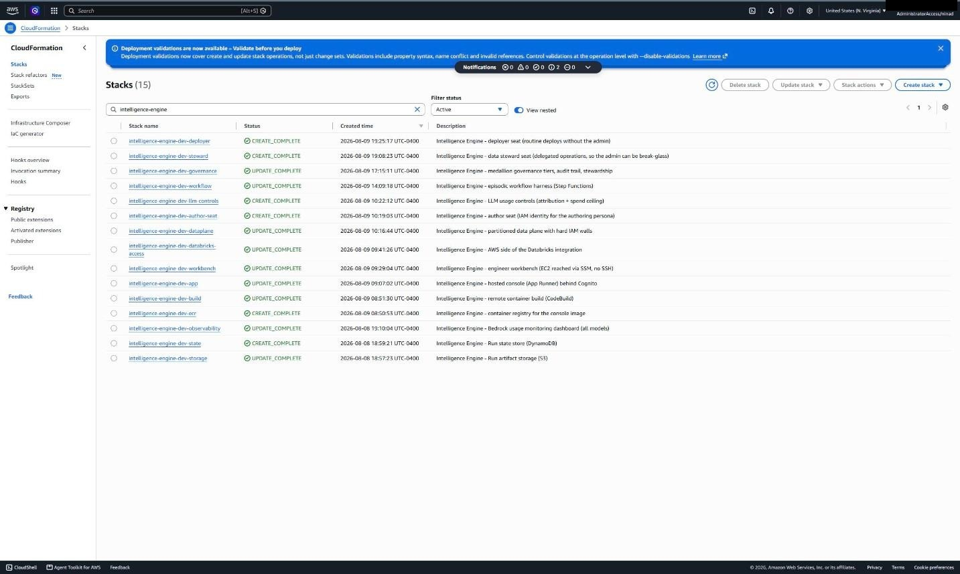
Figure 2. The inventory of record: fifteen stacks, all complete. The two newest are the delegated human seats - steward and deployer.

Who can block what
The permission question (“who can do what”) has a twin that governance reviews usually miss: whose absence stops the system. The design answer is that almost nobody's should.
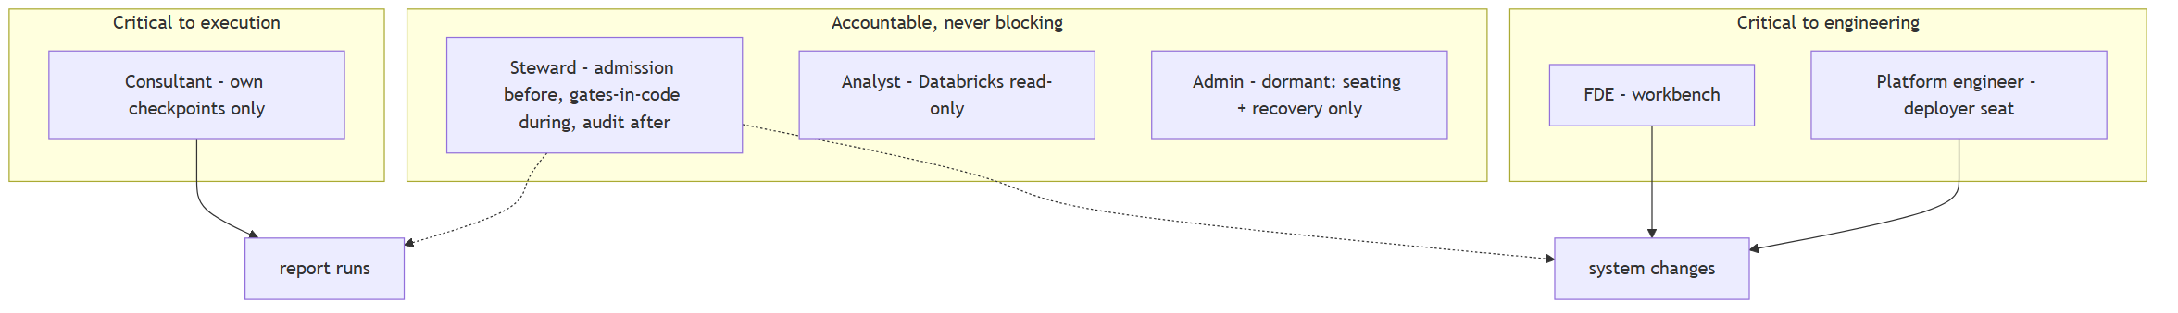
Figure 3. Only the consultant is critical to a run - their own checkpoints. Only the FDE and platform engineer are critical to engineering. The steward governs without blocking; the admin is dormant.
Seat | Surface | Critical to
Consultant | Hosted console (Cognito) | Execution - own checkpoints
Forward-deployed engineer | Workbench terminal + Claude Code | Engineering
Platform engineer | Deployer seat (CloudFormation only) | Engineering
Data steward | Steward seat (admission + audit) | Nothing at runtime
Analyst | Databricks, read-only | Nothing
Account admin | SSO, dormant | Nothing, by design

1. Consultant / Engagement Lead
Surface: the hosted console in a browser. No AWS account and no cloud permissions - a Cognito login created by the data steward. The consultant is the only human a running report ever waits for.

Activity 1.1 - Run a report
- Sign in at the console URL. There is no self-signup; ask a steward for a login.
- Pick a client from the list, or type any company under Research Any Company.
- Entity verification runs first - a nonsense company is rejected for a few hundred tokens instead of tens of thousands.
- Watch progress live, or close the browser: run state is durable and consumes nothing while paused.
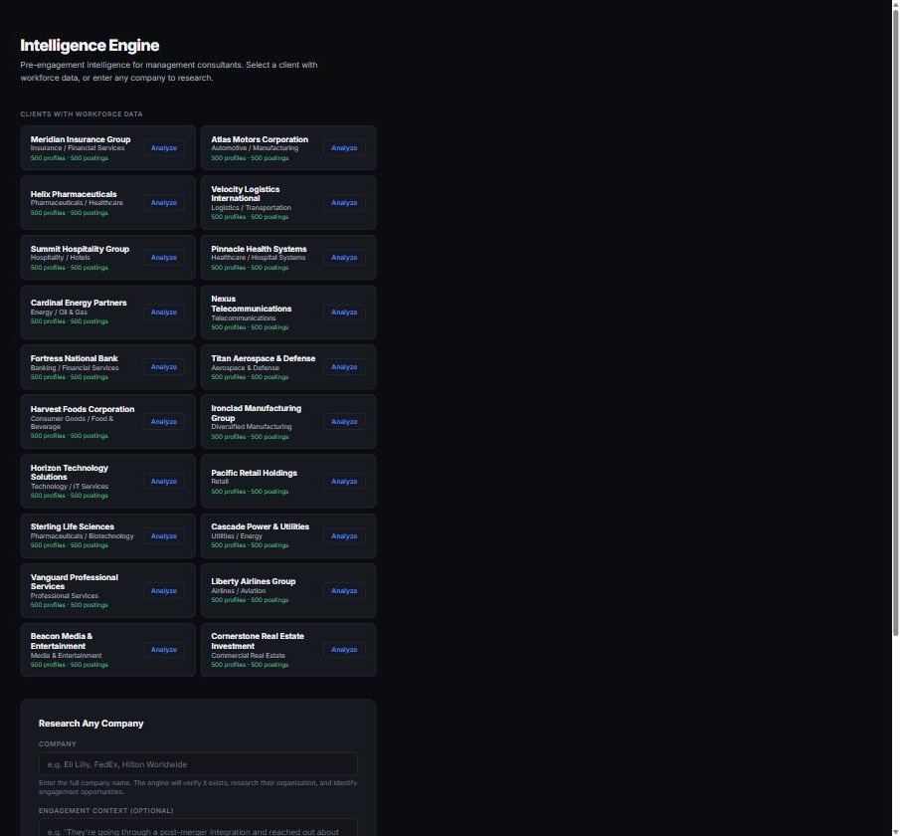
Figure 4. The consultant home: twenty synthetic clients with workforce data, plus free-form company research.

Activity 1.2 - Decide at a checkpoint
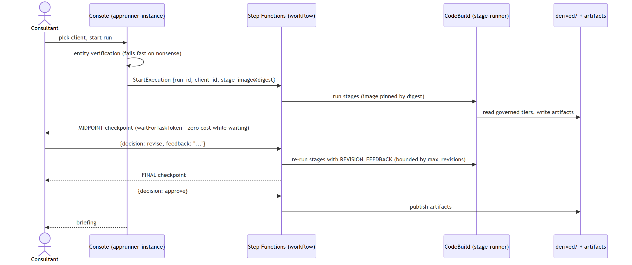
Figure 5. A report run end to end. The two checkpoint pauses use waitForTaskToken, so a run waiting on a human costs nothing for hours or days.
- At the midpoint checkpoint, read the draft and choose: approve, request a revision, or reject.
- A revision takes your written feedback and injects it into the regeneration prompts - be concrete (“the attrition section contradicts the composition chart” beats “make it better”).
- Revisions are bounded (default two per checkpoint), so a run cannot loop forever.
- At the final checkpoint, approve to publish the artifacts.
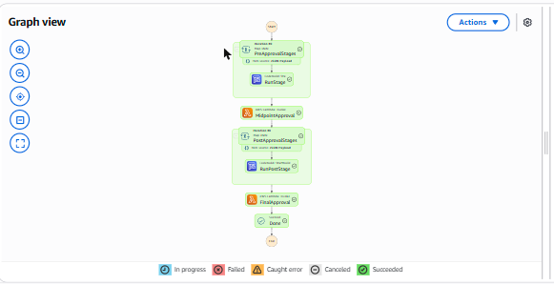
Figure 6. A real execution: stages in green flowing into MidpointApproval and FinalApproval.

What a consultant never has to worry about
- Their login grants no cloud permissions; the app acts for them under its own scoped identity.
- They cannot break the pipeline, the data tiers, or anyone else's run from the console.
- Coarse-looking breakdowns are the privacy floor working - cells below five people are suppressed upstream.

2. Forward-Deployed Engineer (FDE)
Surface: the workbench - an EC2 instance inside the account carrying Claude Code, git, the AWS and Databricks CLIs and Terraform. Reached over SSM only; no SSH key exists anywhere in the estate.

Activity 2.1 - Reach the box
Two identities are in play, and keeping them apart is the whole design. The FDE seat (intelligence-engine-dev-fde) is the human's right to reach the workbench and nothing else: find it, wake it, open a session, sleep it. Everything the engineer can actually do arrives from the instance role once they are at the prompt. Widening an FDE's power is therefore a reviewed template change, never a grant handed to a person.
Path to the prompt | What it needs | When to use it
Local terminal | AWS CLI + Session Manager plugin (one-time install) | Day to day - best ergonomics
Console → Session Manager | Console access + the FDE seat. No install | A borrowed machine; no local setup
CloudShell | Also cloudshell:* - which the FDE seat does not grant | Only if your permission set has it

aws ec2 start-instances --instance-ids <workbench-id> --profile intelligence-fde
aws ssm start-session --target <workbench-id> --profile intelligence-fde
sudo su - ec2-user # lands in ~/intelligence_architecture, venv active
claude
Claude Code on the workbench runs on Amazon Bedrock through the instance role - no API key, no personal login. Agent inference therefore stays inside the account boundary: same Bedrock account, same CloudTrail, same data path as the product's own model calls.

Activity 2.2 - Extend the behavioural eval (a full loop)
The golden replay tests code. It says nothing about whether a *model* still behaves. The seeded-defect eval closes that gap: planted defects, one per failure class the advisory reviewer exists to catch, scored as recall. Extending it is ordinary FDE work, and the loop below was executed on the live workbench.
- Ask Claude Code for the change: add a fourth defect class - a year-over-year trend asserted from point-in-time counts.
- Read the diff it produced, in the terminal, before running anything.
- Run the eval against live Bedrock - four real model calls.
- Read the recall line. That number is evidence about the model, not the code.
- Keep or revert. Below the 2/3 floor is a regression even when every unit test passes.
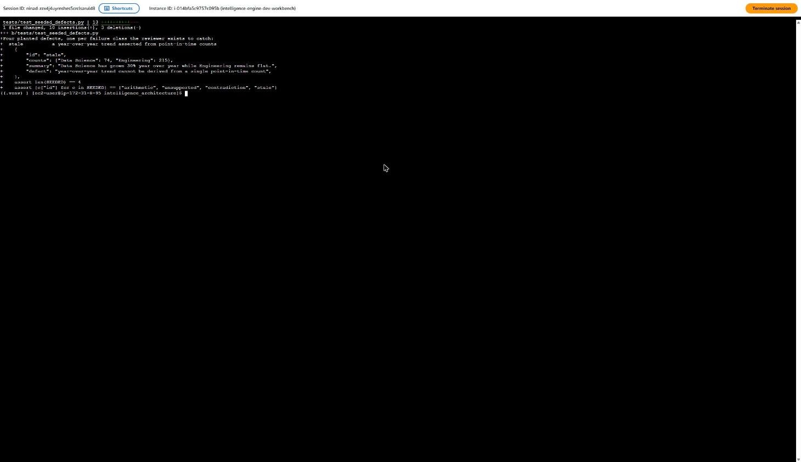
Figure 7. Step 2: the agent's diff. A new 'stale' case with counts, a summary asserting a trend, and the guard test updated from three cases to four.
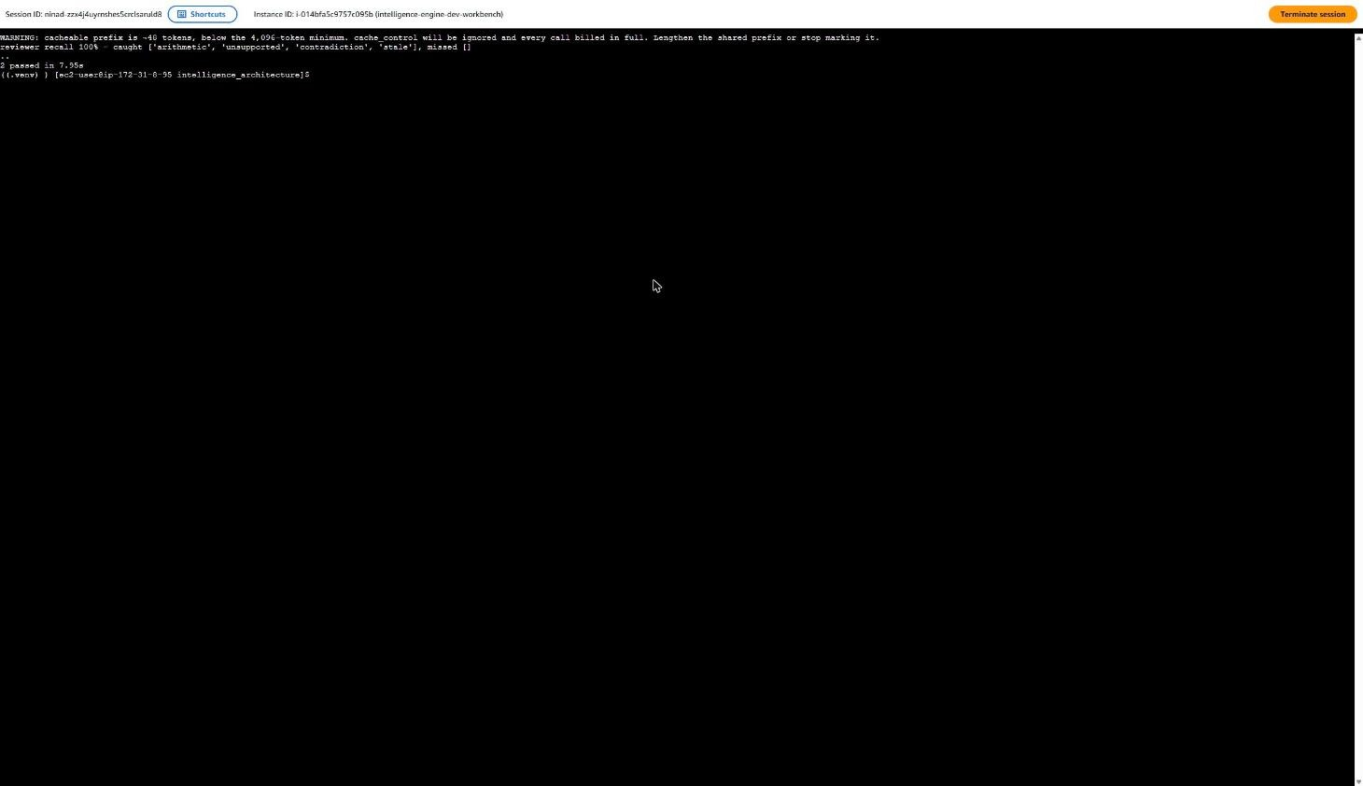
Figure 8. Steps 3-4: the eval against live Bedrock. 'reviewer recall 100% - caught [arithmetic, unsupported, contradiction, stale], missed []'. Note the caching warning above it - the wrapper reports honestly that the prefix is too short to cache.

Activity 2.3 - Investigate model cost, and probe the boundary
Two more activities from the same session, both in the familiar Claude Code interface. First a cost question raised by that caching warning; then a direct test of what this seat may and may not do.
- Ask why the caching warning fired and whether caching is worth pursuing for this workload.
- Ask the agent to probe its own boundary: list the derived tier, then try to update a CloudFormation stack.
- Approve each shell command at the permission prompt - the agent cannot run commands unattended by default.
- Watch it self-correct: the first attempts used a named profile that does not exist on the box, so it checked its caller identity and retried against the instance role.
- Read the verdict table it produces.
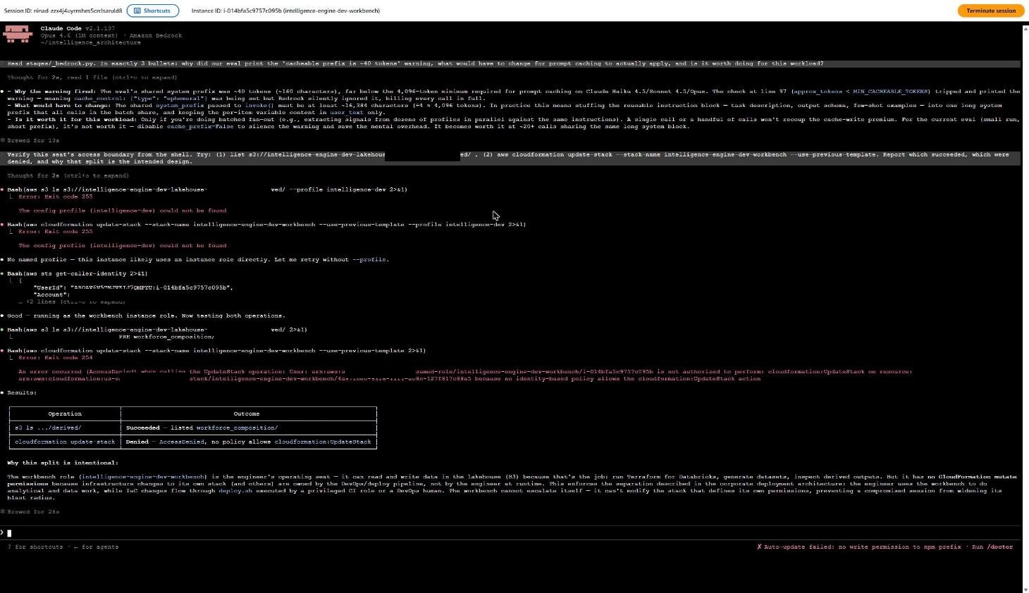
Figure 9. The whole session. Top: why prompt caching does not apply below 4,096 tokens and when it would be worth it. Bottom: the boundary probe - reading derived/ succeeded, cloudformation:UpdateStack was denied - with the agent's own explanation of why that split is intentional.
That denial is the access model asserting itself against the engineer's own agent. The workbench changes code; only the deployer seat changes infrastructure.

Activity 2.4 - Ship a pipeline version
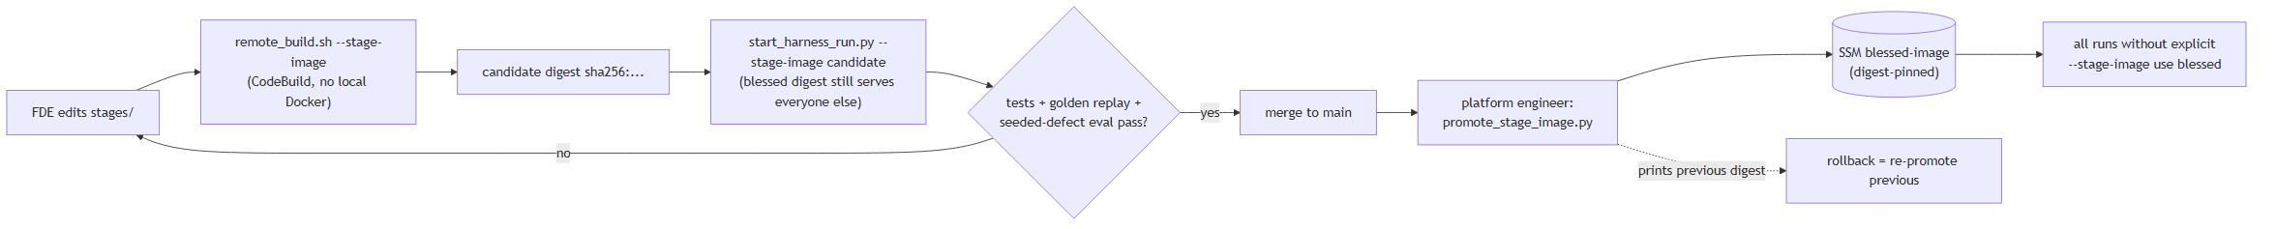
Figure 10. Candidate to blessed. Every run pins an image digest, so which pipeline version produced a report is never ambiguous.
./infrastructure/remote_build.sh --stage-image # builds in CodeBuild; prints digest
python scripts/start_harness_run.py --client sterling-pharma \
--stage-image <repo-uri>@sha256:<candidate> # blessed digest still serves everyone else
When the candidate passes, the digest is handed to the deployer seat for promotion. Releasing is deliberately not an FDE action - the same separation as infrastructure, applied to the pipeline default.

Activity 2.5 - Know where the work shows up
The terminal is one surface, not the whole job.
Question | Surface that answers it
What did I change? | git branch and diff → the pull request
Which pipeline version ran? | Step Functions executions - each input pins an image digest
What did a stage actually do? | CodeBuild build history and its log stream
What did the model see? | /engineer run traces - the exact injected context
What did it produce? | analysis/<client_id>/ in the artifacts bucket
What did it cost in tokens? | CloudWatch Bedrock dashboard; summary() per run
Is the estate still as described? | python scripts/iac_coverage.py
Who did what, account-wide? | CloudTrail - including the agent's own calls

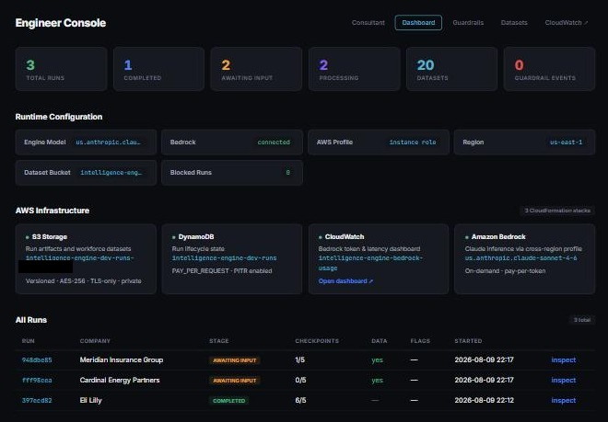
Figure 11. The engineer console: run states, checkpoints, datasets, infrastructure. An observation deck, not a cockpit.
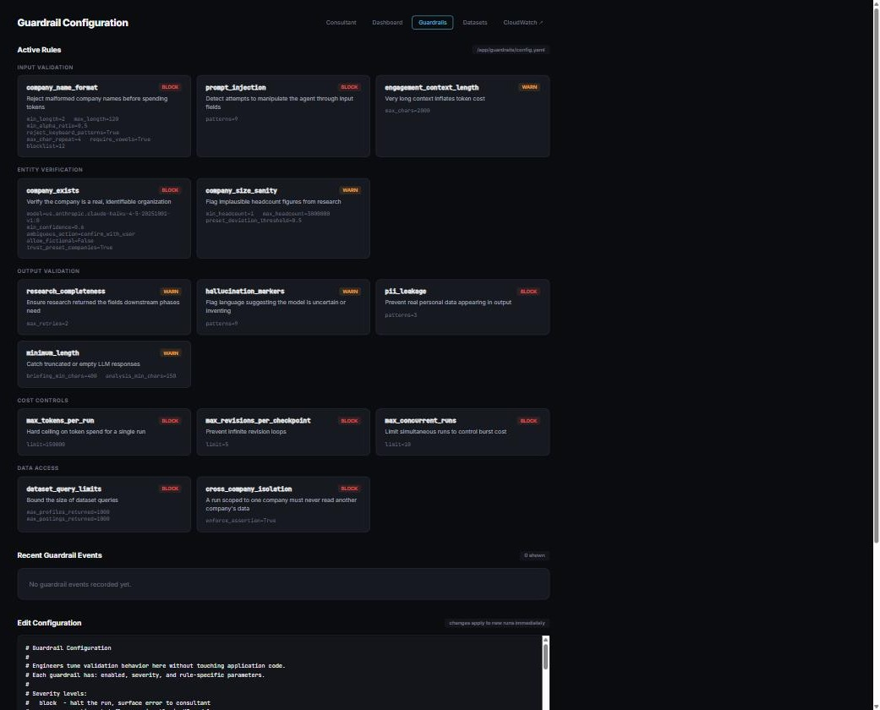
Figure 12. The guardrail surface - input validation, entity verification, output validation, cost ceilings, data-access isolation. Read-only when deployed: enforcement changes ride through git.

3. Platform Engineer
Surface: the deployer seat. Operates CloudFormation on project stacks through cfn-exec - an execution role whose trust policy admits only the CloudFormation service, never a human - and mutates nothing directly.
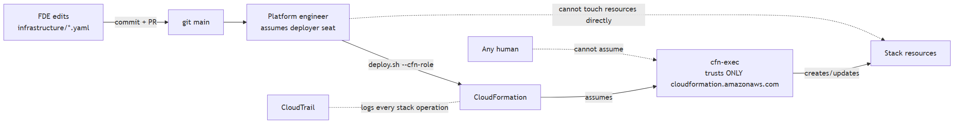
Figure 13. The deploy channel. Boundaries change through exactly one path: a reviewed template, applied as a logged stack operation.

Activity 3.1 - Routine deploy
./infrastructure/deploy.sh --profile intelligence-deployer \
--cfn-role arn:aws:iam::<account>:role/intelligence-engine-dev-cfn-exec
Quirks worth knowing before they surprise you: the app stack deploys twice (it must learn its own URL before Cognito can trust it); the steward stack takes the resulting user-pool id; unspecified parameters reuse their previous values on update.

Activity 3.2 - Verify, every time
python scripts/qa_sweep.py --profile intelligence-deployer
python scripts/iac_coverage.py --profile intelligence-deployer
Both are read-only and exit non-zero on failure, so either can gate a pipeline. An unmanaged resource is an incident, not housekeeping: adopt it into a template or remove it, and find out which seat created it.

Activity 3.3 - Promote or roll back a pipeline version
python scripts/promote_stage_image.py --profile intelligence-deployer --digest sha256:...
The script refuses a digest that is not in ECR, records the blessed image in SSM, and prints the previous digest - rollback is running it again with that value. Promotion affects the next run, never a run already in flight.

Activity 3.4 - Roll back infrastructure
git checkout <last-good-commit> -- infrastructure/cloudformation/<name>.yaml
aws cloudformation deploy ... # the template is the truth you want back
A stack stuck in ROLLBACK_COMPLETE after a failed create must be deleted and recreated - CloudFormation will not update it.

4. Data Steward
Surface: the steward seat. Exactly three capabilities - admit data, admit people, read the audit surface - and no ability to deploy, write a governed tier, invoke a model, or reach the vault.
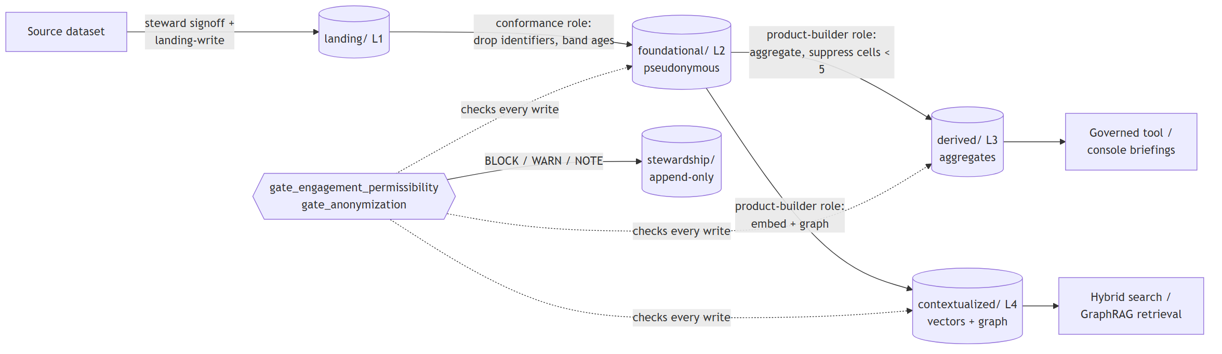
Figure 14. Admission through the medallion tiers. The steward decides what enters; the gates in code enforce the rules on every write thereafter.

Activity 4.1 - Admit a source
aws s3 cp ./drop.jsonl s3://<landing-bucket>/landing/<client>/<source>/<date>/ \
--profile intelligence-steward
The steward seat is the only identity that can write landing/, so every object there is something a steward deliberately placed. Licensing, privacy basis and inferred-attribute sensitivity are decisions taken before this command, not after.
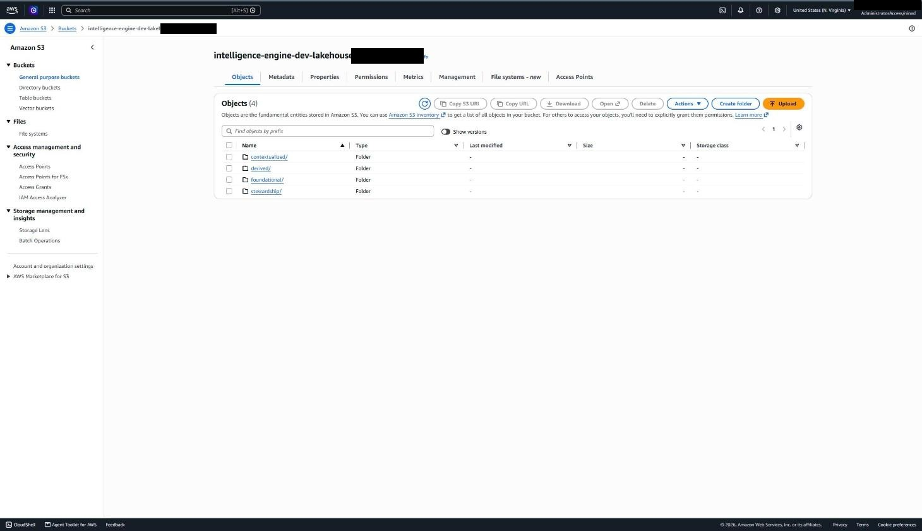
Figure 15. The governed data plane: medallion tiers as prefixes - foundational (pseudonymous), derived (aggregates, small cells suppressed), contextualized (vectors and graph), stewardship (append-only log).

Activity 4.2 - Admit and remove people
aws cognito-idp admin-create-user --profile intelligence-steward ...
aws cognito-idp admin-set-user-password --profile intelligence-steward ... --permanent
aws cognito-idp admin-disable-user --profile intelligence-steward ...
Set a permanent password rather than relying on the temporary-password flow: no email delivery is configured, so an invited user would otherwise be stranded.

Activity 4.3 - Read the audit surface
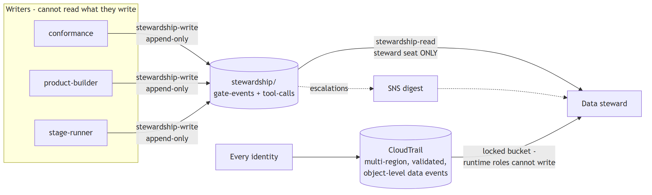
Figure 16. Append-only by construction: the identities that write the log cannot read it, and the identity that reads it can write nothing but the drop zone.
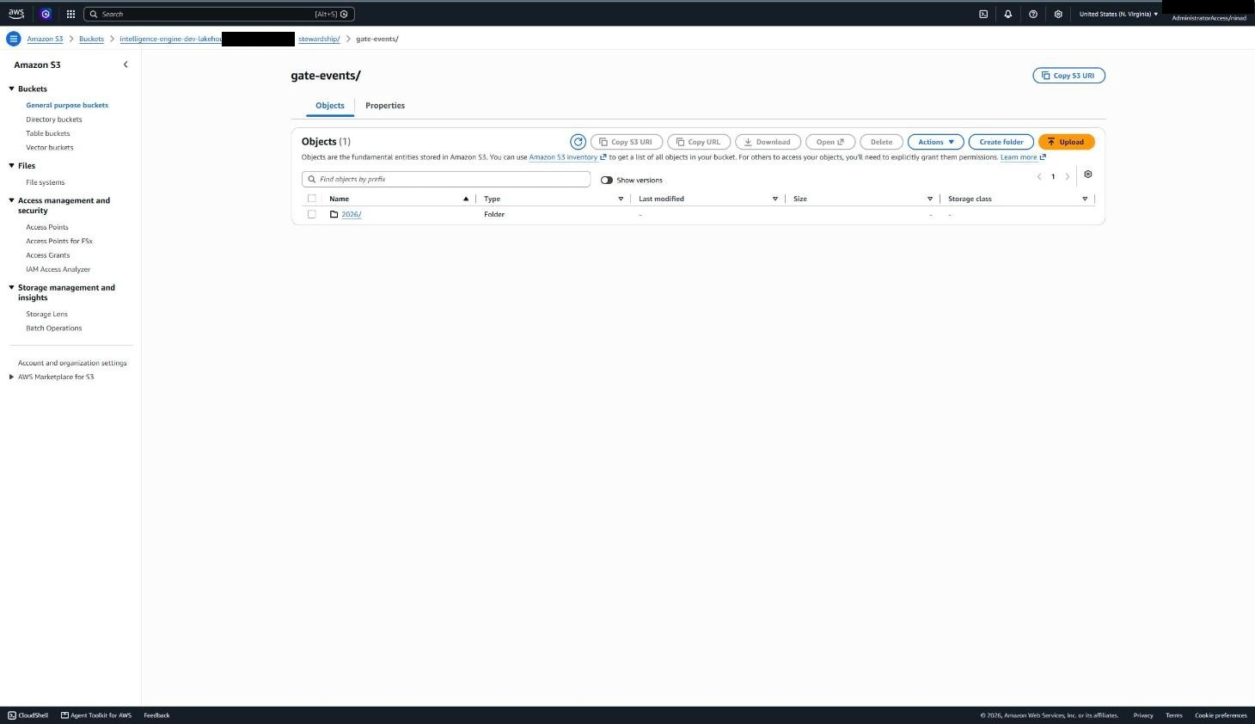
Figure 17. The stewardship log in S3. gate-events/ records every gate evaluation as JSONL - which gate, which caller, BLOCK / WARN / NOTE, and what triggered it.
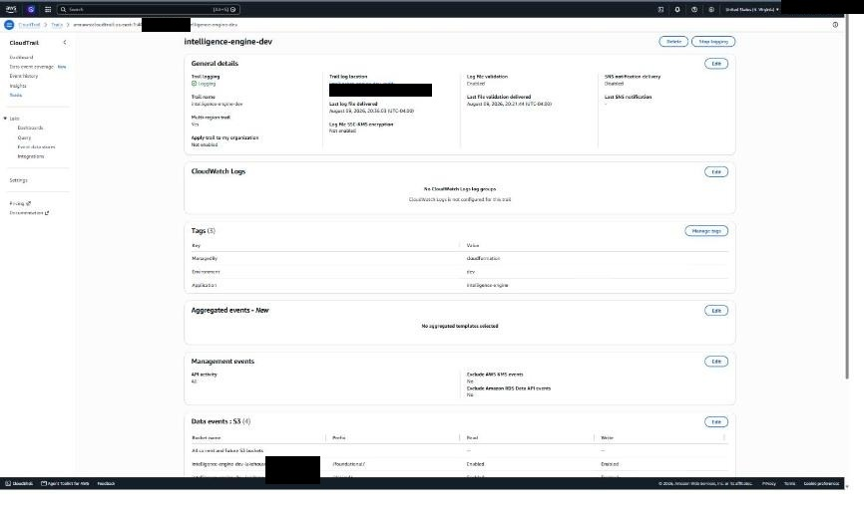
Figure 18. CloudTrail: multi-region, log-file validation enabled, and object-level data events on the governed prefixes - every individual read of governed data, not just management calls.

Activity 4.4 - Review a lineage claim
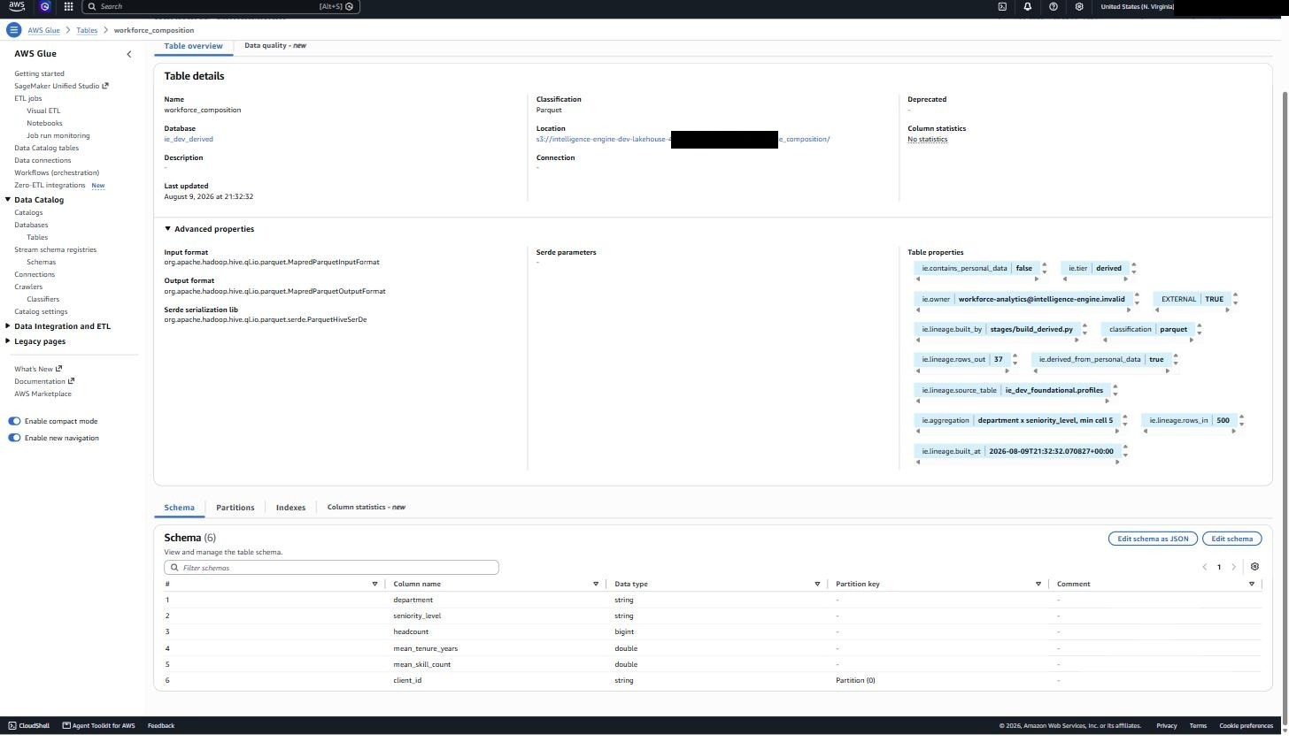
Figure 19. Governance as table metadata: ie.owner names the accountable human, lineage records 500 rows in and 37 aggregate cells out, and contains_personal_data=false sits beside derived_from_personal_data=true - the honest pair.

5. Data Scientist / Analyst
Surface: Databricks, reading the lakehouse in place through Unity Catalog. Zero-copy, read-only, and no AWS credentials in the analyst's hands.
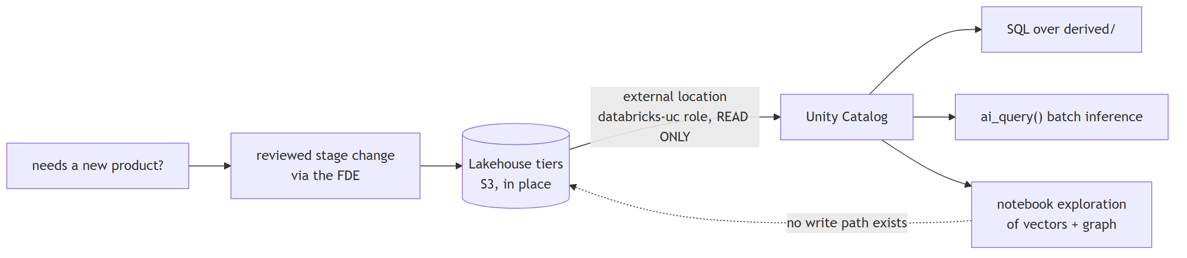
Figure 20. The zero-copy path. No write path exists from the notebook back to the governed tiers.
- derived/ is the everyday surface for BI - a normal external table with suppression already applied.
- foundational/ supports record-grain modelling, and carries record-grain obligations: pseudonymous is not anonymous.
- contextualized/ ships embeddings beside their metadata columns for retrieval prototyping.
- Reconstructing suppressed cells by joining or differencing derived outputs defeats the control the tier exists to provide.
New or changed product tables are requested, not built here: they are a reviewed change to the build stages, run under the product-builder identity with lineage metadata updated. That is what keeps the catalog's ownership claims true.

6. Account Admin
Dormant by design. Two jobs only: seating people, and recovery if the deploy channel itself breaks. Used on a normal day means something is misdesigned.

Activity 6.1 - Seat a person
Each seat is a role trusting the account; seating is one statement granting a principal permission to assume it. Unseating is removing that statement.
{"Effect": "Allow", "Action": "sts:AssumeRole",
"Resource": "arn:aws:iam::<account>:role/intelligence-engine-dev-steward"}
The FDE is seated slightly differently - through the fde role, which itself carries the SSM and EC2 permissions needed to reach the workbench. Consultants are not seated by the admin at all; they are Cognito users the steward manages.

Activity 6.2 - Break glass, then reconcile
Fix the minimum, through a template wherever possible, then prove the estate still matches the repository. Break-glass that leaves untracked state behind is not recovery, it is new damage.
python scripts/iac_coverage.py # must report NO DRIFT afterwards

Appendix A - The harness in detail
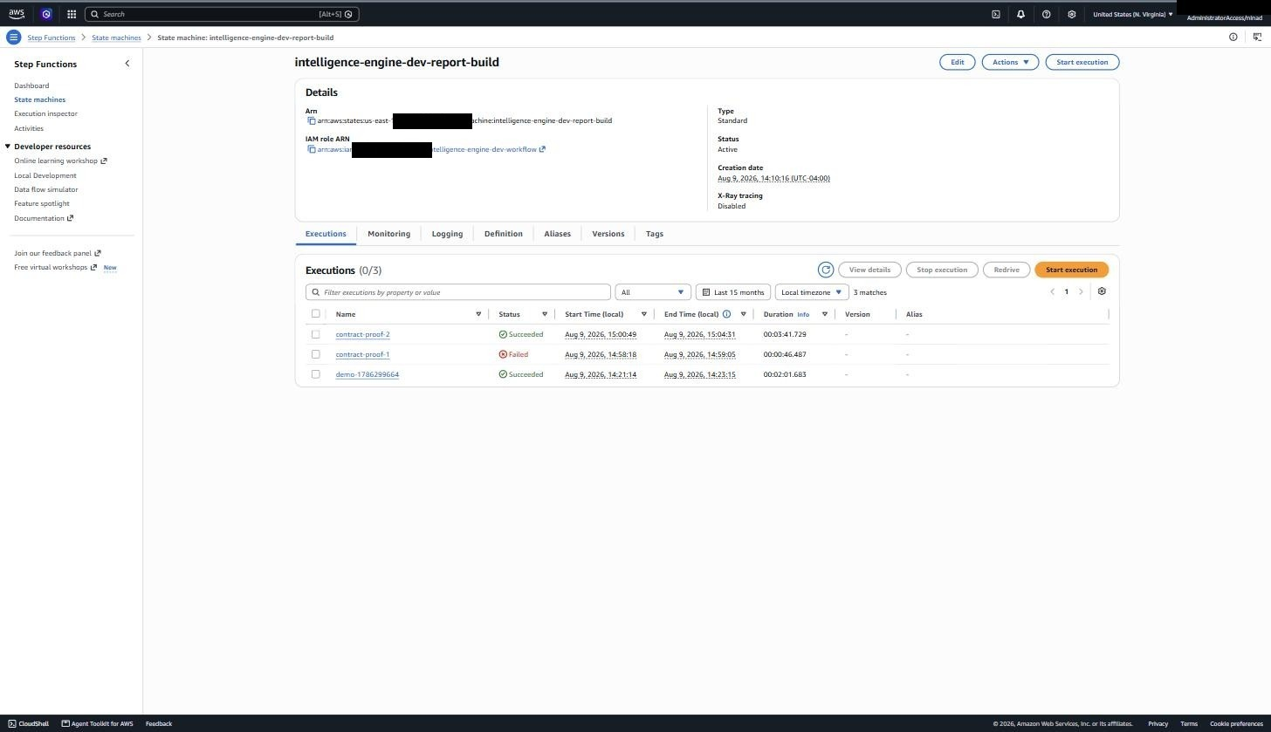
Figure 21. The report-build state machine and its execution history.
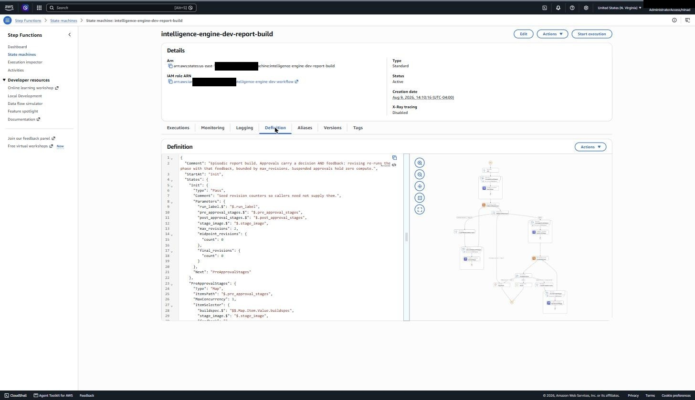
Figure 22. Definition beside graph. Execution input pins stage_image by digest; approvals carry {decision, feedback}; revision loops are bounded by max_revisions.

Appendix B - The seats, as IAM sees them
Role | Held by | Can | Cannot
fde | A human, via AssumeRole | Find, wake, reach, sleep the workbench | Read tiers, invoke models, deploy
workbench | The EC2 instance | Bedrock, tier reads, artifacts, builds, harness runs | Deploy, touch IAM or billing
steward | A human, via AssumeRole | landing-write, Cognito users, read the audit log | Write governed tiers, deploy, vault
deployer | A human, via AssumeRole | CloudFormation on project stacks via cfn-exec | Mutate any resource directly
cfn-exec | CloudFormation only | Create and update stack resources | Be assumed by any human
conformance | CodeBuild | landing-read → foundational-write | Read derived or contextualized
product-builder | CodeBuild | foundational-read → derived + contextualized write | Write foundational
stage-runner | CodeBuild | Tier reads, artifact write, Bedrock | Write any governed tier
databricks-uc | Databricks | Read the lakehouse in place | Write anything

Appendix C - Verifying any claim in this document
Nothing here needs to be taken on trust; each claim has a command.
python scripts/qa_sweep.py # stacks, auth, tiers, harness, idle billing
python scripts/iac_coverage.py # nothing live outside the templates
python -m pytest # the code suite
python -m pytest tests/test_seeded_defects.py -s # model behaviour, live Bedrock
aws iam list-attached-role-policies --role-name intelligence-engine-dev-stage-runner

Appendix D - Where everything lives
Artefact | Location
Repository | github.com/dorchester/intelligence_architecture
Role guides (full command detail) | docs/guides/
Access model, every identity and grant | docs/access-model.md
Architecture diagrams (source of Figures 1, 3, 5, 10, 13, 14, 16, 20) | docs/diagrams.md
Deploy-from-nothing walkthrough | docs/aws-walkthrough.md
Substrate / workload boundary contract | docs/integration-contract.md
This document's generator | scripts/build_role_guide_docx.py
Diagram renderer | scripts/render_diagrams.py
Screenshot trim / redact utility | scripts/prepare_screenshots.py

