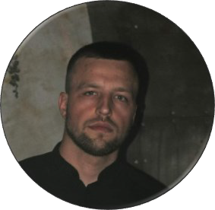Dordea

**Pavel**

**Software Developer**

# CONTACT PROFILE

 +37367599948

pavlik[@duck.com](mailto:nikstone9@gmail.com)  Rezina, MD 5400



## Languages

 Romanian : *First Language*

 Russian : *B1*

 English : B1

## Programming Lang

 Python  C++

 Java

 HTML, CSS, JS

 Delphi  C

## Web

 [Github](https://github.com/dordea) (https://github.com/dordea)

 [TideTime.works](https://tidetime.works/)

(https://tidetime.works)

 [Dordea.codes](https://dordea.codes/) (https://dordea.codes)

Analytical Software Programmer with over 3 years of experience maintaining and repairing software and operating systems to maximize efficiency. Advanced-level knowledge of SQL databases. Skilled with using Python and C++ technologies to offer innovative solutions for end-users.

Seasoned Software Engineer offers JavaScript, CSS and HTML expertise coupled with outstanding problem-solving and multitasking abilities. Thorough and accurate professional with 3 years of diverse experience in startup and late-stage companies. Well-versed in designing and implementing test plans and recommending new enhancements to improve performance.

# EXPERIENCE

 **Software Engineer**

Academia de Stiinte a Republicii Moldova 2021 – 2022  Resolved customer issues by establishing

workarounds and solutions to debug and create defect fixes.

Applied diverse troubleshooting methods to analyze software problems and develop appropriate solutions.

Implemented and tested enhancement feature requests to improve product functionality and extend performance.

# SKILL

 Cybersecurity

 Computer programming  Code Optimization

 Web development

 System Analysis  Version Control

## Education

 Tiraspol State University 2019 - 2022

 Ion Creanga State Pedagogical University 2022 - 2024