

**Accessibility in Word – A Foundation for Web Content**

Before starting the tasks below – open the accessibility checker and look at the errors in this document.  
How many of the following do you see?

Original Count Final Count

Errors: [     ] [     ]

Warnings: [     ] [     ]

## Task 1:

#### File Properties

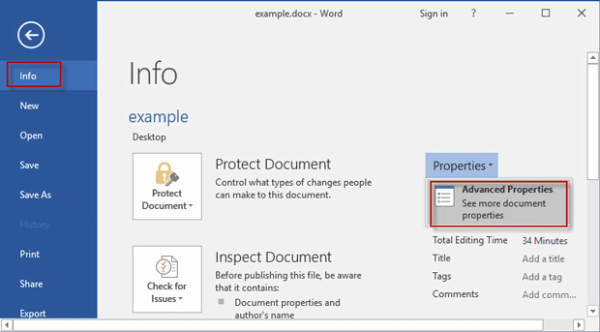

1) Add a descriptive, document title to this Word  
 document.

2) Update the Author field

3) *Optional:* Add Company, Subject, Tags, or other   
 relevant information to the document properties

## Task 2:

#### Headings

Headings should be used to organize documents. People using screen readers or a Braille system use the headings to navigate through a document’s structure – headings allow the user to jump from area to area of the document.

1 – Check that header styles are applied – and not created using bold and/or font sizes.

2 – Make sure the headings used create an outline that follow a hierarchical order

i.e. – Start with “Heading 1” for the title/main heading

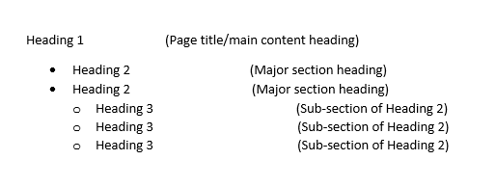

followed by subheadings of “Heading 2”,

“Heading 3” and so forth

Note: Headings should not skip numbers (e.g. jumping from Heading 1 to Heading 3), but should follow a logical order

## Task 3:

#### Images

1. Make sure that all images have alternate text

2. Images should be inline with text

## Task 4:

#### Lists

- Check to see how lists are formatted.

- All lists should be formatted using the built-in tools for ordered (numbered) and unordered (bulleted) lists

#### This includes columns … make sure columnized lists are not created uses tabs

• Lorem ipsum dolor sit amet, • sed do eiusmod tempor incididunt  
consectetur adipiscing elit, ut labore et dolore magna aliqua.

• Netus et malesuada fames ac. • Proin sagittis nisl rhoncus mattis rhoncus

urna neque.

• Sollicitudin aliquam ultrices • Nullam ac tortor vitae purus faucibus

sagittis orci a scelerisque purus semper. ornare.

## Task 5:

#### Links

Links must convey clear and accurate information as to the destination of the link. Make sure the link is not broken, and be prepared to fix links that break over time. When inserting a link, use descriptive anchor text and avoid generic terms (e.g. "Click Here") or a full, long URI for a hyperlink. Screen readers cannot decipher where the link is pointed or going.

* [Click here](htpp://wwww.asurmas.edu/)
* For more information
* [Check out my link](https://usg.edu/)

## Task 6:

#### Tables

Tables can be a good way to present information, but have several accessibility attributes to consider. For Word, the table must have a proper reading order as screen readers read tables from left-to-right and up-to-down. That means you must use Microsoft Word's built-in table builder to create proper table headers.

|  |  |  |  |  |  |  |  |
| --- | --- | --- | --- | --- | --- | --- | --- |
|  | | | | |  |  |  |
|  | | | | |  | | |
|  |  |  |  |  |  |  | |

## Task 7:

#### Accessibility Checker

After you’ve completed tasks 1-6, re-run the accessibility checker.

Count the number of Errors and Warnings and add the totals to the appropriate “Final Count” Column at the beginning of this document