INDEPENDENT PROJECT
DESIGN PORTFOLIO
AdminLTE Interface and Relational Database Design

LIBRARY MANAGEMENT SYSTEM

Student name | __________NIZAN KASSIM MBEGA_______________
Registration number | _____________250242427169__________________
Course / Programme | ___________COMPUTER ENGINEERING ___________
Lecturer | ___SIR RAMADHANI MNDEME__________

Prepared for the supervised project design review

TABLE OF CONTENTS
1. Project Brief 3-4
2. Data Dictionary 5-6
3. Relational Schema 7
4. Entity Relationship Diagram (ERD) 8
5. AdminLTE Interface and Wireframes 9-11
6. AdminLTE Component-Use Matrix 12
7. Database and Interface Design Choices 13
8. Design Consistency Check 14
9. Final Checklist 15
This portfolio describes the Library Management System using the supplied database structure and PHP pages reviewed during development. The wireframes are planning drawings, not screenshots of the live website, and use labels and sample records that match the reviewed system.

1. PROJECT BRIEF

1.1 Project Overview
The Library Management System helps a library keep book, category, member, and borrowing records in one place. It uses a MySQL/MariaDB database to store the records and an AdminLTE 3 interface for common tasks.

1.2 Problem Statement
Managing library records manually can cause errors and make it hard to track books. A librarian may not know how many copies are available, which books are still out, who borrowed them, or which loans are overdue. This system helps the librarian check availability, record borrowing and returns, and review borrowing history.

1.3 Intended Users
Librarians are the main users. They manage books, categories, members, borrowing records, and returns. Students are indirect beneficiaries because clear book availability information can reduce unnecessary requests. The current system does not provide separate student accounts or online borrowing.

1.4 Core Features
No. | Feature | Description
1 | Book management | Add, view, search, and edit book records.
2 | Category management | Group books into categories.
3 | Member management | Register, view, edit, activate, and deactivate members.
4 | Borrowing and returns | Record loans and set a return date when a book comes back.
5 | Availability | Calculate the copies available for borrowing.
6 | Loan tracking | Show all, active, overdue, and returned loans.
7 | History | View borrowing history for books and members.
8 | Book retirement | Mark a book as pending retirement while copies remain out, then retire it after return.
9 | Dashboard | Show counts and recent borrowing activity.

1.5 Scope and Boundaries
Included: book and category records, member records, borrowing and return records, availability calculations, loan status, borrowing history, and a dashboard.
Not included: online borrowing by students, online payments, downloading e-books, or automatic return processing. A librarian records borrowing and returns in the system.

1.6 Assumptions
- Each book record belongs to one category.
- A category may contain many books.
- A member may have many borrowing records over time.
- A book may appear in many borrowing records over time.
- A NULL return_date means the book has not yet been returned.
- Only active members can borrow books, and only active books with available copies can be borrowed.
- A book marked Pending Retirement cannot be borrowed again; it can be retired after all outstanding copies are returned.

1.7 Expected Benefits
- Keep library records together and easier to find.
- Make available and borrowed copies easier to check.
- Help identify overdue loans and review return history.
- Reduce repeated manual counting and record errors.

2. DATA DICTIONARY
A data dictionary describes each table, its fields, data types, keys, and important rules. The field names and types below are based on the supplied SQL dump. Some rules are checked by PHP rather than enforced as SQL constraints.

2.1 Categories Table
Purpose: stores the groups used to organize books.
Field | Data type | Key / rule | Required? | Purpose
category_id | INT | PK, AUTO_INCREMENT | Yes | Unique ID for each category.
category_name | VARCHAR(100) | UNIQUE | Yes | Category name; duplicate names are not allowed.
description | VARCHAR(255) | NULL allowed | No | Short description of the category.

2.2 Books Table
Purpose: stores book details, copy counts, category, and status.
Field | Data type | Key / rule | Required? | Purpose
book_id | INT | PK, AUTO_INCREMENT | Yes | Unique ID for each book record.
category_id | INT | FK to categories.category_id | Yes | Category this book belongs to.
title | VARCHAR(150) | — | Yes | Book title.
author | VARCHAR(100) | — | Yes | Book author.
edition | VARCHAR(50) | NULL allowed | No | Edition information.
total_copies | INT | Required; PHP form rejects negative values | Yes | Total physical copies recorded for this title.
status | VARCHAR(20) | DEFAULT Active; app uses Active, Pending Retirement, Retired | Yes | Shows whether the book can be borrowed or is being retired.

2.3 Members Table
Purpose: stores registered library members.
Field | Data type | Key / rule | Required? | Purpose
member_id | INT | PK, AUTO_INCREMENT | Yes | Unique ID for each member.
full_name | VARCHAR(100) | — | Yes | Member full name.
registration_number | VARCHAR(30) | UNIQUE | Yes | Unique member registration number.
email | VARCHAR(100) | UNIQUE; NULL allowed | No | Email address, if supplied.
phone | VARCHAR(20) | NULL allowed | No | Phone number, if supplied.
status | VARCHAR(20) | DEFAULT Active; app uses Active or Inactive | Yes | Shows if the member is active.

2.4 Borrowings Table
Purpose: stores each book borrowing, expected return date, and actual return date.
Field | Data type | Key / rule | Required? | Purpose
borrowing_id | INT | PK, AUTO_INCREMENT | Yes | Unique ID for each borrowing record.
book_id | INT | FK to books.book_id | Yes | Book involved in the borrowing.
member_id | INT | FK to members.member_id | Yes | Member who borrowed the book.
borrow_date | DATE | Required | Yes | Date the book was borrowed.
due_date | DATE | Required; PHP checks it is not before borrow_date | Yes | Expected return date.
return_date | DATE | NULL allowed | No | Actual return date; NULL means not returned yet.

2.5 Important Rules
- Primary keys identify records in each table.
- Foreign keys connect books to categories and borrowing records to books and members.
- Category names and member registration numbers must be unique. Email is also unique when provided; SQL allows multiple NULL email values.
- The PHP borrowing form checks that the member and book are active and that a copy is available.
- The PHP forms validate important inputs, including required book fields, non-negative copy counts, and due dates not earlier than borrow dates. These checks are not all defined as database CHECK constraints in the supplied SQL dump.
- Available copies are calculated as total_copies minus borrowing records for that book whose return_date is NULL.

3. RELATIONAL SCHEMA
The relational schema shows the tables and how they connect. PK means Primary Key. FK means Foreign Key. UNIQUE means the value cannot be repeated.
Table | Relational schema
CATEGORIES | category_id PK, category_name UNIQUE, description
BOOKS | book_id PK, category_id FK, title, author, edition, total_copies, status
MEMBERS | member_id PK, full_name, registration_number UNIQUE, email UNIQUE NULL, phone, status
BORROWINGS | borrowing_id PK, book_id FK, member_id FK, borrow_date, due_date, return_date NULL

3.1 Relationships
Relationship | Cardinality | Explanation
Categories → Books | 1 to 0..many | One category may have no books or many books. Each book must refer to one category.
Books → Borrowings | 1 to 0..many | One book may have no borrowing records or many over time. Each borrowing record refers to one book.
Members → Borrowings | 1 to 0..many | One member may have no borrowing records or many over time. Each borrowing record refers to one member.

3.2 Optionality
A category may exist before any books are added. A member may register and never borrow a book. A book may never be borrowed. However, every book must have a category, and every borrowing record must refer to an existing book and member.

4. ENTITY RELATIONSHIP DIAGRAM (ERD)
The ERD below shows all four tables, primary keys, foreign keys, and the relationships between them. It is based on the supplied SQL schema.
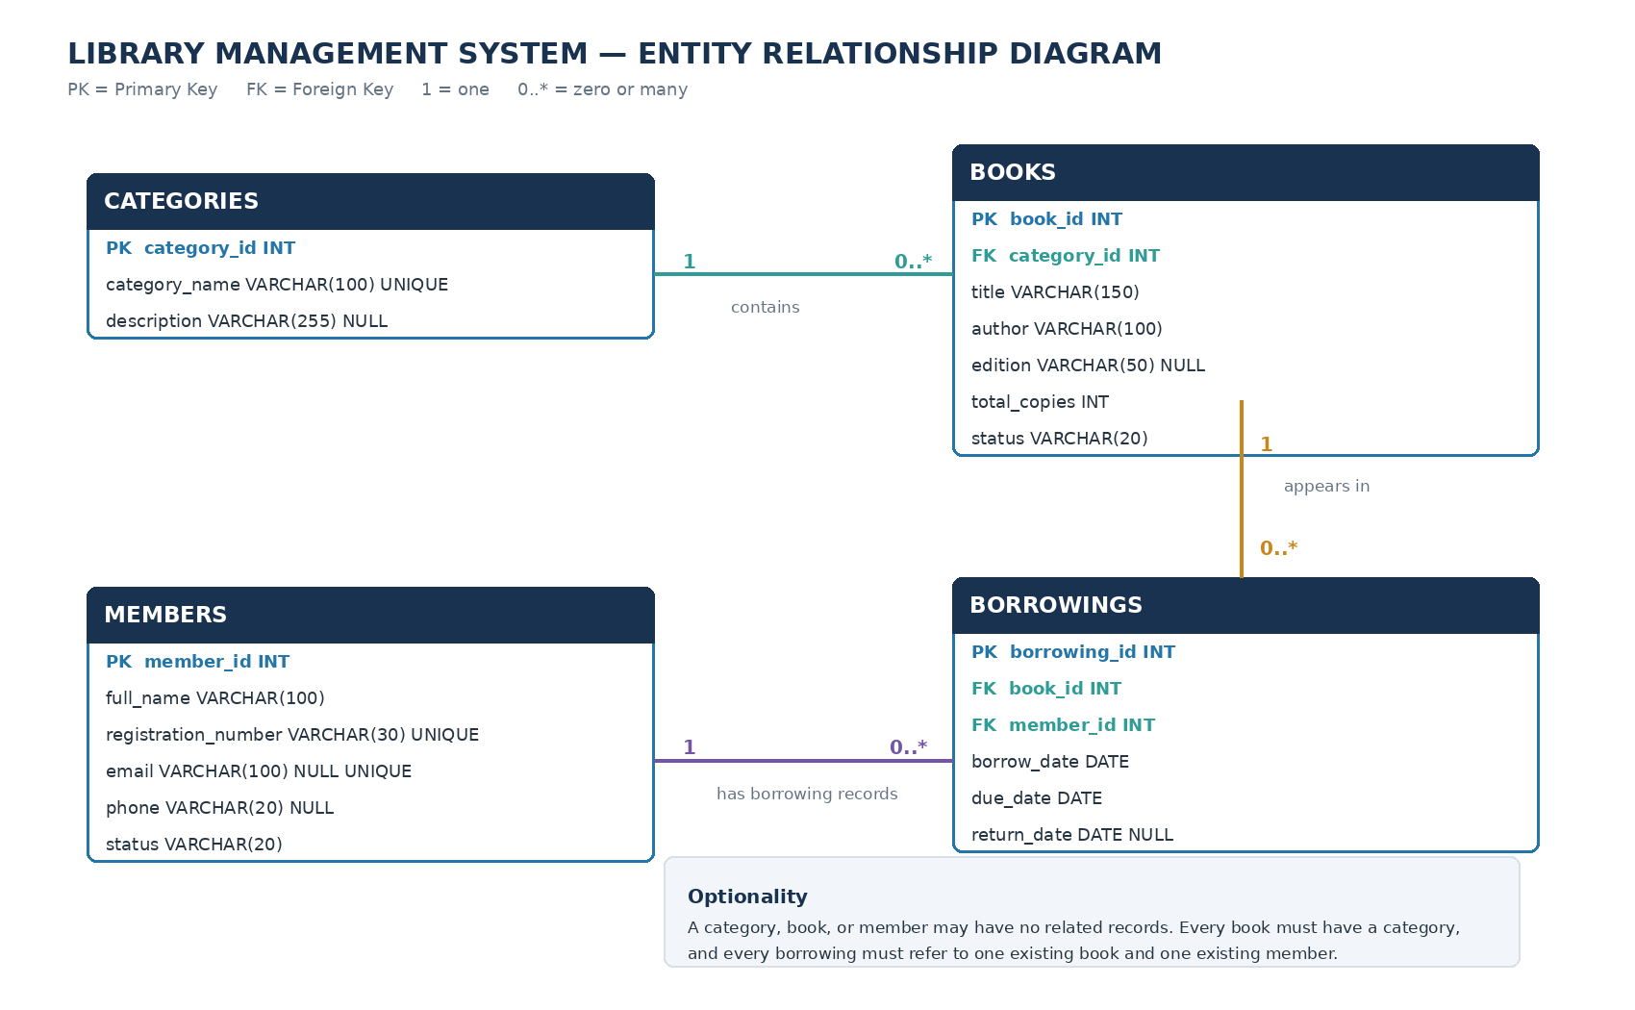
Figure 1. ERD for the Library Management System.

4.1 Reading the ERD
- CATEGORIES to BOOKS: one category can be linked to zero or many book records; each book belongs to one category.
- BOOKS to BORROWINGS: one book can appear in zero or many borrowing records over time; each borrowing record identifies one book.
- MEMBERS to BORROWINGS: one member can have zero or many borrowing records; each borrowing record identifies one member.
- The return_date field is optional because it remains NULL until a book is returned.

4.2 Notation Legend
Notation | Meaning
PK | Primary Key - identifies a record in a table.
FK | Foreign Key - links to a record in another table.
1 | Exactly one related record on that side.
0..* | Zero, one, or many related records.

5. ADMINLTE INTERFACE AND WIREFRAMES
The wireframes are actual visual planning drawings. They show where the main interface components and information will appear. They are not screenshots of the running website. The layouts follow the screens and labels used by the PHP pages.

5.1 Main Navigation
The shared navigation includes Dashboard, Books, Categories, Members, Loans, and Borrowing. It helps the librarian move between common tasks.

5.2 Dashboard Wireframe
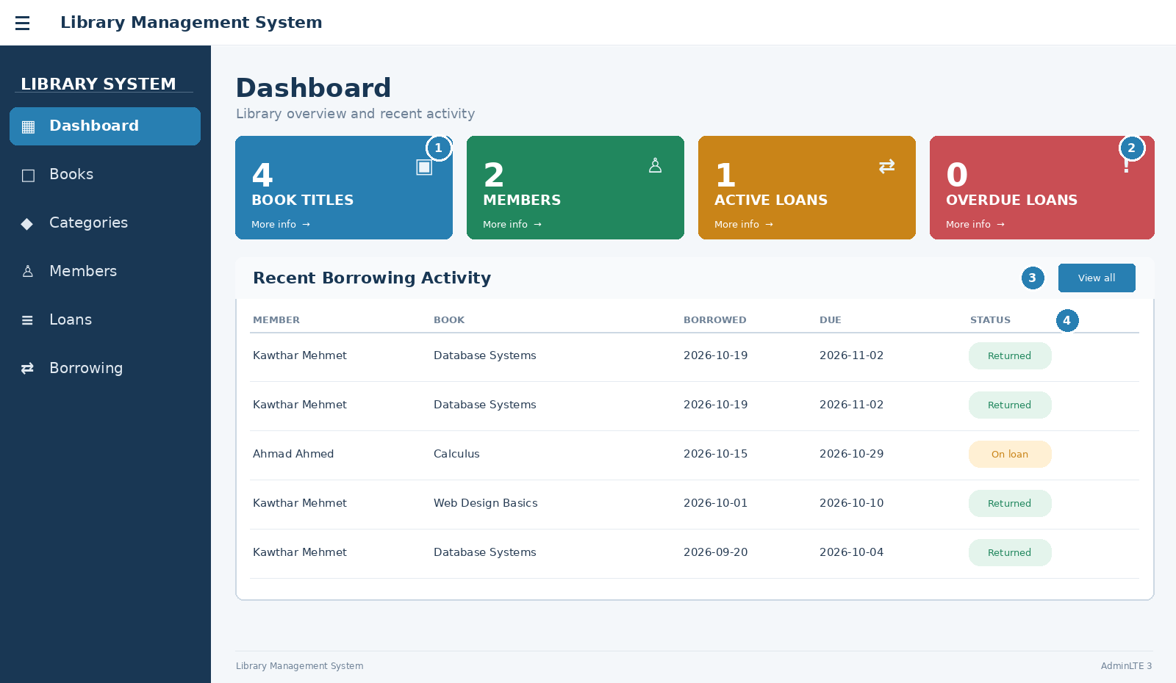
Figure 2. Annotated dashboard wireframe.
Marker | Element | Purpose
1 | Summary Small Boxes | Show book titles, members, active loans, and overdue loans.
2 | Overdue Loans box | Draw attention to loans whose due date has passed and that have not been returned.
3 | Recent Borrowing Activity card | Give a quick view of recent loans.
4 | Status badges | Make Returned and On loan statuses easy to recognize.

5.3 Books List Wireframe
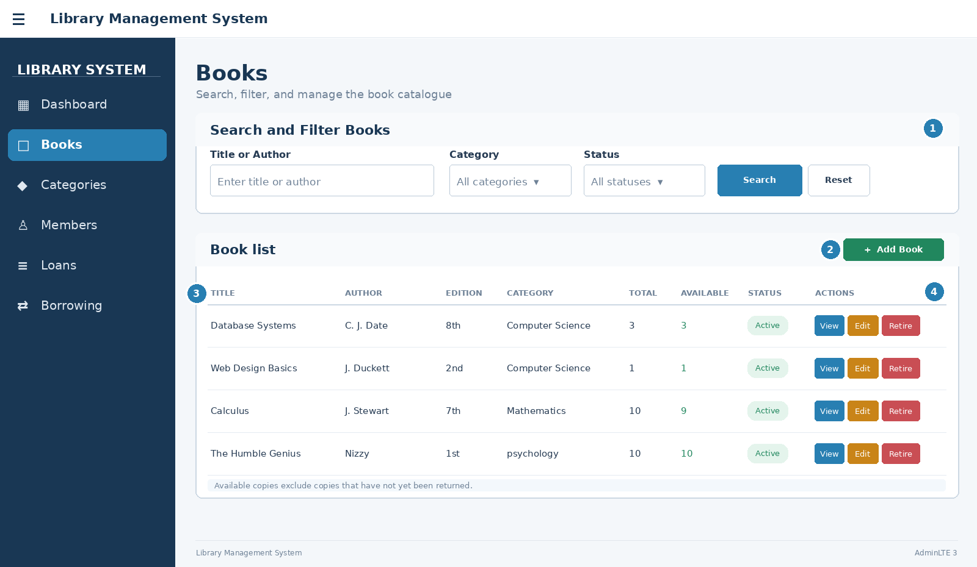
Figure 3. Annotated books list wireframe.
Marker | Element | Purpose
1 | Search and filters | Search by title or author, then filter by category and status.
2 | Add Book button | Open the book entry form.
3 | Book table | Show title, author, edition, category, total, available, and status as in books.php.
4 | Action buttons | Open details, edit the record, or start the retirement process.

5.4 Book Entry/Edit Wireframe
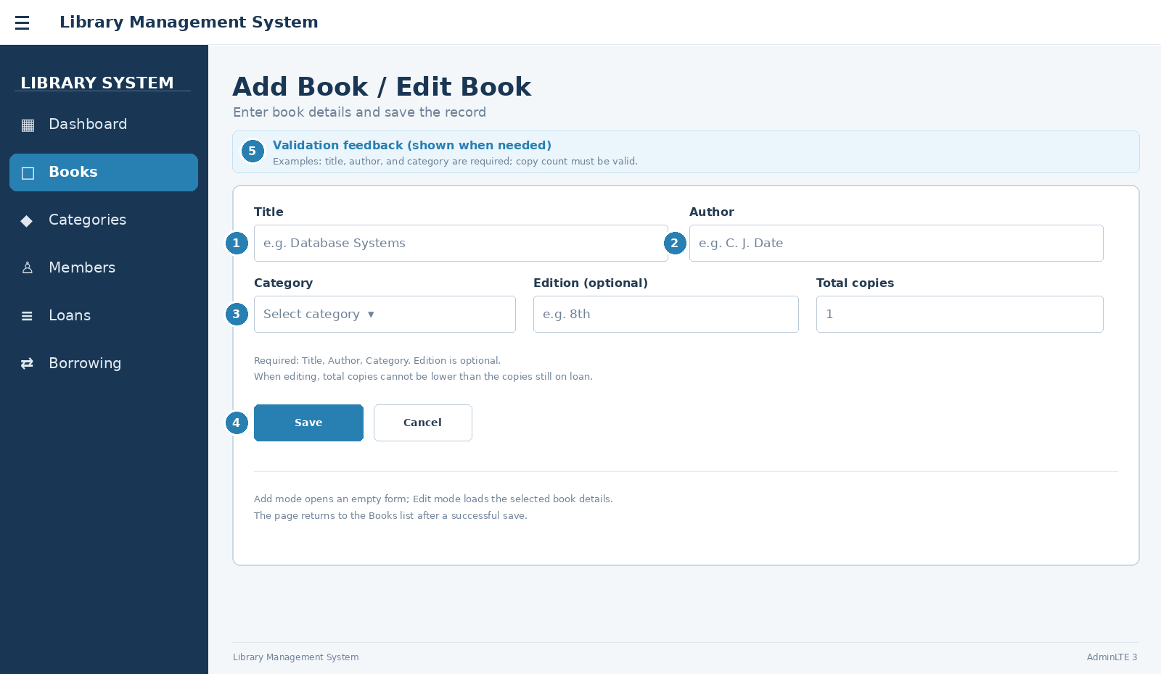
Figure 4. Annotated book entry/edit wireframe.
Marker | Element | Purpose
1 | Title field | Enter the book title; this field is required.
2 | Author field | Enter the author; this field is required.
3 | Category, edition, and copy count | Connect the book to a category and record other book details.
4 | Save and Cancel buttons | Save the form or return without saving.
5 | Validation feedback | Explain what needs to be corrected when a field is missing or invalid.

5.5 Screen Flow
The librarian can open the Books list, search for a record, view its details, or open the entry/edit form. Borrowing is recorded through the Borrowing page. The Loans page lists borrowing records and provides a Return action for books that have not yet been returned.

6. ADMINLTE COMPONENT-USE MATRIX
The table lists distinct AdminLTE 3 components used or planned for the project, the screen where each appears, and the task it supports.
Component | Screen | Purpose | Related data / task
Small Boxes | Dashboard | Show key summary counts at a glance. | Active book titles, active members, active loans, overdue loans.
Cards | Dashboard, Books, Members, Forms | Group related content into clear sections. | Recent activity, record lists, forms.
Responsive Tables | Books, Members, Loans, Details | Display records in labelled columns. | Books, members, borrowing records, history.
Badges | Books, Members, Loans | Show status with a short coloured label. | Active, Inactive, Pending Retirement, Retired, Returned, Overdue, On loan.
Sidebar Navigation Menu | All pages | Move between main pages. | Dashboard, Books, Categories, Members, Loans, Borrowing.
Breadcrumbs | All pages using header.php | Show the page location and provide a route home. | Home and current page title.
Search Form | Books, Members | Find records by useful text. | Book title/author; member name/registration number.
Forms and Input Fields | Book form, Member form, Borrowing | Enter or update information. | Book, member, and borrowing fields.
Buttons | Management pages | Start actions such as save, edit, return, or add. | Create/update records and record returns.
Alerts | Pages using header.php | Show success, warning, or error messages. | Validation results and completed actions.
Nav Pills / Tabs | Loans | Switch between loan lists. | All, Active, Overdue, and Returned.
Callout (planned) | Book details / retirement | Give a clear warning before a book retirement is completed. | Pending Retirement status and copies that are still out.

The component list focuses on components that have a clear job in the interface. Each component should support a real task rather than being added only for decoration.

7. DATABASE AND INTERFACE DESIGN CHOICES

7.1 Why the Data Is Split into Four Tables
Categories, books, members, and borrowings are stored separately because they represent different things. This keeps the records easier to update and avoids repeating member or category details in every borrowing record.

7.2 How Book Availability Is Calculated
The system counts borrowing records for a book where return_date is NULL. It subtracts that number from total_copies. For example, if the library has three copies and one copy is still out, two copies are available.

7.3 Why Borrowing Is a Separate Table
A member may borrow different books over time, and the same book may be borrowed many times. The borrowings table records each event with dates and links it to the relevant member and book. Keeping the record after return preserves borrowing history.

7.4 Why Status Fields Are Used
The book status distinguishes books that can be borrowed from books waiting for retirement or already retired. Member status helps prevent inactive members from borrowing books. Loan status such as Overdue or Returned is calculated from due_date and return_date in the application.

7.5 Why AdminLTE Components Are Used
The dashboard uses summary boxes to highlight important numbers. Tables are suited to lists of books, members, and loans. Forms make record entry clearer, while badges and alerts help users notice statuses and feedback.

8. DESIGN CONSISTENCY CHECK
Check | Result | Notes
Chosen project and scope | Complete | Library Management System; scope and boundaries are stated.
Data dictionary covers all four tables | Complete | Fields, types, keys, optional values, and main rules are listed from the supplied SQL dump.
Relational schema matches the supplied database | Complete | The four tables and their foreign-key links are documented.
ERD includes keys and relationships | Included | The diagram shows four entities and 1 to 0..many relationships.
Wireframes cover Dashboard, List, Entry/Edit | Included | Three labelled wireframes are included. The dashboard shows five recent rows; the book list and form match the reviewed PHP pages.
At least eight AdminLTE components documented | Complete | The matrix lists twelve distinct components and their purposes.
Interface labels and data fields match | Reviewed | The list includes Edition and matches books.php; the entry/edit fields match book_form.php.
Database rules described accurately | Reviewed | The document distinguishes SQL constraints from checks performed in PHP.

9. FINAL CHECKLIST
Requirement from the brief | Status
I chose one project and stated its scope. | Included
My data dictionary explains entities, fields, types, keys, and rules. | Included
My relational-schema outline matches the database design. | Included
My ERD shows entities, keys, relationships, cardinality, and optionality. | Included
My wireframes cover the dashboard, list, and entry/edit screen. | Included
I documented at least eight AdminLTE 3 components and their purposes. | Included
I explained important database and interface choices. | Included
I checked that the data and screens are consistent. | Included

Conclusion
This portfolio explains the Library Management System, its relational database, and the AdminLTE 3 interface plan. The tables store book, category, member, and borrowing information. The ERD shows how the tables connect, and the wireframes show how a librarian can work with the main screens. The design focuses on clear records, book availability, and tracking borrowing and returns.

