KBImage Print Swap: user guide
How to install the panel and swap a print, step by step. For the rules and what to check before each Accept, see Rules and Best Practices. Garment types and part names are in Garment Types and Part Names.
Screenshots are shown under each step. Ones still to be taken are marked “Screenshot to come”.

1. Before you start
You need:
- Photoshop 2022 (version 23.3) or newer
- The UXP Developer Tool (from Adobe Creative Cloud), until IT installs the panel for you
- A Fal API key (ask your admin)
- The original garment photo from the shoot: TIFF or PSD, 4000 px or more on the long edge, 8 or 16 bit RGB
- The print file at full resolution (the PDRF TIF), big enough to cover the garment without enlarging it
Small or web size photos give soft, pasted on results. See section 1 of the rules.

2. Install the panel
- Open Photoshop.
- Open the UXP Developer Tool.
- Click Add Plugin and choose manifest.json in the KBImage Print Swap folder.
- On the new row, click ••• and choose Load.
- In Photoshop, open Plugins > KBImage Print Swap. Dock the panel on the right, about 360 px wide.
Screenshot to come: 02-install-udt.png
After an update: in UDT click ••• > Remove, then Add Plugin again. The Reload button does not always pick up changes.

3. Add the Fal key (once per computer)
- Click the gear at the top right of the panel.
- Paste the key into Fal API key. Click Show to check it.
- Click Test Connection. It should say the key works.
- Click Save.
- Click the ⇄ button to go back to Print Swap.
The key is stored in Photoshop’s secure storage on this computer and is only sent to Fal.
Screenshot to come: 03-settings.png
Other settings:
- Spend warning ($): the running total turns red past this amount.
- Edge bleed (px): how far masked results reach past their edge. Leave at the default.
- Per-action rates: Fal’s prices, used for the cost shown on each button. Reset to defaults puts them back.

4. How every step works
Each step has a header row with its number, name and state:
State | Meaning
locked | An earlier step is not done yet
ready | You can run it
done ✓ | Accepted
To work a step:
- Click the step header to open it.
- Click the step’s main button.
- A progress bar shows Queued, Rendering (with a timer) and Downloading while Fal works.
- Check the result at 100% zoom.
- Click one of:
  - Accept: keep it. The next step opens.
  - Re-run: delete it and run again with the current settings. This costs again.
  - Discard: delete it and stop. No cost.
Screenshot to come: 04-accept-bar.png
The bar under the header shows the money spent this session. Reset starts it at $0.00.

5. The steps

Step 1 · Background
- Pick White (the team’s final, default) or Lighten.
- Tick Hair if the model’s hair falls over the garment.
- Click Background.
- Check the edge of the model and the hair. Click Accept.
Settings: Lighten opacity (%), Edge softness, Refine in Photoshop.
Hair is saved as a channel, KBPS hair. The HAIR layer is built in step 9.
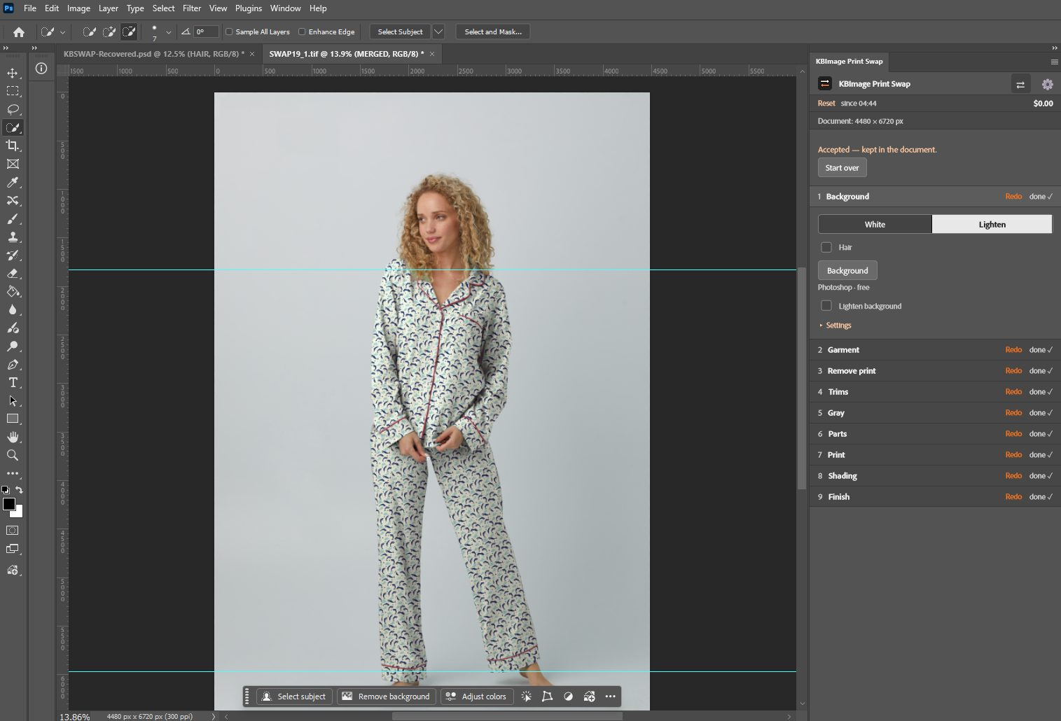
05-step1-background.png

Step 2 · Garment
- Open Garment type and pick the type (A to H). Not on the list? Pick Other (see 5a).
- Click Find garment. SAM finds the garment and takes the hands out.
- Check the marching ants at 100%: the whole garment, and nothing else.
- Fix it if needed (see below), then click Accept.
Fixing the garment. Later steps use the saved channel KBPS garment, not the marching ants on screen. Use these buttons so your fix is saved:
- + Add selection: select the missing area with any selection tool, then click it.
- - Remove selection: select what should not be garment, then click it.
- Use selection as garment: replaces the garment with your whole selection.
If the panel says “Your selection isn’t saved to the garment”, use one of these buttons.
Settings: Grow into old-garment fringe (px), Edge softness, Refine in Photoshop.
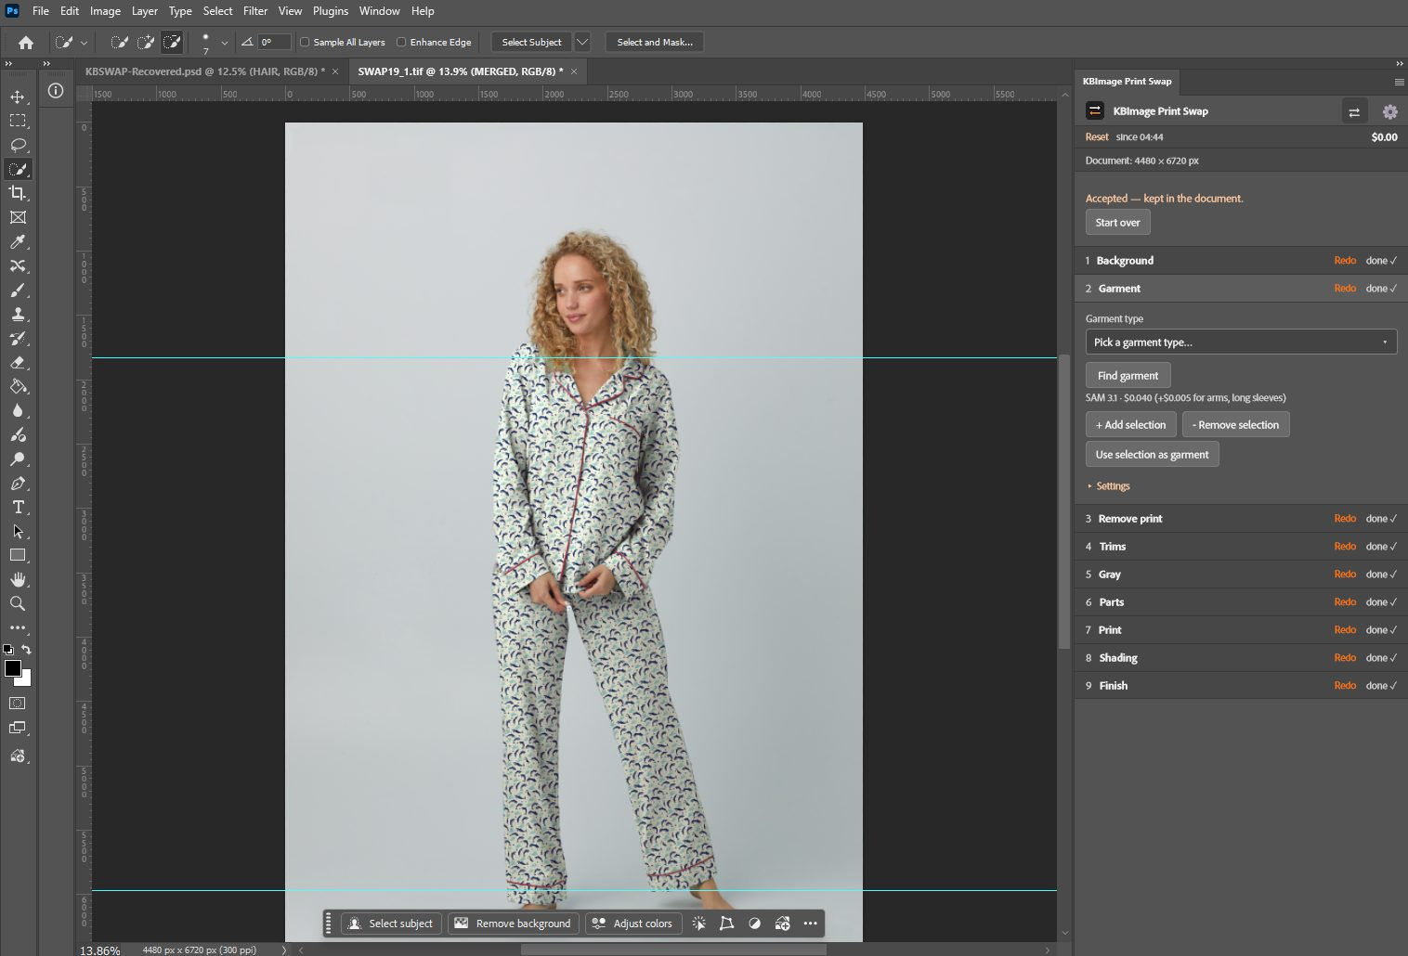
06-step2-garment.png

5a. Other: a garment type that is not on the list
- Pick Other in Garment type.
- Tick the trims this garment has (piping, buttons, lace and so on).
- Tick its parts. Missing one? Type it in Add part (ALL CAPS, 2 to 3 words, e.g. LEFT POCKET FLAP) and click Add part.
- Run the whole swap. When it works, click Save as type, type a short name (e.g. Sleep shirt) and click Save. It shows in the list as I, J and so on.
Screenshot to come: 07-step2-other.png
Changing the type after step 2 asks first and deletes steps 3 to 9. Click Change type or Keep current type.

Step 3 · Remove print
- Click Remove old print. Nano Banana Pro removes the print and keeps the type’s trims. Result: the CLEAN layer.
- Check at 100%: same shape, folds, seams and shadows. Lace and buttons still look like lace and buttons, in their own color.
- Anything redrawn? Click Re-run. Otherwise Accept.
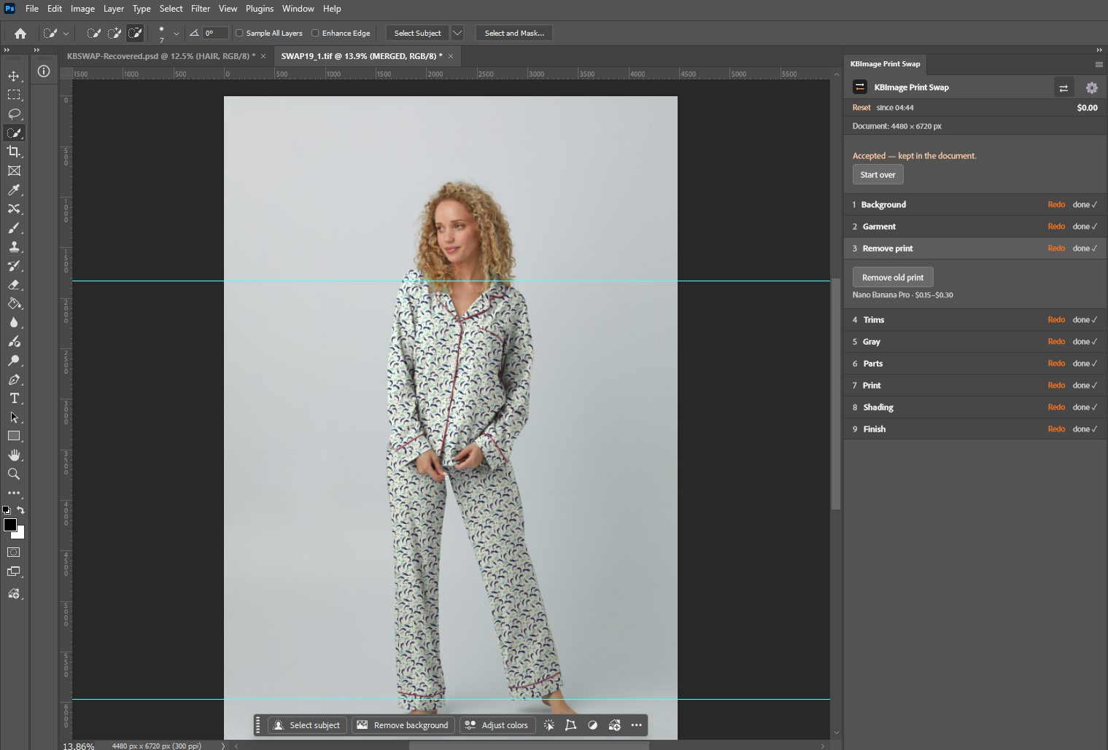
08-step3-clean.png

Step 4 · Trims
The step lists the trims of your type, e.g. “PAJAMA SET: PIPING, BUTTONS”.
Piping
- Check the mode: Colored piping (red, navy, pink) or Neutral piping (white, black, gray). It is picked for you; the line under the buttons says “Auto: …”.
- Click Find piping. Check that every piping line is in the selection and no skin.
- Fix with + Add selection / - Remove selection, or change the mode or Tolerance and Re-run.
- Click Accept. The PIPING group is built on top.
Buttons
- Click Find buttons. SAM looks at close-ups of the garment.
- Add any it missed with + Add selection. Click Accept. The BUTTON group is built on top.
Other trims of the type (lace, drawcord, bow, zipper) work the same way.
Settings and Colors: Tolerance, Edge margin, Button fit (Tight, Normal, Loose), Shrink button mask, Edge softness, Piping color (hex) and Buttons (Hue, Saturation, Lightness) to recolor trims.
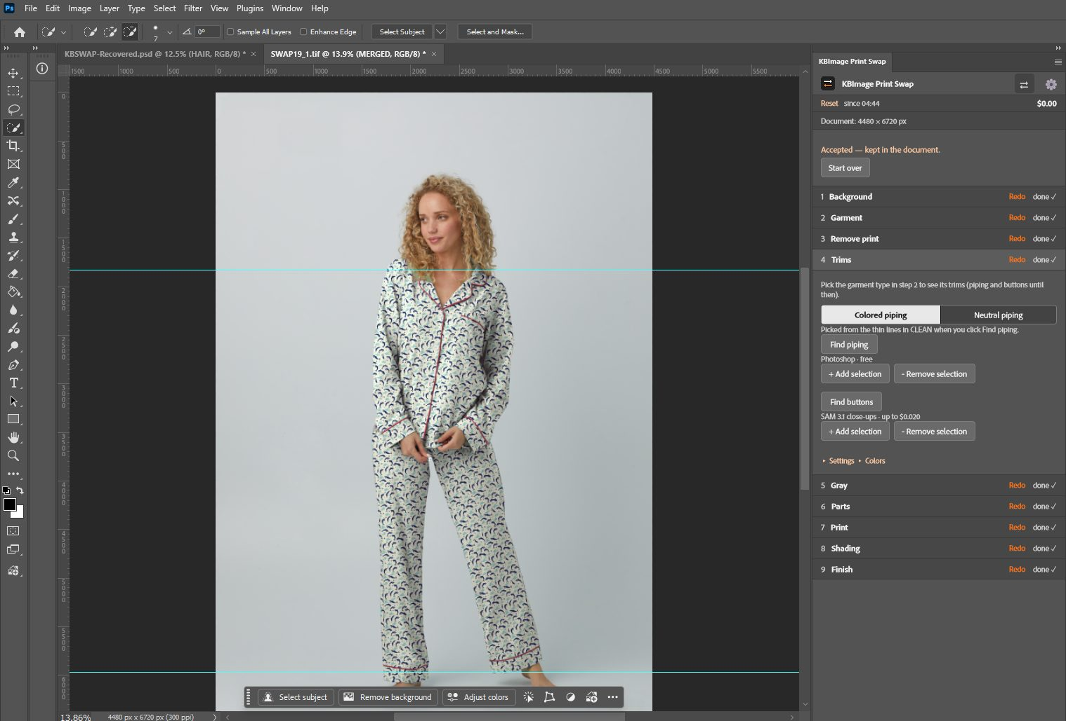
09-step4-trims.png

Step 5 · Gray
- Click Make gray. Result: GREY exact, the garment in neutral gray with its folds.
- Check: even gray, folds visible, no old print showing. Click Accept.
Settings: Target gray.
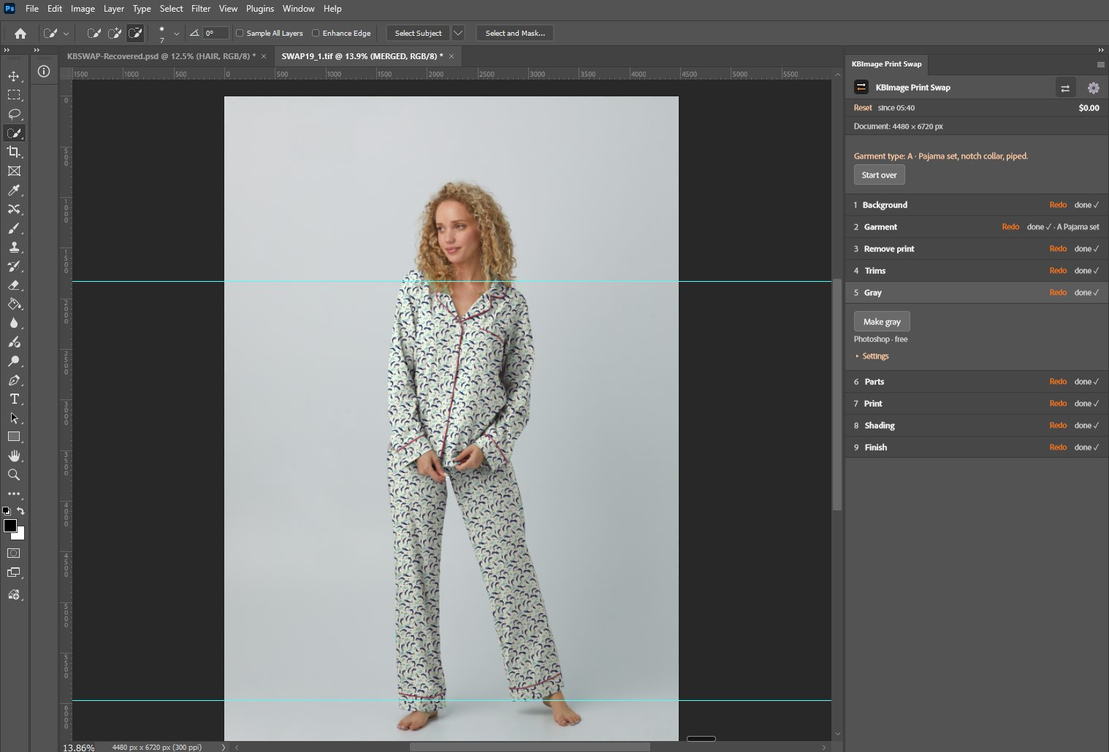
10-step5-gray.png

Step 6 · Parts
- Uncheck any part this garment does not have.
- Click Find parts. SAM makes one mask per part.
- Click a part’s pill to select it. Fix it with + Add selection / - Remove selection. Show shapes shows every part at once.
- Click Accept. Each part gets its own group under PARTS.
Settings: Edge softness, Apply to part, Refine in Photoshop.
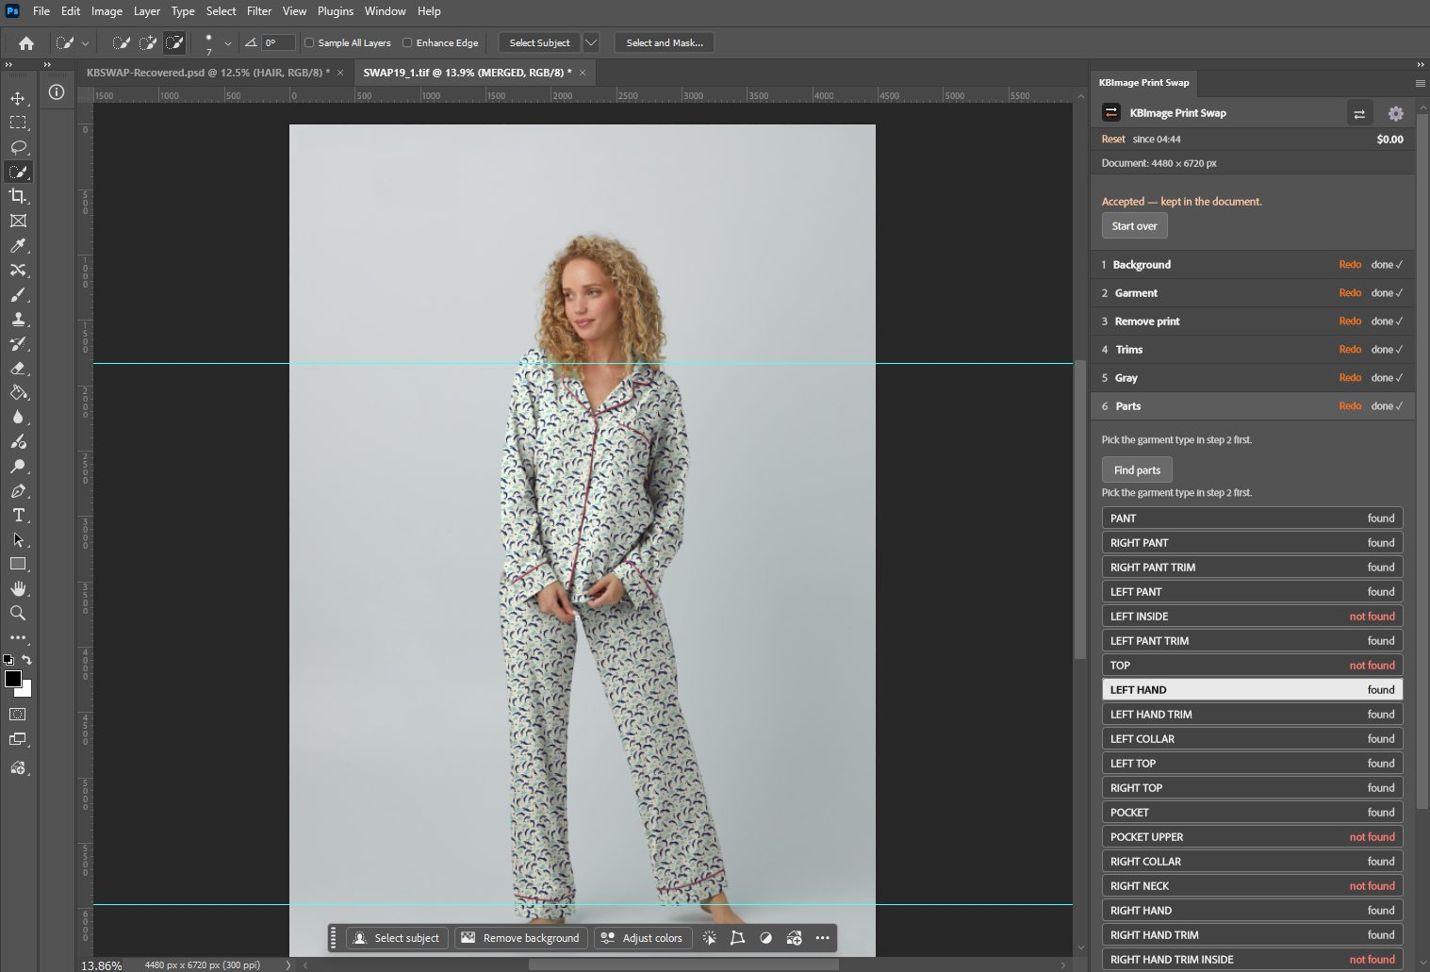
11-step6-parts.png

Step 7 · Print
- Click Choose print and pick the print file. A thumbnail, the file name and its size show under it.
- Set Scale % (whole garment).
- Click Place print. The print is tiled into every part, following each part’s direction.
- Adjust:
  - Rotate print (whole garment): ↺ 15°, ↺ 1°, ↻ 1°, ↻ 15°, 0° (reset), or type an Exact angle and Apply.
  - One part: click the part’s pill in step 6, then use Rotate print in this part and Scale % for this part.
- Click Accept.
To try another print, click Swap print. It keeps every setting.
Screenshot to come: 12-step7-print.png
Screenshot to come: 13-step7-rotate.png

Step 8 · Shading
- Click Build shading. Folds and shadows come back over the print (the team’s GREY group).
- Check that the print follows the folds. Click Accept.
Settings: Brightness 7, Contrast 19, Exposure 0.10, Offset -0.0026, Gamma 0.96, Linear Burn 10%, Veil 10% (the team’s values).
Screenshot to come: 14-step8-shading.png

Step 9 · Finish
- Click Finish. The lighten layer is hidden, MERGED is stamped on top, and HAIR goes over it.
- Check the whole image at 100%. Click Accept. Save the PSD.
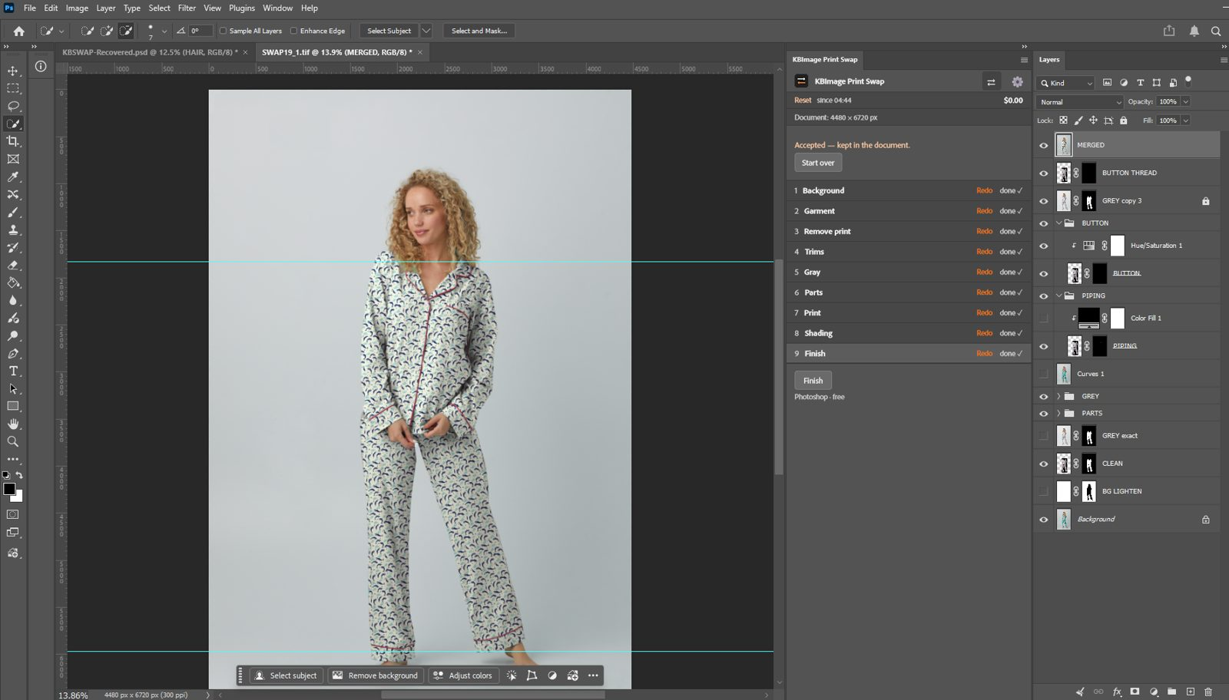
15-step9-finish.png
16-layers-final.png
Swapping again after Finish: while the new print is waiting for Accept, MERGED is hidden so you can see it. On Accept a new MERGED is built. The one before stays below it, hidden, so you can compare. Only the 2 newest are kept.

6. Redo and Start over
- Redo (orange, on a done step): deletes that step and every later one, then sets that step to ready. Earlier steps stay.
- Start over (top of the steps): deletes every Print Swap layer and mask and the garment type. Your photo and your own layers stay. It asks first; Show details lists everything it will delete.
Screenshot to come: 17-start-over.png

7. Troubleshooting
Problem | Fix
“Add your Fal API key in Settings” | Gear > paste key > Save.
A step will not run: “Accept or Re-run the preview that is waiting first” | Find the open step with Accept / Re-run and finish it. If none shows, use Start over.
The print, a rotation or a fix does not show | Check that an older MERGED is not on top. Hide it.
The print got onto the hands | Step 2: select the hands, - Remove selection, then Redo step 3.
White piping not found | Step 4: switch to Neutral piping and Re-run.
Remove print changed the garment shape or the trims | Re-run once. If it happens again, check the photo size and the garment type.
The result looks soft or pixelated | The photo or the print file is too small. Use the originals.
The panel looks stuck or out of date | UDT: Remove and Add the plug-in again, or close and reopen the document.

8. Screenshot list
Take these at 100% panel zoom, panel docked about 360 px wide, Photoshop’s dark theme. Save as PNG in docs/screenshots/.
File | What to show
01-panel-overview.png | The whole panel, a few steps done
02-install-udt.png | UDT with the plug-in loaded
03-settings.png | Settings with the key saved
04-accept-bar.png | A step waiting with Accept, Re-run, Discard
05-step1-background.png | Step 1 open
06-step2-garment.png | Step 2 open, garment selected on the photo
07-step2-other.png | Step 2 with Other open
08-step3-clean.png | Photo after Remove print
09-step4-trims.png | Step 4 with piping found
10-step5-gray.png | Photo after Gray
11-step6-parts.png | Step 6 with part pills
12-step7-print.png | Step 7 with the print thumbnail
13-step7-rotate.png | Step 7 rotate controls with an angle set
14-step8-shading.png | Photo after Shading
15-step9-finish.png | Final image
16-layers-final.png | Layers panel after Finish
17-start-over.png | Start over confirm

