**Dorell James P. Galang** 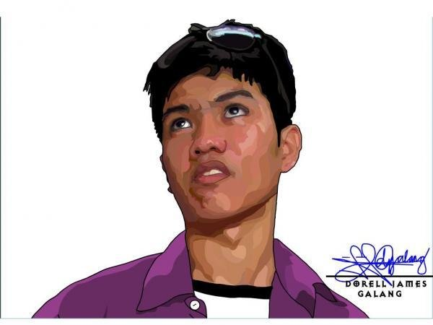

440 Mother Perpetual Street, Hipodromo

Cebu City, Philippines 6000

(+63) 917 561 4793

[me@dorelljames.com](mailto:me@dorelljames.com)

**CAREER OBJECTIVE:**

Web developer, programmer and/or contributor with more than five years of experience in web development. Possesses strong technical skills and ability to work with less supervision and can deliver work effectively and efficiently.

**WORK EXPERIENCE(s):**

* **WebriQ (webriq.us) / Webfactories (webfactories.biz)**

*Senior Web Developer (Full time), February 2014 - Present*

* + Continuous improvement and development of self-developed CMS which caters invaluable sites for clients.
  + Backend developer / technical lead of all web development and programming projects.
* **NCR Cebu Development Center, Inc. (www.ncr.com)**

*Software Engineer (Full time), September 2012 - October 2015*

* + Base platform development on Linux which includes OS image creation, utility development, support and maintenance.
  + Windows OS software / utilities development and support.

*Software Tester (Full time), June 2010 - September 2012*

* + System integration tests on software utilities, Windows OS base images, RPSW and more.
* **SPHosting (sphosting.com) / SupportHQ (supporthq.net)**

*Web Developer (Freelance), June 2010 - Present*

* + All around development to exciting projects given by client which includes little or no knowledge at all.
  + Technical lead and advisor for website maintenance and a lot more.

**EDUCATION:**

**Center for Industrial Technology and Enterprise**

*Information Technology Graduate of Industrial Technician Program / Engineering (Computer), June 2010*

**TECHNICAL SKILLS:**

* **Client Side (Frontend)** –HTML/XHTML including latest HTML5, CSS including latest CSS3, Javascript and other frameworks like jQuery
* **Server Side (Backend)** – PHP includes deep understanding of MVC architecture
* **Server Administration** - Cpanel, Amazon EC2
* **Source Code Management** - Git and SVN
* **Database Management System (DBMS)** – MySQL
* **Requirements analysis and system architecture software** - Entity Relationship Diagram (ERD) using DBDesigner and MySQL Benchmark
* **Web Design Softwares** – Adobe Photoshop & Adobe Illustrator
* **PHP Frameworks, CMS, E-commerce** - Laravel, CakePHP, Wordpress, Prestashop, Interspire

**PERSONAL WORKS (PORTFOLIO):**

*Some of my latest works arranged according to most recent (desc)*

* **Americas Finest Security Agents -** [services.americasfinestsecurity.com](http://services.americasfinestsecurity.com/) (Laravel 5.1)
* **Esports Kingdom -** [app.esportskingdom.com](http://app.esportskingdom.com/) (Laravel 5.1)
* **Condobox PH -** [condobox.com.ph](http://condobox.com.ph) (Wordpress)
* **ClearSight -** [clearsight.com](http://www.clearsight.com/) (Wordpress)
* **Waterloo Louisville** - [waterloolouisville.com](http://waterloolouisville.com/) (Wordpress parallax)
* **Lasik, Medical and Surgery Site(s)** - [bouldereyes.com](http://bouldereyes.com/), [vitalitmed.com](http://vitalitmed.com/), [renewalfacialplastics.com](http://renewalfacialplastics.com/), [miamiaesthetic.com](http://miamiaesthetic.com/home/) (Wordpress theme and plugin creation)
* **Online Adult Store in AU** - [aoadultstore.com.au](http://aoadultstore.com.au/) (Wordpress theme creation and eCommerce plugin integration)
* **Yoga Site in Albany NZ** - [albanyyoga.co.nz](http://albanyyoga.co.nz/) (Joomla to Wordpress conversion)
* **School Site** - [www.rochester-rutherford.org.nz](http://www.rochester-rutherford.org.nz/) (Joomla to Wordpress conversion)
* **Online Children Stuffs Shop (JennyBecs)** - [jennybecs.com](http://jennybecs.com) (Prestashop Theme Customization)
* **Online Magazine (NZToday and ClassicDriver)** - [www.nztoday.co.nz](http://www.nztoday.co.nz) & [www.classicdriver.co.nz](http://www.classicdriver.co.nz) (Hard-coded. PHP and MySQL backend and client-side scripting using jQuery)
* **Online Distillerie (Distillerie)** - [distillerie.co.nz](http://distillerie.co.nz/) (Hard-coded. Illustrator to HTML)

More on this at my personal site portfolio: <http://dorelljames.com/portfolio>

**REFERENCES:**

* **Jess Ciedel Nadela Abuyog**

Relationship : Teammate at NCR

Position : Technical Lead, SCM

Contact No : 09327973661

Email : [JessCiedel.Nadela@ncr.com](mailto:JessCiedel.Nadela@ncr.com)

* **Warwick Berg**

Relationship : Best Personal Client since 2010

Position : Owner of [SPHosting](http://sphosting.com) and other affiliated sites

Email : [admin@supporthq.net](mailto:admin@supporthq.net), [warwick@bergs.net](mailto:warwick@bergs.net)

* **Brendon Baclaan**

Relationship : Former Instructor / Adviser

Position : Multimedia Supervisor, CITE Technical Institute, Inc.

Tel : 346 -1611

Contact No. : 09273827399

Email : [flushma@gmail.com](mailto:flushma@gmail.com)