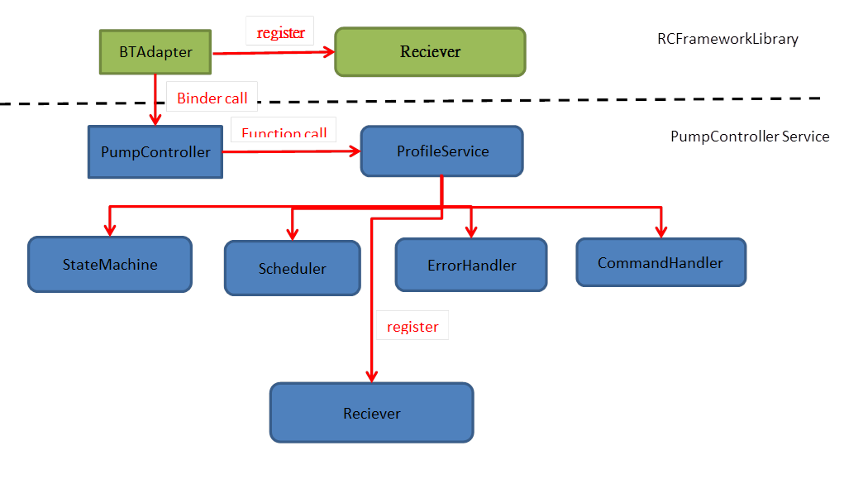

1. BTAdapter 提供介面給UI 去使用並且和UI模組建構ResponseCallback, ex setScanMode, sendBluetoothStateCallBack, sendBluetoothUpCallBack, sendBluetoothDownCallBack等等

BTAdapter interface to the UI to use and UI module constructs ResponseCallback, ex setScanMode, sendBluetoothStateCallBack, sendBluetoothUpCallBack, sendBluetoothDownCallBack and so on

1. BTAdapter 註冊的reciever會去接收由UICommandDispatcher送的response和notification action. 並作相對應的回應.

BTAdapter registered reciever will receive the UICommandDispatcher sent response and notification action. And make the corresponding response.

1. PumpController是一個system process的主要service, 裡面會擁有一些profile service的設計(例如: DeviceInformation_Service, InsulinDel_Service, SoloM_Service等等)

PumpController is a system service's main service, which will have some profile service design (for example: DeviceInformation_Service, InsulinDel_Service, SoloM_Service, etc.)

1. 每個profileService都需要有StaeMachine, Scheduler, ErrorHandler, CommandHandler, 以及相對應的Reciever.這個reciever主要用來作為BTAdapter跟各個profile service的溝通介面.

Each profileService needs StaeMachine, Scheduler, ErrorHandler, CommandHandler, and the corresponding Reciever. This reciever is mainly used as a communication interface between BTAdapter and each profile service.

1. StateMachine負責目前跟Pump的溝通狀態(例如 連線, 斷線或是flight mode等等)

StateMachine is responsible for the current state of communication with the pump (such as connection, disconnection or flight mode, etc.)

1. Scheduler 用來負責各個Command需不需要做retry以及time out的機制

Scheduler used to be responsible for each Command need to do retry and time out of the mechanism

1. ErroHandler 提供當有收到erro訊息或是本身service有流程錯誤要做相對應的處理

ErrorHandler when there is error message received or the service itself has a process error to do the corresponding treatment

1. CommandHandler: 用來處理各Command的打包跟收送處理

CommandHandler: used to deal with each Command packing and sending processing

1. 每個ProfileService 都會註冊一個reciever, 由BTAdapter哪邊送過來的相關action.

Each ProfileService will register a reciever, sent by the BTAdapter side of the relevant action.

預計裡面會有Observer, singleton, factory, strategy, flyweight 各個pattern在裡面. 做好各功能的管理架構.

It is expected there will be Observer, singleton, factory, strategy, flyweight each pattern in it. Good management structure of each function.

Ps: BTAdapter 和 PumpController service都屬於application layer. 只差在功用不同.

Ps: BTAdapter and PumpController service belong to the application layer. Difference only in different functions.