# Software Architecture Design Document 軟體架構設計文件

## 1. Introduction / 簡介

This document describes the software architecture of the Java MVVM Todo List App. It is based on the concept architecture and defines the major components, their responsibilities, and interactions.  
  
本文件說明 Java MVVM 待辦清單應用程式的軟體架構。根據概念架構，定義了主要元件、其職責以及它們之間的互動。

## 2. Architecture Overview / 架構總覽

The application adopts the Model-View-ViewModel (MVVM) pattern to achieve a clean separation of concerns. It uses Android Architecture Components including ViewModel and LiveData, and Room for local data storage.  
  
本應用程式採用 MVVM 架構模式，以達到清晰的職責分離。架構中使用 Android 的架構元件（如 ViewModel 與 LiveData），並以 Room 作為本地資料儲存方案。

## 3. UML Architecture Diagram / UML 架構圖

The following PlantUML diagram illustrates the architectural components and their relations.  
以下為架構元件關係的 PlantUML 圖：

@startuml

left to right direction

package "View Layer" {

class MainActivity

class TaskListFragment

class AddTaskFragment

}

package "ViewModel Layer" {

class TaskViewModel

}

package "Model Layer" {

class Task

class TaskFilter

}

package "Data Layer" {

class TaskRepository <<interface>>

class TaskRepositoryImpl

class TaskDao

class AppDatabase

}

MainActivity --> TaskViewModel

TaskListFragment --> TaskViewModel

AddTaskFragment --> TaskViewModel

TaskViewModel --> TaskRepository

TaskViewModel --> TaskFilter

TaskRepositoryImpl --> TaskDao

TaskDao --> Task

TaskDao --> AppDatabase

TaskRepositoryImpl ..|> TaskRepository

@enduml

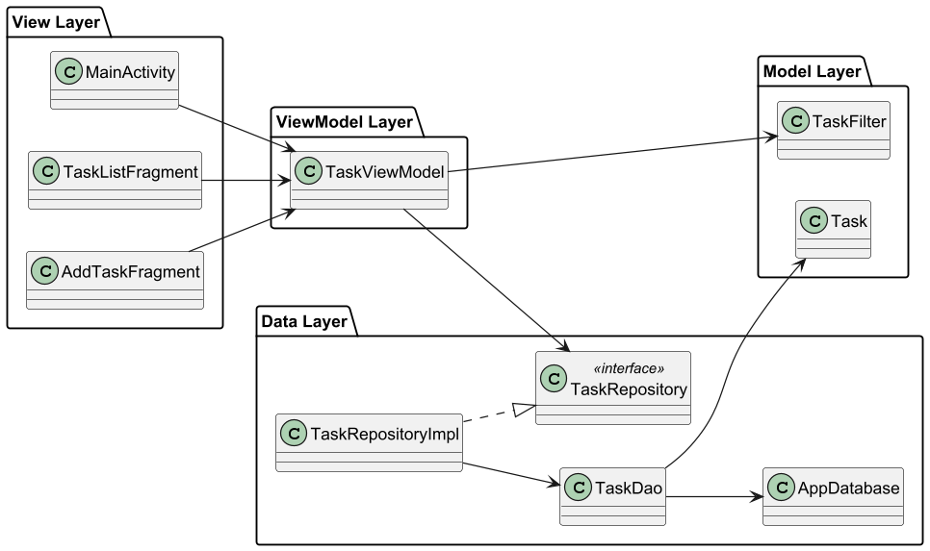

## 4. Component Responsibilities / 元件職責

|  |  |
| --- | --- |
| Component / 元件 | Responsibility / 職責 |
| MainActivity / TaskListFragment | Displays task list UI and handles user navigation / 顯示任務清單與處理使用者操作 |
| TaskViewModel | Prepares data for UI and communicates with Repository / 為 UI 準備資料並與資料庫互動 |
| TaskRepository | Defines data access abstraction / 定義資料存取的抽象介面 |
| TaskRepositoryImpl | Implements data operations using Room / 使用 Room 實作資料操作 |
| TaskDao | Provides SQL access methods / 提供 SQL 資料存取方法 |
| AppDatabase | Room database holder / Room 資料庫容器 |
| Task | Domain model representing a task / 任務的領域模型 |
| TaskFilter | Filtering criteria value object / 篩選條件的值物件 |

## 5. Technologies / 使用技術

- Java  
- Android Jetpack (ViewModel, LiveData)  
- Room (SQLite ORM)  
- MVVM Architecture  
- PlantUML (for diagrams)  
  
- Java  
- Android Jetpack（ViewModel、LiveData）  
- Room（SQLite ORM）  
- MVVM 架構  
- PlantUML（用於繪圖）