CMPE172

HW3-Salesforce

Minh Ngo-010980398

## Part I. Account Creation for Salesforce

A picture containing screenshot

Description generated with high confidence

A screenshot of a cell phone

Description generated with very high confidenceI created an account for this assignment. The pictures are listed below.

## Part II. Platform Development

### A screenshot of a cell phone Description generated with very high confidenceOverall Progress

Step-by-step

In these screenshots, I have finished all of the required quizzes and tutorials.

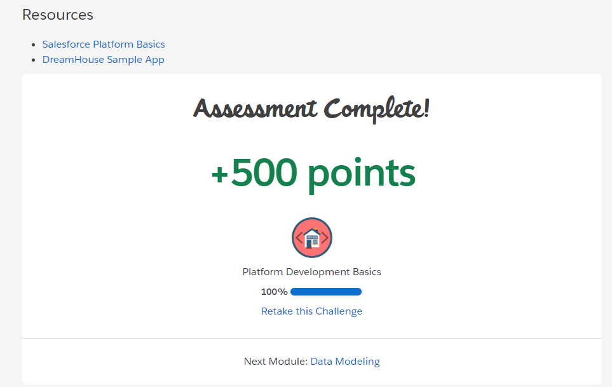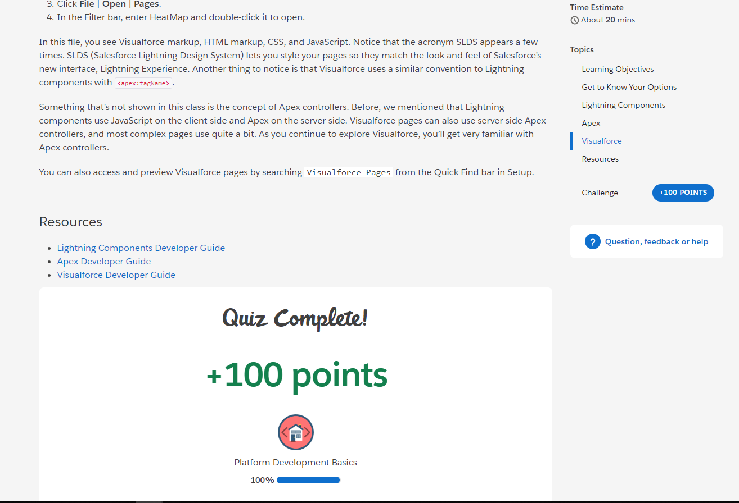

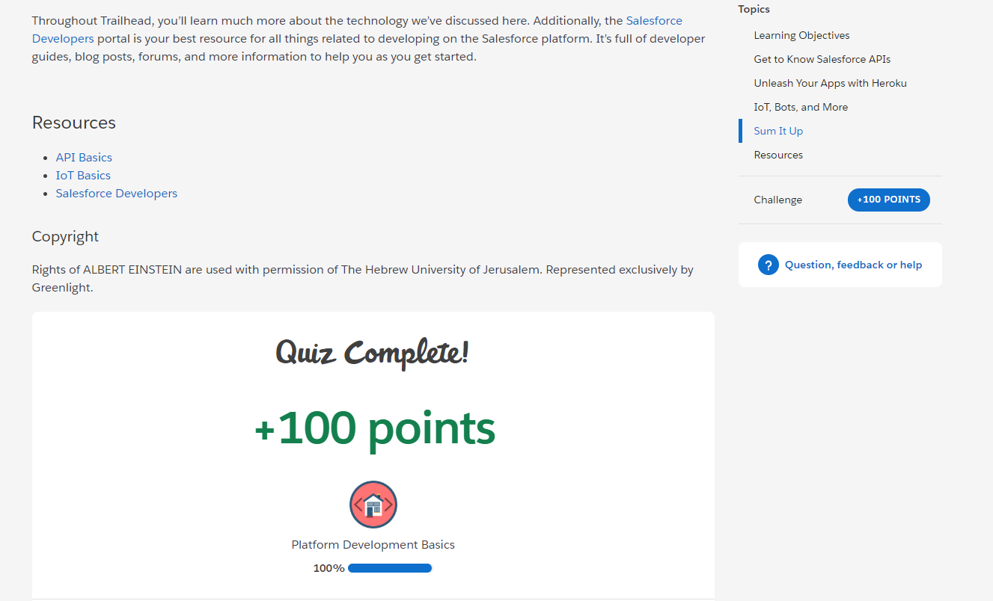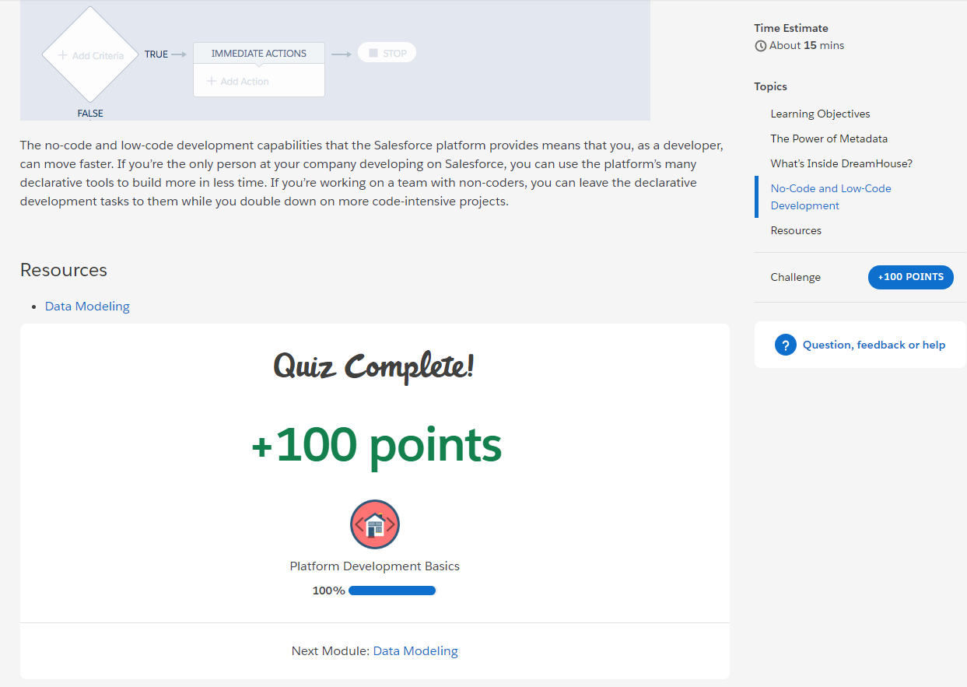

## Part III. Quick Start: Lightning Components

### Create server apex controller class

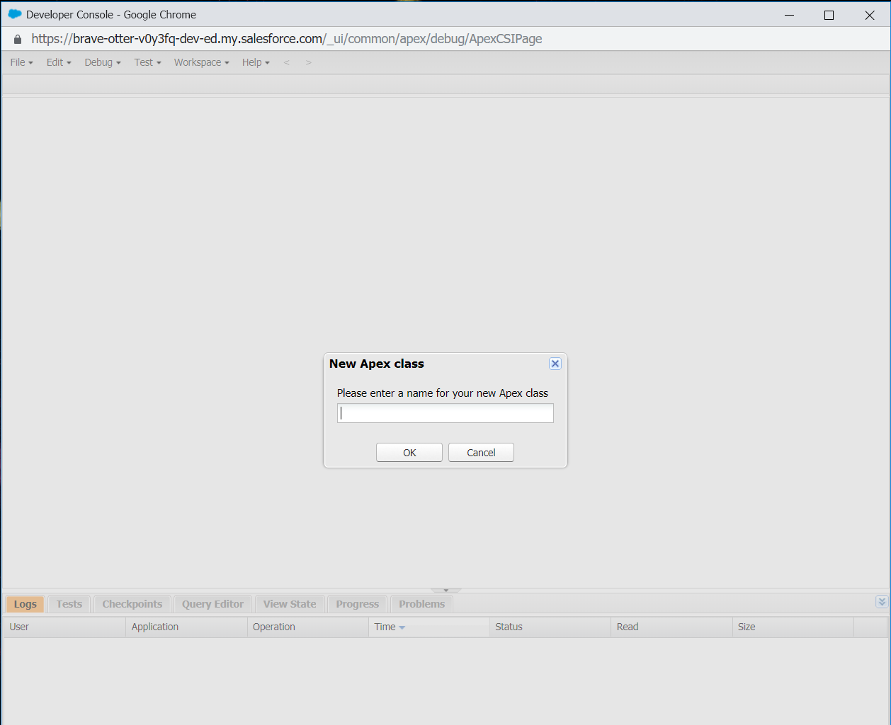

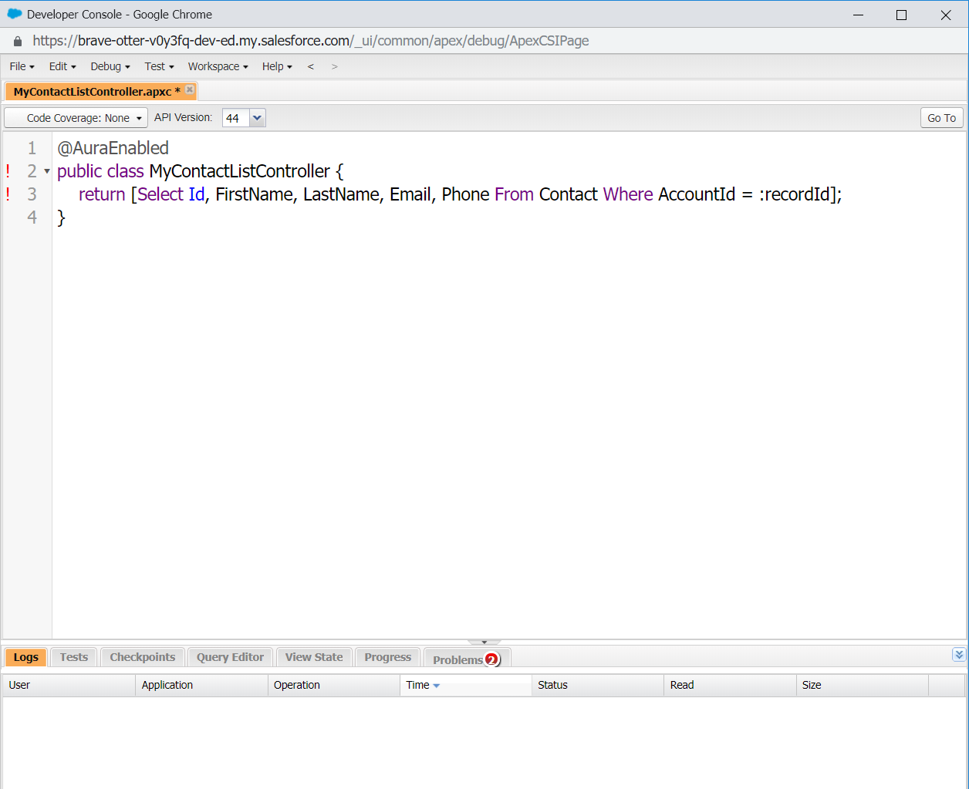

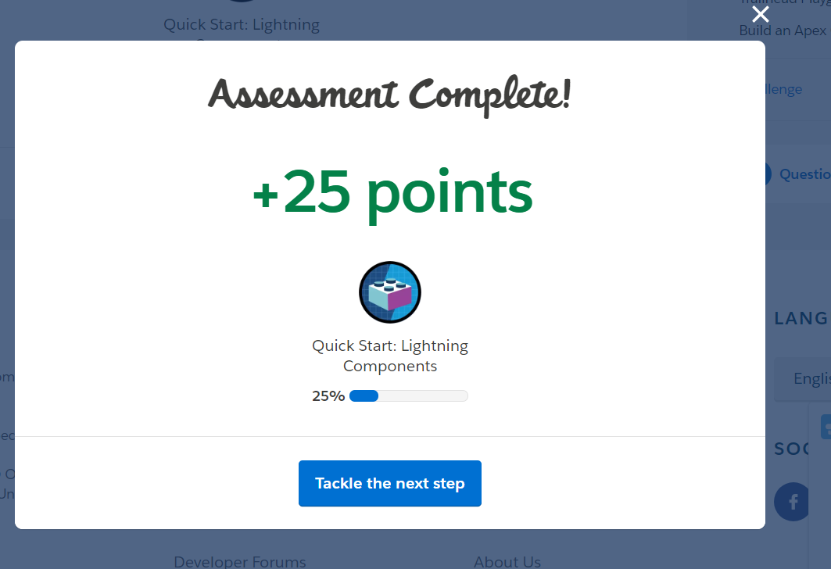

Create lightning component

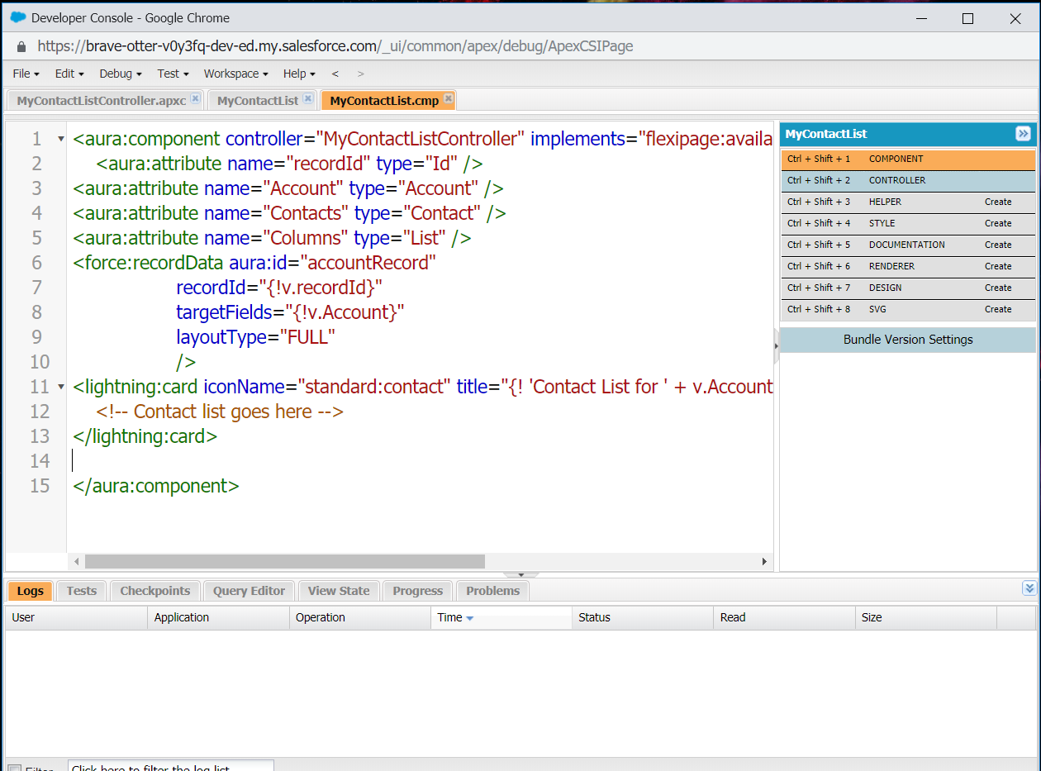

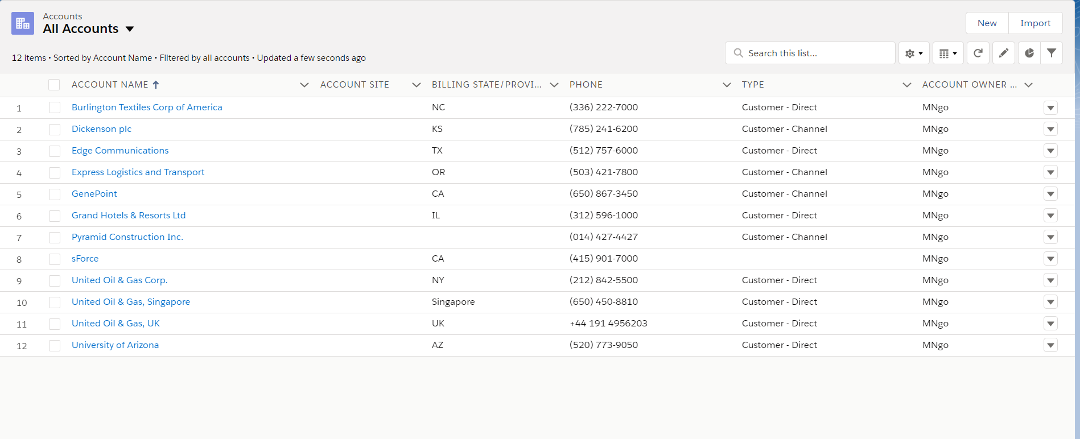

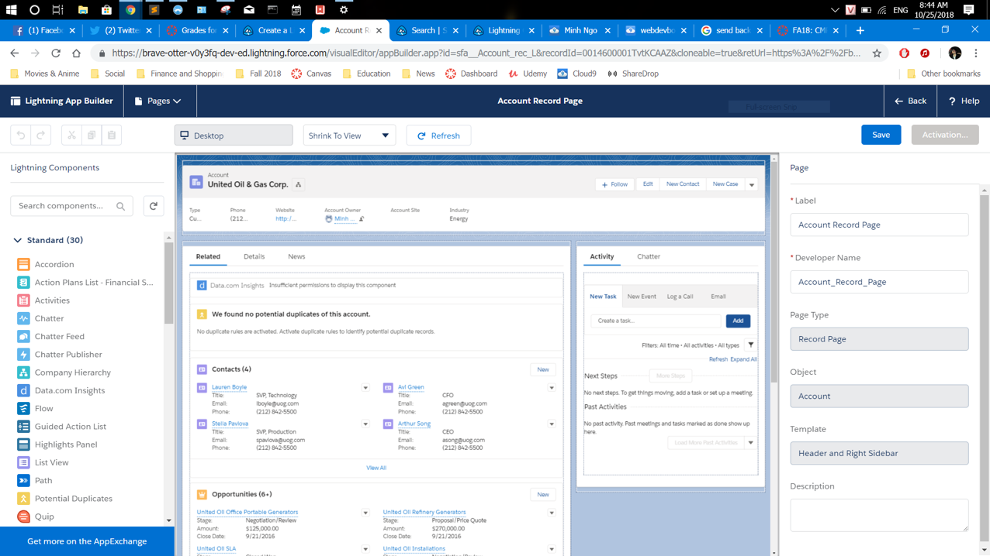

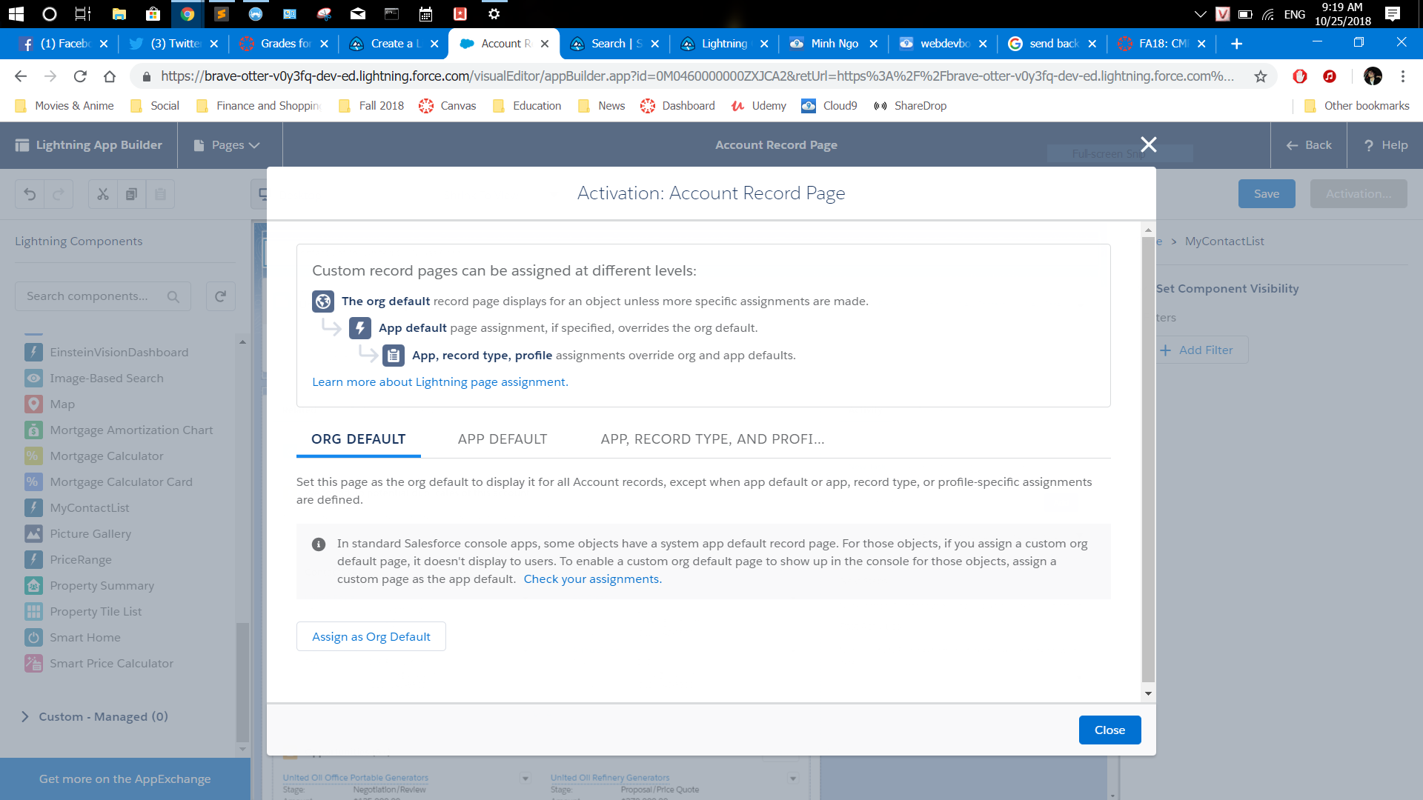

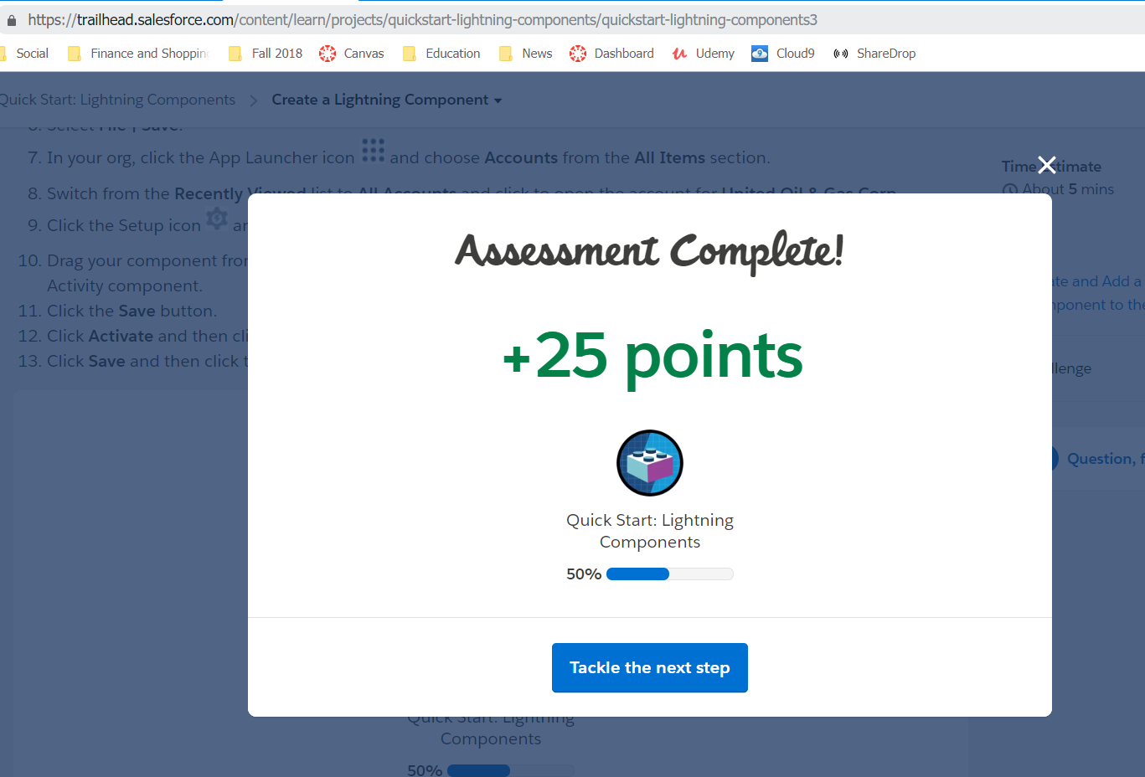

### ../../../../Volumes/ST32/salesRetrieve a contact list

### Render and preview contact list

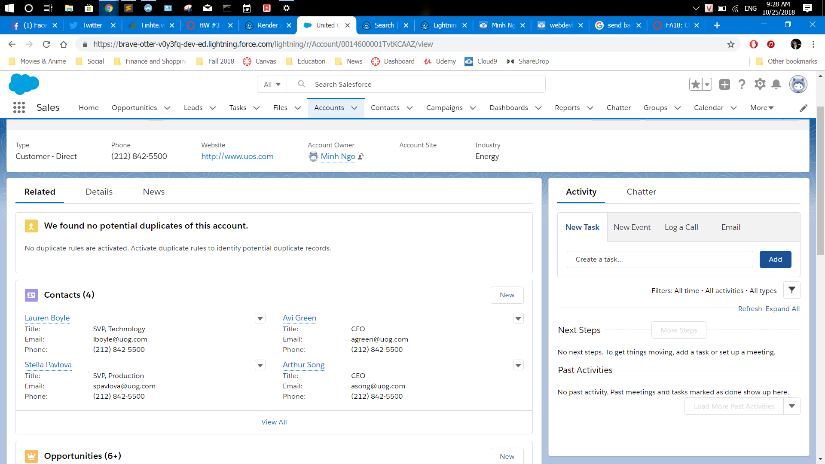

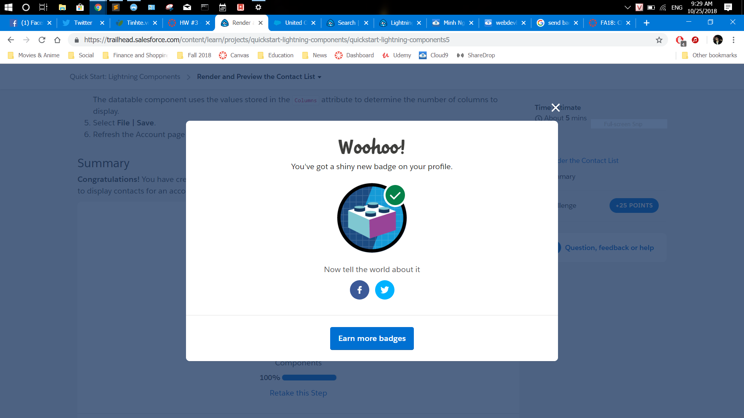

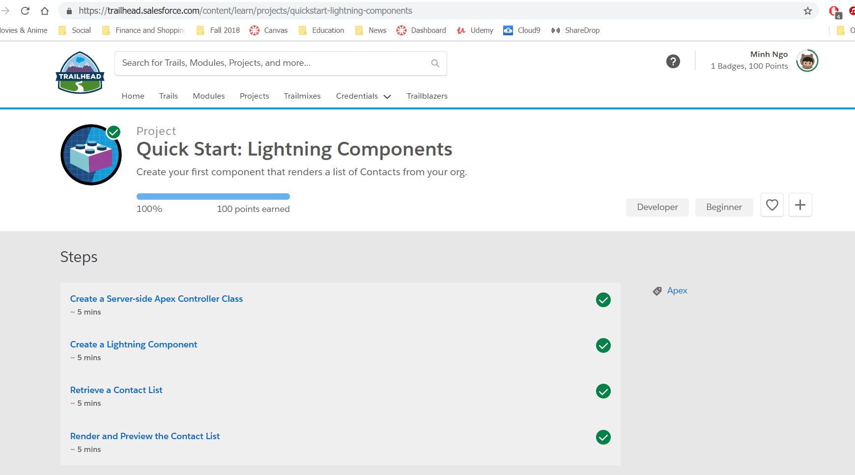

## Part IV. Lightning Components Basic

### ../../Downloads/Lightning%20component%20basics/salesforce-13.PNGBefore you start

### Getting started with lightning components

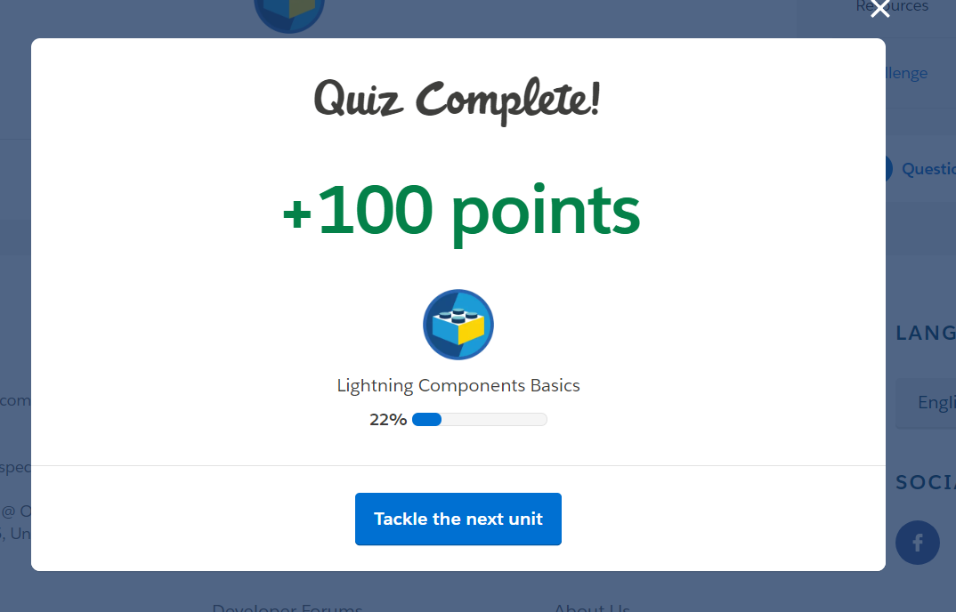

### ../../Downloads/Lightning%20component%20basics/salesforce-15.PNGCreate and edit lightning components

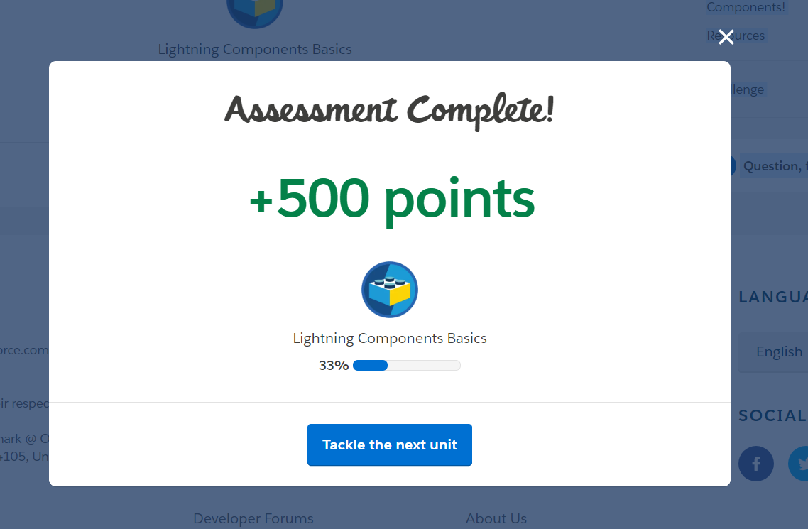

### Attributes and Expressions

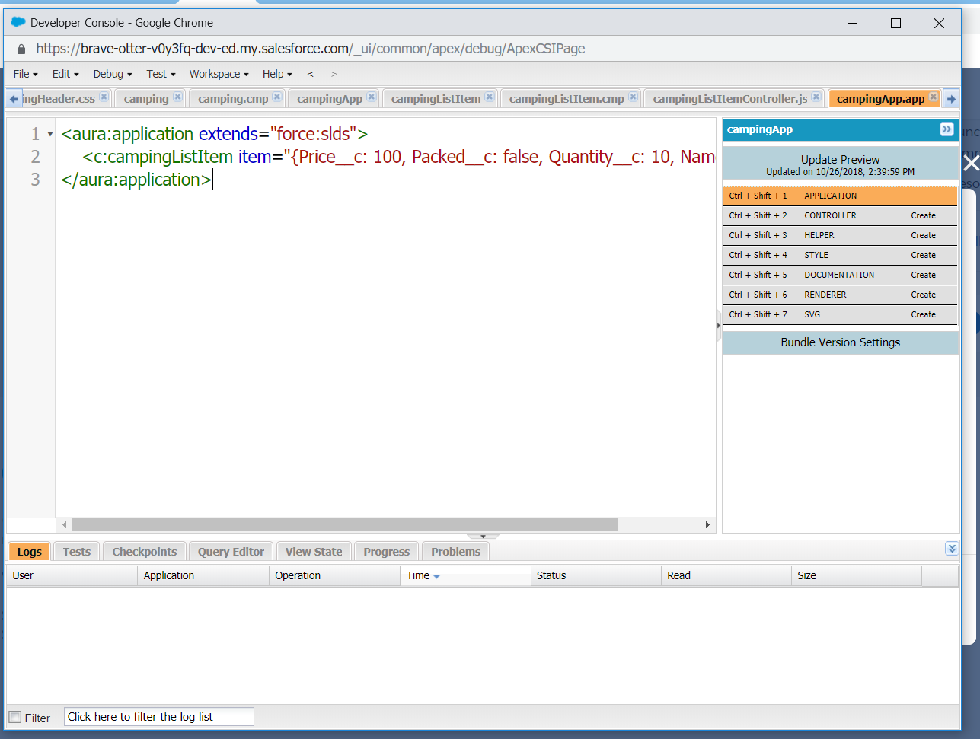

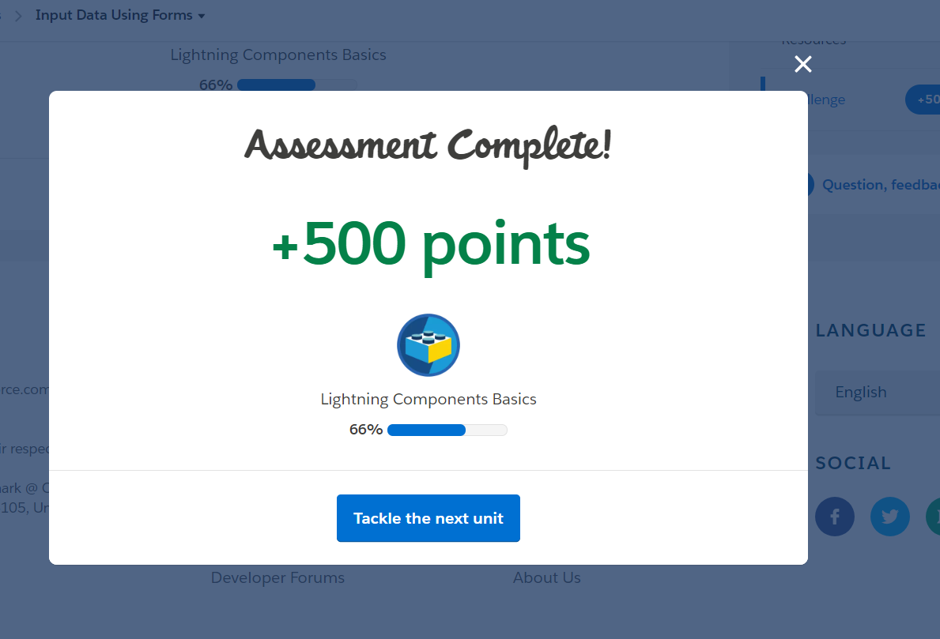

### Handle actions with controller

### ../../Downloads/Lightning%20component%20basics/salesforce-20.PNGInput Data Using Forms

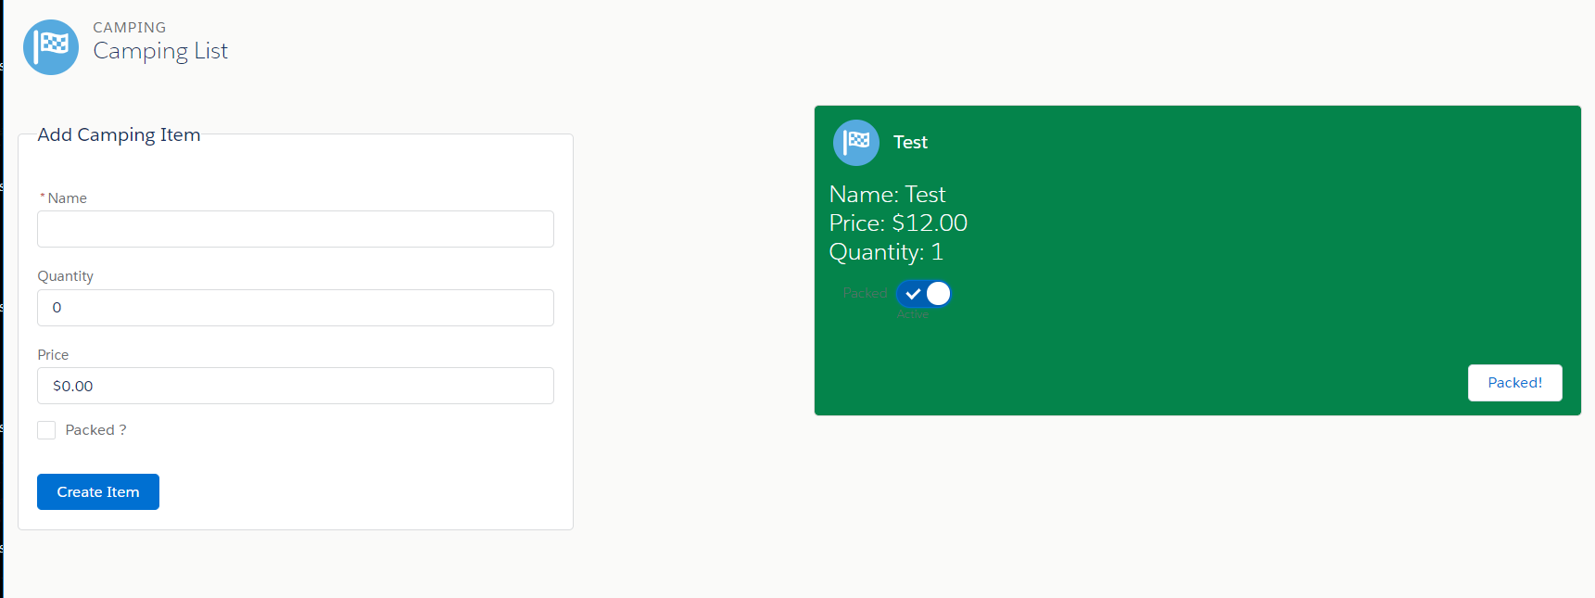

### Connect to salesforce with server-side controllers

### ../../Downloads/Lightning%20component%20basics/salesforce-25.PNG../../Downloads/Lightning%20component%20basics/salesforce-22.PNGConnect components with events

### The Next Step

### ../../Downloads/Lightning%20component%20basics/salesforce-25.PNGCompletion of the module

