CMPE172

HW7

Team GreenFace

Minh Ngo, Viet Nguyen and Hoa Nguyen

## Part I.

1. Create RootCA

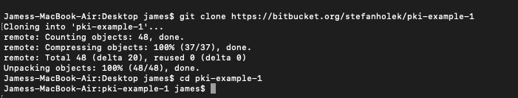Clone resources

* 1.1 Create directories for the assignment
* 1.2 Create Database
* 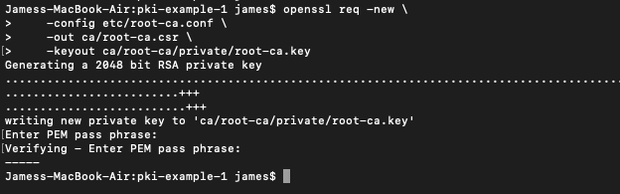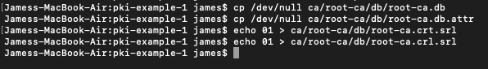1.3 Create CA Request
* 1.4 Create CA Certificate

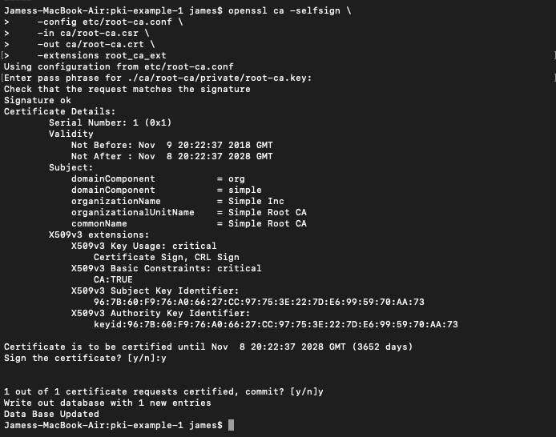

1. Create Signing CA

We go through the same process as the above.

* ../Downloads/2.1.png2.1 Create directory
* 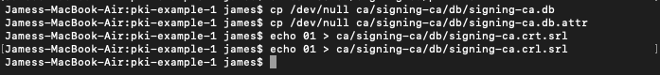2.2 Create database
* 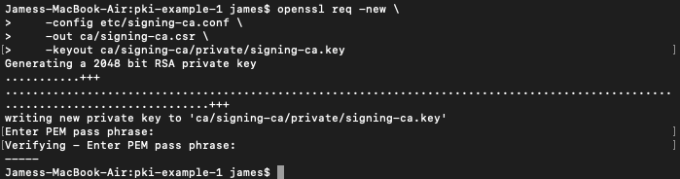2.3 Create CA request
* 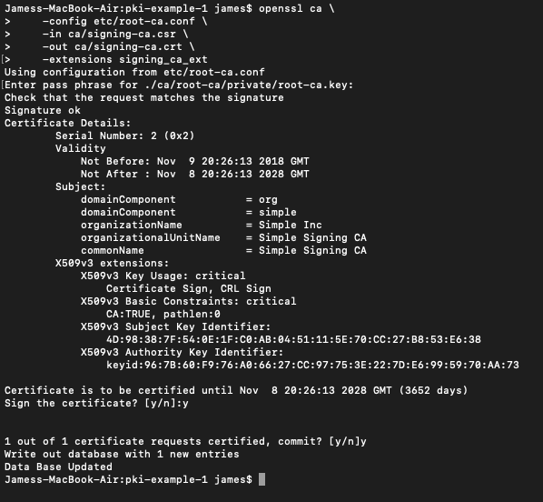2.4 Create CA certificate

1. Operate signing CA

* 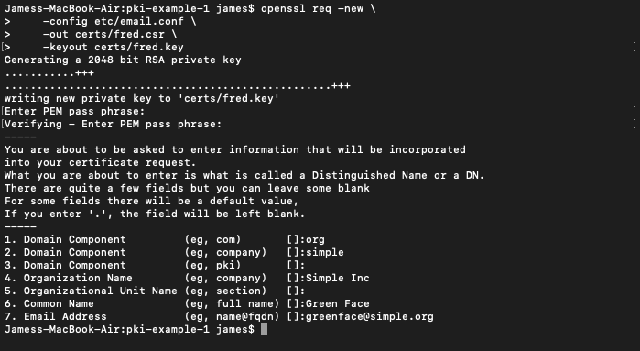3.1 Create email request
* 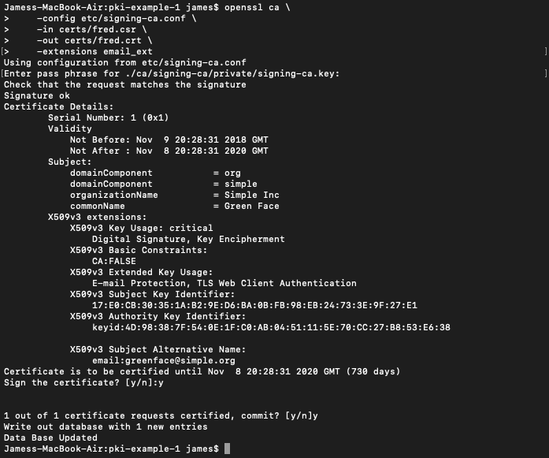3.2 Create email certificate

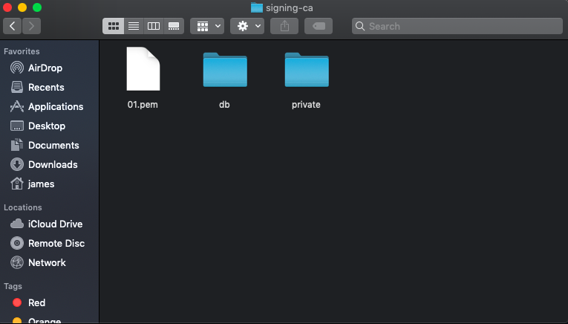After step 3.2, here is the result in host machine’s file system.

* 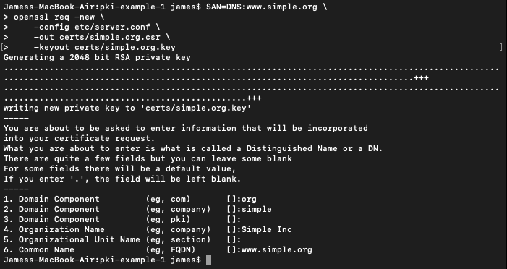3.3 Create TLS server request
* 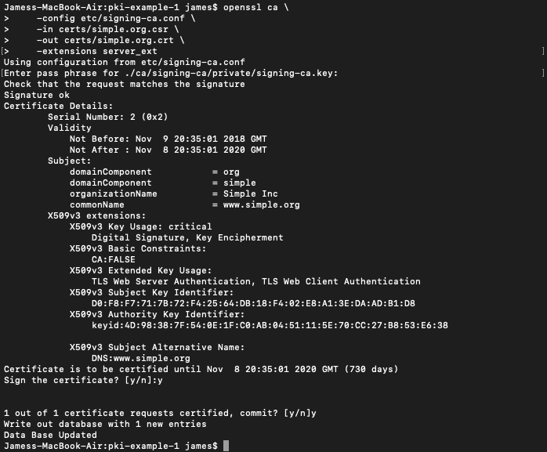3.4 Create TLS server certificate

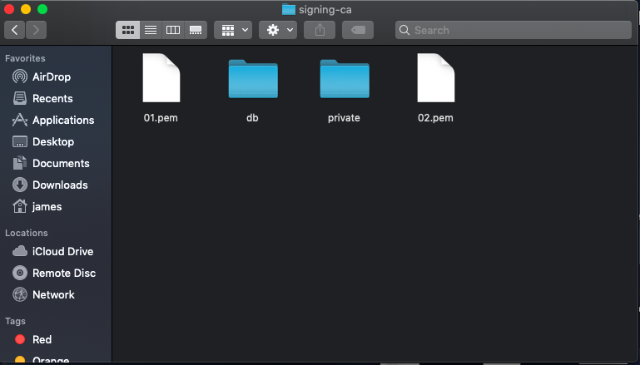The second pem file now appears in the file system.

* 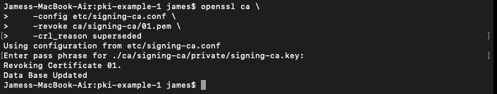3.5 Revoke certificate
* 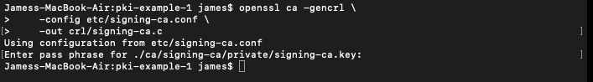3.6 Create CRL

1. Ouput Formats

* 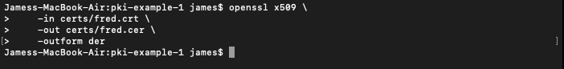4.1 Create DER certificate
* 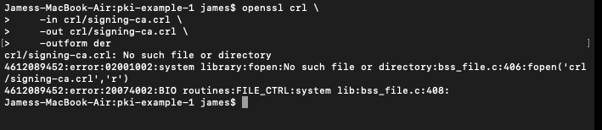4.2 Create DER CRL
* 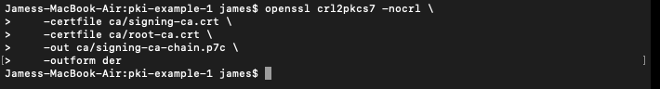4.3 Create PKCS#7 bundle
* 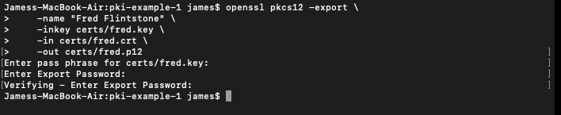4.4 Create PKCS#12 bundle
* 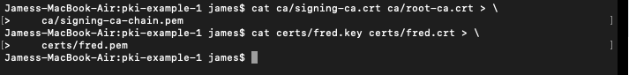4.5 Create PEM bundle

1. View Results

* 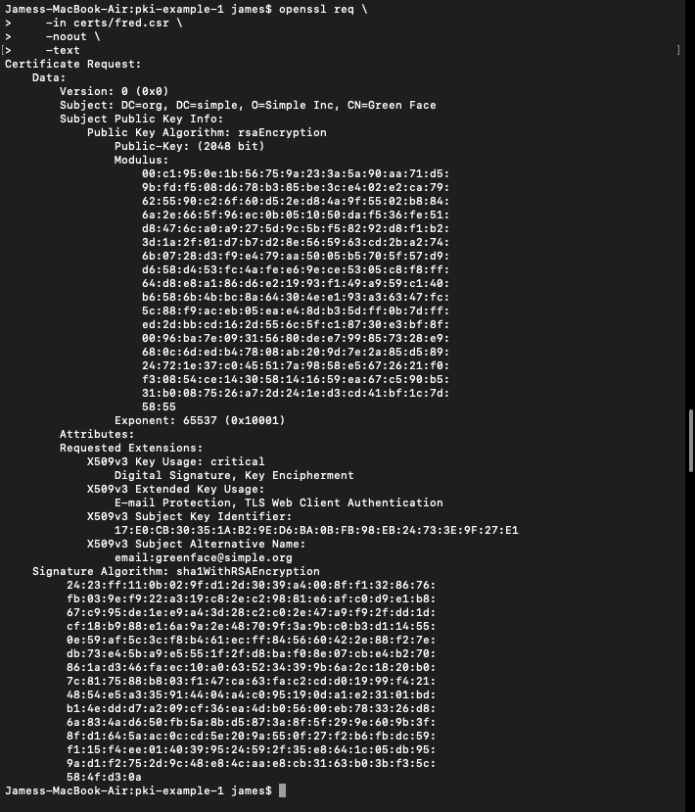5.1 View requests
* 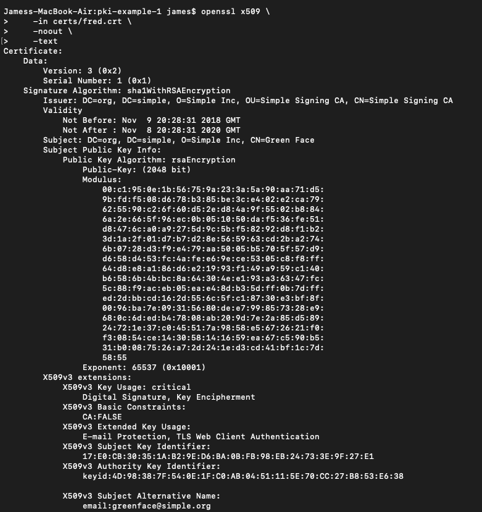5.2 View certificate
* 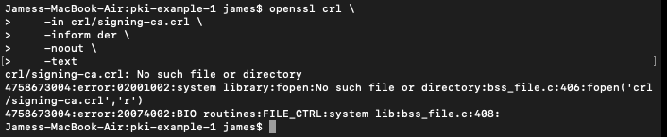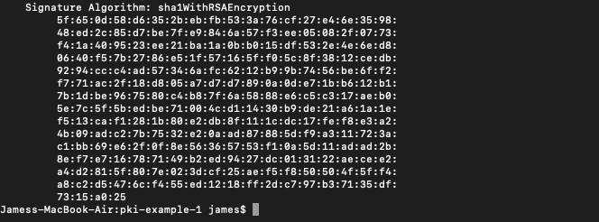5.3 View CRL
* 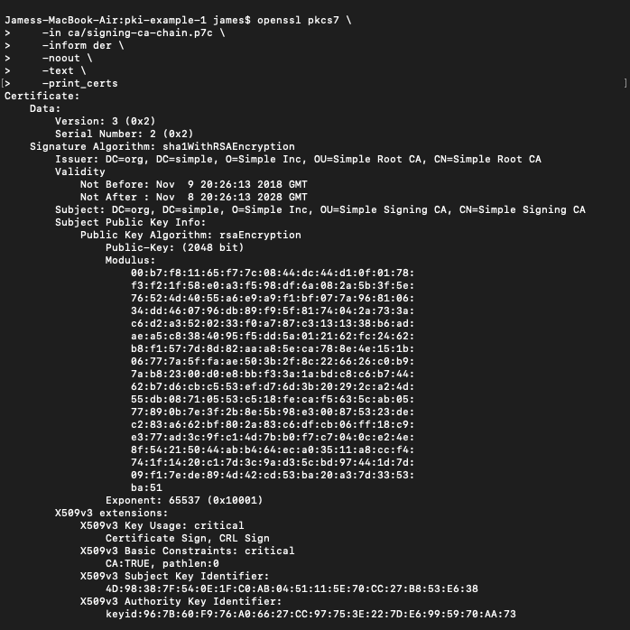5.4 View PKCS#7 bundle

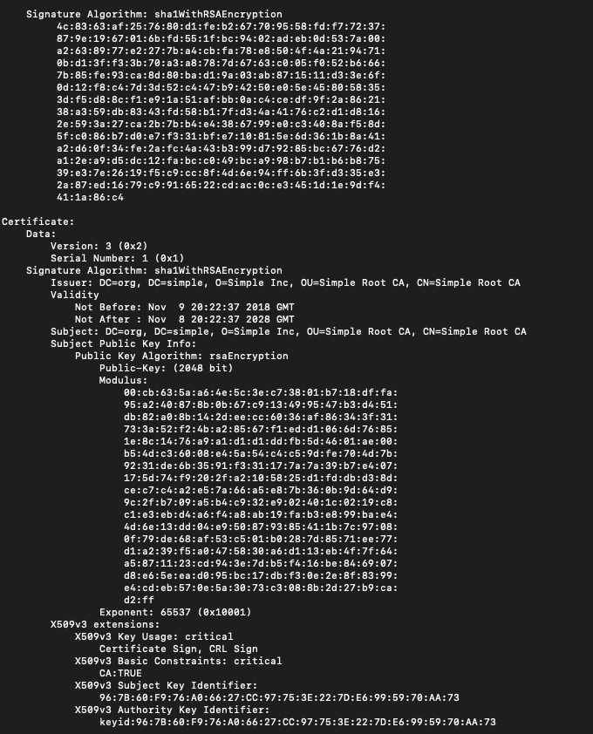

* 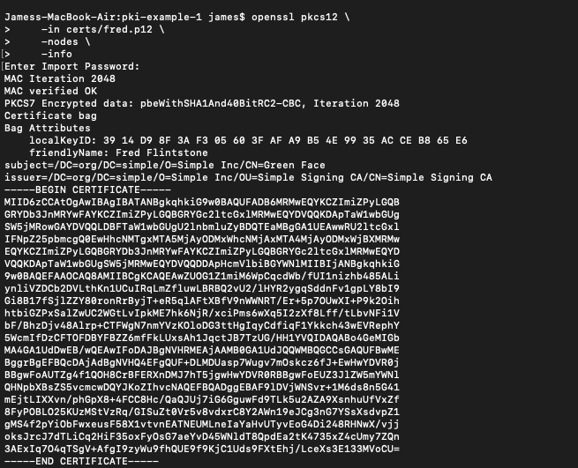5.5 View PKCS#12 bundle

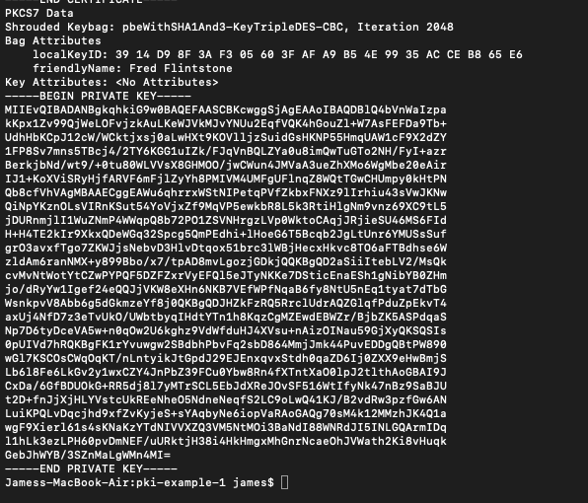

## Part II. Using Tomcat and deploy

