CMPE172

Assignment 2 Karaf

Team GreenFace: Viet Nguyen, Hoa Nguyen, Minh Ngo

Github Link: <https://github.com/MrJc010/twitterapp>

# Table of content

Table of Contents

Table of content 1

Abstract 2

Design Pattern and UML Diagram 3

Design Pattern 3

UML Diagrams 3

Sequence Diagram 4

4

Activity Diagram 4

Use Cases 6

Junit Test and Test Cases 9

Junit Test Screenshot 11

Screenshot of Web GUI 12

# Abstract

Twitter is a popular social networking platform for many people in the United States. For our assignment two, we intend to build a Twitter client app based on web technologies and Twitter Rest API. The app shall have a web user interface for easy interaction with major functionalities. The app shall be able to allow user to type his or her keys for Twitter account accessing. Major functionalities such as posting a tweet, retrieving latest tweet, getting list of followers, checking on top trend around the globe, getting user’s user name, find user’s tweet (from certain keywords) and private messaging shall be supported using eight Twitter REST Api. In a shorter explanation, this client app is the gateway for Twitter user to get connected to the social networking site in a much simpler and productive manner.

# Design Pattern and UML Diagram

### Design Pattern

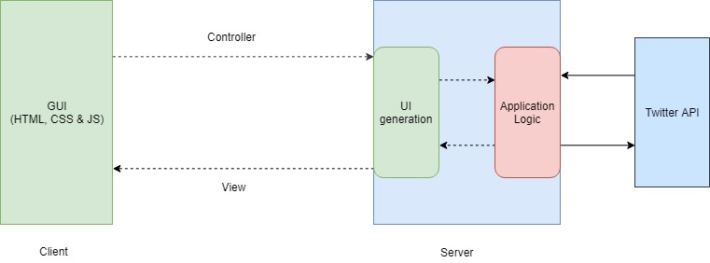We follow the client-server design pattern for our twitter application.

Figure 1 Client and Server Pattern

UML Diagrams

### Sequence Diagram

### 

Figure 2 Sequence Diagram

### Activity Diagram



Figure 3 Get User Name Activity Diagram



Figure 4 Get Latest Tweet Activity Diagram



Figure 5 Get Twitter Trend Activity Diagram



Figure 6 Post A Tweet Activity Diagram



Figure 7 Find a Tweet Activity Diagram



Figure 8 Send Message Actitvity Diagram



Figure 9 Set Twitter Key Activity Diagram

# Use Cases

Use Case #1

|  |  |
| --- | --- |
| **Use Case Name** | **Login Account (By key)** |
| Participating Actors | User |
| Flow of Events | |  |  | | --- | --- | | User | Website’s responses | | 1. User types four keys to log in |  | |  | 2. Website will redirect user to a new page (after successful log-in) | | 3. User continues his actions. |  | |
| Entry Condition | User can get access to the website |
| Exit Condition | User successfully logged in to his or her account. |
| Quality Requirements | Users are able to access his or her account quickly with valid account information. |

Use case #2

|  |  |
| --- | --- |
| **Use Case Name** | **Perform major operations on Twitter account** |
| Participating Actors | User |
| Flow of Events | |  |  | | --- | --- | | User | Website’s responses | | 1. User clicks on specific buttons to perform specific actions ( check the variation). |  | |  | 2. Website will perform those instructions and return results to user | | 3. User continues his actions. |  | |
| Entry Condition | User can get access to the website |
| Variations | 8 Variations   |  |  | | --- | --- | | Post Tweet | User’s tweet will be posted on his or her account. | | Get Tweet | User will see his or her latest tweet. | | Send Message | User’s private message will be sent to a target twitter user. | | Find Tweet | User can check for the existence of a tweet made by himself or herself. | | Login | User can switch to another account or login to a current account. | | Get User Name | User will see his or her account name on top of the site | | Get Trends | User will see the list of tweet trends around the world. | | Get Followers | User will see the list of followers. | |
| Exit Condition | User successfully get the results of his or her desired operations (check the variations) |
| Quality Requirements | Alll of these operations should perform successfully withouy noticeable delay. |

# Junit Test and Test Cases

|  |  |  |  |  |  |
| --- | --- | --- | --- | --- | --- |
| **Test Case #** | **Reason for testing** | **Test Case Input** | **Expected Output** | **Actual Output**  **And Result** | **Oracle** |
| 1 | Test the Post Tweet functionality | Given Input:  “this is a tweet for testing by M” | The same tweet shows up in user account’s tweet timeline | Passed.  Junit Test result is in the screenshot in the next section. | 1. **Environment:**  iMac  2. **OS:** Mac OS Mojave  3. **Testing strategy:**  Use JUnit Test and check user’s twitter account. |
| 2 | Test the Get Tweet functionality | Use Twitter API to retrieve for latest tweet made by user | The tweet made by previous action should show up. | Passed.  Junit Test result is in the screenshot in the next section. | 1. **Environment:**  iMac  2. **OS:** Mac OS Mojave  3. **Testing strategy:**  Use JUnit Test and check user’s twitter account. |
| 3 | Test the Send Message functionality | Send the following content “this is a JUnit test message version 2” to Minh’s account. | The tweet should show up in Minh’ message inbox. | Passed.  Junit Test result is in the screenshot in the next section. | 1. **Environment:**  iMac  2. **OS:** Mac OS Mojave  3. **Testing strategy:**  Use JUnit Test and check user’s twitter account. |
| 4 | Test the Find Tweet functionality | Find a previouslt posted tweet | The Tweet should show up if it does exist. If not, inform the user | Passed.  Junit Test result is in the screenshot in the next section. | 1. **Environment:**  iMac  2. **OS:** Mac OS Mojave  3. **Testing strategy:**  Use JUnit Test and check user’s twitter account. |
| 5 | Test the Get User Name functionality | User clicks on the Get User Name | The web should display his or her user name. | Passed.  Junit Test result is in the screenshot in the next section. | 1. **Environment:**  iMac  2. **OS:** Mac OS Mojave  3. **Testing strategy:**  Use JUnit Test and check user’s twitter account. |
| 6 | Test the Get Trend functionality | User clicks on the Get Trend button | The web will display list of latest trends | Passed.  Junit Test result is in the screenshot in the next section. | 1. **Environment:**  iMac  2. **OS:** Mac OS Mojave  3. **Testing strategy:**  Use JUnit Test and check user’s twitter account. |
| 7 | Test the Get Follower functionality | User clicks on the button | The web will display the list of followers of user. | Passed.  Junit Test result is in the screenshot in the next section. | 1. **Environment:**  iMac  2. **OS:** Mac OS Mojave  3. **Testing strategy:**  Use JUnit Test and check user’s twitter account. |
| 8 | Test the set account key  Functionality | User types 4 different account keys to the form. | The web GUI will redirect to a new home page for the user to proceed. | Passed.  Junit Test result is in the screenshot in the next section. | 1. **Environment:**  iMac  2. **OS:** Mac OS Mojave  3. **Testing strategy:**  Use JUnit Test and check user’s twitter account. |

# Junit Test Screenshot

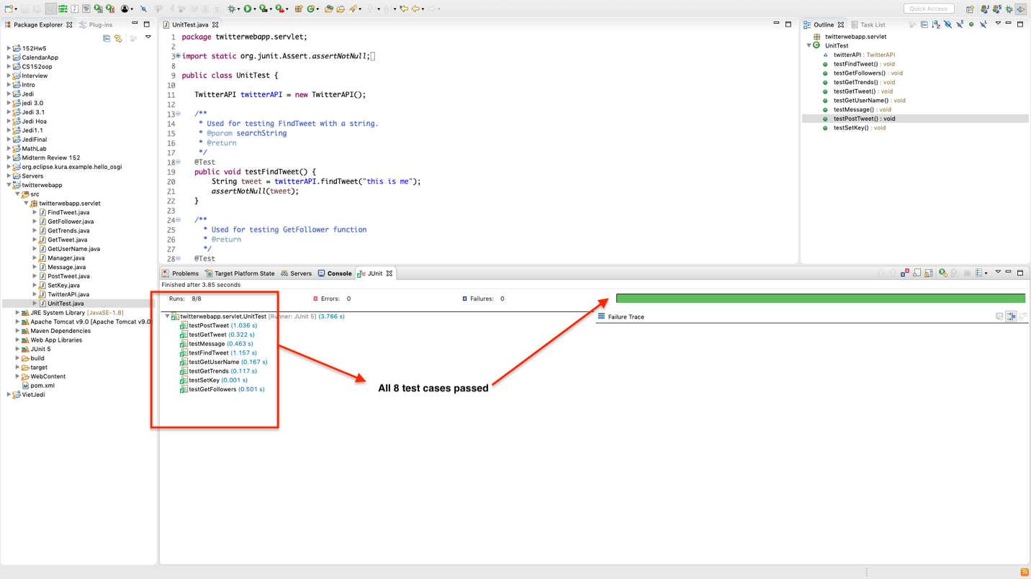

The code will be provided in the github repository.

<https://github.com/MrJc010/twitterapp>

# Screenshot of Web GUI

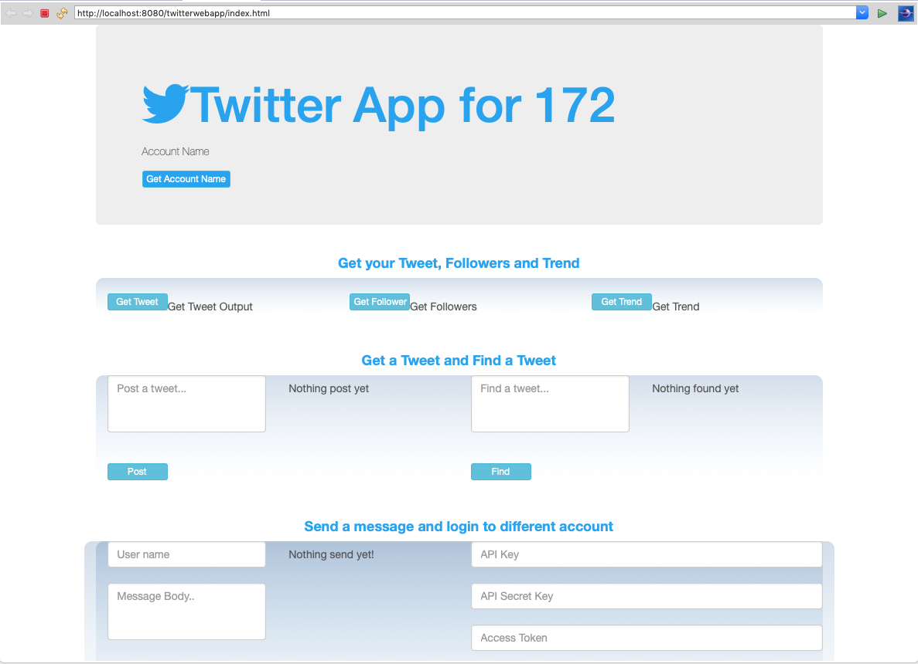

# Screenshots

## Deploy and launch our application on karaf

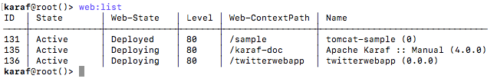

Figure 10 List of installed application on Karaf web console

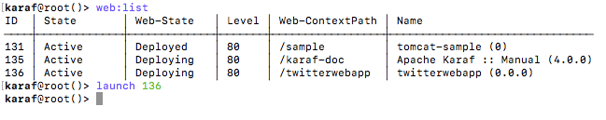

Figure 11 Launch our Twitter Karaf App (Process ID #136)

## Walkthrough of our twitter client app’s main functionalities.

1. Posting a tweet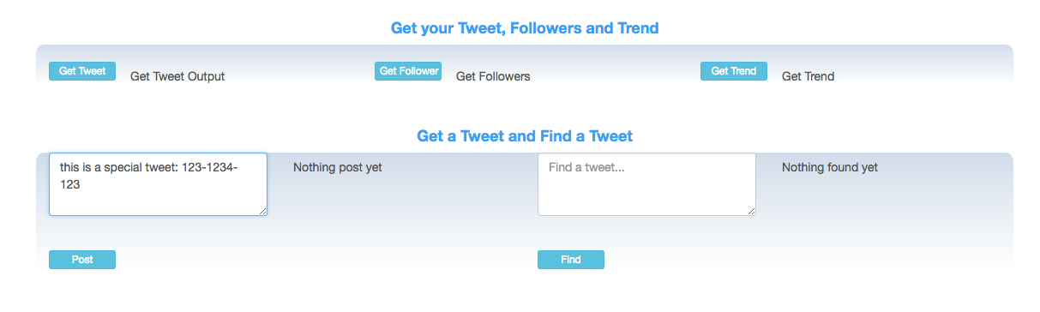

Figure 12 Type the content of the tweet into the input box

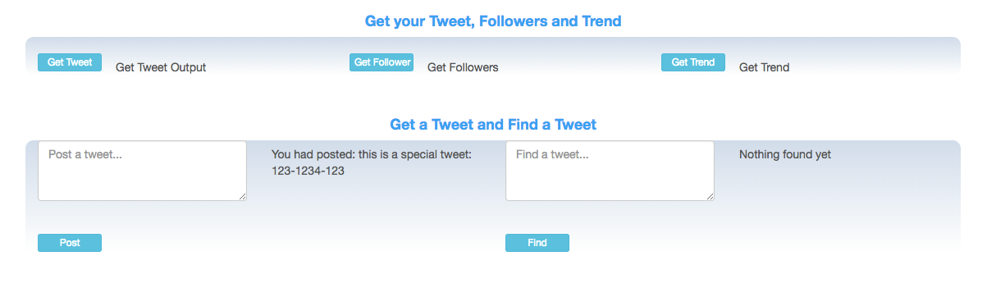

Figure 13 The Tweet was tweeted successfully

1. Find a Tweet

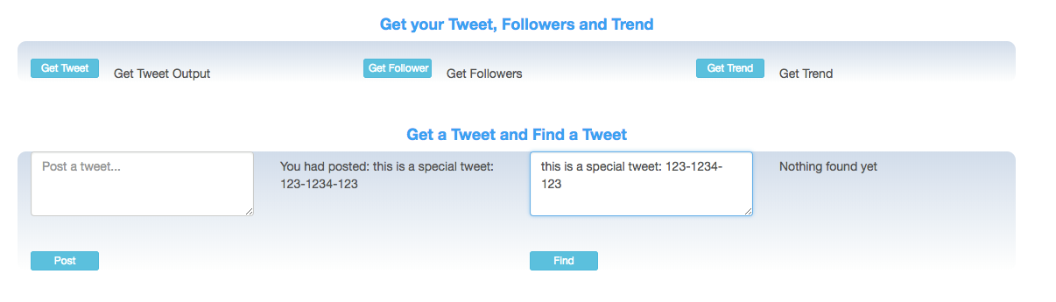

Figure 14 Find a tweet in user's account

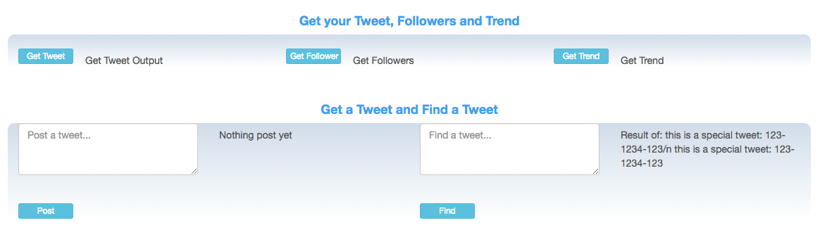

Figure 15 The searched tweet was found successfully.

Besides these, our app also supports various other functionalities (with the support of 8 Twitter REST APIs as required). We also put comment in the code to specify which API is used.

We implemented all of the required APIs in [**twitterapp**](https://github.com/MrJc010/twitterapp)**/[twitterwebapp](https://github.com/MrJc010/twitterapp/tree/master/twitterwebapp)/[src](https://github.com/MrJc010/twitterapp/tree/master/twitterwebapp/src)/[twitterwebapp](https://github.com/MrJc010/twitterapp/tree/master/twitterwebapp/src/twitterwebapp)/servlet**/ (as found on our twitter GitHub repository).