LIBRARY MANAGEMENT SYSTEM
Project Title
Library Management System using Python
Objective
The objective of this project is to develop a console-based Library Management System that helps a librarian manage books efficiently. The system allows users to add books, view available books, issue books, return books, search books, and count available books.
Problem Statement
Develop a console-based Library Management System using Python. The application should allow a librarian to manage books by adding, viewing, issuing, returning, and searching books.
Tools and Technologies Used
- Programming Language: Python
- IDE: VS Code
- Concepts Used:
  - Object-Oriented Programming (OOP)
  - Classes and Objects
  - Functions
  - Lists
  - Conditional Statements
  - Loops
  - Modules
Project Structure
LibraryManagement/
├── main.py
├── book.py
└── library_utils.py
Description of Files
book.py
Contains the Book class with the following attributes:
- book_id
- title
- author
- is_issued
Methods:
- issue_book()
- return_book()
- display()
library_utils.py
Contains utility functions:
- search_book()
- count_available_books()
- display_all_books()
main.py
Implements the menu-driven program and manages user interactions.
Features of the System
- Add New Book
- View All Books
- Issue Book
- Return Book
- Search Book by ID
- Count Available Books
- Exit Application
Implementation Details
Book Class
The Book class represents a book in the library.
Attributes:
- Book ID
- Title
- Author
- Issue Status
Methods:
- issue_book() changes status from Available to Issued.
- return_book() changes status from Issued to Available.
- display() shows complete book details.
Utility Functions
search_book()
Searches a book using Book ID.
count_available_books()
Counts the number of books available in the library.
display_all_books()
Displays all books stored in the library.

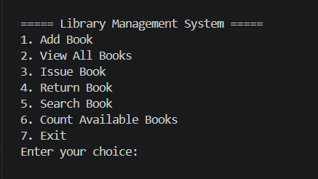

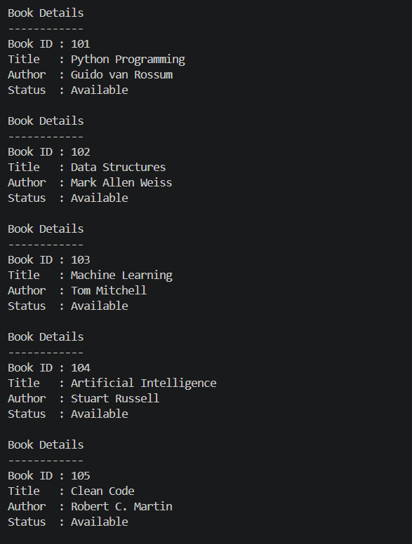

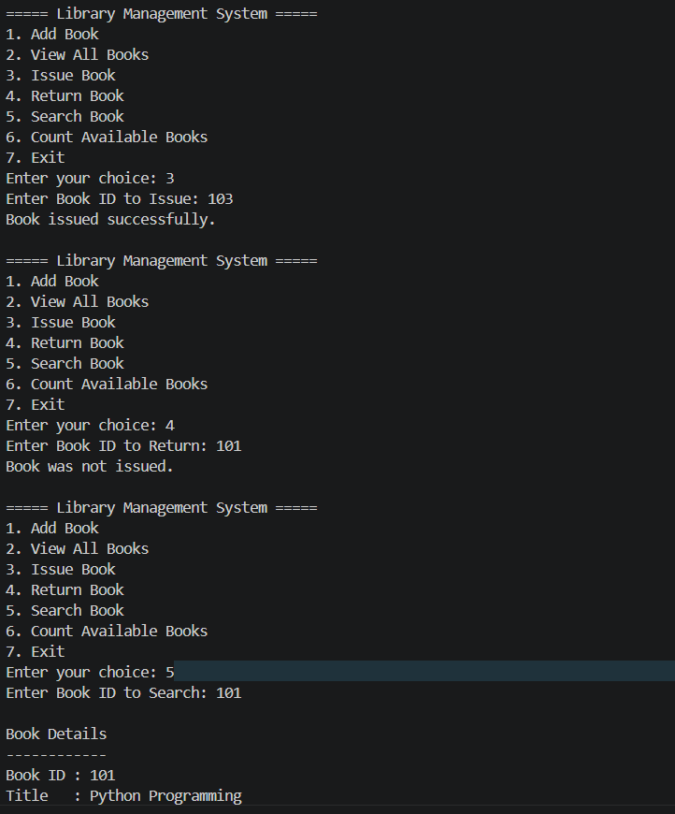

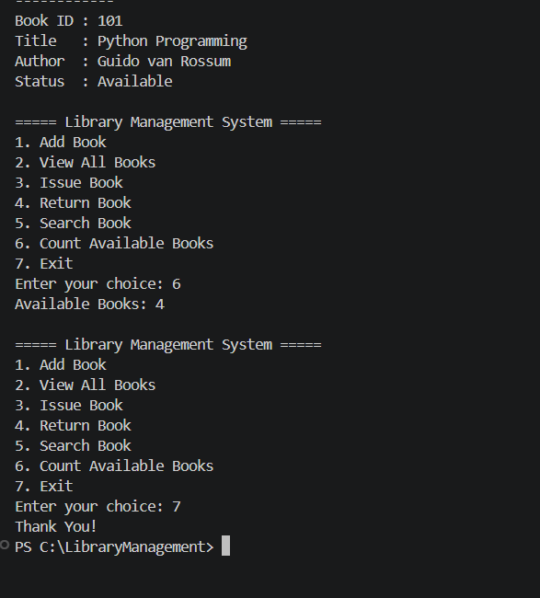

Advantages
- Easy to use.
- Simple menu-driven interface.
- Efficient book management.
- Demonstrates Object-Oriented Programming concepts.
- Can be extended for real-world library applications.
Conclusion
The Library Management System successfully manages library books through a console-based interface. The project demonstrates the use of Python programming concepts such as classes, objects, functions, modules, lists, loops, and conditional statements. It provides a simple and effective solution for handling library operations such as adding, issuing, returning, and searching books.

