Matthew Langendorfer

Midterm Project (raw code)

import json

import matplotlib.pyplot as plt

numlist = []

dict = {}

f = open("/Users/ml/Desktop/midterm-project/numbers.txt", "r")

text = f.read()

for num in text:

    if num.isdigit():

        numlist.append(int(num))

for num in numlist:

    if num in dict.keys():

        dict[num] += 1

    else:

        dict[num] = 1

for key, value in dict.items():

    print(f"{key} : {value}")

plt.bar(list(dict.keys()), dict.values(), color='g')

plt.xlabel("Value")

plt.ylabel("Frequency")

plt.title('Frequency of Text File')

plt.show()

y = json.dumps(dict)

print(y)

with open("out.json", "w") as outfile:

    json.dump(y, outfile)

import pandas as pd  
  
df = pd.read_csv('/Users/ml/Desktop/ViewingActivity.csv')  
df.shape

(200, 10)

df.head(1)

Profile Name Start Time Duration Attributes \  
0 Charlie 2013-03-20 5:17:53 0:00:05 NaN   
  
 Title Supplemental Video Type \  
0 Star Trek: Deep Space Nine: Season 5: Empok No... NaN   
  
 Device Type Bookmark Latest Bookmark Country   
0 Mac 0:00:05 Not latest view US (United States)

df = df.drop(['Profile Name', 'Attributes', 'Supplemental Video Type', 'Device Type', 'Bookmark', 'Latest Bookmark', 'Country'], axis=1)  
df.head(1)

Start Time Duration \  
0 2013-03-20 5:17:53 0:00:05   
  
 Title   
0 Star Trek: Deep Space Nine: Season 5: Empok No...

df.dtypes

Start Time object  
Duration object  
Title object  
dtype: object

df['Start Time'] = pd.to_datetime(df['Start Time'], utc=True)  
df.dtypes

Start Time datetime64[ns, UTC]  
Duration object  
Title object  
dtype: object

df = df.set_index('Start Time')  
  
df.index = df.index.tz_convert('US/Eastern')  
  
df = df.reset_index()  
  
df.head(1)

Start Time Duration \  
0 2013-03-20 01:17:53-04:00 0:00:05   
  
 Title   
0 Star Trek: Deep Space Nine: Season 5: Empok No...

df['Duration'] = pd.to_timedelta(df['Duration'])  
df.dtypes

Start Time datetime64[ns, US/Eastern]  
Duration timedelta64[ns]  
Title object  
dtype: object

startrek = df[df['Title'].str.contains('Star Trek: Deep Space Nine', regex=False)]

startrek.shape

(43, 3)

startrek = startrek[(startrek['Duration'] > '0 days 00:01:00')]  
startrek.shape

(38, 3)

startrek['Duration'].sum()

Timedelta('0 days 20:00:57')

startrek['weekday'] = startrek['Start Time'].dt.weekday  
startrek['hour'] = startrek['Start Time'].dt.hour  
  
startrek.head(1)

Start Time Duration \  
1 2013-03-20 00:27:45-04:00 0 days 00:44:31   
  
 Title weekday hour   
1 Star Trek: Deep Space Nine: Season 5: Blaze of... 2 0

%matplotlib inline  
import matplotlib

startrek['weekday'] = pd.Categorical(startrek['weekday'], categories=  
 [0,1,2,3,4,5,6],  
 ordered=True)  
  
startrek_by_day = startrek['weekday'].value_counts()  
  
startrek_by_day = startrek_by_day.sort_index()  
  
matplotlib.rcParams.update({'font.size': 22})  
  
startrek_by_day.plot(kind='bar', figsize=(20,10), title='Trek Episodes Watched by Day')

<AxesSubplot:title={'center':'Trek Episodes Watched by Day'}>

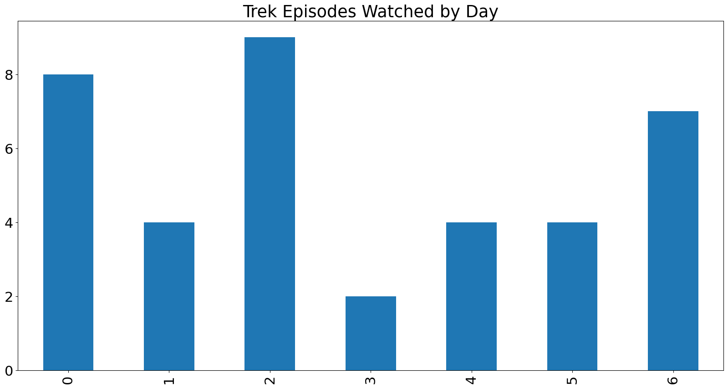

startrek['hour'] = pd.Categorical(startrek['hour'], categories=  
 [0,1,2,3,4,5,6,7,8,9,10,11,12,13,14,15,16,17,18,19,20,21,22,23],  
 ordered=True)  
  
startrek_by_hour = startrek['hour'].value_counts()  
  
startrek_by_hour = startrek_by_hour.sort_index()  
  
startrek_by_hour.plot(kind='line', figsize=(20,10), title='DS9 Episodes Watched by Hour')

<AxesSubplot:title={'center':'DS9 Episodes Watched by Hour'}>

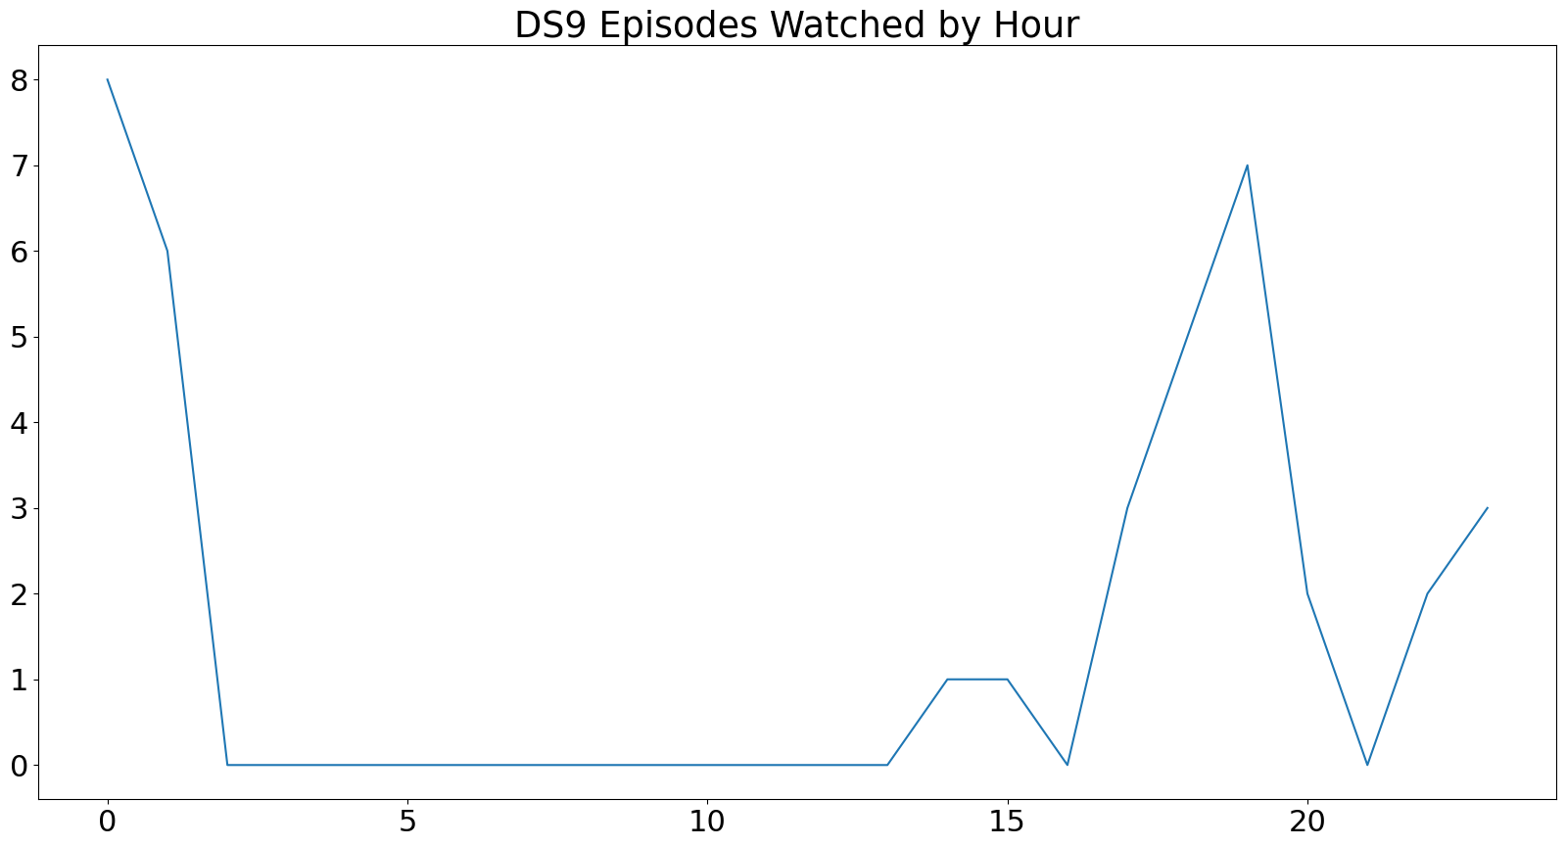

startrek['weekday'] = pd.Categorical(startrek['weekday'], categories=  
 [0,1,2,3,4,5,6],  
 ordered=True)  
  
startrek_by_day = startrek['weekday'].value_counts()  
  
startrek_by_day = startrek_by_day.sort_index()  
  
matplotlib.rcParams.update({'font.size': 22})  
  
startrek_by_day.plot(kind='hist', figsize=(20,10), title='Frequency of Multiple Episodes Watched')

<AxesSubplot:title={'center':'Frequency of Multiple Episodes Watched'}, ylabel='Frequency'>

