

Assessment Cover Page
Student Full Name | Dorian Casu
Student Number | Sba25146
Module Title | Data Preparation  Statistical Techniques for DA  Machine Learning
Assessment Title | Integrated CA2
Lecturer/Supervisor | David McQuaid  Cristiani Eccher  Muhammad Iqbal
Assessment Due Date | 21.12.2025
Date of Submission | 18.12.2025
Use of AI Tools
Choose the statement that fits your work and delete the other.
I have not used any AI tools or technologies in the preparation of this assessment.
Declaration
By submitting this assessment, I confirm that I have read the CCT policy on academic misconduct and understand the implications of submitting work that is not my own or does not appropriately reference material taken from a third party or other source.
I declare it to be my own work and that all material from third parties has been appropriately referenced.
I further confirm that this work has not previously been submitted for assessment by myself or someone else in CCT College Dublin or any other higher education institution.

The dataset used in this analysis has a shape of (2080, 13). Where each row represents an individual housing observation, and each column corresponds to a specific feature (social, economic, environmental, etc.) that influences housing demand and prices in Ireland. We have 3 categorical features (county, house type, and demand category) and 10 numerical features (income, land price, transport score, school quality, crime rate, green space, flood risk, broadband score, demand score, predicted house price). A combination of categorical and numerical variables makes the dataset suitable for both regression and classification tasks.
The dataset contains a small proportion of missing values:
- Average income: 3 missing values;
- Transport score: 3 missing values;
- School quality index: 5 missing values;
- Crime rate: 5 missing values;
- Flood risk score: 3 missing values.
The percentage of missing values is very low, since all other data is complete. We can remove the missing values without significantly affecting our data integrity. A check for duplicated rows confirmed that the dataset contains zero duplicate observations. To improve readability within the dataset, we renamed several columns. Specifically, “avg_income_eur” was renamed “income” and “avg_land_price_eur_m2” to “land_price”. In addition, categorical entries labelled as ‘‘UnKnown” were replaced with missing values “NaN”. We have examined each column to confirm the data type (numerical/categorical), number of unique values, and distribution of values. We concluded that the dataset was well-balanced geographically, with 80 observations per county. This step also ensured that all features were correctly formatted. The analysis showed that the amount of missing values per column was minimal, with no variable exceeding 0.20% of the total data. Given such a small proportion of missing values, we decided to remove all rows that contain any missing data. Removing the rows resulted in a cleaned dataset “dfclean” with 2053 observations and 13 attributes. EDA was conducted using multiple visualisation techniques to understand distributions, relationships, and potential anomalies within the data.

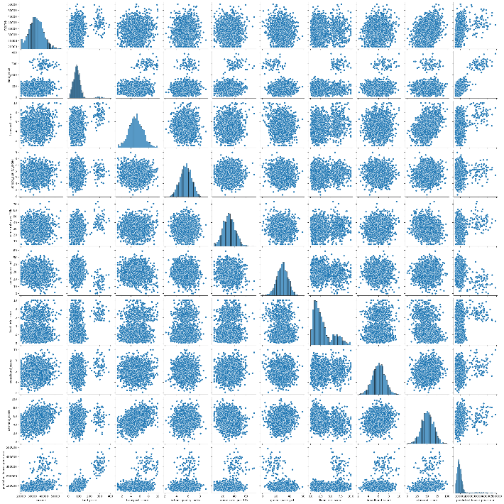
A pairplot of all numerical variables was generated to inspect linear and non-linear relationships and clustering patterns. This provided some insights into which features may influence housing prices.
Histograms were created for each variable to assess data distribution and skewness:
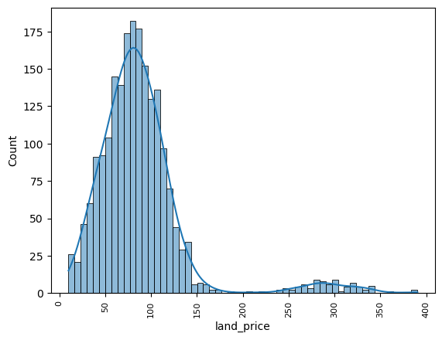
Land price showed a strong concentration between €20 and €140 per m2, with a long right tail extending up to €390 per m2, indicating premium land areas.
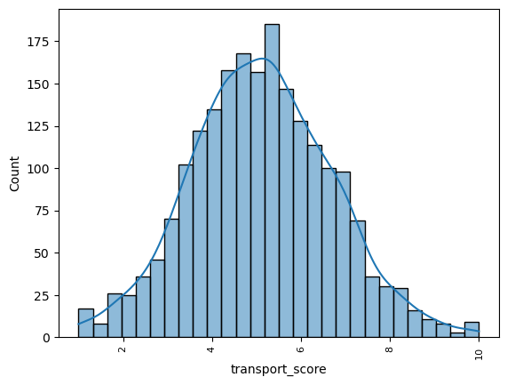

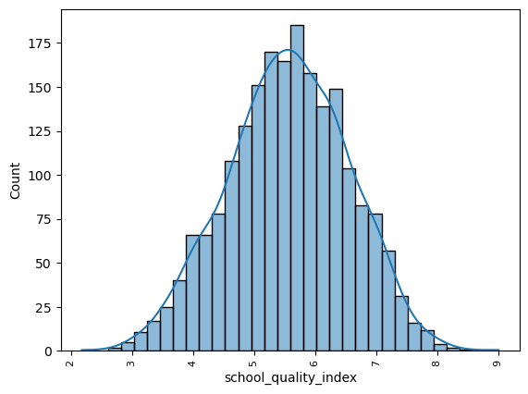
Transport score and school quality index displayed approximately normal distributions.

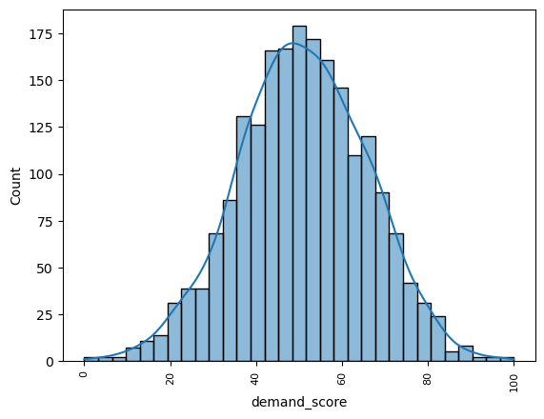
Demand category revealed some class imbalances, with a majority of observations classified as Average, followed by High and Low demand.
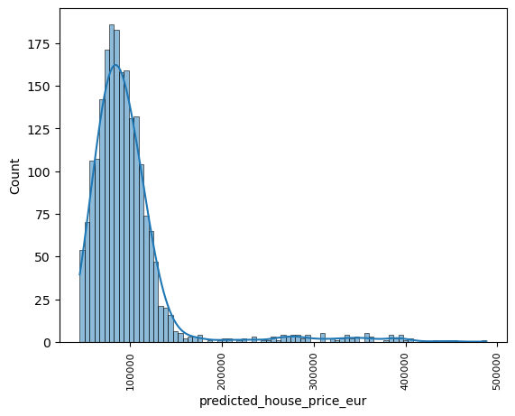
Predicted house prices showed a heavy right skew, with most prices between €40 000 and €130 000, and extreme values reaching up to €488 286.

We have also generated boxplots for all numerical variables to detect outliers:
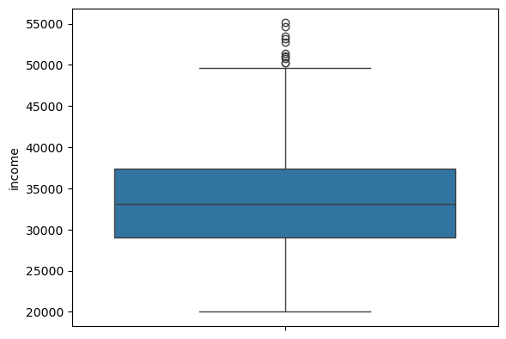
Income showed a high concentration around €34 000 with outliers above €50 000.
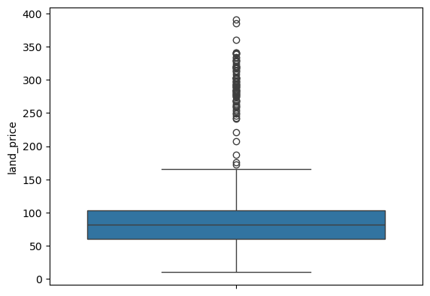
Land price contained extreme values above €170 per m2.
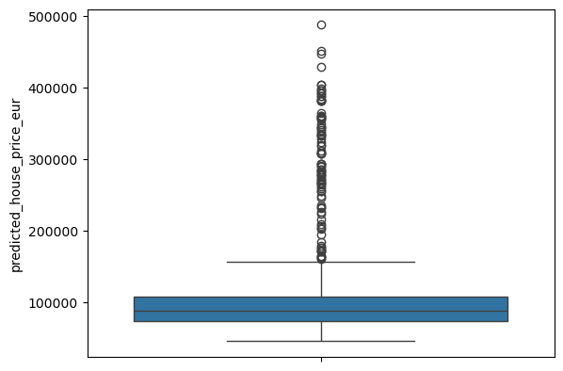
Predicted house price showed significant outliers from €160 000 upwards, which is associated with luxury or high-demand properties.
We have decided to keep the outliers, as they represent realistic market conditions and offer meaningful information for predictive modelling.
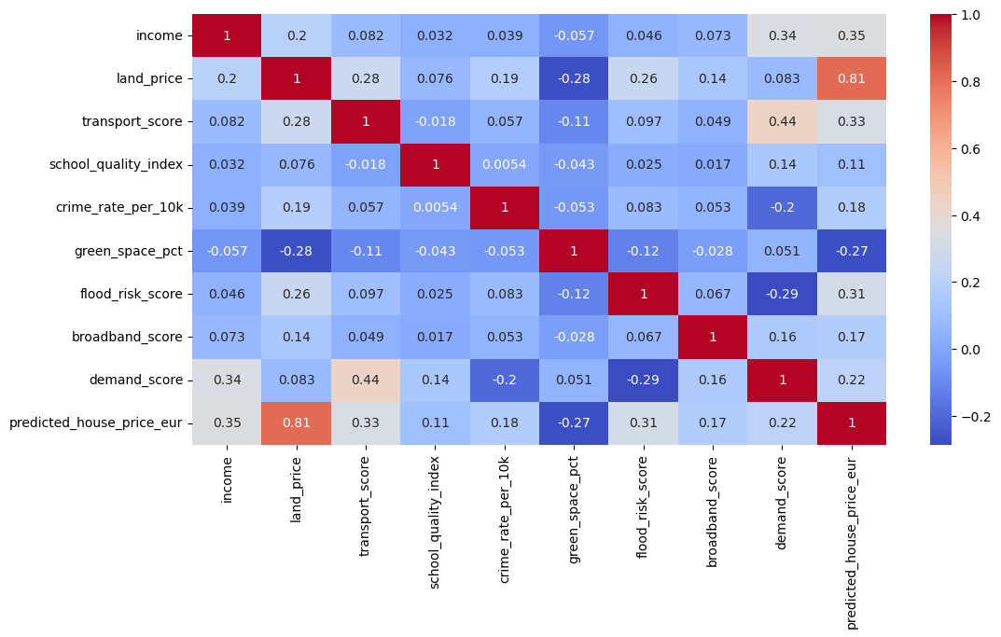
A correlation heatmap was created to examine relationships between numerical variables. Land Price showed the strongest positive correlation (0.81) with our target variable; other features showed moderate correlation, such as Income (0.35), Transport score (0.33), and Flood Risk score (0.31). The strongest negative correlation was observed with the green space percentage (-0.27), which implies an urbanisation effect. Basically, if the house is in a city, its price is higher than if the same house is located in a rural area.
A descriptive statistical analysis was made in order to summarise the main characteristics of our cleaned dataset. The analysis includes probability distributions, measures of central tendency, dispersion metrics, and normality testing. The probability distribution of the county variable was made using normalised frequencies. Each county represents approximately 4% of the dataset, confirming a uniform and balanced geographical distribution across the 26 counties. The house type distribution shows that detached houses are the most common property type in our dataset, followed by apartments, while studios represent the smallest share. The demand category variable is moderately imbalanced, with Average demand being the dominant class, followed by high and low categories. We have included descriptive statistics for all numerical variables, including mean, median, mode, standard deviation, variance, range, interquartile range (IQR), and skewness.
We have observed:
- Income: mean income is €33 216, with a median of €33 091, indicating a near-symmetric distribution. Skewness is a low amount of 0.15, which suggests that the income is relatively normally distributed, though some high-income outliers exist.
- Land price: Mean value is €88 per m2, with a strong skew of 2.62. A large range indicates significant differences in prices across regions.
- Transport Score: mean close to median and low skewness, suggesting relatively stable distribution.
- School Quality Index: similar to Transport score, with a low skewness and relatively stable distribution.
- Crime rate: Moderate variability with slight skew, reflects higher crime rates in a limited number of locations.
- Green space percentage: Shows moderate spread with slight negative skew.
- Flood risk score: Strong positive skew of 1.08, suggesting most areas have low flood risk with a small number of high-risk locations.
- Broadband score: Shows low variance and near-zero skewness, indicating a consistent broadband availability across regions.
- Demand score: Mean is 50.8, median is 50.6, which are almost identical, together with low skewness, suggest a well-balanced demand metric.
We have also applied the Shapiro-Wilk test to all numerical variables to assess normality. We concluded that most variables do not follow a normal distribution, including: income, land price, transport score, crime rate, green space, and flood risk. While broadband score and demand score can be considered approximately normally distributed.
To complete the descriptive statistics, we have created several statistical visualisations.

We have created barplots of the average predicted house price by county, house type and demand category.

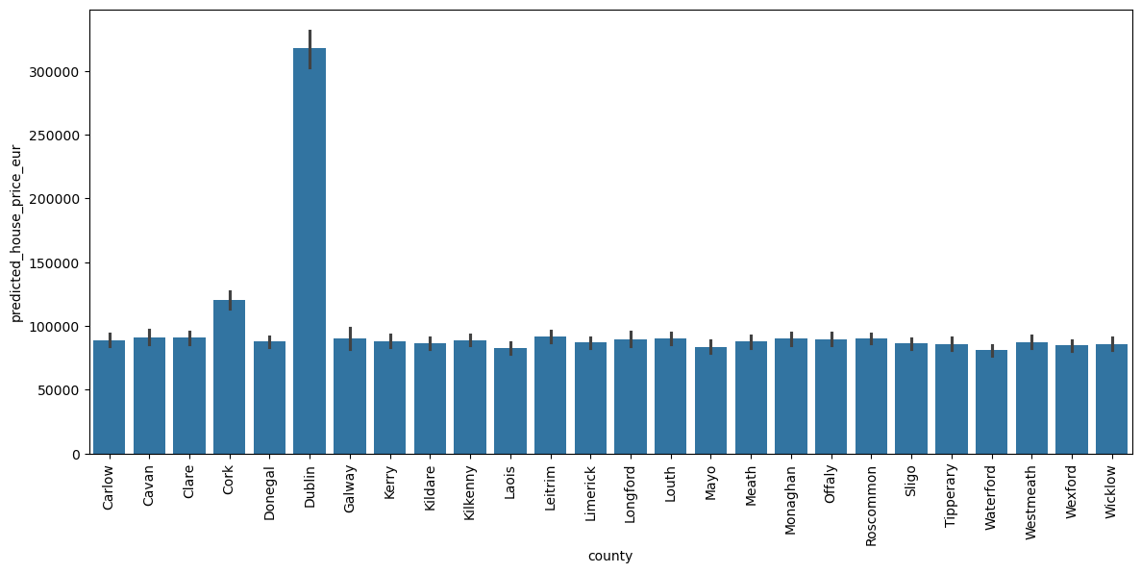We observe that Dublin stands out significantly, with a mean predicted price exceeding €300 000, while most other counties cluster around €100 000 to €120 000. Cork shows the second-highest prices.
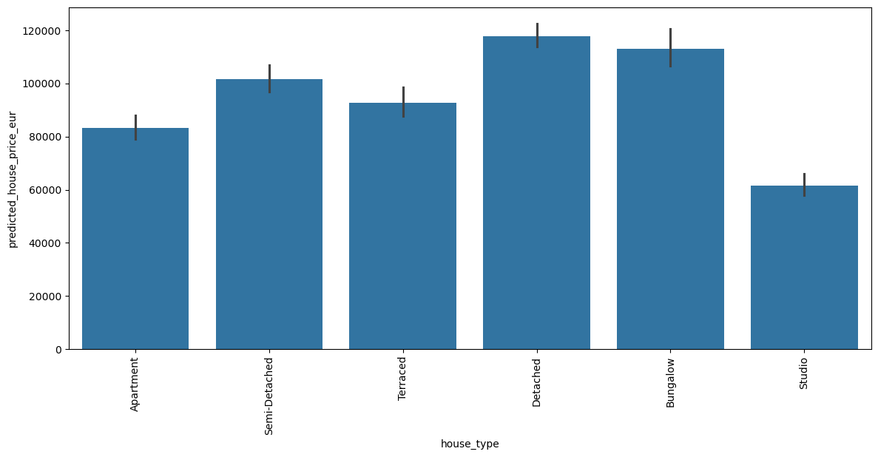Detached houses and bungalows have the highest average prices of €110 000, while studios have the lowest at €60,000.
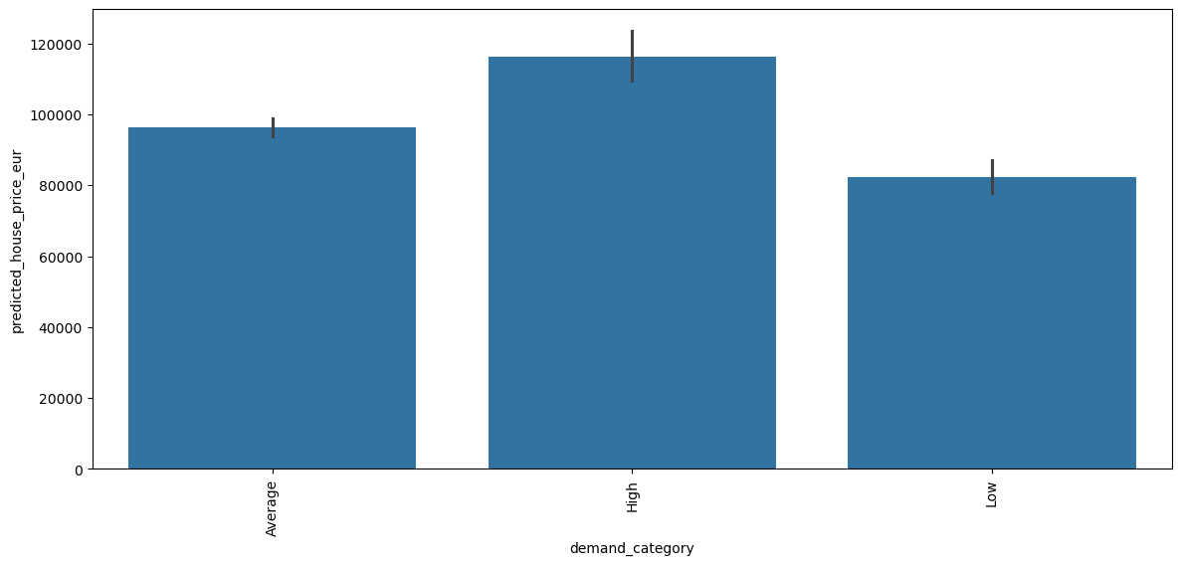
High-demand areas have higher prices (approx. €110 000) compared to average (approx. €95 000) and low-demand (approx. €82 000).
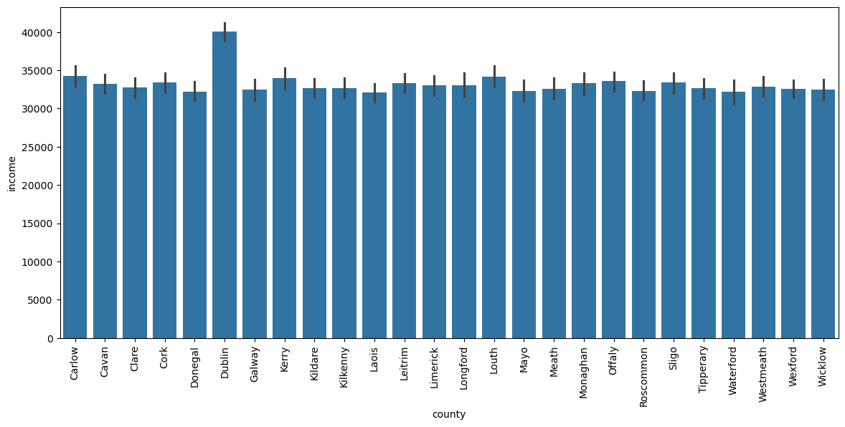
The bar plot of average income by county shows that Dublin stands out with an average income close to €40 000 compared to a max of €34 000 elsewhere.
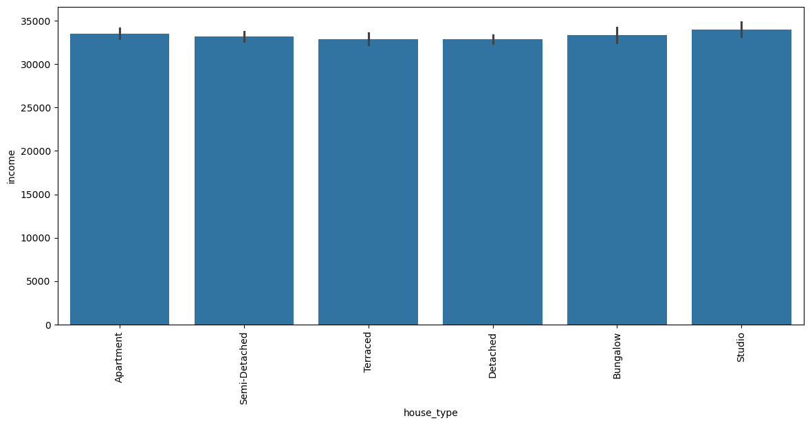
Income varies minimally by house type.
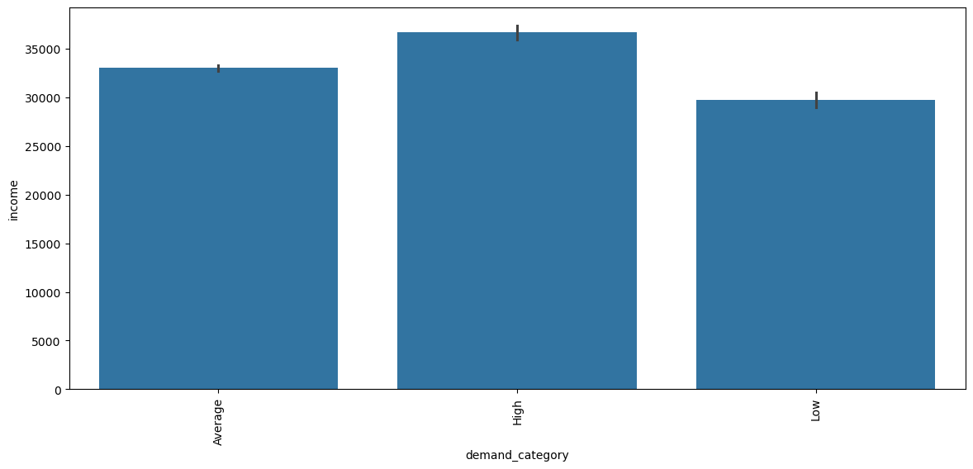
Higher demand categories are associated with higher average income, thus reinforcing the link between income, demand, and house prices.

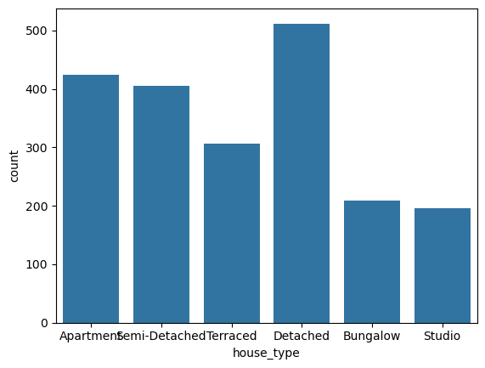
In this count plot, we observe that detached houses are the most common, apartments form the second-largest category, and studios are relatively rare.
To examine if housing prices differ meaningfully across market demand levels, we have selected two independent samples from the dataset High demand areas and low demand areas. The analysed variable was the predicted house price (EUR). We have applied a 95% confidence interval for the mean using the Student’s t-distribution, which is appropriate for large samples. The estimated mean house price for high-demand areas was €116 139 with a 95% confidence interval of [€109 044 and €123 234] while low-demand areas had a mean of €82 211 with a 95% confidence interval of [€77 501 and €86 921]. The confidence intervals do not overlap, indicating a statistically meaningful difference between the two groups. The results confirm that houses in high-demand areas are, on average, significantly more expensive.
To explore statistically significant relationships between selected features and the target, we have conducted three hypothesis tests.
First, we used an independent two-sample t-test to compare average income levels between Dublin and Cork. The test produced a t-statistic of 7.35 with a p-value < 0.001, leading to rejection of the null hypothesis. This indicates a statistically significant difference in income between the two counties, with Dublin showing a higher average income level. This result confirms our previous findings.
Secondly, a one-way Anova was performed to examine whether predicted house prices differ across demand categories (low, average, high). The Anova returned an F-statistic of 33.18 with p-value < 0.001, showing strong evidence against the null hypothesis. This confirms that at least one demand category has a significantly different mean house price. If we combine this result with the results of the confidence interval analysis, we can conclude that the demand level is a key driver of house price variation.
Another one-way Anova was conducted to test whether crime rates differ across house types (detached, semi-detached, and apartment). The results showed an F-statistic of 1.33 and a p-value of 0.266. This suggests that there is no statistically significant difference in crime rates across the house types. Showing that crime is more location-dependent than property-type dependent.
We fitted a simple linear regression model using land price as the independent variable. The model produced a slope coefficient of 820.59, indicating that for every €1 increase in land price per m2, the predicted house price increases by approximately €821. The intercept of €25 605 represents the baseline house price if the land price would be zero. The model achieved an R2 value of 0.657, meaning that approximately 65.7% of the variance in “predicted house price“ is explained by land price alone. This supports the results we had obtained from the heatmap: land price has a strong predictive power, yet we still require additional variables to fully capture housing price variation.
We have also performed a chi-square test to explore associations between each feature and the target variable. Among all tested variables, income was the only feature showing a statistically significant relationship with house price (p < 0.05). Other variables did not show significance in this test, which is expected since the chi-square test is more suitable for categorical data rather than numeric targets.
Next, we have applied encoding, scaling, and feature engineering techniques to several features in order to prepare our dataset for machine learning models. Using “Label Encoding” we have encoded several categorical values: “county”, “house type”, and “demand category”. We have encoded these features to convert non-numerical data into a machine-readable format. Several numerical features (income, land price, transport score, school quality index, crime rate, green space, flood risk, broadband score, and demand score) were standardised using Standard Scaler. Scaling was applied to ensure that variables measured on different scales (such as income vs broadband score) contribute equally to model training. We have also engineered a new feature called “environment” by subtracting the flood risk score from the green space pct. The new feature shows a combined environment quality of an area by combining positive (green space) and negative (flood risk) factors.
PCA (principal component analysis) and LDA (linear discriminant analysis) have been applied to explore dimensionality reduction. Initially, we have divided the target variable into three categories: Low, Medium and high.
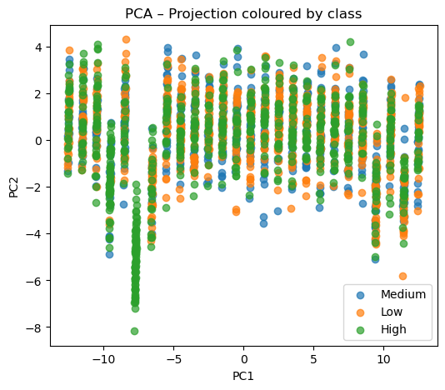
The PCA scatter plot shows a significant overlap, particularly of the medium category.
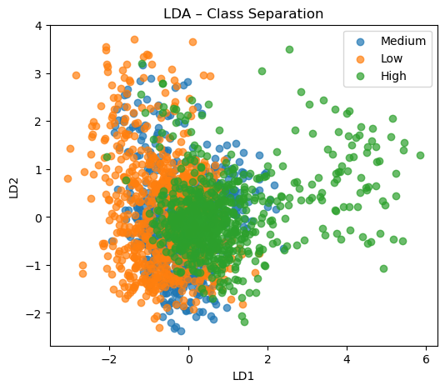
We have also applied LDA (a supervised technique). The LDA projection shows a better separation between Low and High categories, while Medium is still partially overlapped.
As for the second experiment, we have divided our target into two categories only: Low and High.
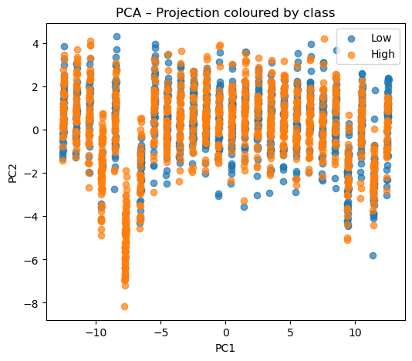
PCA still shows overlapping clusters, similar to the three-category case.
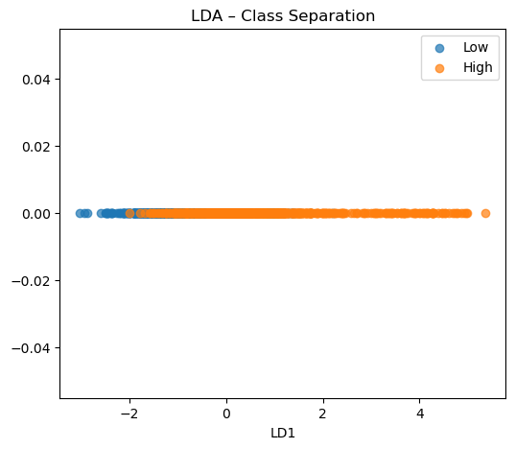
LDA improved separation slightly, but we can still observe some remaining overlap.
Main differences between PCA and LDA are that PCA focuses on capturing variance and is useful for dimensionality reduction, while LDA uses class labels to improve class separation, making it more suitable for classification tasks. LDA provided a better separability than PCA, however overlapping areas were present in both.
Regarding supervised or unsupervised learning approach, we consider that a supervised learning approach is the most suitable choice for this particular dataset. Supervised learning uses labeled data, where the target is known. In this case, our target is the predicted house price, which we have categorised into different classes. Our objective is classification, predicting house price categories based on features. Our independent variables are those with the strongest relationships with our target variable: land price, income, transport score, flood risk score, demand score, crime rate, broadband score, school quality, and green space. While our target is the house price category with three classes (low, medium, and high), and two classes (low and high). To predict house price categories, we have selected Random Forest Classifier and we have used a GridSearchCV with 5-fold cross-validation to find optimal parameters. Given parameters were: n_estimators: 100, 200, 300; max_depth: 4, 8, 10, None; and max_features: 5,10,20. For the three class target the best hyperparameters are: n_estimators 200, max_depth 4, max_features 5, while for two class target best hyperparameters are n_estimators 100, max_depth 8, max_feature 5.
We have trained Random Forest Classifiers using two train-test splits (80/20 and 70/30) and evaluated them using accuracy, precision, recall, F1 score, and confusion matrix. We have also performed k-fold cross-validation (with 10, 20 and 30 folds). Using the PCA transformed features we have also trained our models to explore the impact of dimensionality reduction on prediction.

Results:
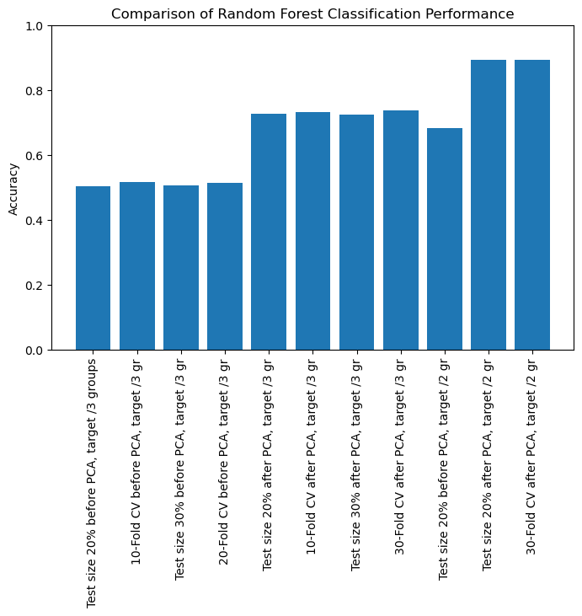

Model / Evaluation | Accuracy
Test size 20% before PCA, target /3 gr | 0.503650
10-Fold CV before PCA, target /3 gr | 0.515342
Test size 30% before PCA, target /3 gr | 0.506494
20-Fold CV before PCA, target /3 gr | 0.514830
Test size 20% after PCA, target /3 gr | 0.727494
10-Fold CV after PCA, target /3 gr | 0.732595
Test size 30% after PCA, target /3 gr | 0.724026
30-Fold CV after PCA, target /3 gr | 0.738527
Test size 20% before PCA, target /2 gr | 0.683698
Test size 20% after PCA, target /2 gr | 0.892944
30-Fold CV after PCA, target /2 gr | 0.892391

The results show that PCA-transformed features have improved test accuracy for the 3-class target scenario. Accuracy went from 50% to 73,8%. Cross-validation accuracies are lower than single split test accuracies due to averaging over folds. The 2-class target setup shows constantly high accuracies across all configurations, given that it’s a simpler task. With PCA-transformed features, accuracy reaches 89%. We can conclude that dimensionality reduction and target simplification can improve predictive performance.

