3
Forms
Over the coming chapters you develop an example application for the management of tasks. As with every desktop application, the Task Manager needs a graphic surface with various views, which might also be referred to as "forms".
In this chapter, you examine the "Matisse" Form Builder in NetBeans IDE. You learn how to create your own forms, while also creating a form required by our Task Manager.

Form Builder
NetBeans IDE 5.0 revolutionized the design of graphic user interfaces for Java desktop applications. The "Matisse" Form Builder, in other words, the modules in NetBeans IDE for visual composition of forms, introduced the new "GroupLayout" layout manager, together with a GUI builder optimized to use it.
In contrast to the previous layout managers, which were based on co-ordinates and the boxing of components, the GroupLayout introduced a new concept: that of distributing components according to their alignment to each other and according to the relative nearness to other components and the edges of the form. In short, this approach lets you design your forms far more intuitively than before, while providing a correspondence between design and deployment that had until then never been matched before.
The Form Builder consists of a number of views, which you look at in some detail during the remainder of this chapter. A global overview of all the views can be seen in figure 1.
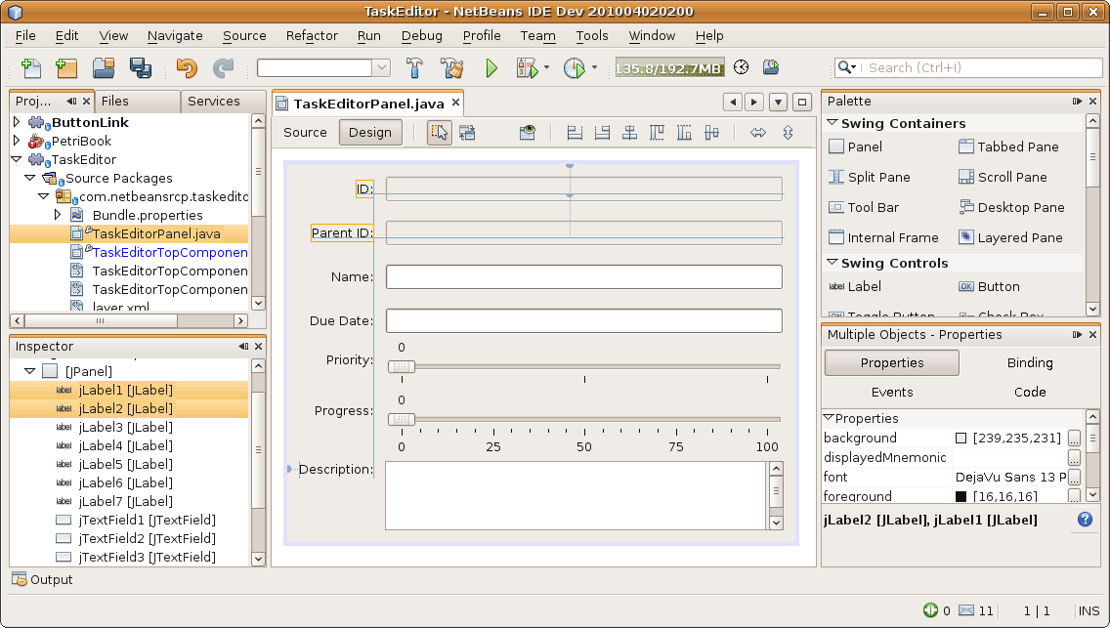
Insert image 1766_3_1.png

The Form Editor has multiple views, derived from the NetBeans MultiView API. In other words, it provides different perspectives on the same component. You can switch between the views via the toggle buttons "Source" and "Design". Unsurprisingly, the Design view shows the graphic view of the components, while the Source view shows the source code. In the Design view, you can arrange components onto a form via standard drag-and-drop behavior. In the Source view, you can type the source code, with the parts that relate to the visual components being protected in blue blocks that cannot be directly edited in this view. The Source view provides access to all the code that is processed once the application is up and running. NetBeans IDE creates supporting XML files for metadata relating to the visual composition of the form, but these files do not contain any of the code required for application processing.
The Inspector window gives you a hierarhical view on the component structure of the current form. By clicking on a component in the Inspector window, you can quickly gain access to it in the form.
The Palette displays a list of components that you can drag and drop into the form. The standard palette includes all the Swing and AWT components and you can extend it by adding your own components to it via the Palette Manager.
The Properties window shows the properties of the current component. Where applicable, the Properties window also lets you modify the current component's properties. It's quite easy to modify properties thanks to the special property editors provided for the most frequently used data types.
The Connection wizard simplifies the writing and registeration of event listeners, though you do not use this wizard in the creation of the Task Manager.
The Form Tester gives you a quick preview of how your application appears when it is deployed. You can preview your form under different look-and-feels, while you can also register additional look-and-feels, if those provided prove insufficient.
Now that you have a general understanding of the "Matisse" Form Builder's main forms, lets take the next step in the creation of our Task Manager. In the same way as done in the previous chapter, create a new module. This time, name it "TaskEditor". In the next section, you create a new form and add it to this newly created module.

Creating a Form
You now create a new form in the new module. To create a new form, right-click the main package of the "TaskEditor" module and choose New | Other. In the category "Swing GUI Forms", select "JPanel Form", and then click Next.
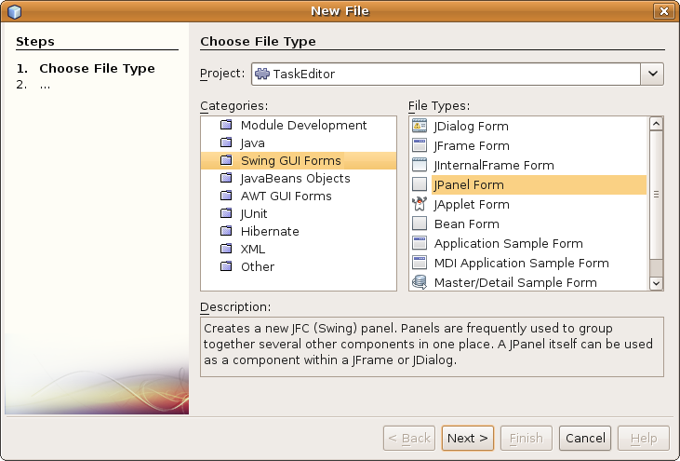
Insert image 1766_3_2.png

In the second wizard panel, type "TaskEditorPanel" as the name of the class and click Finish.
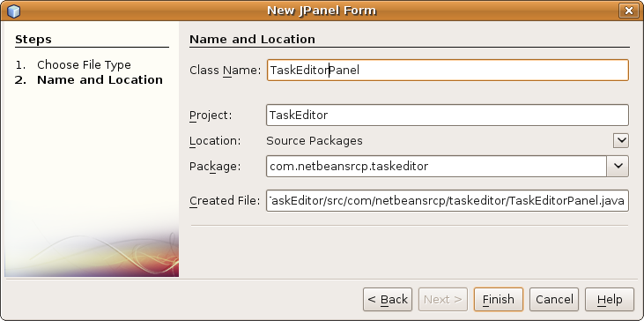
Insert image 1766_3_3.png
The Form Builder opens and shows the empty JPanel form. (see figure 4).
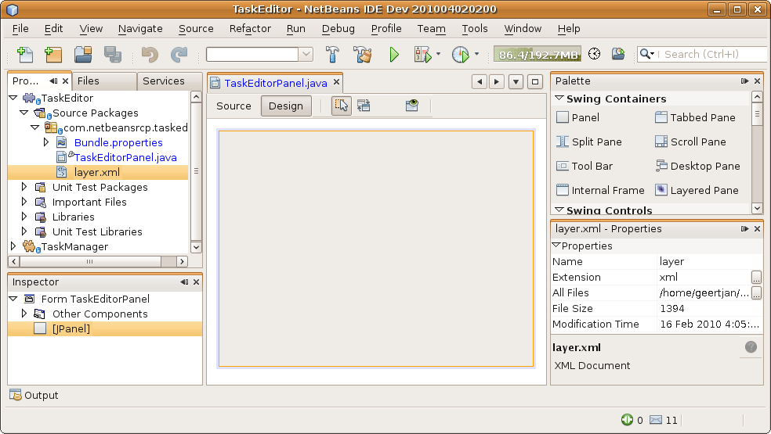
Insert image 1766_3_4.png

Laying Out a Form
The simplest way of laying out a form is to drag components from the palette and to drop them onto the form. Alternatively, you can click a component in the palette and then click the place on the form where you'd like the component to be created. In this case, when you hold down the Shift key, you can very efficiently create multiple components of the same type.
Returning to our TaskManager, click the "Label" component in the Palette, move the cursor over the form, and click your mouse again. A new label, with the name "JLabel1", appears on the form, together with two anchors, showing the location of the label relative to the sides of the form, as shown in figure 5.
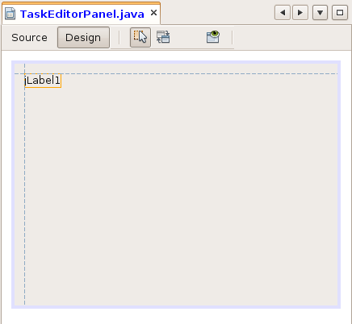
Insert image 1766_3_5.png

Aligning Components on a Form
The Form Builder uses "GroupLayout" as its default layout manager. As described earlier, GroupLayout relies heavily on the relationship of components to each other and to the edges of the form.
To that end, the Form Builder supports the design of components even before you add components to a form. As soon as you add a component near to another component, or near to the edge of the form, the Form Builder attempts to determine the relative position of the component and how the component relates to the other components in the form.
While moving a component in the form, the currently chosen position of the component is shown in the Form Builder by means of dashed lines between the components and the edges, as well as a text display above the form, as shown in figure 6:

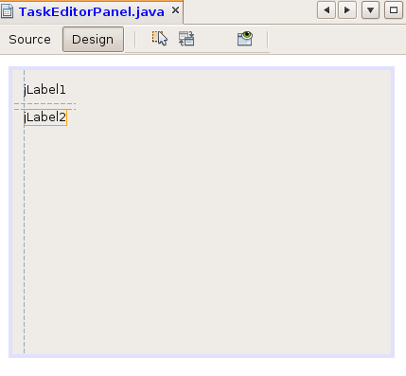
Insert image 1766_3_6.png

As soon as components are placed on the form, the display is updated. The dashed lines are replaced by full lines, showing the position of the sides of the component relative to the other components and the edges. In this way, the anchoring of the component relative to its surroundings are shown to you.
Now, add a second JLabel to the form. Use the Form Builder's guidance lines to suggest a desirable distance between the two components and position the new JLabel so that it is right aligned with the previously dropped JLabel.
Notice that when you place the second JLabel on the form, the relative position to the first JLabel, as well as to the top and left edges of the form, are shown (figure 7).

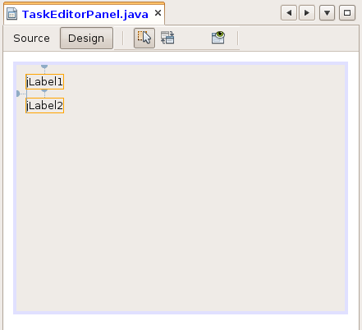

Insert image 1766_3_7.png
By double-clicking a JLabel, you can change its name.
Now add four JTextFields, two JSliders, a JTextArea and seven JLabels to the form.
After double-clicking each of the JLabels, change their texts to "ID", "Parent ID", "Name", "Due Date", "Priority", "Progress", and "Description".
Move the components around the form until they are placed as shown in figure 8.

Space Distribution
Now let's define what should happen when the end user changes the size of the form.
Right-click one of the components and notice the menu item "Auto Resizing". Via this menu item, you can specify the new size of the component after the form has been resized.
Select all the text fields as well as the text area. Then right-click and select "Auto-Resizing | Horizontal". Next, select only the text area, right-click, and choose "Auto-Resizing | Vertical".
Now click the "Preview Design" icon, which is in the toolbar to the right of the "Design"/"View" toggle buttons. The form appears in preview mode. Resize it and make sure that the components within the form are laid out as expected when the form resizes.

Component Properties
When you select a component in the form, its properties are shown in the Properties window. You can modify the properties there, often via a property editor specifically created for the data type in question.
Turning again to our TaskManager, let's define some important properties for the components you created in the previous section.
The JTextFields for the ID and Parent ID serve no other purpose than to be displayed to the end user. Therefore, they should neither be editable nor active. Change the properties "editable" and "enabled" to "false".
The JSlider showing the priority should start at 0, have a maximum of 2, and change in value in steps of 1. Change the "maximum" property to 2, the "value" property to 0, and the "majorTickspacing" property to 1. Next, the ticks should be shown on the slider, while a snapping effect should occur as it is dragged left and right. To that end, change the "paintTicks" and "snapToTicks" properties to true.
Next, let's look at the JSlider showing the progress of the tasks in the Task Manager. As done for the priority slider, make sure to let the user see the slider's ticks and let the slider snap from tick to tick as the user moves it left and right. In addition, let's show the numerical values to the end user in this case. Set the "paintLabels" property to "true". The JSlider values should begin at 0 and end with a maximum of 100. Therefore, set the "value" property to 0 and the "maximum" property to 100. Movement of the slider should occur in steps of 5% and you mark each 25% setting so that the user can see the relative position of the current value. Therefore, set the "minorTickspacing" property to 5 and the "majorTickspacing" property to 25.
Finally, empty the values of the texts in the text fields.
The form should now look as shown in figure 9.
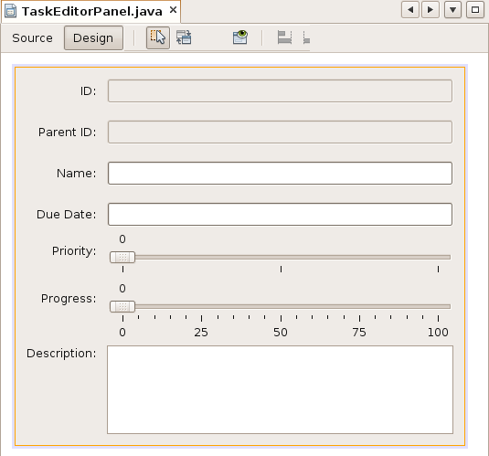

Insert image 1766_3_9.png

Event-Handling
The handling of events is also supported by tools in the Form Builder. When you right-click a component in the Form Builder, the "Events" menu item contains all the events that are relevant to the current component. If you select an event in the list, a Listener is generated as an anonymous inner class, within the protected "blue block" in the "Source" view of the editor. In addition, the Listener is automatically registered to be used with the selected component.
Next, you provide the form with a task instance. Then you synchronize the properties of the task instance with the current values displayed in the form. To that end, you need to be able to access the "TaskModel" module. As shown in the previous chapter, set a dependency in the "TaskEditor" module on the "TaskModel" module. Make sure that the "TaskModel" module exposes its API package, which contains the Task interface.
Now that the API class is available, switch to the "Source" view of the panel and add an instance variable of the type Task:
private Task task = new TaskImpl();
Next, you need a method that writes the content of the form into the task:
private void updateTask() {
this.task.setName(this.jTextField3.getText());
Date due = null;
try {
due = DateFormat.getDateInstance().parse(this.jTextField4.getText());
} catch (ParseException exception) {
due = new Date();
}
this.task.setDue(due);
if (!this.jSlider1.getValueIsAdjusting()) {
switch (this.jSlider1.getValue()) {
case 0:
this.task.setPrio(Task.Priority.LOW);
break;
case 1:
this.task.setPrio(Task.Priority.MEDIUM);
break;
case 2:
this.task.setPrio(Task.Priority.HIGH);
}
}
this.task.setProgr(this.jSlider2.getValue());
this.task.setDescr(this.jTextArea1.getText());
}

You also need a method that updates the form with the values of the task:
private void updateForm() {
this.jTextField1.setText(this.task.getId());
this.jTextField2.setText(this.task.getParentId());
this.jTextField3.setText(this.task.getName());
this.jTextField4.setText(DateFormat.getDateInstance().format(this.task.getDue()));
this.jTextArea1.setText(this.task.getDescr());
if (Task.Priority.LOW.equals(this.task.getPrio())) {
this.jSlider1.setValue(0);
} else if (Task.Priority.MEDIUM.equals(this.task.getPrio())) {
this.jSlider1.setValue(1);
} else {
this.jSlider1.setValue(2);
}
this.jSlider2.setValue(this.task.getProgr());
}

When you display the form, call the method for putting the values of the task into the form. Therefore, overwrite the constructor of the form as follows:
public TaskEditorPanel() {
initComponents();
this.updateForm();
}
Now let's register two ChangeListeners on the sliders. These call our update task method whenever the value of the sliders changes. Right-click the first slider, select "Events", and then "Change | stateChanged". The Form Builder adds a new event in the Source view. Do the same for the second slider.
Implement the two events as follows:
private void jSlider1StateChanged(javax.swing.event.ChangeEvent evt) {
this.updateTask();
}
private void jSlider2StateChanged(javax.swing.event.ChangeEvent evt) {
this.updateTask();
}
You can treat changes in the text fields in the same way. In the next section, you look at a different way of doing so, so that you learn how to modify generated code.

Modification of Generated Code
You've probably noticed that NetBeans IDE generates code in protected "blue blocks" that prevent you from making modifications directly in the source view of the Form Builder. In this way, the Form Builder ensures that the metadata of the form description handled in the "Visual" view remains synchronized with the source code in the "Source" view. If you want to change the code in the "blue blocks", you need to use the "Code" tab of the Properties window, rather than the editor itself.
The properties in the Properties window correspond to specific places in the source code, parts of which can be edited in multiline editors in the Properties window. In this example, you use one of the multiline editors in the Properties window to register your own Listener on the text components in the panel.
Start by creating a DocumentListener and writing it to an instance variable:

private DocumentListener docListener = new DocumentListener() {
@Override
public void insertUpdate(DocumentEvent evt) {
TaskEditorPanel.this.updateTask();
}
@Override
public void removeUpdate(DocumentEvent evt) {
TaskEditorPanel.this.updateTask();
}
@Override
public void changedUpdate(DocumentEvent evt) {
TaskEditorPanel.this.updateTask();
}
};

Now, in the design view, select the "Name" text field. Open the "Code" tab of the Properties window. Now click on the "..." button next to "Post-Listeners Code". In the text area that appears, enter the following statement and click OK:
this.jTextField3.getDocument().addDocumentListener(this.docListener);
Do the same for each of the other text fields.

Extending the Palette
You've already used the palette to quickly and easily add components to your form. In this section, you'll add the panel as a new component to the palette. That enable you to drag and drop the panel onto a window, in the next chapter, in the same way that you dragged and dropped JLabels and JTextFields earlier in this chapter.
Right-click in the Palette and choose the "Palette Manager" menu item to open the Palette Manager. In the Palette Manager, click "New Category" and type "My Category" in the "New Palette Category" dialog. Click OK. You should now see the "My Category" item at the top of the Palette Manager.
Back in the Palette Manager, click "Add from Project". In the "Install Components to Palette" wizard, choose the Task Manager project and then select the "TaskEditor" module project. Click Next. From the JavaBeans available in the project, select our task editor panel and then select the new "My Category" category in the final page of the wizard. Click Finish.

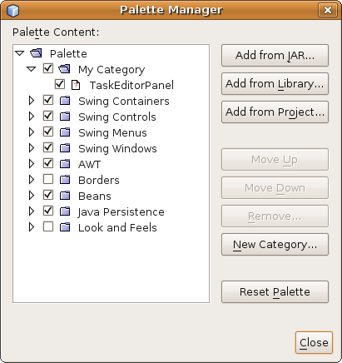
Insert image 1766_3_10.png
Now the palette contains your own custom component, containing the task editor panel which you reuse in the next chapter.

Summary
In this chapter, you learned how to use the "Matisse" Form Builder and created a form required by the Task Manager.

