4
Window System
Large desktop applications need to provide many different views for visualizing data. These views have to be managed and shown and the NetBeans Platform handles these requirements for you out of the box via its docking framework.
While it once might have been sufficient for a docking framework to provide static fixed window layouts, today the user expects far more flexibility. Windows should be openable, movable, and, generally, customizable at runtime. The user tends to assume that the positions of views are modifiable and that they persist across restarts of the application. Not only that, but applications are assumed to be so flexible that views should be detachable from the application's main window, enabling them to be displayed on multiple monitors at the same time. While once the simple fact of the availability of menus and toolbars was sufficient, today a far more dynamic handling is needed so that window content can be adapted dynamically. Connected to these expectations of flexibility, plugins are increasingly becoming a standard technology, with the user assuming their windows to be pluggable, too.
In short, the requirements for window management have become quite complex and can only be met by means of an external docking framework, otherwise all these various concerns would need to be coded (and debugged, tested, and maintained) by hand. The NetBeans Platform provides all of these features via its docking framework, known as the NetBeans Window System. It also provides an API to let you programmatically access the window system. Together, the window system and its API fulfil all the requirements described above, letting you concentrate on your domain knowledge and business logic rather than on the work of creating a custom window management facility for each of your applications.
This chapter teaches you how to define views and their respective positions in the main window, both declaratively and programmatically. Moreover, you learn how to customize the default window layout and how to group views so that they open and close as a unit. Finally, you examine the persistence of views across restarts of the application.

Creating a Window
The NetBeans Window System simplifies window management by letting you use a default component for displaying windows. The default component, that is, the superclass of all windows, is the TopComponen class, which is derived from the standard JComponent class. It defines many methods for controlling a window and handles notification of main window system events.
The WindowManager is the central class controlling all the windows in the application. Though you can implement this class yourself, this is seldom done since normally the default WindowManager is sufficient. Similarly, you typically use the standard TopComponent class, rather than creating your own top level Swing components. In contrast to the TopComponent class, the default WindowManager cannot manage your own top level Swing components, so that these cannot take advantage of the Window System API.
Now let's create a TopComponent and let it be an editor for working with tasks. This is done most easily by using the "New Window" wizard.
- In the Projects window, right-click the TaskEditor module project node and choose "New | Window".
- On the first page of the wizard select “Editor” for “Window Position” and “Open on Application Start”.
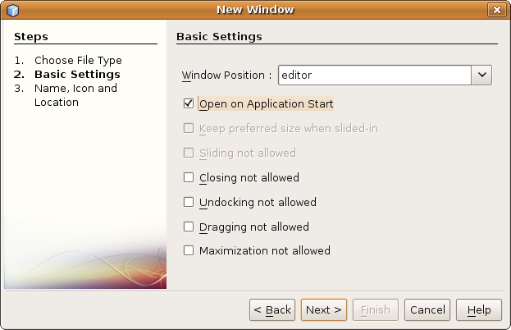
Insert image 1766_4_1.png
Click Next.
- In the next page of the wizard, type “TaskEditor” in “Class Name Prefix”. This prefix is used for all the generated files. It is possible to specify an icon that will be displayed in the tab of the new window, but let's skip that for the moment.
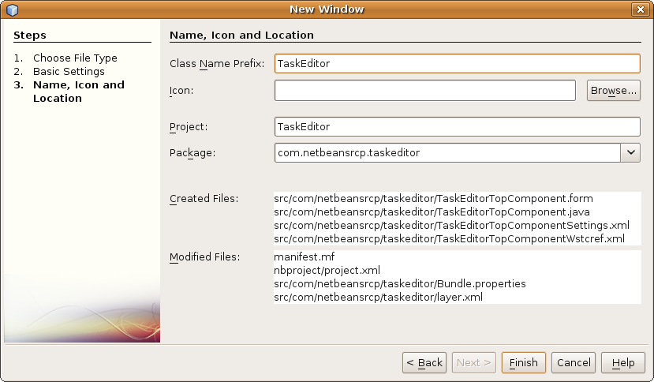
Insert image 1766_4_2.png
Click Finish and all the files are generated into your module source structure.
- Next, open the newly created TaskEditorComponent and drag the TaskEditorPanel from the palette, which is where you put it at the end of the last chapter, onto the form.
- The size of the component automatically adjusts to the required size of the panel. Position the panel with the preferred spacing to the left and top and activate the automatic resizing of the panel in horizontal and vertical direction. The form should now look similar to the following picture.

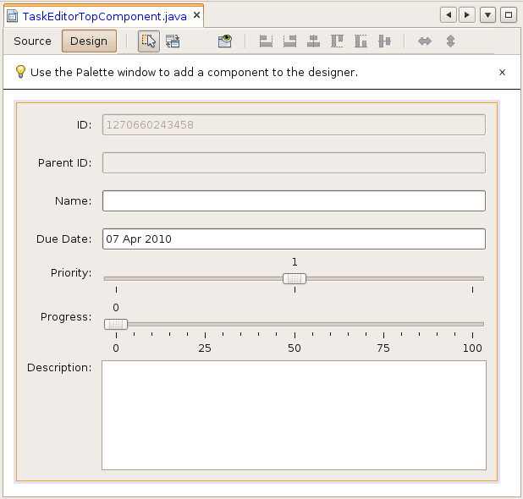
Insert image 1766_4_3.png

- Start the application. You now see a tab containing the new TaskEditor Window, which holds your form.

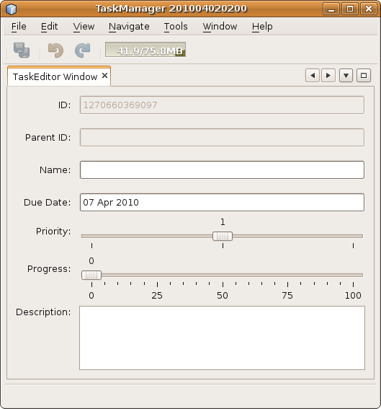
Insert image 1766_4_4.png

Examining the Generated Files
You have used a wizard to create a new TopComponent. However, the wizard did more than that. Let's take a look at all the files that have been created and at all the files that have been modified, as well as how these files work together.
The only Java class that was generated is the TopComponent that will contain the TaskEditor. Here it is:
@ConvertAsProperties(dtd = "-//com.netbeansrcp.taskeditor//TaskEditor//EN", autostore = false)
public final class TaskEditorTopComponent extends TopComponent {
private static TaskEditorTopComponent instance;
/** path to the icon used by the component and its open action */
// static final String ICON_PATH = "SET/PATH/TO/ICON/HERE";
private static final String PREFERRED_ID = "TaskEditorTopComponent";

public TaskEditorTopComponent() {
initComponents();
setName(NbBundle.getMessage(TaskEditorTopComponent.class, "CTL_TaskEditorTopComponent"));
setToolTipText(NbBundle.getMessage(TaskEditorTopComponent.class, "HINT_TaskEditorTopComponent"));
// setIcon(ImageUtilities.loadImage(ICON_PATH, true));

}

/** This method is called from within the constructor to
* initialize the form.
* WARNING: Do NOT modify this code. The content of this method is
* always regenerated by the Form Editor.
*/
// <editor-fold defaultstate="collapsed" desc="Generated Code">
private void initComponents() {

javax.swing.GroupLayout layout = new javax.swing.GroupLayout(this);
this.setLayout(layout);
layout.setHorizontalGroup(
layout.createParallelGroup(javax.swing.GroupLayout.Alignment.LEADING)
.addGap(0, 555, Short.MAX_VALUE)
);
layout.setVerticalGroup(
layout.createParallelGroup(javax.swing.GroupLayout.Alignment.LEADING)
.addGap(0, 442, Short.MAX_VALUE)
);
}// </editor-fold>

// Variables declaration - do not modify
// End of variables declaration
/**
* Gets default instance. Do not use directly: reserved for *.settings files only,
* i.e. deserialization routines; otherwise you could get a non-deserialized instance.
* To obtain the singleton instance, use {@link #findInstance}.
*/
public static synchronized TaskEditorTopComponent getDefault() {
if (instance == null) {
instance = new TaskEditorTopComponent();
}
return instance;
}

/**
* Obtain the TaskEditorTopComponent instance. Never call {@link #getDefault} directly!
*/
public static synchronized TaskEditorTopComponent findInstance() {
TopComponent win = WindowManager.getDefault().findTopComponent(PREFERRED_ID);
if (win == null) {
Logger.getLogger(TaskEditorTopComponent.class.getName()).warning(
"Cannot find " + PREFERRED_ID + " component. It will not be located properly in the window system.");
return getDefault();
}
if (win instanceof TaskEditorTopComponent) {
return (TaskEditorTopComponent) win;
}
Logger.getLogger(TaskEditorTopComponent.class.getName()).warning(
"There seem to be multiple components with the '" + PREFERRED_ID
+ "' ID. That is a potential source of errors and unexpected behavior.");
return getDefault();
}

@Override
public int getPersistenceType() {
return TopComponent.PERSISTENCE_ALWAYS;
}

@Override
public void componentOpened() {
// TODO add custom code on component opening
}

@Override
public void componentClosed() {
// TODO add custom code on component closing
}

void writeProperties(java.util.Properties p) {
// better to version settings since initial version as advocated at
// http://wiki.apidesign.org/wiki/PropertyFiles
p.setProperty("version", "1.0");
// TODO store your settings
}

Object readProperties(java.util.Properties p) {
if (instance == null) {
instance = this;
}
instance.readPropertiesImpl(p);
return instance;
}

private void readPropertiesImpl(java.util.Properties p) {
String version = p.getProperty("version");
// TODO read your settings according to their version
}

@Override
protected String preferredID() {
return PREFERRED_ID;
}

}
As expected, the class TaskEditorTopComponent extends the TopComponent class.
Let's look at it more closely:
- For efficient resource usage, the generated TopComponent is implemented as a singleton. A private constructor prohibits its incorrect usage from the outside by disallowing direct instantiation of the class. The static attribute instance holds the only instance in existence. The static method getDefault creates and returns this instance if necessary on demand. Typically, getDefault should never be called directly. Instead of this, you should use findInstance, which delegates to getDefault if necessary. findInstance tries to retrieve the instance using the WindowManager and the ID of the TopComponent before falling back to the singleton instance. This ensures the correct usage of persistent information.
- The constructor creates the component tree for the TaskEditorTopComponent by calling the method initComponents(). This method contains only code generated via the NetBeans “Matisse” Form Builder and is read-only in the NetBeans Java editor. You can change the code in this method using the Form Builder's Property Sheet, as will be shown later.
- The static property PreferredID holds the TopComponent ID used for identification of the TopComponent. As indicated by its name, the ID can be changed by the Window System, if name clashes occur. The ID is used throughout all the configuration files.
- The methods componentOpened() and componentClosed() are part of the lifecycle of the TopComponent.
- You learn about the method getPersistenceType() later, in the section about the persistence of TopComponents.
Note: The code only defines the visual aspects of the TaskEditorTopComponent and manages the singleton instance of this component. In no way does the code describe how and where the instance is shown.
Two small XML files are created by the wizard. The first is the TopComponent's settings file:
<?xml version="1.0" encoding="UTF-8"?>
<!DOCTYPE settings PUBLIC "-//NetBeans//DTD Session settings 1.0//EN" "http://www.netbeans.org/dtds/sessionsettings-1_0.dtd">
<settings version="1.0">
<module name=”com.netbeansrcp.taskeditor" spec="1.0"/>
<instanceof class="org.openide.windows.TopComponent"/>
<instanceof class="com.netbeansrcp.taskeditor.TaskEditorTopComponent"/>
<instance class="com.netbeansrcp.taskeditor.TaskEditorTopComponent" method="getDefault"/>
</settings>
The settings file describes the persistent instance of the TopComponent. As you can see, the configuration above describes that the TopComponent belongs to the module TaskEditor in the specification version “1.0” and that it is an instance of the types TopComponent and TaskEditorTopComponent. Also described is that the instance that is created is done so using the method call TaskEditorTopComponent.getDefault().
<?xml version="1.0" encoding="UTF-8"?>
<!DOCTYPE tc-ref PUBLIC "-//NetBeans//DTD Top Component in Mode Properties 2.0//EN" "http://www.netbeans.org/dtds/tc-ref2_0.dtd">
<tc-ref version="2.0" >
<module name="com.netbeansrcp.taskeditor" spec="1.0"/>
<tc-id id="TaskEditorTopComponent"/>
<state opened="true"/>
</tc-ref>
The WSTCREF (window system creation file) describes the position of the TopComponent within the main window. This becomes more clear with the following file. The other important information in the ref-file is the opened state at application start.
Typically, you do not have to change these two configuration files by hand. This is not true for the following file, the layer.xml, which you often need to change manually, to register new folders and files in the filesystem.
<?xml version="1.0" encoding="UTF-8"?>
<!DOCTYPE filesystem PUBLIC "-//NetBeans//DTD Filesystem 1.2//EN" "http://www.netbeans.org/dtds/filesystem-1_2.dtd">
<filesystem>
<folder name="Actions">
<folder name="Window">
<file name="com-netbeansrcp-taskeditor-TaskEditorAction.instance">
<attr name="component" methodvalue="com.netbeansrcp.taskeditor.TaskEditorTopComponent.findInstance"/>
<attr name="displayName" bundlevalue="com.netbeansrcp.taskeditor.Bundle#CTL_TaskEditorAction"/>
<attr name="instanceCreate" methodvalue="org.openide.windows.TopComponent.openAction"/>
</file>
</folder>
</folder>
<folder name="Menu">
<folder name="Window">
<file name="TaskEditorAction.shadow">
<attr name="originalFile" stringvalue="Actions/Window/com-netbeansrcp-taskeditor-TaskEditorAction.instance"/>
</file>
</folder>
</folder>
<folder name="Windows2">
<folder name="Components">
<file name="TaskEditorTopComponent.settings" url="TaskEditorTopComponentSettings.xml"/>
</folder>
<folder name="Modes">
<folder name="editor">
<file name="TaskEditorTopComponent.wstcref" url="TaskEditorTopComponentWstcref.xml"/>
</folder>
</folder>
</folder>
</filesystem>
The layer.xml is integrated into the SystemFileSystem using the module manifest . The SystemFileSystem is a virtual filesystem for user settings. Each module can supply a layer file for merging configuration data from the module into the SystemFileSystem.
The Window System API and the Actions API reserve a number of folders in the virtual filesystem for holding its configuration data. These folders enable specific subfolders and files relating to window system registration to be added to the filesystem.
- Let's have a look at the folder “Windows2”. “Windows2” contains a folder named “Components”, which contains a virtual file with the name of the TopComponent and the extension “.settings”. This “.settings” file redirects to the real settings file. It is used to make the configuration known to the Window System.
- In addition, the “Windows2” folder contains a folder named “Modes”, which contains a folder named “editor”. Modes represent the possible positions at which TopComponents can be shown in the application (further details to Modes are described in section ??). The “editor” folder contains a “.wstcref” file for our TopComponent, which refers to the real ref-file. This registers the TopComponent in the mode “editor”, so it shows up where typically editor windows are opened.
- Next, take a look at the folder “Actions”. It contains a folder named “Window” which contains a file declaring the action opening the TaskEditorTopComponent. The name is typically following Java class naming conventions with dots replaced by dashes and ending in”.instance”. The declaration of the virtual file itself consists of three critical parts. The attribute component describes how to create the component (methodvalue declares which method to call). The attribute displayName describes the default action name as shown e.g. in menu items. A possible declaration is the bundlevalue which describes the bundle and key to use to retrieve the display name. The attribute instanceCreate uses a static method call to create a real action to use.
- The folder “Menu” describes the application main menu. The folder “Window” contains a “.shadow” file. The attribute originalFile uses the full path in the SystemFileSytem to delegate to the original action declaration as described above. “.shadow” files are used as symbolic links to real defined virtual files. This declaration adds the action to the real menubar of the application.
As a result, important parts of the Window System API are not called programmatically, but are simply used declaratively. Declarative aspects include configuration and the positioning of windows, as well as the construction of the menu.
In addition, you discovered that the wizard for creating TopComponents always creates singleton views. If you would like to change that, you need to adapt the code created by the wizard. For the time being, it is sufficient to use the singleton approach, particularly as it is more resource friendly.

Automatic Window Lifecycle Management
A further major advantage of the Window System API is that it provides a WindowManager that controls the lifecycle of all the windows defined in the application. The WindowManager notifies all TopComponents about state changes using callback methods, as listed below.
- componentOpened() is called after the TopComponent has been opened. If multiple TopComponents are opened into the same position (called “mode”), the NetBeans Window System uses a tabbed container, with one TopComponent per tab. Of all available TopComponents found within a shared tabbed container, only the content of the selected TopComponent is visible.
- componentShowing() notifies the component that its content is now visible. This TopComponent is now either selected or is the only component in a separate container.
- componentActivated() is called after the TopComponent has gained the input focus or has become the selected component.
- componentDeactivated() is called after the TopComponent has lost the input focus.
- componentHidden() notifies the TopComponent that its content is no longer visible.
- componentClosed() is called after the TopComponent has been closed.

Let's illustrate this lifecycle via an example that logs all the callback methods to the Output Window of NetBeans IDE, which is your development environment on top of the NetBeans Platform.
- Create a new NetBeans Platform application and name it “WindowSystemExamples”.
- Add a new module named “LifeCycle”, with code name base “com.netbeansrcp.lifecycle”.
- Add a TopComponent , with class name prefix “LifeCycleDemo”, making sure to indicate that it should be automatically opened in the editor area at application startup.
- Override the lifecycle methods as follows:

public void componentOpened() {
super.componentOpened();
System.out.println("componentOpened()");
}

protected void componentShowing() {
super.componentShowing();
System.out.println("componentShowing()");
}

protected void componentActivated() {
super.componentActivated();
System.out.println("componentActivated()");

}

@Override
protected void componentDeactivated() {
super.componentDeactivated();
System.out.println("componentDeactivated()");
}

@Override
protected void componentHidden() {
super.componentHidden();
System.out.println("componentHidden()");
}

@Override
public void componentClosed() {
super.componentClosed();
System.out.println("componentClosed()");
}

Start the new application. The TopComponent “LifecycleDemo” is autmatically opened at start up. Select the TopComponent and inspect the output in the NetBeans IDE Output Window. You should see the following:
componentOpened()
componentShowing()
componentActivated()
The TopComponent has passed the first half of its lifecycle and is now activated.
Close the LifecycleTopComponent and inspect the output again, to understand the second half of the TopComponent lifecycle. You should see the following output:
componentHidden()
componentDeactivated()
componentClosed()
You have learned that the TopComponent's lifecycle is automatically controlled by the NetBeans Platform. Between the start and the end of the TopComponent's lifecycle are six different states, all managed by the NetBeans Platform, with notifications sent via callbacks.

Programmatically Managing the Window Lifecycle
You can manage the lifecycle of a TopComponent programmatically. For this purpose, the TopComponent provides the following methods:
- open() opens the TopComponent
- requestVisible() request the Window System to select to TopComponent in its actual container
- requestActive() requests to transfer the input focus to the TopComponent

Let's now modify the LifeCycleDemoTopComponent for demonstration purposes.
- Add a JButton to the TopComponent, as follows:
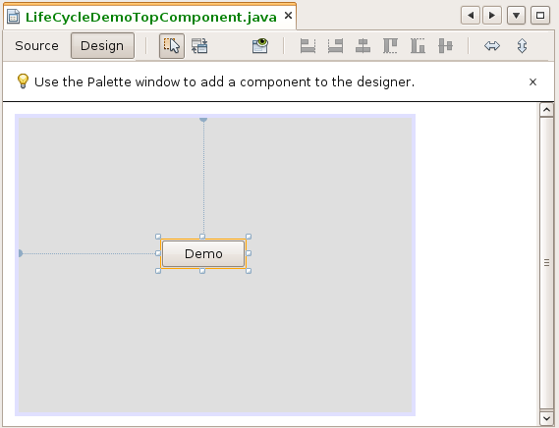
Insert image 1766_4_5.png

- Implement an ActionEventListener as follows:

private void jButton1ActionPerformed(java.awt.event.ActionEvent evt) {

this.close();

RequestProcessor.getDefault().post(new java.lang.Runnable() {

public void run() {
java.awt.EventQueue.invokeLater(new java.lang.Runnable() {

public void run() {
com.netbeansrcp.lifecycle.LifeCycleDemoTopComponent.this.open();
}
});
}
}, 3000);

RequestProcessor.getDefault().post(new java.lang.Runnable() {

public void run() {
java.awt.EventQueue.invokeLater(new java.lang.Runnable() {

public void run() {
com.netbeansrcp.lifecycle.LifeCycleDemoTopComponent.this.requestActive();
}
});
}
}, 6000);
}

2. Restart the application. When you click the button, the LifecycleDemoTopComponent is closed via the close() method, called above in the first line of the code you entered.
The RequestProcessor provides a thread pool. The default instance of this pool lets you execute a Runnable after a short delay, thanks to the post() method. Since the TopComponent's lifecycle methos should be called from the AWT event thread, you do not call them directly in the run() method, but by posting a new Runnable to the EventQueue, which in the end calls the Window System API methods.
The argument 3000 ensures that the execution of the Runnable is delayed for 3000ms so that the TopComponent is opened again after 3s.
After six seconds the second Runnable posted to the EventQueue is executed and requestActive() is called for your LifecycleDemoTopComponent. Your TopComponent is now shown in the foreground, if it had been behind other windows previously.
You have learned how to manage the lifecycle of a TopComponent. Via the example you have seen how to open a TopComponent and make it focusable.

Positioning of Windows
The NetBeans Window System divides the available space in the main window into areas that are called “modes”. Each mode represents a specific area of the main window, providing a container for windows in a predefined position in the frame. You can add windows, i.e., TopComponents, to a mode, either declaratively or programmatically.
A standard layout is provided by the NetBeans Window System, corresponding to the layout of NetBeans IDE. For example, the predefined modes correspond to the names used in the corresponding positions in NetBeans IDE, such as “editor” and “explorer”. If needed, you can define your own modes, too. No wizard is provided for this purpose in NetBeans IDE, so that you need to create the mode definition files yourself manually.
In the previous section you learned about the layer.xml file. To create a default layout for an application, each TopComponent needs to be declaratively registered within the “Windows2 | Modes” folder, within a subfolder named after the mode in which the TopComponent should be docked.
To demonstrate declarative registration of TopComponents, edit the layer.xml in the Lifecycle module, changing the folder name “Windows2 | Modes | editor” to “Windows | Modes | rightSlidingSide”, as shown below:
layer.xml
// ...
<folder name="Windows2">
<folder name="Components">
<file name="LifecycleDemoTopComponent.settings"
url="LifecycleDemoTopComponentSettings.xml"/>
</folder>
<folder name="Modes">
<folder name="rightSlidingSide">
<file name="LifecycleDemoTopComponent.wstcref"
url="LifecycleDemoTopComponentWstcref.xml"/>
</folder>
</folder>
</folder>
// ...

Select “Clean & Build” on the application node in the Projects window, to remove the “build” folder containing the last used window layout, and start the application again. When the application starts up, notice that the LifecycleDemoTopComponent is not opened in the editor mode. Instead, it is represented by a button on the right sidebar of the application (see illustration 6). That is the “rightSlidingSide” mode, providing a container for minimized windows.
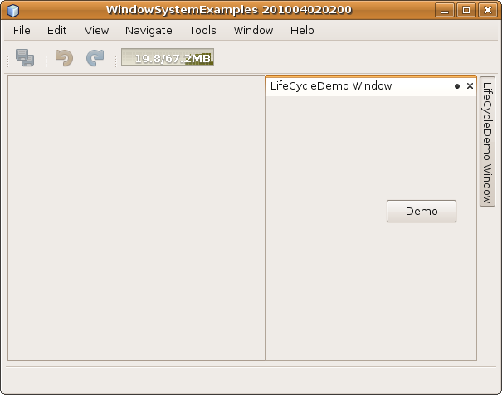
Insert image 1766_4_6.png

As you have seen, providing a default layout via declarative registrations of TopComponents is rather easy. You only need to create an entry in the layer.xml for the TopComponent, in a folder with the name of the desired mode, within the “Windows2 | Modes” folder.
Sometimes declarative registration alone is too static for your business needs. Fortunately, positioning of TopComponents can also be done programmatically. In the next example, you create a TopComponent that moves to new modes via a click of a button.
- Add to the WindowSystemExamples application a new module named “Modes”, with the code name base com.netbeansrcp.modes.
- Within the module, create a TopComponent called ModesDemo, which is opened when the application starts into the “editor” mode.
- Add two JButtons to the TopComponent with the texts “Back” and “Forward”, as well as a JLabel with an empty initial text. The TopComponent should look something like this:
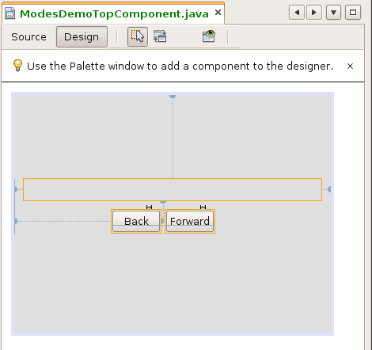
Insert image 1766_4_7.png

4. In the Source view, add the code below:
private static final String[] MODES = new String[]{
"properties", "commonpalette", "rightSlidingSide",
"bottomSlidingSide", "output", "debugger", "navigator",
"explorer", "leftSlidingSide", "editor"
};

private void changeMode(boolean next) {
Mode currentMode = WindowManager.getDefault().findMode(this);
String currentModeName = currentMode.getName();

String nextModeName = "editor";
for (int i = 0; i < MODES.length; i++) {
String modeName = MODES[i];
if (modeName.equals(currentModeName)) {
if (next) {
nextModeName = (i + 1 < MODES.length) ? MODES[i + 1] : MODES[0];
} else {
nextModeName = (i - 1 >= 0) ? MODES[i - 1] : MODES[MODES.length - 1];
}
break;
}
}

Mode nextMode = WindowManager.getDefault().findMode(nextModeName);
if (nextMode != null) {
this.jLabel1.setText(nextModeName);
nextMode.dockInto(this);
this.open();
this.requestActive();
}
}
private void jButton2ActionPerformed(java.awt.event.ActionEvent evt) {
this.changeMode(true);
}
private void jButton1ActionPerformed(java.awt.event.ActionEvent evt) {
this.changeMode(false);
}
The static string array contains the names of the most important modes. These modes can also be identified dynamically, by calling WindowManager.getDefault().getModes().
The ActionListener delegates the call to the method changeMode() and gives the desired back/forward direction. This method determines via WindowManager.getDefault ().findMode (this) the mode in which the TopComponent is displayed, as well as the name of the current mode.
The string array is then searched and dockInto(this) is called to dock the TopComponent into a different mode.
Note: Because the layout of the NetBeans Plattform is persisted when the application shuts down, first perform a “Clean & Build” on the application project. With the removal of the “build” folder, the layout settings are also deleted, so that the default layout is used when the application starts again.
Using the two buttons, you can let the TopComponent be docked in some of the most commonly used modes (see illustration 8).
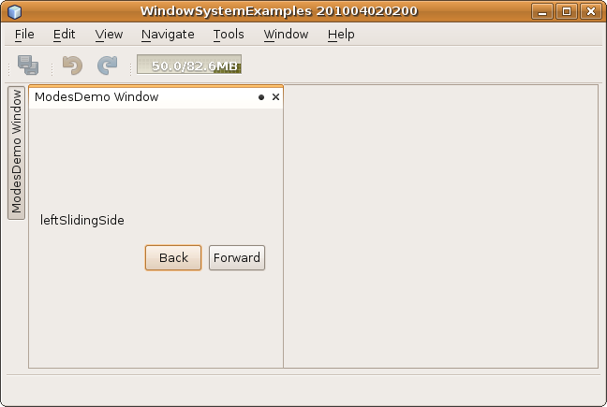
Insert image 1766_4_8.png
You have programmatically docked a TopComponent into various places within the available modes in the application. In the process, you have learned how TopComponents can be docked dynamically, that is, at runtime, into desired positions. Both the declarative and the programmatic approaches to docking should now be familiar to you.
In the next section, you learn how to extend the standard layout and define your own modes.

Creating Custom Modes
You can get quite far with the standard modes provided by the NetBeans Platform. Still, sometimes you may need to provide a custom mode, to provide a new position for the TopComponents within the application. A custom mode is created declaratively in XML files, rather than programmatically in Java code.
In the following example, you create two new modes that are positioned side by side directly below the main toolbar, using a specific location relative to each other.
- Create a new module named CustomModes, with code name base “com.netbeansrcp.custommodes”, within the existing WindowSystemExamples application.
- Right-click the module project and choose New | Other to open the New File dialog. Then choose Other | Empty File, as shown below:
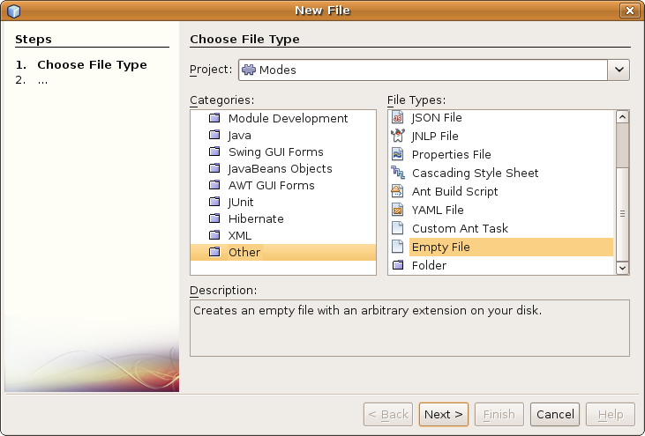
Insert image 1766_4_9.png
3. Type “mode1.wsmode” as the new file name and file extension, as shown below:
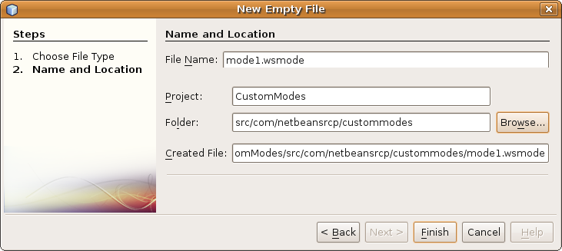
Insert image 1766_4_10.png
Click Finish.
4. Define the content of the new “mode1.wsmode” as follows:
<?xml version="1.0" encoding="UTF-8"?>
<!DOCTYPE mode PUBLIC
"-//NetBeans//DTD Mode Properties 2.3//EN"
"http://www.netbeans.org/dtds/mode-properties2_3.dtd">
<mode version="2.3">
<name unique="mode1" />
<kind type="view" />
<state type="joined" />
<constraints>
<path orientation="vertical" number="20" weight="0.2"/>
<path orientation="horizontal" number="20" weight="0.5"/>
</constraints>
</mode>
4. Create another file to define the second mode and name it “mode2.wsmode”. Add this content to the new file:
<?xml version="1.0" encoding="UTF-8"?>
<!DOCTYPE mode PUBLIC
"-//NetBeans//DTD Mode Properties 2.3//EN"
"http://www.netbeans.org/dtds/mode-properties2_3.dtd">
<mode version="2.3">
<name unique="mode2" />
<kind type="view" />
<state type="joined" />
<constraints>
<path orientation="vertical" number="20" weight="0.2"/>
<path orientation="horizontal" number="40" weight="0.5"/>
</constraints>
</mode>
Via the two wsmode files described above, you have defined two custom modes. The first mode has the unique name “mode1”, with the second named “mode2”. Both are created for normal TopComponents (“view” instead of “editor”) that are integrated into the main window, rather than being undocked by default (“joined” instead of “separated”).
The constraints elements in the files are comparable to GridBagLayout, with a relative horizontal and vertical position, as well as a relative horizontal and vertical weight. You place mode1 in position 20/20 with a weighting of 0,5/0,2, while mode2 is placed in position 20/40 with the same weighting.
If all the other defined modes have TopComponents opened within them, the TopComponents in the two new modes should lie side by side, right above the status bar, taking up 20% of the available vertical space, with the horizontal space shared between them.
5. Let's now create two new TopComponents and register them in the layer.xml file so that they will be displayed in your new modes. Do this by using the New Window wizard twice in the “CustomModes” module, first creating a window called “RedTopComponent” and then a window called “BlueTopComponent”.
Note: In the wizard, in both cases, it does not matter what you set to be the window position, since you are going to change that setting manually afterwards. Let both of them open automatically when the application starts.
6. In the Design mode of both TopComponents, add a JPanel to each of the TopComponents. Change the background property of the panel in the RedTopComponent to red and in the BlueTopComponent to blue.
7. Edit the layer.xml of “CustomModes” module, registering the two “.wsmode” files and ensuring that the two new TopComponents open in the new modes:
<folder name="Windows2">
<folder name="Components">
<file name="BlueTopComponent.settings" url="BlueTopComponentSettings.xml"/>
<file name="RedTopComponent.settings" url="RedTopComponentSettings.xml"/>
</folder>
<folder name="Modes">
<file name="mode1.wsmode" url="mode1.wsmode"/>
<file name="mode2.wsmode" url="mode2.wsmode"/>
<folder name="mode1">
<file name="RedTopComponent.wstcref" url="RedTopComponentWstcref.xml"/>
</folder>
<folder name="mode2">
<file name="BlueTopComponent.wstcref" url="BlueTopComponentWstcref.xml"/>
</folder>
</folder>
</folder>
8. As before, perform a “Clean & Build” on the application project node and then start the application again. It should look as shown below:
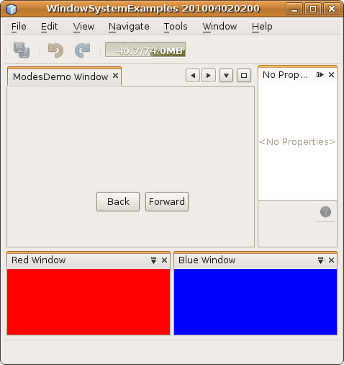
Insert image 1766_4_11.png

In summary, you defined two new modes in XML files and registered them in the module's layer.xml file. To confirm that the modes work correctly, you use the layer.xml file to register two new TopComponents so that they open by default into the new modes. As a result, you now know how to extend the default layout of a NetBeans Platform application with new modes.

Creating Window Groups
Some windows should always open and close together with other windows. For example, in NetBeans IDE, the Matisse GUI Builder's Design mode always opens together with the Inspector, the Palette, and the Properties window. That combination of windows constitutes a workspace to use when laying out an application's user interface. To achieve this yourself in your own application, you need to define a TopComponent group.
In the following example, you group the two TopComponents you have created in the previous sections and open and close them together as a single unit.
- To get started, within the CustomModes module, create a new empty file named “colorgroup.wsgrp”, with the following content:
<?xml version="1.0" encoding="UTF-8"?>

<!DOCTYPE group PUBLIC
"-//NetBeans//DTD Group Properties 2.0//EN"
"http://www.netbeans.org/dtds/group-properties2_0.dtd">

<group version="2.0">
<name unique="colorgroup" />
<state opened="false" />
</group>

You have now defined a group named “colorgoup” and you have specified that initially the TopComponents within the group are closed.
2. Let's now specify which TopComponents belong to the group. Create two new files called “RedTopComponentWstcgrp.xml” and “BlueTopComponentWstcgrp.xml”, with the content shown below:
<?xml version="1.0" encoding="UTF-8" ?>

<!DOCTYPE tc-group PUBLIC "-//NetBeans//DTD Top Component in Group Properties 2.0//EN" "http://www.netbeans.org/dtds/tc-group2_0.dtd">

<tc-group version="2.0">
<module name="com.netbeansrcp.custommodes" spec="1.0"/>
<tc-id id="RedTopComponent" />
<open-close-behavior open="true" close="true" />
</tc-group>

<?xml version="1.0" encoding="UTF-8"?>

<!DOCTYPE tc-ref PUBLIC "-//NetBeans//DTD Top Component in Mode Properties 2.0//EN" "http://www.netbeans.org/dtds/tc-ref2_0.dtd">

<tc-ref version="2.0" >
<module name="com.netbeansrcp.custommodes" spec="1.0"/>
<tc-id id="BlueTopComponent"/>
<open-close-behavior open="true" close="true" />
</tc-ref>

You now have a file per TopComponent, providing the TopComponent's a unique ID, while declaring the state of the TopComponent when the group to which it belongs is opened or closed.
3. Now modify the layer.xml to register the two files created in the previous step, within the “Windows2 | Groups” folder:
<folder name="Groups">

<file name="colorgroup.wsgrp" url="colorgroup.wsgrp"/>

<folder name="colorgroup">
<file name="RedTopComponent.wstcgrp" url="RedTopComponentWstcgrp.xml"/>
<file name="BlueTopComponent.wstcgrp"
url="BlueTopComponentWstcgrp.xml"/>
</folder>
</folder>

The file colorgroup.wsgrp declares the group to the Window System and refers to the group definition file of the same name. The subfolder ”colorgroup” describes the contents of the group and adds references to the file for each TopComponent, so that they now belong to the group.
4. Use the “New Action” wizard to create two new actions, “OpenRedBlueAction” and “CloseRedBlueAction”, with display names “OpenRedBlue” and “CloseRedBlue”, for opening/closing the group. Within the ActionListener classes generated by the “New Action” wizard, define the code to be invoked as follows:
public void actionPerformed(ActionEvent evt) {
TopComponentGroup myGroup = WindowManager.getDefault().findTopComponentGroup("colorgroup");
if (myGroup != null) {
myGroup.open();
}
}

public void actionPerformed(ActionEvent evt) {
TopComponentGroup myGroup = WindowManager.getDefault().findTopComponentGroup("colorgroup");
if (myGroup != null) {
myGroup.close();
}
}

5. Modify the files BlueTopComponentWstcref.xml and RedTopComponentWstcref.xml, to ensure that their individual default states are set to closed:
<state opened="false"/>

6. Choose “Clean & Build” on the application to remove the “build” folder that contains the user settings persisted from the last deployment of the application. Start the application again. Select Window | OpenRedBlue and notice that both TopComponents open. Then select Window | CloseRedBlue and notice that both TopComponents close.
In summary, you have learned how to define a group of TopComponents that open and close together as a unit.

Extending the Default TopComponent Persistence
You've probably noticed that when you restart the application, its layout is not reset to its default state. Instead, the layout settings from the last deployment are reused whenever you restart the application. That is what the user typically expects, though this may be inconvenient during development. During development, if you'd like the default layout to be used when you run the application, you need to select “Clean & Build” on the application node. This menu item deletes the application's “build” folder, which contains the “testuserdir” folder, where the settings from the previous deployment are stored.
It is this feature, that of automatic persistence, that we now look at more closely. In this section, we extend the persistence of our application, since the NetBeans Platform allows us to access the persistence feature and to save additional data when the application is closed.
In the next example, we create a simple form with content that is restored when the application restarts.
- Create a new NetBeans Platform application, containing a new module, with a TopComponent created via the New Window wizard. The TopComponent should have “PersistenceDemo” as its class name prefix, it should be positioned with the “editor” mode, and it should open when the application starts.
Design the content of the new TopComponent as shown below:
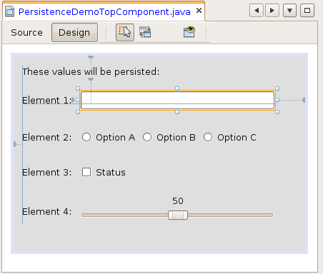
Insert image 1766_4_12.png
The Window System API provides special support for serialization of configuration data. To store configuration data, and to reload them at restart, we need to override the methods “writeProperties” and “readProperties”, which are generated by the New Window wizard when you created the TopComponent. These methods are required so that the @ConvertAsProperties annotation, declared at the top of the TopComponent class, is able to generate the code at compile time for persisting the specified settings.
To finetune the TopComponent persistence outlined above, you have two additional values that need to be set, but which are set by default when you use the “New Window” wizard to create your TopComponent:
- The value returned by the preferredID() method. The returned value uniquely identifies the TopComponent to the window system.
- The value returned by the getPersistenceType method. This value determines the conditions under which the TopComponent is persisted. The value TopComponent.PERSISTENCE_ALWAYS specifies that the content of the TopComponent will be persisted, in so far as you have specified settings for persistence. PERSISTENCE_NEVER specifies that when the application closes, nothing set in the TopComponent will be persisted. Finally, PERSISTENCE_ONLY_OPENED specifies that a TopComponent is only persisted if it is open when the applications shuts down. The latter is useful if the TopComponent is some kind of editor, for example, as in the cases of the editor windows in NetBeans IDE, which reopen on start up if they had been closed when the application shut down.
2. In the case of the Task Manager, specify that the TaskEditorTopComponent should persist if it was open when the application shut down. Next, define the writeProperties and readProperties methods as follows:
void writeProperties(java.util.Properties p) {
// better to version settings since initial version as advocated at
// http://wiki.apidesign.org/wiki/PropertyFiles
p.setProperty("version", "1.0");
p.setProperty("element1", jTextField1.getText());
if (jRadioButton1.isSelected()) {
p.setProperty("element2", "1");
}
if (jRadioButton2.isSelected()) {
p.setProperty("element2", "2");
}
if (jRadioButton3.isSelected()) {
p.setProperty("element2", "3");
}
p.setProperty("element3", String.valueOf(jCheckBox1.isSelected()));
p.setProperty("element4", String.valueOf(jSlider1.getValue()));
}
Object readProperties(java.util.Properties p) {
if (instance == null) {
instance = this;
}
instance.readPropertiesImpl(p);
return instance;
}
private void readPropertiesImpl(java.util.Properties p) {
String version = p.getProperty("version");
jTextField1.setText(p.getProperty("element1","empty"));
if (p.getProperty("element2").equals("1")) {
jRadioButton1.setSelected(true);
}
if (p.getProperty("element2").equals("2")) {
jRadioButton2.setSelected(true);
}
if (p.getProperty("element2").equals("3")) {
jRadioButton3.setSelected(true);
}
if (p.getProperty("element3").equals("true")) {
jCheckBox1.setSelected(true);
} else {
jCheckBox1.setSelected(false);
}
jSlider1.setValue(Integer.parseInt(p.getProperty("element4")));
}
3. Restart the application. Enter some values into the TopComponent and then close the application. When you restart the application, notice that the values you specified are restored:
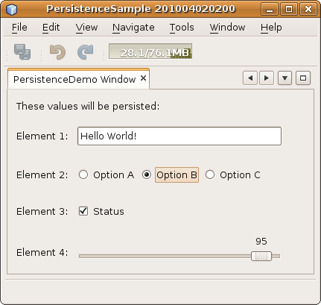
Insert image 1766_4_13.png
When you close the application, do a “Clean and Build” on the TaskManager project node. Then, now that the application user directory is now removed, restart the application and notice that all the values are set back to their defaults.
In summary, you have extended the persistence of the TopComponent, so that the values specified in the TopComponent at the time the application shuts down are restored when the application is restarted.

