5
Lookup
“Lookup” is the NetBeans Platform response to the need for loose coupling at all levels of software architecture. On the level of modules, lookups enable service providers to centrally register their services and consumers to find them. On the level of individual components, lookups enable the exchange of information between a provider and any number of consumers. The information can either be messages, data, or information about component state and capabilities.

Registering and Finding Services
In a modular system, the implementation of a service should be exchangeable, while it should even be possible for there to be several implementations of a single service. Users of those services need a central mechanism to find service providers. As a result, you need to be able to register an implementation of a service and also the possibility of finding registered services.
NetBeans provides a so called “default Lookup” to find registered services. The API of a Lookup is similar to Map<Class, Collection<Object>>, where the key is a type and the values are instances of the type.
The result of a Lookup might not only be one or more objects but also an observable Lookup.Result, which provides access to several other stored objects. The default Lookup is a Lookup that evaluates the service declarations in the META-INF/services folder. It is callable through the Lookup.getDefault() method. By asking for a service interface in this way, you receive instances of implementing classes registered in the META-INF/services folder.
To demonstrate this approach, you continue to develop the TaskModel module in the next sections, since the TaskModel module should not only provide a new task but also add a unique ID to it. This can be done in several ways, which is the reason why you do not work with a direct implementation, but with a service around which you provide replaceable implementations. In this simple scenario, the standard implementation is defined in the same module as the service definition.
- In the TaskManager, create a new module named “TaskIDGenerator”, with “com.netbeansrcp.taskidgenerator “ as the unique ID.
- In the new module, create an interface named “TaskIdGenerator”, within a package named “com.netbeansrcp.taskidgenerator.api”, using this code:

public interface TaskIdGenerator {
public String generateID();
}
- Create an implementation, named “ TaskIdGeneratorImpl”, in the package “com.netbeansrcp.taskidgenerator”, with this code:
public class TaskIdGeneratorImpl implements TaskIdGenerator {
private Random random = new Random();
public String generateID() {
String id = "000000" + this.random.nextInt();
id = id.substring(id.length()-6);
return id;
}
}

Now the service is to be registered, using the standard JDK 6 Java extension mechanism. That mechanism entails the creation of a folder named META-INF/services, containing a file named after the interface, containing a list of names of implementating classes.
Instead of creating that file manually, add a dependency on the NetBeans Lookup API, and then annotate the “ TaskIdGeneratorImpl” class as follows:
@ServiceProvider(service=TaskIdGenerator.class)
public class TaskIdGeneratorImpl implements TaskIdGenerator {
5. Declare the package com.netbeansrcp.taskidgenerator.api as part of the public interface of the module.
This is all you need to do to register the new service. Next, you need to be able to find the service, from the TaskModel module.
1. The implementation of the task should use the TaskIdGenerator to generate an ID and assign it to the id attribute. Therefore the TaskModel module needs to declare a dependency to the taskidGenerator module.
2. As already mentioned, it’s very easy to find a service. The only thing you need to do is to ask for the interface of the service using the default Lookup:
public TaskImpl(String name, String parentId) {
TaskIdGenerator idGen =
Lookup.getDefault().lookup(
com.netbeansrcp.taskidgenerator.api.TaskIdGenerator.class);
this.id = idGen.generateID();

this.name = name;
// ...

Note: To use the Lookup class above, you need to declare a dependency in the TaskModel module on the Lookup API module.
3. Now start the application. The TaskEditor should show a generated 6-digit ID.
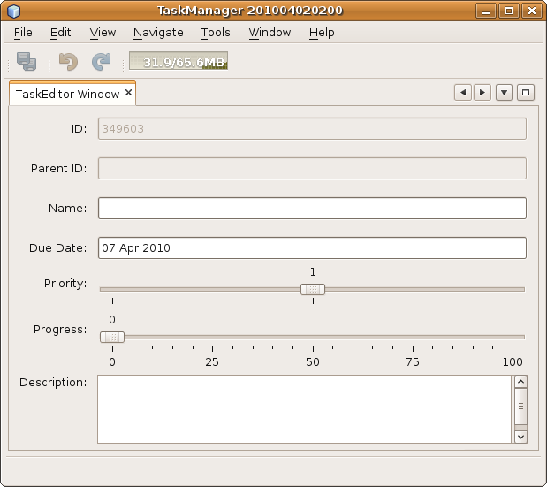
Insert image 1766_5_1.png
In summary, you have been introduced to the default Lookup mechanism for finding services. In order to register a service, you only need to annotate a class with the @ServiceProvider annotation to fulfil the Java extension mechanism requirement, since this annotation causes the META-INF/services folder to be created at compile time, together with the required service provider registration. The default Lookup finds the files created at compile time in the META-INF/services folder, evaluates them, and gives back instances of registered implementing classes.
When you look in the Files window, the “build” folder shows the META-INF/services folder with its content that has correctly been created at compile time thanks to the @ServiceProvider annotation:
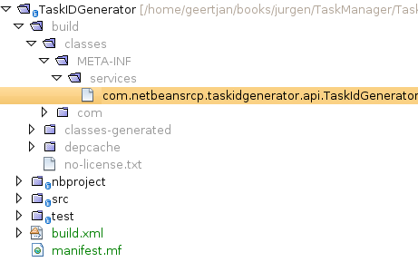
Insert image 1766_5_2.png

Creating Extension Points
The default Lookup is also used to provide extension points. Extension points are made available whenever an algorithm needs to be exchangeable or extensible.
Note: Readers familiar with the term “Service Provider Interface” have a relevant background for understanding the concepts addressed in this section.
For the ID generator you've built so far, it would make sense to add a validator. After all, it is currently fairly likely for the generator to create the same ID twice or to return a negative ID. The number of types of validators that could be relevant for the ID is endless, hence you need to make it possible for any number of validators to be made available dynamically.
- Start by creating a validation service. Do this by defining an interface named “IdValidator” in the package “com.netbeansrcp.taskidgenerator.api”.
- As an implementation of the interface, create a class named “UniqueIdValidator” in the package “com.netbeansrcp.taskidgenerator”. The implementation pseudo-checks the uniqueness of Ids.
The code for the interface and its implementation is below:
public interface IdValidator {
boolean validate(String id);
}

@ServiceProvider(service=IdValidator.class)
public class UniqueIdValidator implements IdValidator {
public boolean validate(String id) {
System.out.println("UniqueIdValidator.validate(" + id + ")");
return true;
}
}
- Now you need to define an extension point. This extension point consists of logic in TaskIdGeneratorImpl that searches for all IdValidators and calls their validate(String) method.
In addition, the extension point consists of documentation stating that all TaskIdGenerators embed services made available by IdValidators.
To this end, you need to rewrite TaskIdGeneratorImpl.
Again you use the default Lookup. This time, though, you won’t only search for one instance but for all instances of a type. This means you receive all registered implementations of the service.
In addition, you work with a “Lookup.Result” object, which encapsulates the search result and is able to dynamically notify listeners when the lookup content changes. You look at this feature later in the chapter.
The Lookup.Result either holda a collection of found instances or a collection of Lookup.Items. Lookup.Items do not only allow access to found instances but also to meta data such as types, IDs, and display names.
After requesting the found instances, you are able to call them at a well-defined and documented parts of the software. This way, you create software that is extensible by yourself or third party vendors.
@ServiceProvider(service=TaskIdGenerator.class)
public class TaskIdGeneratorImpl implements TaskIdGenerator {

private Random random = new Random();

public String generateID() {
Lookup.Result<IdValidator> rslt = Lookup.getDefault().lookupResult(IdValidator.class);
String id = null;
boolean valid = false;
while (!valid) {

id = this.getId();

valid = true;
for (IdValidator validator : rslt.allInstances()) {

valid = valid & validator.validate(id);
}
}
return id;
}

private String getId() {
String id = "000000" + this.random.nextInt();
return id.substring(id.length() - 6);
}

}
The generateID() method uses Lookup.getDefault().lookup(...) to receive a Lookup.Result<IdValidator> from the default Lookup that holds all registered implementations of the IdValidator interface.
The found instances are used to validate the generated IDs. Therefore, the “valid” flag is set to “true” and all found IdValidator instances are asked if the accept the ID. If a validator does not accept the ID, the flag is set to false, a new ID is generated, and validated again. This step is repeated until all the validators accept the ID.
5. Start your application and look at the output. You should find the output includes the following line:
UniqueIdValidator.validate(954566)
The message above proves that the IdValidator is found and called.
In summary, you have created an extension point and used it in the TaskManager. As an exercise, you can create another service provider to make available another implementation of the service and reuse the extension point.

Using Extension Points Externally
In the previous section, the extension point is defined in the same module as where it is used. In order to connect to the extension point from an external module, you need to do the same as before. You need to read the documentation, find out about the extension points of the application, and implement the relevant service interfaces. As before, once you have implemented a service interface, use the @ServiceProvider annotation to register the implementation.
Let's look at this process using the TaskManager application.
- In the TaskManager, create a new module named “NotNegativeIdValidator”, with “com.netbeansrcp.notnegativeidvalidator” as the code name base.
- In the new module, declare a dependency on the modules “TaskIDGenerator” and “Lookup”.
- Create a new class as the service provider, named NotNegativeIdValidator, defined as follows:
@ServiceProvider(service=IdValidator.class)
public class NotNegativeIdValidator implements IdValidator {
public boolean validate(String id) {
System.out.println("NotNegativeIdValidator.validate(" + id + ")");
return !id.startsWith("-");
}
}

Start the application and look at the output.. It should include lines like this:
UniqueIdValidator.validate(357769)
NotNegativeIdValidator.validate(357769)
As you can see, the module NotNegativeIdValidator extended another module.
In summary, for a moment you switched to the role of an external programmer. The external programmer extended your own IdValidator. From the documentation of the TaskManager, the external programmer found the name of the IdValidator interface. As a result, the external programmer created a new module and then implemented the interface. After using the @ServiceProvider annotation to register the interface, the service was found and used automatically when the application started.

Enabling Loosely Coupled Communication
Apart from its involvement in the registration and finding of services, the Lookup has another important task. The Lookup is the primary mechanism enabling objects to exchange information without being dependent on each other.
To make loose coupling possible, an information provider is able to administer its own Lookup, providing it to anyone interested in its information. Into its Lookup, the provider can put objects that the consumer might find useful. The consumer needs only to find the Lookup and get the objects, based on their type.
The ability to administer and provide a Lookup is defined via the Lookup.Provider interface:
Lookup getLookup()
In this section, you create a new window in a new module. The new window shows a log of previously created tasks, without the module that contains the window having a dependency on the TaskEditorTopComponent window. This scenario reflects a typical Master/Detail relationship implemented on the NetBeans Platform. A different approach is described in the chapter on Nodes and Explorer Views.
- The main source for new tasks in the example is the TaskEditorTopComponent. It does not hold a reference to the task being edited. Instead, the task is handled by the TaskEditorPanel only. To make the task publicly available, change its modified from private to public in the TaskEditorPanel, as shown below:
public Task task = new TaskImpl();
- The TaskEditor should handle a Lookup and provide it using the Lookup.Provider interface. The TopComponent class already implements Lookup.Provider and therefore your TaskEditorTopComponent doesn’t need to do so explicitly. In addition to implementing Lookup.Provider, TopComponents provide a method for resetting the lookup. Therefore, you need to extend the constructor of TaskEditorTopComponent to create a new Lookup and set it for the TopComponent. Instead of implementing your own Lookup, you use the Lookups class, which creates a Lookup with one single object:
private TaskEditorTopComponent() {
initComponents();
// ...
this.associateLookup(
Lookups.singleton(((TaskEditorPanel)this.taskEditorPanel1).task)
);
}
That’s all that needs to be done on the side providing the information, which is, in this case, the Task.

Loosely Coupled Consumption
You have now exposed data that any other part of your application can consume. To that end, you create a new module containing a new TopComponent, where the Task is consumed.
- Create a new module named ”TaskLog”, with “org.netbeansrcp.tasklog” as the code name base.
- Set a dependency on the “TaskModel” module.
- Use the New Window Component wizard to create a new TopComponent. The window should appear in the “properties” mode and the class name prefix is “TaskLog”.
- The tasks consumed by the TopComponent are displayed in a JList. In the IDE, drag a JList and drop it on the TopComponent. Let it take up the TopComponent's complete vertical and horizontal space and remove the default content so that it is empty as shown below.
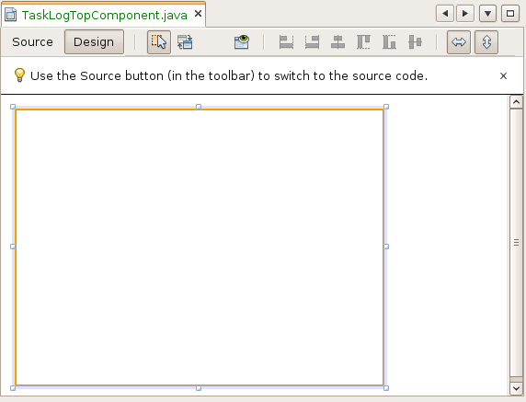
Insert image 1766_5_3.png
- Swith to the Source view of the TopComponent and add an instance variable for a DefaultListModel, which you will use to store Tasks. After the TopComponent is opened, the currently edited Task is shown in the JList.
- To synchronize the data in the view with the editor, implement a PropertyChangeListener for the TaskLogTopComponent. When the TopComponent opens, add the property change listener and remove it when the TopComponent closes.
The code described above is listed below:
final class TaskLogTopComponent extends TopComponent implements PropertyChangeListener {

private DefaultListModel listModel = new DefaultListModel();
// ...

public void componentOpened() {
Task task =
WindowManager.getDefault().
findTopComponent("TaskEditorTopComponent").
getLookup().lookup(Task.class);
this.listModel.addElement(task);
task.addPropertyChangeListener(this);
}

public void componentClosed() {
for ( Enumeration e = this.listModel.elements(); e.hasMoreElements(); ) {
((Task)e.nextElement()).removePropertyChangeListener(this);
}
}
// ...
public void propertyChange(PropertyChangeEvent arg0) {
this.jList1.repaint();
}
- To link the DefaultListModel to the JList, select the Jlist open the Code section of the Properties window, and add the line below to the “Custom Creation” property:
new Jlist(this.listModel);
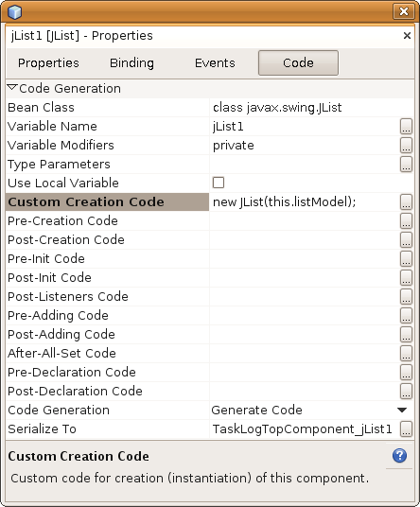
Insert image 1766_5_4.png

- Run the application. On the right side of the application, that is, in the Properties mode, you see the TaskLog. The only item in the list is the item for the currently edited task. As you edit the task, the task log in the JList is updated.
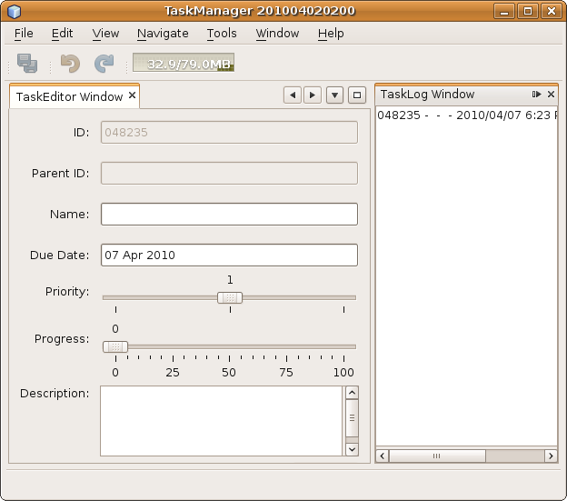
Insert image 1766_5_5.png

In summary, you added the current Task to the Lookup of the TaskEditorTopComponent. You then created another module, containing another TopComponent. In the latter TopComponent, you use the WindowManager to find the first TopComponent by means of its unique ID. Then the first TopComponent's Lookup is queried for its Task object.
The second TopComponent acquired data from the first TopComponent without there being a dependency between the two. Of course, you do still have a different kind of dependency between the two TopComponents since you hardcoded the name of the first TopComponent in order to enable the WindowManager to find it. That part of the example changes later in this chapter, to remove even that semi-dependency between the two modules.
You have now seen how two loosely coupled objects can exchange data with each other. The potential number of consumers of the data is unlimited. It is also irrelevant whether the consumer is part of the original application or contributed by an external third party vendor.
For current purposes of the example, you implemented a PropertyChangeListener, to keep the two TopComponents synchronized. A later chapter shows a better way of doing this, in the context of working with nodes and explorer views.

Creating New Tasks
Let's now prevent tasks from being created automatically whenever the TopComponent opens. Instead, let's let the user click a button in the TopComponent whenever a new task should be added to the TaskManager.
- In the “Matisse” GUI Builder, use the Palette to add a JButton to the TaskEditorPanel. Change the text displayed in the JButton to “Create New Task”.
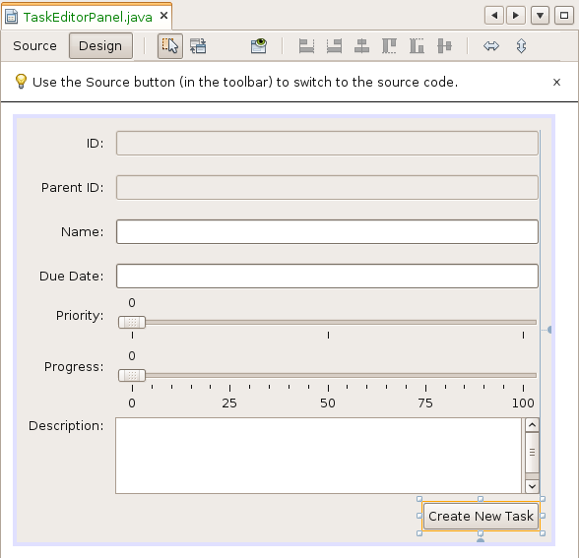
Insert image 1766_5_6.png

- Double-click the JButton so the the Source view opens, with the cursor in the definition of a new actionPerformed event. Use the event to create a new task and update the form, as shown below:
private void jButton1ActionPerformed(java.awt.event.ActionEvent evt) {
this.task = new TaskImpl();
this.updateForm();
}
- To prevent a Task from being created whenever the form opens, which is currently the case, change the code in the panel as follows:

public class TaskEditorPanel extends javax.swing.JPanel {
// ...
private boolean noUpdate = false;
// ...
private void updateTask() {
if (this.noUpdate) return;
// ...
// ...
private void updateForm() {
this.noUpdate = true;
// ...
this.noUpdate = false;
}
- Finally, you need to inform the TaskEditorTopComponent about newly created Tasks. To that end, add a PropertyChangeListener to the JPanel, as follows:

public class TaskEditorPanel extends javax.swing.JPanel {

public static final String PROP_TASK = "TASK";
private PropertyChangeSupport pcs;
// ...

@Override
public synchronized void addPropertyChangeListener(PropertyChangeListener listener) {
if (pcs == null) {
pcs = new PropertyChangeSupport(this);
}
this.pcs.addPropertyChangeListener(listener);
}

@Override
public synchronized void removePropertyChangeListener(PropertyChangeListener listener) {
if (pcs != null) {
this.pcs.removePropertyChangeListener(listener);
}
}

private void jButton1ActionPerformed(java.awt.event.ActionEvent evt) {
Task oldTask = this.task;
this.task = new TaskImpl();
this.pcs.firePropertyChange(PROP_TASK, oldTask, this.task);
this.updateForm();
}
// ...

Run the application again. Edit some of the values in the form and notice that the form is cleared and a new Task ID is assigned whenever you click the JButton.
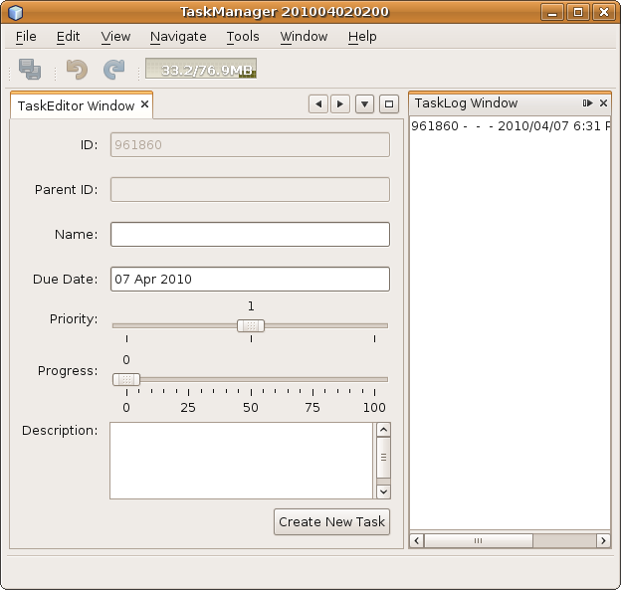
Insert image 1766_5_7.png
However, the list in the Task Log remains unchanged. It only shows the initial task. Neither the TaskEditorTopComponent nor the TaskLogTopComponent currently support the ability to be dynamically updated. Part of the reason for this is that the Task Log only looks into the Lookup once for a Task, that is, when the Task Log opens. Another part of the reason for the lacking dynamic update support is that the Lookup you are using is itself not observable. A Lookup created via Lookups.singleton() can only contain a fixed object, which is certainly insufficient for applications requiring dynamic handling of custom objects, such as, in this case, tasks.
In the next section, you learn how to dynamically update the content of a Lookup and how consumers can be dynamically notified about changes to the Lookup.

Dynamic Changes and Notifications
As a vital aspect of a communication mechanism for modular applications, Lookup supports dynamic content , as well as consumer notifications when the dynamic content changes.
There are two support classes helping you to implement your own dynamic Lookup: AbstractLookup and InstanceContent.
- AbstractLookup is not an abstract class, as the name suggests. It is a full featured Lookup implementation.
- The content of an AbstractLookup is controlled and managed by the class InstanceContent.
Together, these classes provide the basis for implementing Lookups with dynamic content.
Let's now implement a dynamic Lookup for the TaskManager. As soon as a new Task has been created in the TaskEditor, the new task is added to the list of logs in the Task Logs window, as shown below.
- Modify the TaskEditorTopComponent.. To control the Lookup content, create an InstanceContent object and store it as a member for later use.
- In the constructor of the TaskEditorTopComponent, instantiate an AbstractLookup using that InstanceContent object. Associate the Lookup with the TaskEditorTopComponent.
- Now the Lookup content needs to be updated, if a new task is created. To achieve this, register a PropertyChangeListener on the TaskEditorPanel and add new tasks to the InstanceContent.
The code below is the result of the above steps:
final class TaskEditorTopComponent extends TopComponent {

// ...
private InstanceContent ic = new InstanceContent();
private PropertyChangeListener taskChangeListener =
new ListenForTaskChanges();
// ...

private TaskEditorTopComponent() {
initComponents();
// ...

this.taskEditorPanel1.addPropertyChangeListener(taskChangeListener);
this.ic.add(((TaskEditorPanel) this.taskEditorPanel1).task);

this.associateLookup(new AbstractLookup(this.ic));
}

private class ListenForTaskChanges implements PropertyChangeListener {

public void propertyChange(PropertyChangeEvent arg0) {

if (TaskEditorPanel.PROP_TASK.equals(arg0.getPropertyName())) {

List newContent = new ArrayList();
newContent.add(((TaskEditorPanel) TaskEditorTopComponent.this.taskEditorPanel1).task);

TaskEditorTopComponent.this.ic.set(newContent, null);
}
}

}

That's all that's needed to make the current task available in the Lookup of the TaskEditorTopComponent.
Next, TaskLogTopComponent needs to be notified about changed Tasks in the Lookup of TaskEditTopComponent. In the previous example, you already used Lookup.Result to search for objects. However, there is one essential feature of Lookup.Result that you have not yet used. That is the ability of Lookup.Result to notify LookupListeners about changes in the requested result.
To use the LookupListener and receive notifications, change TaskLogTopComponent to implement the LookupListener interface. Register the LookupListener on the Lookup.Result that is created while the component is opening:
final class TaskLogTopComponent extends TopComponent
implements PropertyChangeListener, LookupListener {

// ...
private Lookup.Result<Task> result;

// ...
public void componentOpened() {
this.result =
WindowManager.getDefault().
findTopComponent("TaskEditorTopComponent").
getLookup().lookupResult(Task.class);
this.result.addLookupListener(this);
for (Task task : this.result.allInstances()) {
this.listModel.addElement(task);
task.addPropertyChangeListener(this);
}
}

public void componentClosed() {
for (Enumeration e = this.listModel.elements(); e.hasMoreElements();) {
((Task) e.nextElement()).removePropertyChangeListener(this);
}
this.result = null;
}

public void resultChanged(LookupEvent evt) {
Lookup.Result<Task> rslt = (Result<Task>) evt.getSource();
for (Task task : rslt.allInstances()) {
this.listModel.addElement(task);
task.addPropertyChangeListener(this);
}
}
// ...
}
Run the application again.
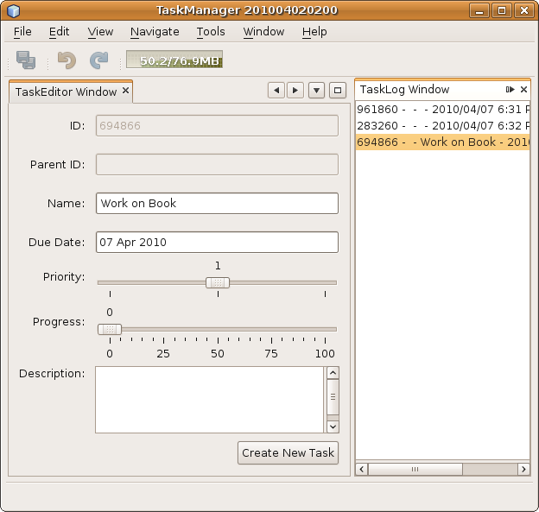
Insert image 1766_5_8.png
When you click the JButton to create a task, the new task is added to the list of already defined tasks in the TaskLogTopComponent. Now, although TaskEditorTopComponent and TaskLogTopComponent are not dependent on each other, they exchange information dynamically.
In summary, you learnt how to create and manage Lookups with dynamic content. For these purposes, the classes AbstractLookup and InstanceContent provide everything you need. Furthermore, you have explored the usage of LookupListeners as monitors for Lookups and you have used them to receive notifications about changes in the Lookup. All in all, in just a few lines of code, you saw how two objects can exchange information without being directly dependent on each other.

Creating an Additional Task Provider
At this stage, there are still a few imperfections to clean up. Firstly, a hard coded ID is used to find the TaskEditorTopComponent via the WindowManager. The section after this one presents a solution to that problem. Secondly, and that is the focus of the current section, the architecture you currently have could be more flexible. If there were to be a second source of tasks, you want to be able to show those tasks in the TaskLogTopComponent.
Currently, only tasks provided by the TaskEditorTopComponent can be displayed in the TaskLogTopComponent. To demonstrate the problem, you create yet another module. The module provides a new window, where Tasks can be created. As in the case of the TaskEditorTopComponent, the created tasks will be made accessible via the TopComponent's Lookup.
- In the TaskManager, create a new module named “TaskDuplicator”, with “org.netbeansrcp.taskduplicator” as the code name base.
- In the new module, add a dependency on the TaskModel module.
- In the new module, use the New Window Component wizard to create a new TopComponent with “TaskDuplicator” as the class name prefix. Choose “explorer” as the window position and also select “Open on Application Start”.
- Add two JLabels to the TopComponent for each of the following properties: “Name”, “Due Date”, “Priority”, “Progress” and “Description”. The first of each pair of JLabels shows the name, while the second shows the value.
- Add a JButton for creating new tasks. The TopComponent should now look something like the illustration below:
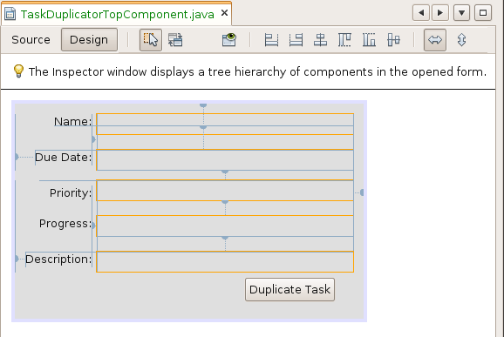
Insert image 1766_5_9.png

- Switch to the source view of the TaskDuplicatorTopComponent. You want the TaskDuplicatorTopComponent to behave similarly to the TaskLogTopComponent. That means that the TopComponent should monitor the Lookup of the TaskEditorTopComponent and show the values of the current task. In addition, the TaskDuplicatorTopComponent provides a Lookup containing the created tasks. Therefore, the following code needs to be added to the TaskDuplicatorTopComponent:
final class TaskDuplicatorTopComponent extends TopComponent
implements PropertyChangeListener, LookupListener {

private Lookup.Result<Task> result;
private Task task;
private InstanceContent ic = new InstanceContent();

// ...
private TaskDuplicatorTopComponent() {

// ...
this.associateLookup(new AbstractLookup(this.ic));
}

public void componentOpened() {
this.result = WindowManager.getDefault().
findTopComponent("TaskEditorTopComponent").
getLookup().lookupResult(Task.class);
this.result.addLookupListener(this);
this.task = (Task) (this.result.allInstances().toArray())[0];
this.task.addPropertyChangeListener(this);
}

public void componentClosed() {
this.task.removePropertyChangeListener(this);
this.result = null;
}

public void propertyChange(PropertyChangeEvent arg0) {
this.updateTaskInfo();
}

public void resultChanged(LookupEvent arg0) {
Task[] tasks = this.result.allInstances().
toArray(new com.netbeansrcp.taskmodel.TaskImpl[]{});
Task newTask = tasks[tasks.length - 1];

this.task.removePropertyChangeListener(this);
this.task = newTask;
this.task.addPropertyChangeListener(this);

this.updateTaskInfo();
}

private void updateTaskInfo() {
this.jLabel6.setText(this.task.getName());
this.jLabel7.setText(DateFormat.getInstance().format(this.task.getDue()));
this.jLabel8.setText("" + this.task.getPrio());
this.jLabel9.setText("" + this.task.getProgr());
this.jLabel10.setText(this.task.getDescr());
}
private void jButton1ActionPerformed(java.awt.event.ActionEvent evt) {
Task t = new TaskImpl();
t.setName(this.task.getName());
t.setDue(this.task.getDue());
t.setPrio(this.task.getPrio());
t.setProgr(this.task.getProgr());
t.setDescr(this.task.getDescr());
List<Task> tasks = new ArrayList<Task>();
tasks.add(t);
this.ic.set(tasks, null);
}
// ...

Let's look carefully at the code above. In the constructor of the TopComponent, you created a dynamic Lookup using AbstractLookup and InstanceContent, and you associated the dynamic Lookup with the TopComponent.
When the TopComponent opens, the TaskEditorTopComponent is found via its ID. The Lookup of the TaskEditorTopComponent is requested and a LookupListener is registered on it. The LookupListener is triggered when changes to a Task are made available to the Lookup of the TaskEditorTopComponent .
You register a PropertyChangeListener on the currently available Task, so that you can be notified of changes to the Task. In the related propertyChange method, you update the values of the labels in the form, so that the data is always current. When the TopComponent is closed, you detach the listener.
When the Lookup of the TaskEditorTopComponent changes, you use the resultChanged method to retrieve all the Tasks from the Lookup. You detach the PropertyChangeListener from the old task, since you are only interested in changes to the new task, so that you then attach the PropertyChangeListener to the new task.
You also need to react to clicks in the TaskDuplicatorTopComponent. Whenever the button in the TaskDuplicatorTopComponent is clicked, you create a new Task, set its values to those of the currently edited Task, and add the new Task to the InstanceContent of the TaskDuplicatorTopComponent. That makes the new Task available via the Lookup of the TaskDuplicatorTopComponent.
You now have two sources of new Tasks, the TaskEditorTopComponent and the TaskDuplicatorTopComponent.. The next challenge is to change the TaskLogTopComponent in such a way that both sources of Tasks are consumed, with the Tasks created by both TopComponents being made available in the JList in the TaskLogTopComponent.

Proxy Lookups
As the name suggests, there is a way to hide several Lookups behind a single Lookup instance. The Lookup API provides a class called ProxyLookup to support this. The class can take an array of Lookups in its constructor and delegates to them. Importantly, the order of objects in the array is taken into account. For a normal Lookup.lookup(<class>) call, the first result found in the Lookup is returned. In that case, one Lookup can hide the content of another Lookup.
Let's make use of ProxyLookup in the TaskManager. With the help of a ProxyLookup, you can easily hide the fact that there are now two sources of tasks, TaskEditorTopComponent and TaskdDuplicatorTopComponent.
Introducing the ProxyLookup means making a very small change to TaskLogTopComponent. You need to query both Lookups and create a ProxyLookup for them, though for right now you continue to use hardcoded IDs to find the TopComponents.
The Module shall provide a service, which allows an unified access to sources of tasks. The service implementation shall create the ProxyLookup aggregating the Lookups of TaskEditorTopComponent and TaskdDuplicatorTopComponent.
- In the TaskManager, create a new module called “TaskSource”, with “org.netbeansrcp.tasksource” as the code name base.
- Declare dependencies on the Lookup API and the Windows System API.
- Define the service interface com.netbeansrcp.tasksource.api.TaskSource. The only object you want to export is a Lookup providing access to created tasks in the system, so it is enough to extend the interface Lookup.Provider.
public interface TaskSource extends Lookup.Provider {
}
- Expose the package containing the interface defined above to the other modules in the application. Right-click the module project, choose Properties, and use the API Versioning tab to make the package containing the service public.
- Define the implementation of the service. Define the getLookup() method as discussed above, searching the TopComponents, creating the ProxyLookup for the returned TopComponents, and returning a ProxyLookup:
@ServiceProvider(service=TaskSource.class)
public class TaskSourceImpl implements TaskSource {
public Lookup getLookup() {
Lookup l1 = WindowManager.getDefault().
findTopComponent("TaskEditorTopComponent").getLookup();
Lookup l2 = WindowManager.getDefault().
findTopComponent("TaskDuplicatorTopComponent").getLookup();

return new ProxyLookup(new Lookup[]{l1, l2});
}
}
- Now everything is ready. You can clean up the code in the TaskLogTopComponent. In the TaskLog module, start by adding a dependency on the new TaskSource module. Then remove the code causing the unwanted dependencies on a specific TopComponents and, instead, use the TaskSource service implemented above:
public void componentOpened() {

this.result =
Lookup.getDefault().lookup(TaskSource.class).
getLookup().lookupResult(Task.class);
this.result.addLookupListener(this);

// ...
}
- Run the application again. As expected, all tasks are shown in the TaskLog as before, no matter if they are created by the TaskEditor or the TaskDuplicator. The ProxyLookup is doing its job, that is, it merges the two Lookups correctly.
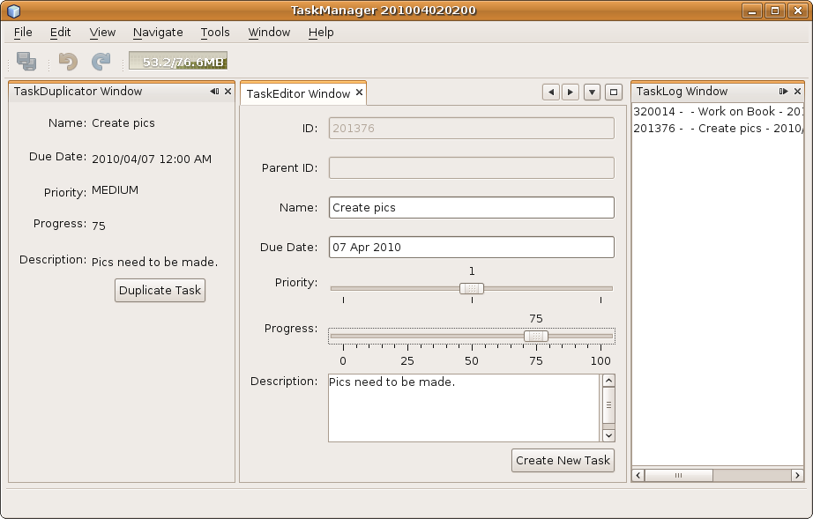
Insert image 1766_5_10.png
In summary, you have now been introduced to ProxyLookups. You used this new concept to combine two Lookups behind a single Lookup. This gives you the possibility to reduce dependencies on a lot of Lookup.Providers to just a single dependency on one ProxyLookup. Overall, ProxyLookups are a further way to reduce dependencies and increase the flexibility of your architecture.
At this point, the example looks a lot better than it did at the beginning of this chapter. You have minimized dependencies as far as possible, though there is a still one further step to take in that direction since you are using a string to identify the name of the TaskEditorTopComponent. If the ID of the TaskEditorTopComponent changes, the TaskLogTopComponent will not be able to find it anymore. The next section shows how this problem can be solved.

Listening to the Selection
You created the TaskSource module to decouple the TaskLogTopComponent from the Lookups of the TaskEditorTopComponent and TaskDuplicatorTopComponent. The latter two TopComponent can both provide new data, in this case Tasks, based on user interaction. Because TopComponents are the primary user interface of a NetBeans Platform application, their Lookups play an important role in communicating information resulting from user interactions. For user interfaces, this kind of communication is a very typical use case and whenever there are any such typical patterns, the NetBeans Platform tends to provide some kind of special support. One support method that you can now begin making sense of is org.openide.util.Utilities.actionsGlobalContext.
The static method Utilities.actionsGlobalContext() gives you access to the Lookup of whichever TopComponent currently is the activated TopComponent.
Since the user can only work on one TopComponent at a time, there is always at most one active TopComponent. With that in mind, you never needed to merge the Lookups of the two TopComponents at all. You can simply remove the TaskSource module without any loss of function ality, if you change the TaskLogTopComponent in the way shown below:
Old:

public void componentOpened() {
// ...

this.result = Lookup.getDefault().lookup(TaskSource.class).getLookup().lookupResult(Task.class);

// ...
}

New:

public void componentOpened() {
// ...

this.result = Utilities.actionsGlobalContext().lookupResult(Task.class);

// ...
}

Such a small change! But now the Task Log has no dependencies on the IDs of the two TopComponents anymore.
You now have three modules exchanging information without knowing about each other. That means that there are no methods in one of these modules making use of methods in one of the other modules. As a result, you can focus on the business logic of each module, without needing to worry about integration problems caused by changes in one of the other modules.
Furthermore, take note of how the communication mechanism based on Lookup is extremely flexible. At any time, you can add either new sources of Tasks or new consumers of Tasks. When you do so, none of the other modules are affected in any way. In particular, when you are dealing with Master-Detail views, this flexibility is very powerful.

Creating a Service Facade
Lookups are one of the fundamental patterns of the NetBeans Plattform. Most of the chapters that follow make use of it. However, before you turn to another chapter, let's refactor the TaskModel a bit. Since you have learned how services can be defined and how you can access them using the default Lookup, let's provide a service for creating and managing tasks.
The problem is that you currently have many classes accessing the TaskModel directly. Hence, the creation and management of tasks is dispersed all over the code. To clean this up, you introduce the class TaskManager, which is a service facade. The TaskManager is responsible for the creation and removal of tasks, as well as for providing access to existing tasks.
- In the TaskModel module, define an interface named “TaskManager” in the “com.netbeansrcp.taskmodel.api” package.
- Move the “Task” class to the “com.netbeansrcp.taskmodel.api” too. Make this package publicly available to all the modules in the application, by right-clicking the module, choosing Properties, and then using the API Versioning tab to specify that this package is public. The other package, that is, the main package, should contain the “TaskImpl” class and, later, the “TaskManagerImpl” class too. In this way, you hide the implementing classes from other modules, so that they cannot accidentally be used by someone else.
- Define the “TaskManager” interface as follows:
public interface TaskManager {

Task createTask();

Task createTask(String name, String parentId);

void removeTask(String id);

List<Task> getTopLevelTasks();

Task getTask(String id);
static final String PROP_TASKLIST_ADD = "TASK_LIST_ADD";
static final String PROP_TASKLIST_REMOVE = "TASK_LIST_REMOVE";

public void addPropertyChangeListener(java.beans.PropertyChangeListener listener);

public void removePropertyChangeListener(java.beans.PropertyChangeListener listener);
}

The TaskManager interface above suits your purposes, since it provides the following:
- A method to create parents Tasks and a second method to create Tasks using a parent ID.
- For deleting Tasks, just one method is necessary, taking a Task ID as argument.
- Two query methods are available as well. One returns all available parent Tasks, the other allows direct access to a Task using its ID.
- The last part of the code defines methods for adding and removing PropertyChangeListeners and two constants used as property names via the PropertyChangeEvents for added and removed Tasks.
- Create the class TaskManagerImpl in the main package, that is, “com.netbeansrcp.taskmodel”, which means that it cannot be used by other modules, and implement the TaskManager interface as follows:.

@ServiceProvider(service=TaskManager.class)
public class TaskManagerImpl implements TaskManager {

private List<Task> topLevelTasks;
private PropertyChangeSupport pss;

public TaskManagerImpl() {
this.topLevelTasks = new ArrayList<Task>();
this.pss = new PropertyChangeSupport(this);
}

public synchronized Task createTask() {
Task task = new TaskImpl();
this.topLevelTasks.add(task);
this.pss.firePropertyChange(PROP_TASKLIST_ADD, null, task);
return task;
}

public synchronized Task createTask(String name, String parentId) {
Task task = new TaskImpl(name, parentId);
Task parent = this.getTask(parentId);
if (null != parent) parent.addChild(task);
this.pss.firePropertyChange(PROP_TASKLIST_ADD, parent, task);
return task;
}

public synchronized void removeTask(String id) {

Task task = this.getTask(id);
if (null != task) {

Task parent = this.getTask(task.getParentId());
if (null != parent) {
parent.remove(task);
}

this.topLevelTasks.remove(task);

this.pss.firePropertyChange(PROP_TASKLIST_REMOVE, parent, task);
}
}

public List<Task> getTopLevelTasks() {
return Collections.unmodifiableList(this.topLevelTasks);
}

public Task getTask(String id) {

for (Task task : this.topLevelTasks) {

Task found = this.findTask(task, id);
if (null != found) return found;
}

return null;
}

private Task findTask(Task task, String id) {

if (id.equals(task.getId())) return task;

for ( Task child : task.getChildren() ) {

Task found = this.findTask(child, id);
if (null != found) return found;
}

return null;
}

public synchronized void addPropertyChangeListener(PropertyChangeListener listener) {
this.pss.addPropertyChangeListener(listener);
}

public synchronized void removePropertyChangeListener(PropertyChangeListener listener) {
this.pss.removePropertyChangeListener(listener);
}
}

Take note of the following:
- The constructor is simple. You create a list as storage for TopLevelTasks and a PropertyChangeSupport to manage and notify the Listeners.
- The createTask() method instantiates new Tasks, adds them to the list, and fires a creation event.
- The create method instantiates a Task, adds it to the List of TopLevelTasks, and fires an event that notifies all registered listeners about the change.
- The second create method needs to do a bit more. It creates a Task for a given parent, so that you can create child elements in a hierarchy. To find the related task, you use getTask, which you use immediately, adding a new child Task. You synchronize these methods since multiple threads can make use of these methods.
- Removal of tasks is made possible via the removeTask method, which uses the getTask method to find the task it needs to delete. If there are subtasks, these need to be deleted too. Finally you fire a PropertyChangeEvent to send a notification of the deletion.
- To return existing Tasks, you have the methods getTopLevelTasks, which returns an unmodifiable list of TopLevelTasks, and getTask, which lets you return a single Task. The latter method searches through TopLevelTasks and lets findTask determine whether the Task is available in the hierarchy. If the Task is found, it is returned. Next, the code determines whether the found Task is the root element or not. If it is not the root element, the subtasks are searched recursively until the ID is found.

When you now try to build your application, you will encounter a problem! After all, until now you have been directly accessing “TaskImpl”, which now no longer belongs to the publicly accessible interfaces of your application. The NetBeans Platform prevents the build from succeeding in this scenario, which is one of the advantages of using the NetBeans runtime container, since it prevents you from using types that are not part of the publicly declared packages.
As a result, you need to slightly rewrite parts of your code, to make use of TaskManager instead of TaskImpl. For example, below you see rewritten parts of the classes TaskEditorPanel and TaskDuplicatorTopComponent:

public class TaskEditorPanel extends javax.swing.JPanel {

// ...
private TaskManager taskMgr;
// ...

public TaskEditorPanel() {

if (null == this.taskMgr) {
this.taskMgr = Lookup.getDefault().lookup(TaskManager.class);
}

if (null != this.taskMgr) {
this.task = this.taskMgr.createTask();
}

initComponents();
this.updateForm();
this.pss = new PropertyChangeSupport(this);
}
// ...
}

final class TaskDuplicatorTopComponent extends TopComponent
implements PropertyChangeListener, LookupListener {

// ...
private void jButton1ActionPerformed(java.awt.event.ActionEvent evt) {

TaskManager taskMgr = Lookup.getDefault().lookup(TaskManager.class);
if (null != taskMgr) {

Task t = taskMgr.createTask();
t.setName(this.task.getName());
t.setDue(this.task.getDue());

// ...
}

// ...
}
// ...
}

