6
Actions
In Swing, an Action provides an ActionListener, together with additional information, such as tooltips, icons, and the Action's activated state. One aim of Swing Actions is that they should be reusable, that is, invokable from a menu item as well as a related toolbar button and keyboard shortcut.
The NetBeans Platform provides an Action framework in which you can organize Actions declaratively. In many cases, you can simply reuse your existing Actions exactly as they were before you used the NetBeans Platform, once you have declared them. For more complex scenarios, you can make use of specific NetBeans Platform Action classes that offer the advantages of additional features, such as more complex displays in toolbars and support for context-sensitive help.

Preparing to Work with Global Actions
Let's start by looking at global actions, that is, those that should always be enabled. These types of actions are not very different to standard Swing Actions. For example, you might want to create “New Task” and “Edit Task” Actions and then make them invokable fromthe menubar and toolbar of the TaskManager.
However, before you begin working with global Actions, let's make some changes to our application. It should be possible for the TaskEditorTopComponent to open for a specific Task. You should therefore be able to pass a into the TaskEditorTopComponent.Rather than the TaskEditorPanel creating a new Task in its constructor, the Task needs to be passed into it and made available to the TaskEditorTopComponent.
On the other hand, it may make sense for a TaskEditorTopComponent to create a new Task, rather than providing an existing Task, which can then be made available for editing. Therefore, the TaskEditorTopComponent should provide two constructors. If a Task is passed into the TaskEditorTopComponent, the TaskEditorTopComponent and the TaskEditorPanel are initialized. If no Task is passed in, a new Task is created and is made available for editing.
Furthermore, it is currently only possible to edit a single Task at a time. It would make sense to be able to work on several Tasks at the same time in different editors. At the same time, you should make sure that the Task is only opened once by the same editor . The TaskEditorTopComponent should therefore provide a method for creating new or finding existing editors. In addition, it would be useful if TaskEditorPanels were automatically closed for deleted Tasks.
- Remove from the constructor of the TaskEditorPanel the logic for creating new Tasks, along with the instance variable for storing the TaskManager, which is now redundant:
public TaskEditorPanel() {
initComponents();
this.pcs = new PropertyChangeSupport(this);
}
- Introduce a new method to update a Task:
public void updateTask(Task task) {
Task oldTask = this.task;
this.task = task;
this.pcs.firePropertyChange(PROP_TASK, oldTask, this.task);
this.updateForm();
}
- Let's now turn to the TaskEditorTopComponent, which currently is not able to be instantiated either with or without a Task being provided. You now need to be able to pass a Task for initializing the TaskEditorPanel. The new default constructor creates, with the support of a chained constructor, a new Task and passes this to the former constructor for the remaining initialization of the editor.
- In addition, it should now be able to return several instances of the TaskEditorTopComponent that are each responsible for a specific Task. Hence, the class should be extended by a static method for creating new or finding existing instances. These instances are stored in a Map<Task, TaskEditorTopComponent> which is populated by the former constructor with newly created instances. The method checks whether the Map, for the given Task, already stores a responsible instance, otherwise create a new one if necessary. Additionally, this method registers a Listener on the TaskManager to close the relevant editor for the case of deleting a task. As an instance is now responsible for a particular Task this should be able to be queried, so we introduce another appropriate method. Consequently, the changes to the TaskEditorTopComponent look as follows:
TaskEditorTopComponent.java
private static Map<Task, TaskEditorTopComponent> tcByTask = new HashMap<Task, TaskEditorTopComponent>();

public static TaskEditorTopComponent findInstance(Task task) {
TaskEditorTopComponent tc = tcByTask.get(task);
if (null == tc) {
tc = new TaskEditorTopComponent(task);
}
if (null == taskMgr) {
taskMgr = Lookup.getDefault().lookup(TaskManager.class);
taskMgr.addPropertyChangeListener(new ListenForRemovedNodes());
}
return tc;
}

private class ListenForRemovedNodes implements PropertyChangeListener {
public void propertyChange(PropertyChangeEvent arg0) {
if (TaskManager.PROP_TASKLIST_REMOVE.equals(arg0.getPropertyName())) {
Task task = (Task) arg0.getNewValue();
TaskEditorTopComponent tc = tcByTask.get(task);
if (null != tc) {
tc.close();
tcByTask.remove(task);
}
}
}
}

private TaskEditorTopComponent() {
this(Lookup.getDefault().lookup(TaskManager.class));
}

private TaskEditorTopComponent(TaskManager taskMgr) {
this((taskMgr != null) ? taskMgr.createTask() : null);
}

private TaskEditorTopComponent(Task task) {
initComponents();

// ...

((TaskEditorPanel) this.jPanel1).updateTask(task);
this.ic.add(((TaskEditorPanel) this.jPanel1).task);

this.associateLookup(new AbstractLookup(this.ic));
tcByTask.put(task, this);
}

public String getTaskId() {
Task task = ((TaskEditorPanel) this.jPanel1).task;
return (null != task) ? task.getId() : "";
}

With that our preparations are complete and you can turn to the following discussions on Actions.

Creating Global Actions
Let's start with an Action to add new TopLevelTasks. It will create a new Task and display it in the TaskEditorPanel.
- Right-click the TaskEditor module project node and choose New | Action.Choose Always Enabled as the Action type (as shown in figure 6_1).
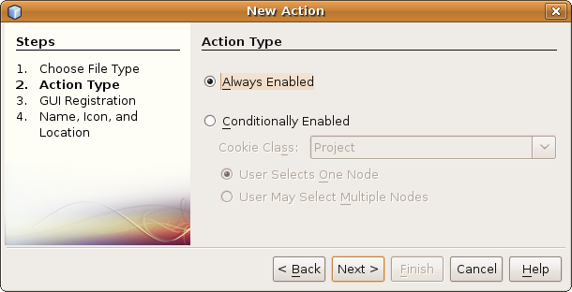
Insert image 1766_6_1.png
Click Next.
- Choose “Edit” as the category of the Action, which determines where in the Options window's Keymap section it will be displayed.
- Check the “Global Menu Item” checkbox. Now you can specify where the Action should appear in the menubar. Choose Edit and then choose any position you want within the Edit menu.
Note: You do not need to insert the Action in the toolbar at this time, nor assign a keyboard shortcut.
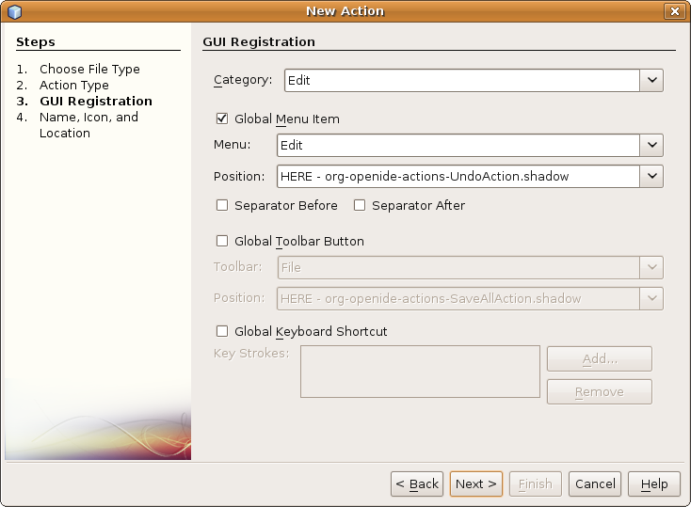
Insert image 1766_6_2.png
Click Next.
- Name the action “NewTaskAction”, with “New” as the display name. Optionally, specify an icon.
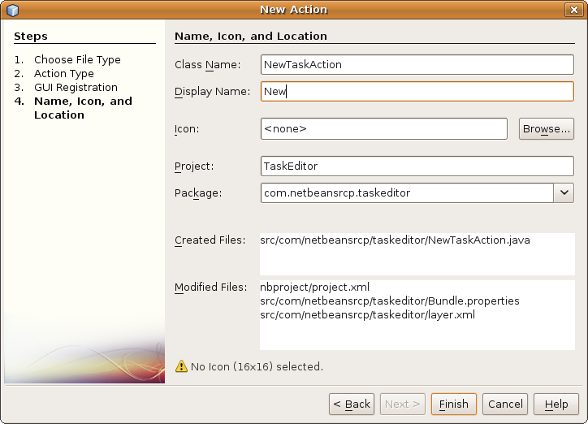
Insert image 1766_6_3.png
- The actionPerformed method of the generated class NewTaskAction should create a new Task and display it in a TaskEditor. Therefore, implement the method as follows:
public void actionPerformed(ActionEvent e) {
TaskManager taskMgr = Lookup.getDefault().lookup(TaskManager.class);
if (null != taskMgr) {
Task task = taskMgr.createTask();
TaskEditorTopComponent win = TaskEditorTopComponent.findInstance(task);
win.open();
win.requestActive();
}
}
- Run the application again. In the Edit menu there is now a “New” menu item. When you select the menu item, a new Task is created in the Task Editor.
In summary, you have used the New Action wizard to create and register a new global Action.

Examining the Created Files
The wizard created a simple ActionListener and registered it declaratively in the layer.xml file. As a result, the Actions folder now has an Edit subfolder, with this content in the layer.xml file:
<folder name="Actions">
<folder name="Edit">
<file name="com-netbeansrcp-taskeditor-NewTaskAction.instance">
<attr name="delegate" newvalue="com.netbeansrcp.taskeditor.NewTaskAction"/>
<attr name="displayName" bundlevalue="com.netbeansrcp.taskeditor.Bundle#CTL_NewTaskAction"/>
<attr name="iconBase" stringvalue="com/netbeansrcp/taskeditor/icon.png"/>
<attr name="instanceCreate" methodvalue="org.openide.awt.Actions.alwaysEnabled"/>
<attr name="noIconInMenu" boolvalue="false"/>
</file>
</folder>
</folder>
Below the Edit folder, you see that an “.instance” file has been registered. That file represents an instance of the class for which it is registered. A set of attributes have been defined for the file:
- delegate
- displayName
- iconBase
- instanceCreate:
- noIconInMenu
In addition to the Action registration, the wizard has created a Menu registration too in the layer.xml file:
<folder name="Menu">
<folder name="Edit">
<file name="com-netbeansrcp-taskeditor-NewTaskAction.shadow">
<attr name="originalFile" stringvalue="Actions/Edit/com-netbeansrcp-taskeditor-NewTaskAction.instance"/>
<attr name="position" intvalue="100"/>
</file>
</folder>
</folder>
Within the “Edit” menu, a shadow file has been registered. Shadow files do not represent an instance, but serve as a symbolic reference, which is a familiar concept from the Unix world. Has the Action instance been directly attached to the menu, deleting the menu registration would have caused the removal of the Action, too. Thanks to the shadow files, removing the menu registration does not mean that the Action registration itself is removed, since the Action is registered separately. Also, when you decide to let the user invoke the Action from a toolbar or keyboard shortcut, you will again use shadow files. The Action will then be instantiated once, not each time it is invoked from the various places where the user invokes it from.

Enabling Users to Invoke Actions
Let's now allow the user to invoke the action from a toolbar button and a keyboard shortcut as well. After all, you can connect Actions to a variety of places. Actions are often attached, for example, to context menus within Explorer Views, files of certain MIME types, or the editor. Often these Actions only make sense if they react in a context sensitive way to the element from whose context menu they are called. This too is supported by the NetBeans Platform.
In this case, though, you simply want to have the Action always be enabled and present in the toolbar, as well as from the menubar where it is already found.

Toolbar
You have already seen how Actions are attached to menus. All that is involved is registering the corresponding Action class in the appropriate position in the layer.xml file. The same approach applies to toolbar buttons, where a new toolbar button is registered within a subfolder of the “Toolbars” folder, as follows in the layer.xml file:
<folder name="Toolbars">
<folder name="Edit">
<file name="com-netbeansrcp-taskeditor-NewTaskAction.shadow">
<attr name="originalFile" stringvalue="Actions/Edit/com-netbeansrcp-taskeditor-NewTaskAction.instance"/>
</file>
</folder>
</folder>
Note: For toolbar buttons, it is important that you register an Action for which an icon has been registered in the layer.xml file. Otherwise no icon will be shown for the Action in the toolbar.
Run the application. The Action is now visible in the Edit toolbar.
In summary, you have attached an Action declaratively to a toolbar. You simply had to add a shadow file entry to the relevant location in the layer.xml file.

Keyboard
Actions can be triggered by pressing key combinations on a keyboard. As with menus and toolbars, a keybinding is implemented within the NetBeans Platform declaratively. The relevant folder in this case is “Shortcuts”, while the file that you need to register there is again a shadow file.
Consequently, the name of the shadow file does not relate to the name of the Action that is to be triggered, but instead indicates the key combination in an Emacs-like notation, consisting of a modifier followed by a key designator. Between the modifier and designator a hyphen is required.
The following are valid modifiers:
C Ctrl Key
A Alt Key
S Shift Key
M Meta Key, for example, Command Button
Since the Ctrl key on the Mac is different to what it is on a conventional PC, the NeBeans Platform provides us a further wildcard, with a corresponding key that varies depending on the operating system:
D Standard Acceleration Key
(e.g. PC: Ctrl Key, Mac: Command Key)
O Alternative Acceleration Key
(e.g. PC: Alt Key, Mac: Ctrl Key)
As a key designator, the name of each key constant is derived from java.awt.event.KeyEvent, with the leading VK_ of the constant name removed.
You now want to bind your action to the key combination standard accelerator key-A, which on the Mac is Command-A, while on the PC it is Ctrl-A.
Following the description above, register the Action to be invoked from a shortcut as follows in the layer.xml file:
<folder name="Shortcuts">
<file name="D-A.shadow">
<attr name="originalFile" stringvalue="Actions/Edit/com-netbeansrcp-taskeditor-NewTaskAction.instance" />
</file>
</folder>
Run the application again. Press Ctrl-A on a PC or Command-A on a Mac. When you do so, you should see that the Task Log registers the creation of a new Task.
In summary, you have now declaratively bound an Action to a keyboard shortcut.

