10
Dialogs
In this chapter you learn how to use the NetBeans Dialogs API to interact with the user. You start by looking at simple notifications and then at the set of standard dialogs that the Dialogs API provides. Next, you focus on how to integrate your existing complex dialogs into your application, in particular, focusing on multi-step dialogs, which are often called “wizards”.
The topics covered in this chapter will teach you the following:
- how to create notifications
- how to use standard dialogs
- how to integrate complex dialogs
- how to create wizards

Notifications
Let's start by looking at simple notifications. Simple notifications include information dialogs, warning messages, and failure notifications.
The NotifyDescriptor class is responsible for describing the notification, that is, the message itself and the options available to the user when responding to the message. The NotifyDescriptor.Message class is responsible for pure notifications without the possibility of receiving a response from the user, much like a JOptionPane. It provides the simplest form of communication with the user. It describes a dialog, which is shown via the DialogDisplayer class. The DialogDisplayer class is implemented as a singleton. It can create dialogs to be displayed immediately or delayed in the EDT.
Let's now demonstrate these classes in action. In the example application, you'll inform the user of the tasks shown by the filter. The steps below introduce the code that follows.
- You need an instance of NotifyDescriptor.Message if you need to provide a simple notification without the possibility of reaction from the user.
- You can pass the constructor a message and, optionally, a message type, which can between an information message or a warning message. Depending on the type used, a corresponding icon is shown. In this case, you want to inform the user that specific tasks are no longer shown. Therefore you use the message type NotifyDescriptor.INFORMATION.MESSAGE.
- Pass the NotifyDescriptor to the notify() method of the singleton instance of the DialogDisplayer.
- The filtering of tasks is handled in the PriorityFilter module. Specifically, the filtering code is provided by the filter() method in the PriorityFilterTopComponent class. Find that method and enhance it with the code shown below, after declaring a dependency on the Dialogs API.
The steps above are expressed in code as follows:
private void filter(Task.Priority prio) {
OverviewTopComponent tc = (OverviewTopComponent) WindowManager.getDefault().findTopComponent("OverviewTopComponent");
Node root = tc.getExplorerManager().getRootContext();

if (root instanceof PriorityFilterNode) {
root = ((PriorityFilterNode) root).getOriginal();
}

Node newRoot = (null != prio) ? new PriorityFilterNode(root, prio) : root;
tc.getExplorerManager().setRootContext(newRoot);

String msg = "";
if (null != prio) {

String prioTxt = "";
switch (prio) {
case LOW:
prioTxt = "low";
break;
case MEDIUM:
prioTxt = "medium";
break;
case HIGH:
prioTxt = "high";
}
msg = "Only Tasks with priority\n" + prioTxt + " or higher are shown.";

} else {
msg = "All tasks are shown independent of priority";
}

NotifyDescriptor d = new NotifyDescriptor.Message(
msg, NotifyDescriptor.WARNING_MESSAGE);
DialogDisplayer.getDefault().notify(d);
}

Start the application and filter the tasks in the overview. When you do so, you are notified of tasks that are shown:
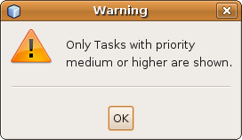

Insert image 1766_10_1.png

To summarize, you have extended the application with a simple notification in a dialog. To that end, you used the NotifyDescriptor class, displaying the dialog via the DialogDisplayer class.

Standard Dialogs
Let's now take a look at some slightly more complex dialogs that provide actual possibility for user interaction. These are implemented just as simply as the notification shown in the previous section. Once again, you use the NotifyDescriptor class and display the described dialog via the DialogDisplayer class.
In this case, the NotifyDescriptor is a NotifyDescriptor.Confirmation or a NotifyDescriptor.InputLine. These give the user the possibility of confirming or aborting the dialog and, in the latter case, of typing a single-line text.
In the example application, let's enable the user to confirm the deletion process, prior to the deletion actually taking place. Deleting a task is currently done in the RemoveAction class, within the TaskActions module. Now you need to add code to this class.
The steps below explain the code that follows.
- Create an instance of NotifyDescriptor.Confirmation to display a confirmation dialog.
- Pass the constructor the message, a dialog title, an option type, and a message type. The option type defines the combination of the Yes, No, OK, and Cancel buttons you want to use. The message type is the same thing as the message type used in the previous section. In this case, you need a Yes and a No button for displaying a warning. For that you use NotifyDescriptor.YES_NO_OPTION and NotifyDescriptor.WARNING_MESSAGE. You can give a default answer by setting up the buttons setValue(...) method of DialogDisplayer. In this case, the NO_OPTION would make sense.
- The value of the clicked button is returned by the DialogDisplayer via the notify() method.
In the RemoveAction within the TaskActions module, the steps above can be implemented as follows, requiring a dependency in the TaskActions module on the Dialogs API:
public void actionPerformed(ActionEvent arg0) {

if (null != this.result && 0 < this.result.allInstances().size()) {

Task task = this.result.allInstances().iterator().next();

String msg = "Do you really want to delete the task " + task.getId() + " ?";
NotifyDescriptor d =
new NotifyDescriptor.Confirmation(
msg,
"Delete Task",
NotifyDescriptor.YES_NO_OPTION,
NotifyDescriptor.WARNING_MESSAGE);

d.setValue(NotifyDescriptor.NO_OPTION);

Object res = DialogDisplayer.getDefault().notify(d);
if (null != res && DialogDescriptor.YES_OPTION == res) {

TaskManager taskMgr = Lookup.getDefault().lookup(TaskManager.class);
if (null != taskMgr && null != task) {
taskMgr.removeTask(task.getId());
}
}
}
}

Start the application and try to delete a task. A dialog pops up asking if you really want to delete the task. The task is only deleted if the message is confirmed.
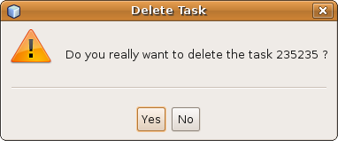

Insert image 1766_10_2.png

To summarize, you have seen how easy it is to use default dialogs. As an example, you used a simple confirmation dialog. Next, you used a NotifyDescriptor.Confirmation, displaying it via a DialogDisplayer. Using the method setValue(), you selected an answer button. The answer chosen by the user is the return value of the notify() method. In addition, a question with a single-line text as answer can be created via NotifyDescriptor.InputLine, with the return value available via the method getInputText().

Custom Dialogs
Often the NetBeans Platform standard dialogs are not as flexible as you'd like them to be. More typically, you need to create your own dialogs, containing your own domain-specific Swing components. In this section, you focus on single-pane dialogs, while the next section examines the support for wizards, that is, multi-pane dialogs.
Let's say that, in the example application, you want to provide another Action in the toolbar. This Action allows filtering of tasks by priority, similar to the PriorityFilterTopComponent. However, while PriorityFilterTopComponent provides several buttons for the different priorities, let's say that the new Action should use a dialog to enable the user to set how the filtering should be done.
Since the logic to filter tasks remain the same, whether used from the TopComponent or from the new dialog that you will create, let's reuse the filtering logic in the Action.
- In the PriorityFilter module, create a new helper class named Filter.
- Move the filtering logic from the PriorityFilterTopComponent to the new Filter class:
public class Filter {

public static void filter(Task.Priority prio) {

// paste filter code from the PriorityFilterTopComponent here
}

}

Back in the PriorityFilterTopComponent, reuse the filter method as follows:

private void filter(Task.Priority prio) {
Filter.filter(prio);
}

Now let's create an Action that manages the filtering via a dialog. You need to create your own dialog, enabling the user to set a priority via a radio button.
The main difference from the previously displayed standard dialogs is the usage of the Descriptor class. While you previously used the NotifyDescriptor class, you will now use the DialogDescriptor class instead. The DialogDescriptor class extends NotifyDescriptor, providing additional capabilities for displaying custom content, while also giving you control over dialog features such as modality, button look and feel, and context sensitive help. Just like the NotifyDescriptor, the DialogDescriptor is displayed via a DialogDisplayer.
- Start by creating a JPanel for the custom content of the dialog. To that end, in the PriorityFilter module, create a JPanel called FilterPanel.
- On the FilterPanel, using the Matisse GUI Builder, add a JLabel and a ButtonGroup with four JRadioButtons. The result should be as shown below. Adding the JRadioButtons to the JButtonGroup is done via the property “buttonGroup” in the Properties window, for each of the JRadioButtons.

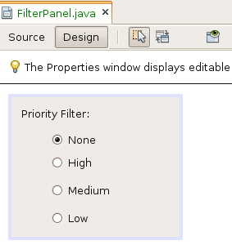

Insert image 1766_10_3.png

The purpose of the FilterPanel is to allow the selection of a priority. Therefore, you should introduce a method that returns the selected priority, as follows:
public class FilterPanel extends javax.swing.JPanel {
/** Creates new form FilterPanel */
public FilterPanel() {
initComponents();
}
public Priority getPriority() {
if (this.jRadioButton2.isSelected()) return Priority.HIGH;
if (this.jRadioButton3.isSelected()) return Priority.MEDIUM;
if (this.jRadioButton4.isSelected()) return Priority.LOW;
return null;
}

// ...
You can pass the FilterPanel to the DialogDescriptor, since the JPanel is the custom content. The dialog should be shown when a related Action from the task toolbar is activated. Take the steps below to create the Action:
- In the PriorityFilter module, use the New Action wizard, as described in the Actions chapter, to create an “Always Enabled” action. Click Next.
- In the “Category” field, choose “Tools”. You do not need an entry in a menu. However, an entry should be added to the global toolbar “Task”, after the RemoveAction. Click Next.
- Name the class FilterTasksAction, with "Filter Tasks" as the display name. Choose an icon to be displated in the toolbar.
- Click Finish and the ActionListener class is created and registered in the layer.xml file.
- In the toolbar, you want to see not only the icon, but also the textual name of the Action. Therefore, override, just as you did for the other Actions, the getToolbarPresenter() method, returning a corresponding JButton.
- The FilterAction should display a dialog which, in turn, should contain the FilterPanel you created earlier. You need to create a DialogDescriptor with a constructor that should receive an instance of the Jpanel, together with a title, a modality flag, an option type, an option preselection, and an ActionListener for the buttons.
- Instead of the option types you could pass a list of custom options and their alignment, together with a help context, neither of which you need to do in the context of the example application. Instead, you display the created DialogDescriptor, as usual, via the DialogDisplayer. The result is returned by the display() method and you can read the selected priority directly in the FilterPanel.
The steps above describes the code below:
public final class FilterTasksAction extends AbstractAction implements Presenter.Toolbar {

private JButton toolbarBtn;

@Override
public void actionPerformed(ActionEvent e) {
FilterPanel filterPanel = new FilterPanel();
DialogDescriptor dd =
new DialogDescriptor(
filterPanel,
"Priority Filter",
true,
DialogDescriptor.OK_CANCEL_OPTION,
DialogDescriptor.OK_OPTION,
null);
Object result = DialogDisplayer.getDefault().notify(dd);
if (null != result && DialogDescriptor.OK_OPTION == result) {
Filter.filter(filterPanel.getPriority());
}
}

@Override
public Component getToolbarPresenter() {
if (null == this.toolbarBtn) {
this.toolbarBtn = new JButton(this);
}
return this.toolbarBtn;
}

}
In the example, you do not need dynamic behavior during the display of the dialog, therefore you need to pass “null” instead of an ActionListener, when creating the DialogDescriptor.
Now start the application again. When you click "Filter Tasks", the dialog shown below appears. It requires the user to specify a priority. If the dialog is cancelled, no filtering takes place; if you confirm, the dialog it is filtered, using the selected priority.
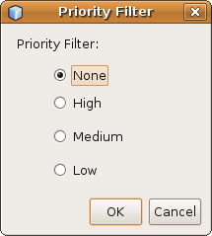

Insert image 1766_10_4.png

To summarize, you have seen how you can create dialogs with custom content. The dialog is displayed, as usual, via the DialogDisplayer class. However, instead of a NotifyDescriptor class, the DialogDescriptor class is used to define the content to be displayed. For example, you can pass a JPanel to a DialogDescriptor, with custom content, which gives you control over the content and appearance of the dialog you create.

Wizards
Though custom dialogs are an improvement over standard dialogs, they're often not sufficient either. Especially when a lot of information needs to be gathered during a single process, a single-pane dialog is limiting. In this section, you learn how to create multi-pane dialogs, which are normally called “wizards”.

Creating a Wizard
In the example application, let's create a wizard to manage the creation of new tasks. You will create it in the TaskActions module, taking the steps below to do so.
- NetBeans IDE provides a wizard for creating new wizards. To use this wizard, choose New | Wizard from the context menu of the TaskActions module.
- On the first page of the wizard, as shown in the illustration below, select, firstly, the type of registration. A custom wizard is not registered in the “New File” wizard, needing to be called programmatically from somewhere in your code instead. Choosing “New File” wizard will result in layer entries being added that will register the wizard in the New File dialog of the application.
For custom wizards, you can choose if the wizard should pass through a sequence of separate panels, in linear fashion or dynamically, based on the choices made by the user. The first option creates code that lets the user pass through the sequence of panels forward and backward, without branching off or skipping panels. The second creates code that, by default, gives you full control over the order of the panels and allows a dynamic order of the panels to be created.
You also need to specify how many panels should be created for the new wizard. For the example, let's create a custom wizard, i.e., with its own registration, that is, not registered in the layer, but invoked from your own code, with a static panel sequence, and three panels.
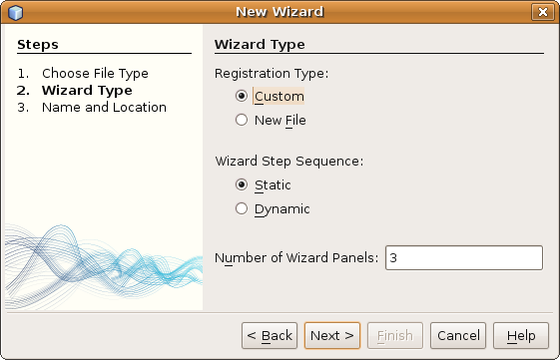
Insert image 1766_10_5.png

- On the second page of the wizard, as shown below, specify a class name prefix for the classes to be generated, as well as the destination package. For the example, set NewTask as the prefix and com.netbeansrcp.taskactions.wizards as the package.

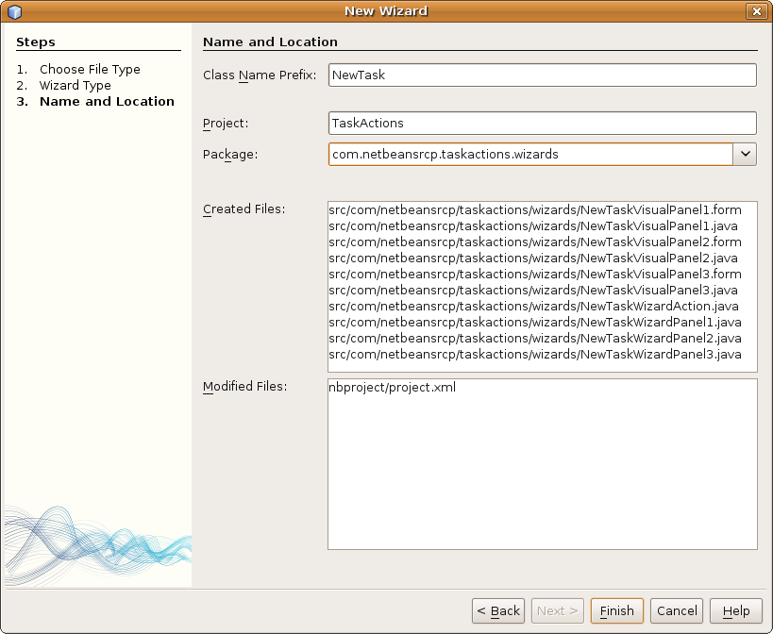
Insert image 1766_10_6.png

- When you finish the wizard, the following classes are created:
- an action to invoke the wizard named NewTaskWizardAction
- three WizardDescriptor.Panels with the prefix NewTaskWizardPanel
- three JPanels with the prefix NewTaskWizardVisualPanel
Each of the JPanels is responsible for visually representing a step in the wizard.
The WizardDescriptor.Panels are responsible for controlling the step. These manage the JPanels by, at the beginning of the step, reading the settings, initializing the JPanels with this settings, and saving the entered data before the user continues with the next step. They also check the validity of the entered values and provide support for listeners, as well as a help context for the step.
In custom wizards, a WizardDescriptor is created by the Action class that is generated by the Wizard wizard. A WizardDescriptor represents the description of the dialog, manages the WizardDescriptor.Panels, controls the iteration through the panels, and manages global dialog settings.
The Action is responsible for creating the WizardDescriptor, to initialize it with WizardDescriptor.Panels, and to create, via the DialogDisplayer, the corresponding dialog, and to display it. In addition, it initializes both the WizardDescriptor and the JPanels with property values.
Let's now start with the visual design of the individual panels of the wizard.

Designing the Wizard Panels
On the first page of the wizard, you need to inform the user as to whether they are creating a TopLevelTask or a subtask.
The JPanel for this step requires only a JLabel, which you can access from the outside to set the text dynamically. Therefore, take the following steps:
- Open the NewTaskVisualPanel1 class in the Matisse GUI Builder.
- Add a JLabel and, in the Source view, publish the JLabel via a corresponding getter.
- In addition, override the getName() method to give the step a reasonable name.
- To let all steps have a panel with the same size, set for this panel, as well as all following JPanels, the “preferredSize” property to 460,300.

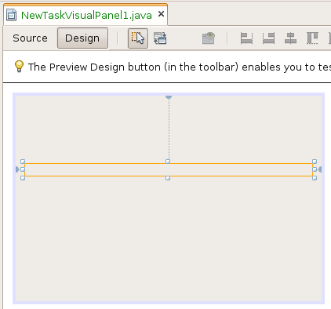
Insert image 1766_10_7.png

public final class NewTaskVisualPanel1 extends JPanel {

public NewTaskVisualPanel1() {
initComponents();
}

public JLabel getInfoLabel() {
return this.jLabel1;
}

public @Override String getName() {
return "Introduction";
}

// ...

- On the second page of the wizard, let the user set the name of the task, its due date, priority, and current progress.
To this end, open the NewTaskVisualPanel2 class and add four JLabels, two JtextFields, and two JSliders, as seen in the illustration below. Set the labeled JLabels to the same size, align them to the right, and set the horizontalAlignment property to TRAILING.
For the first JSlider, set the “value” property to 1, the “maximum” property to 2, and the “majorTickSpacing” property to 1. Enable the “paintTicks” and “snapToTicks” properties. For the second JSlider, set the “value” property to 0, the “majorTickSpacing” property to 25 and the “minorTickSpacing” property to 5. Enable the properties “paintLabels”, “paintTicks”, and “snapToTicks”.
Finally, make the JTextField and the JSlider available to other modules in the application via getter methods and again override the getName() method.
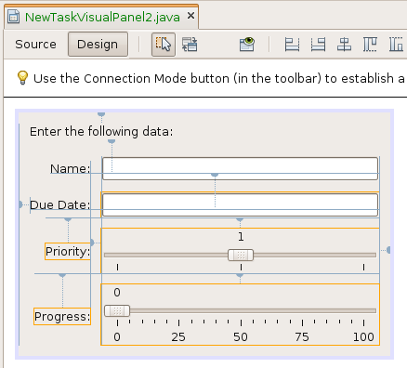

Insert image 1766_10_8.png

public final class NewTaskVisualPanel2 extends JPanel {

public NewTaskVisualPanel2() {
initComponents();
}

public JSlider getPriority() {
return jSlider1;
}

public JSlider getProgress() {
return jSlider2;
}

public JTextField getNameField() {
return jTextField1;
}

public JTextField getDue() {
return jTextField2;
}

@Override
public String getName() {
return "Details";
}

// ...

- Last but not least, let's turn to the third panel. Here you want to ask the user to provide a detailed description of the task. Open the NewTaskVisualPanel3 class and then add a JLabel and a JTextArea. Make these components available to the other classes in the module via getter methods and override getName().

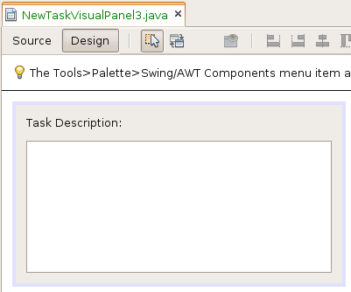
Insert image 1766_10_9.png

public final class NewTaskVisualPanel3 extends JPanel {

/** Creates new form NewTaskVisualPanel3 */
public NewTaskVisualPanel3() {
initComponents();
}

public JTextArea getDescription() {
return this.jTextArea1;
}

public @Override String getName() {
return "Description";
}

// ...

The graphic design of the individual steps is completed. Now let's turn to examining how the wizard steps are controlled.

Controlling the Wizard Panels
The WizardDescriptor.Panel class controls the wizard panels, fulfilling the following responsibilities:
- Creation of the visual representation of the step. This task is handled by the getComponent() method which is already completely implemented and must be extended only by any possible initializations.
- Reading the settings for the step, initializing the visual panel, and storing the settings. For these tasks the methods readSettings(...) and storeSettings(...) are provided. The wizard does not currently operates with generics, so that an object is passed to these methods. This object is actually the WizardDescriptor and is used to store the settings that are stored with putProperty(...) and read out with getProperty(...).
- Checking the validity of entered values and supporting listeners. This responsibility is mapped to the methods isValid() and add- and removeChangeListener(...).
- Supporting context-sensitive help by returning a help context via the getHelp() method.
Before you proceed with the coding of each wizard panel, prepare the storage of the settings in the properties of the WizardDescriptor. To do this, you need to create an interface with constants for the property names to the separate settings.
- In the package “com.netbeansrcp.taskactions.wizards”, create a Java interface named NewTaskConstants.
- Define the content of your new class as follows.
public interface NewTaskConstants {

String PARENT_ID = "PARENT_ID";
String NAME = "NAME";
String DUE = "DUE";
String PRIORITY = "PRIORITY";
String PROGRESS = "PROGRESS";
String DESCRIPTION = "DESCRIPTION";

}
- Turn to the first wizard panel, which should display whether a TopLevelTask or a subtask is created with, where relevant, the ID of the parent. To achieve this, pass the ID of the parent task to the panel. If it is set, create a subtask, else create a TopLevelTask.
- Passing the value takes place via the properties of WizardDescriptor, which are passed to the readSettings() method. In this method, you read the intended property PARENT_ID and remember the value.
- The visual representation of the panel is provided by the getComponent() method, where you create and initialize a NewTaskVisualPanel1. In this case, you provide the information label with accompanying text.
Based on the steps above, the implementation of the first wizard panel therefore looks as follows:
public class NewTaskWizardPanel1 implements WizardDescriptor.Panel {

private NewTaskVisualPanel1 component;

public Component getComponent() {

if (component == null) {
component =
new NewTaskVisualPanel1();
}

return component;
}

public HelpCtx getHelp() {
return HelpCtx.DEFAULT_HELP;
}

public boolean isValid() {
return true;
}

public final void addChangeListener(ChangeListener l) {
}

public final void removeChangeListener(ChangeListener l) {
}

public void readSettings(Object settings) {

WizardDescriptor wd = (WizardDescriptor) settings;
String parentId =
(String) wd.getProperty(NewTaskConstants.PARENT_ID);

String txt = "";
if (null == parentId) {
txt = "You want a Task without parent" +
" Create Task...";
} else {
txt = "You want to create a Subtask for the task with the ID..." +
parentId;
}
((NewTaskVisualPanel1) this.getComponent()).getInfoLabel().
setText(txt);
}

public void storeSettings(Object settings) {
}
}

Validating Entered Values
Use the second panel of the wizard to ask for the details of the task to be created. The values entered by the user need to be stored. To this end, you use the method storeSettings(). This method stores the values as properties in the WizardDescriptor. The entered values need to be validated. To query the validity of the panel, the method isValid() is used. The state of the panel is monitored via a ChangeListener.
In the example application, only the input of the date should be validated, since the conversion of text to date is error prone. Therefore, register a DocumentListener on the Document of the JTextField for the date input. When the text changes, the listener checks the validity and sets it accordingly.
Following the instructions in the paragraphs above, implement the NewTaskWizardPanel2 class as follows:
public class NewTaskWizardPanel2 implements WizardDescriptor.Panel, DocumentListener {

private NewTaskVisualPanel2 component;
private WizardDescriptor wd;
private boolean valid = true;
private ChangeSupport cs = new ChangeSupport(this);

public Component getComponent() {
if (component == null) {
component =
new NewTaskVisualPanel2();
this.component.getDue().
setText(DateFormat.getDateInstance().
format(new Date()));
this.component.getDue().getDocument().addDocumentListener(this);
}
return component;
}

public HelpCtx getHelp() {
return HelpCtx.DEFAULT_HELP;
}

public void readSettings(Object settings) {

this.wd = (WizardDescriptor) settings;
}

public void storeSettings(Object settings) {

this.wd.putProperty(NewTaskConstants.NAME,
this.component.getNameField().getText());
try {
this.wd.putProperty(NewTaskConstants.DUE,
DateFormat.getDateInstance().
parse(this.component.getDue().getText()));
} catch (Exception e) {
}

Priority prio = null;
switch (this.component.getPriority().getValue()) {
case 0:
prio = Priority.LOW;
break;
case 1:
prio = Priority.MEDIUM;
break;
case 2:
prio = Priority.HIGH;
break;
}
this.wd.putProperty(NewTaskConstants.PRIORITY, prio);

this.wd.putProperty(NewTaskConstants.PROGRESS,
this.component.getProgress().getValue());
}

public boolean isValid() {
return this.valid;
}

public void addChangeListener(ChangeListener arg0) {
this.cs.addChangeListener(arg0);
}

public void removeChangeListener(ChangeListener arg0) {
this.cs.removeChangeListener(arg0);
}

public void insertUpdate(DocumentEvent arg0) {
this.changeDue();
}

public void removeUpdate(DocumentEvent arg0) {
this.changeDue();
}

public void changedUpdate(DocumentEvent arg0) {
this.changeDue();
}

private void changeDue() {

boolean old = this.valid;
try {

DateFormat.getDateInstance().
parse(this.component.getDue().getText());
this.wd.putProperty("WizardPanel_errorMessage", null);
this.valid = true;
} catch (Exception ex) {

this.wd.putProperty("WizardPanel_errorMessage",
"Due date not formatted correctly!");
this.valid = false;
}

if (old != this.valid) {
this.cs.fireChange();
}
}
}
The exchange of data takes place in the readSettings() method and the storeSettings() method. Since you do not pass in any data, the readSettings() only stores the WizardDescriptor. On the other hand, in the storeSettings() method, the fields of the NewTaskVisualPanel2 are read and, if necessary, converted to data types corresponding to task properties. Then they are written into a property of the WizardDescriptor via the putProperty() method.
For validation, first of all the initialization of the NewTaskVisualPanel2 in getComponent() is important. Here you can immediately register the NewTaskWizardPanel2 itself as a listener on the Document of the JTextField for the date input. Once the text of the due date is changed, the corresponding listener method is called, delegating its call to changeDue().
In changeDue(), check whether the text can be converted to a date and set the validity flag to valid. If the date input is invalid, set the property WizardPanel_errorMessage in the WizardDescriptor. The value of the property appears as an error message at the bottom of the dialog, as shown in the illustration below. If the date input is valid, set the property to null so that the displayed error message is deleted.
You have to support listener for the validity so that a dynamic change of validity and the related dynamic display of the error messages work. Therefore the methods addChangeListener and removeChangeListener are responsible. You extend NewTaskWizardPanel2 by an attribute of the type ChangeSupport which is analogous to the already discussed PropertyChangeSupport. So you do not have to manage these listener. In the methods used to register and unregister the ChangeListener you delegate the call to this ChangeSupport. To notify the registered listeners about changes to the validity of current inputs you only have to call the method fireChange() on the ChangeSupport in changeDue(). So the displayed error message changes dynamically as you type in the due date.
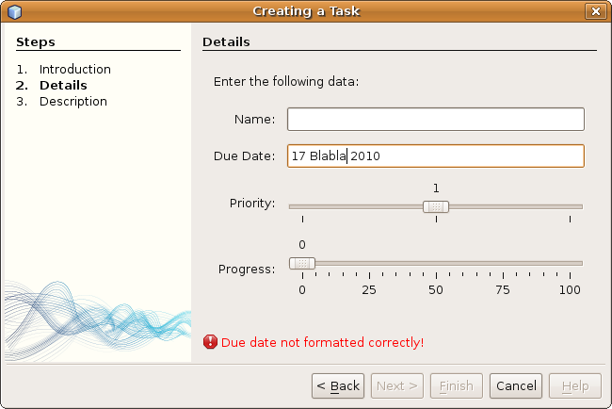
Insert image 1766_10_10.png

The third panel of the wizard asks the user for the detailed description of the task. Again, here you need to save the entered value via the storeSettings() method. If you followed the implementation of the previous panel, the implementation shows nothing special:
public class NewTaskWizardPanel3 implements WizardDescriptor.Panel {

private NewTaskVisualPanel3 component;

public Component getComponent() {
if (component == null) {
component =
new NewTaskVisualPanel3();
}
return component;
}

public HelpCtx getHelp() {
return HelpCtx.DEFAULT_HELP;
}

public boolean isValid() {
return true;
}

public final void addChangeListener(ChangeListener l) {
}

public final void removeChangeListener(ChangeListener l) {
}

public void readSettings(Object settings) {
}

public void storeSettings(Object settings) {

WizardDescriptor wd = (WizardDescriptor) settings;

wd.putProperty(NewTaskConstants.DESCRIPTION,
this.component.getDescription().getText());
}
}

Invoking the Wizard
Let's now focus on the NewTaskWizardAction class created by the Wizard wizard. The Action class is responsible for defining the WizardDescriptor, initializing it, and displaying it using the DialogDisplayer class. The Wizard wizard generated most of the code needed for these tasks.
In the steps below, you extend the responsibility of the action by letting it create new tasks. A new task should be created either as a TopLevelTask or as a subtask. The deciding factor is whether the ID of a parent task is known, which is determined by whether an ID is passed to the Action.
You begin by subclassing ActionListener, rather than CallableSystemAction. As discussed in the chapter on Actions, subclassing ActionListener is simpler and more idiomatic than subclassing CallableSystemAction. The Wizard wizard should probably have created an ActionListener class for you, instead of a CallableSystemAction class and, if you want to start contributing to the NetBeans Platform community by submitting issues in the NetBeans Issuezilla, this would be a good time to start doing so!
Once you have changed the code so that ActionListener is subclassed, you rewrite the signature of the existing actionPerformed() method to receive the parent ID. If the ID is set, a subtask is created for the specified task. If the IDE is not set, a TopLevelTask is created. To remain compliant with the Action interface, you introduce a new actionPerformed() method that delegates to your new actionPerformed(String) method and passes null as the parent ID.
Following the description above, the class NewTaskWizardAction now looks as follows:
public final class NewTaskWizardAction implements ActionListener {

private WizardDescriptor.Panel[] panels;

public void actionPerformed(ActionEvent e) {
this.actionPerformed (“”);
}

public void actionPerformed(String parentId) {

WizardDescriptor wizardDescriptor =
new WizardDescriptor(getPanels());
wizardDescriptor.setTitleFormat(new MessageFormat("{0}"));
wizardDescriptor.setTitle("Creating a Task");

wizardDescriptor.putProperty("WizardPanel_image",
Utilities.loadImage("com/netbeansrcp/taskactions" +
"/TaskBackground.png"));
wizardDescriptor.putProperty(NewTaskConstants.PARENT_ID, parentId);

Dialog dialog =
DialogDisplayer.getDefault().createDialog(wizardDescriptor);
dialog.setVisible(true);
dialog.toFront();
boolean cancelled =
wizardDescriptor.getValue() !=
WizardDescriptor.FINISH_OPTION;
if (!cancelled) {

TaskManager taskMgr =
Lookup.getDefault().
lookup(TaskManager.class);

if (null != taskMgr) {

Task task = null;
if (null != parentId) {

task = taskMgr.createTask(
(String) wizardDescriptor.getProperty(
NewTaskConstants.NAME), parentId);
} else {

task = taskMgr.createTask().getLookup().lookup(Task.class);

task.setName(
(String) wizardDescriptor.getProperty(
NewTaskConstants.NAME));
}

task.setDue(
(Date) wizardDescriptor.getProperty(
NewTaskConstants.DUE));

task.setPrio(
(Task.Priority) wizardDescriptor.getProperty(
NewTaskConstants.PRIORITY));

task.setProgr(
(Integer) wizardDescriptor.getProperty(
NewTaskConstants.PROGRESS));

task.setDescr(
(String) wizardDescriptor.getProperty(
NewTaskConstants.DESCRIPTION));
}
}
}

private WizardDescriptor.Panel[] getPanels() {
if (panels == null) {
panels =new WizardDescriptor.Panel[]{new NewTaskWizardPanel1(),
new NewTaskWizardPanel2(),
new NewTaskWizardPanel3()};
String[] steps = new String[panels.length];
for (int i = 0; i < panels.length;
i++) {
Component c = panels[i].getComponent();
steps[i] = c.getName();
if (c instanceof JComponent) {
JComponent jc = (JComponent) c;
jc.putClientProperty("WizardPanel_contentSelectedIndex",
new Integer(i));
jc.putClientProperty("WizardPanel_contentData", steps);
jc.putClientProperty("WizardPanel_autoWizardStyle",
Boolean.TRUE);
jc.putClientProperty("WizardPanel_contentDisplayed",
Boolean.TRUE);
jc.putClientProperty("WizardPanel_contentNumbered",
Boolean.TRUE);
}
}
}
return panels;
}

}

}

When required, the method getPanels() creates a WizardDescriptor.Panel[] and initializes it with instances of the three NewTaskWizardPanels. It iterates over this array, obtains each JPanel from the WizardDescriptor.Panel, transfers the name to a String[], and sets some of the following listed client properties on the JPanel:
WizardPanel_autoWizardStyle | Boolean | Activates the automatic lay outing of the wizard and leads to the verifying of the following properties.
WizardPanel_contentDisplayed | Boolean | Provies a list of the steps on the right side with the background image.
WizardPanel_helpDisplayed | Boolean | Turns on the help display and, if steps are displayed, the help and content panes are put into tabbed pane.
WizardPanel_contentNumbered | Boolean | Provides the numbering of steps.
WizardPanel_contentSelectedIndex | Integer | Provides the index of the step, starting at 0.
WizardPanel_contentData | String[] | Provides the step names displayed in the content pane.
WizardPanel_image | Image | Provides the image displayed as background of the content pane.
WizardPanel_errorMessage | String | Provides the error message for the invalid state of the panel.
WizardPanel_helpURL | URL | Provies the URL of the help topics for this panel.

These properties can usually be placed in either the JPanel or the WizardDescriptor, although the helpURL can only be set on the JPanel, while the error message can only be set on the WizardDesriptor.
As previously disussed, the method actionPerformed() calls actionPerformed(String) with a null argument. This method, in turn, is responsible for the real action and creates a WizardDescriptor, to which it passes the WizardDescriptor.Panels obtained from the getPanels() method.
Next, the format for the title, and the title itself, are set, where the placeholder {0} is replaced by the name of the JPanel and the placeholder {1} is replaced by the name returned from the WizardDescriptor.Iterator. By default, the name returned is an indication of which step is being displayed.
Next, you set properties on the WizardDescriptor, for specifying a background image and the ID of the parenet task. The dialog described by the WizardDescriptor is created and displayed via the DialogDisplayer.
As usual, the return of the display() method is the result of the wizard. If the wizard has not been cancelled, you obtain the TaskManager from the Lookup and use it to create a new task. The task properties are set by the values specified in the WizardDescriptor. At this point, you have completely implemented the Action and now need to integrate it into the existing AddNewAction.
The actionPerformed() method of the AddNewAction must no longer create and open a new task. It should leave this to the AddNewWizardAction. Remove the related calls on the TaskManager and, instead, get the AddNewWizardAction and call it. Depending on whether a TopLevelTask or a subtask should be created, pass the ID of the parent task, so that the method now looks as follows:
public void actionPerformed(ActionEvent arg0) {

Task task = null;
if (null != this.result && 0 < this.result.allInstances().size()) {

task = this.result.allInstances().iterator().next();

SystemAction.get(NewTaskWizardAction.class).performAction(task.getId());

} else {

SystemAction.get(NewTaskWizardAction.class).performAction();
}

}

Start the application and initiate the creation of a new task. It no longer opens a TaskEditor with a new task but, instead, the recently created wizard. The wizard asks the user to specify values for the new task and then creates it.
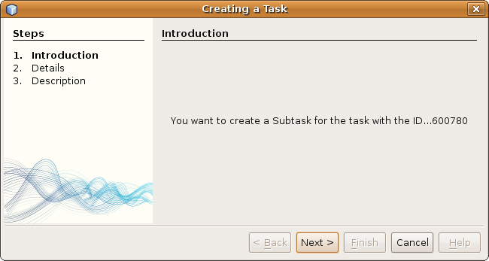
Insert image 1766_10_11.png
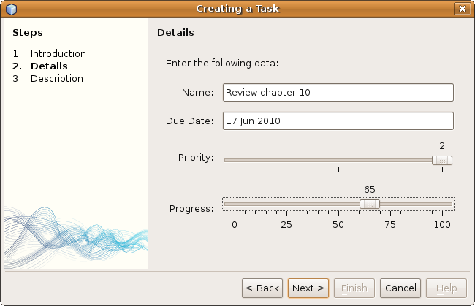
Insert image 1766_10_12.png
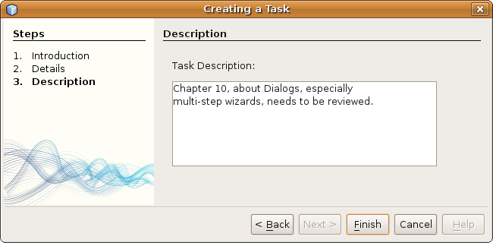
Insert image 1766_10_13.png

Summary
You have learned how to create notifications, dialogs, and wizards. Most of the focus of this chapter has been on creating a wizard. The Wizard wizard created an Action to start the new wizard and a WizardDescriptor to control the dialog. In addition, for each step, the Wizard wizard created a JPanel for graphic display and a WizardDescriptor.Panel to control the step. The JPanel visualizes a step graphically and publishes its components. The WizardDescriptor.Panel creates, manages, and controls the JPanel.

