11
Settings
When you want to let the user configure the application, the NetBeans Platform provides two sets of APIs to help you.
- On the one hand, you can make use of the Utilities API, which provides a NetBeans-specific Java Preferences API implementation. Though you can continue to program against the standard JDK Preferences class when you use the NetBeans-specific implementation, the configuration data is stored in the NetBeans Platform user directory, rather than in the location where the standard Preferences class would normally put it.
- On the other hand, the Options API lets you create panels that integrate with the NetBeans Platform Options window, so that you have a centralized location where you can integrate with an extensible user interface for the user to define the application's settings.
In this chapter you extend the Options window so that the user is able to configure a user-specific storage location for the tasks handled by the Task Manager.

Integrating with the Options Window
Two different extension points are provided for integrating panels into the Options window.
- The Options window offers several primary panels, identified by their large icons along the top of the Options window. These primary panels can be used to configure the most important groupings of settings in an application.
- Secondary panels are provided so that you can provide panels with less important settings needed for configuring the application. For example, one of the default primary panels is named “Miscellaneous”, containing secondary panels within it.
For the sample application that you are creating, you need to create a primary panel to configure the path pointing to the location where the tasks are stored. Extensions to the Options window can be provided in a new module or within the same module that provides the feature which the Options window extension complements. In this instance, that is, for the sample application, you provide the extensions to the Options window in a new module.
- Create a new module named Preferences with ”org.netbeansrcp.preferences” as the code name base. Set a dependency on the Utilities API, which provides the NbPreferences class. Also set a dependency on the Filesystem API, so that you can access the local filesystem via the LocalFileSystem class.
- Within the “org.netbeansrcp.preferences” main package, create a new package named “api”. Within the “api” package, create a Java interface named Preferences to provide access to the settings provided by the module:
public interface Preferences {
String PATH_CHANGED = "path_changed";
void setPersistencePath(String path);
File getPersistencePath();
void addPropertyChangeListener(PropertyChangeListener listener);
void removePropertyChangeListener(PropertyChangeListener listener);
}
The implementation of this interface needs to create the module's settings, aided by the NetBeans Preferences API.
Via the NbPreferences API class, you can create a Preferences object for the root of a configuration or for a specific class within the configuration. If you create a Preferences object for a class,the path to the location of the configuration is defined by the name of the code name base of the module, together with the name of the file, within the NetBeans Platform user directory. The settings themselves are saves as properties, with the file name using the “.properties” extension.

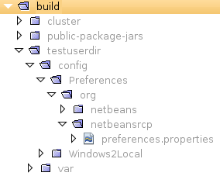
For the sample application, you need to store the settings for the Preferences module, so that the path and the file name should be as shown in illustration 11-1.

Insert image 1766_11_1.png

Create a new class named “PreferencesImpl”, for implementing your Preferences interface. The implementation uses a preference named “DIRECTORY” to load and store the absolute path to the location for storing tasks. You also need to be able to inform other modules of changes to the setting, to which end you include support for a PropertyChangeListener. Taking these considerations into account, our implementation needs to be defined as follows:
public class PreferencesImpl implements Preferences {

private PropertyChangeSupport pss = new PropertyChangeSupport(this);

public void setPersistencePath(String path) {
this.pss.firePropertyChange(PATH_CHANGED, this.getPersistencePath(),
path);
NbPreferences.forModule(PreferencesPanel.class).
put("DIRECTORY", path);
}

public File getPersistencePath() {
String taskDir =
NbPreferences.forModule(PreferencesPanel.class).
get("DIRECTORY",
new LocalFileSystem().getRootDirectory().getAbsolutePath());

File file = new File(taskDir);
return file;
}

public synchronized void addPropertyChangeListener(PropertyChangeListener listener) {
this.pss.addPropertyChangeListener(listener);
}

public synchronized void removePropertyChangeListener(PropertyChangeListener listener) {
this.pss.removePropertyChangeListener(listener);
}
}
Note: The PreferencesPanel, referred to in the code above, does not exist yet. You create it later in this section; until then, a red error underline will be shown in the editor.
- To register the above class in the META-INF/services folder, let the module depend on the Lookup API. Then annotate the PreferencesImpl class as follows:
@ServiceProvider(service=Preferences.class)

- Right-click the main package and choose New | Other | Module Development | Options Panel and click Next. The Options Panel wizard opens, enabling you to create a new Options window extension.
- On the first page (see Illustration 11-2) you need to decide whether to provide a primary panel or a secondary panel. Create a primary panel named “Task Manager”, with “task manager” as the keywords. The keywords enable the user to quickly open the Options window from the Quick Search field in the application, if you choose to support this feature.
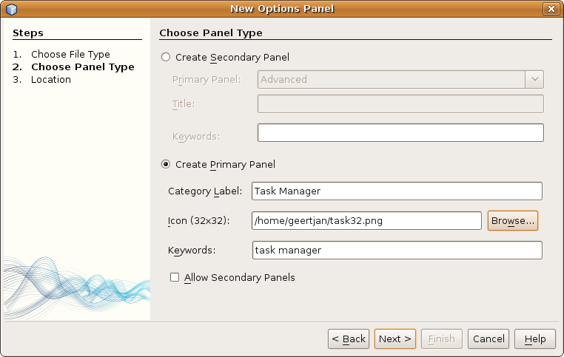

Insert image 1766_11_2.png

- As usual, the second page (see Illustration 11-3) offers the possibility to specify a name prefix to be used for the created classes.

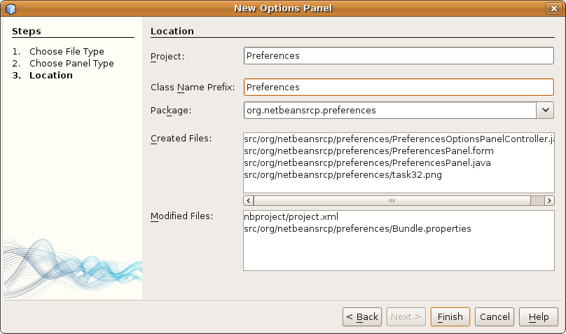

Insert image 1766_11_3.png

When you click Finish, the wizard generates two classes:
- PreferencesPanel. Responsible for visualization, loading, and storing of configuration data, as well as data validation.
- PreferencesOptionsPanelController. Responsible for creating the panel and managing communication between the panel and the Options window. It uses a PropertyChangeListener to monitor the state of the panel.
The PreferencesOptionsPanelController has the following class annotation that, at compile time, generates entries in the layer file to register the Options panel in the Options window:
@OptionsPanelController.TopLevelRegistration(categoryName = "#OptionsCategory_Name_Preferences",
iconBase = "org/netbeansrcp/preferences/task32.png",
keywords = "#OptionsCategory_Keywords_Preferences",
keywordsCategory = "Preferences")

Now you can start to layout the panel to let the user configure the storage location of their tasks.
- Open the PreferencesPanel and change the layout to BorderLayout.
- Add a JLabel, a JTextField, and a JButton. The “editable” property of the JTextField needs to be unselected because you will provide a JfileChooser for setting the path. After theses steps the dialog should look like as shown in illustration 11-4:

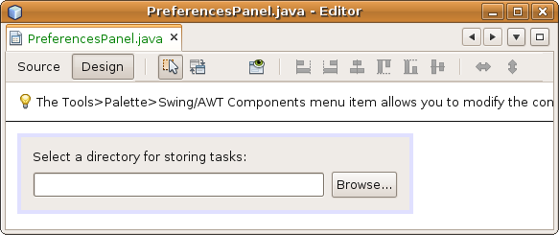

Insert image 1766_11_4.png

- Register an ActionListener on the JButton, so that you can open a JFileChooser when the JButton is clicked and update the JTextField with the path to the selected directory. The content of the ActionListener should be as follows:
JFileChooser chooser = new JFileChooser();

chooser.setFileSelectionMode(JFileChooser.DIRECTORIES_ONLY);

int rc = chooser.showOpenDialog(this);

if (JFileChooser.APPROVE_OPTION == rc) {

this.jTextField1.setText(chooser.getSelectedFile().

getAbsolutePath());

}
- Next, you need to implement loading, storing and validation of the preferences. For each of these tasks, a separate method is provided in the PreferencesPanel class: load() to load the preferences, store() to save them, and isValid() for validation purposes. Implement them as follows:
void load() {
this.jTextField1.setText(Lookup.getDefault().lookup(Preferences.class).getPersistencePath().getAbsolutePath());
}

void store() {
Lookup.getDefault().lookup(Preferences.class).setPersistencePath(this.jTextField1.getText());
}

boolean valid() {
return new File(this.jTextField1.getText()).isDirectory();
}
- Start the application again and open the Options window. You should be able to see your TaskManager primary panel, including the icon that you specified (see illustration 11-5). Select a folder, close the Options window, and exit the application. When you restart the application, notice that the selected value continues to be shown in the Options window.

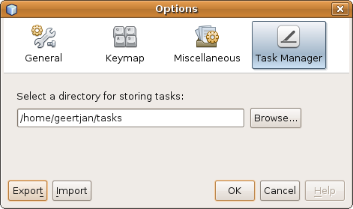

Insert image 1766_11_5.png

Summary
You have learnt how to use the NbPreferences class to store application specific settings in the NetBeans Platform user directory via the default Java Preferences API. In addition, you have learnt how to attach a new primary panel to the Options window, which is the centralized location for integrating user interfaces for configuring the features provided by the modules making up the application. Most of the required classes were generated automatically by a wizard, only a few manual tweaks were required to complete this application requirement. You only needed to design a JPanel and to read and write configuration data using the Java Preferences API.
Though you didn't learn how to add a secondary panel to the Miscellaneous panel, there's no magic there, either. The same approach is taken as for the primary panel, except that you specify in the Options Panel wizard that you would like to create a secondary panel rather than a primary panel. The wizard then creates all the required classes, with you only needing to design the JPanel to display the configuration settings, as well as the logic to read and write the required settings.

