13
Branding
When you are "branding" an application, you are interested in customizing or personalizing those aspects of the application that come from modules provided by the NetBeans Platform. Rather than forcing you to change the module's sources, the NetBeans Platform enables you to brand them in a number of different ways, as explained in this chapter.
Among other things, in this chapter you learn how to:
- Change the name of the application launcher
- Change the strings in the NetBeans Platform's modules
- Include your own splash screen

Application Launcher
The name of the application launcher is set in the Project Properties dialog of the TaskManager application. Right-click the TaskManager project node, choose Properties, click Application, and then type the letters that should form the launcher name:
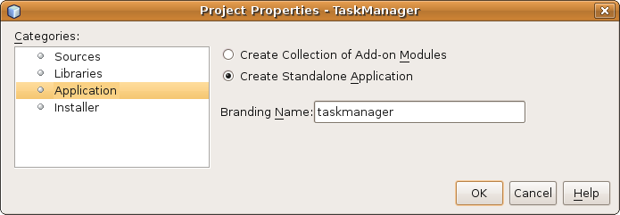

Insert image 1766_13_1.png

Limiting the Set of NetBeans Platform Modules
Next, you need to limit the set of NetBeans Platform modules that the application will make available. In the Libraries tab of the TaskManager Project Properties dialog, you see a list of modules and module-collections, which are called “clusters”, that are required by the application.
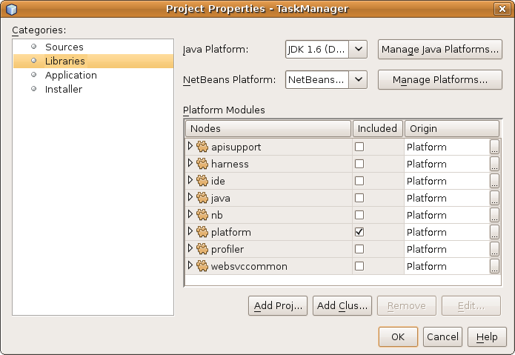
Insert image 1766_13_2.png

Here you can remove groups of modules, as well as individual modules, that are superfluous to the application. However, whenever you remove a module that is required by another module in the application, a helpful warning message is printed in red in the dialog above, to indicate that you are removing a required module.
Deselect all clusters except for “platform”, although even here you do not need all modules. Within the “platform” cluster, make sure you actually need all the modules in the list before continuing with the rest of this chapter.

Application Title and Icons
A Branding Editor, new in NetBeans IDE 6.9, lets you customize a number of visual features in the application. Right-click the TaskManager project node, choose Branding, and then the Branding Editor shown below appears.
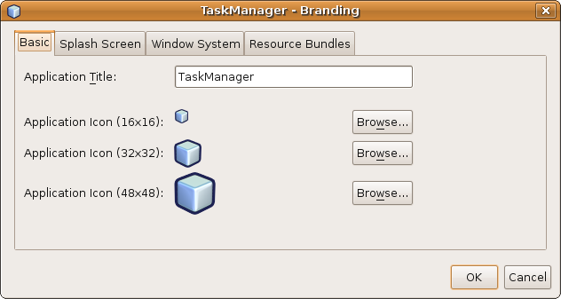
Use the “Basic” tab to define a title that will be displayed in the application title bar. Then look at the icons, below are the default icons shown in various places in the application, such as the small icon in the top left of dialogs, such as the Branding Editor itself::

Insert image 1766_13_3.png
Browse to the icons relevant to your application, using the “Browse” buttons above.

Splash Screen
A splash screen is a visual placeholder shown to the end user while the modules in the application are loaded and the application, as a whole, starts. The splash screen also displays information about the specific step in the process that is currently being completed. Via a progress bar, the user is informed of the number of steps that are left to be completed.
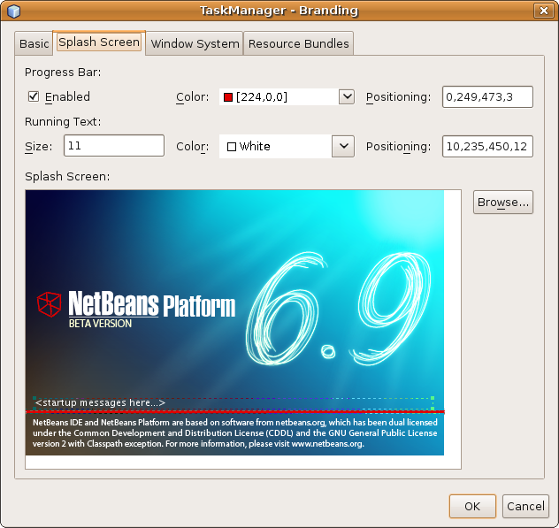
Insert image 1766_13_4.png
In NetBeans IDE, you can adjust all three of these aspects according to the business needs of your application, as shown in the screenshot above. You can set your own background image as a visual placeholder for the application during startup, as well as the positioning and adjusting of the progress text shown during the startup sequence.

Window System Features
Though the NetBeans Platform window system provides many features out of the box, not all end users will find those features useful. For example, some end users are not very technical and will be confused after undocking and moving windows around the screen, since they will not immediately know how to put all the windows back in their original positions. For some end users, you will want to disable the feature that allows windows to be closed. When you do so, the small “x” in the top right corner of the windows will be removed, so that the end user will not be able to close the windows in the application.
Window system features can be removed per window, via client properties set in the constructor of your TopComponent classes. However, it is better if all the windows in an application have the same behavior. You can modify window behavior for the whole application in the Branding editor. Right-click the TaskManager project node in the Projects window, choose Branding, and then choose the “Window System” tab, as shown below:
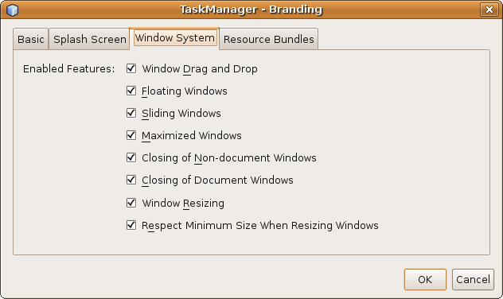
Insert image 1766_13_5.png
By default, all the window system features are enabled. To disable a feature, uncheck the related checkbox in the pane above. Properties are then added to the application “branding” folder (visible in the Files window), which override the default properties defined in the NetBeans Platform.

Display Texts
All the bundle files in the NetBeans Platform modules in your application can be branded. That means that you're able to override any display texts used in your application, such as menu items and titlebars in dialogs.
In the Branding editor, which you can shown by right-clicking the TaskManager project node and choosing “Branding”, choose the “Resource Bundles” tab and then you see a long list of all the bundle files from the NetBeans Platform modules in the application, as shown below:
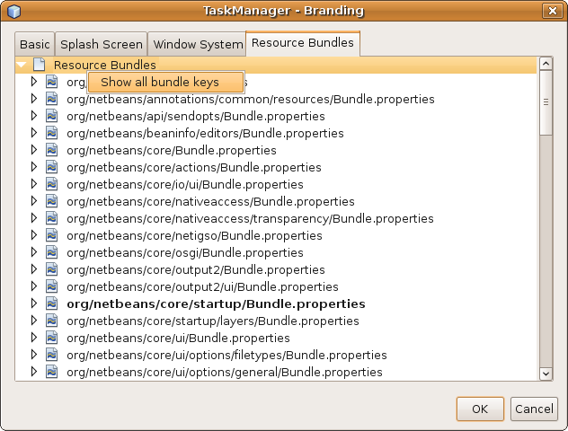
Insert image 1766_13_6.png

To find a particular string, right-click the root node of the list and choose “Show all bundle keys”. Then simply type the string (e.g., “Save” if you are searching for the string defining the “Sve” menu item) when the pane in the Branding editor is active. Then the search string appears in a text field at the bottom of the Branding editor and the first instance matching the search string is found, as shown in the next screenshot. Find the next instance of the matched string by pressing F3; continue pressing F3 and you will continue seeing the next instance, until you find the specific instance you are looking for.
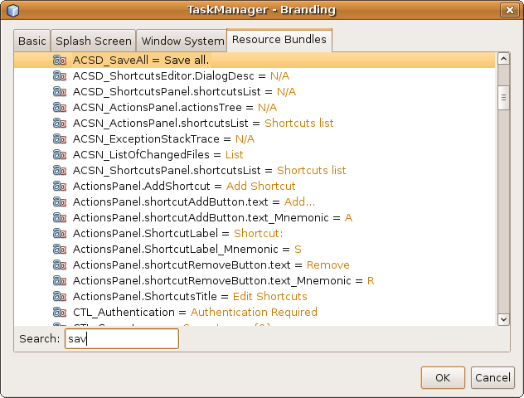
Insert image 1766_13_7.png

When you find the string you are looking for, right-click it and choose “Add to Branding”. You are then prompted to provide a string that overrides the original string in the NetBeans Platform. When you press OK, the string is added to a properties file that you can see in the “branding” folder (in the Files window) of the application. When the application is compiled, a JAR is created containing the overridden bundle file, which will override the matching bundle file in the NetBeans Platform.

Summary
In this section, you have completed the branding of the application. It now has its own application name, libraries, splash screen, icons, and display texts.

