14
Distribution & Updates
Now that the development cycle of the Task Manager is coming to an end, it is time to think about how best to distribute it. Not only do you need to think about distributing the application itself, but also about how to provide additional features and patches between releases of the application. The modular structure of the application implies that the delivery of plugins should be possible, which is one of the areas explored in this chapter.

Creating a ZIP Distribution
The NetBeans Platform lets you distribute your application in one or more different ways, from ZIP archive, to webstart-enabled, to installer-based. In this section, you learn about these standard distribution mechanisms for NetBeans Platform applications.
The distribution of a ZIP archive lets you provide the complete application to your end users, that is, all the modules and their configuration files, together with the launcher that starts them. Launchers for Windows and Unix-based systems can be created, as well as Mac OSX distributions.
Once users receive the ZIP file, they simply need to unpack it and double-click the launcher to start the application.

- To create such a ZIP distribution for the Task Manager, right-click the project node in the Projects window, and choose “Build ZIP Distribution”. A build script builds the whole application and creates the ZIP archive in the newly created “dist” folder of the application, which you can see in the Files window:
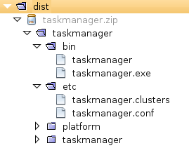

- Now you can try out the generated launcher. Unzip the ZIP archive created above. Then start the launcher relevant for your operating system. The Task Manager should now welcome you, starting with its splash screen.
You have learnt how to create a ZIP archive for the application, with a minimum of effort. Now that you have created it, you need to distribute it to your users, who simply need to unpack it and then run the launcher relevant to their operating system.
Even though we have only covered the ZIP distribution, the NetBeans Platform provides support for Mac OSX and web start, in a very similar way. Right-click the project node in the Projects window, and choose the menu item for creating a Mac OSX distribution, a web start distribution, or both, depending on your business needs. Then read the Output window and inspect the Files window for the generated results.

Creating an Installer
To create an installer for the Task Manager , right-click the project node and choose Properties. Use the Installer pane, shown below, to specify the target operating systems for the installers you would like to create:

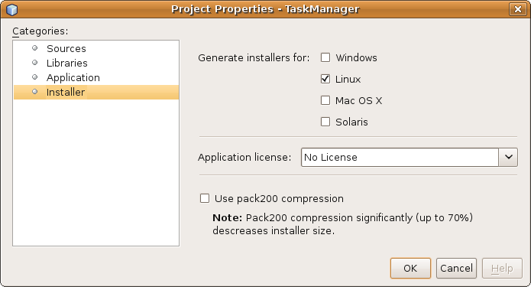
Click OK in the dialog above and then right-click the project node in the Projects window, choosing “Build Installers”. The selected installers are then built. Open the Files window to see the generated installers, which are now ready to be distributed to the end users.

Enabling Online Updates
By enabling the application to be updated online, you provide support for dynamic substitution, loading, and reloading of the modules in your application. A typical use case for this feature is that it enables you to distribute bug fixes to your end users, in between release cycles. Where, before, the end users would need to wait for the next release to benefit from bug fixes, you can now simply distribute an individual patched module to them instead, regardless of the current state of the next release of the application.
The support for online updates of NetBeans Platform applications comprises two components:
- Server component. NetBeans Platform AutoUpdate Service polls an update center, defined in XML format, for new and updated modules.
- Client component. NetBeans Platform Plugin Manager provides a user interface in a NetBeans Platform application, invoked via Tools | Plugins, for registering update centers and installing new and updated plugins.
The deployment format of modules is the NBM (“NetBeans Module”) format. It is simply a ZIP archive, containing the JARs in the module, together with their configuration files. In NetBeans IDE, you can generate an NBM file for each of your modules. These NBM files need to be registered in the Update Center descriptor file, which can also be created in NetBeans IDE. The Update Center then consists of the Update Center descriptor file, together with the modules that are registered within it.
Take the steps below to create NBM files and the Update Center descriptor. You register the Update Center descriptor in the sample application and use it to install updates to the modules in the application.
- Add the NetBeans Platform modules “Auto Update Services” and “Auto Update UI” to the application. Do this by right-clicking the project node in the Projexts window, choosing Properties, and then Libraries. Select the two modules, as shown below, and then click OK:
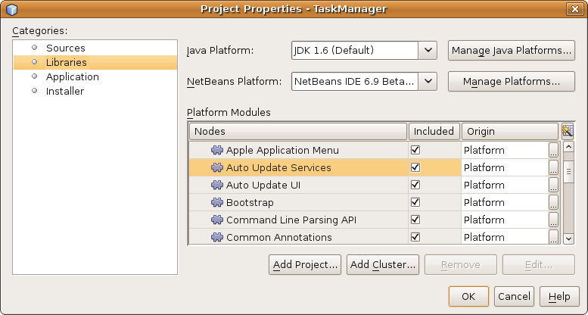
- Check that the Plugin Manager is now available. Do this by right-clicking the application, choosing “Clean All” (to remove the user directory), and then “Run”. The user directory is recreated, while the application restarts. When the application has started, go to the Tools menu and notice that you now have a “Plugins” menu item. Choose the Plugins menu item and your new Plugin Manager opens:
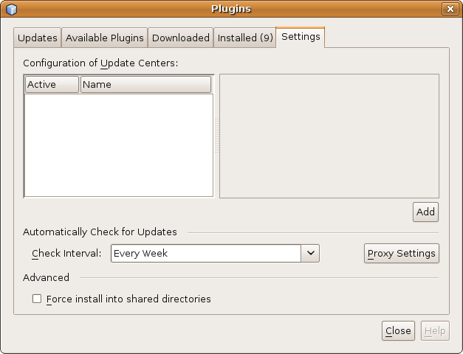
- Next, let's create NBM files for all the modules in the application. Right-click the Task Manager project node and choose “Create NBMs”. Now an NBM file is created for each module.
The new NBM files are created in the build/updates/ directory, as shown below:
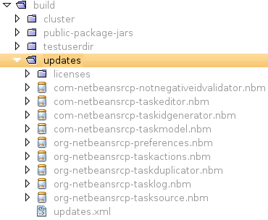

One of the files above is named “updates.xml”. This is the Update Center descriptor. It is an XML file that defines an element for each module, with attributes for information such as the download location and the module's related dependencies.
<?xml version="1.0" encoding="UTF-8" ?>
<!DOCTYPE module_updates PUBLIC "-//NetBeans//DTD Autoupdate Catalog 2.6//EN" "http://www.netbeans.org/dtds/autoupdate-catalog-2_6.dtd">
<module_updates timestamp="09/45/06/02/05/2010">
<module codenamebase="com.netbeansrcp.notnegativeidvalidator" distribution="com-netbeansrcp-notnegativeidvalidator.nbm" downloadsize="2907" homepage="" license="AD9FBBC9" moduleauthor="" needsrestart="false" releasedate="2010/05/02" targetcluster="taskmanager">
<manifest AutoUpdate-Show-In-Client="true" OpenIDE-Module="com.netbeansrcp.notnegativeidvalidator" OpenIDE-Module-Implementation-Version="100502" OpenIDE-Module-Java-Dependencies="Java &gt; 1.6" OpenIDE-Module-Module-Dependencies="com.netbeansrcp.taskidgenerator &gt; 1.0, org.openide.util.lookup &gt; 8.2" OpenIDE-Module-Name="NotNegativeIdValidator" OpenIDE-Module-Requires="org.openide.modules.ModuleFormat1" OpenIDE-Module-Specification-Version="1.0"/>
</module>
…
…
…
Here any URL can be used to describe where the module can be downloaded. The URL is by default simply set to the name of the module, which results in a local reference to the |updates.xml”. For our sample application, you can assume that all the modules are located directly beside the “updates.xml”, meaning that you do not need to change anything in the generated Update Center descriptor.
- Now you need to publish the Update Center descriptor, as well as the modules you want to make available to end users. Do this by uploading the Update Center descriptor file to a web server. For testing purposes, you could put it somewhere locally, together with the various modules.
In the application, choose Tools | Plugins, go to the Settings tab, click Add and then enter the URL to the Update Center descriptor.
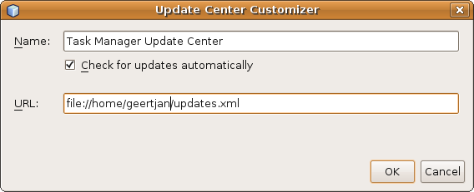

Summary
You have set up and used an Update Center. You did this by creating an Update Center descriptor, together with a set of NBM files. When you deliver the application, the end user can use the Plugin Manager to update the application with new features and patches.

