Obstructive Sleep Apnea Syndrome:

4D CTs analysis to access location and measure of obstruction

Hospital Project 2018-2019

Chiara Rossi & Deise Origuella

Contents

2 Identification of the Clinical Problem and Medical Request 2

3 Designed Solution and Workflow 2

3.1 Workflow 2

3.2 Workflow 3

3.2.1 Preprocessing of the reference image 3

3.2.2 Segmentation of the Throat 3

3.2.3 Extraction of the centerline 4

3.2.4 Registration 5

3.2.5 Extraction of Cross-section 6

3.2.6 Volume Extraction 6

# Identification of the Clinical Problem and Medical Request

Obstructive Sleep Apnea Syndrome is a pathology for which the upper air pathways occlude while sleeping. The region of interest can be split in three parts where the obstruction can occur and be caused by different mechanisms:

* The nasopharynx: described as the volume between the skull base and the bony palate. Obstruction caused by the soft palate, was not taken in consideration in this work.
* The oropharynx: volume between the bony palate and the epiglottis. Obstruction caused by the base of the tongue, the volume can be divided into two subsections (above and below the base of the tongue).
* The hypopharynx: volume below the epiglottis, this last structure causes the obstruction itself.

The pathological condition is investigated using 4D CT on 57 patients. Three sets of scans are acquired, each composed of 29 scans over time for each patient. The first set of acquisitions investigates the critical pathological condition of the patient; the second set is performed while the patient is wearing a device that allows the jaw to be in a normal healthy position, while for the last one the patient’s jaw is taken to a maximal pronation.

Given the dataset just proposed, the aim of the project is to localize the obstruction and to quantify the same. The investigation should consider separately the three regions described above, because the obstruction can occur in all of them but in each it is reflects different pathological cases.

Besides the mentioned goal, the given request includes also to develop an automatic algorithm that is able to identify, measure and compare the obstruction between different acquisitions and among patients as well.

# Designed Solution and Workflow

First, it is exposed how the problem is approached and the method to solve the given problem. The following algorithm is developed analyzing and working on a scan related to a healthy subject, without obstructions. The aim is to extract an atlas of a quantity related to the amount of air or the level of obstruction in each region, that can be farther registered onto the other acquisitions and among patients.

The algorithm is developed in python, using Anaconda. The libraries employed are SimpleITK for the image and Sci-kit image for the image processing. It is important to mentioned them because, although these packages have been downloaded on the working station provided at the hospital, an update would be required for a future work. For the registration and transformation steps, the programs used are Elastix and Transformix.

## Workflow

The chosen approach to create the atlas, concerns extracting a quantity related to the amount of obstruction in the throat. For this, the first step is to extract the cross-section of the throat in the horizontal plane, given a centerline, for each slice of the scan. The obstruction can be related to the cross section of the throat in a specific point. In fact, this quantity measures the minimum diameter of the planar section of the throat in a specific height, which allows to identify the obstruction of the interesting section. The cross-section can be easily extracted when the centerline of the anatomical structure is drawn. Therefore, the atlas should contain a general centerline of a throat, which can be registered onto different scans. Afterwards, the cross-section can be easily extracted by an automatic process.

Beside this approach, another method is proposed given the tough difficulties found along the resolution. This approach consists in the evaluation the volume of air segmented in the throat. This can be done slice by slice or region by region. In this case the atlas might consist in the segmented region of interest, from which an easy computation allows to extract the quantity.

## Workflow

In order to achieve the quantitative measurements just described, many steps must be accomplished first.

### Preprocessing of the reference image

When uploading the image, a few steps are required to be able to easily process the image afterwards. Firstly, the image is filtered by applying the OTSU filter, in order to extract a binary image.

### Segmentation of the Throat

The segmentation of the region of interest is executed by region growing. The aim is to segment the throat region by means of the air contained in the throat. The crucial point of this step is to identify the correct seed point within the region of interest. In the proposed algorithm this step will not be repeated but its aim is only to extract the throat region of the healthy control. Therefore, it is not considered an issue along the work. In healthy conditions, the whole throat is connected, a connected threshold function is applied. It is important to highlight that the air contained in the mouth is segmented as well, although this doesn’t belong to the interesting region. As well as the background, due to openings between the patient air pathways and the environment.

In the healthy subject used (image source: <https://www.embodi3d.com/files/category/37-medical-ct-scan-files/>), there must be an opening of the air pathways with the outside, so the segmentation also involves the background. Therefore, a cropping step follows to select only the throat length of interest. This step is performed by using a function that allows to maintain the image’s geometrical properties the same as in the original one, in order to make the registration process easier.

Figure Segmentation of the whole image and cut of the ROI

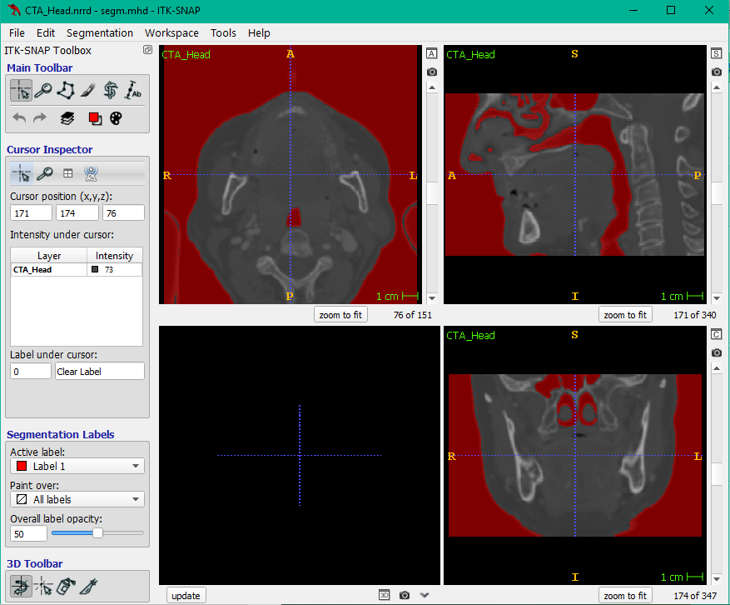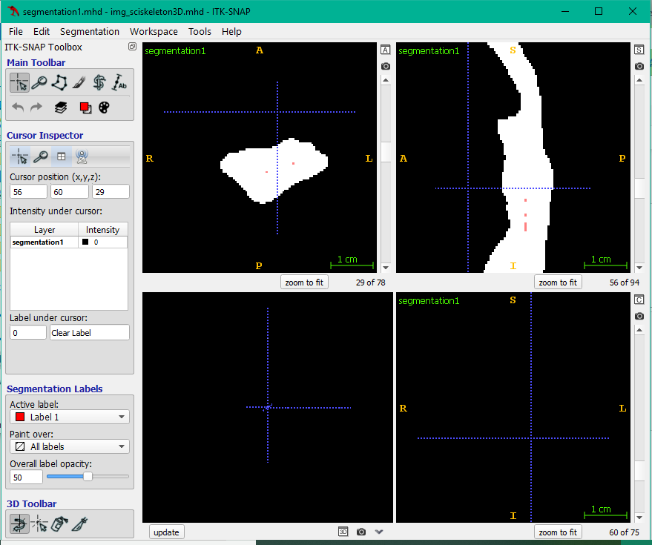

### Extraction of the centerline

This step concerns several computational issues. It is very challenging to extract automatically a central line, especially given that the throat structure cannot be modelled as a tube. Several approaches are followed to manage this turning point. This problem can be developed in different ways: skeletonization of the throat, thinning of the structure or computing the medial axis. Different algorithms allow to extract the centerline, and many have been applied to manage the extraction of the same.

* **3D direct extraction of the centerline**

Unfortunately, there are few libraries that allow a direct 3D extraction of a centerline, because mostly are designed for 2D structures. In this case the scikit-image has a skeletonize_3D function. This is the approach that is used in the following steps (script: skel3D). Although the approximated good result, the main problem is that sometimes several points in a single slice are identified as central, or vice versa, some slices are missed. This is a flaw in the algorithm that mainly involves the unfeasibility of the tube-like shape as a model of the throat. This problem doesn’t occur in the upper part since the structure seems more tubular. Besides this, itk has a new algorithm that consists of a thinning filter of a 3D image. This last algorithm is not completed implemented yet, and it is based on C++ language, but the documentation is provided (Homann H. Implementation of a 3D thinning algorithm. 2007). Other systems are investigated, and a few are proposed here below, although not implemented due to inconsistency with the approach followed or high computational demand:

- VMTK: this tool allows to extract semi-automatically a centerline. It is quite complicated to start with since it is not possible to use it through anaconda, but a specific programming language is required. A lab version is available with a graphic interface, but it is not free. Unfortunately, it is incompatible with the version of phyton used for the rest of the work. A drawback is that the start and end of the line must be drawn manually. An advantage is that using this tool would help also the further process of extracting the cross-section because it is a function already implemented in the system.

<https://github.com/vmtk/vmtk/issues> ; <http://www.vmtk.org/index.html>

- TubeTK: it is a toolkit implemented in C++.

<http://www.tubetk.org/>

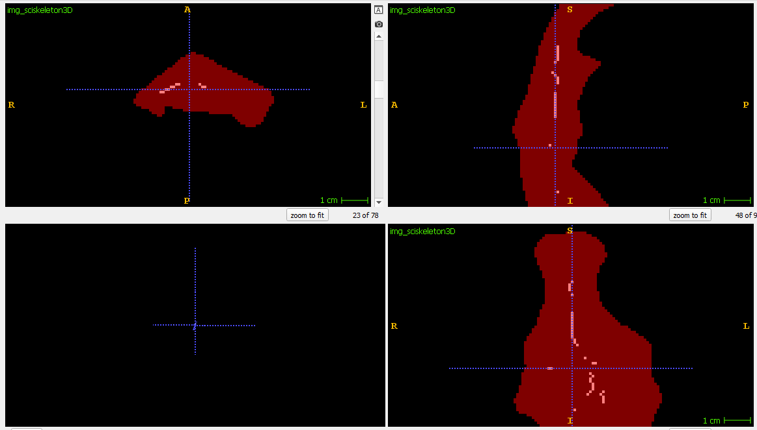

Figure 3D skeleton

* **2D centerline**

In this case the 3D image is processed slice by slice, for which the centerline is extracted. Given this approach, there are two possibilities to go back to find the 3D corresponding centerline. Firstly, the centerline is computed for all the slices in the sagittal and horizontal plane, afterwards the multiplication of the two images should give back an unique centerline in 3D. However, this approach did not give a satisfying result. Another approach is to extract the center line slice by slice in the horizontal plane, consider for each the middle point. Of course, this approximation doesn’t represent ideally the centerline requested, nevertheless it can be considered a good approximation.

There are two main issues to cope with in all the approaches implemented during the extraction of the centerline: first the lack of continuity of the resulted line, secondly the multiple points identified as central. The main cause can be referred to the geometry of the analysed structure: the throat anatomy is far away from a tube-like model, especially when a pathological case is investigated. In order to overcome to the difficulties exposed, a healthy CT is used during the atlas development.

Figure Middle point extracted from 2D Horizontal skeleton

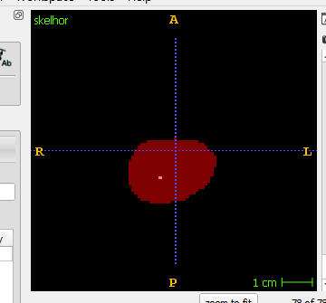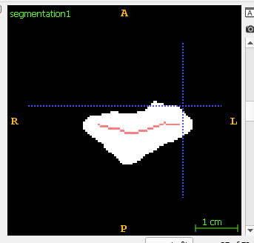

Figure 2D horizontal skeleton

### Registration

One important step is to obtain the transformations between a healthy patient scan and the other 3 patient cases, which is done through pairwise image registration. The final transformation vectors will then be applied on the centerline and the segmentation of the throat of the healthy patient to adapt to each case that needs to be calculated. This is done using the software Elastix and, for optimal results, it has to be achieved in three steps.

* + First, a rigid registration is done to bring both images to the same spatial coordinates and achieve initial alignment;
  + Secondly, an affine registration is done to implement the initial deformations between both images;
  + Lastly, a deformable registration is used to acquire the final and more exact spatial alignment.

The output for each registration is a transformation file that can be used on the binary images of the extracted centerline.

Another attempted approach on image registration was using SimpleITK. A big advantage would be keeping the whole algorithm on the same programming language, therefore SimpleITK does not provide some parameters necessary for a reliable registration, inducing errors in the dataset. Also, the computation time was significantly larger than using Elastix.

### Extraction of Cross-section

The cross-section is defined as the Euclidean distance of each point belonging to the region of interest with respect to the centerline. It is evaluated slice by slice and the value considered is the highest one which represents the furthest point of the region. When there is an obstruction this quantity should be zero. The main concern on this quantity, is when an obstructed region is considered, although the obstruction doesn’t involve the whole structure but only part of it. If there are some lateral open regions, this quantity is not really representative of the whole structure. (scripts: skel_slicehor, skel3D)

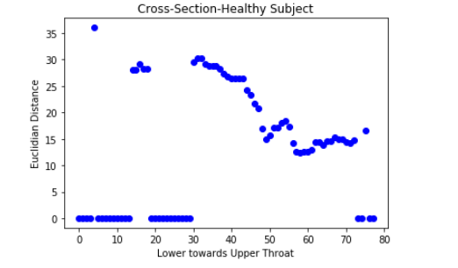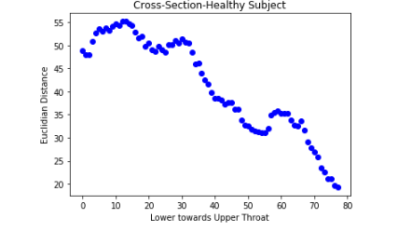When the cross-section is extracted for the whole throat, a plot of the cross-section over the length of the throat is developed so to visualize the trend of the quantity along the throat. If a single region of the three wants to be focused on, the minimum of the cross-section in that region can be considered.

Figure Cross-section extracted from 3D skeletonization

Figure Cross-section extracted from middle-point of horizontal skeletonization, 2D

### Volume Extraction

A possible alternative is to extract the volume of the segmented region. In this case, the segmentation could be the registered image. However, the centerline could be useful to identify the three regions of interest since the labelling of the segmentation is not an option given the whole connected structure. This approach has been investigated only for the healthy subject. The plot in this case concerns the volume measured slice by slice over the throat’s length. When the analysis wants to focus region by region, the sum of the volume over that region is a representative measure.

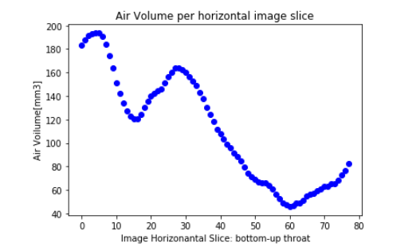

Figure Volume per Slice