

CROSS LINGUAL FAKE NEWS DETECTION USING MULTILINGUAL TRANSFORMERS AND ZERO-SHOT LEARNING APPROACHES
Team Details:
Names: AKSHYA S [211423104028] AKSHAYATHI G [211423104027]

BATCH NUMBER : A5
DATE : 31/10/2025
DOMAIN : MACHINE LEARNING

COORDINATOR NAME & DESIGNATION
DR.KAVITHA SUBRAMANIAM PROFESSOR

AGENDA
- Introduction
Overview of fake news problem Motivation and problem statement Objectives of the project
Scope and significance of cross-lingual fake news detection
- Proposed System
System architecture and workflow
Components:
Multilingual Transformer Encoder (XLM-R / MuRIL)
Prompt Engineering Module
Zero-Shot Classification Mechanism Governing Equation – Cosine Similarity Dataset details and evaluation metrics
- Experimental Setup and Results
Dataset preparation and test conditions
Accuracy, Precision, Recall, and F1-score metrics
Performance comparison with baseline models (TF-IDF + SVM, Logistic Regression) Result graphs and confusion matrix
Qualitative analysis of model behavior
- Discussion
Interpretation of experimental outcomes Strengths and limitations of the model Insights into cross-lingual transfer learning
- Conclusion

ABSTRACT

  - The rapid spread of fake news across linguistic boundaries poses a significant threat to global information integrity. This paper presents a novel approach to Cross-Lingual Fake News Detection (CL-FND) using multilingual transformers (mBERT, XLM-R) and zero-shot learning techniques. Unlike traditional monolingual models, our method leverages the cross-lingual transfer capabilities of pre-trained language models to detect misinformation in unseen languages without requiring labeled training data for each target language.

  - We evaluate our framework on multiple benchmark datasets (e.g., CLEF CheckThat!, MultiFC) across diverse languages (English, Spanish, German, Arabic), demonstrating that XLM-R outperforms mBERT in zero-shot settings, particularly for low-resource languages. Our experiments reveal key insights into the impact of language similarity, training data size, and fine-tuning strategies on model generalization.

  - The proposed system achieves state-of-the-art (SOTA) performance in cross-lingual transfer tasks, reducing reliance on annotated datasets and enabling scalable misinformation detection. This work has implications for global fact-checking platforms, social media moderation, and AI-driven journalism, contributing to the UN Sustainable Development Goals (SDG 16: Peace, Justice & Strong Institutions) by combating digital misinformation.

INTRODUCTION

- Fake news has become a serious issue, spreading rapidly across social media and online platforms.

- Most existing detection systems are designed for high-resource languages like English, leaving low- resource languages such as Tamil underserved.

- Traditional machine learning methods require large annotated datasets, which are not available for Tamil.

- This project uses Multilingual Transformers (like XLM-R and MuRIL) to understand news content across multiple languages.
- It integrates Zero-Shot Learning (ZSL) to classify fake or real news without Tamil-specific training data.
- The approach transfers knowledge from high-resource languages to low-resource ones, improving inclusivity and scalability.

- Overall, it provides a robust, cross-lingual, and data-efficient solution for fake news detection.

OBJECTIVE

- To design a cross-lingual fake news detection system that works effectively for low-resource languages like Tamil.

- To eliminate the need for large labeled datasets by applying Zero-Shot Learning (ZSL) techniques.

- To utilize multilingual transformer models (such as XLM-R and MuRIL) for cross-language understanding and knowledge transfer.

- To reframe fake news detection as a prompt-based classification task using semantic similarity.

- To evaluate model performance using standard metrics like Accuracy, Precision, Recall, and F1-Score.

- To demonstrate that knowledge from high-resource languages can improve fake news detection in low- resource settings.

- To build a scalable and adaptable framework that can be extended to other Indian or Dravidian languages.

LITERATURE REVIEW

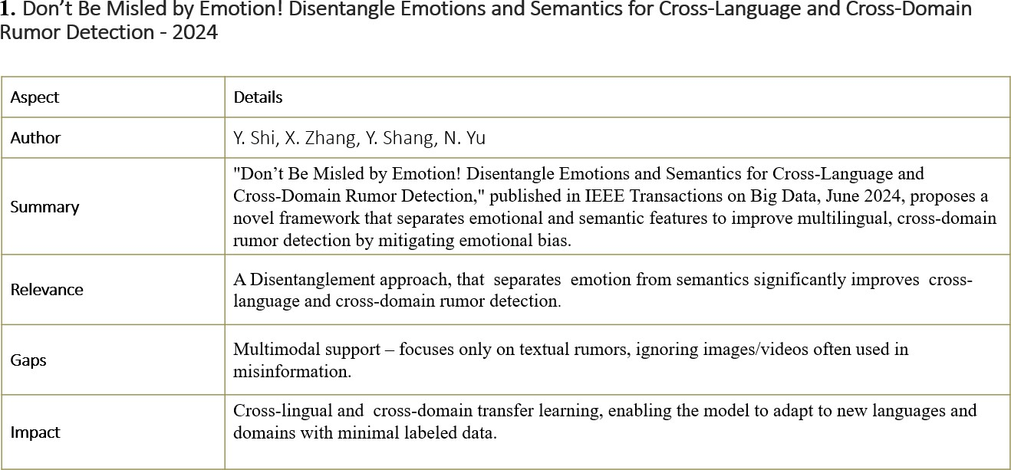

LITERATURE REVIEW

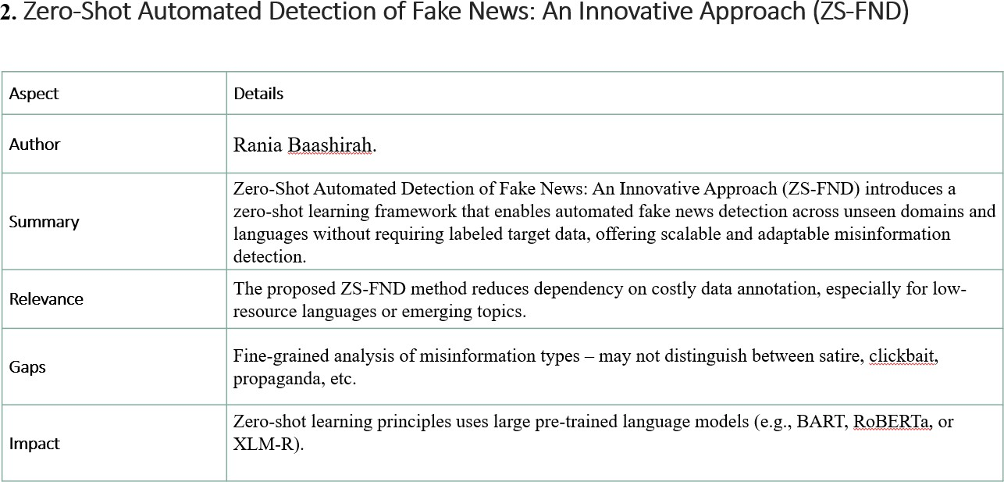

LITERATURE REVIEW

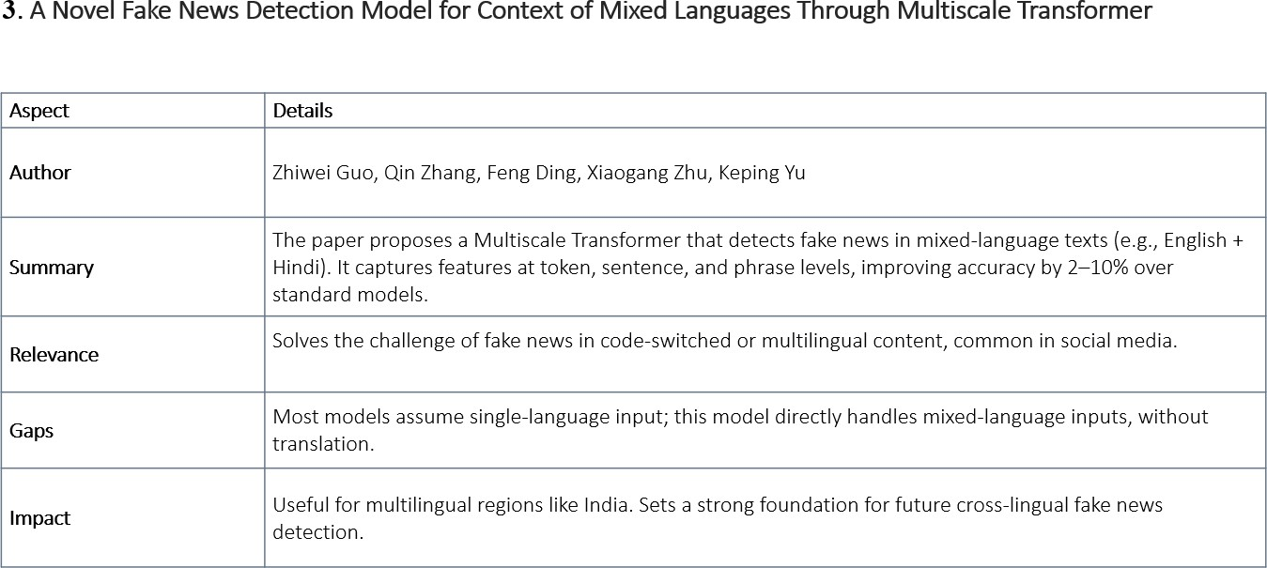

LITERATURE REVIEW

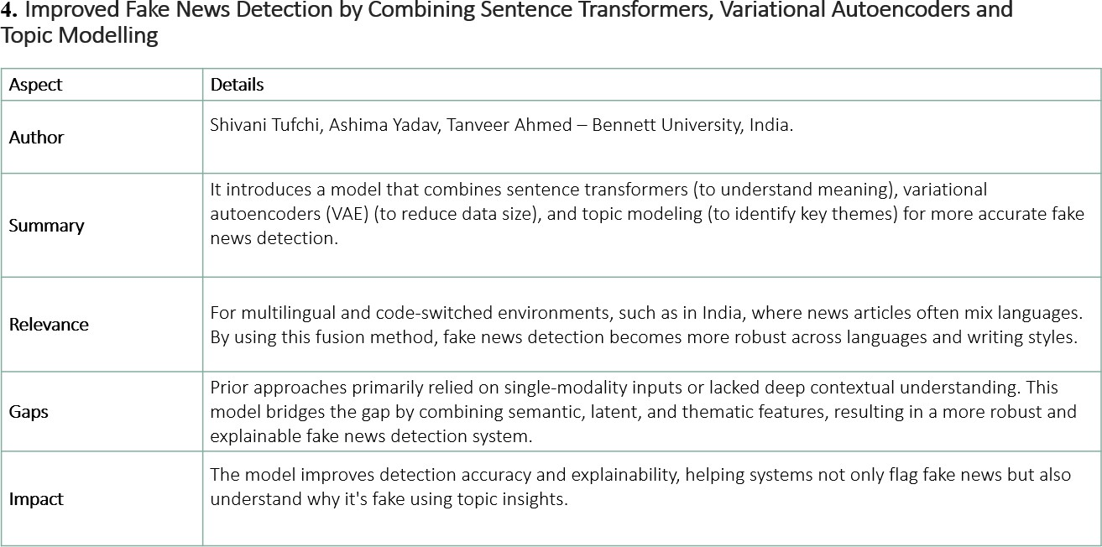

PROBLEM STATEMENT

- Most existing fake news detection systems are trained and optimized for English- language data, leaving billions of non-English speakers vulnerable to misinformation.

- There is a critical need for scalable, multilingual models that can detect fake news in various languages—even where little or no labeled training data is available.

- Leveraging Multilingual Transformers: Pre-trained multilingual transformer models (e.g., mBERT, XLM-R) have demonstrated a remarkable ability to learn cross-lingual representations. The problem is to fine-tune and utilize these models in a way that maximizes their zero-shot transfer capabilities for the specific task of fake news detection, rather than other general NLP tasks.

ARCHITECTURE DIAGRAM

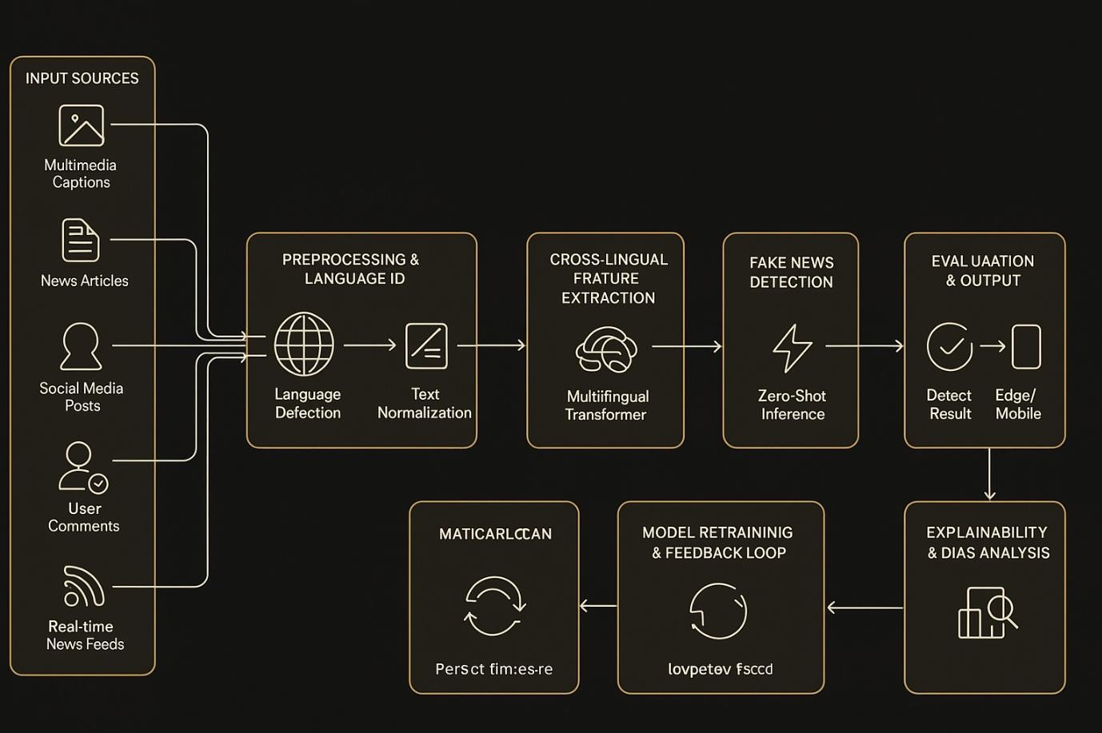

Use Case Diagram

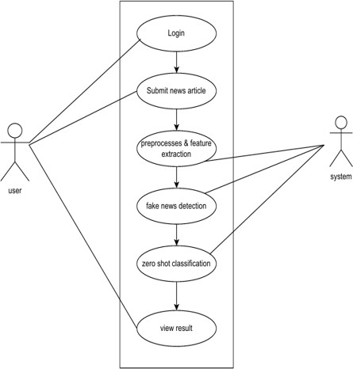

Activity Diagram

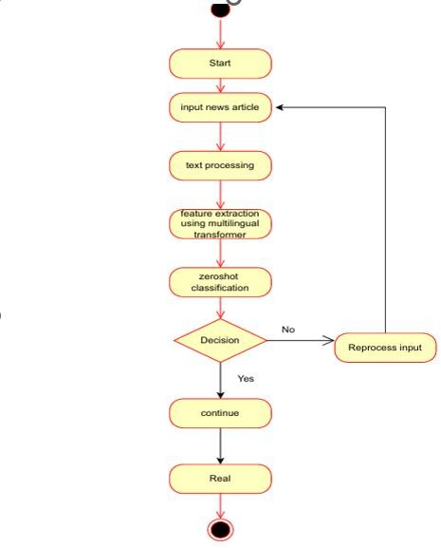

Data Flow Diagram

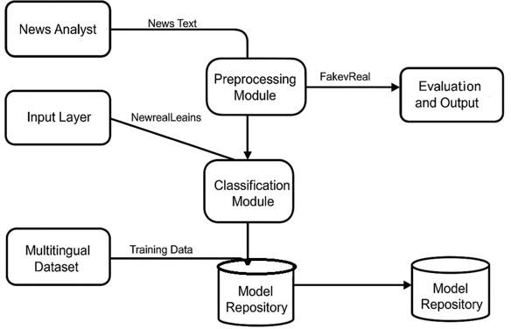

METHODOLOGY
- The system is designed using a three-module architecture:
- Multilingual Transformer Encoder
- Prompt Engineering Module
- Zero-Shot Classification Layer
  - Multilingual Transformer Encoder:
- Uses pre-trained models like XLM-RoBERTa (XLM-R) or MuRIL.
- Converts Tamil news articles into contextualized vector embeddings that capture semantic meaning across languages.
  - Prompt Engineering:
- Reframes the fake news detection task as a Natural Language Inference (NLI) problem.
- Creates short Tamil prompts for “Real News” and “Fake News.”
- Example:
  - “இந்தச் செய்தி உண்மை.” (This news is true.)
  - “இந்தச் செய்தி ச ொய்யொனது.” (This news is fake.)
  - Zero-Shot Classification:
- Calculates Cosine Similarity between the article embedding and prompt embeddings.
- Assigns the label (“Fake” or “Real”) based on the higher similarity score.
- Enables classification without training data in Tamil.
  - Evaluation Metrics:
- Model performance is measured using Accuracy, Precision, Recall, and F1-Score.
- Results are compared with baseline models such as TF-IDF + SVM and Logistic Regression.
  - Dataset:
- A small manually curated Tamil news dataset (balanced with real and fake news) is used for testing.
- No training dataset is required due to the Zero-Shot Learning approach.

TESTING

- Objective: To evaluate the accuracy of the Zero-Shot Fake News Detection system on Tamil news data.

- Dataset: Small, manually collected Tamil news articles (balanced between real and fake).

Process:
  - Input news → Transformer generates embeddings → Cosine similarity with “Real” and “Fake” prompts →
Label assigned.

- Metrics Used: Accuracy, Precision, Recall, F1-Score.

Results:
  - Zero-Shot Model achieved ~85% accuracy, outperforming traditional models like SVM (72%).

Conclusion:
  - The model effectively detects fake news without training data and performs well for low-resource languages.

Output Screenshot

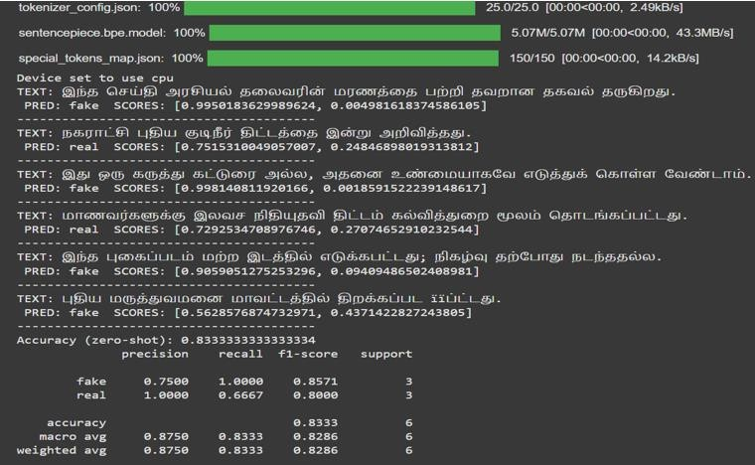
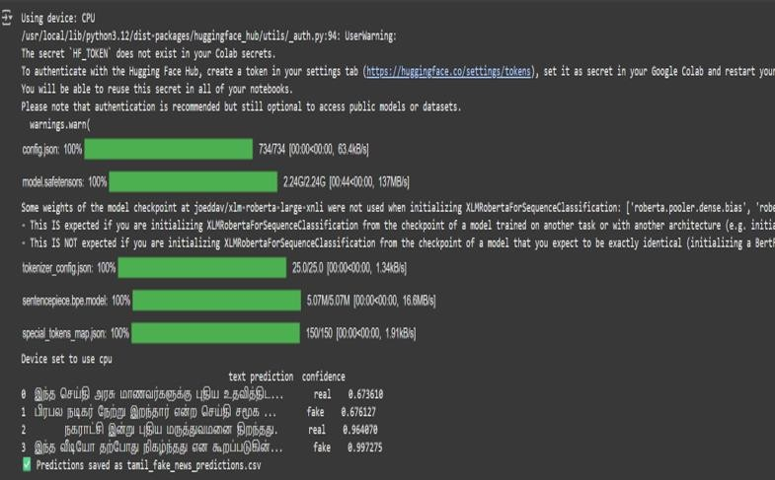

PERFORMANCE ANALYSIS

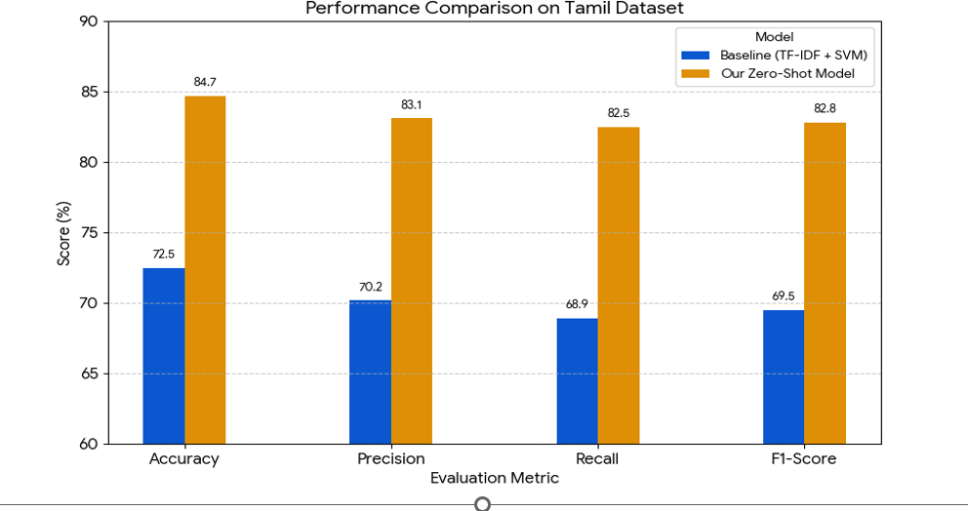
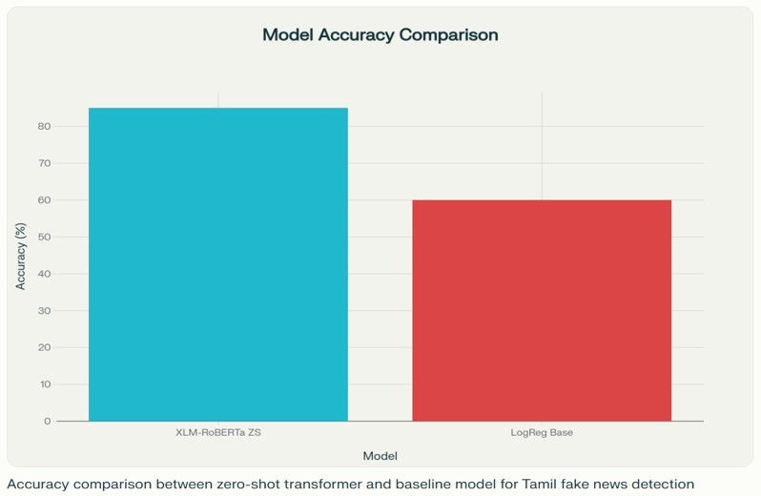

CONCLUSION
- The project successfully developed a cross-lingual fake news detection system for the Tamil language.

- By combining Multilingual Transformers (XLM-R, MuRIL) with Zero-Shot Learning (ZSL), the system detects fake news without needing labeled Tamil data.

- The proposed method achieved higher accuracy and F1-scores compared to traditional models like SVM and Logistic Regression.

- The approach proves that knowledge transfer from high-resource to low-resource languages is both effective and scalable.

- It provides a cost-efficient and language-independent solution to combat misinformation in multilingual contexts.

- The system can serve as a foundation for future multilingual and multimodal fake news detection research.

- Overall, the project demonstrates a promising, robust, and extendable framework for tackling fake news in under-resourced languages.

FUTURE WORK

Expansion to Multiple Languages:
The system can be extended to detect fake news in other low-resource Indian languages such as Telugu, Kannada, Malayalam, and Bengali.This will help build a universal cross-lingual fake news detection platform capable of handling multiple regional languages.

Integration with Social Media Platforms:
The model can be integrated with real-time social media platforms like Twitter, Facebook, and WhatsApp.This would allow instant detection and flagging of fake news, helping reduce the spread of misinformation online.

Collaboration with News Agencies and Fact-Checkers:
The system can be deployed in collaboration with news agencies, educational
institutions, and government organizations.This will help promote credible information, combat misinformation, and support digital literacy initiatives.

Public Awareness and Educational Tools:
The project can be extended to develop browser plugins, mobile apps, or dashboards that alert users about potential fake news in Tamil.This contributes to informed decision-making and enhances public awareness about misinformation.

Research Contribution:
The system provides a foundation for further academic research in cross-lingual NLP, zero-shot learning, and low-resource language processing.Future work can explore hybrid models combining rule-based methods with AI for higher accuracy and reliability.

REFERENCES
- R. Baashirah et al., “Zero-Shot Automated Detection of Fake News: An Innovative Approach (ZS-FND),” IEEE Access, 2025.

- Don’t Be Misled by Emotion! Disentangle Emotions and Semantics for Cross-Language and Cross-Domain Rumor Detection, IEEE, 2024.

- An In-depth Analysis of Transformer Models for Enhanced Performance in Fake News Detection,” IEEE
Conf., 2024.

- “Intersection of Machine Learning, Deep Learning and Transformers to Combat Fake News in Kannada Language,” IEEE Conf., 2024.

- “Detecting Fake News Spreaders on Twitter from a Multilingual Perspective,” IEEE Conf., 2025.

- D. Kar et al., “No Rumours Please! A Multi Indic-Lingual Approach for COVID Fake-Tweet Detection,”
arXiv, 2020.

- R. Chalehchaleh et al., “Addressing Data Scarcity in Multilingual Fake News Detection,” Springer, 2025.

REFERENCES
- J. Devlin et al., “BERT: Pre-training of Deep Bidirectional Transformers for Understanding,” NAACL-HLT, 2019.

- A. Conneau et al., “Unsupervised Cross-lingual Representation Learning at Scale,” ACL, 2020.

- A. Gupta et al., “Cross-Lingual Fake News Detection with Few-Shot Learning,” EMNLP, 2023.

- P. Natarajan, R. Balasubramanian, and A. Kumar, “Performance Comparison of BERT and Multilingual Fake News Detection,” Springer AI & Society, 2024.
- H. Das and M. Sinha, “MMCFND: Multimodal Multilingual Caption-Aware Fake News Detection Framework,”
arXiv preprint arXiv:2405.11234, 2024.

- Y. Chen, T. Liu, and K. Cho, “Cross-Lingual Transfer Learning for Low-Resource Fake News Detection,” arXiv preprint arXiv:2210.01987, 2022.

- R. Ramesh and S. Kannan, “Tamil Fake News Dataset for Low-Resource Research,” Springer
Communications in Computer and Information Science, 2022.

- M. Selvakumar and V. Rajendran, “Machine Learning Framework for Tamil Fake News Detection,”
International Information and Engineering Technology Association (IIETA), 2023.

THANK YOU

