xarm-ik-explorer
TECHNICAL REPORT
Derivation and Implementation of Forward and Inverse Kinematics
for a 5-DOF Robotic Arm — Analytical and Numerical Approaches

Donald R. OKE
Personal Research Project · 2026

Contents: 1. Introduction · 2. Robot & URDF · 3. Forward Kinematics · 4. Analytical IK · 5. Numerical IK · 6. Comparison

Abstract

This report documents the derivation and implementation of forward and inverse kinematics for a 5-DOF X-Arm robotic manipulator, built entirely from scratch without reliance on the manufacturer's proprietary IK library. Starting from the raw URDF file, kinematic parameters are manually extracted and a Denavit-Hartenberg parameter table is constructed from analysis of the kinematic diagram. Two independent IK solvers are derived and compared: an analytical solver based on geometric closure (Al-Kashi), and a numerical solver using Damped Least Squares with Jacobian iteration. An interactive 3D visualizer is implemented to compare both solvers in real time. Results demonstrate sub-millimeter precision for the analytical solver and configurable convergence behavior for the numerical approach.

1. Introduction
1.1 Motivation
The manufacturer of the X-Arm provides a proprietary IK API. This project deliberately bypasses it. The goal is to demonstrate that the full kinematic chain — forward and inverse — can be derived from first principles using only the raw URDF specification as input.

Two independent solvers are developed and compared:
— Analytical solver (Al-Kashi) — closed-form geometric solution, deterministic, sub-millisecond
— Numerical solver (DLS / Jacobian) — iterative convergence with multi-restart strategy

A key finding during development is that the standard shoulder-angle formula θ'₂ = α + β, commonly derived assuming a horizontal reference, produces systematic errors up to 27 mm with this robot's DH convention — where θ'₂ = 0 corresponds to the arm pointing straight up. The corrected formula is derived in Section 4.

1.2 Report Structure
Section | Content
2 — Robot & URDF | Physical description, URDF extraction, kinematic parameters
3 — Forward Kinematics | Kinematic diagram, DH table, transformation matrices, validation
4 — Analytical IK | Geometric derivation, corrected T2 formula, mirror method
5 — Numerical IK | Jacobian, DLS algorithm, convergence strategy
6 — Comparison | Precision, speed, workspace coverage, limitations

2. Robot & URDF Analysis
2.1 Platform Overview
The X-Arm is a 5-DOF serial manipulator with all-revolute joints. All kinematic parameters are derived from its URDF file (package arm_info) with no additional manufacturer documentation.

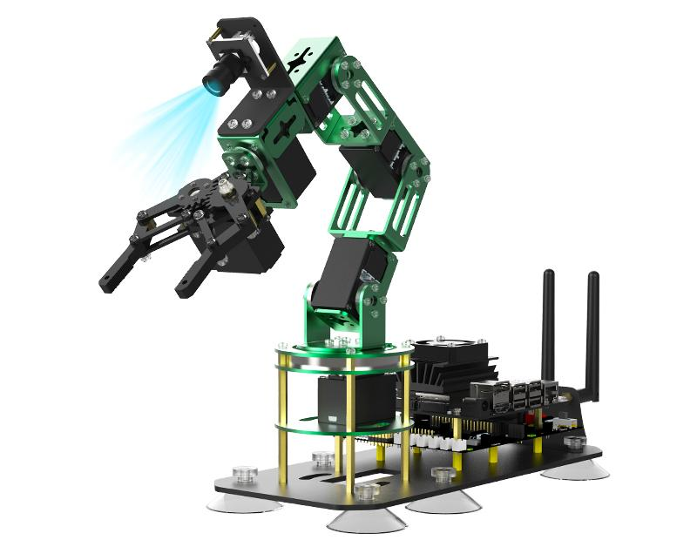
Figure 1 — X-Arm 5-DOF manipulator

2.2 Link Lengths — Extracted from URDF
Link lengths L1 through L5 are read directly from the URDF origin xyz attributes. L6 is measured physically on the robot.

Link | URDF Joint | origin xyz (m) | Value (mm) | Physical meaning
L1 | joint1 | (0, 0, 0.06605) | 66.05 | Ground → J1 (fixed Z offset — no joint)
L2 | joint2 | (0, −3.2×10⁻⁴, 0.04145) | 41.45 | J1 → J2 (Y ≈ 0, neglected)
L3 | joint3 | (−0.08285, 0, 0) | 82.85 | J2 → J3 (local X axis)
L4 | joint4 | (−0.08285, 0, 0) | 82.85 | J3 → J4 (local X axis)
L5 | joint5 | (−0.07385, −0.001, 0) | 73.85 | J4 → J5 (Y = −1 mm, neglected)
L6 | — | — | 90.00 | J5 → end-effector (physical measurement)
L56 = L5+L6 | — | — | 163.85 | Wrist to tool tip
L1 enters the kinematic chain as a pure Z translation in T01 — a constant matrix with no associated joint variable.

2.3 OFFSET Vector — Determined from HOME Observation
With the robot in HOME position, all internal DH angles equal zero by convention. OFFSET equals the servo values at HOME, converted to radians.

HOME (servo, deg) = [90, 90, 90, 0, 90]
OFFSET = [π/2, π/2, π/2, 0, π/2]
θ'ᵢ = servo_rad − OFFSET[i]

2.4 Neglected URDF Parameters
Parameter | URDF Value | Estimated effect | Decision
joint1 rpy[0] | −0.0108 rad (≈ −0.6°) | < 0.5 mm | Neglected
joint2 xyz[1] | −3.2 × 10⁻⁴ m | < 0.1 mm | Neglected
joint4 rpy[2] | 0.0083 rad (≈ 0.5°) | < 0.2 mm | Neglected
joint5 xyz[1] | −1.0 × 10⁻³ m | < 0.1 mm | Neglected

2.5 Joint Limits
Joint | DH limits (rad) | DH limits (°) | Servo limits (°)
J1 Base | [−π/2, +π/2] | [−90°, +90°] | [ 0°, 180°]
J2 Shoulder | [−π/2, +π/2] | [−90°, +90°] | [ 0°, 180°]
J3 Elbow 1 | [−π/2, +π/2] | [−90°, +90°] | [ 0°, 180°]
J4 Elbow 2 | [ 0, +π] | [ 0°, +180°] | [ 0°, 180°]
J5 Gripper | [−π/2, +π] | [−90°, +180°] | [ 0°, 270°]
J4 midpoint is at 180° — used in mirror IK: θ'₄_mirror = 180° − θ'₄.

2.6 Parameter Summary
Parameter | Value | Unit
L1, L2, L3, L4, L5, L6 | 66.05 · 41.45 · 82.85 · 82.85 · 73.85 · 90.00 | mm
L56 = L5 + L6 | 163.85 | mm
OFFSET | [π/2, π/2, π/2, 0, π/2] | rad
HOME (servo) | [90°, 90°, 90°, 0°, 90°] | deg
FK(HOME) | X = 0 · Y = 163.85 · Z = 273.20 | mm

3. Forward Kinematics
3.1 Kinematic Diagram
The kinematic diagram establishes the frame assignment for the DH parameterization and is the primary reference from which the DH table is derived.

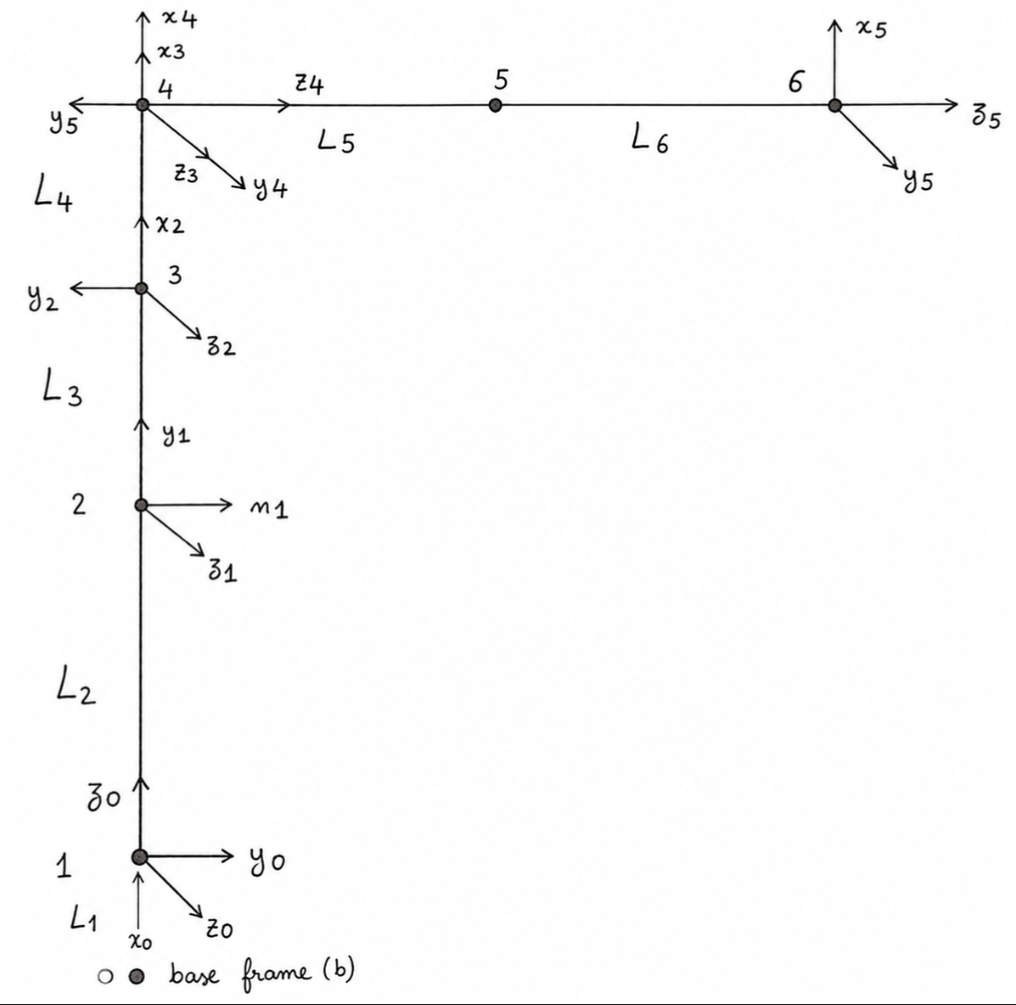
Figure 2 — Kinematic diagram: frames F0–F5, link lengths L1–L6, HOME configuration

3.2 DH Parameter Table
Frame | θ'ᵢ (joint angle) | dᵢ (offset) | αᵢ (twist) | aᵢ (length)
0 → 1 | θ'₁ + π/2 | L2 | π/2 | 0
1 → 2 | θ'₂ + π/2 | 0 | 0 | L3
2 → 3 | θ'₃ | 0 | 0 | L4
3 → 4 | θ'₄ | 0 | π/2 | 0
4 → 5 (Tool) | θ'₅ | L5 + L6 | 0 | 0
θ'ᵢ = servo_rad − OFFSET[i]

3.3 Transformation Matrices
Each matrix Tᵢ,ᵢ₊₁ is derived from the DH parameters. θ'ₙ denotes the internal angle of joint n.
T06 = T01 @ T12 @ T23 @ T34 @ T45 @ T56

3.3.1 T01 — Fixed base offset
T01 = [[1, 0, 0, 0 ], [0, 1, 0, 0 ], [0, 0, 1, L1 ], [0, 0, 0, 1 ]]
Constant — no joint variable. L1 = 66.05 mm, pure Z translation.

3.3.2 T12 — Joint 1
T12 = [[-sin(θ'₁), 0, cos(θ'₁), 0 ],
[ cos(θ'₁), 0, sin(θ'₁), 0 ],
[ 0, 1, 0, L2 ],
[ 0, 0, 0, 1 ]]

3.3.3 T23 — Joint 2
T23 = [[-sin(θ'₂), -cos(θ'₂), 0, -L3·sin(θ'₂) ],
[ cos(θ'₂), -sin(θ'₂), 0, L3·cos(θ'₂) ],
[ 0, 0, 1, 0 ],
[ 0, 0, 0, 1 ]]

3.3.4 T34 — Joint 3
T34 = [[ cos(θ'₃), -sin(θ'₃), 0, L4·cos(θ'₃) ],
[ sin(θ'₃), cos(θ'₃), 0, L4·sin(θ'₃) ],
[ 0, 0, 1, 0 ],
[ 0, 0, 0, 1 ]]

3.3.5 T45 — Joint 4
T45 = [[ cos(θ'₄), 0, sin(θ'₄), 0 ],
[ sin(θ'₄), 0, -cos(θ'₄), 0 ],
[ 0, 1, 0, 0 ],
[ 0, 0, 0, 1 ]]

3.3.6 T56 — Joint 5 (wrist + tool)
T56 = [[ cos(θ'₅), -sin(θ'₅), 0, 0 ],
[ sin(θ'₅), cos(θ'₅), 0, 0 ],
[ 0, 0, 1, L5 + L6 ],
[ 0, 0, 0, 1 ]]

3.3.7 T06 — Full transformation matrix
T06 is the product of all intermediate matrices and encodes the full pose of the end-effector in the base frame:
T06 = T01 @ T12 @ T23 @ T34 @ T45 @ T56

T06 = [[ r11, r12, r13, X ],
[ r21, r22, r23, Y ],
[ r31, r32, r33, Z ],
[ 0, 0, 0, 1 ]]

The last column gives the Cartesian end-effector position directly:
[X, Y, Z] = T06[:3, 3]
The 3×3 upper-left block of T06 is the rotation matrix of the end-effector frame relative to the base frame. In this project only the position [X, Y, Z] is used for IK.

3.4 Validation
Configuration | Servo angles (°) | FK result — [X, Y, Z] (mm) | Status
HOME | [90, 90, 90, 0, 90] | [ 0.00, 163.85, 273.20] | ✓
Vertical | [ 0, 90, 90, 90, 90] | [ 0.00, 0.00, 437.05] | ✓
X negative | [180, 90, 90, 0, 90] | [−163.85, 0.00, 273.20] | ✓

4. Analytical Inverse Kinematics
The analytical solver computes the five joint angles directly from a target position (X, Y, Z) and a desired wrist pitch φ. The derivation follows three distinct stages: (i) geometric analysis using angles θ'ᵢ measured directly on the kinematic diagrams, (ii) conversion of geometric angles to internal DH angles θᵢ via a geometric offset, and (iii) conversion of DH angles to physical servo commands via the servo offset established in Section 2.3.

Two distinct offsets are used in this derivation and must not be confused: OFFSET_geo converts geometric angles θ' to DH angles θ, while OFFSET_servo converts DH angles θ to servo commands (already established in Section 2.3 from HOME observation).

4.1 Geometric Angles vs. DH Angles
All angles appearing in the kinematic diagrams (Figures 3 to 6) are geometric angles, denoted θ'ᵢ — measured directly from horizontal or vertical reference lines, following standard planar trigonometry. These are distinct from the internal DH angles θᵢ used in the transformation matrices of Section 3.

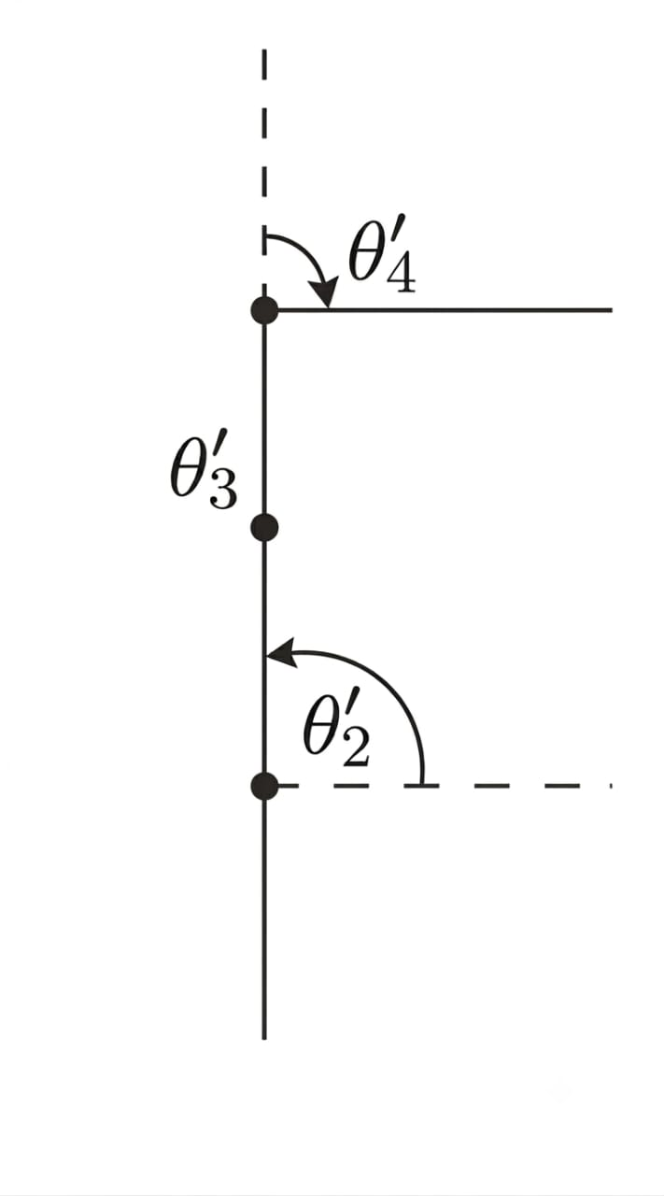
Figure 3 — Geometric configuration at HOME. The last link is perpendicular to the body, giving θ'₂ = 90° and θ'₄ = −90° (geometric reference), while by DH convention θ₂ = θ₃ = θ₄ = 0.

4.2 Geometric Offset — OFFSET_geo
At HOME, all internal DH angles are zero by construction (θ₂ = θ₃ = θ₄ = 0), while the geometric diagram (Figure 3) shows non-zero geometric angles for joints 2 and 4. Comparing the two gives the geometric offset for each joint:

θ'₂_HOME = 90° and θ₂_HOME (DH) = 0 → θ₂ = θ'₂ − 90°
θ'₄_HOME = −90° and θ₄_HOME (DH) = 0 → θ₄ = θ'₄ + 90°
θ'₁_HOME = θ₁_HOME and θ'₃_HOME = θ₃_HOME → no offset for J1, J3

The geometric offset vector is therefore:
OFFSET_geo = [0, −π/2, 0, +π/2, 0]
θᵢ = θ'ᵢ − OFFSET_geo[i]

Joint | Relation | Note
J1 | θ₁ = θ'₁ | No geometric offset — direct azimuth
J2 | θ₂ = θ'₂ − π/2 | θ'₂ = 90° (vertical) ⟶ θ₂ = 0
J3 | θ₃ = θ'₃ | No geometric offset — relative elbow angle
J4 | θ₄ = θ'₄ + π/2 | θ'₄ = −90° ⟶ θ₄ = 0

4.3 Step 1 — Joint 1: Base Azimuth
J1 orients the arm toward the target in the horizontal (X, Y) plane. There is no geometric offset for this joint (Section 4.2):

θ'₁ = θ₁ = arctan2(Y, X) (servo, before OFFSET_servo)

For targets with Y < 0, this azimuth falls outside the servo range [0°, 180°]. The mirror method (Section 4.8) handles this case.

4.4 Step 2 — Wrist Pivot Position
The end-effector is connected to J4 via the rigid segment L56 = L5 + L6, oriented at angle φ from the horizontal. The position of J4 is found by subtracting the tool contribution from the target:

R = √(X² + Y²)
R_m4 = R − L56 · cos(φ)
Z_m4 = Z − L56 · sin(φ) − L1 − L2
dist = √(R_m4² + Z_m4²)

Workspace condition for a valid solution:
|L3 − L4| ≤ dist ≤ L3 + L4

4.5 Step 3 — Joint 3: Elbow Angle
Figure 4 shows the triangle formed by J2, J3, J4 in the vertical plane. The geometric angle θ'₃ at J3 — the angle between link L3 and link L4 — is found by the law of cosines (Al-Kashi):

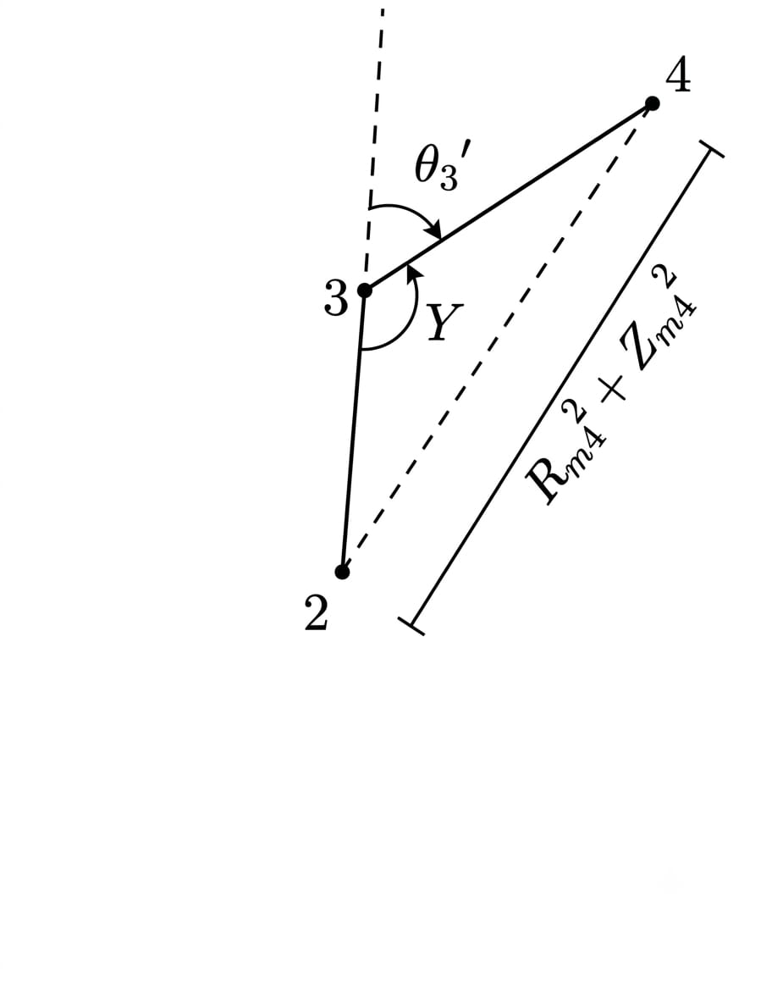
Figure 4 — Triangle J2–J3–J4: geometric angle θ'₃ at the elbow, by Al-Kashi

cos(θ'₃) = (R_m4² + Z_m4² − L3² − L4²) / (2 · L3 · L4)
sin(θ'₃) = ± √(1 − cos²(θ'₃)) [+ elbow up / − elbow down]
θ'₃ = arctan2(sin(θ'₃), cos(θ'₃))

Since J3 has no geometric offset (Section 4.2), the DH angle is identical:
θ₃ = θ'₃

4.6 Step 4 — Joint 2: Shoulder Angle
Figure 5 shows the geometry in the (R_m4, Z_m4) plane. The geometric angle θ'₂ — measured from the horizontal axis at J2 — is decomposed as θ'₂ = α + β:

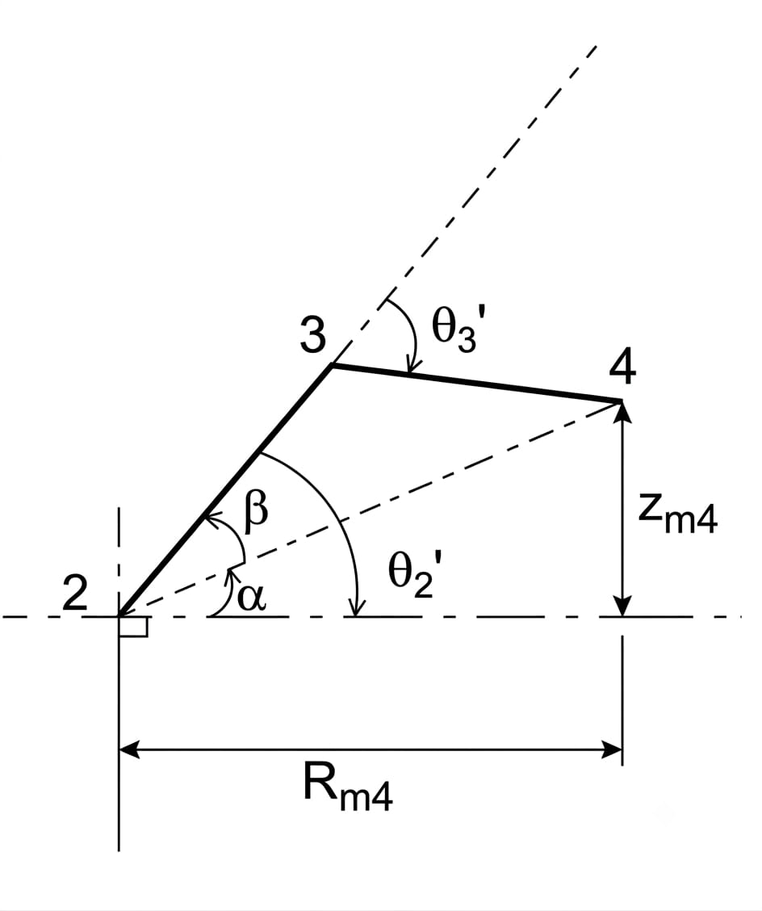
Figure 5 — Geometric shoulder angle θ'₂ = α + β, measured from horizontal at J2

A = L3 + L4 · cos(θ'₃)
B = L4 · sin(θ'₃)
α = arctan2(Z_m4, R_m4) [angle of J2→J4 from horizontal]
β = arctan2(B, A) [triangle correction]
θ'₂ = α + β

Converting to the internal DH angle using the geometric offset established in Section 4.2:
θ₂ = θ'₂ − π/2

Direct conversion using θ₂ = α + β − π/2 was implemented and validated to under 0.05 mm against forward kinematics across the full test suite (Section 4.10).

4.7 Step 5 — Joint 4 and Joint 5
Figure 6 shows the full chain with the geometric closure constraint: the wrist pitch φ — angle of L56 from horizontal — equals the sum of all geometric angles up to the wrist:

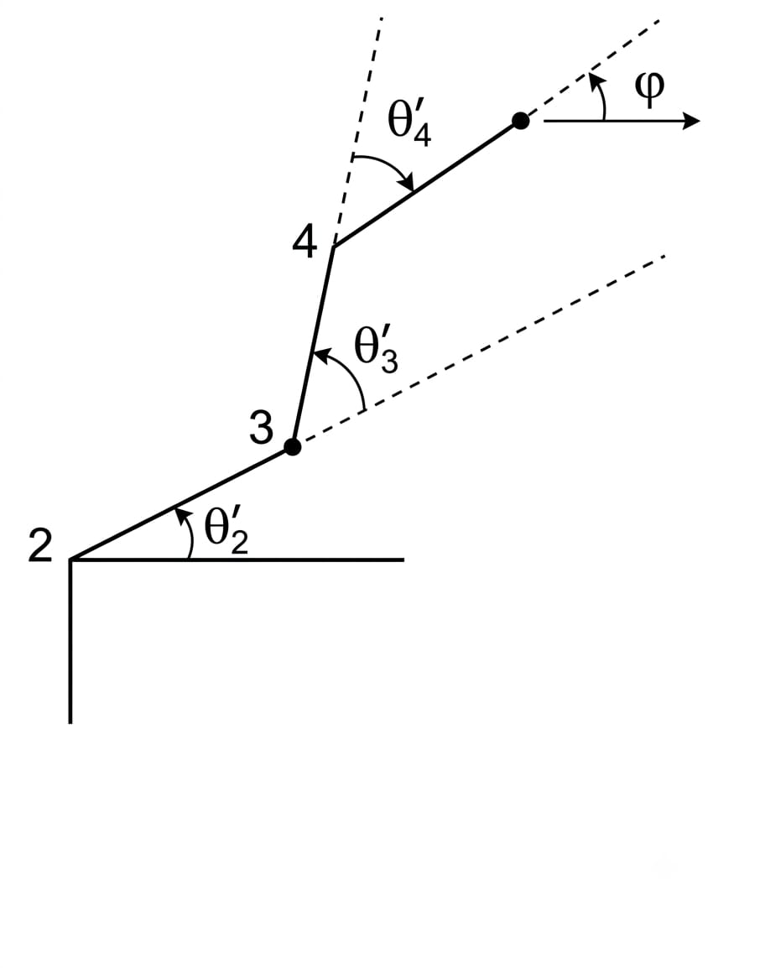
Figure 6 — Geometric closure: φ = θ'₂ + θ'₃ + θ'₄

θ'₄ = φ − θ'₂ − θ'₃

Converting to the internal DH angle:
θ₄ = θ'₄ + π/2

J5 controls gripper orientation and is set independently by the user — no geometric derivation needed:
θ₅ = θ'₅ (user-defined gripper angle, before OFFSET_servo)

4.8 From DH Angles to Servo Commands
Once all internal DH angles θ₁ ... θ₅ are known, the physical servo commands are obtained using OFFSET_servo, established in Section 2.3 from HOME observation:

servoᵢ = θᵢ + OFFSET_servo[i]
OFFSET_servo = [π/2, π/2, π/2, 0, π/2] (Section 2.3)

This is the second, independent offset of the pipeline. OFFSET_geo (Section 4.2) is internal to the geometric derivation; OFFSET_servo is the physical calibration of the robot.

4.9 Mirror Configuration — Targets with Y < 0
The servo range of J1 is [0°, 180°], covering azimuths [0°, 180°] — the front half-space (Y ≥ 0). For targets with Y < 0, the required azimuth falls outside this range and no direct solution exists.

The mirror method solves the IK for the opposite target (−X, −Y, Z) — which lies in the reachable half-space — then applies a symmetry transformation to the resulting DH angles to recover a valid configuration reaching the original target:

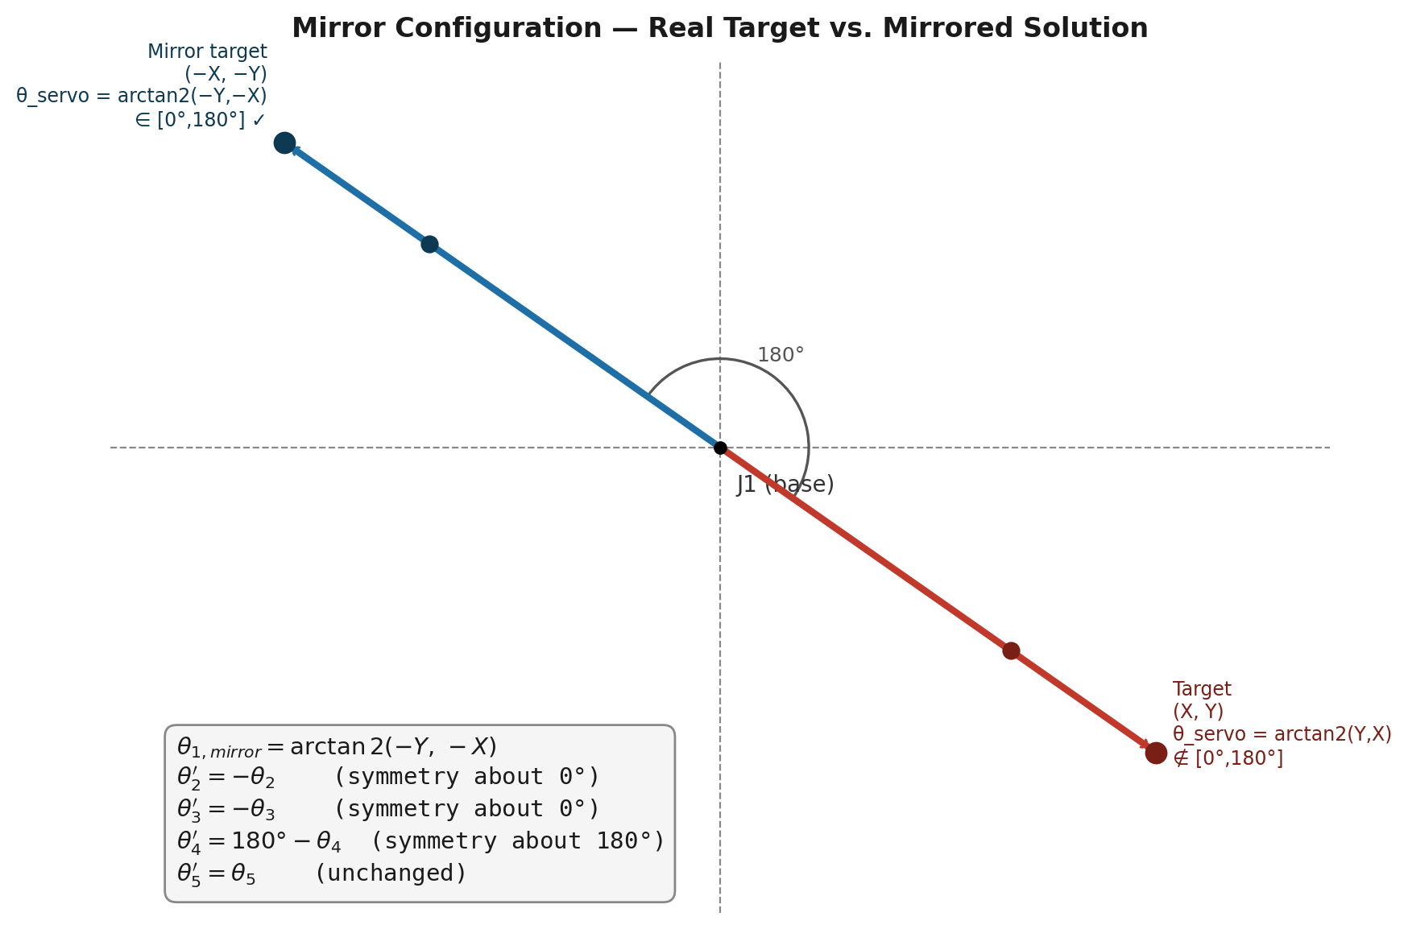
Figure 7 — Mirror configuration: solving for (−X,−Y) then reflecting joint angles to reach (X,Y)

θ₁_mirror = arctan2(−Y, −X) [J1 points toward the real target directly]
θ₂_mirror = −θ₂ [symmetry about 0° — DH range centered on 0]
θ₃_mirror = −θ₃ [symmetry about 0° — DH range centered on 0]
θ₄_mirror = 180° − θ₄ [symmetry about 180° — midpoint of J4 DH range [0°,180°]]
θ₅_mirror = θ₅ [unchanged — gripper independent of arm pose]

θ₂ and θ₃ are reflected about 0° because their DH ranges [−π/2, +π/2] are centered there. θ₄ is reflected about 180°, the midpoint of its DH range [0°, +π], since OFFSET_servo[3] = 0 places this joint's range differently from the others.

4.10 Automatic φ Fallback
When no solution exists for the requested φ, the solver searches in ±5° steps up to ±180°, trying both elbow configurations and the mirror method at each step. Every candidate solution is validated against forward kinematics — rejected if the resulting error exceeds 1 mm.

4.11 Validation Results
Target [X, Y, Z] (mm) | φ (°) | Method | FK error (mm) | Status
[0, 163.85, 273.20] | 0 | Direct | 0.000 | ✓
[0, 0, 437.05] | 90 | Direct | 0.000 | ✓
[100, 150, 300] | 10 | Direct | 0.008 | ✓
[0, −163.85, 273.20] | 0 | Mirror | 0.000 | ✓
[100, −100, 300] | 0 | Mirror + φ fallback | 0.000 | ✓

5. Numerical Inverse Kinematics
The numerical solver approaches IK as an iterative optimization problem: starting from an initial joint configuration, it applies successive corrections using the robot's Jacobian matrix until the end-effector converges to the target position. Unlike the analytical solver, it requires no geometric assumptions and handles any kinematic chain configuration.

5.1 Algorithm Parameters
Parameter | Symbol | Value | Role
Convergence tolerance | TOL | 10.0 mm | Iteration stops when ‖e‖ < TOL
Step size | α | 0.5 | Scales the joint update at each iteration
Max iterations | MAX_ITER | 1000 | Iteration limit per restart attempt
Max DLS damping | λ_max | 0.05 | Maximum damping coefficient
Singularity threshold | ε | 0.01 | Manipulability below which λ activates
Random restarts | N_RESTARTS | 5 | Additional random starting configurations

5.2 Position-Only Jacobian
The Jacobian J ∈ ℝ³ˣ⁵ maps joint velocity to end-effector Cartesian velocity. Only the translational part (3 rows) is used, as the solver targets position only — orientation of the end-effector is not constrained.

For a revolute joint i with axis zᵢ and origin pᵢ, the i-th column of the Jacobian is:

J[:,i] = zᵢ × (pₑ − pᵢ)

where pₑ is the end-effector position and × denotes the cross product. In the implementation, zᵢ and pᵢ are extracted from the i-th intermediate transformation matrix:

for i in [T01, T02, T03, T04, T05]:
zᵢ = Tᵢ[:3, 2] # z-axis of frame i in base coordinates
pᵢ = Tᵢ[:3, 3] # origin of frame i in base coordinates
J[:,i] = cross(zᵢ, pₑ − pᵢ)

5.3 Damped Least Squares (DLS) Update
The standard pseudo-inverse Jᵀ(JJᵀ)⁻¹ becomes numerically unstable near kinematic singularities, where det(J) → 0. The Damped Least Squares formulation regularizes the inversion by adding a damping term λ²I:

J_dls = Jᵀ · (J · Jᵀ + λ² · I)⁻¹
Δθ = α · J_dls · e
θ = clip(θ + Δθ, θ_min, θ_max)

where e = [X, Y, Z]_target − FK(θ) is the Cartesian error vector and clip enforces joint limits at every step.

5.4 Adaptive Damping
The damping coefficient λ is not fixed. It activates only near singularities, where the manipulability measure w falls below the threshold ε:

w = √|det(J · Jᵀ)| [manipulability measure]

if w < ε:
λ² = λ_max² · (1 − (w / ε)²)
else:
λ² = 0 [pure pseudo-inverse]

This strategy preserves convergence speed in non-singular regions while protecting against numerical blow-up at singularities. When λ² = 0, the update reduces to the standard Moore-Penrose pseudo-inverse.

5.5 Multi-Restart Strategy
A single gradient descent may converge to a local minimum or diverge entirely depending on the starting configuration. The multi-restart strategy mitigates this by running the same DLS iteration from multiple initial configurations:

— Start 0 — current robot configuration (warm start from angles_depart)
— Starts 1 to N_RESTARTS — random configurations uniformly sampled within joint limits

rng = RandomGenerator(seed=42) # reproducible
starts = [current_config]
for _ in range(N_RESTARTS):
rand = [uniform(lo, hi) for (lo, hi) in JOINT_LIMITS]
starts.append(rand)

The algorithm retains the best solution across all restarts (minimum FK error). If any restart converges below TOL, the search stops early. The warm start (current configuration) is always tried first, exploiting temporal continuity in sequential motion.
Seed 42 ensures reproducibility. The same sequence of random starting configurations is generated for every call, making debugging and comparison deterministic.

5.6 Complete Algorithm
Combining the above components, the full numerical IK algorithm for a single restart is:

function _ik_depuis(target, θ_init):
θ ← θ_init
best ← θ_init, best_err ← ∞

for iter in 1 .. MAX_ITER:
xyz, frames ← FK(θ + OFFSET)
e ← target − xyz
err ← ‖e‖

if err < best_err:
best ← θ, best_err ← err
if err < TOL:
return θ, err # converged

J ← jacobian(θ, frames)
w ← √|det(J·Jᵀ)|
λ² ← λ_max²·(1−(w/ε)²) if w < ε else 0
J_dls ← Jᵀ·(J·Jᵀ + λ²·I)⁻¹
θ ← clip(θ + α·J_dls·e)

return best, best_err # best found, not converged

5.7 Joint 5 Treatment
Joint 5 controls gripper orientation and is excluded from the optimization. Its value is fixed by the user and injected after convergence:

servos = degrees(θ_best + OFFSET)
servos[4] = θ₅_servo_deg # user-defined gripper angle

5.8 Validation Results
The numerical solver is validated on a standard test suite. Convergence tolerance is TOL = 10 mm.

Target [X, Y, Z] (mm) | FK error (mm) | φ real (°) | Manip (norm.) | Status
[0, 163.85, 273.20] | < 0.01 | 0.0 | 1.2074 | ✓
[0, 0, 437.05] | < 0.01 | 90.0 | — | ✓
[−163.85, 0, 273.20] | < 0.01 | 0.0 | 1.2074 | ✓
[0, −163.85, 273.20] | < 0.01 | — | — | ✓
[100, 150, 300] | < 0.01 | — | — | ✓
[150, 100, 300] | < 0.01 | — | — | ✓
[100, 0, 350] | < 0.01 | — | — | ✓

The numerical solver does not target a specific φ — wrist pitch is a free variable, determined by the optimizer. This contrasts with the analytical solver which takes φ as an explicit input.

5.9 Warm Start — Sequential Motion
When the robot is moving sequentially from one target to the next, passing the previous joint configuration as angles_depart significantly improves convergence speed and solution continuity:

Step | Target (mm) | Error (mm) | Continuity
HOME | [0, 163.85, 273.20] | < 0.01 | —
Move 1 | [50, 150, 280] | < 0.01 | ✓ smooth
Move 2 | [100, 120, 300] | < 0.01 | ✓ smooth
Move 3 | [120, 80, 320] | < 0.01 | ✓ smooth

Continued in Section 6 — Comparison: Analytical vs. Numerical IK

