Lab 5 - Assignment 2 (DynamoDB) - Evidence Screenshots

AWS Root Sign-In (one-time IAM elevation)
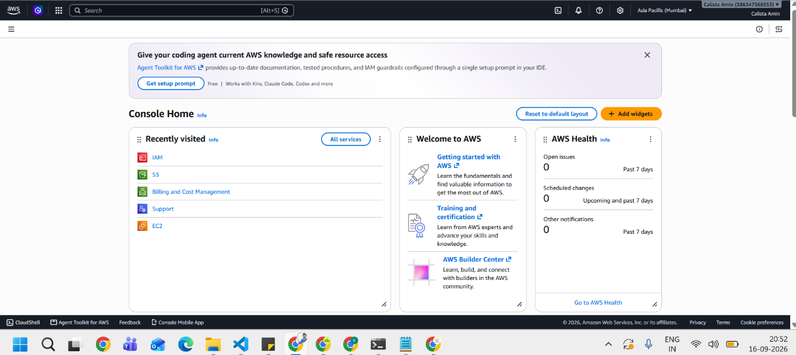
Signed in as account root - required one-time to create the IAM policy and role, since the calista-labs IAM user holds read-only IAM access by design.

DynamoDB - Before: No Tables
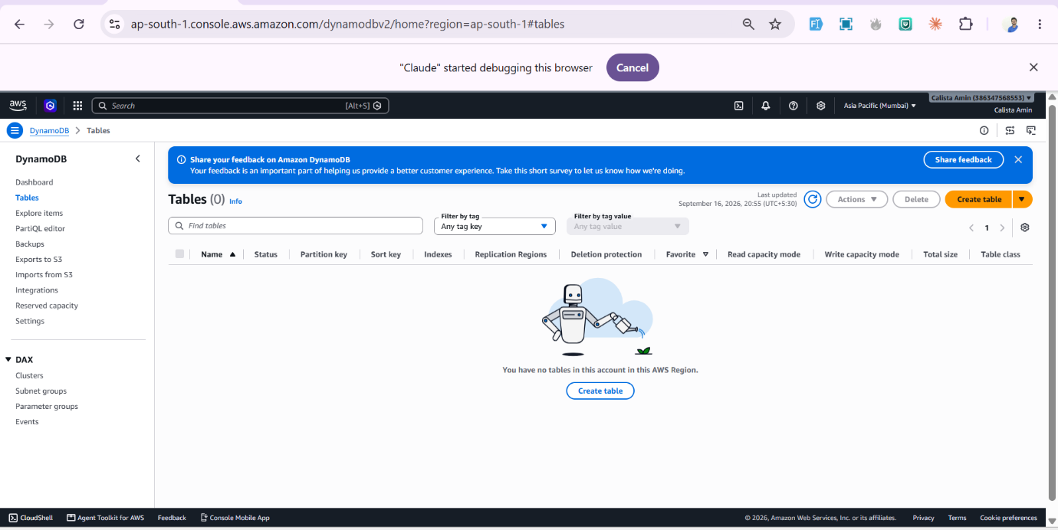
DynamoDB console, ap-south-1, prior to table creation.

DynamoDB - Table Configuration
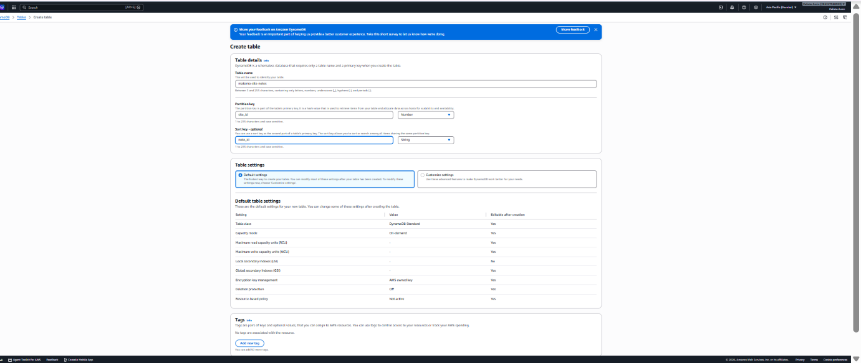
Creating matomo-site-notes: partition key site_id (Number), sort key note_id (String), default on-demand capacity.

DynamoDB - Table Active
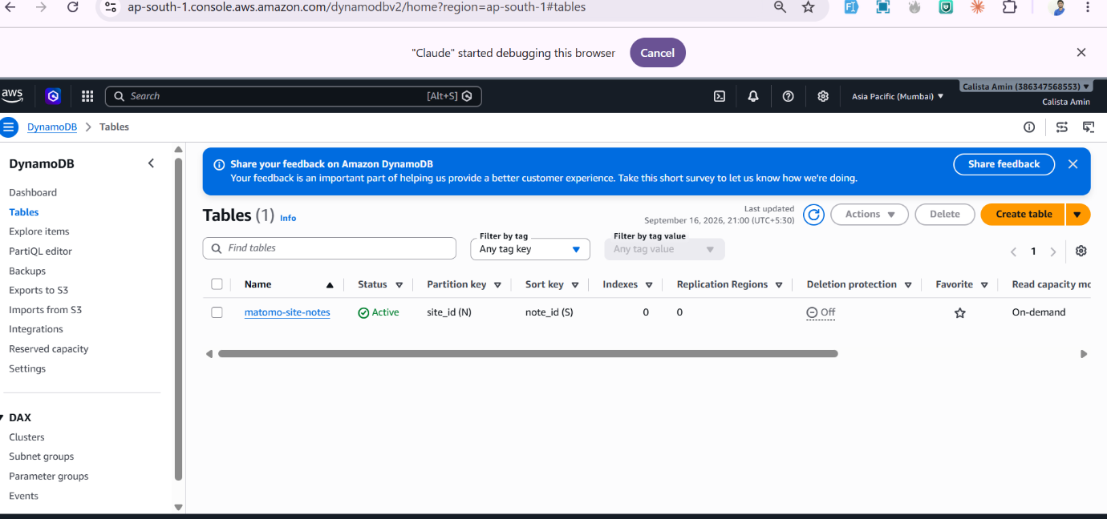
matomo-site-notes table shown Active, confirming schema: site_id (N) / note_id (S).

IAM - Policy Created
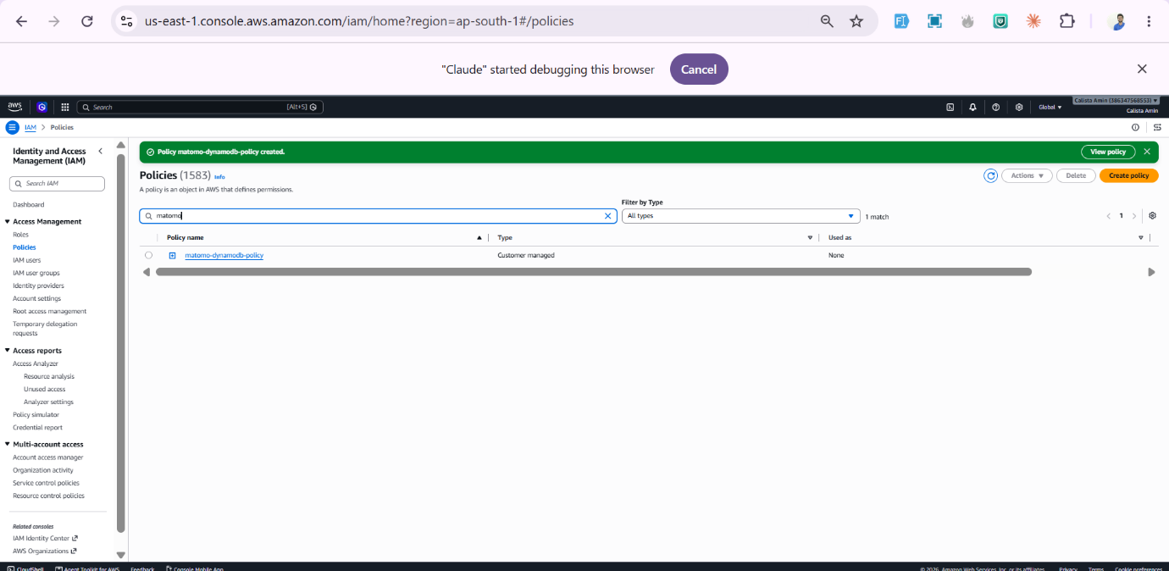
matomo-dynamodb-policy: a customer-managed policy scoped to exactly one table ARN, not blanket DynamoDB access.

IAM - Role Created
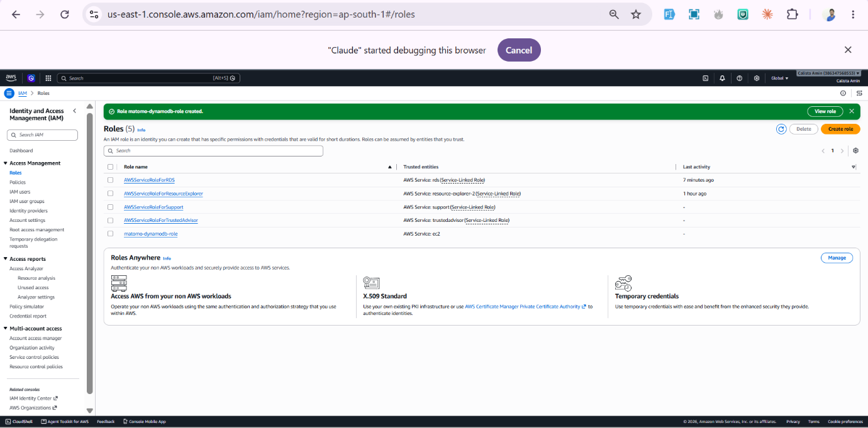
matomo-dynamodb-role, trusted entity EC2, with matomo-dynamodb-policy attached.

IAM Role Attached to EC2
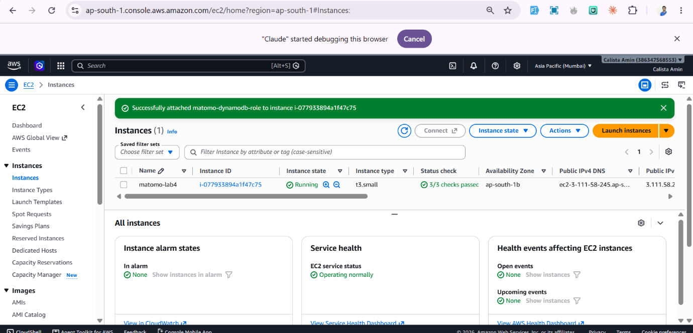
Confirmation banner: matomo-dynamodb-role successfully attached to instance i-077933894a1f47c75 (matomo-lab4), completed live without stopping the running instance.

Notes App - Live in Browser
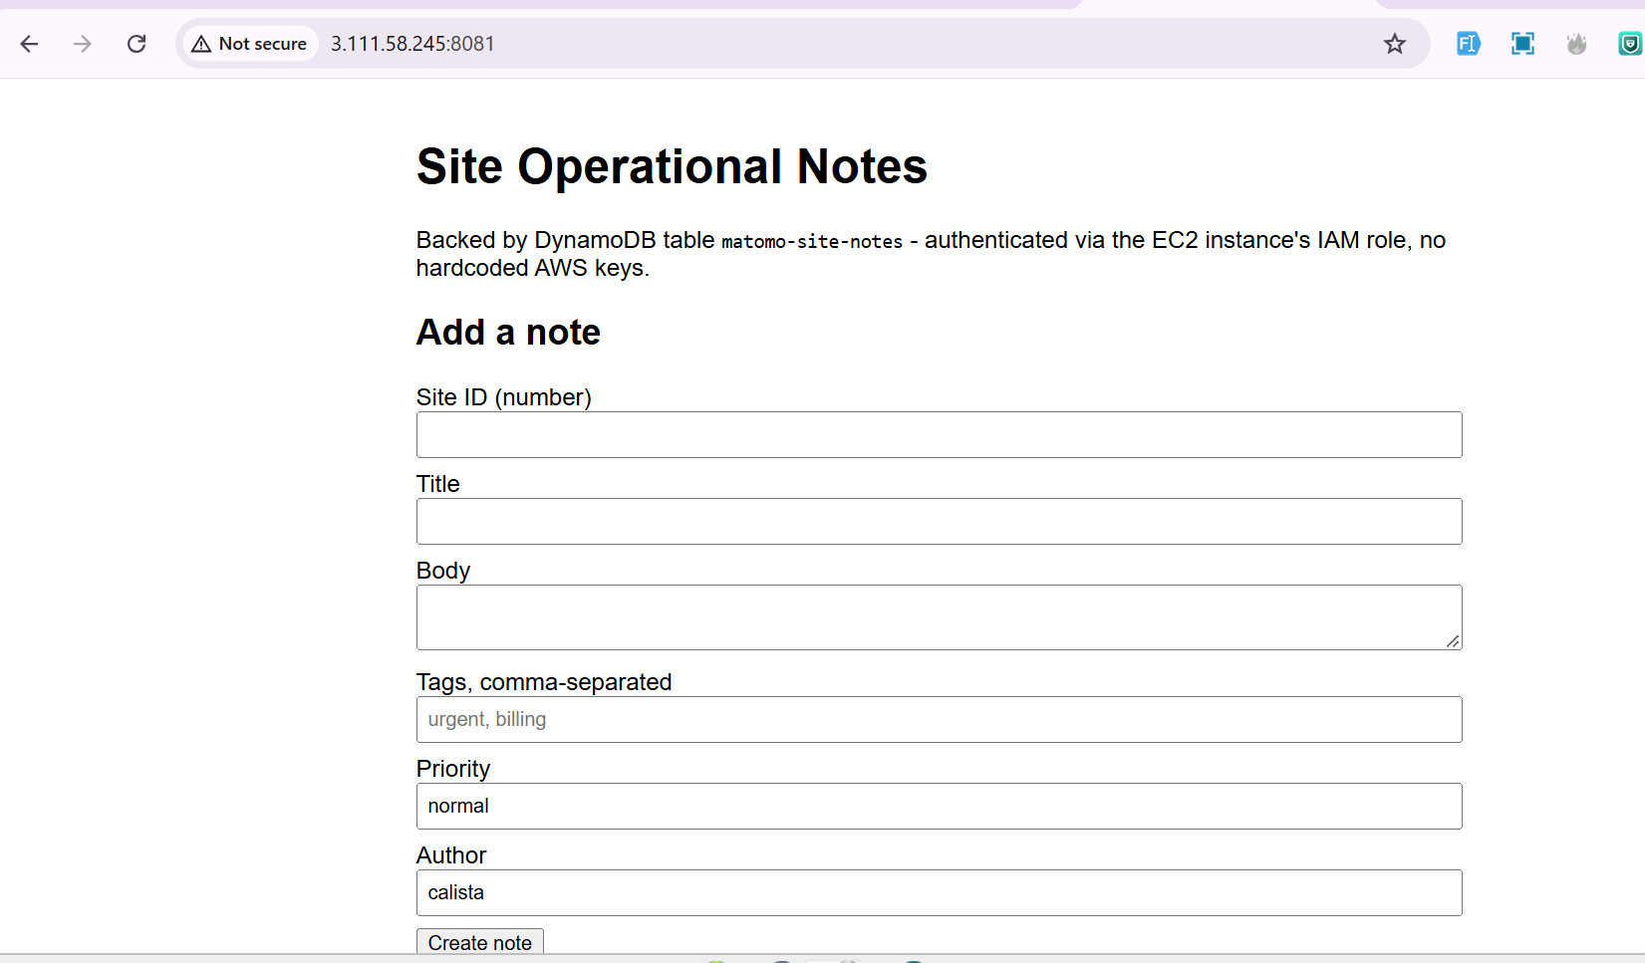
http://3.111.58.245:8081/ loading successfully after opening port 8081 at both the ufw host firewall and the EC2 security group - confirms the full stack (Nginx, PHP-FPM, DynamoDB via IAM role) is working end to end.

CRUD: Create + Read
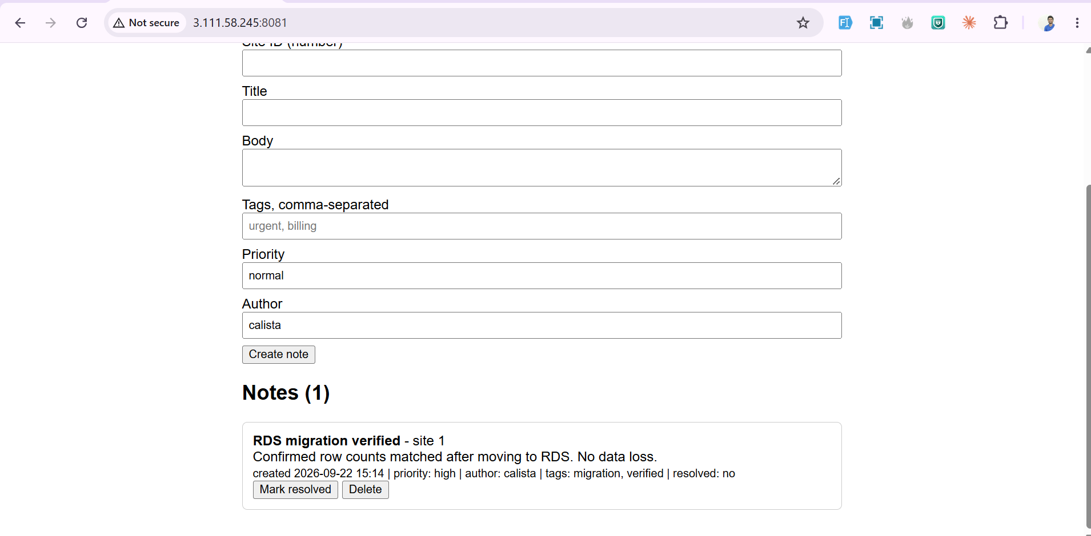
Note 'RDS migration verified' created for site 1 and immediately listed back - Notes (1) - confirming a live write and read against the matomo-site-notes DynamoDB table via the app.

DynamoDB Item Detail - 5+ Attribute Types (Required Evidence)
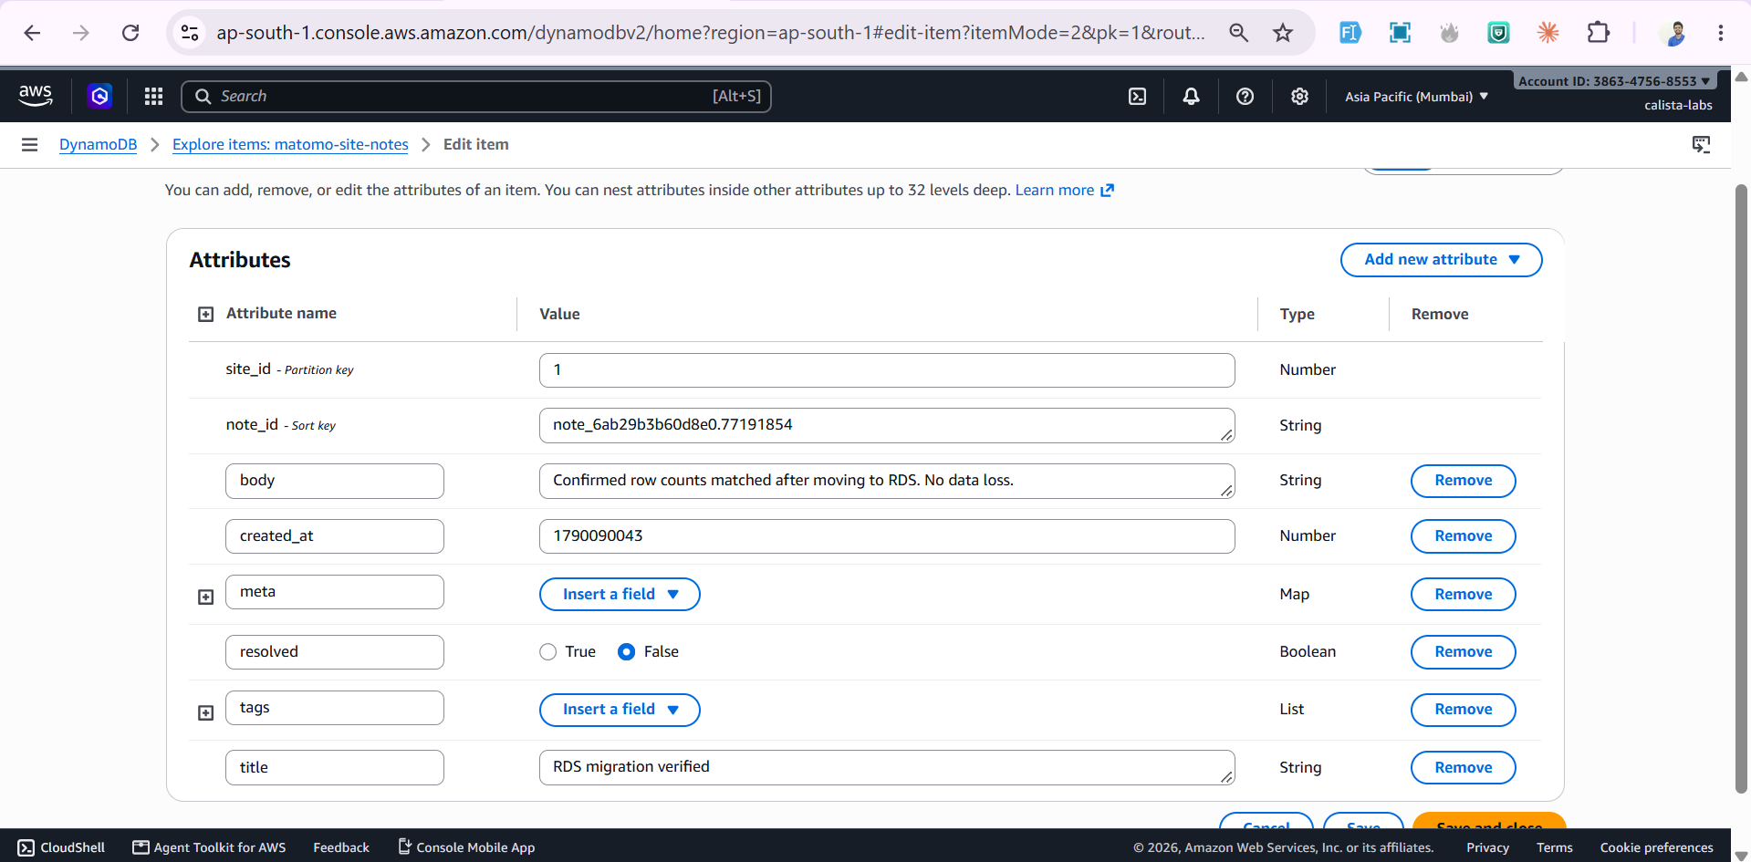
Full attribute view of the created item: site_id (Number), note_id (String), body (String), created_at (Number), meta (Map), resolved (Boolean), tags (List), title (String) - five distinct DynamoDB data types on one item, satisfying the assignment's minimum requirement.

CRUD: Update
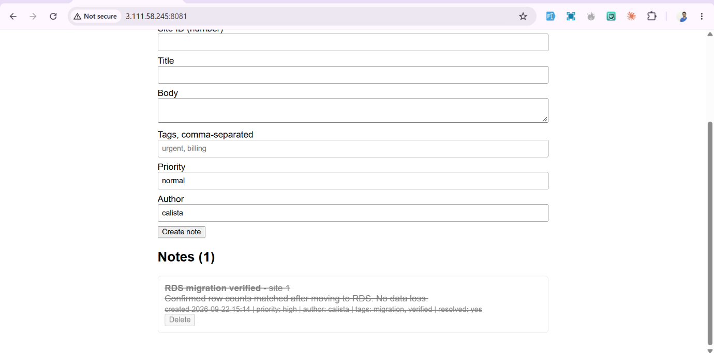
Note marked resolved (resolved: yes) via the app's Update action - a live UpdateItem call against DynamoDB, reflected immediately in the UI (strikethrough styling).

CRUD: Delete
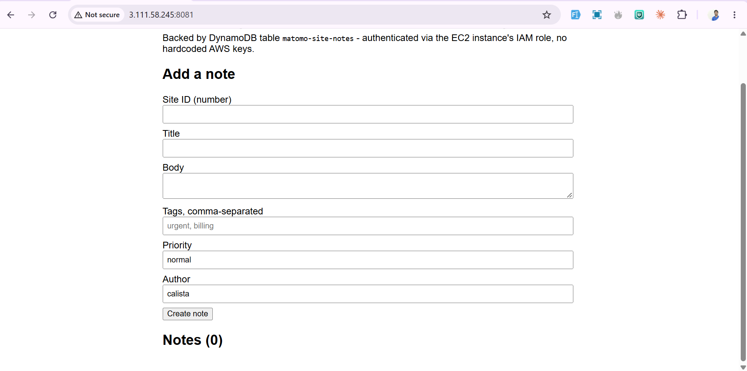
Note removed via the app's Delete action - Notes (0), confirming a live DeleteItem call against DynamoDB. Completes the full Create/Read/Update/Delete cycle for Assignment 2.

