Git Workflow Guide: Clone GitHub Repo, Add Gerrit, Commit & Push

1. Clone Repository from GitHub
Open your terminal or Git Bash.
Navigate to the directory where you want to place the project.
Run the command:
git clone https://github.com/<your-account>/<repo>.git
Example:
git clone https://github.com/doristee/MyCleanRepo.git
Enter the cloned repository:
cd <repo>

2. Add Gerrit Remote to Local Repository
Ensure you have access to your Gerrit server and SSH keys configured.
Verify remote configuration:
git remote -v
You will see:
origin https://github.com/doristee/MyCleanRepo.git (fetch)
origin https://github.com/doristee/MyCleanRepo.git (push)
Add Gerrit as a new remote:
git remote add gerrit ssh://<gerrit-username>@<gerrit-host>:29418/<project-path>
Example:
git remote add gerrit ssh://user3@han:29418/MyCleanRepo.git
Verify remote configuration:
git remote -v
You will see:
gerrit ssh://user3@han:29418/MyCleanRepo.git (fetch)
gerrit ssh://user3@han:29418/MyCleanRepo.git (push)
origin https://github.com/doristee/MyCleanRepo.git (fetch)
origin https://github.com/doristee/MyCleanRepo.git (push)

3. Create a New File or Make Changes
Create or modify files inside your project directory.
For example, create a new file:
mkdir src
echo "Sample change" > src/demo.txt
Or edit existing files using your preferred editor.

4. Stage and Commit Your Changes
Add your changes to the staging area:
git add .
Commit your changes with a message:
git commit -m "Add demo file or make modifications"

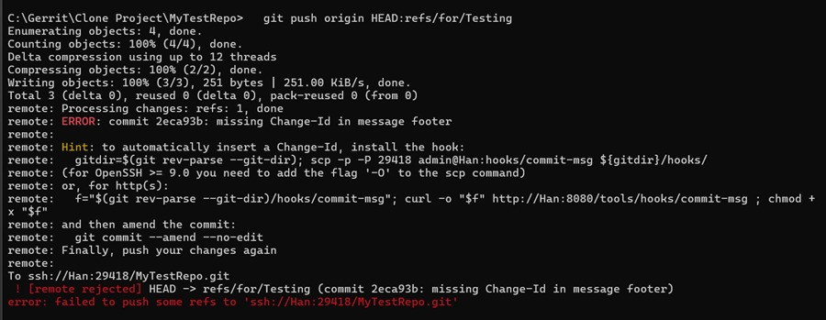
If Gerrit requires Change-Id and you have not installed commit-msg hook, add it using:
- Download hook via HTTP by Git bash
curl -o .git/hooks/commit-msg http://han:8080/tools/hooks/commit-msg
chmod +x .git/hooks/commit-msgb.
- Download hook via HTTP by command prompt
scp -O -P 29418 username@han:hooks/commit-msg .git/hooks/commit-msg
- Manually download hook via HTTP by browser
Open Gerrit in your browser
http://han:8080/tools/hooks/commit-msg
Save the file in:<Your repository directory>\.git\hooks\commit-msg
- Verify hook is installed
Git bash: ls -l .git/hooks
Cmd prompt: dir .git\hooks
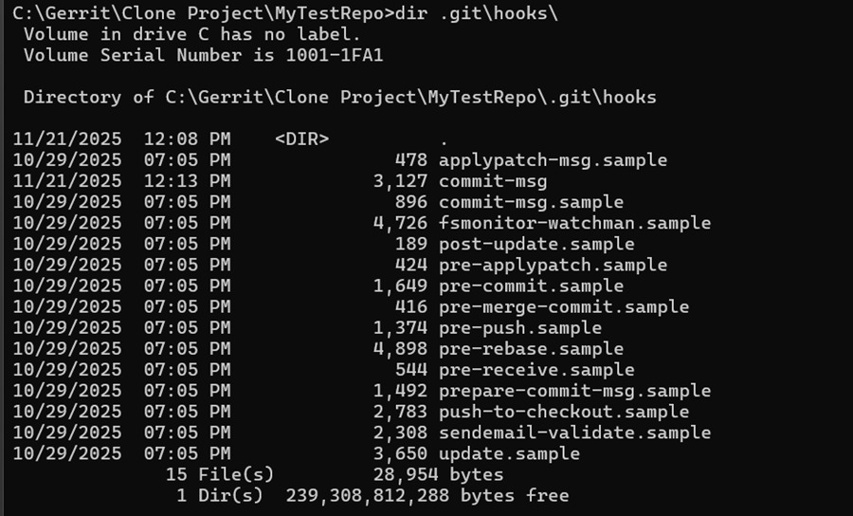

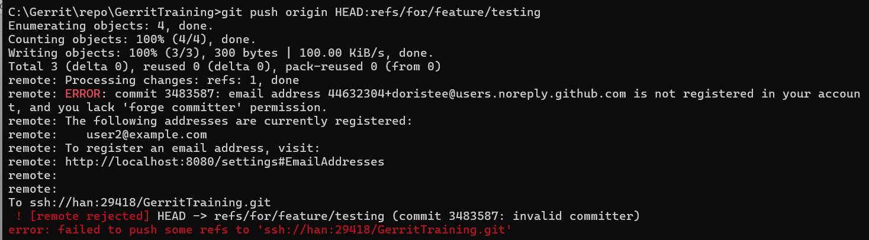
Check current commit author:
git log -1
Configure git user name and email address:
git config --global user.name "username"
git config --global user.email username@example.com
Update author email for the last commit:
git commit --amend --reset-author -m "Update text“
# From main, cut out your feature branch
Your origin is GitHub, so fetch + update local main:
git fetch origin
git checkout main
git merge origin/main
If you prefer a clean history, you can use rebase:
git fetch origin
git checkout main
git rebase origin/main
After completion, your main is the latest version.
# Locally create your feature branch, Cut a new feature branch from the updated main
git checkout -b feature/testing origin/main
****
git fetch gerrit
git checkout -b sync/gerrit-master remotes/gerrit/master
Result:
Gerrit master (official base)
└── sync/gerrit-master ← This branch *will definitely* be able to push to Gerrit
Next step: Move your changes onto Gerrit’s history. You can rebase feature/testing onto Gerrit master:
git checkout feature/testing
git rebase remotes/gerrit/master
Result:
Gerrit master
├── sync/gerrit-master (pure sync)
└── feature/testing (now a descendant of Gerrit master!)
At this point, push → Gerrit will accept it.
****
# Modify → commit
git add .
git commit -m "First commit for testing purpose"
If there is conflict, resolve the conflict → continue:
git add .
git rebase --continue
Note: Gerrit requires Change-Id. If there is no Change-Id (and if you previously submitted a review, remember to use):
git commit –amend
git commit --amend --no-edit

5. Push to Gerrit Feature Branch for Review
Ensure your target Gerrit branch exists (e.g., master).
Push your changes to Gerrit for review:
git push gerrit HEAD:refs/for/master
OR with topic:
git push gerrit HEAD:refs/for/master%topic=feature-testing
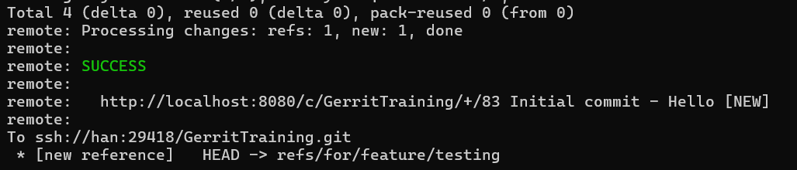

Reviewer approves
Click Submit.
Gerrit merges your change into master automatically

🎯 Conclusion: The Standard Gerrit Flow
You do NOT need to create a feature branch in Gerrit before pushing code for review.
Gerrit’s standard workflow does NOT use feature branches on the server.
Instead, Gerrit uses Change-Id and refs/for/ review branches.
And this is different from GitHub workflows.
You DO NOT:
- Create remote feature branches in Gerrit
- Push to feature branches
- Merge feature branches yourself
Gerrit handles all merging after review.

STANDARD PRACTICE SUMMARY (Very Important)
Platform | Standard practice
GitHub / GitLab | Create feature branches → push branch → open Pull Request → merge PR to main
Gerrit | Create local feature branches → push to refs/for/master → open Change → reviewers approve → Gerrit merges into master

Key difference:
GitHub uses feature branches on the server — branch-based workflow
Gerrit uses Change + patch sets — review-based workflow (no server feature branches needed).

Why creating remote feature branches is NOT recommended in Gerrit
It pollutes the repo with many branches
Reviewers need to check multiple branches
It bypasses Gerrit review workflow
Only project owners are allowed to create branches
It breaks Change-Id tracking

Why Gerrit does not need feature branches
Because Gerrit uses Change-Id to track revisions of the same change.
Example:
- Patch Set 1 → reviewer asks changes
- Patch Set 2 → you amend and push again
- Patch Set 3 → you fix and push again
But all belong to ONE review, not multiple branches.

