Setting Up Gerrit Web Interface on Windows (For Personal Use)

- Prepare Your Environment
Before setting up Gerrit on Windows, make sure you have the following installed:
- Install Git for Windows
- Download from https://git-scm.com/downloads.
- Run the installer and select “Add Git to PATH” during installation.
- Verify installation:
Open Command Prompt and run:
git –version
You should see something like git version 2.x.x.
- Install Java (Gerrit requires Java 11+):
  - Download OpenJDK 11 or higher (https://www.oracle.com/java/technologies/javase-downloads.html)
  - Set JAVA_HOME environment variable:
setx JAVA_HOME "C:\Program Files\Eclipse Adoptium\jdk-17.0.8.1-hotspot"
setx PATH "%JAVA_HOME%\bin;%PATH%"
  - Verify installation:
java -version
- Optional: Python (for scripting)

Download and Prepare Gerrit
- Go to official Gerrit download page.
- Download the latest Gerrit .war file (e.g. gerrit-3.x.war)
- Create a folder, e.g. C:\Gerrit
- Move the downloaded .war file into that folder.

- Initialize Gerrit Site
- Open Command Prompt as Administrator.
- Navigate to your Gerrit folder: cd C:\Gerrit
- Run this command:
java -jar gerrit-3.13.1.war init --batch --dev -d gerrit_site
This will create a Gerrit site directory and set up the web service.
- During installation, you will be prompted for:
  - Install type: Choose “Standalone site” (simplest).
  - Database: Use H2 (embedded) for testing or MySQL/PostgreSQL for production.
  - HTTP/HTTPS port: Usually 8080.
  - Gerrit user: Admin username.
  - SSH port: Usually 29418 (for Git push).
  - Create initial admin account and password.

Start Gerrit Web Server
Config file (gerrit.config) will be exist in C:\Gerrit\gerrit_site\etc\
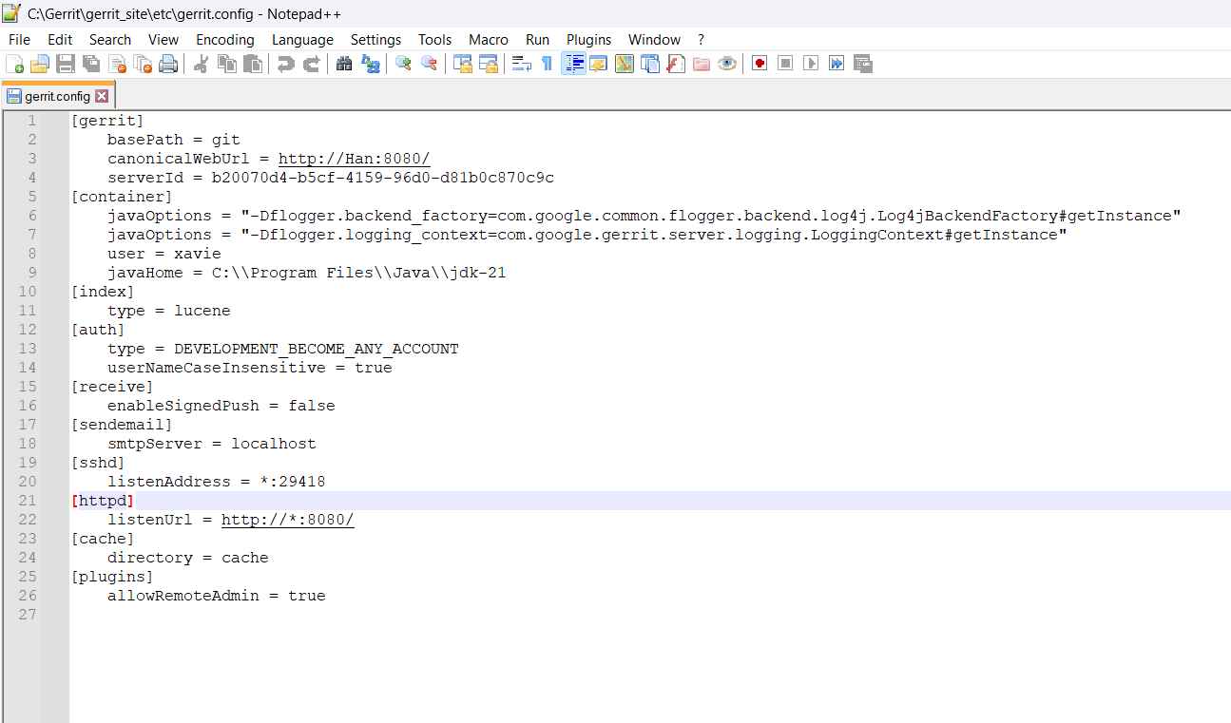
- Open Command Prompt and navigate to the bin folder:
cd C:\Gerrit\gerrit_site\bin
- Run Gerrit: gerrit.sh start
- Check if Gerrit is running:
- Open a browser and go to: http://localhost:8080
- Login with the admin account you created.

- Promote your user to Administrator
- Option 1: Add user to Administrators group by using set-account
  - Run this as an existing admin (usually via SSH):
ssh -p 29418 admin@localhost gerrit set-members Administrators –add user1
- Gerrit SSH port (default: 29418)
- From Gerrit Web UI (if you already have admin)
- Browse → Groups → Administrators
- Members → Add
- Add user1
- Save
- After adding to Administrators
- Log out user1
- Clear browser cache (or use Incognito)
- Log in again
- Now user1 should see:
- Admin menu
- Access to:
- Plugins
- Repositories

Repositories Management
- Create a New Repositories
- In Gerrit web interface, go to Browse → Repositories → Create New.
- Search for a project
- In the search bar at the top, type:
- project:<project-name>
- This will open that project directly.
- REST API (if web UI not available)
- You can list all projects via REST API:
curl -u user: HTTP_Credential_password http://<your-gerrit-url>/a/projects/
Example:
curl -u admin:WOH9QWw1E4k3XklUrtXhTmXAhd1kSrw9RsnhU9qNLA http://localhost:8080/a/projects/

Clone and Work with Repository
- Run: ssh -p 29418 admin@localhost
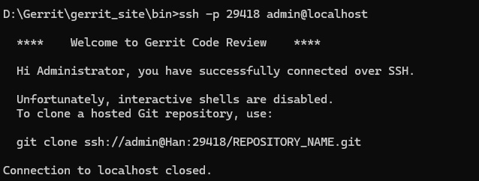
- Run: git clone ssh://<username>@localhost:29418/<Project_name>.git
Example: git clone ssh://admin@Han:29418/GerritTraining.git
- You can then make your local changes and commit normally.

Preconditions:
There is a created SSH key stored on your computer. If you’ve never do so, please generate and add an SSH Key.
- Open Git Bash
- Generate a SSH key
- Run this command in Git Bash:
ssh-keygen -t rsa -b 4096 -C your-email@example.com or
ssh-keygen -t ed25519 -C your-email@example.com
- Then just press Enter for each prompt:
- Enter file in which to save the key (/c/Users/<yourname>/.ssh/id_rsa): [Press Enter]
- Enter passphrase (empty for no passphrase): [Press Enter]
- Enter same passphrase again: [Press Enter]
- You should see:
- Your identification has been saved in /c/Users/<yourname>/.ssh/id_rsa
- Your public key has been saved in /c/Users/<yourname>/.ssh/id_rsa.pub
- This means your SSH key pair is successfully created.
- Copy your public key
- Now run:
cat ~/.ssh/id_rsa.pub (git bash)
type %USERPROFILE%\.ssh\id_rsa.pub (cmd)
This will show a long line like:
ssh-rsa AAAAB3NzaC1yc2EAAAADAQABAAABAQC... admin@example.com
- Copy this entire line from ssh-rsa all the way to your email.
- Add it in Gerrit
- Go back to your browser → http://han:8080
- Go to Settings → SSH Keys
- In the New SSH key textbox, paste the key you just copied
- The Add button will now turn blue / clickable
- Click Add
- Now your SSH key will appear under “Active SSH Keys.”

- Add email to the Setting page of the particular user
- Test your connection
- In Git Bash, try:
ssh -p 29418 admin@han gerrit version
- If you see something like:
gerrit version 3.13.x
- Then your SSH key works perfectly

Submit Code for Review
- Commit changes:
- cd MyTestProject
git add .
- Adds all modified, deleted, or new files in your working directory to the staging area.
- The staging area (also called the index) is where you prepare files before committing them.
- Example:
If you edited files like index.html, app.js, and README.md, this command stages them all.
- Alternative:
You can add specific files instead of all:
git add README.md app.js
- Commit your staged changes
git commit -m "Initial commit"
- Creates a snapshot of all files currently in the staging area.
- Records your changes with a message describing what was done.
- Example:
The commit message "Initial commit" usually refers to the first commit in a new project or repository.
- After this command:
Git saves a new commit with a unique hash ID, your author information, timestamp, and the commit message.
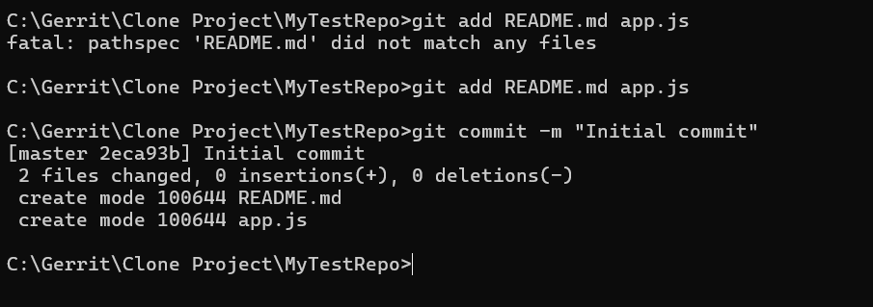

- Push for review:
- Check current remotes (optional but recommended)
git remote -v
- If origin does NOT exist (add it)
Gerrit over SSH (recommended)
git remote add origin ssh://admin@Han:29418/TestProject
- If origin already exists (change it)
git remote set-url origin ssh://admin@Han:29418/TestProject
- Verify
git remote -v
Expected output:
origin ssh://admin@Han:29418/TestProject (fetch)
origin ssh://admin@Han:29418/TestProject (push)
- Push your commit to refs/for/<branch>
git push origin HEAD:refs/for/main
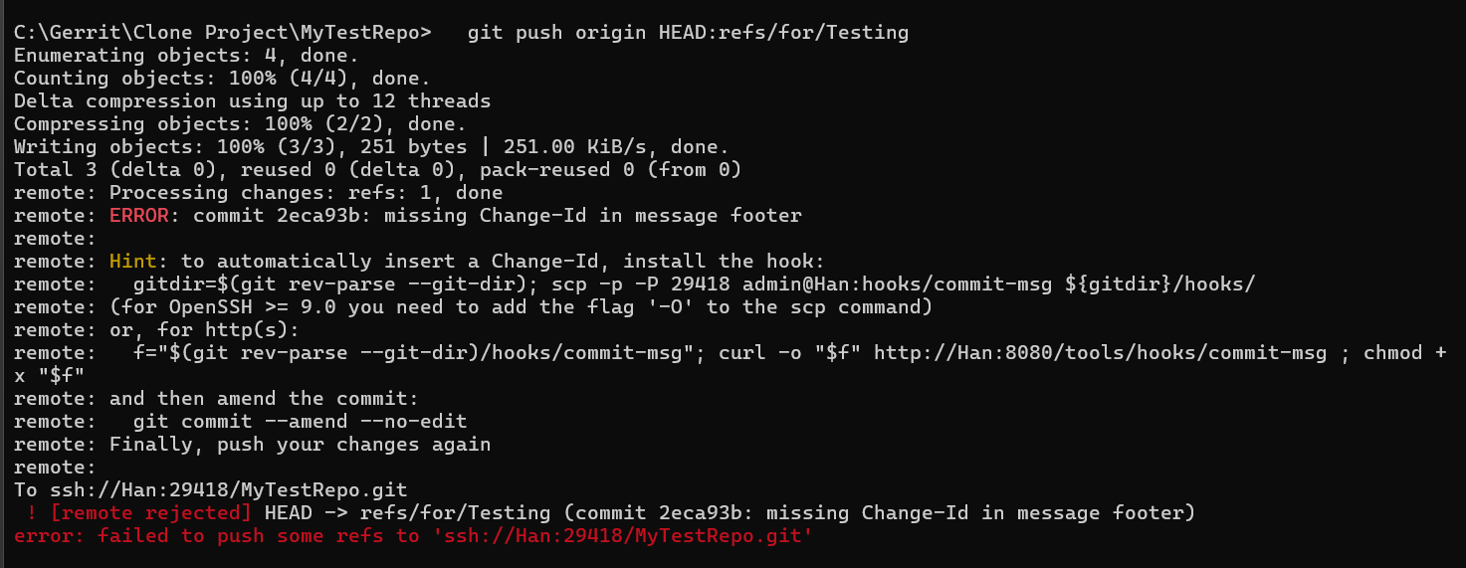
- ERROR: commit 2eca93b: missing Change-Id in message footer
- Gerrit requires every commit pushed to refs/for/<branch> to contain a Change-Id line in the commit message footer.
- Your commit does not have a Change-Id, so Gerrit rejects the push.
- How to fix it: Install Gerrit commit-msg hook
- Download hook via HTTP by Git bash
- curl -o .git/hooks/commit-msg http://Han:8080/tools/hooks/commit-msg
- chmod +x .git/hooks/commit-msg
- Download hook via HTTP by command prompt
- scp -O -P 29418 admin@Han:hooks/commit-msg .git/hooks/commit-msg
- Manually download hook via HTTP by browser
- Open Gerrit in your browser
http://Han:8080/tools/hooks/commit-msg
- Save the file in:
<Your repository directory>\.git\hooks\commit-msg
- Verify hook is installed
- Git bash: ls -l .git/hooks
- Cmd prompt: dir .git\hooks
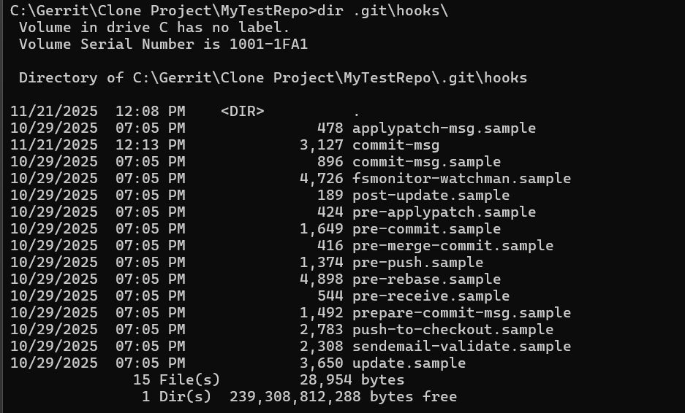
- Amend the commit (do NOT change content)
git commit --amend --no-edit
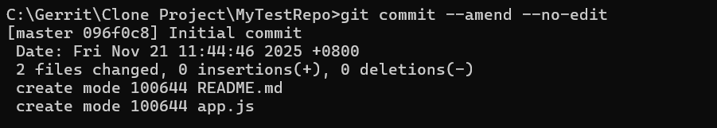
- Push again
git push origin HEAD:refs/for/main
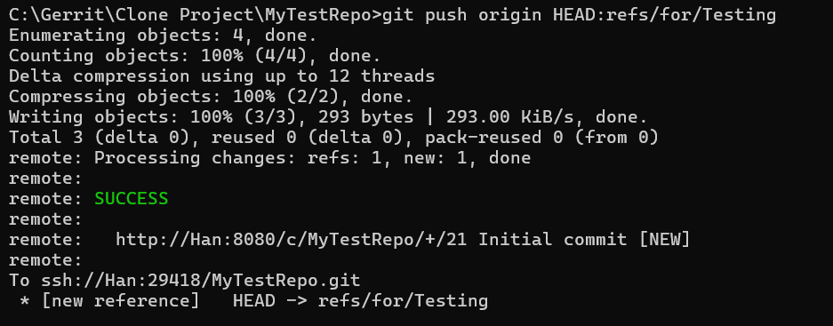
Other users (e.g. project owners) who have configured Gerrit to notify them of new changes will be automatically sent an email message when the push is completed.
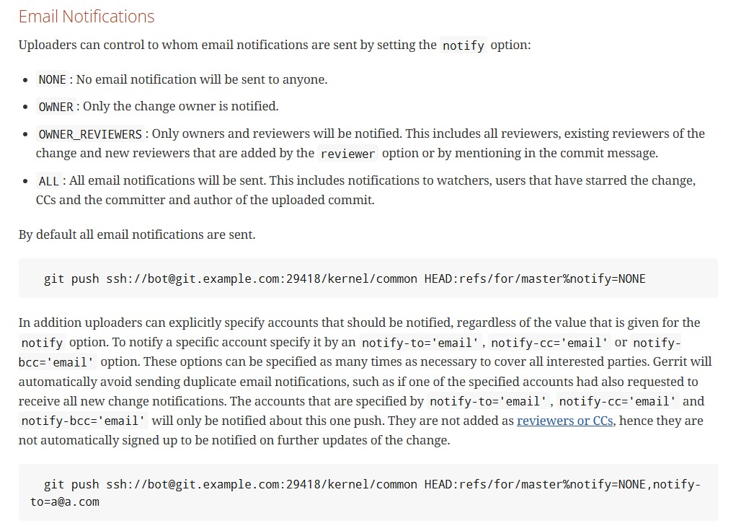
- Verify the push in Gerrit
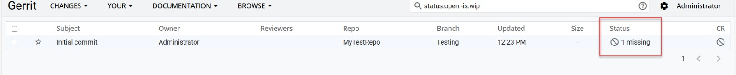

In Gerrit, seeing “1 missing” after you push a commit for review means one required condition has not been satisfied, so the change cannot be submitted yet.

Gerrit requires certain labels / approvals before a change can be merged.
“1 missing” = one required approval is missing.

- Review page contents
- On your Gerrit review page, you’ll see:
- Commit message and change ID
- Diffs (what files changed)
- Reviewers (who will approve it)
- Buttons like “Reply”, “Abandon”, “Submit”, or “Rebase” depending on permissions.
- What happens next
- Reviewers comment or approve your change.
- Once it’s approved (+2 Code-Review and +1 Verified usually), Gerrit automatically merges it into the main branch.

- Gerrit workflow
- Developer commits locally.
- Pushes with refs/for/<branch> (e.g. refs/for/main).
- Gerrit receives the commit and creates a code review entry.
- Reviewers can comment, request changes, or approve.
- Once approved, Gerrit merges the change into main.
- Breakdown:
- origin → the name of your remote repository (set when you cloned it).
- HEAD → refers to your current checked-out commit/branch.
- refs/for/main → tells Gerrit you’re submitting this change for review to the main branch.
- Full Gerrit workflow summary
Step | Action | Command / Description
1 | Stage all modified and new files | git add .
2 | Commit staged changes with a message | git commit -m "Initial commit"
3 | Push to Gerrit for code review targeting the main branch | git push origin HEAD:refs/for/main
4 | Get Gerrit link | Copy from terminal or search owner:self
5 | Wait for review | Reviewers approve or comment
6 | Merge after approval | Gerrit merges automatically into main

- Add Reviewer
ssh -p 29418 admin@Han gerrit create-account alice --full-name "\"Alice Tan\"" --email alice@example.com
ssh -p 29418 admin@Han gerrit create-account bob --full-name "\"Bob Lee\"" --email bob@example.com

- How to create a user in Gerrit
- Generate a new SSH key
ssh-keygen -t rsa -b 4096 -C “doristee73@gmail.com”
- Create an account
ssh -p 29418 admin@Han gerrit create-account doris

Troubleshooting Tips:
- Generate Missing Host Keys on Windows
- Run this in PowerShell as Administrator on the Gerrit server:
- Navigate to OpenSSH folder
cd "C:\ProgramData\ssh"
- Generate host keys if missing
ssh-keygen -A
- This command creates:
ssh_host_rsa_key and ssh_host_rsa_key.pub
ssh_host_ed25519_key and ssh_host_ed25519_key.pub
(and possibly ECDSA keys)
- Verify Fingerprints
- After generating or locating the .pub files:
ssh-keygen -lf ssh_host_rsa_key.pub
ssh-keygen -lf ssh_host_ed25519_key.pub
- Gerrit rejects the push (e.g. missing Change-Id or permission issue)
- Database exception issue
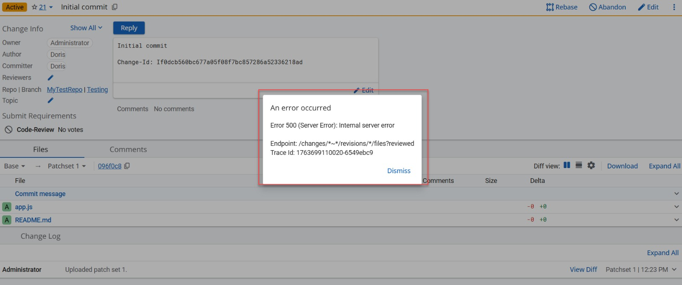

- Host key of the Gerrit server has been changed

