Git Workflow Guide: Clone GitHub Repo, Add Gerrit, Commit & Push

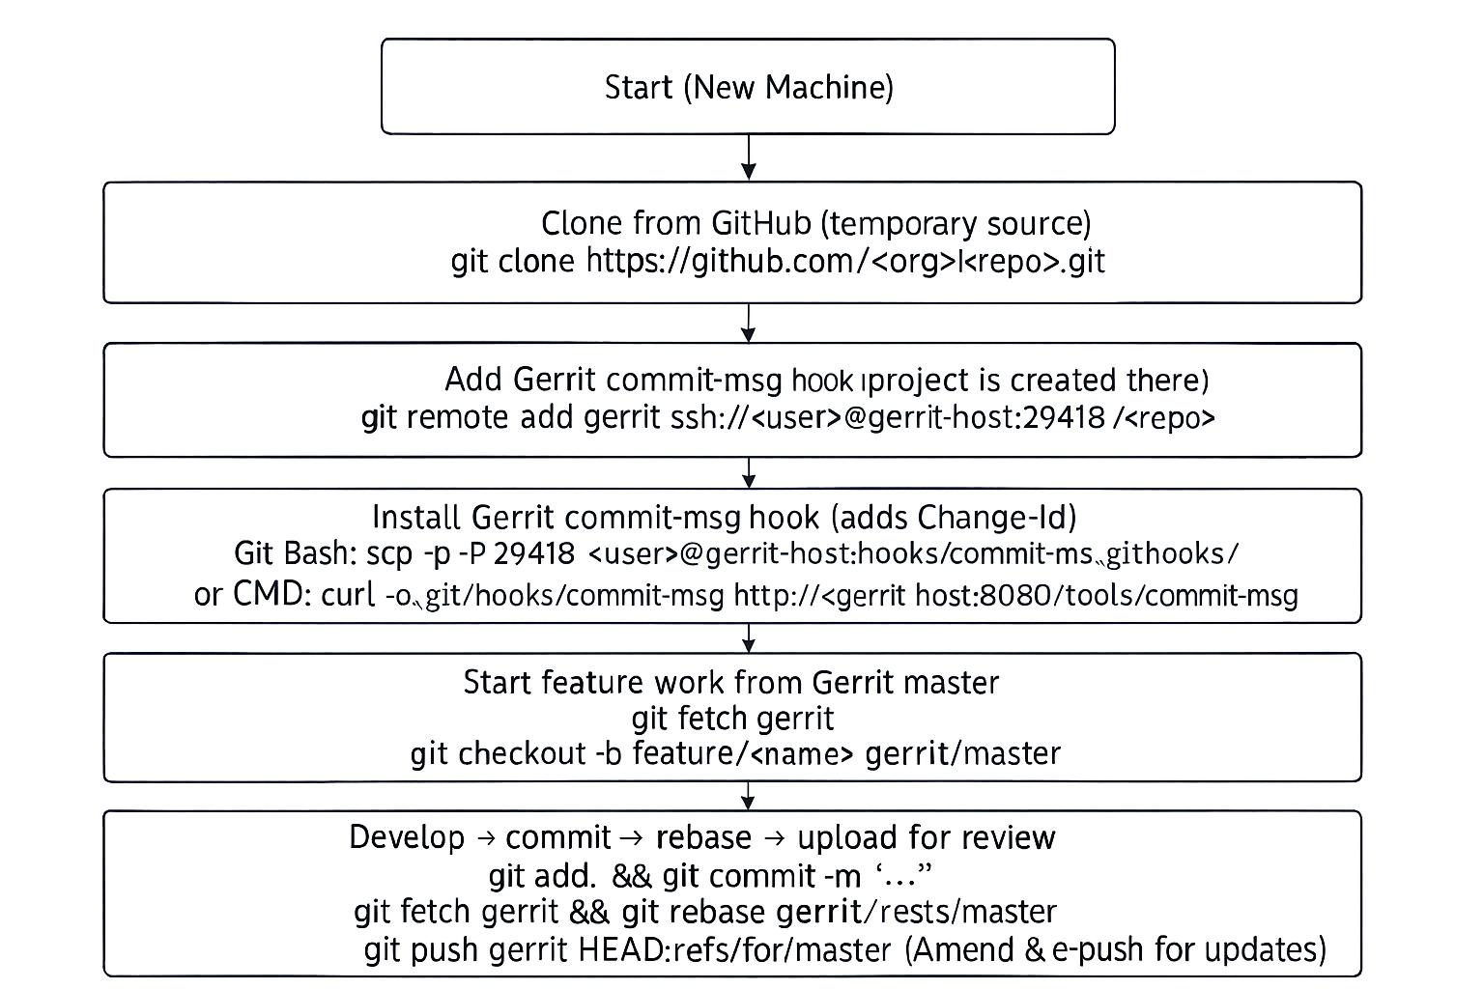

1. Clone Repository from GitHub
Open your terminal or Git Bash.
Navigate to the directory where you want to place the project.
Run the command:
git clone https://github.com/<your-account>/<repo>.git
git clone ssh://<your-account>@han:29418/<repo>.git
Example:
git clone https://github.com/doristee/MyCleanRepo.git
git clone ssh://user4@han:29418/MyCleanRepo.git

2. Configure git user name and email address:
git config --global user.name "username"
git config --global user.email username@example.com
Example:
git config --global user.name "user1"
git config --global user.email user1@example.com

3. Add Gerrit Remote to Local Repository
Ensure you have access to your Gerrit server and SSH keys configured.
- Access to the cloned repository:
cd <repo>
- Verify remote configuration:
git remote -v
- You will see:
origin https://github.com/doristee/MyCleanRepo.git (fetch)
origin https://github.com/doristee/MyCleanRepo.git (push)
- Add Gerrit as a new remote:
git remote add gerrit ssh://<gerrit-username>@<gerrit-host>:29418/<project-path>
Example:
git remote add gerrit ssh://user1@han:29418/MyCleanRepo.git
- Verify remote configuration:
git remote -v
- You will see:
gerrit ssh://user1@han:29418/MyCleanRepo.git (fetch)
gerrit ssh://user1@han:29418/MyCleanRepo.git (push)
origin https://github.com/doristee/MyCleanRepo.git (fetch)
origin https://github.com/doristee/MyCleanRepo.git (push)

4. If Gerrit requires Change-Id and you have not installed commit-msg hook
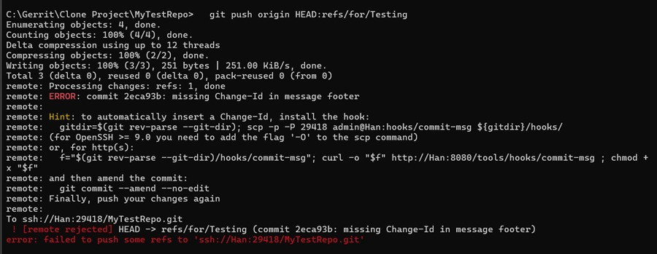
If Gerrit requires Change-Id and you have not installed commit-msg hook, add it using:
- Download hook via HTTP by Git bash (Recommended):
scp -O -P 29418 username@han:hooks/commit-msg .git/hooks/
chmod +x .git/hooks/commit-msg
Example:
scp -O -P 29418 user1@han:hooks/commit-msg .git/hooks/
chmod +x .git/hooks/commit-msg
- Download hook via HTTP by command prompt:
curl.exe -o .git\hooks\commit-msg http://han:8080/tools/hooks/commit-msg
scp -O -P 29418 username@han:hooks/commit-msg .git/hooks/commit-msg
- Manually download hook via HTTP by browser
Open Gerrit in your browser
http://han:8080/tools/hooks/commit-msg
Save the file in:<Your repository directory>\.git\hooks\commit-msg
- Verify hook is installed
Git bash: ls -l .git/hooks
Cmd prompt: dir .git\hooks
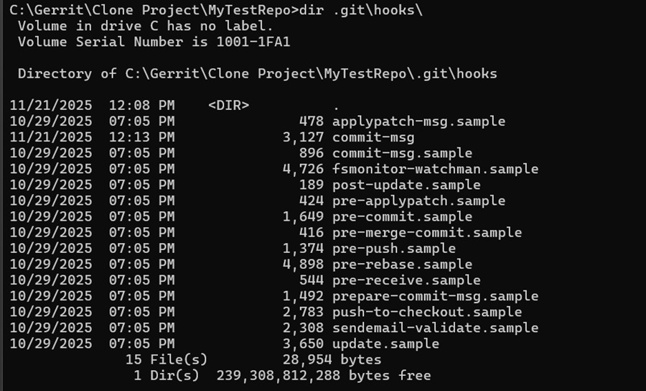
5. Locally create your feature branch, from main, cut out your feature branch
Pull latest changes from master
git fetch gerrit
git checkout master
git pull gerrit master
or
git fetch gerrit
git checkout -b feature/username gerrit/master

6. Create a New File or Make Changes
Create or modify files inside your project directory.
For example, create a new file:
mkdir src
echo "Sample change" > src/demo.txt
Or edit existing files using your preferred editor.

7. Stage and Commit Your Changes
Add your changes to the staging area:
git add . OR
git add src/main/app.js
git add README.md
git add config/settings.json
Commit your changes with a message:
git commit -m "Add demo file or make modifications"

- If it’s prompted email address issue as below:
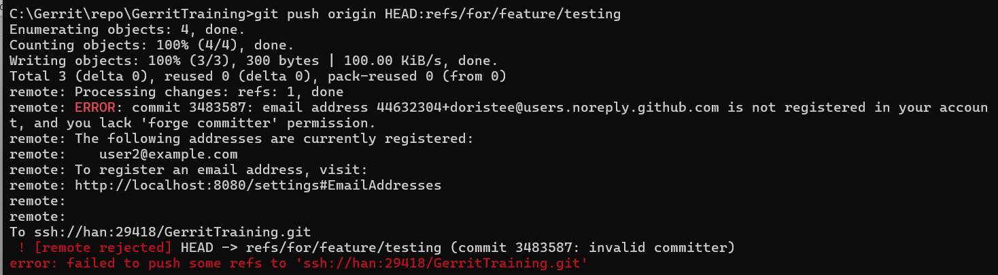
- Check current commit author:
git log -1
- Configure git user name and email address:
git config --global user.name "username"
git config --global user.email username@example.com
- Update author email for the last commit:
git commit --amend --reset-author -m "Update text“
- If there is conflict, resolve the conflict → continue:
git status
git log --oneline --graph --decorate
git add .
git rebase --continue

Note: Gerrit requires Change-Id. If there is no Change-Id (and if you previously submitted a review, remember to use):
git commit --amend
git commit --amend --no-edit

8. Push to Gerrit Feature Branch for Review
Ensure your target Gerrit branch exists (e.g., master).
Push your changes to Gerrit for review:
git fetch gerrit
git rebase gerrit/master
git push gerrit HEAD:refs/for/master
OR with topic:
git push gerrit HEAD:refs/for/master%topic=feature-testing
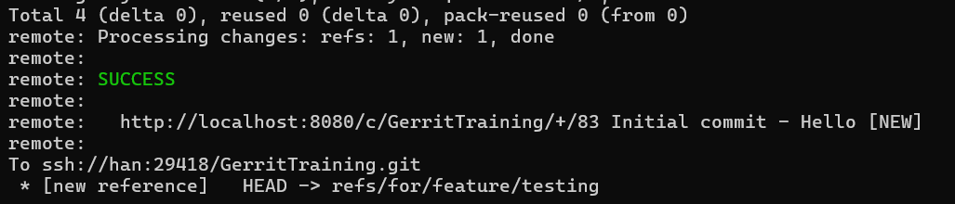

Reviewer approves
Click Submit.
Gerrit merges your change into master automatically

🎯 Conclusion: The Standard Gerrit Flow
You do NOT need to create a remote feature branch in Gerrit before pushing code for review.
Gerrit’s standard workflow does NOT use feature branches on the server.
Instead, Gerrit uses Change-Id and refs/for/ review branches.
And this is different from GitHub workflows.
You DO NOT:
- Create remote feature branches in Gerrit
- Push to feature branches
- Merge feature branches yourself
Gerrit handles all merging after review.

STANDARD PRACTICE SUMMARY (Very Important)
Platform | Standard practice
GitHub / GitLab | Create feature branches → push branch → open Pull Request → merge PR to main
Gerrit | Create local feature branches → push to refs/for/master → open Change → reviewers approve → Gerrit merges into master

Key difference:
GitHub uses feature branches on the server — branch-based workflow
Gerrit uses Change + patch sets — review-based workflow (no server feature branches needed).

Why creating remote feature branches is NOT recommended in Gerrit
It pollutes the repo with many branches
Reviewers need to check multiple branches
It bypasses Gerrit review workflow
Only project owners are allowed to create branches
It breaks Change-Id tracking

Why Gerrit does not need feature branches
Because Gerrit uses Change-Id to track revisions of the same change.
Example:
- Patch Set 1 → reviewer asks changes
- Patch Set 2 → you amend and push again
- Patch Set 3 → you fix and push again
But all belong to ONE review, not multiple branches.

Simplified & Recommended Gerrit Workflow
This workflow is designed to be easy, clean, and correct for everyday development with Gerrit.

🟦 1. Start a new feature / task
When you begin working on something new, always base it on the latest Gerrit master:
git fetch gerrit
git checkout -b feature/testing gerrit/master
This ensures your branch starts from the official latest history.

🟦 2. Commit your changes (no need to fetch or rebase yet)
You can commit freely without syncing with Gerrit every time:
git add .
git commit -m "update"
You may repeat commit as many times as you want — this is all local.

🟦 3. Before pushing to Gerrit (MOST important)
Always make sure your feature branch is rebased onto the latest Gerrit master before pushing:
git fetch gerrit
git rebase gerrit/master
git commit --amend --no-edit
git push gerrit HEAD:refs/for/master
This prevents Gerrit “Merge Conflict” errors and keeps your patch clean.

🟦 4. Reviewer requests changes? (Update patchset)
Do NOT create a new commit.
Instead, amend the last commit and push again:
Stay on your feature branch
git status # make sure you're on the current branch
git add <files...>

Amend the existing review commit (keep the same Change-Id)
git commit --amend --no-edit
# or if you want to edit the message:
# git commit --amend
git push gerrit HEAD:refs/for/master

When would you run git fetch gerrit again?
- If you want to rebase your work on top of the latest gerrit/master before amending/pushing.
git fetch gerrit
git log -1 # optional
git log --oneline --decorate --graph --max-count=5 gerrit/master # optional
git rebase gerrit/master
# resolve conflicts if any, then continue:
# git rebase --continue
git commit --amend --no-edit
git push gerrit HEAD:refs/for/master

You have multiple commits but want one review
In Gerrit, each commit becomes a separate Change. If you want to keep it as one Change, squash them locally:
git rebase -i gerrit/master # mark later commits as 'fixup' or 'squash'
git commit --amend --no-edit # ensure the Change-Id stays
git push gerrit HEAD:refs/for/master

This updates your existing change as a new patchset in Gerrit.

✅ Summary (Very Simple)
Action | What to do
Start new work | git checkout -b featureX gerrit/master
Commit locally | git commit -m (no rebase needed)
Push to Gerrit | git fetch, git rebase, git push
Update patchset | git commit --amend, git push

