Applied Databases project

4.3 Normalisation
4.3.1 Database Design

Student: Doris Zdravkovic

The purpose of this work is to examine the following database that was designed to store the following information on a company’s employees and departments:

• Employee ID
• Employee Name
• Employee Salary
• Department Name
• Department Location
• Department Budget

and give my opinion and proposal on how to improve and organize its data.

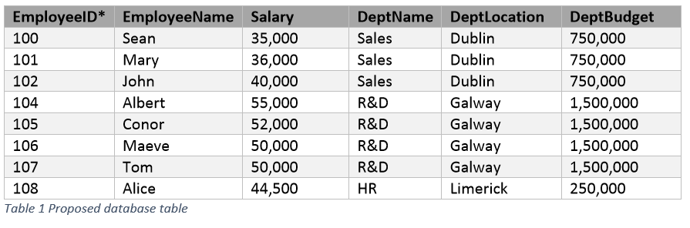

Normalization is a database design technique that organizes tables in manner that reduces redundancy and dependency of data. Normalization divides larger tables into smaller tables and links them using relationships. The purpose of Normalization is to eliminate redundant (useless) data and ensure data is stored logically.

As it is the processes of reducing the redundancy of data in the table and also improving the data integrity it is required to deal with many issues such as:

- Insertion anomaly: It occurs when we cannot insert data to the table without the presence of another attribute
- Update anomaly: It is a data inconsistency that results from data redundancy and a partial update of data.
- Deletion Anomaly: It occurs when certain attributes are lost because of the deletion of other attributes.

In brief, normalization is a way of organizing the data in the database. Normalization entails organizing the columns and tables of a database to ensure that their dependencies are properly enforced by database integrity constraints. It usually divides a large table into smaller ones, so it is more efficient. Smaller tables are usually easier to navigate. (www.edureka.co)

What is a Primary key?

A primary is a single column value used to identify a database record uniquely.
It has following attributes
- A primary key cannot be NULL
- A primary key value must be unique
- The primary key values should rarely be changed
- The primary key must be given a value when a new record is inserted.
The only unique key in the table above is EmployeeID. EmployeeID key has all necessary above mentioned features to be the primary key in the table discussed. (www.guru99.com)

What is a Foreign key?

Foreign Key references the primary key of another table. It helps connect tables. Foreign key features:

- A foreign key can have a different name from its primary key
- It ensures rows in one table have corresponding rows in another
- Unlike the Primary key, they do not have to be unique. Most often they aren't
- Foreign keys can be null even though primary keys can not

(www.guru99.com)

In the table above, DeptName key would meet all above mentioned requirements and foreign key features. As we can see, foreign key (DeptName) is not unique, it has different name that the primary key (EmployeeID) and it can have null value.

My proposal for this table:

Having said that the purpose of normalization is to eliminate redundant data and ensure data is stored logically, we can see this table is not a perfect example of logically organized data. This table should be divided in two and linked with the foreign key. As I mentioned before, looking at the features of foreign keys, DeptName key would meet all requirements to connect two tables. In my point of view, tables should look like this:

Table 1:

In the first table there is a primary key (EmployeeID). EmployeeID numbers are unique and each number represents each person (EmployeeName), their salary and the department name where they work. Having only these data in the table makes the data better organized and transparent.

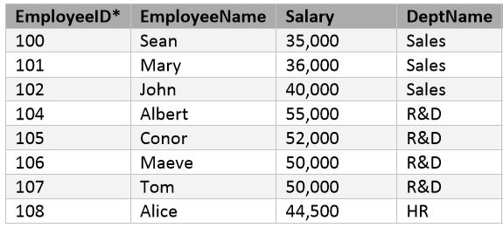

Table 2:

The second tables consists of department name, department location and its budget. As we can see DeptName key is a foreign key as it is stated in both tables and it that way it connects them.

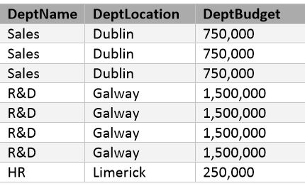

In order to have organized data the structure of the table is better when it is divided into two tables, Employee table and Department table. Now they are pretty simple to navigate through and organize its data. This is particularly useful if there is more information in the tables. Employee table for example could contain more information like employee surname or phone/email details as only having employeeName column could cause some confusion in a case there are two employees with the same name, so adding employee surname column could make table easier to navigate.

References used:

https://www.edureka.co/blog/normalization-in-sql/

https://www.guru99.com/database-normalization.html

Lectures: Topic 4 - Normalizations

