Zürcher Hochschule für Angewandte Wissenschaften

School of Management and Law

Degree:

Master of Science in Banking and Finance

Module:

Advanced Quantitative Methods, FS 23

**Commodity Futures:   
What drives asset prices?  
Causality and cointegration**

Authors:

Kern Dorit, Küchler Jan, Mattmann Cédric

Class:

W.MA.BF.22HS.CMDSTZb

Submitted to

Dr. Tomasz Orpiszewski

Submission date: 4th of June, 2023

**Contents**

1 Introduction 4

2 Literature Review 4

3 Methodology 5

4 Data and Sources 5

4.1 Data Retrieval 5

4.2 Verifying and Cleaning of Data 6

4.2.1 Missing Data 6

4.2.2 Outliers 7

4.3 Description of Data 7

4.3.1 Subsamples 7

4.3.2 Stationarity (Cédric) 8

4.3.3 Normality Test 9

4.3.3.1 Box Plots 9

4.3.3.2 Histogram 10

4.3.3.3 Shapiro-Wilk Test 11

4.4 Database Setup 11

5 Analysis of Cointegration & Causality 13

5.1 Cointegration 13

5.2 Causality 13

6 Conclusion 14

7 Bibliography 14

8 Appendix 15

8.1 Appendix 1 15

8.2 Appendix 2 15

8.3 Appendix 3 18

8.4 Appendix 4 21

8.5 Appendix 5 22

8.6 Appendix 6 23

**List of Figures**

Figure 1: Selected Instruments 6

Figure 2: Descriptive Statistics of Subsamples 7

Figure 3: Box Plots 10

Figure 4: Histogram 10

Figure 5: SQLite Data Bank 12

# Introduction

This paper aims to investigate the causal relationships and long-term equilibrium dynamics among a set of commodity futures through the lens of cointegration analysis and Granger causality testing.

# Literature Review

Studies have shown that many economic time series follow a stochastic process and can be classified as non-stationary. The methods for the analysis of regression models and hypothesis tests require the use of stationary time series. If this requirement is ignored and non-stationary time series are used, there is a risk of spurious regressions (Winker, 2017, pp. 268-269). A common method for testing the null hypothesis of non-stationarity is the Augmented Dickey-Fuller unit root test (Winker, 2017, pp. 273-275; Acikalin & Basci, 2016, p. 569).

To avoid the difficulties resulting from spurious correlations, non-stationary time series can be differenced to make them stationary. A disadvantage of the analysis of differences is that information about long term dependencies get lost (Gerhards, 1994, p. 73).

It is often of interest to determine whether there are certain dependencies between non-stationary time series (Gerhards, 1994, p. 73). Cointegration occurs when two or more non-stationary variables exhibit a common long-term trend and do not drift away from each other (Kirchgässner, Wolters, & Hassler, 2023, p. 209). The time series therefore develop in parallel in the long term and the difference between the two time series remains the same over time, although both time series individually have a trend (Gerhards, 1994, p. 74).

The Granger Causality Test is used to find out whether a Time Series can help to predict another Time Series. It states that a variable X is Granger-causal for Y if, for a given amount of information up to time t-1, variable Y can be predicted better at time t than without the inclusion of variable X. The Granger causality test can apply in one direction or in both directions. The Times Series must also be stationary for Granger Causality (Granger, 1969, pp. 431-436)

This means that in case of non-stationary data, as described above, the time series must first be differentiated.

# Methodology

For the analysis, 20 different commodity futures are analyzed and tested for causality and cointegration. As reference of the commodity futures, the first generic commodity future will be used. The analysis will be done mainly by using Python and SQL is used as support. The raw data for this is obtained from Refinitiv. For an additional control of the data, the data will be pulled via Excel on the one hand and directly via Python API interface on the other hand. Afterwards, the data has to be cleaned due to missing values. Then an SQL database is created for further processing. In this way, the data can be processed more easily and efficiently.

The first step of the main analysis is to test the stationarity of all time series in level and first difference. Thereafter, each asset is tested against each other for cointegration and granger causality. Both analyses are performed in Python using a loop to test all possible combinations. The respective results are saved and added to this work as a table.

# Data and Sources

## Data Retrieval

The data used in this paper is obtained from Refinitiv and covers a period of ten years, from 02.05.2013 to 01.05.2023. We focus on analysing the daily closing prices of the 1st generic commodity futures for twenty different instruments.

Ein Bild, das Text, Screenshot, Schrift, Zahl enthält.

Figure 1: Selected Instruments

To gather the data, two methods were employed: the Formula Builder in the Excel Add-in and the Eikon API. Both approaches utilized the same parameters, including the asset keys, daily intervals, and the "CLOSE" field for the specified time horizon as defined above.

During the comparison of the two datasets, we observed that the data obtained through the Eikon API did not contain any NaN values as those dates were excluded. For that reason, we dropped the NaN values in the excel data to enable comparability. By employing the method .info() in pandas we identified that the data format in the two data differs in some asset classes. However, by utilizing the .describe() method in pandas, we confirmed that the values were identical (see Appendix 1).

## Verifying and Cleaning of Data

### Missing Data

In the data cleaning process, we initially examined the samples (plots see Appendix 2) and observed a significant number of days with more than 50% missing values, which coincided with public holidays in the USA. Additionally, we identified missing values for assets traded in Shanghai due to public holidays in China. Consequently, we proceeded by excluding these data points. As a result of the cleaning process, the initial sample, consisting of 2601 trading days, was reduced to 2357 trading days for each asset.

Furthermore, we encountered additional randomly missing dates across certain asset classes. To address this issue, we applied the .ffill() method in pandas. This method allowed us to replace the NaN values in each selected row with the values from the previous row, ensuring a consistent and continuous dataset.

### Outliers

To identify and address outliers, we employed a methodology that involved calculating the moving average and standard deviation for each asset class. Any data points that fell outside a certain threshold were identified as outliers. Subsequently, these outliers were replaced with the corresponding moving average value, effectively smoothing the data and reducing the impact of extreme values. The plots of clean data are found in the Appendix 3.

## Description of Data

### Subsamples

After cleaning the data, we divided the set into five subsamples, each representing a two-year interval. To gain insights into the data distribution within each subsample, we employed the .describe() method to generate descriptive statistics.

Ein Bild, das Text, Software, Zahl, Computersymbol enthält.

Figure 2: Descriptive Statistics of Subsamples

Following the analysis, the data was exported to Excel and consolidated, as depicted in Table 2 above.

This table provides information on the number of observations, mean, standard deviation, minimum, and maximum price for each asset throughout the entire period. Additionally, it presents the average market price of each asset during different time periods. The standard deviations of each asset within the entire sample were visualized using a colour scale, ranging from green (indicating the lowest standard deviation) to red (representing the highest standard deviation). Additionally, the means of each asset in every subsample were also color-coded, with lighter shades denoting lower prices and darker shades indicating higher prices.

It becomes evident that the commodities Soybean, Aluminium and Zinc show the highest standard deviation in the full sample. This might result from lower volumes in this asset classes. Furthermore, once can notice that the prices in the last subsample are almost without exception the highest. From May 2015 till May 2019 the prices were usually the lowest. This downward pressure on commodity prices might be connected to several factors such as oversupply, reduced demand from emerging economies, and a stronger US Dollar.

### Stationarity

Variables of economic time series are often non-stationary, they follow a trend and have cycles. A method to make variables of time series stationary is a first difference change.

We analyzed whether the time series are stationary or not. In a first step, we plotted the cleaned data (see appendix 2). At first glance, it seems that the time series have a unit root. Afterwards, we performed the Augmented Dickey-Fuller (ADF) test with a null and alternative hypothesis to test if the time series are stationary:

: Nonstationary time series

: Stationary time series

The null hypothesis can be rejected if the p-value is less than 𝛼. We use a 95% confidence interval, which means that the alpha is 5%. We tested stationary of commodity futures on both level and first differences, using up to 2 lags.

The ADF tests computed with one and two lags at price level show in both cases high p-values over 20% (see appendix 4). The null hypothesis can’t be rejected. Therefore, it can be assumed that the time series have a unit root at price level.

The ADF test computed with one and two lags at first differences (absolute returns) show in both cases p-values of 0% (see appendix 4) The null hypothesis can be rejected. It can be assumed that the time series at first differences are stationary.

### Normality Test

Normality tests check if a dataset follows a normal distribution and calculate the probability of the underlying random variable being normally distributed.

To tests if the data is normal distributed we are using to different types of normality test:

* Visual method – Box Plots
* Visual method - Histogram
* Statistical method – Shapiro-Wilk test

#### Box Plots

The shape of a box plot can indicate whether a statistical dataset is normally distributed or skewed. If the median is positioned in the middle of the box and the whiskers are approximately equal on both sides of the box, it indicates a symmetric distribution.

In the table below 6 examples are shown, the others can be seen in the appendix 5. In most cases a non-symmetrical distribution can be recognized. In the case of LCc1, for example, one would have to look more closely. For this reason, another visual method will be used in the next chapter.

|  |  |  |
| --- | --- | --- |
| Cc1 | CUUc1 | LCc1 |
| NGc1 | PAc1 | SFSc1[1] |

Figure 3: Box Plots

#### Histogram

The histogram is used to represent frequency distributions for statistical data. In a normal distribution, the distribution is Bell-shaped.

We again created a histogram for all assets and manually checked for a normal distribution. All histograms have been archived in the appendix 6. As in the previous chapter, most of the time series can be classified as not normally distributed. This time one can also guess at LCCc1 that it is not normally distributed. But to be sure, we apply a statistical method for the control.

|  |  |  |
| --- | --- | --- |
| CC1 | CUUc1 | LCc1 |
| NGc1 | PAc1 | SFSc1 |

Figure 4: Histogram

#### Shapiro-Wilk Test

The Shapiro-Wilk test is a statistical Method for checking if Data is normal distributed. This is being done by testing the zero hypothesis that data is normally distributed.

For the Shapiro-Wilk test, we formulate following two hypotheses:

: The sample comes from a normal distribution

: The sample is not coming from a normal distribution

To test the hypothesis, we use a 95% confidence interval, which means that the alpha is 5%.

The Shapiro-Wilk test confirms our finding from the Box Plots and the Histograms as all p-values are smaller than 5%. Therefore, the zero hypothesis can be rejected, meaning that data is not normal distributed.

This was to be expected since stock market prices are usually not normally distributed. Performance figures are excluded from this statement.

## Database Setup

As a database allows simple handling and a clear structuring of the data, the clean data is loaded into a database in SQLite. We established a connection between Python and SQLite and created a table named ASSET_PRICES using a timestamp as the primary key and the different asset classes as columns with data type FLOAT. Afterwards we imported the data exported by Refinitiv via Excel into the SQL database.

Ein Bild, das Text, Schrift, Papier, Screenshot enthält.

Figure 5: SQLite Data Bank

After the analysis, we uploaded the results of the cointegration and causality tests into new tables – RESULTS_COINTEGRATION_1, RESULTS_COINTEGRATION_2 and RESULTS_CAUSALITY – in the same database (see appendix 9)

# Analysis of Cointegration & Causality

## Cointegration

The commodity futures at price level could be classified as nonstationary using the ADF test. To find out whether two commodity futures time series share a common long-run trend, have a long-run equilibrium and do not drift away from each other, they were tested for cointegration with a confidence interval of 95% and an alpha level of 5%:

: No Cointegration

: Cointegration

The test for cointegration was performed with one and two lags. The matrix with the calculated P-values as well as the visualizations can be found in appendix 7. The commodity future pairs with a P-value of less than 5% are highlighted in green. Using a lag of 1, 63 of the 380 null hypotheses could be rejected. Therefore, with an alpha level of 5%, 63 commodity future pairs can be assumed to be cointegrated. The test with a lag of 2 showed similar results and 62 commodity future pairs could be assumed to be cointegrated.

## Causality

As already mentioned in chapter 5.1 Cointegration, the data are not stationary. For this reason, the time series must be differenced. Thereafter, we check again with the ADF test whether the data are stationary.

For the Granger Causality Test, we compare all variables with each other. For this we use a confidence interval of 95% and an alpha level of 5%. The hypothesis for the Granger Causality Test is as follows:

: No Granger Causality

: Granger Causality

The matrix with all the P-values can be seen in the appendix 8. Of all these, 104 cases with a P-value of less than 5% are marked in red in the table. This means, that the hypothesis for these cases can be rejected as there is a Granger Causality relation in place for them.

# Conclusion

Like many financial time series, the twenty commodity futures analyzed follow stochastic trends, have cycles and are therefore non-stationary.

If non-stationary time series are used for the analysis of regression models, there is a risk of spurious regressions. With the first difference, the twenty time series analyzed became stationary and the risk of spurious regressions could be minimized. A disadvantage of the analysis of the first difference is that information about long-term dependencies gets lost.

The cointegration test was used to examine whether the individual pairs of the non-stationary commodity futures time series at the price level show a common long-term trend and do not move away from each other. Out of the 380 regressions analyzed with a lag of 1, 63 pairs were cointegrated. The result with a lag of 2 remained almost identical with 62 cointegrated pairs.

The Granger Causality Test indicated which variables can be used to predict future changes in other variables. Since the data for the Granger Causality Test should always be stationary, market prices must always be differentiated first. In the end, out of a total of 400 combinations, only 104 combinations showed a Granger Causality. Only the commodities PAc1 and PLc1 are not useful for predictions in any combination. All others can be used for at least one other commodity.

# Bibliography

Acikalin, S., & Basci, E. S. (2016). Cointegration and Causality Relationship between BIST 100 and BIST Gold Indices. *Yonetim Ve Ekonomi, 23*(2), pp. 565-574. https://doi.org/10.18657/yecbu.53293.

Gerhards, T. (1994). Das Konzept der Kointegration. *Theorie und Empirie flexibler Wechselkurse. Wirtschaftswissenschaftliche Beiträge, vol 99.*, 79-91. https://doi.org/10.1007/978-3-642-51510-1_5.

Granger, C. (1969). Investigating Causal Relations by Econometric Models and Cross-spectral Methods. *Econometrica, 37*(3), 424-438. https://doi.org/10.2307/1912791.

Kirchgässner, G., Wolters, J., & Hassler, U. (2023). *Introduction to Modern Time Series Analysis* (Vol. 2). Berlin, Heidelberg: Springer Berlin Heidelberg. https://doi.org/10.1007/978-3-642-33436-8.

Winker, P. (2017). Nichtstationarität und Kointegration. In *Empirische Wirtschaftsforschung und Ökonometrie* (4 ed., pp. 267 - 288). Berlin, Heidelberg: Springer Gabler. https://doi.org/10.1007/978-3-662-49299-4_12.

# Appendix

## Appendix 1

Comparison of data sets

Ein Bild, das Text, Screenshot, Schrift, Zahl enthält.

## Appendix 2

Plots original data

Ein Bild, das Diagramm, Text, Reihe, Screenshot enthält.
Ein Bild, das Text, Screenshot, Reihe, Diagramm enthält.
Ein Bild, das Text, Screenshot, Schrift, Diagramm enthält.
Ein Bild, das Diagramm, Reihe, Text, Screenshot enthält.
Ein Bild, das Text, Reihe, Diagramm, Schrift enthält.
Ein Bild, das Text, Diagramm, Screenshot, Reihe enthält.
Ein Bild, das Text, Diagramm, Screenshot, Reihe enthält.
Ein Bild, das Text, Screenshot, Diagramm, Schrift enthält.
Ein Bild, das Text, Screenshot, Diagramm, Reihe enthält.
Ein Bild, das Screenshot, Diagramm, Text, Reihe enthält.
Ein Bild, das Text, Screenshot, Diagramm, Schrift enthält.
Ein Bild, das Text, Diagramm, Screenshot, Reihe enthält.
Ein Bild, das Text, Diagramm, Reihe, Screenshot enthält.
Ein Bild, das Text, Screenshot, Diagramm, Schrift enthält.
Ein Bild, das Diagramm, Reihe, Screenshot, Schrift enthält.
Ein Bild, das Diagramm, Text, Screenshot, Reihe enthält.
Ein Bild, das Diagramm, Reihe, Screenshot, Text enthält.
Ein Bild, das Text, Screenshot, Diagramm, Reihe enthält.
Ein Bild, das Text, Diagramm, Screenshot, Reihe enthält.
Ein Bild, das Text, Reihe, Diagramm, Schrift enthält.

## Appendix 3

Plots clean data

Ein Bild, das Text, Diagramm, Screenshot, Reihe enthält.
Ein Bild, das Text, Screenshot, Diagramm, Reihe enthält.
Ein Bild, das Diagramm, Reihe, Screenshot, Text enthält.
Ein Bild, das Text, Screenshot, Diagramm, Reihe enthält.
Ein Bild, das Reihe, Diagramm, Screenshot, Schrift enthält.
Ein Bild, das Text, Screenshot, Schrift, Diagramm enthält.
Ein Bild, das Text, Reihe, Diagramm, Schrift enthält.
Ein Bild, das Text, Diagramm, Screenshot, Reihe enthält.
Ein Bild, das Text, Screenshot, Diagramm, Schrift enthält.
Ein Bild, das Screenshot, Text, Diagramm, Reihe enthält.
Ein Bild, das Text, Screenshot, Schrift, Reihe enthält.
Ein Bild, das Text, Schrift, Screenshot, Diagramm enthält.
Ein Bild, das Text, Screenshot, Diagramm, Reihe enthält.
Ein Bild, das Text, Diagramm, Schrift, Screenshot enthält.
Ein Bild, das Diagramm, Text, Reihe, Schrift enthält.
Ein Bild, das Reihe, Diagramm, Schrift, Screenshot enthält.
Ein Bild, das Text, Screenshot, Schrift, Reihe enthält.
Ein Bild, das Text, Screenshot, Reihe, Schrift enthält.
Ein Bild, das Diagramm, Reihe, Screenshot, Schrift enthält.
Ein Bild, das Text, Reihe, Diagramm, Schrift enthält.

## Appendix 4

ADF-Test Prices (Level) ADF-Test Absolute Returns

Ein Bild, das Text, Quittung, Algebra enthält.
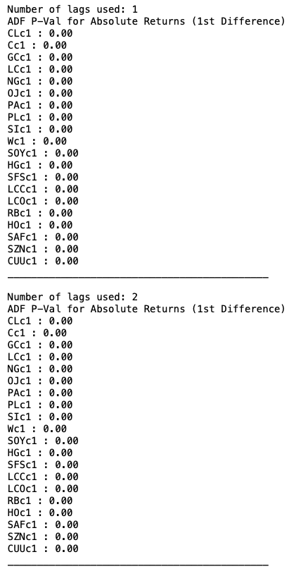

## Appendix 5

Box Plots

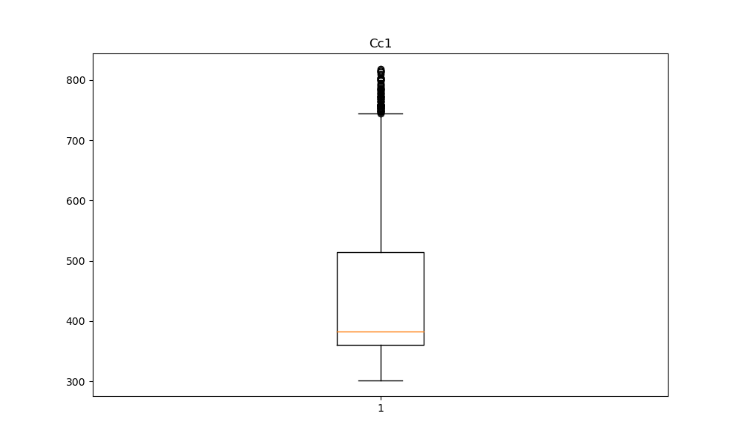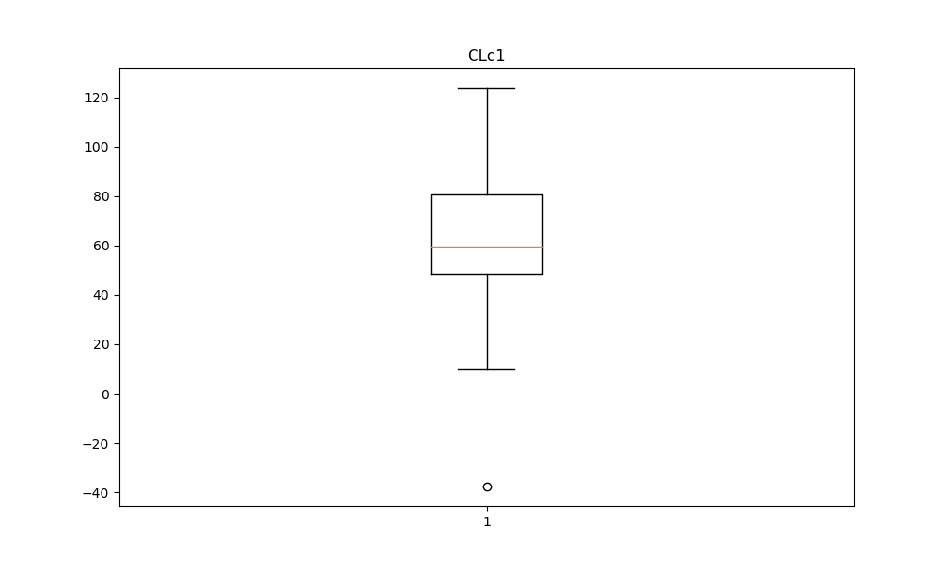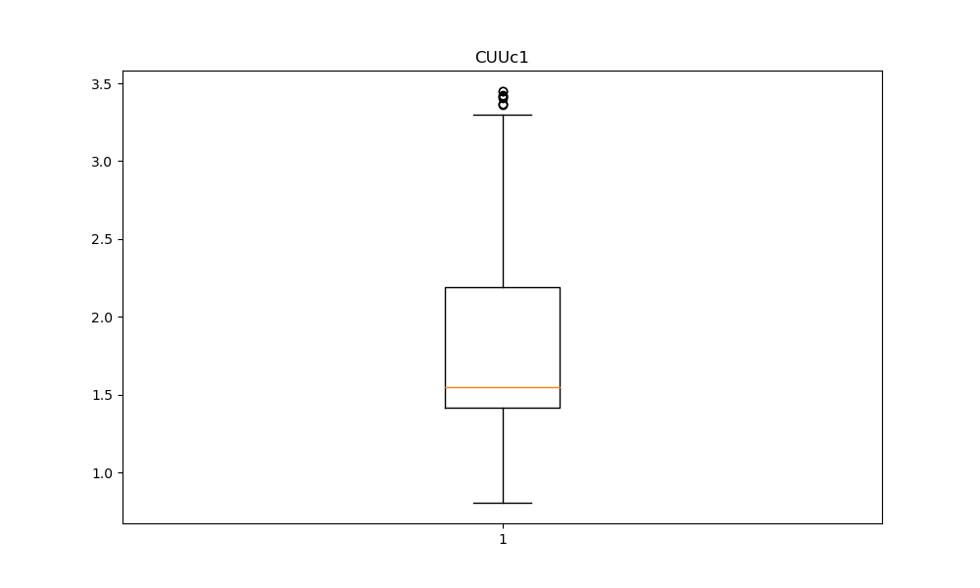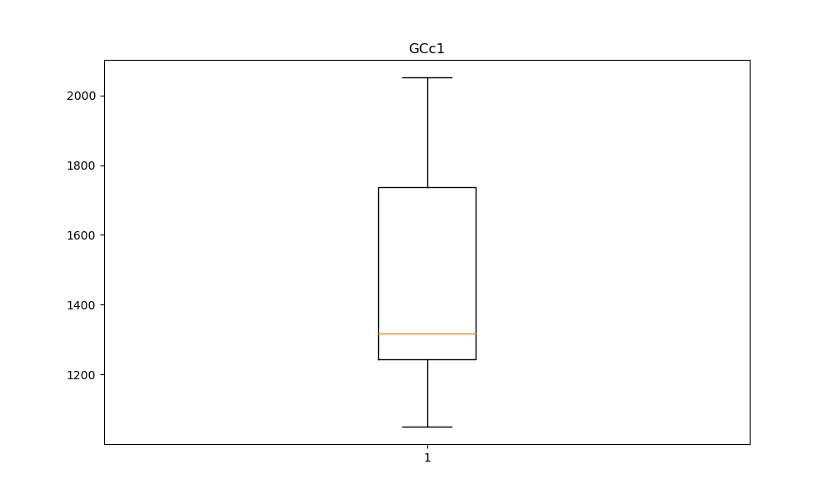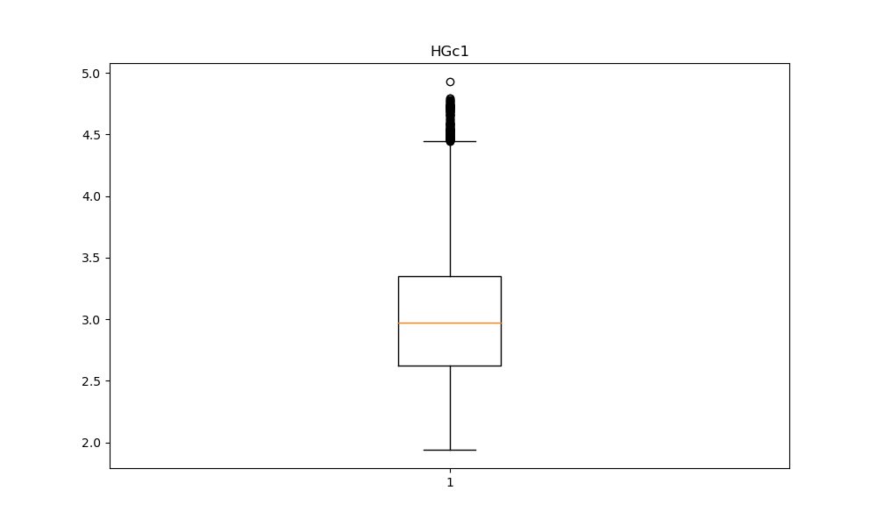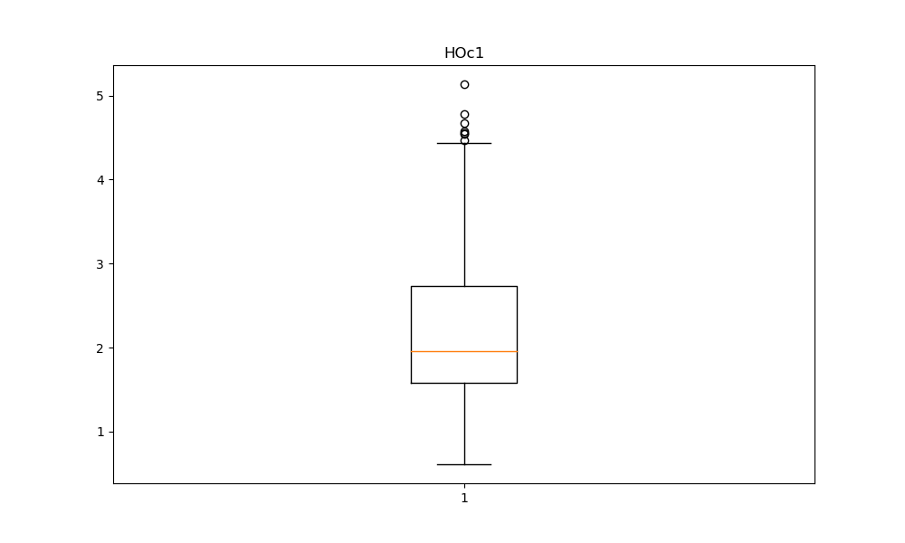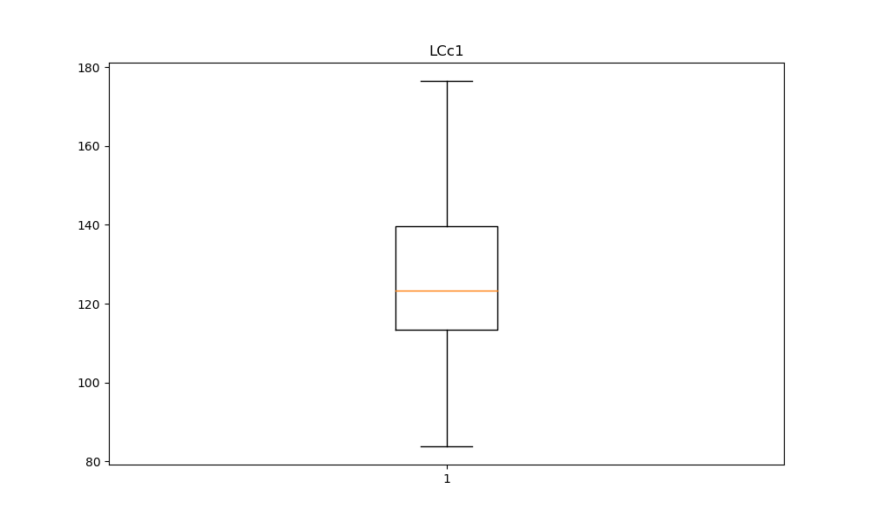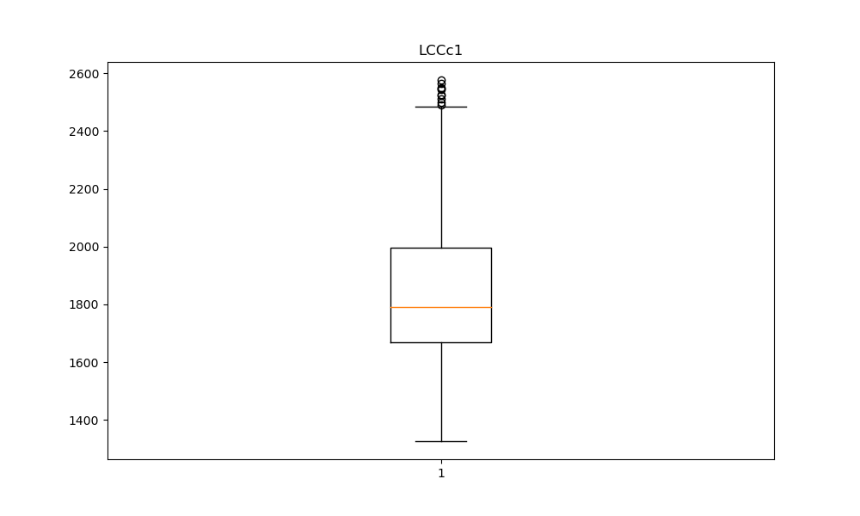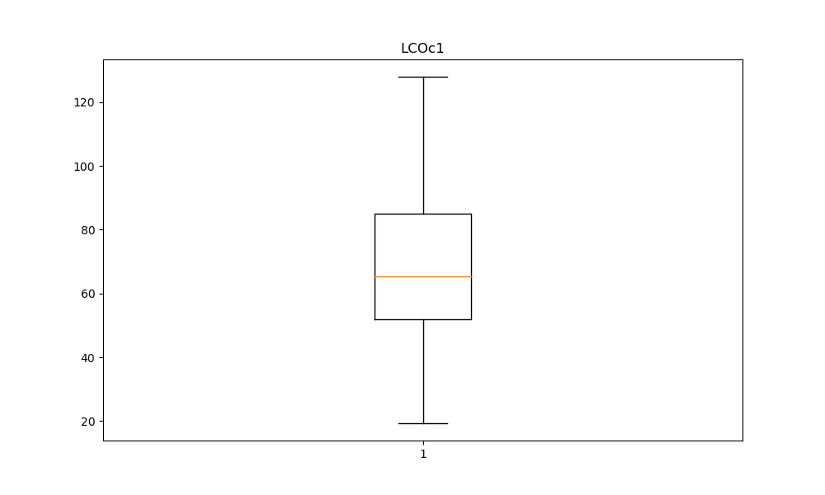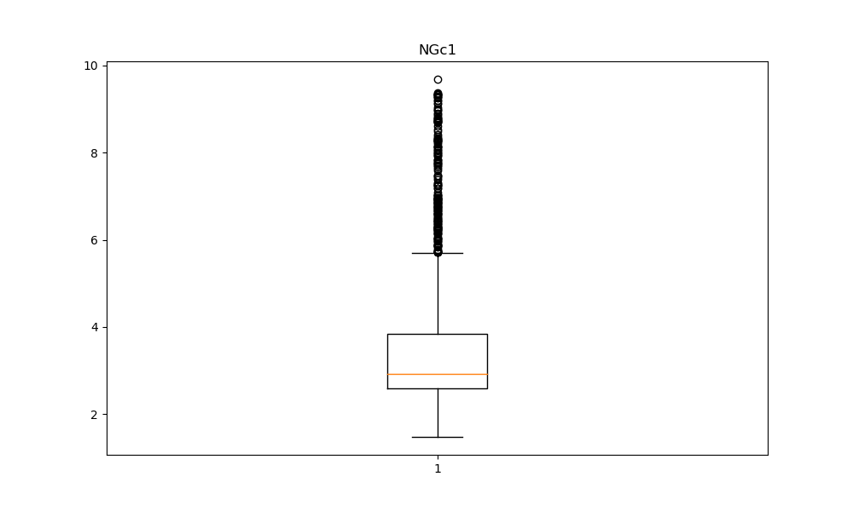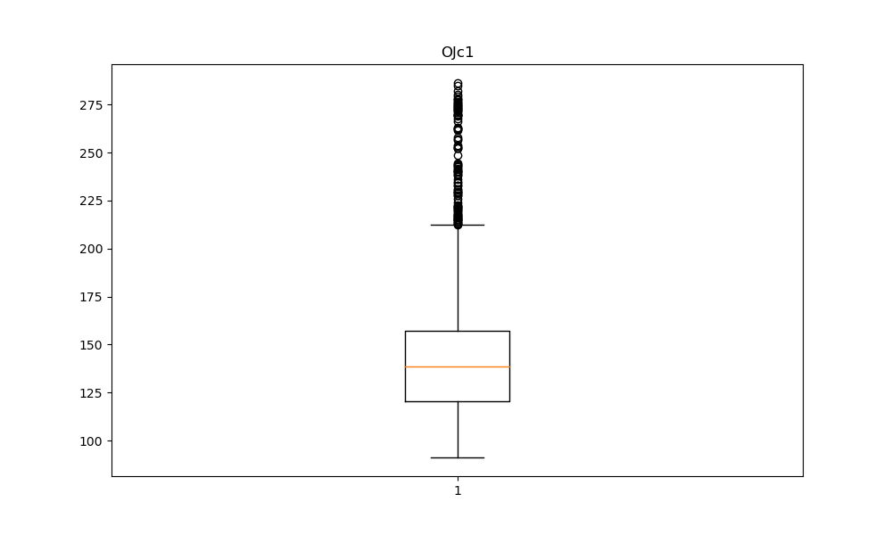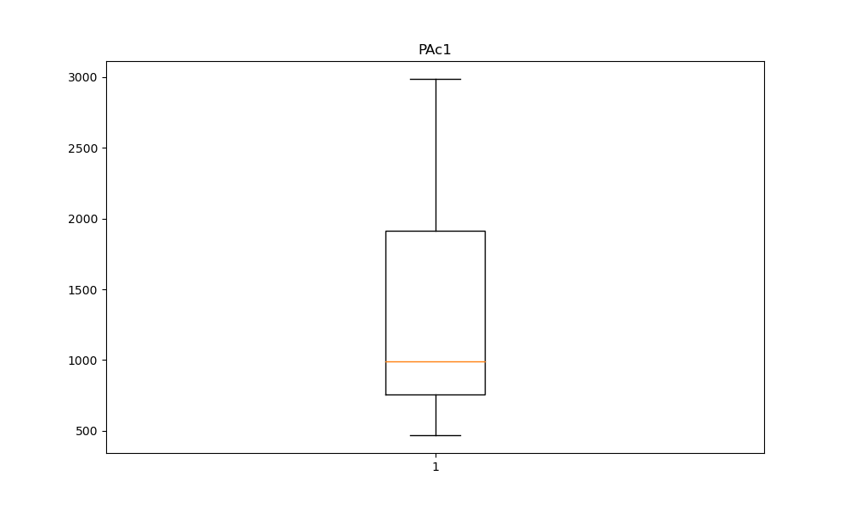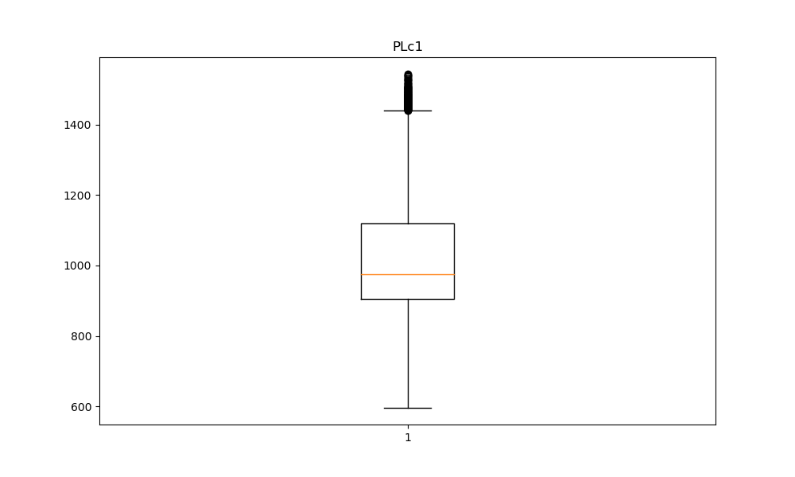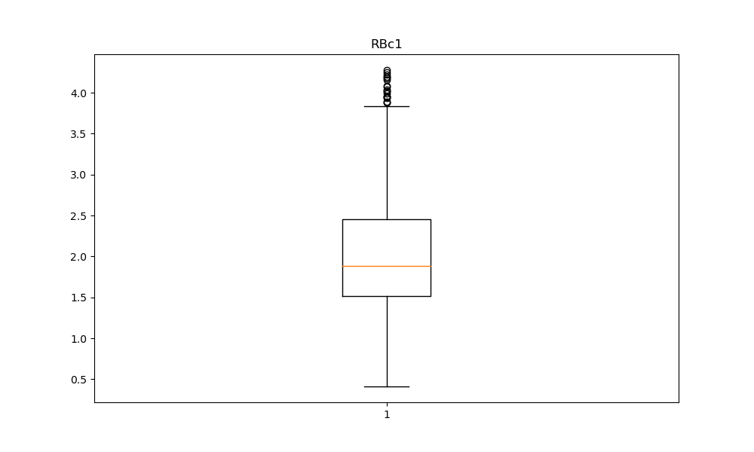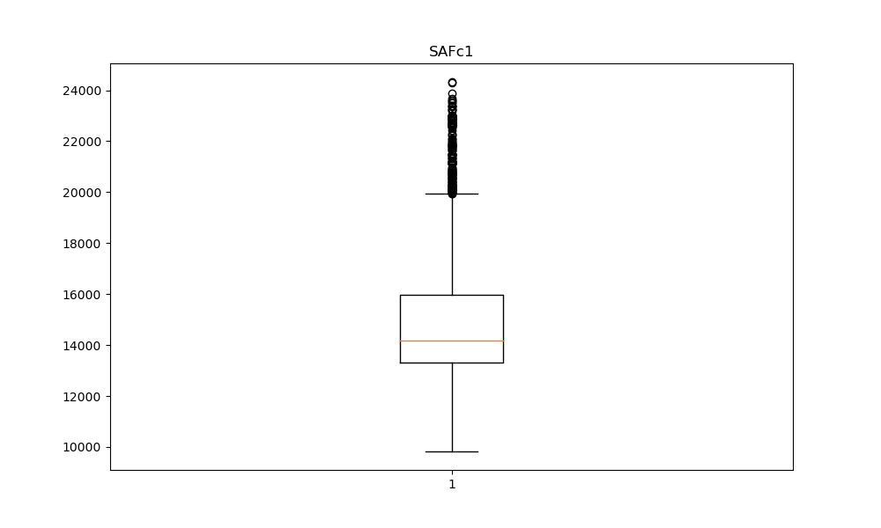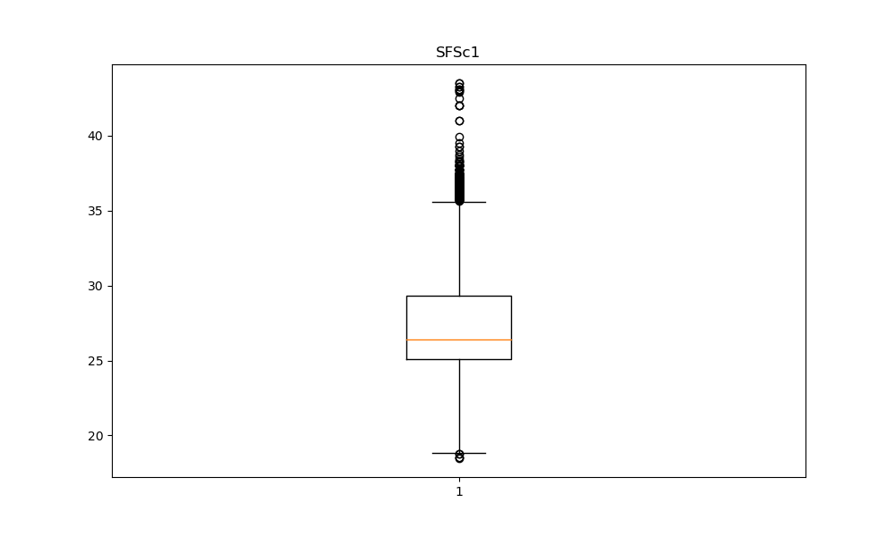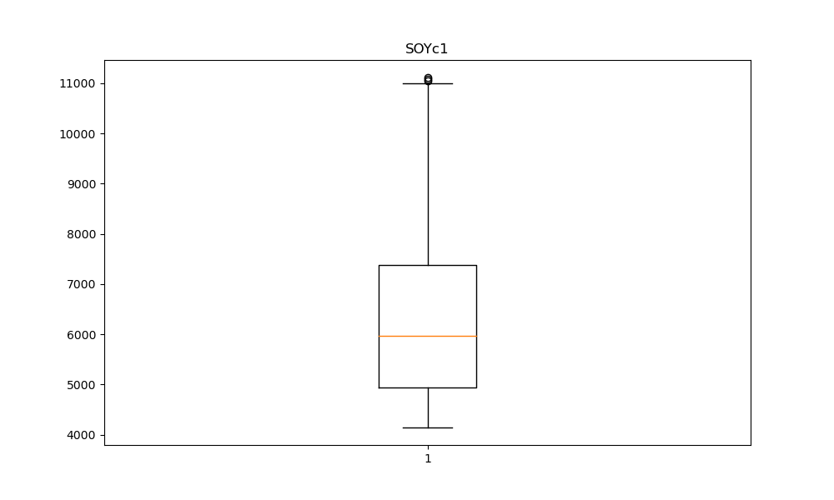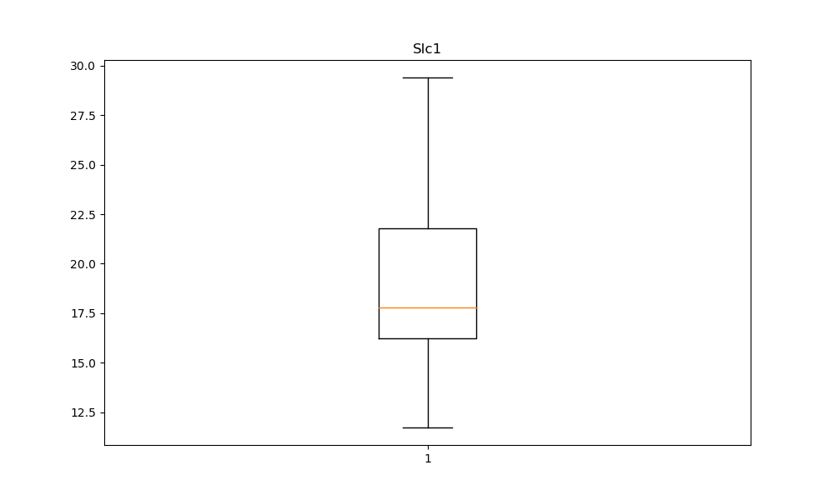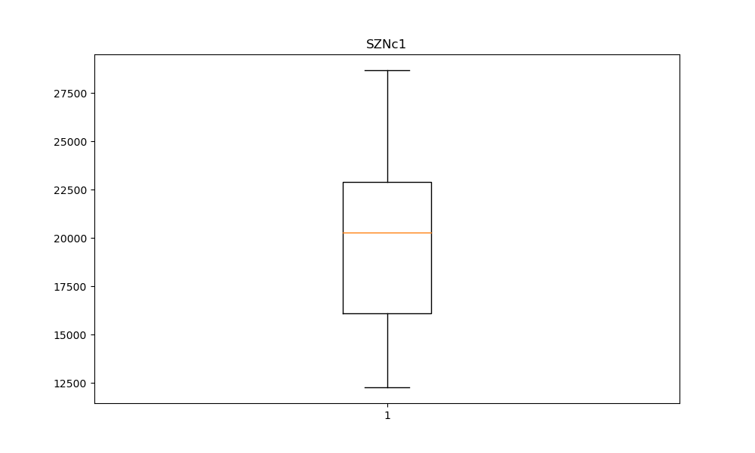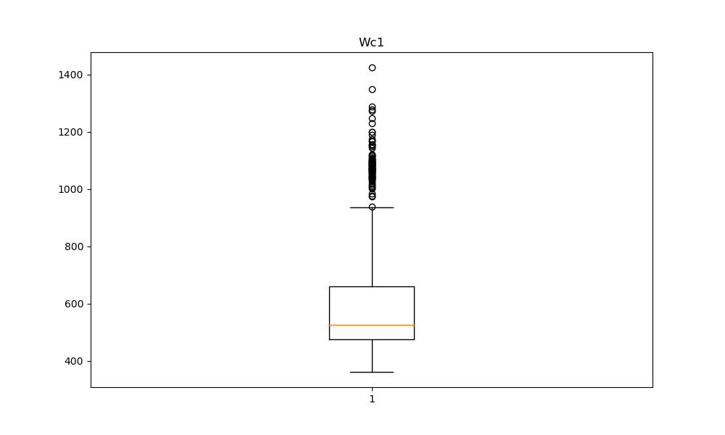

## Appendix 6

Histograms

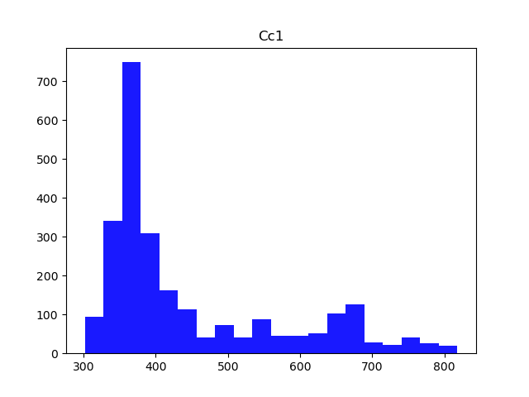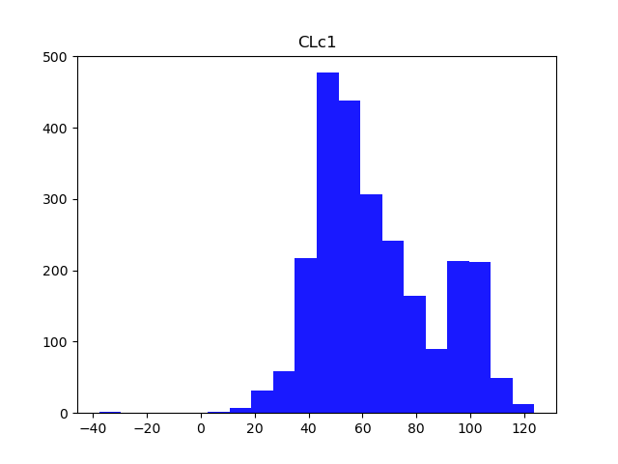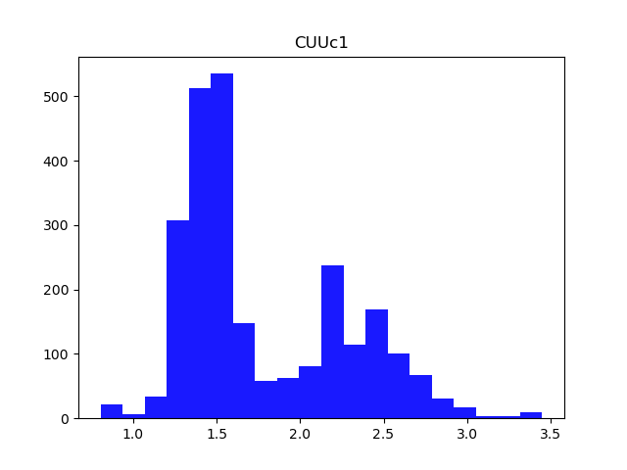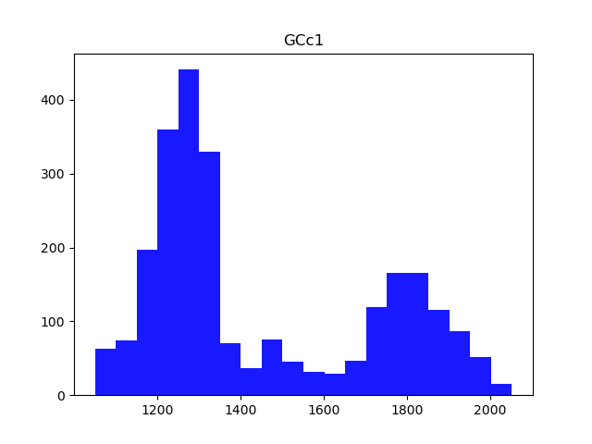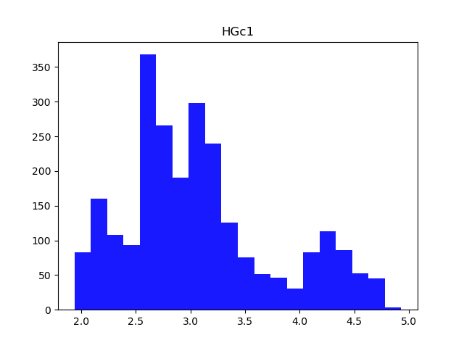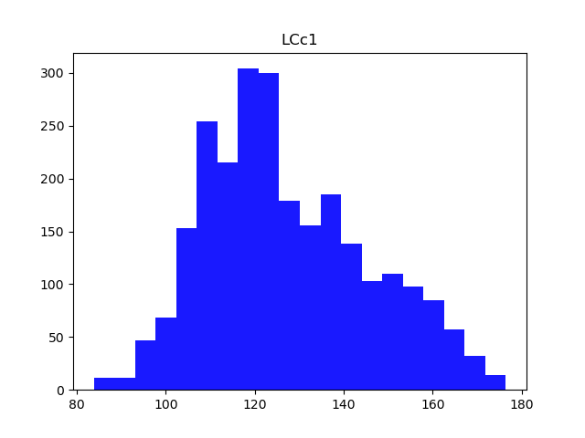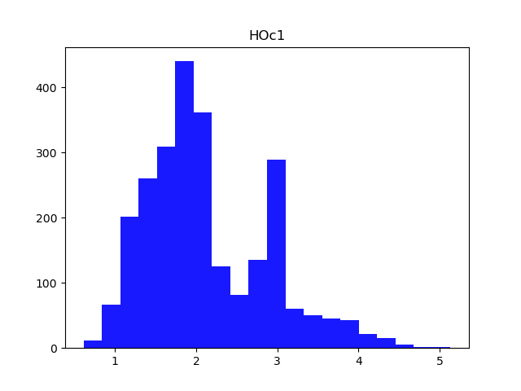5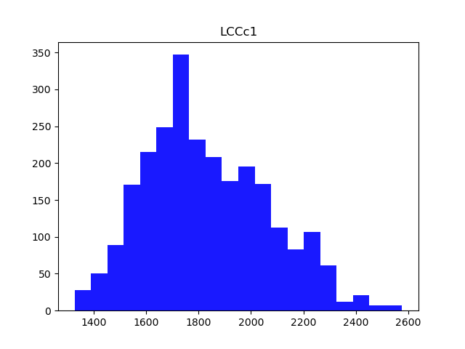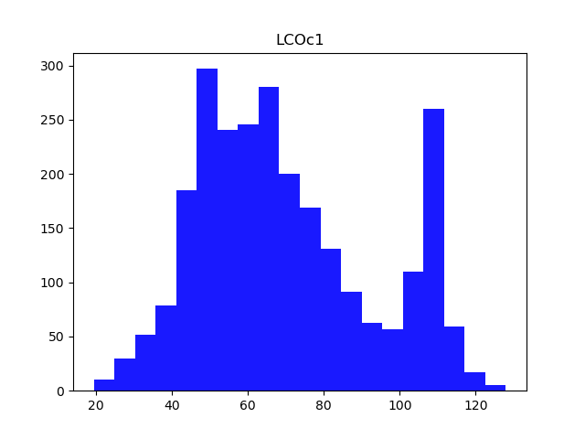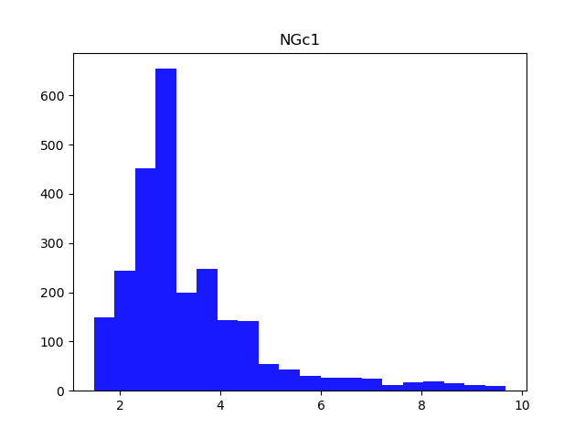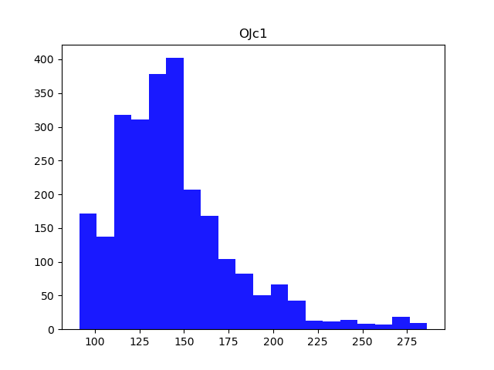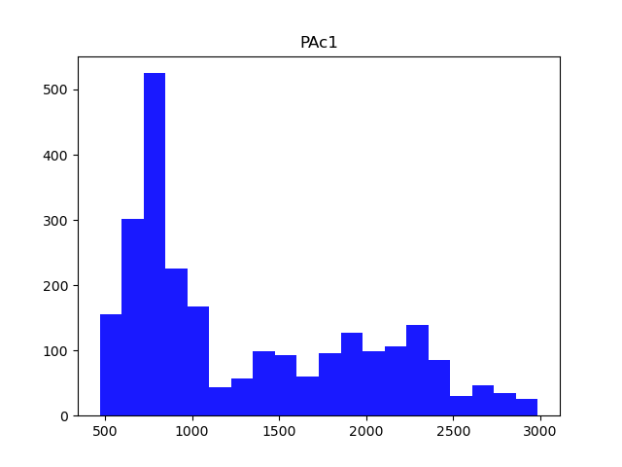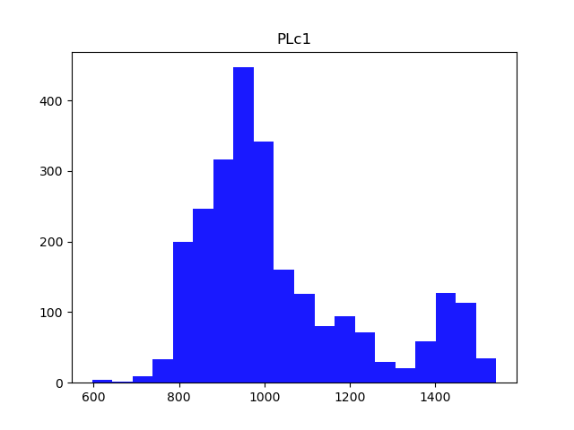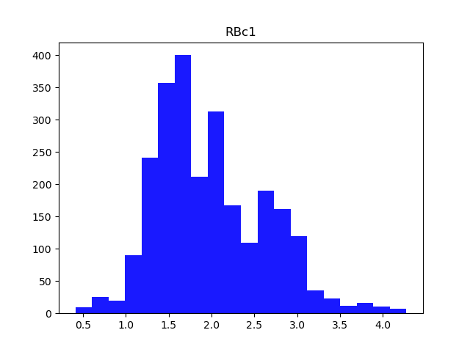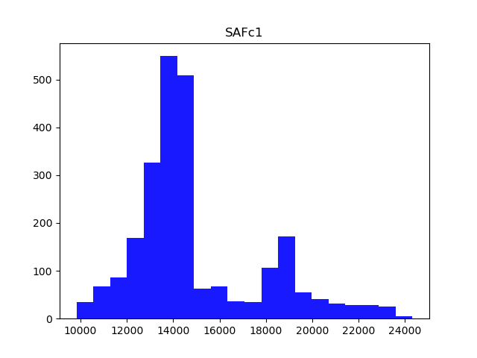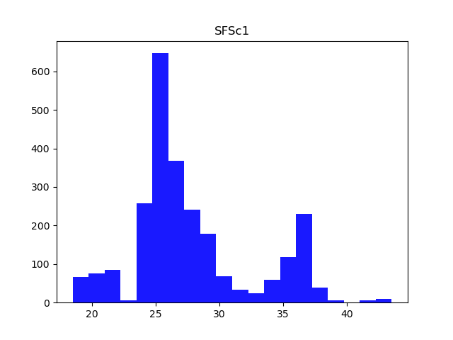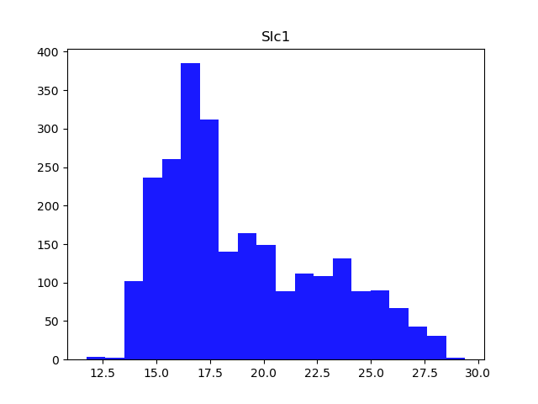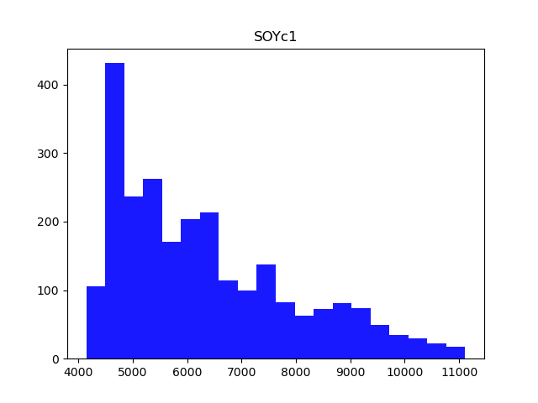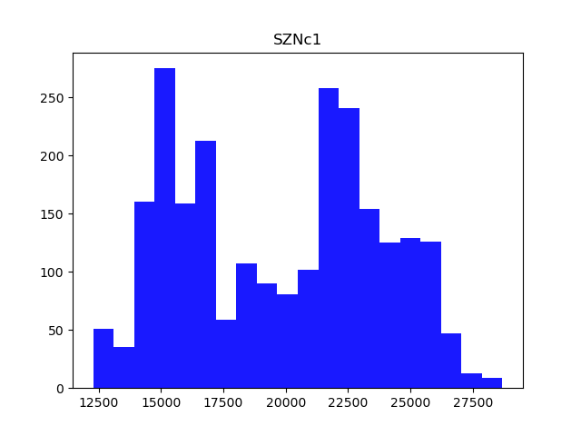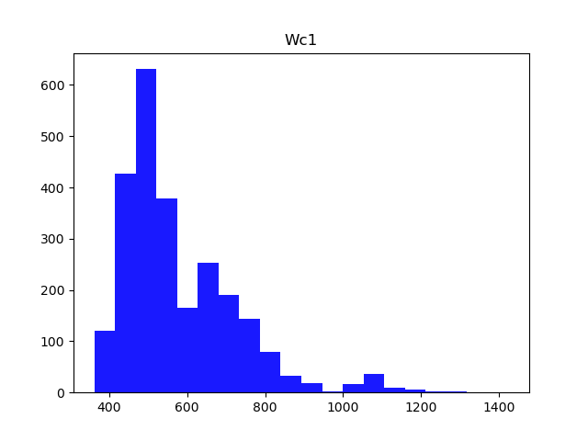

## Appendix 7

Cointegration

Ein Bild, das Text, Screenshot, Schwarzweiß, Elfenbein enthält.
Ein Bild, das Screenshot, Text, Quadrat, Rechteck enthält.
Ein Bild, das Screenshot, Text, Quadrat, Rechteck enthält.

## Appendix 8

Granger Causality

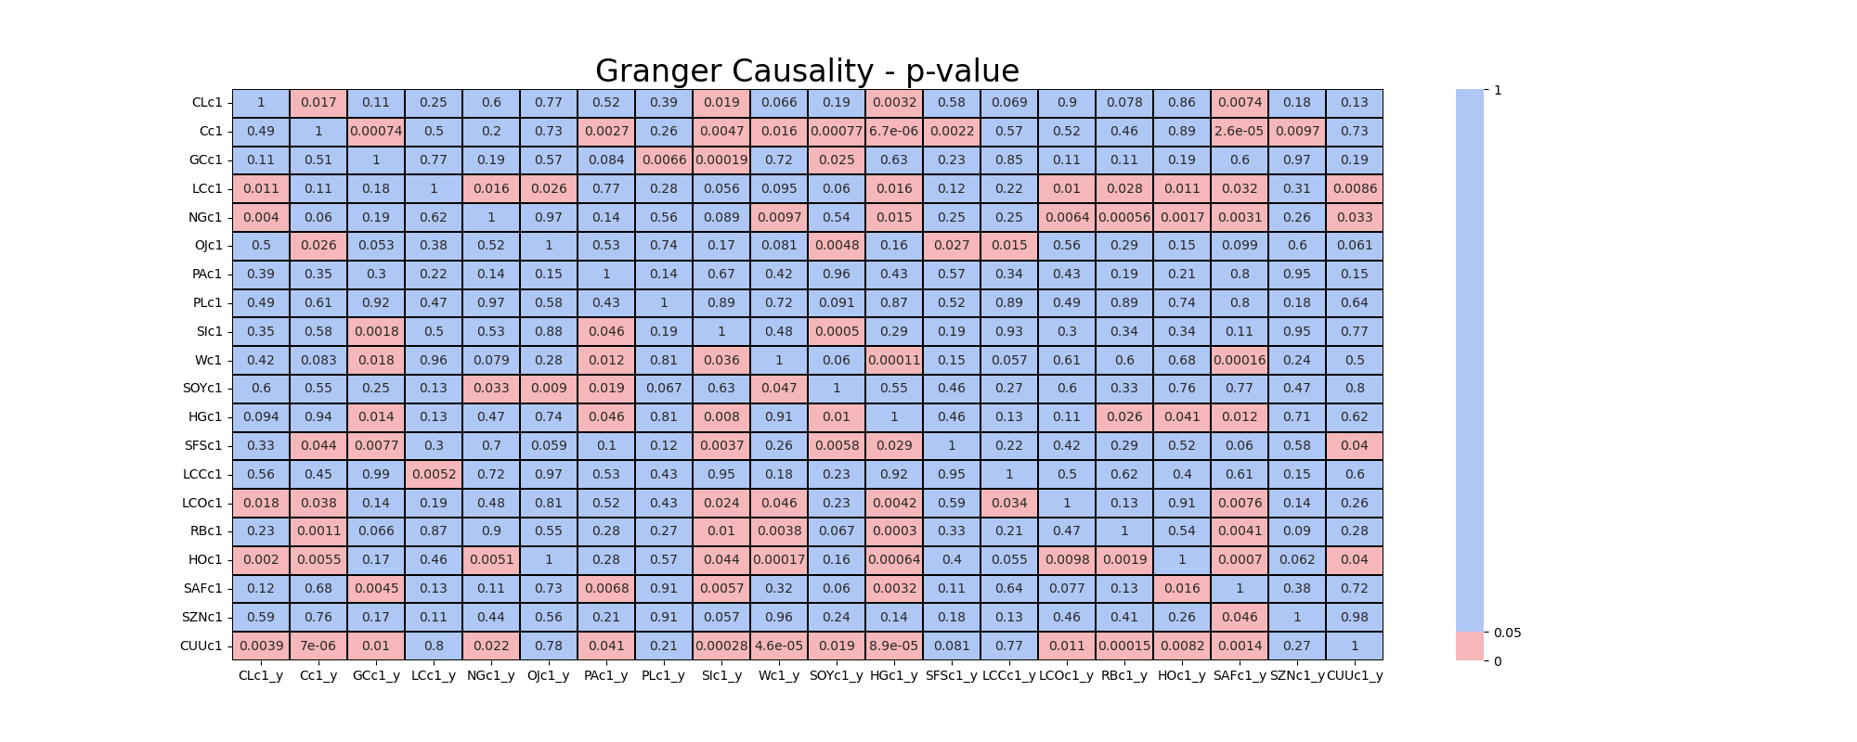

## Appendix 9

Table RESULTS_COINTEGRATION_1

Ein Bild, das Text, Schrift, Papier, Screenshot enthält.

Table RESULTS_COINTEGRATION_2

Ein Bild, das Text, Schrift, Papier, Screenshot enthält.

Table RESULTS_CAUSALITY

Ein Bild, das Text, Screenshot, Schrift, Papier enthält.

1.