David Miguel Orive Ramírez

DORIVERAMIREZ@GMAIL.COM  Made in java with spring boot, jpa, hibernate & H2 Database

JAVA MANAGEMENT OF ITEMS

**Overview** 2

Main view 2

Register view 2

Login view 3

Error page 3

CRUD Items view 4

CRUD Item_{id} view 6

CRUD Users view 8

API MENU view 10

# **Overview**

## Main view

In the main view you have several options to go, if you want to go to an option that you don’t have enough permissions, it will be throw an page not found exception. You have to be logged to go to the last three options.

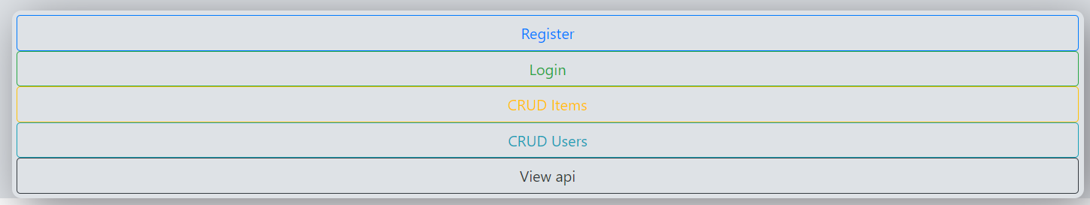

## Register view

In the register view you have to put your information (only the username and password), if you want to be an admin you have to write “_admin” at the end of your username, or press the admin checkbox, your username will be stored in the database without the “_admin” anyways, so if you want to log in you must put your username without it.

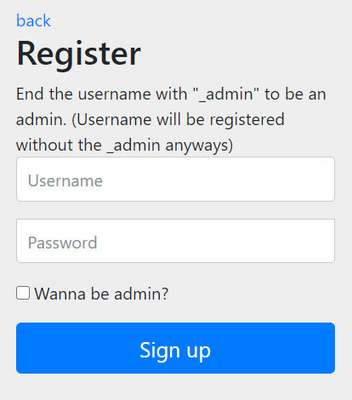

## Login view

In the login view you have to enter your information that you had put before in the register view. If you try to enter in another views without stay logged, you will be redirected to this view automatically.

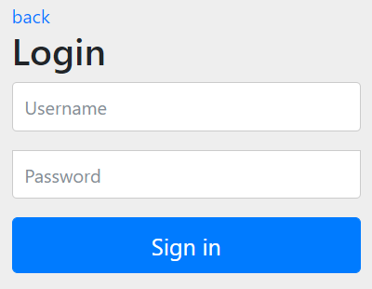

## Error page

If you don’t have enough permissions or you’re trying to enter in a page that doesn’t exist, you will find this error page.

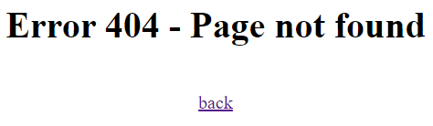

## CRUD Items view (User rights)

In this view you will have several options, first you will need to create an item to interact with it, so you have to press the “+” button in the top-right of the screen:

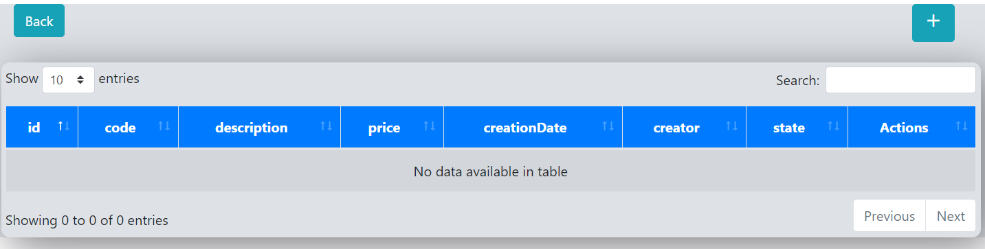

The creation date will be the actual day by default, and the State will be “Unabled” as default, you can’t modify the ID, it will be generated automatically as UUID.

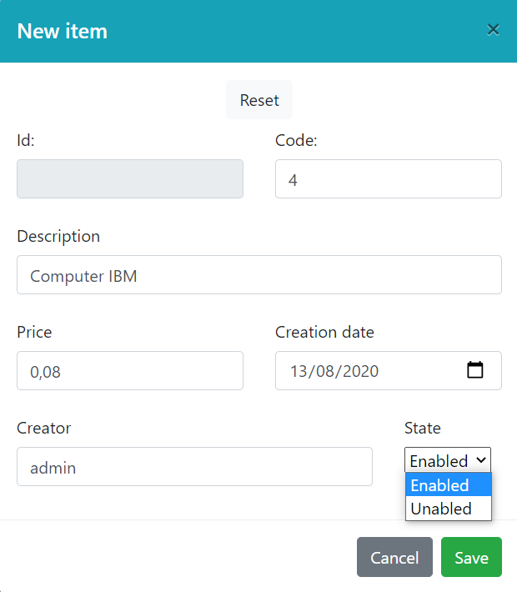

Once you have finished the creation of the item, you will encounter something like this:

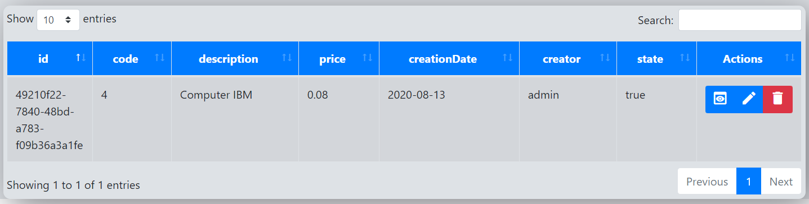

In the right, you have these three options:

Go to the specific item, where you can add price reductions and suppliers to it.

Edit the specific item, it will open the creation modal but with-it information pasted.

Delete the specific item.

If you try to edit the item, you will encounter something like this:

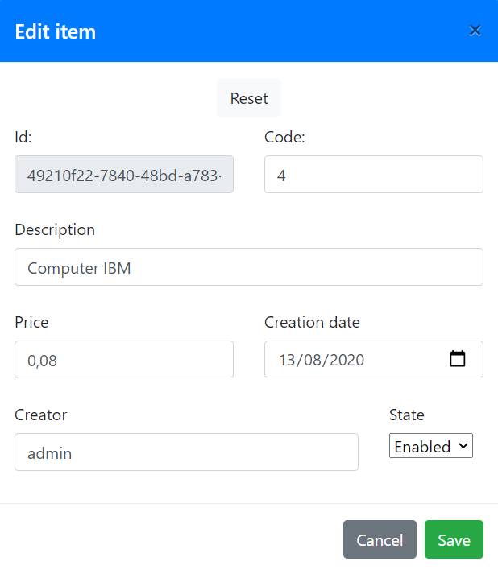

If you try to delete the item, it will throw this warning:

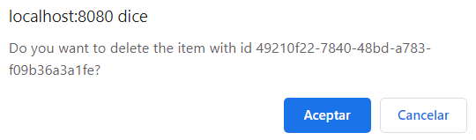

## CRUD Item_{id} view (User rights)

In this view you can interact with a CRUD of Price Reductions and Suppliers, and if you want you can link the Supplier to the item or unlink them.

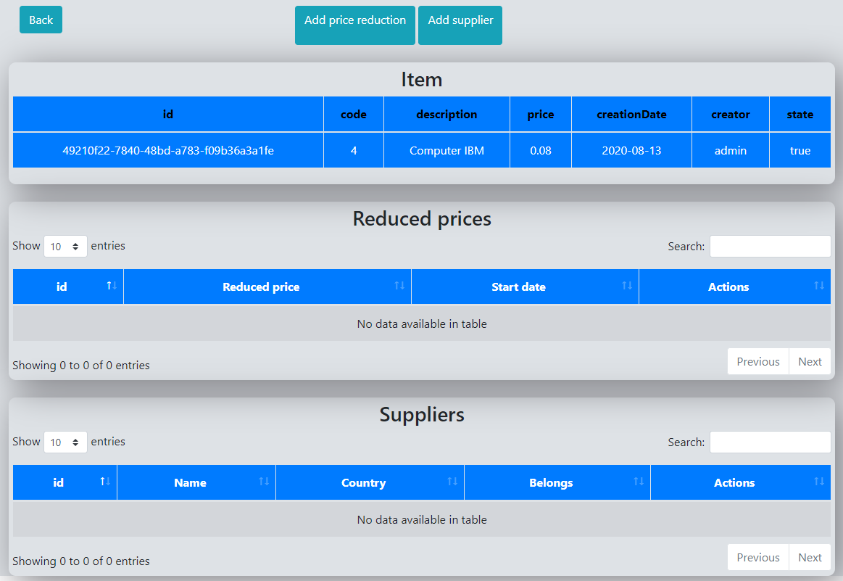

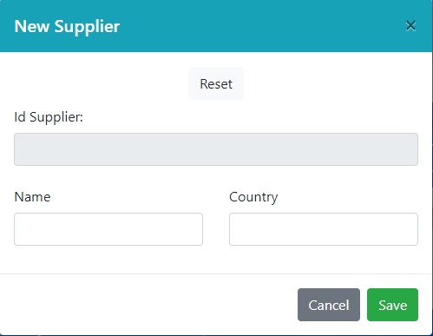 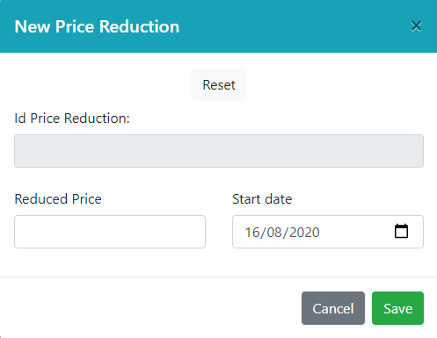

If you create a price reduction, it will be assigned automatically to the item, because is a “many-to-one” relationship. If you create a supplier, it will not be assigned to any item, and you can select if you want to assign it to the item that you have in front of you, or another one, that is because is a “many-to-many” relationship.

Once you have created a new supplier, you will see that:

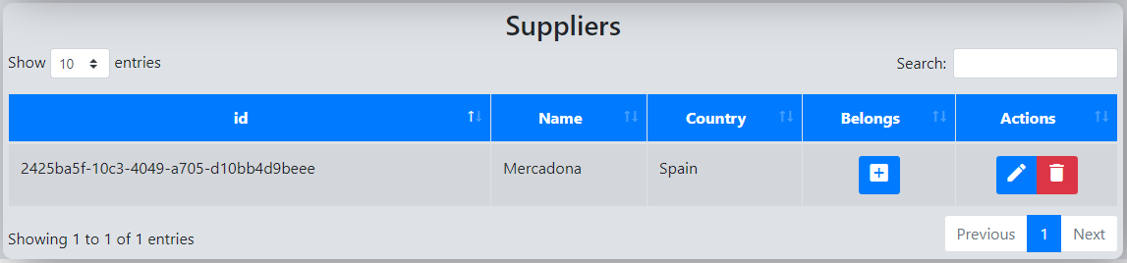

The actions are similar to the previous view, but if you want to link it, you will have to press this button. 

You will encounter this warning: 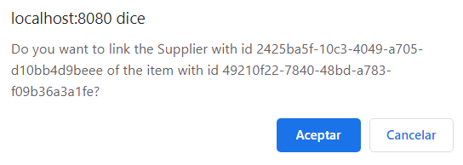

Now, the supplier is linked.

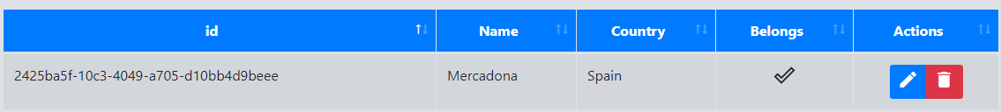

If you want to unlink it, you will have to press the delete button, and it will throw this warning:

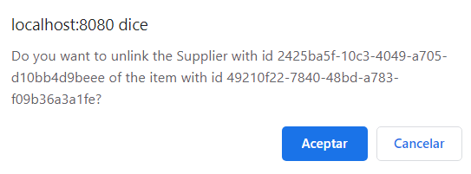

So, the end of the process will be something like this:

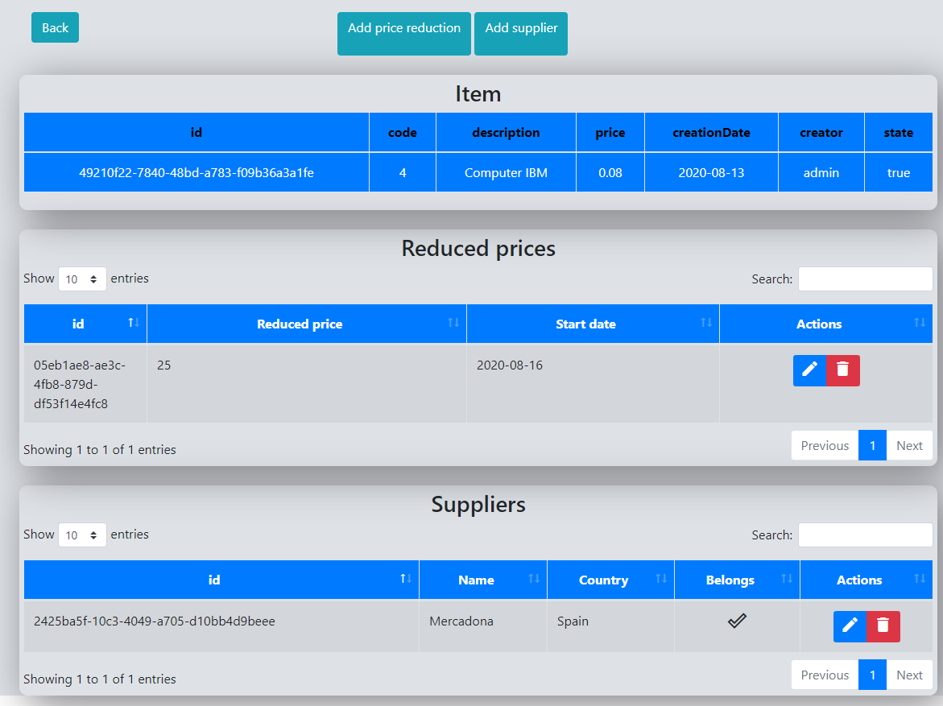

## CRUD Users view (Admin rights)

In this view you can interact with the users, changing his permissions and using the CRUD.

When you register in the API, it will automatically create the roles “ADMIN” and “USER” if there are not created before, and then you can create any users with that two roles any times that you want. This is a “restricted many-to-many” relationship, because users can only have one of these roles, but the roles will only exist as unique separate entity.

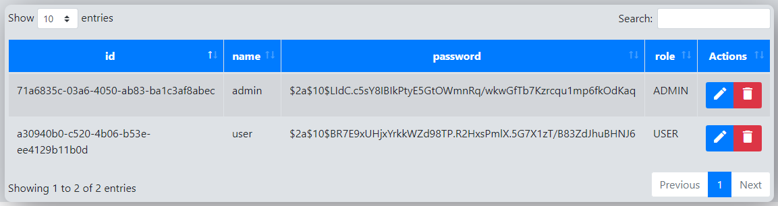

If you want to change the role of any user, you will have to edit him and add or not “_admin” at the end of the username, the password will be reset if you do it.

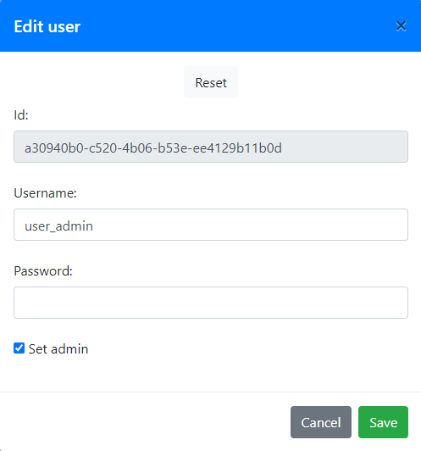

Now, the role is changed and the username still as “user”.

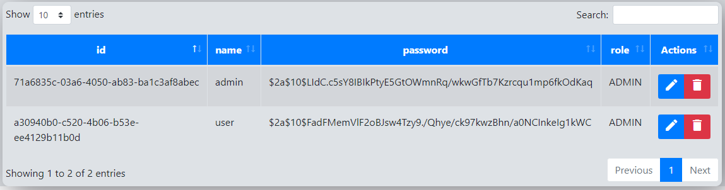

## API MENU view (User rights)

In this view you have several options to go, which will show you a “GET” of the elements that are stored in the database directly in your web browser. This is mostly used for testing purposes.

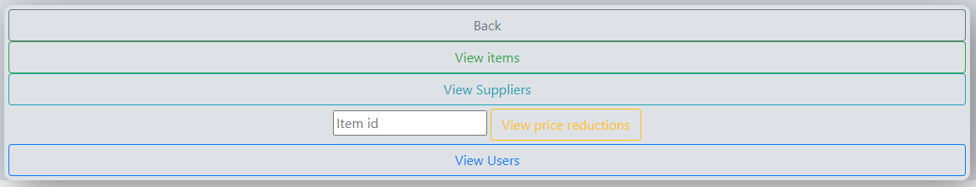

If you go to the view, you will encounter something like this:

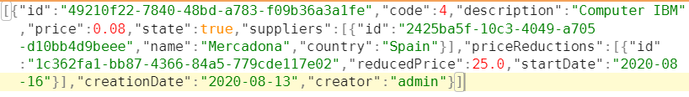

And this is the same for the other views, but if you want to view the price reductions of an item, you must put the item id in the API MENU, like that:



If you want to do a “GET” of the users you must be an administrator.