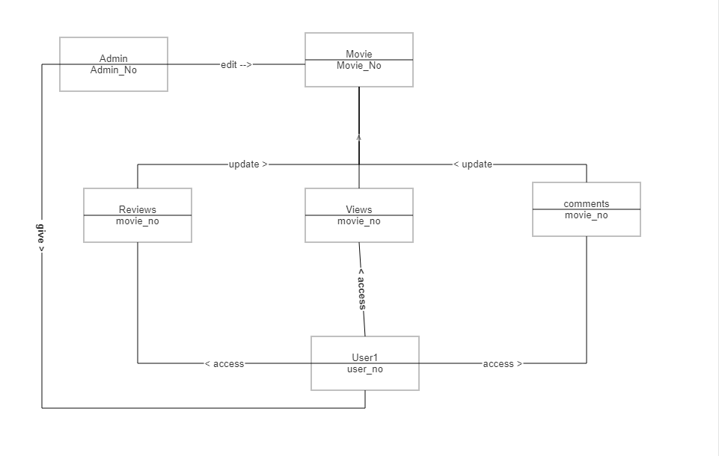1. ER Diagram

2. Task

3. No, I don’t see any matching rows in both city and country tables.

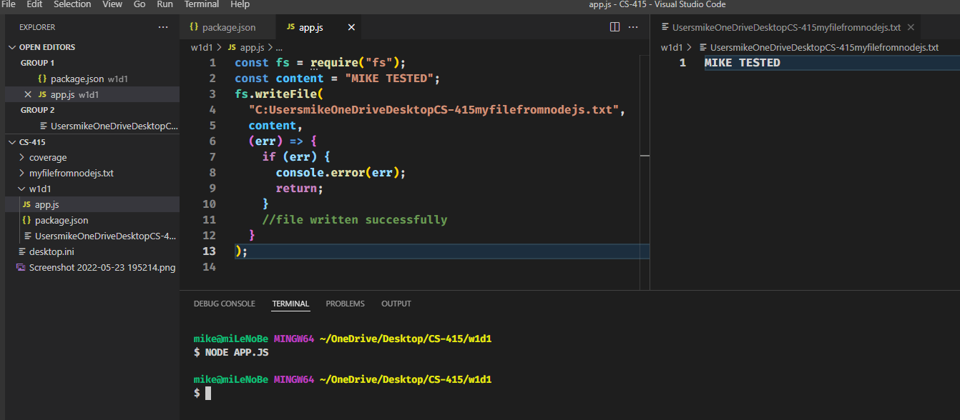4. NodeJS app that writes data into a file