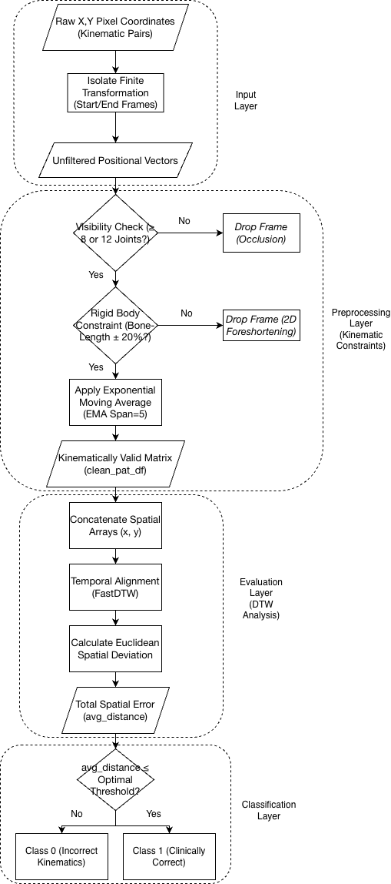

Box | Flowchart | Understanding | Code
Raw X,Y Pixel Coordinates (Kinematic Pairs) | 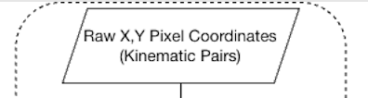 | We start by opening the CSV file and reading the raw, messy data captured by the camera for that specific patient. | raw_pat_df = pd.read_csv(p_file)
Anatomical Translator (YOLO to MediaPipe Mapping) | 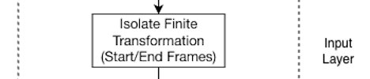 | YOLO and MediaPipe use different names for the same body parts (like Ym5 vs Lm11). This acts like a translator so our math works perfectly for both frameworks. | raw_pat_df.rename(columns=yolo_to_mp_map, inplace=True)
Primary Joints Visible? (Confidence ≥ 65%) | 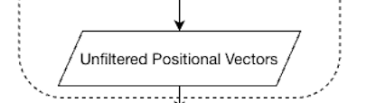 | We ask the AI, "Are you sure you can see the main moving parts, like the shoulder and elbow?" If the camera is less than 65% confident, we throw the frame in the trash because the data is unreliable. | clean_df = clean_df[(clean_df[v_col_s] >= 0.65) & (clean_df[v_col_e] >= 0.65)]
12-Point Global Visibility? (Confidence > 50%) | 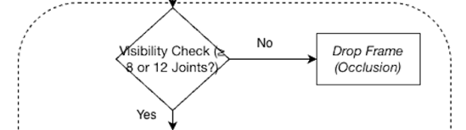 | We check the whole body. If the camera can't see enough joints, it means the patient walked off-screen or is blocked by an object. We drop that frame. | v_cols = [c for c in clean_df.columns if '_v' in c]  clean_df = clean_df[(clean_df[v_cols] > 0.5).sum(axis=1) >= 12]
Rigid Body Constraint (Bone-Length 0.5x to 1.5x?) | 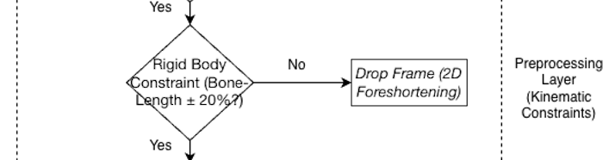 | The "Bouncer". If a camera glitch makes the patient's arm look like it shrank by half or stretched impossibly long, it violates physics. We drop that physically impossible frame. | bone_lengths = np.sqrt((clean_df[col_sx] - clean_df[col_ex])**2 + (clean_df[col_sy] - clean_df[col_ey])**2)  baseline = bone_lengths.median()  clean_df = clean_df[(bone_lengths >= baseline * 0.50) & (bone_lengths <= baseline * 1.50)]
Apply Exponential Moving Average (EMA Span=5) | 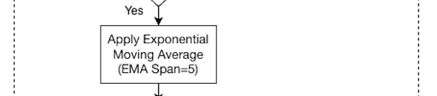 | The camera has tiny micro-shakes. We apply a mathematical "damper" (EMA) to smooth out the jitter so the movement looks human and fluid for the UI dashboard. | clean_df[coord_cols] = clean_df[coord_cols].ewm(span=5, adjust=False).mean()
Kinematically Valid Matrix (clean_pat_df) | 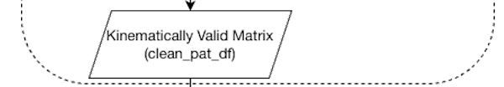 | We now have perfectly clean, smooth data. Here, we chop the video down to only the frames where the patient is actually doing the exercise (cutting out the standing-around time). | rep_df = clean_pat_df[(clean_pat_df['Frame'] >= start_f) & (clean_pat_df['Frame'] <= end_f)]
Isolate Active Joints & Apply Mean-Centering | 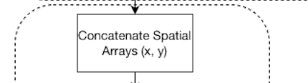 | We grab only the joints needed for this exercise. Then, we subtract the "average" position. This forces the AI to ignore where the patient is standing in the room, and only judge the shape of their movement. | expert_seq = expert_seq - np.mean(expert_seq, axis=0)  patient_seq = patient_seq - np.mean(patient_seq, axis=0)
Temporal Alignment (FastDTW) | 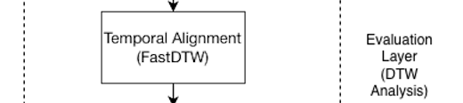 | The DTW "Rubber Band". The patient might exercise faster or slower than the expert. DTW stretches the timeline so their speeds match perfectly before grading. | distance, path = fastdtw(patient_seq, expert_seq, dist=euclidean)
Calculate Euclidean Spatial Deviation | 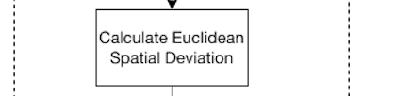 | Now that their speeds match, how far off was the patient's physical form from the expert? We calculate the error score. | avg_distance = distance / len(path)
Total Spatial Error (avg_distance) | 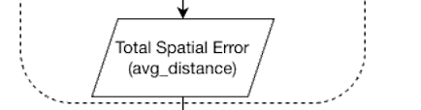 | This isn't an action, it's just the final numerical score that Box 10 produced for that specific joint.
avg_distance ≤ Optimal Threshold? | 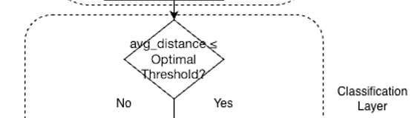 | The grading threshold. If the error for this specific joint is smaller than our strict limit (like 0.08), the patient gets a point for doing this body part correctly. | if avg_distance <= threshold:  correct_joints += 1
Passing Joints ≥ 80.0%? | 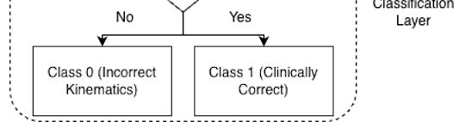 | The Final Grade. Did the patient get at least 80% of their active joints correct? If yes, they pass. If not, they fail the repetition. | return 1 if (correct_joints / total_joints * 100) >= 80.0 else 0

Author & Year | Core Methodology & Models | Preprocessing & Extracted Features | Experimental Setup & Interventions | Dataset Used | Exact Clinical Accuracy | Limitations & Interesting Findings
Černek et al. (2025) | Pose Estimation Benchmarking: Evaluates 2D (MediaPipe, YOLOv7, AlphaPose, HRNet) and 3D (MotionBERT, MHFormer, STCFormer) estimators. | BBox Transformation & 8D Series: Proposes a "Bounding Box" similarity transformation to fix 3D scaling. Extracted 8 main body angles (using Cosine distance between bones) to represent each motion as an 8-dimensional time series. | DTW & Fine-Tuning Splits: Applied Dynamic Time Warping (DTW) with Euclidean distance to evaluate the similarity of the 8D time series. Fine-tuned the neural networks using three specific cross-validation splits: cross-subject, cross-camera, and cross-exercise. | REHAB24-6 | 98% Peak Accuracy: 1-NN classification reached 98% accuracy on Arm Abduction using MHFormer+HRNet. Fine-tuning HRNet reduced 2D pixel error by more than half (e.g., from 16 to 7 pixels). MediaPipe Pose Lite operated at an exact 18.3 FPS on a CPU. | Depth Error Bottleneck: Monocular 3D models still struggle significantly with depth accuracy; the depth error is consistently higher than 2D error. Insight: Mean Per Joint Position Error (MPJPE) lacks correlation with 1-NN and Silhouette clinical grading metrics.
Tang et al. (2025) | LLM Prompt Engineering: Feeds skeletal features into GPT-4o using Zero-Shot, Few-Shot (1 to 5), Chain-of-Thought (CoT), Certainty, and Probability elicitation prompts. | Clinical Feature Extraction: Did not use raw (x,y,z) coordinates. Instead, compressed sequences into 3-5 explicit joint angles per frame (e.g., Knee Valgus Angle, Trunk Inclination) to form a num_frames x num_features array. | Two-Step Role-Play Framework: Tested various k-shot prompt combinations. Determined that 3-shot prompting combined with certainty elicitation was the optimal setup. Used a two-step framework: the LLM first predicted exercise quality, and then a "role-play prompt" (acting as a physiotherapist) was used to generate textual feedback. | UI-PRMD & REHAB24-6 | 70% Overall Accuracy: 3-shot prompting with Certainty elicitation achieved an overall 70% accuracy on REHAB24-6. For specific exercises, the LLM scored 0.67 on Arm Abduction, 0.74 on Leg Lunge, and 0.75 on Squats. | Rigid Hallucinations & Overconfidence: Zero-shot CoT caused the LLM to invent its own rigid, incorrect thresholds (e.g., forcing a hard 150-degree cutoff for shoulder abduction). Insight: The LLM exhibited extreme overconfidence, generating certainty scores between 0.8 and 1.0 even when its assessment was completely wrong.
Author & Year | Core Methodology & Models | Preprocessing & Extracted Features | Experimental Setup & Interventions | Dataset Used | Exact Clinical Accuracy | Limitations & Interesting Findings

