OpenShelter – Life Saving Data Access.
Design Document
Date: April 25th, 2018

Contact information
Haim Leshem (haimleshem1@gmail.com) - Student, Developer.
Nadav Avisar (mrnad12@gmail.com) - Full-Stack Developer.
Daniel Morad Saka (Danielsaka2@gmail.com) – Developer.
Maor Israel (maoris@ac.sce.ac.il) – Programmer.
Dor Lugasi-Gal (DorLugasiGal@gmail.com) – Student, Front End.

Index

1 Introduction
1.1 Background
1.2 Design Goals
2 Architecture
2.1 Introduction
2.2 Data
2.3 User Interface
2.3.1 Vendor Session Screens
2.3.2 Customer Session Screens

Introduction

Background
Nowadays the current reality in Israel, the threat of a rocket attack is imminent. The status quo can change in an instant from a time of quiet to a time of war. This causes panic and confusion in the public. In these times of confusion, a person is at his most vulnerable position, and recent events have proven that making the wrong decisions in a time of emergency could lead to tragic results.
OpenShelter aims to assure the public that even in a time of emergency, a solution is available for them.
Using the Open City program implemented by the city of Beer Sheva, and using the Estimote beacons, we can take advantage of the power of IoT solutions to build a better functioning city for the public.
OpenShelter, in future sight, can be expanded and used not only for its intended purpose, but can be implemented in other countries with other threats (Hurricanes, floods etc.).

Design Goals
OpenShelter is a project that aims to bring order to the usually chaotic situation of a rocket attack.
Galla is an Enterprise Resource Planning (ERP) tool for small shops. It is a scalable piece of hardware. The shop may start with only one device, but may scale up to connect multiple devices together as the business grows.
galla.com, the service from Powai Technologies Pvt. Ltd. provides shop keepers with these kinds of services:
- Services to administer and maintain Galla
- Services of accounting, demand forecasting, cash-flow management etc.
- A web-based shopping interface for customers to locate best deals which hook up through the device as additional orders
galla.com may be only one of the services. Through Galla, the shopkeeper may interface with other such services from other organizations. Figure 1 shows a schematic of the proposed vision for Galla, galla.com and other services.

Architecture
2.1 Introduction
- OpenShelter is a cross-platform application and can run on Android and IOS devices.
- 'n' is the maximum number of clients allowed
- The database and the API are deployed on the server.
- The client is required to have internet connectivity for real time, up to date navigation.
- The client is required to have his Bluetooth and location services turned on.

Top Level Architecture
  - We will implement a 2-tier architecture, which will be consisted of:
- A server, which holds the database and manage API calls (Backend)
- A client, who communicates with the API.
- In addition, a remote API will be used to get emergency alerts, and a constant communication link will be established with the city control if a Bluetooth event has occurred.
- This architecture enables us to achieve the required Quality Attributes as follows:
  - Performance and Cost: Having a relatively small amount of information on the server and the distribution of the application on multiple devices will not only increase performance but will also reduce maintenance costs.
  - Flexibility: Flexibility is implemented through multi platforming.
  - Security: Security will be implemented in the client tier, and will be separated from the server. This will ensure that every message that gets passed to the server will be sterilized

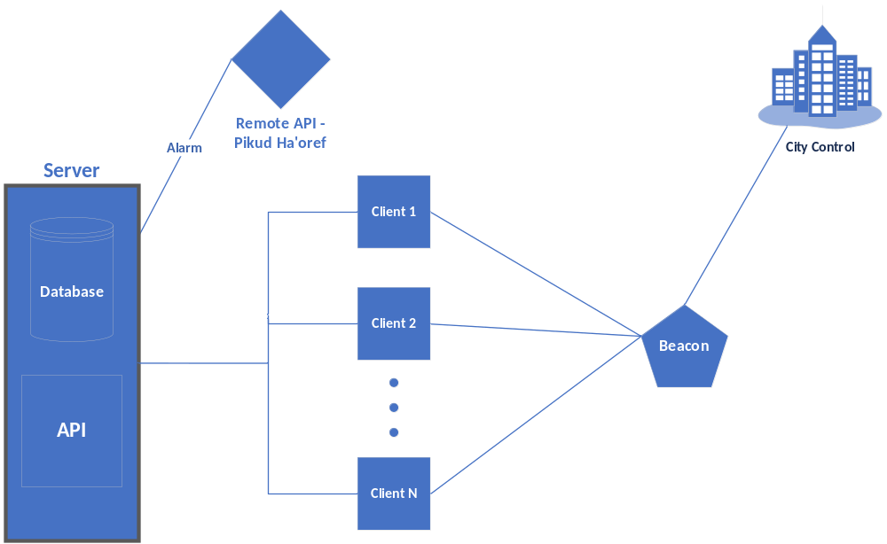

Data Model
In the following we list the attributes of each of the collections, and their primary keys .
- Users
  - _id
  - email
  - password
  - fullName
  - phone
- shelters
  - _id
  - Type
  - Properties:
    - Name
  - Geometry:
    - type
    - Coordinates

- buildings
  - _id
  - Type
  - Properties:
    - Name
  - Geometry:
    - type
  - Coordinates

- Shelter_info
  - _id
  - People_counter

- streetlights
  - _id
  - Type
  - Properties:
    - Lampost
    - CentralLig
  - Geometry:
    - type
  - Coordinates

User Interface

Registration Screen
  - Registration screen
- Profile
  - Manage account
  - Add contacts
  - Log out
- Sign In
- Map
- About

