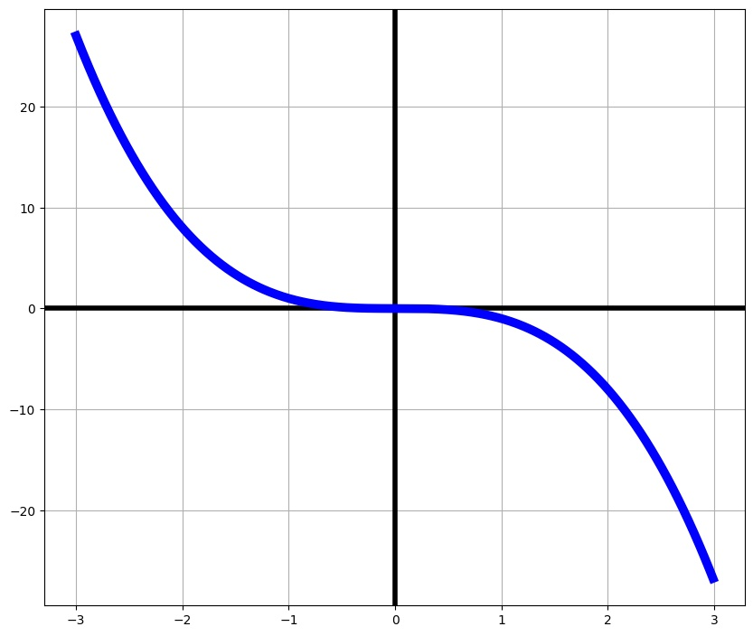

1. f(x)=-x<sup>3

|  |  |  |  |  |  |
| --- | --- | --- | --- | --- | --- |
| Easy | T/F | Middle | T/F | Hard | T/F |
| f(x)=3<br>Linear function | F | f(x)=x<sup>3-2<br>f(2)=8<br>f‘(x)=-3x<sup>2 | F | f‘‘(x)=-6x<br>f‘(1)=-3<br>f(0)=0<br>Cubic function | T |
| f(x) = -x<sup>3<br>f(0)=0 | T | f‘(x)=2x <br>f(0)=0<br>Cubic function | F | f(x)=x<sup>5<br>f(2)=8<br>f’(0)=0<br>Polynomial function | F |
|  |  | f(x)=-x<sup>3<br>f’(x)=-3x<sup>2<br>Polynomial function | T |  |  |
|  |  |  |  |  |  |
|  |  |  |  |  |  |

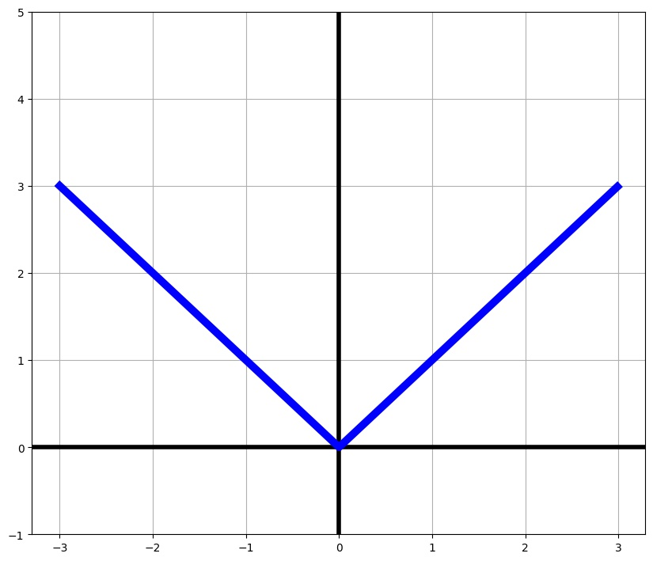

1. f(x)=|x|

|  |  |  |  |  |  |
| --- | --- | --- | --- | --- | --- |
| Easy | T/F | Middle | T/F | Hard | T/F |
|  |  | f(x)=|x|<br>f(0)=0<br>f(-1)=1 | T | f(x)=|x|<br>f(x)=f(-x)<br>f(-100)=100<br>f(0)=0 | T |
|  |  | f(x)=x<sup>2+7x<br>f’(x)=2x<br>f(0)=0 | F | f(2)=2<br>f’(2)=1<br>f’(-2)=-1<br>Has no derivative at 0 | T |
|  |  |  |  | f(x)=f(-x)<br>f‘(2)=1<br>f(10)=-10<br>Linear function | F |
|  |  |  |  |  |  |
|  |  |  |  |  |  |

|  |  |
| --- | --- |
| Wahr | Falsch |
| f(x) = |x| | f(x) = 1/x |
| Hat keine Ableitung in 0 | f‘(x)=-1 |
| f(0) = 0 |  |
|  |  |
|  |  |

Sie lassen mich nicht durch? Dabei bin ich viel cooler als all diese überall ableitbaren Funktionen!

Würden Sie sagen, ich bin „edgy“ genug, um durchzukommen? Hahahaha

Ein Bild, das Diagramm, Kreis, Reihe enthält.

|  |  |  |  |  |  |
| --- | --- | --- | --- | --- | --- |
| Easy | T/F | Middle | T/F | Hard | T/F |
|  |  | f(x)=3x<br>f‘(x)=3<br>Linear function | F | Special permit for function in R<sup>2<br>f(t)= (cos(t), sin(t)) | T |
|  |  |  |  |  |  |
|  |  |  |  |  |  |

|  |  |
| --- | --- |
| Wahr | Falsch |
| Spezielle Erlaubnis für Funktion in R2 | f(x) = 3x |
| f(t) = (cos(t), sin(t)) | f‘(x) = 3 |
|  | Lineare Funktion |
|  |  |
|  |  |

„Du bist doch keine echte Funktion“, sagen sie immer. Aber ich werde schon durchkommen!

Haha!! Danke, vielen Dank!

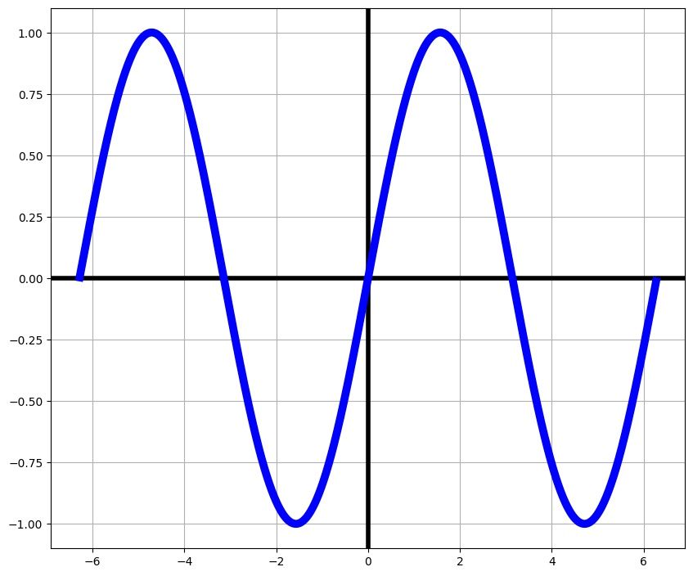

1. F(x)=sin(x)

|  |  |  |  |  |  |
| --- | --- | --- | --- | --- | --- |
| Easy | T/F | Middle | T/F | Hard | T/F |
| f(x) = sin(x)<br>f(0)=0 | T | f(x)=cos(x)<br>f’(x)=-sin(x)<br>f(0)=0 | F | f(x)=sin(x)<br>f’(x)=cos(x)<br>f(100)=20<br>Periodic function | F |
| f(x)=x<sup>2+x+5<br>f(0)=3 | F | f(x)=sin(x)<br>f’(x)=cos(x)<br>f’(0)=1 | T | f(x)=f(2πx)<br>f’(2π)=1<br>f(0)=0<br>f(π)=0 | T |
|  |  | f’(x)=cos(x)<br>f(0)=0<br>Periodic function | T |  |  |

|  |  |
| --- | --- |
| Wahr | Falsch |
| f(x) = sin(x) | f(100) = 20 |
| f‘(x) = cos(x) | f‘(x) = sin(x) |
| f(0) = 0 | Lineare Funktion |
| Sinusfunktion |  |
|  |  |

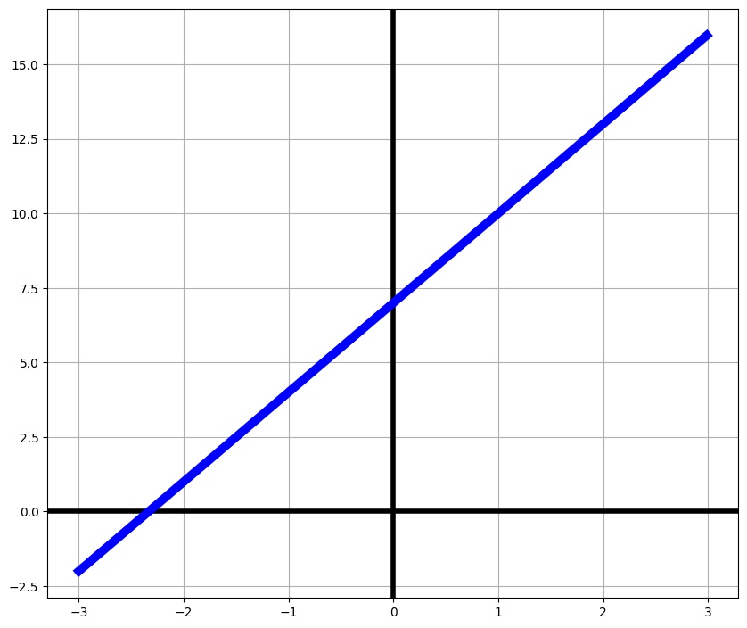

1. f(x)=3x+7

|  |  |  |  |  |  |
| --- | --- | --- | --- | --- | --- |
| Easy | T/F | Middle | T/F | Hard | T/F |
| f(x)=3x+7<br>Linear function | T | f’(x)=3<br>f(1)=10<br>Linear function | T | Antiderivative F(x)=(3/2)x<sup>2+7x+C<br>f’(x)=3<br>f(0)=7<br>Linear function | T |
| f(0)=7<br>Linear function | T | f(x)=x<sup>2<br>f(0)=7<br>Linear function | F | x(y)=-(7/3)+(1/3)y<br>x(10)=1<br>Linear function | T |
| f(1)=-3<br>Quadratic function | F | f(x)=3x+7<br>f’(x)=3<br>f(100)=307 | T | Antiderivative F(x)=3x<sup>3-x+C<br>f’’(x)=0<br>f(1)=10<br>Linear function | F |
|  |  |  |  |  |  |
|  |  |  |  |  |  |

|  |  |
| --- | --- |
| Wahr | Falsch |
| f(x) = 3x+7 | f(x) = 1/x |
| Lineare Funktion | f‘(x)=-1 |
| f(0) = 7 |  |
| f'(x) = 3 | f(x) = x<sup>2+7 |
|  | Quadratische Funktion |

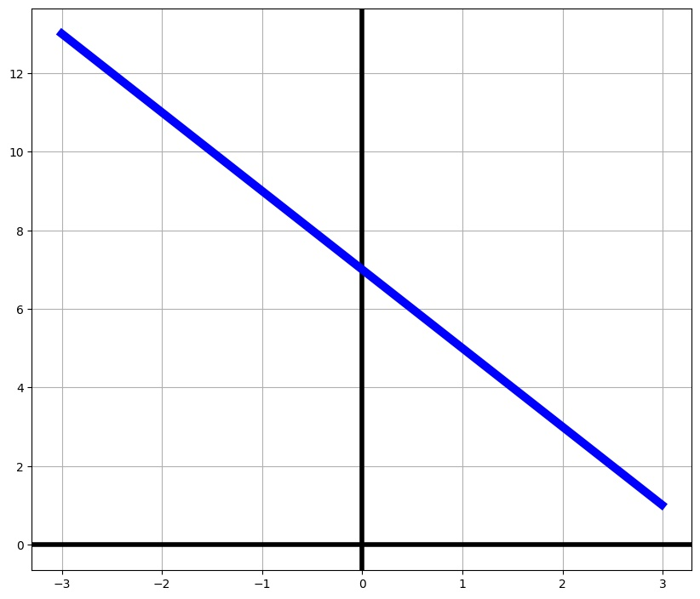

1. f(x)=-2x+7

|  |  |  |  |  |  |
| --- | --- | --- | --- | --- | --- |
| Easy | T/F | Middle | T/F | Hard | T/F |
| f(x)=-2x+7<br>Linear function | T | f(x)=7-2x<br>f’(x)=-2<br>Linear function | T | f(12)=-17<br>f’(-33)=-2<br>Linear function | T |
| f(-1)=2<br>f(0)=7 | F | f(x)=-2x+7<br>f’(x)=-2<br>Antiderivative F(x)=-x<sup>2+C | F | f(5)=2<br>f(0)=7<br>Linear function | F |
| f(x)=x<sup>3<br>Cubic function | F |  |  |  |  |
| f(-1)=9<br>f(0)=7 | T |  |  |  |  |
|  |  |  |  |  |  |

|  |  |
| --- | --- |
| Wahr | Falsch |
| f(x) = -2x+7 | f(x) = x |
| f(0) = 7 | f(x) = ex |
| f‘(0) = -2 |  |
| Lineare Funktion |  |
|  |  |

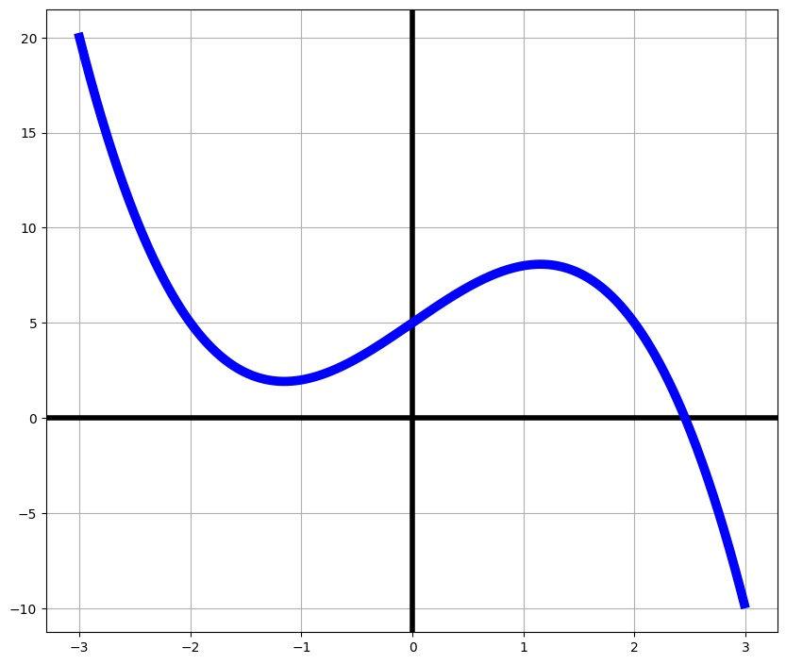

1. f(x)=-x<sup>3+4x+5

|  |  |  |  |  |  |
| --- | --- | --- | --- | --- | --- |
| Easy | T/F | Middle | T/F | Hard | T/F |
| f(x)=e<sup>x<br>Exponential function | F | f(x)=-x<sup>3+4x+5<br>f’(x)=x-5<br>Has 1 Zero/Root | F | Antiderivative F(x)=(1/3)x<sup>4+2x<sup>2+5x+C<br>f’(x)=3x<sup>2+4<br>Cubic function | T |
| f(x)=-x<sup>3+4x+5<br>Has 1 Zero/Root | T | f(x)=cos(x)<br>f’(x)=-sin(x) | F |  |  |
| f(x)= -x<sup>3+4x+5  <br>Has 3 Zeros/Roots | F |  |  |  |  |
| f(12)=-17<br>f’(-33)=-2<br>Linear function | F |  |  |  |  |
|  |  |  |  |  |  |

|  |  |
| --- | --- |
| Wahr | Falsch |
| f(x) = -x<sup>3+4*x+5 | f(x) = cos(x) |
| f'(x)=3x<sup>2+4 | f‘(x)=-1 |
| Polynomfunktion | f‘(3) =10 |
|  | Logarithmusfunktion |

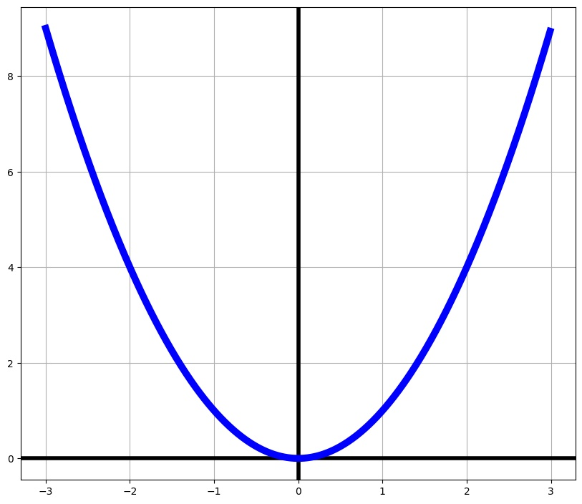

1. f(x)=x<sup>2

|  |  |  |  |  |  |
| --- | --- | --- | --- | --- | --- |
| Easy | T/F | Middle | T/F | Hard | T/F |
| f(x)=-x<sup>2<br>f(0)=0 | F | f(x)=0<br>I look like a smile, smiling at you. Please let me in! | F | f(x)=x<sup>3<br>f’(x)=3x<sup>2<br>Polynomial function | F |
| f(x)=x<sup>2<br>Quadratic function | T | Antiderivative F(x)=x<sup>4-x+C<br>f(0)=0<br>f’(0)=0 | F | f(x)=tan(x)<br>f(0)=0<br>Periodic function | F |
| f(1)=1<br>Logarithmic function | F | f’(2)>0<br>f’(-1)<0<br>Quadratic function | T |  |  |
|  |  |  |  |  |  |
|  |  |  |  |  |  |

|  |  |
| --- | --- |
| Wahr | Falsch |
| f(x) = x2 | f(x)=x3+2x |
| f'(0) = 0 | f‘(-2)=4 |
| f(0) = 0 |  |
| Quadratische Funktion |  |
|  |  |

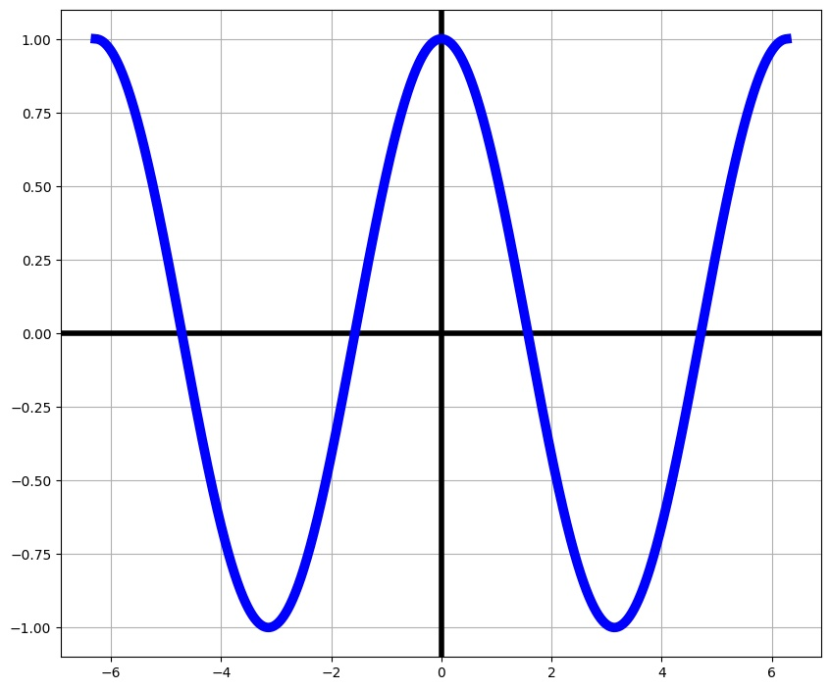

1. f(x)=cos(x)

|  |  |  |  |  |  |
| --- | --- | --- | --- | --- | --- |
| Easy | T/F | Middle | T/F | Hard | T/F |
| f(0)=1<br>Periodic function | T | f(x)=-sin(x)<br>Antiderivative F(x)=cos(x)+C<br>f(π)=-1 | F | f’(x)=-sin(x)<br>f(0)=f(2π)<br>f(200π)=1 | T |
| f’(x)=0<br>Linear function | F | f(x)=cos(x)<br>Antiderivative F(x)=sin(x)+C<br>Periodic function | T | f(x)=sin(x+2π)<br>f‘(x)=-sin(x)<br>Periodic function | F |
|  |  |  |  |  |  |

|  |  |
| --- | --- |
| Wahr | Falsch |
| f(x) = cos(x) | f(x) = x<sup>2 |
| Ist periodisch | f(0) = 0 |
| f(0) = 0 | Lineare Funktion |
| Cosinusfunktion |  |
|  |  |

Ein Bild, das Reihe, Diagramm, parallel enthält.

1. F(x)=log(x)

|  |  |  |  |  |  |
| --- | --- | --- | --- | --- | --- |
| Easy | T/F | Middle | T/F | Hard | T/F |
|  |  | f(x)=√x<br>f(1)=0<br>f(3)>1 | F | f(x)= log(x)<br>f(exp(x))=x<br>f(1)=0 | T |
|  |  | f(x)=log(x)<br>f’(x)=1/x<br>f(1)=0 | T |  |  |
|  |  |  |  |  |  |
|  |  |  |  |  |  |
|  |  |  |  |  |  |

Ein Bild, das Reihe, Diagramm, parallel, Zahl enthält.

1. F(x)=exp(x)

|  |  |  |  |  |  |
| --- | --- | --- | --- | --- | --- |
| Easy | T/F | Middle | T/F | Hard | T/F |
|  |  | f(x)=e<sup>x<br>f’(x)=e<sup>x<br>Grows very fast | T | f(x)=e<sup>x<br>f‘(x)=xe<sup>x<br>f(1)=e | F |
|  |  | f(x)=e<sup>x<br>f(1)=e<br>f(x) is never 0 | T |  |  |
|  |  | f(x)= 2x<sup>3<br>f’(x)=6x<sup>2<br>Polynomial function | F |  |  |
|  |  |  |  |  |  |
|  |  |  |  |  |  |

Ein Bild, das Reihe, Diagramm, parallel enthält.

1. F(x)=sqrt(x)

|  |  |  |  |  |  |
| --- | --- | --- | --- | --- | --- |
| Easy | T/F | Middle | T/F | Hard | T/F |
|  |  | f(x)=log(x)<br>f(0)=0<br>f(1)=1 | F | f(x)= √x<br>f’(x)=(1/2)(1/√x)<br>f(4)=2 | T |
|  |  |  |  | f(x)=√x<br>f‘(x)=(1/2)√x<br>f(1)=1 | F |
|  |  |  |  | f(x)= √x<br>f(x<sup>2)=x<br>f(0)=0 | T |
|  |  |  |  | f(x)= √x<br>f’(x)=(1/2)(1/√x)<br>f(1)=5 | F |
|  |  |  |  |  |  |

Ein Bild, das Reihe, Diagramm, parallel, Farbigkeit enthält.

1. F(x)=tan(x)

|  |  |  |  |  |  |
| --- | --- | --- | --- | --- | --- |
| Easy | T/F | Middle | T/F | Hard | T/F |
| f(0)=0<br>Linear function | F | f(x)=tan(x)<br>f’(x)=3x<br>Periodic function | F | f(x)=tan(x)<br>f((1/2)π)=-100<br>f(0)=0 | F |
|  |  |  |  |  |  |
|  |  |  |  |  |  |
|  |  |  |  |  |  |
|  |  |  |  |  |  |

Hinweise: Stammfunktion von /Ableitung von

Exponential, Logarithmus, Wurzel, Tangens,

nicht stetige Funktion (step function),

Matura, please

It’s every functions dream to get to be in the Matura(/Abitur/SATs/final exam)! Functions wanting to be considered need lots of permits and documents to prove they are a good fit, but it’s not too difficult to get forgeries or steal someone else’s permit.

Luckily, we have bureaucracy and its relentless agent: you! Make sure you only accept functions whose permits fits their graph and ensure the integrity of the Matura!