Technical Documentation

Introduction

This document gives an overview of the application ActivityRoutePlanner.

It describes the application, the layout, the functionality of the controllers and model classes and how it fits together.

Finally it gives an overview of the database's structure and how is it possible to use OpenStreetMap (OSM) Data for routing.

Overview
The application is an activity based route planner.
The user sets a start and an end point. Furthermore the user can add activities to a list. The planner searches points where the user can do this activities and returns a route from start to end point passing by the founded points.
The application has been developed with Ruby on Rails.
For the routing task the application uses PostgreSQL 8.4, PostGIS, osm2po and pgRouting.
To display the map, points and routes it uses OpenLayers, Yahoo! User Interface Library and JavaScript.

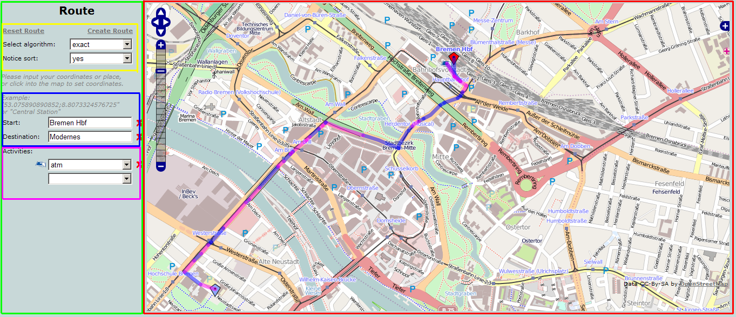Figure 1: Screenshot Application
Figure 1 shows the different areas of the application. They are included in the file init/index.html.erb.
In the following section is described which area is rendered in which section:
- Red: Content. View: init/_content. The map will be loaded with javascript.
- Green: Menu. View: init/_menu
- Yellow: Algorithm. View: generate_place/_algorithmus_form
- Blue: Points. View: init/_form
- Purple: Activities. View: activity/_index
The views will be described in the next chapter.

Views
In this application, each view has his own task. The following listing gives you an overview of all views.
- activity
  - _form.html.erb
  - _index.htmlerb
  - updateActivity.jsp.erb
- calculate_route
  - calculate_route.jsp.erb
- generate_place
  - _algorithmus_form.jsp.erb
  - set_algorithmus.jsp.erb
  - update_place.js.erb
- init
  - _content.html.erb
  - _form.html.erb
  - _header.html.erb
  - _menu.html.erb
  - index.html.erb
- layouts
  - application.html.erb
- place
  - _place_form.html.erb
Each *.jsp.erb file will handle the action for each Ajax-Call after the controller has finish his tasks. Each *.jsp.erb file will finally render the menu.

Activity
At this views, the user can add, update or delete an activity. The view index.html.erb parses for each selected activity a select box, where the user can choose another activity or delete that activity. The user can only choose a activity once. Everytime the _form.html.erb is called, the view will get the possible activity list from the activity class.
The icon of an activity will be searched at the Hash Image_URL, which is defined in class global.rb, with the Key TAG$VALUE.
Finally, one select box will be added with no selection from the controller.

Calculate Route
At this view, the controller will find the shortest path and the Ajax-Callback will show this at the map.

Generate Place
In this view, the user is able to select the route algorithm and is able to select, if the algorithm has to notice sorting of activities.
Finally, the JS file update_places.js.erb will handle the Ajax-Callback after setting, updating or deleting start- or end point.

Init
This view builds the application layout. Index.html.erb sets the views menu.html.erb and content.html.erb. Menu will sets the form for selecting algorithm and activities, content sets the map.

Layouts
The view application.html.erb sets the header of the HTML page.

Place
The view _place_form.html.erb renders the form for a point (start or end point).

Controllers
Controllers handle the user inputs and verifies the data. In the following listing you can see all controllers in this application:

- activity_controller.rb
- calculate_route_controller.rb
- generate_place_controller.rb
- init_controller.rb

Activity Controller
The activity controller handle the action to set a new activity, update a activity or delete an activity. Finally the controller will execute the updateActivity.jsp.erb file.

Calculate Route Controller
The calculate route controller handles the routes finding. The controller writes the route nin an kml file with name “kmlRoute_”SESSIONID.kml and will be stored at the “public” directory. At the end of his tasks, the controller will execute the calculate_route.jsp.erb file.

Generate Place Controller
This controller handles the user input to set, update or delete a point (start- or end point). Finally, the controller will execute the update_place.js.erb file after setting, updating or deleting a point, or execute the set_algorithmus.jsp.erb file after setting the algorithm or sorting of activities.
If the user has not set start- and end point, it will not be able to select activities

Init Controller
The init controller is called at the start of the application and sets necessary objects.

Classes
In the following listing you can see all classes of this application.

- activity.rb
- geo_result.rb
- global.rb
- point.rb
- route_generator.rb
- route.rb

All classes are stored in the directory “models”.

Activity
The activity class got the attributes tag, value and result. Result is the nearest point(start- or end int) to that activity.

Geo Result
This class represents an route result and stores them.

Global
This class saves all global attributes. The attributes are valid all over the application.

Point
This class represents an point (start- or end point) and controls the database attributes to get points.

Route Generator
This class generate has SQL-Statements for searching the route in the database.

Route
This class represents the route self.

JavaScript

Database
This chapter describes how to install a database and import OSM data for routing purposes.
- Install PostgreSQL 8.4. (pgRouting works only for this version)
- Install PostGIS
- Install pgRouting (For windows see http://www.davidgis.fr/documentation/pgrouting-1.02/)
- Create a database with a postgis template
- Execute scripts in the database from {pgRoutingDir}/Shared/Contrib in this order:
routing_core.sql, routing_core_wrappers.sql, routing_topology.sql
This scripts add functions to the database to use the pgRouting library!

- Prepare data for routing with osm2po. See http://osm2po.de/download.php?dl=osm2po-free.pdf Page 5.
Short:
java –Xmx256m –jar osm2po.jar bremen.osm prefix=hb
This will create a 'hb' directory in the current directory with an SQL script and some other files.
Execute the script in the database. After executing the script the shell gives 2 commands like:
psql -U postgres -q -1 -c "SELECT DropGeometryTable('hb_topo');" -d [dbname]
psql -U postgres -q -1 -f "{WorkDir}\hb\hb_p3_topo_0.sql" -d [dbname]
Execute this 2 commands.
- After this steps the database has a table with a topology for routing 'hb_topo'.
PgRouting requests a certain structure with column names to use the algorithms. To adjust the database its needed to create some tables and copy some data.
Add the following columns with the following values from the 'hb_topo' table:
New Column name | Data column name (hb_topo table) | Type
gid | id | Integer
the_geom | geom_way | Geometry
length | length(geom_way) | Double precision
Name | osm_name | Varchar

DONE!
After this is it possible to execute a query like:
SELECT rt.gid, asKML(rt.the_geom) AS geojson,length(rt.the_geom) AS length, hb_topo.gid
FROM hb_topo, (SELECT gid, the_geom FROM dijkstra_sp('hb_topo',5841,3526)) as rt
WHERE hb_topo.gid=rt.gid;
It finds the route from the vertice with the ID 5842 to the vertice with the ID 3526!

http://www.openstreetmap.de/
http://www.rubyonrails.org/
http://www.postgresql.de/
http://postgis.refractions.net/
http://osm2po.de/
http://www.pgrouting.org/
http://openlayers.org/
http://developer.yahoo.com/yui/

