SOLANGE: Planning a Transdisciplinary Quantum-Oncology Research Platform Under Technological Uncertainty

Doron Cohen, Manuel Blanco, and Amit Mekel
Center for Information Systems and Technology, Claremont Graduate University
TNDY 315: Principles of Project Management in a Complex World
Dr. Matthew Muga
September 27, 2026
SOLANGE: Planning a Transdisciplinary Quantum-Oncology Research Platform Under Technological Uncertainty
This paper presents the project plan for SOLANGE, a research platform that combines quantum computing, high-performance computing, and artificial intelligence to study cancer mutations for which no approved targeted drug exists. The platform is the subject of a doctoral dissertation (Cohen, 2026a), and our team treats it here as a complex, transdisciplinary project.
Project Area: Quantum Computing for Non-Druggable Cancer Mutations
Lung cancer was the most frequently diagnosed cancer in 2022 and the leading cause of cancer death worldwide (Bray et al., 2024). The dissertation estimates that about 60% of non-small cell lung cancer (NSCLC) patients carry mutations for which no approved targeted therapy exists (Cohen, 2026a). Part of the obstacle is computational. Designing a drug for a mutated protein requires an accurate model of the electrons at the mutated site, and classical methods lose accuracy as the number of strongly interacting electrons grows. Quantum computers are expected to handle this problem better, but current hardware is noisy. IBM plans its first large-scale, fault-tolerant system, Starling, for 2029 (IBM, 2025a).
SOLANGE does not assume that quantum computation is needed. For each mutation, the platform runs two independent classical methods and decides whether the problem is classically tractable or whether quantum computation is warranted (Cohen, 2026a). A provenance layer called LEON seals every result and re-verifies it before anyone may rely on it, following the audit-trail logic of FDA 21 CFR Part 11 (Cohen, 2026a; U.S. Food and Drug Administration [FDA], 2003).
The project draws on chemistry, physics, quantum computing, mathematics, biology, oncology, software engineering, regulation, finance, and international health cooperation, and each discipline defines success differently. It is also a wicked problem in the sense of Rittel and Webber (1972): the team cannot fully define what the platform must compute until it has tried to compute it.
Prior Work in This Space
What Went Wrong
Two patterns explain most failures in this space. The first is promises that ran ahead of evidence. MD Anderson Cancer Center spent $62 million on an oncology project built on IBM Watson before canceling it, and a former IBM chief medical scientist said there was very little published evidence that Watson improved patient outcomes (Strickland, 2019). Watson also reasoned from statistics about main outcomes, while oncologists reason from individual cases, and the two sides never closed that gap (Strickland, 2019).
The second pattern is claims of quantum advantage that later moved. In 2023, IBM reported accurate results from a 127-qubit processor at a scale beyond brute-force classical computation (Kim et al., 2023). Researchers at the Flatiron Institute then reproduced the experiment with classical tensor-network methods, more accurately, and some of the simulations could run on a mobile phone (Schirber, 2024). For chemistry, Lee et al. (2023) found no evidence yet of an exponential quantum advantage across chemical space and advised that it should not be assumed. IBM itself wrote in late 2025 that quantum advantage had not yet been achieved, because rigorous validation was still missing (IBM, 2025b).
What Went Well and Why
Progress on hard cancer targets has come from patient, structure-based work. KRAS was long considered very difficult to drug because it binds GTP extremely tightly and had no known allosteric site. Ostrem et al. (2013) found a new pocket in the G12C mutant, and eight years later the FDA granted accelerated approval to sotorasib for KRAS G12C-mutated NSCLC (FDA, 2021). In 2026, a Phase 1 trial of rezatapopt, which restores the normal shape of Y220C-mutated p53, reported a 20% response rate (The ASCO Post, 2026), and SOLANGE removed TP53 Y220C from its targets (Cohen, 2026a). Infrastructure advanced through long partnerships. Cleveland Clinic and IBM began a 10-year program in 2021 that combines quantum computing, artificial intelligence, and high-performance computing and trains the workforce the field lacks (Cleveland Clinic, 2023).
The lesson is direct. Projects in this space advanced when evidence set the pace, and they failed when marketing or a vendor roadmap set it. SOLANGE follows the first pattern. Every real biological target it has measured so far has proven classically tractable, and the platform reports that finding instead of hiding it (Cohen, 2026a). None of the projects above performs the task at the center of SOLANGE. The Cleveland Clinic and IBM partnership is the closest in spirit, but it builds shared research infrastructure. The dissertation found no counterpart, in the literature it reviewed as of September 2026, to a platform that decides per target, at runtime, whether quantum computation is warranted, by running two independent classical methods on the same active space and sealing each verdict in an audit trail aligned with FDA Part 11 (Cohen, 2026a).
How the Project Plan Was Constructed
The plan follows design science research, which builds and evaluates a working artifact (Cohen, 2026a). We built the plan from two directions. Working backward, the defense date fixed the end point. Working forward, we asked what each phase could deliver with the technology that exists today. The result allows about 20 months from proposal acceptance to defense, because simulator engineering, hardware access, and expert recruitment cannot be shortened without losing rigor (Cohen, 2026a). Figure 1 shows the full timeline. The completed phases have already produced a working platform, a dissertation proposal, a research poster, and a manuscript prepared for arXiv submission (Cohen, 2026b). The Appendix shows screenshots of each.
Phases, Milestones, and Team Roles
Phases 1 and 2, the literature foundation and the deployed prototype, are complete. Phase 3A validates the architecture on a quantum simulator. Its 20-electron, 40-qubit run was completed on August 4, 2026, and a 24-electron run is pending. Between July and August 2026, small test jobs of 4 to 8 qubits also ran on three real IBM Heron devices (Kingston, Marrakesh, and Fez). These jobs validated the pipeline, not chemical accuracy. Phase 3B scales the run to IBM Heron r3 hardware from September to December 2026, if access is granted. Phase 4 evaluates the platform from January to April 2027 in six sub-phases, including a four- to six-member expert panel. Phases 5 to 7 cover writing, revisions, and the defense in late 2027 (Cohen, 2026a).
Four milestones anchor the plan: proposal acceptance, the Phase 3B access decision, the freeze of pre-registered evaluation criteria, and the defense. Three management tracks run beside the phases. The team re-baselines the roadmap each quarter against the largest calculation actually completed, a countermeasure from our A3 analysis. Manuel Blanco, a senior banker, leads funding and investor relations, including binational science grants and an academic collaboration with IBM Research Israel. Amit Mekel, a senior diplomat, leads international partnerships and health diplomacy with partner hospitals and health ministries. Doron Cohen leads the project and the technical work.
The Most Difficult Phase
Phase 3B is the hardest phase to execute, for three reasons. First, it depends on an outside decision, because access to Heron r3 runs through the IBM Quantum Network and can take three to six months to secure (Cohen, 2026a). Second, the hardware is immature, so a run can fail for reasons the team does not control. Our A3 found that earlier slippage came from gate dates that followed a vendor roadmap. Third, success is hardest to define here. A chemist may count a converged energy as success, a funder may expect a quantum result, and an oncologist wants clinical relevance.
The plan responds in three ways. Phase 3B is formally contingent: without access by December 2026, it becomes future work, and the defense proceeds on Phases 3A and 4 (Cohen, 2026a). A target enters the hardware stage only if it fits the largest calculation already completed on real hardware. Each discipline records its acceptance criterion before a run. Evidence discipline also matters. On September 23, 2026, the project retracted an energy result after a check showed that the mutation had not been applied to the structure (Cohen, 2026a).

Figure 1
SOLANGE Project Timeline, March 2026 to February 2028
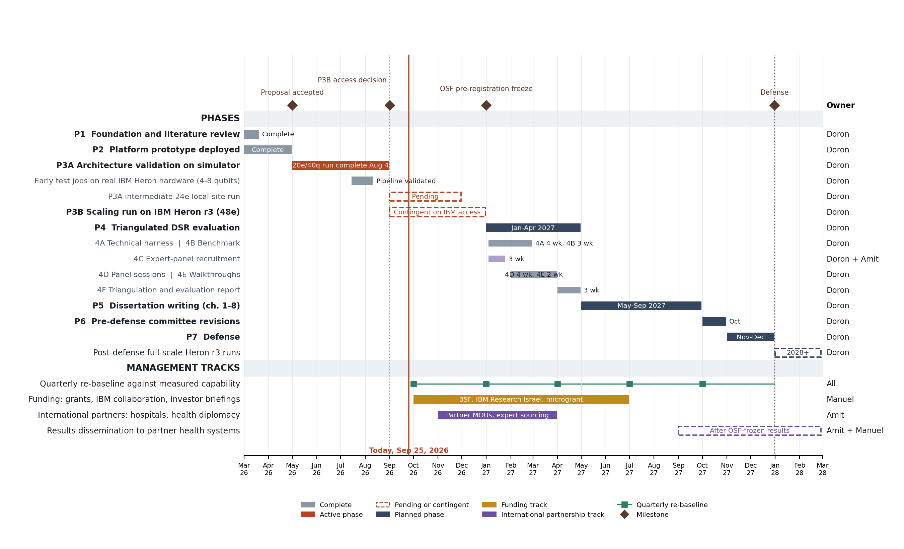
Note. Phases, durations, sub-phases, and milestones follow the dissertation timeline (Cohen, 2026a), updated to September 25, 2026. The management tracks and owners are the team plan for this project. Dashed bars are pending or contingent work. Phase 3B depends on IBM Quantum Network access.

Project Artifacts
Table 1 lists the artifacts the project would maintain if it went forward. The categories follow Section 4.6 of the PMBOK Guide (PMI, 2021).
Table 1
Artifacts the SOLANGE Project Would Maintain
Artifact | PMBOK category | How we would use it | Owner
Project charter | Strategy | Authorizes the project, names the four milestones, and states that Phase 3B is contingent on IBM access. | Doron
Roadmap | Strategy | Shows phases, milestones, and decision points (Figure 1). Re-baselined each quarter against measured capability, never against a vendor date. | Doron
Assumption log | Logs and registers | Records every modeling choice behind a result, such as the active space, selection threshold, and basis set, so each result can be traced to its assumptions. | Doron
Risk register | Logs and registers | Tracks IBM access, hardware noise, funding gaps, and expert recruitment, each with an owner and a planned response. | All
Stakeholder register | Logs and registers | Lists chemists, oncologists, the committee, regulators, funders, and foreign health partners, with what each group counts as success. | Amit
Change log | Logs and registers | Records formal changes, such as removing TP53 Y220C after rezatapopt entered trials and retracting an energy result. | Doron
Communications management plan | Plans | Defines who receives which result and through which channel. Every result carries its Cynefin context: established or experimental. | Amit
Test plan | Plans | Holds the pre-registered thresholds: 100% audit-trail integrity, at least 95% end-to-end execution, and an expert rating mean of at least 5.0 (Cohen, 2026a). | Doron
Budget | Baselines | Approved estimate for compute time, hardware access, and the expert panel. Compared with actual spending each quarter. | Manuel
Memoranda of understanding | Agreements | Set the terms of data use and expert participation with partner hospitals and research institutions. | Amit and Manuel
Project Management Model
We would manage SOLANGE with the Cynefin framework as the main model, inside a hybrid life cycle. Cynefin diagnoses cause-and-effect relationships in five contexts (PMI, 2021, Section 4.2.5.1). In a complicated context, the unknowns are known, and experts apply analysis and good practices. In a complex context, the unknowns are unknown, so the team works in repeated cycles of probe, sense, and respond. When the context is unclear, the framework recommends breaking the problem into parts and matching each part to a context. SOLANGE needs this split. The classification stage is complicated, so it follows a predictive plan with fixed milestones. The quantum stage is complex, so it follows short cycles in which the team runs a calculation, measures the result, and decides what enters the next cycle. The quarterly re-baseline in Figure 1 schedules those cycles. Chapter 3 of the PMBOK Guide allows parts of one project to follow different approaches (PMI, 2021). This structure avoids both failures that Rittel and Webber (1972) describe: the fixed plan and free improvisation.
Cynefin leaves one gap, because Table 4-1 of the PMBOK Guide does not link it to stakeholders (PMI, 2021). We therefore add the cross-cultural communication model. It explains that the background of the sender shapes a message, and the background of the receiver shapes its interpretation (PMI, 2021, Section 4.2.2.1). A chemist, an oncologist, an investor, and a health official will read the same result differently, and the Watson experience shows the cost of such misreading (Strickland, 2019). Each result will therefore state its Cynefin context, established or experimental, and conditional results will be presented in a live briefing, not only in a written report (PMI, 2021, Section 4.2.2.2). Manuel applies this rule with funders, and Amit applies it with partner governments and hospitals. Every model costs time and expertise (PMI, 2021, Section 4.1), so the second model is justified only by the domain it adds. This combination is the tailoring decision at the center of the plan.
References
The ASCO Post. (2026, March 13). p53 reactivator rezatapopt in TP53 Y220C-mutated solid tumors. https://ascopost.com/news/march-2026/p53-reactivator-rezatapopt-in-tp53-y220c-mutated-solid-tumors/
Bray, F., Laversanne, M., Sung, H., Ferlay, J., Siegel, R. L., Soerjomataram, I., & Jemal, A. (2024). Global cancer statistics 2022: GLOBOCAN estimates of incidence and mortality worldwide for 36 cancers in 185 countries. CA: A Cancer Journal for Clinicians, 74(3), 229-263. https://doi.org/10.3322/caac.21834
Cleveland Clinic. (2023, March 20). Cleveland Clinic and IBM unveil first quantum computer dedicated to healthcare research [Press release]. https://newsroom.clevelandclinic.org/2023/03/20/cleveland-clinic-and-ibm-unveil-first-quantum-computer-dedicated-to-healthcare-research
Cohen, D. (2026a). Deciding when quantum computation is warranted: A governed instrument for classical-tractability adjudication in non-druggable oncology [Doctoral dissertation proposal, Claremont Graduate University]. https://nsclc-quantum-viewer.netlify.app/dissertation_revised
Cohen, D. (2026b). A governed QC-AI-HPC architecture for deciding when quantum computation is warranted in non-druggable oncology [Unpublished manuscript prepared for arXiv submission]. Claremont Graduate University. https://github.com/doron66-collab/lili2014/tree/main/arxiv
IBM. (2025a, June 10). How IBM will build the world's first large-scale, fault-tolerant quantum computer. IBM Quantum Computing Blog. https://www.ibm.com/quantum/blog/large-scale-ftqc
IBM. (2025b, November 12). Scaling for quantum advantage and beyond. IBM Quantum Computing Blog. https://www.ibm.com/quantum/blog/qdc-2025
Kim, Y., Eddins, A., Anand, S., Wei, K. X., van den Berg, E., Rosenblatt, S., Nayfeh, H., Wu, Y., Zaletel, M., Temme, K., & Kandala, A. (2023). Evidence for the utility of quantum computing before fault tolerance. Nature, 618, 500-505. https://doi.org/10.1038/s41586-023-06096-3
Lee, S., Lee, J., Zhai, H., Tong, Y., Dalzell, A. M., Kumar, A., Helms, P., Gray, J., Cui, Z.-H., Liu, W., Kastoryano, M., Babbush, R., Preskill, J., Reichman, D. R., Campbell, E. T., Valeev, E. F., Lin, L., & Chan, G. K.-L. (2023). Evaluating the evidence for exponential quantum advantage in ground-state quantum chemistry. Nature Communications, 14, Article 1952. https://doi.org/10.1038/s41467-023-37587-6
Ostrem, J. M., Peters, U., Sos, M. L., Wells, J. A., & Shokat, K. M. (2013). K-Ras(G12C) inhibitors allosterically control GTP affinity and effector interactions. Nature, 503, 548-551. https://doi.org/10.1038/nature12796
Project Management Institute. (2021). A guide to the project management body of knowledge (PMBOK guide) (7th ed.). Project Management Institute.
Rittel, H. W. J., & Webber, M. M. (1972). Dilemmas in a general theory of planning (Working Paper No. 194). Institute of Urban and Regional Development, University of California, Berkeley. https://escholarship.org/uc/item/01v4t1c9
Schirber, M. (2024). A moving target for quantum advantage. Physics, 17, 13. https://physics.aps.org/articles/v17/13
Strickland, E. (2019, April 2). How IBM Watson overpromised and underdelivered on AI health care. IEEE Spectrum. https://spectrum.ieee.org/how-ibm-watson-overpromised-and-underdelivered-on-ai-health-care
U.S. Food and Drug Administration. (2003). Part 11, electronic records; electronic signatures: Scope and application [Guidance for industry]. https://www.fda.gov/regulatory-information/search-fda-guidance-documents/part-11-electronic-records-electronic-signatures-scope-and-application
U.S. Food and Drug Administration. (2021, May 28). FDA grants accelerated approval to sotorasib for KRAS G12C mutated NSCLC. https://www.fda.gov/drugs/resources-information-approved-drugs/fda-grants-accelerated-approval-sotorasib-kras-g12c-mutated-nsclc
Appendix: Supporting Artifacts
The screenshots below show the working SOLANGE platform and the dissertation behind the project plan.
Screenshot 1. SOLANGE platform, Dashboard: the classical tractability plane. Each point is a target classified by measured entanglement and active-space size (Cohen, 2026a).
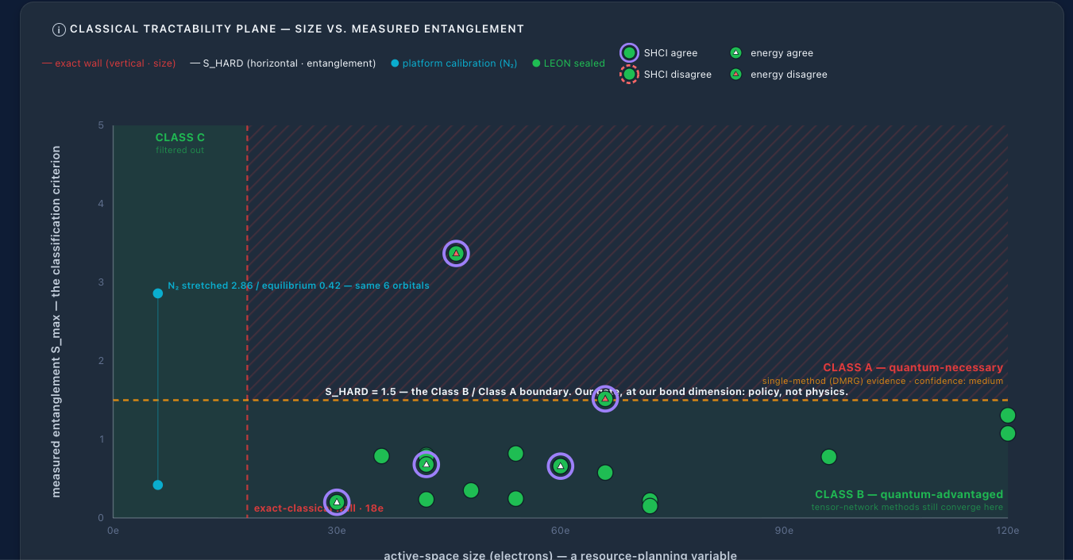
Screenshot 2. SOLANGE platform, Orchestration: the two-method classifier (DMRG and SHCI) with sealed results for real targets (Cohen, 2026a).
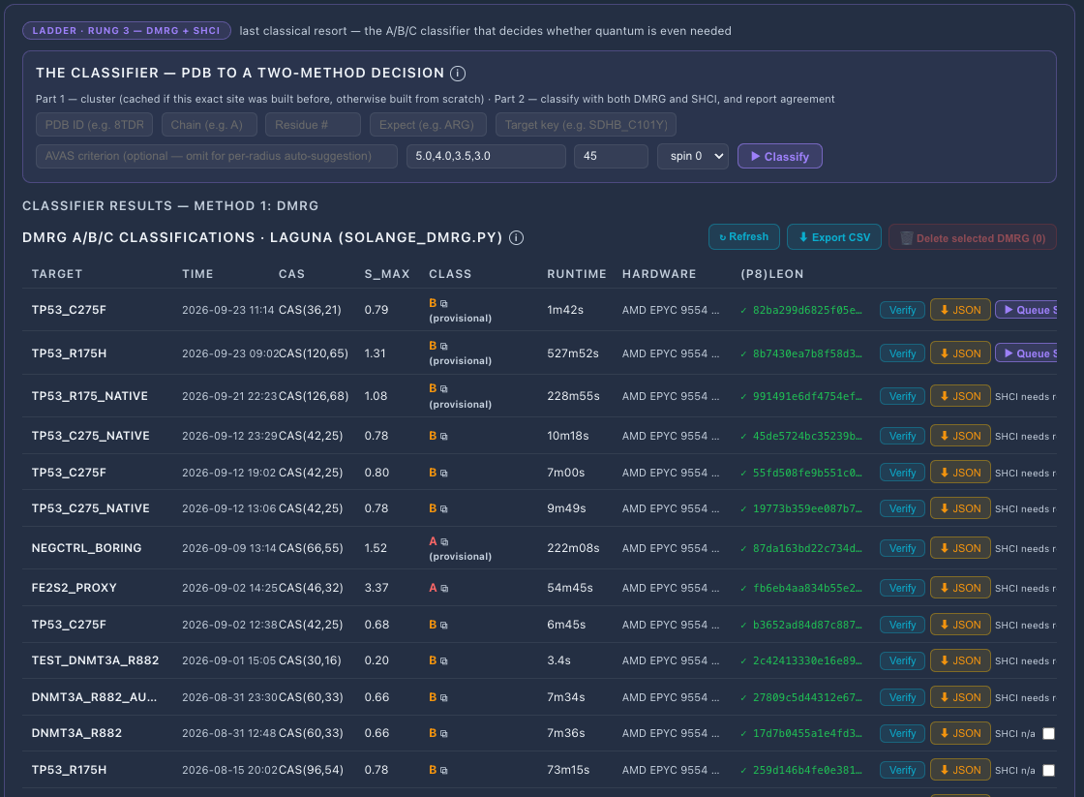
Screenshot 3. SOLANGE platform, Orchestration: pipeline test jobs on real IBM Heron hardware, July to August 2026 (Cohen, 2026a).
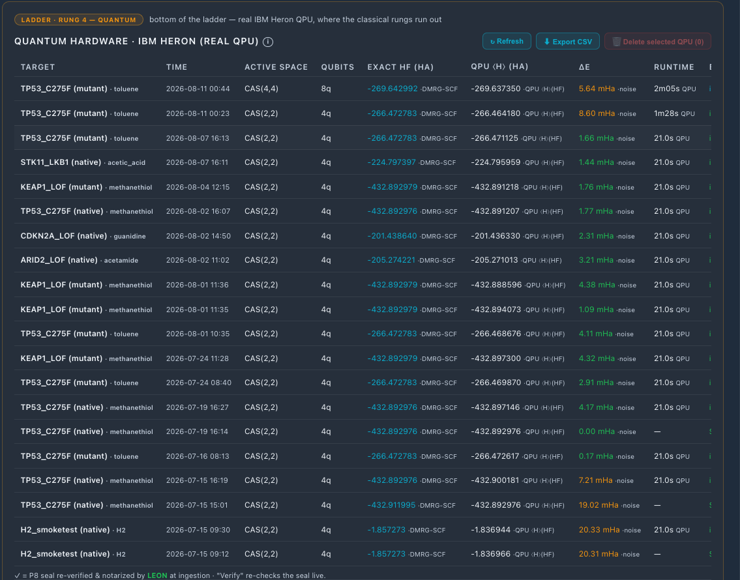
Screenshot 4. SOLANGE platform, Compliance: the LEON audit trail and the P1 to P9 provenance schema (Cohen, 2026a).
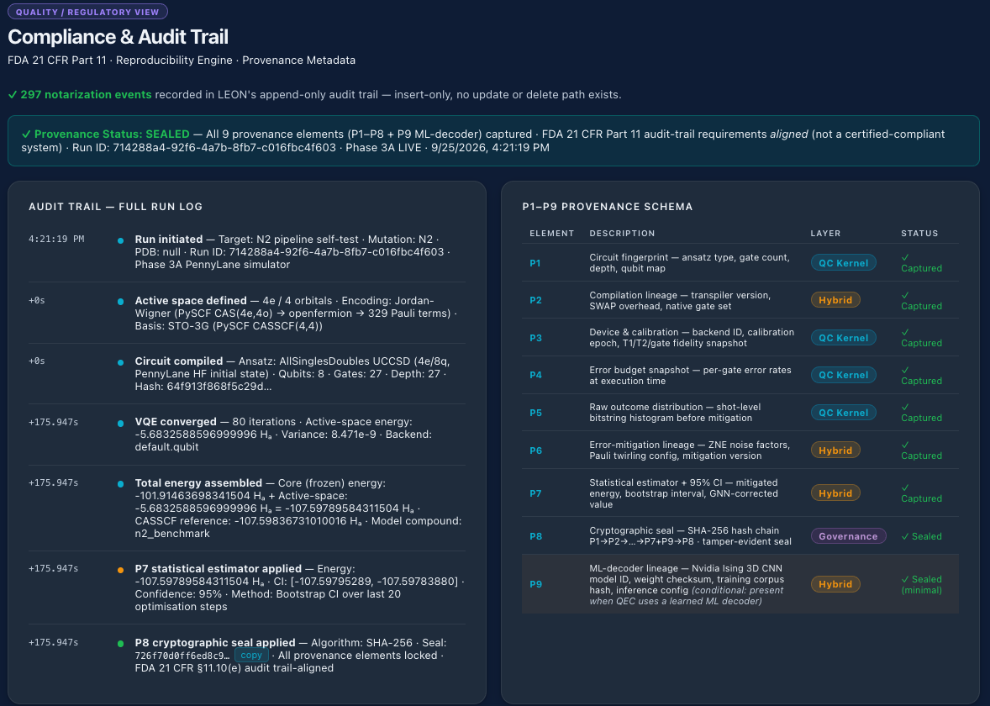
Screenshot 5. SOLANGE research poster, IST 697, May 2026.
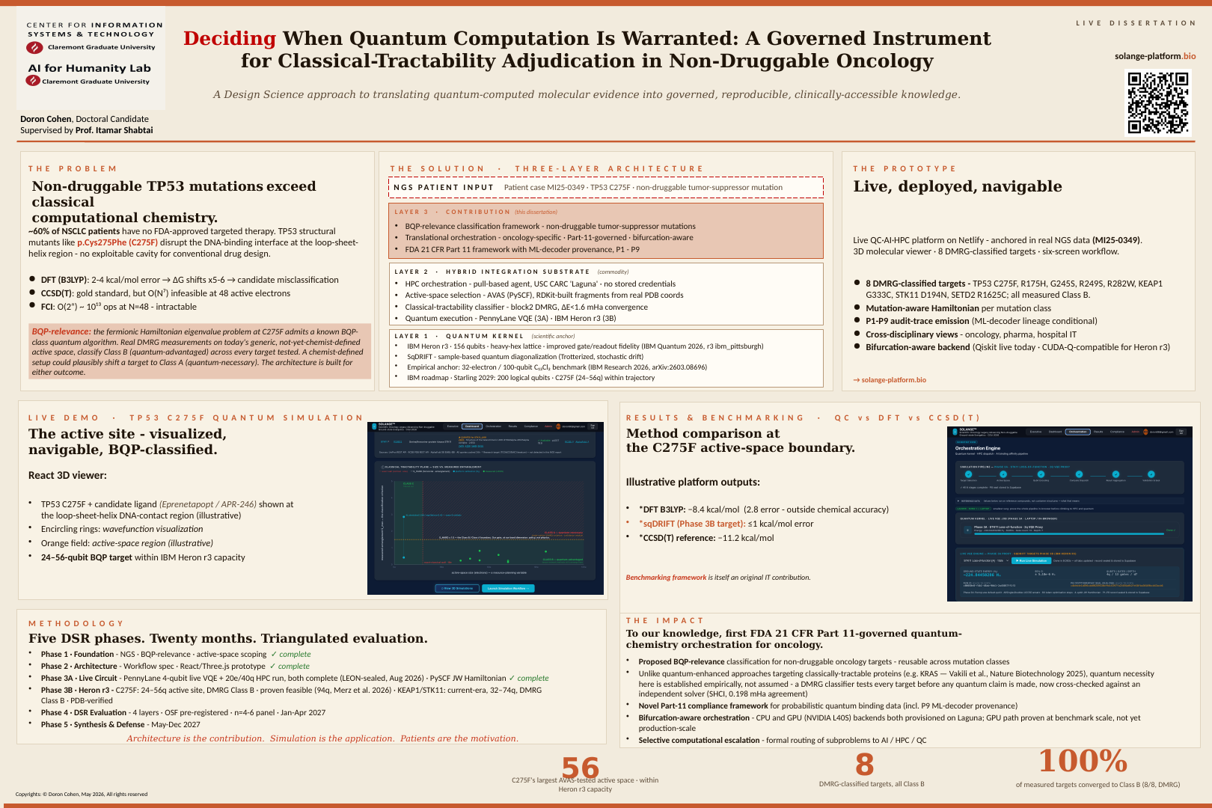
Screenshot 6. Manuscript prepared for arXiv submission, September 2026 working draft, first page (Cohen, 2026b).
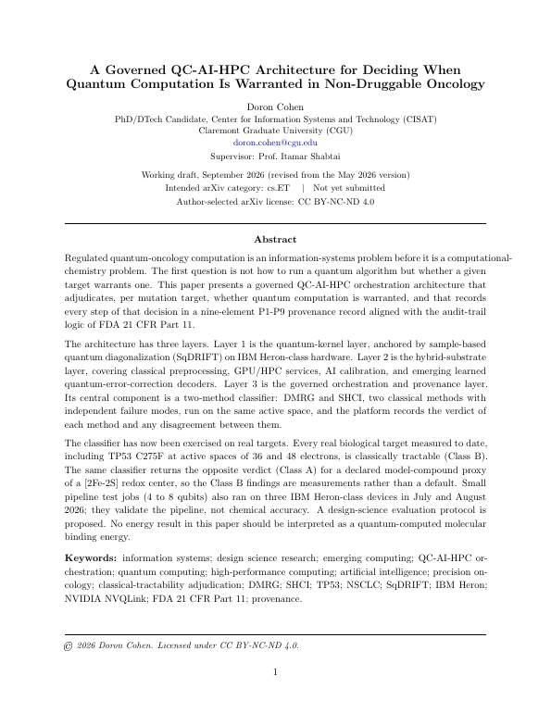
Screenshot 7. SOLANGE dissertation proposal, title page (Cohen, 2026a).
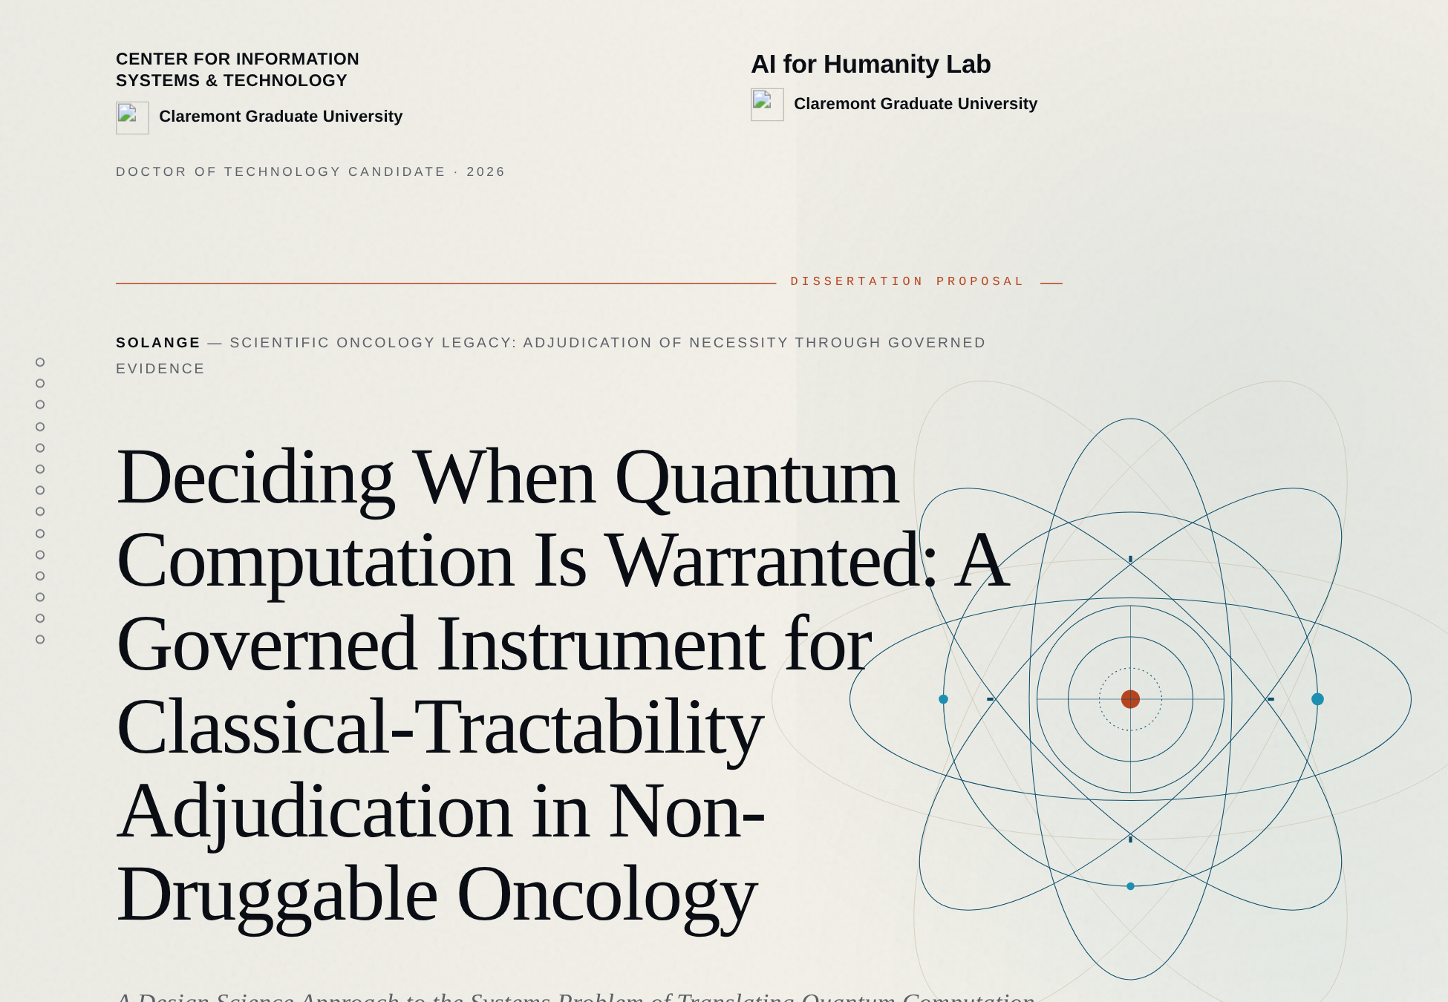
Screenshot 8. SOLANGE dissertation abstract, stating that every real biological target measured to date is classically tractable (Cohen, 2026a).
