SOLANGE
System Architecture — the tools we use and how they fit together
A two-part map: (A) the external services the platform runs on, and (B) the internal components and the "pull loop" that moves a job from the browser to the cluster / quantum hardware and back, verified.

Part A — External Infrastructure
SOLANGE is assembled from a small set of managed third-party services. Nothing here is installed by the end user; each service does one job and they talk to each other over HTTPS. The diagram shows every external tool and the direction data flows between them.
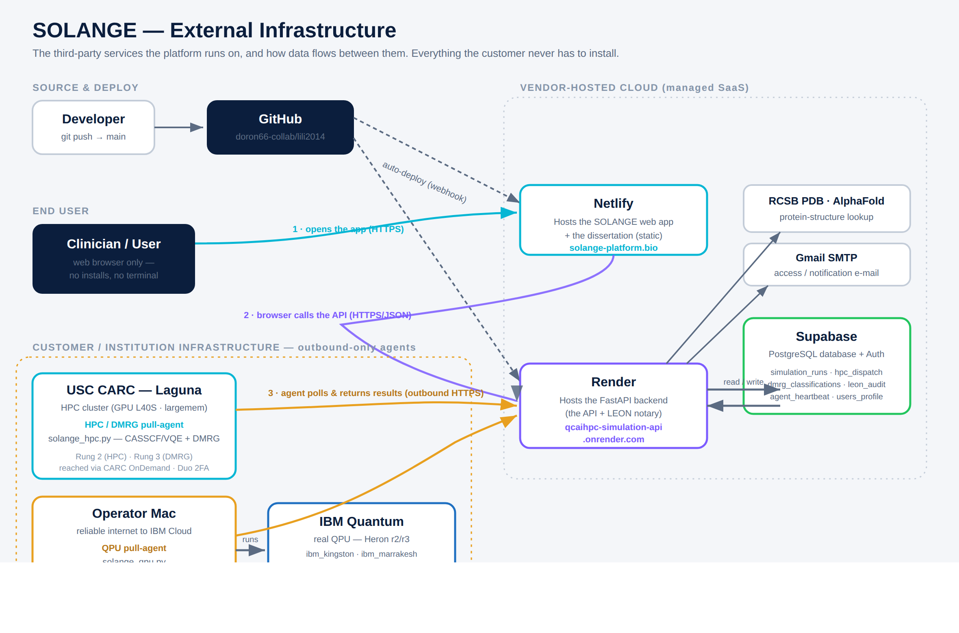
Figure A — External infrastructure. Vendor-hosted cloud (dashed box), the source/deploy chain, and the customer-side pull-agents.

The services, one by one
GitHub — the single source of truth
doron66-collab/lili2014 holds all the code (frontend, backend, agent scripts, the dissertation). A git push to the main branch is the one action that triggers everything downstream: GitHub notifies Netlify and Render by webhook, and they rebuild automatically. There is no manual "deploy" step.
Netlify — hosts the web app
Netlify builds and serves the frontend — the SOLANGE interface and the dissertation — as static files at solange-platform.bio. It watches the main branch; every push rebuilds the site within a minute or two. Netlify holds no secrets and does no computation — it just serves the pages the browser loads.
Render — hosts the backend (the API + LEON)
Render runs the FastAPI backend (Python) at qcaihpc-simulation-api.onrender.com. This is the brain of the operation: it holds the job queue, receives results, runs the LEON notary, and reads/writes the database. Also watches main and redeploys on push. It is the only component the browser and the agents both talk to.
Supabase — the database
A hosted PostgreSQL database plus authentication. Everything durable lives here — the job queue, sealed results, DMRG classifications, and the immutable audit trail. The backend reads and writes it; inserts require the service_role key (held only by the backend, never in the browser). Key tables:
- hpc_dispatch — the job queue (queued → running → done).
- simulation_runs — every sealed HPC/QPU result.
- dmrg_classifications — the Rung-3 A/B/C verdicts.
- leon_audit — append-only record of every notarization.
- agent_heartbeat — agent liveness (drives the green/red dot).
IBM Quantum — the real quantum hardware
The actual QPUs — IBM Heron processors (ibm_kingston, ibm_marrakesh = Heron r2) — reached through Qiskit Runtime. This is the only truly quantum step in the whole system; everything else is classical infrastructure around it. Reached from the operator Mac, which has reliable internet to IBM Cloud.
USC CARC — Laguna (the HPC cluster)
The academic supercomputer where the classical heavy lifting runs — CASSCF/VQE on GPU nodes (L40S) and DMRG on large-memory nodes. It is a secured environment (interactive Duo 2FA, no inbound automation), reached through CARC OnDemand → JupyterLab. The HPC/DMRG agent runs inside your authenticated session there.
The operator Mac + structure/email services
The Mac runs the QPU agent (it needs a stable connection to IBM). Two supporting services complete the picture: RCSB PDB / AlphaFold (the backend fetches protein structures from them on demand), and Gmail SMTP (access / notification e-mail).

How the data flows (the numbered arrows)
- 1 · Open the app: the user’s browser loads the SOLANGE app from Netlify over HTTPS.
- 2 · Use the app: the browser calls the Render API (HTTPS/JSON) for everything dynamic — queuing jobs, reading results. Render reads/writes Supabase.
- 3 · Agents work: the Laguna and Mac agents poll the Render API outbound, claim queued jobs, run them locally, and return sealed results — again outbound only.
✕ Critical security property (DP2): no arrow ever points INTO the cluster or the Mac from the cloud. The agents only reach out. There is no stored credential outside the trust boundary and no inbound path — which is exactly why a secured HPC environment permits this pattern.

Part B — Internal Architecture & the Pull Loop
This is the inside view: what SOLANGE is actually made of, and how a single job travels end to end. Four layers — frontend, backend, database, and the pull-agents — connected by one repeating loop.
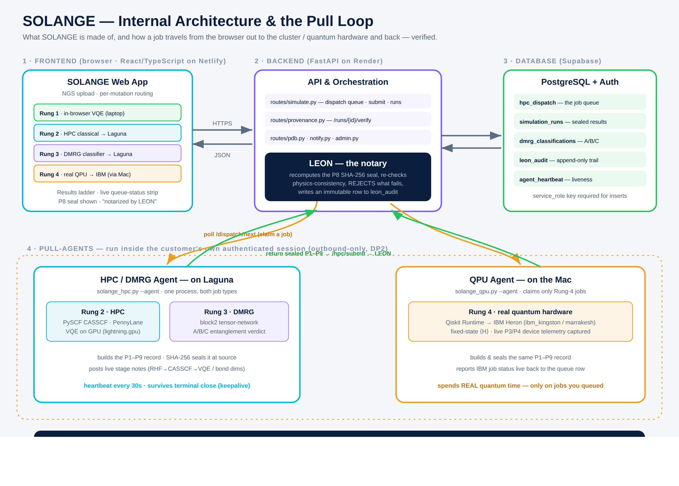
Figure B — Internal architecture. The four layers and the job lifecycle (bottom strip).

1 · Frontend — the web app
The React/TypeScript interface in the browser. Its heart is the orchestration ladder, ordered small→large: Rung 1 (in-browser VQE on a laptop), Rung 2 (classical HPC on Laguna), Rung 3 (DMRG classifier on Laguna), Rung 4 (real QPU on IBM, via the Mac). A target climbs only as far as its size and BQP-class require. Every returned result shows its P8 seal and "notarized by LEON."

2 · Backend — API, orchestration & LEON
The FastAPI service. A few route modules do the work — simulate.py (the dispatch queue, result submission, run listing), provenance.py (on-demand re-verification), plus pdb.py, notify.py, admin.py. Sitting on the return path is LEON (Lineage-Evidence Orchestration & Notarization): it independently recomputes the P8 SHA-256 seal over the P1–P9 fields, re-checks the physics-consistency invariant, rejects anything that fails (the row never enters the store), and writes an immutable line to leon_audit. This is the "verify, don’t trust" principle in code — and it is named in memory of Leon.

3 · Database — Supabase
The same tables described in Part A, seen from the inside: the queue the backend writes and the agents read, the sealed results the ladder displays, and the audit trail LEON appends to. It is the durable memory of the whole system.

4 · Pull-agents — where the compute actually happens
HPC / DMRG agent (Laguna) — one process (solange_hpc.py --agent) that handles both classical rungs. Rung 2 uses PySCF (CASSCF) and PennyLane VQE on GPU; Rung 3 uses the block2 tensor-network library for the A/B/C entanglement verdict. It builds the P1–P9 record, SHA-256-seals it at source, streams live stage notes (RHF→CASSCF→VQE step, or DMRG bond dimensions), and keeps a heartbeat every 30 s so it never looks offline mid-run. A keepalive supervisor lets it survive the terminal closing.
QPU agent (Mac) — a second process (solange_qpu.py --agent) that claims only Rung-4 jobs. It submits circuits to IBM Heron via Qiskit Runtime, captures live device telemetry (calibration epoch, gate/readout error, T1/T2) into P3/P4, seals the same P1–P9 record, and reports the live IBM job status back to the queue row. Each job it claims spends real quantum time — so it only ever runs work you explicitly queued.

The pull loop — a job’s life, step by step
This single loop is the operational core, and every step is provenance-tracked:
- Queued — you tick a mutation in the browser and press a Rung button; the backend writes a row to hpc_dispatch.
- Claimed — the matching agent, polling outbound, sees the job and marks it running.
- Executed — the agent runs it with full in-environment privileges (on Laguna, or on the IBM QPU).
- Returned & sealed — the agent builds the P1–P9 record and SHA-256-seals it at source, then POSTs it to /hpc/submit.
- Verified — LEON recomputes the seal and the physics check; a mismatch is rejected, not stored.
- Stored & shown — the accepted row lands in simulation_runs and appears in the ladder, re-verifiable on demand forever after.

Quick reference — who talks to whom
From | To | What crosses
Developer | GitHub | git push to main
GitHub | Netlify + Render | deploy webhook (auto-rebuild)
Browser | Netlify | loads the static web app (HTTPS)
Browser | Render API | queue jobs, read results (HTTPS/JSON)
Render | Supabase | read / write all tables (service_role)
Render | PDB / AlphaFold / Gmail | structure lookup · e-mail
Laguna agent | Render API | poll queue · return sealed result (outbound)
Mac QPU agent | Render API | poll queue · return sealed result (outbound)
Mac QPU agent | IBM Quantum | run circuits (Qiskit Runtime)
Note the asymmetry: the cloud never initiates a connection into Laguna or the Mac. The agents always reach out. That one rule is the entire security posture.

